REVISION NOTICE TABLE
DATE | DESCRIPTION OF REVISION

PROCESSING NOTES
Cruise: 2019-052
Agency: PBS, Ecosystem Sciences Division, Nanaimo, B.C.
Chief Scientist: Neville C.
Platform: Sea Crest
Location: Strait of Georgia
Project: Strait of Georgia Juvenile Salmon
Date: 18 June 2019 - 6 July 2019

Processed by: Germaine Gatien
Date of Processing: 24 April 2020 – 5 May 2020
Number of original HEX files: 53 (+1 empty) Number of CTD files: 53

INSTRUMENT SUMMARY
A SeaBird Model SBE-25 CTD (s/n 0404) was used with temperature sensor #2449, conductivity sensor #1764, Wetlabs ECO Fluorometer #2216, dissolved oxygen sensor #1176, SBE pH sensor 0852 and pressure sensor #464.

SUMMARY OF QUALITY AND CONCERNS
There was a log book available plus a spreadsheet of events.

The format used for header information in the raw files did not permit automatic conversion into IOS Headers. If the following format is used in the HEX files the information will be entered automatically and this will make data processing quicker and less error-prone:
** Latitude: 49 9.781 N
** Longitude: 123 32.970 W
** Station: 39
** Depth: 378 m
There was a spreadsheet provided with the necessary information which is very helpful.

The configuration file used at sea contained out-of-date calibration parameters. All instruments had been recalibrated in November 2018 except the fluorometer. The offset used for the fluorometer had been changed from the one used since the last factory check. While this could have been done on purpose if deep fluorescence values seemed too large, in this case it produced significantly negative values for most depths. So the offset on file from the previous factory calibration was used. This produced deep fluorescence values similar to those found during another cruise in the Strait of Georgia in June 2019 using a different type of fluorometer.

Deployment involved a soak at the surface for between 38 seconds and 2.7 minutes before starting the cast. Few soaks lasted for the recommended 2 minutes to allow equilibration of the conductivity sensor. Some were so short that the dissolved oxygen sensor did not turn on until the CTD was at 10 to 20m depth (it takes about 52s in water before the DO sensor turns on.). When a dissolved oxygen sensor is in use, it is recommended that there be a soak at 10m before running casts. If that is undesirable for a particular project, then a lengthy surface soak is particularly important.

There are concerns about the reliability of the salinity data so they are reported with only 3 decimal places. There were many unstable excursions in salinity. These are likely due to variable flow rates leading to misalignment of temperature and conductivity. Plumbing or pump problems are possible causes. Some of the noise looks related to descent rate variations which may again be a result of flow rate issues. Near-surface values are also questionable for some casts due to a very short surface soak.

For dissolved oxygen there are two concerns. First, because of the deployment method there are likely to be values that are too high around 10m as bubbles are released. Second, the upcast data often look unrealistic with values that vary little and are much lower than downcast values. This could also be due to some problem in the flow that affected the salinity data. While there is no evidence of this affecting the downcast dissolved oxygen data, that is a possibility.

There was no calibration sampling during this cruise and no history of sensors being used since they were last serviced at the factory. No recalibration was applied.

While the CTD fluorescence data are expressed in concentration units, they do not always compare well to extracted chlorophyll samples.

Warning: The pH:SBE:Nominal data should be used with caution; no field calibration data are available. Calibration is required for each cast to get absolute values, although general trends within a cast are likely real.

PROCESSING SUMMARY
1. Seasave - This step was completed at sea. The file names were in standard format.

2. Preliminary Steps
A spreadsheet with event information was provided.

The configuration file used at sea was out of date with calibrations from 2015 and 2017. All instruments had been recalibrated in November 2018 except the fluorometer. The file used at sea had a different offset for the fluorometer than has been in use since the last factory check. While this may could have been done on purpose if deep fluorescence values seemed too large, in this case it produced significantly negative values for most depths. So the offset on file from the previous factory calibration was used. This produced deep fluorescence values similar to those found during another cruise in the Strait of Georgia in June 2019 using a different type of fluorometer.
The configuration file with the most recent calibration parameters was saved as 2019-052-ctd.xmlcon.

The cruise summary sheet was completed.

3. Conversion of Raw Data
The HEX files were converted using configuration file 2019-052-ctd.xmlcon.
There was no 10m soak. The surface soak varied from 38 seconds to 2.7 minutes with very few lasting the recommended 2 minutes. Some downcasts started before the DO sensor turned on – at about 52 seconds after entering water. Examination of a selection of casts shows problems in dissolved oxygen data near the surface and upcasts and downcasts look significantly different at most depths. Even a long surface soak will likely not resolve the problem of bubbles causing falsely high DO values as the CTD experiences higher pressures. Peaks in DO at 5 to 10m could be real but are more likely due to the release of bubbles as pressure increases. Since there was no calibration sampling it will be difficult to confirm that the near-surface values are bad.

Conductivity looks like it was not fully equilibrated for some casts with very short soaks.
Fluorescence and pH look normal. Temperature mostly looks fine for most casts checked but #187 had very bad temperature during most of the downcast. All data looked poor below 20m.
From the upcasts it appears that the surface is between -1db and -0.1db but since there would be water still moving in the tubing, this is likely as close to 0 as expected for this type of test and it is within the specifications for the instrument.

4. WILDEDIT
Most casts had no spikes. At least one cast did have spikes in the data but tests showed WILDEDIT made no significant difference with a variety of settings; the spikes involved too many points for WILDEDIT to be effective. It looks like something was wrong with the plumbing. WILDEDIT was not run.

5. WFILTER
Tests were run to find a suitable setting to remove steps in pressure without smoothing the pressure too much. WFILTER was run using a cosine filter, size 5 on the pressure, depth, temperature and conductivity channels. Tests to check how well this worked are inconclusive; instabilities were decreased but many remain. (Later it was decided that size 9 improved the data somewhat, so this step was repeated with that value for all channels and the steps 4 to 12 were rerun.)

6. ALIGNCTD
Based on tests run for other cruises in this project using the same DO sensor, ALIGNCTD was run on all casts to advance the DO channel by 2.5s. Plots were examined after this step and the results do not look good, but that is likely because the DO data are poor during upcasts and the beginning of downcasts.

7. CELLTM
CELLTM was run on all casts using the SeaBird recommended parameters, (α, 1/β) = (0.04, 8). When problems were found in the conductivity channel, tests were run using a variety of settings but none had any better results to (0.04,8).

8. DERIVE
Program DERIVE was run to calculate salinity and dissolved oxygen concentration (tau correction included). Plots were examined and it is clear that the data have been improved, but many problems remain.

Plots were made of dissolved oxygen concentration data.
One cast that did have a full 2minute soak was examined. Dissolved oxygen spiked to very high values at first, then dropped to ~4.8mL/L followed by a gradual rise to ~5..4mL/L at the end of the soak. As the CTD moved downwards DO continued a slow rise until it reached 6m. Then there was a sharp rise to about 6.8mL/L at 9.5m followed by a sharp drop until it reached values close to those at the surface when the CTD reached about 12m. That peak at 9.5m is likely caused by bubble release.

Unfortunately the upcast DO profiles look suspiciously low and it not clear why that should be so. Those values are always slightly lower than upcasts due to slow response and shed wakes, but the shape of the profiles are usually similar. In this case there is often very little variation with depth.

A quick comparison was made with a cast from the same area during 2019-050 but there was a 13-day separation plus they were some distance apart. No attempt was made to compare values, only profile shapes. The 2019-050-0061 cast had similar DO profiles in the downcast and upcast and showed little change between 1m and 10m. (The upcast results are from times when the CTD was stopped for bottles so we do expect values close to downcasts.) The 2019-052-0009 cast showed a peak in DO at about 10m during the downcast while the upcast values were both much lower. The upcast data look odd and will be studied later.

Another comparison was made between casts 2019-043-0046 and 2019-052-0137 which were fairly close in space but 18 days apart. Again the 2019-043 upcast and downcast values are similar at 1m and 10m and downcasts and upcasts are similar at the surface with no subsurface peak while the 2019-052 cast does have a subsurface peak on the downcast and very low values for the whole upcast.

So while the timing and positions are not the same, there is certainly no evidence of unusually low DO values in the Strait of Georgia in early June 2019 as appears in the 2019-052 upcasts. And there is also no evidence of peaks at 10m in those earlier cruises, so the peaks in 2019-052 are likely due to bubbles.

Cruise 2019-053 used the same equipment in September so those data were processed up to this stage to see if the same problems were found. The dissolved oxygen upcasts are closer to downcasts for many casts and near-surface values are higher. The soaks were generally somewhat longer but again there were no 10m soaks.

Salinity values also appear to be affected by short soaks, but not as severely as dissolved oxygen.

9. Conversion to IOS Headers
The IOSSHELL routine was used to convert the CNV files to IOS Headers. One cast was missing its latitude header; that was added and the file was reconverted.
CLEAN was run to replace pad values in the pressure channel with interpolated values.
Merge Headers was used to add latitude, longitude, water depth and station names.
Times were checked against the log and while the file times were expected to be in local time (UTC-7 hours) they were actually 9 hours off. Likely an attempt to change the computer from PST to PDT moved in the wrong direction.
ADD TIME CHANNEL was run to add 9 hours to all start times.

10. Checking Headers
A cross-reference list was produced and checked against the event spreadsheet; one error in an event number in the merge file was found and corrected and the last 2 routines were rerun for that file.
The cross-reference list then looked fine.
The header check was run. There were many negative values; most will likely be removed by DELETE. This will be checked again later. No other problems were noted. The speed check looks fine, so there are likely no problems with dates. The track plot looks fine.

Since there was no subsurface soak, CLIP was not needed.

The surface check shows a mean value of +0.1b with values ranging from -0.7db to +1.1db. As it starts recording as it passes through the surface this indicates a good pressure calibration. As noted earlier at the end of casts conductivity went to 0 when pressure was between -1.1db and -0.1db. Because there is some lag in conductivity due to water remaining in the cell, the pressure is likely well within the expected range.

11. SHIFT
Conductivity
Tests were run to see what alignment parameter for conductivity would improve stability in T-S space.
Many casts looked bad with all settings tried – they have large unstable features.
For most casts a large shift was needed with a setting of +5.5 records looking best overall. This is an unusually large alignment correction suggesting a problem with flow to the sensor. This may account for the unusually large differences between downcasts and upcasts, particularly in salinity and dissolved oxygen.
There were a few casts (#4 and 235 to 246) that looked worse with the large shift; an advance of +0.6 records is a setting that has been used in the past for this CTD and looked good for these casts.
SHIFT was run apply an advance of 5.5 records to all casts except #4, 235, 239, 241, 246 and 251 for which the choice was +0.6 records.

Fluorescence
The fluorometer was not pumped, so a shift in alignment is expected to be small or unnecessary. Profile plots of temperature and fluorescence were examined. In many places the upcast temperature looks poor so it is hard to judge, but overall the alignment looks reasonably good.
Dissolved Oxygen
This channel was aligned earlier but the effect is impossible to judge due to the bad upcast data.
pH
Tests were run on the alignment of the pH traces with temperature. An advance of 10 or 15 records was found to improve the alignment on other 2017/2018 cruises using this equipment. For this cruise a setting of +10 records looks ok overall, but there is considerable variation which may be due to temperature problems .
SHIFT was run on all casts to advance the pH signal by 10 records.

12. DELETE
DELETE was run on all casts using the following parameters:
Surface Record Removal: Last Press Min. Surface Swell Pressure Tolerance: 1.0
Swells deleted. Warning message if pressure difference of 2.00
Drop rates < 0.3m/s (calculated over 5 points) was deleted from 10db to 10db above the maximum pressure.
COMMENTS ON WARNINGS: The only warning came from cast #143 at the bottom and during the upcast so are of no concern.

13. DETAILED EDITING
Almost all casts need some editing with many unstable features, particularly near the surface. At greater depths there are problems in the salinity data. Examination of profiles shows that there are frequent sections of “jittery” values that appear in salinity during downcasts. These reflect the descent rate even though the rate was usually not low enough to lead to shed wake corruption as indicated by the temperature showing few reversals. Conductivity and salinity both move towards higher values when the descent rate is at a local minimum. So the problem is likely due to the pump not being able to maintain a steady flow rate in these conditions. The fact that both conductivity and salinity are higher would normally suggest the temperature is too low, but the temperature profiles are usually quite smooth. The problem is likely that the alignment is off and conductivity advance is too high in these areas. No perfect alignment is possible and is especially problematic for this data set.

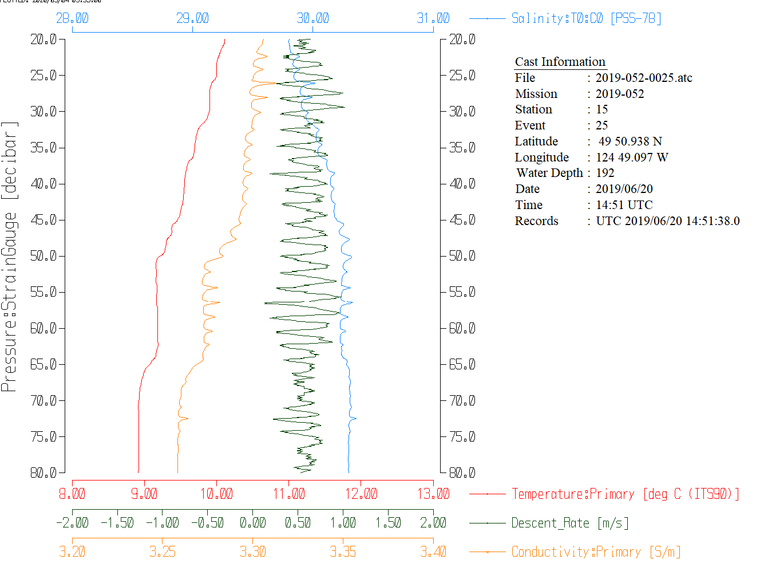
Tests were run on one cast to try to improve the stability:
- The filter width was increased from 5 to 9 and that made no great difference. But it may help slightly and certainly does not make matters worse. Conductivity is noisier than temperature or pressure so a test was made of using larger widths for conductivity but the difference was slight.
- The window filter step was skipped, and pressure only was filtered at the DELETE stage. The result was worse. So the filtering step was useful.
- Examination of upcasts versus downcasts shows very poor data during the upcasts starting with the first cast. This was observed in the dissolved oxygen data earlier. So upcasts will not be useful as a substitute for downcasts that are heavily corrupted.
- Casts from cruise 2019-053 were processed up to the DELETE stage using the shift values used for this cruise. Plots were examined to see if the results were any better. Overall the dissolved oxygen profiles look better, especially near the surface. T-S plots look somewhat better than from 2019-052 if the higher shift value of +5.5 is applied but tests will need to be run to find the best setting for that cruise. Many of the casts showed a “jitter” in salinity and temperature during upcasts similar to those was noted during 2019-052.

Some of the cases with particularly noisy salinity have low and noisy descent rates. Some cases involved shed wake corruption and temperature is affected as well as salinity, but in other cases it looks as though the variable descent rate affected flow to the conductivity sensor. However, there are cases with quite steady descent rates that also have bad conductivity data.

CTDEDIT was used to remove records corrupted by shed wakes and to clean salinity where unstable features looked likely to be caused by misalignment of T and C. Where salinity was very noisy while temperature data looked ok, salinity points only were removed if it was clear which values are good and which bad. All casts required some editing. Notes of editing details were made in the headers.

T-S plots were examined after this step. Many unstable features remain. Some minor instability is expected in this area but so many large unstable features..

16. Calibration checks
Sensor History – This was the first use of the dissolved oxygen, pressure, temperature and conductivity sensors since they were last calibrated.
Comparison of repeat casts –There were no repeat casts.
Historic Ranges – Where available, profiles of temperature and salinity were examined with a 3-standard deviation climatology superimposed. All temperature data fell within the climatology except for a few high values around 25m for events #235 and #239. Salinity data all fell within the climatology except for some high values during cast #18 around 25m. The excursions are not considered indicative of calibration problems.
Post-cruise calibrations – There was a post-cruise calibration of pressure only.

17. CALIBRATE
There was no calibration sampling and no history of use during other cruises.
No recalibration was applied.

18. Fluorescence Filter
There are some negative fluorescence values at the surface, so CLEAN was run on the FIL files to replace those with pad values.
There were also some negative dissolved oxygen values at the surface so CLEAN was run again to replace those with pad values.
A median filter, size 5, was applied to the fluorescence data.

19. Bin Average and REMOVE
The files were bin averaged using 1db bins.
Plots were examined and some DO spikes were seen just after the groups of negative values that had been padded, so a text editor was used to replace those with pad values as well.
REMOVE was run to remove Scan_Number, Oxygen:Voltage, Descent Rate and Flag channels.

Dissolved Oxygen was derived in mass units and that was used to calculate DO saturation. Plots of near-surface saturation show a range of 55% to 125%. Such variability is not unusual in this region where some casts are in tidally mixed regions with small vertical gradients while others have high near-surface DO gradients. A bigger concern is the high values at about 10m in some casts – this could be due to bubbles being released as pressure increases. So the near-surface DO values are not as reliable as usual.

REORDER was used to get the 2 dissolved oxygen channels together.

20. HEADER EDIT and final checks of CTD files.
Header Edit was used to fix headers, fix formats and to add the following note to the headers:
Conductivity, Fluorescence:URU:Wetlabs and pH:SBE data are nominal and unedited
except that some records were removed in editing temperature and salinity.

The CTD was soaked at the surface for between 37s and 2.7 minutes. Some of
the downcasts started before the dissolved oxygen sensor had turned on.

There was no salinity or dissolved oxygen calibration sampling from this cruise.
This was the first use of the sensors since they were last serviced at the
factory so calibration drift is likely low.

There are concerns about the reliability of the salinity data so they are only
reported with 3 decimal places.

The problems with salinity are somewhat random unstable excursions that derive
from the conductivity channel and are likely due to variations in the alignment
with temperature data. This may be due to variable flow rates possibly due to
a pump/plumbing problem. The temperature data look fine. Near-surface salinity
values are also questionable for some casts due to a very short surface soak.

Dissolved oxygen values are likely to be high around 10 to 20m as bubbles are
released as there was no initial 10m soak. For cases with very short soak
periods the sensor had not turned on until the CTD was on its way down so
near-surface data are missing.

While the CTD fluorescence data are expressed in concentration units, they
do not always compare well to extracted chlorophyll samples.

WARNING: The pH:SBE:Nominal data should be used with caution; no field calibration
data were available at the time of processing.
Calibration is required for each cast to get absolute values, although general
trends within a cast are likely real.

For details on the processing see document: 2019-052_Processing_Report.doc.

A cross-reference listing was produced.
A header check was run on the CTD files and no problems were found.
The sensor history was updated.
Track plots were produced and look fine; they were added to the end of this report.
Plots of CTD casts were examined and no further problems were found.

Particulars
50. Went to 295m by mistake
88. Slowed down at 40m
167. Went to 190m due to miscommunication.

CRUISE SUMMARY

Cruise ID#: 2019-052
Dates: Start: 18 June 2018 End: 6 July 2019
Location: Sea Crest
Party Chief: Neville C.
CTD# | Make | Model | Serial# | Used with Rosette? | CTD Calibration Sheet Competed?
1 | SEABIRD | 25 | 404 | No | Yes

CTD CALIBRATION INFORMATION
Make/Model/Serial#: SEABIRD/SBE25/0404 Cruise ID#: 2019-052

Calibration Information
Sensor |  | Pre-Cruise |  | Post Cruise
Name | S/N | Date | Location | Date | Location
Temperature | 2449 | 8Nov2018 | Factory
Conductivity | 1764 | 21Nov2018 | Factory
ECO Fluorometer | 4185 | 07Mar2017 | Factory
SBE43 Oxygen | 1176 | 3Nov2018 | Factory
pH | 0852 | 13Dec2018 | Factory
Pressure | 0464 | 26Nov2018 | Factory

