REVISION NOTICE TABLE
DATE | DESCRIPTION OF REVISION
26 Feb 2025 | Removed original Silicate & Flag:Silicate channels and renamed corrected versions of those channels. TSG channel names/units updated. G.G.
26 March 2023 | Added HPLC data. J.R.

PROCESSING NOTES
Cruise: 2019-050
Agency: OSD
Location: Strait of Georgia / Juan de Fuca Strait
Project: Strait of Georgia Water Properties Survey
Party Chief: Chandler P.
Platform: Vector
Date: 2 June 2019 – 8 June 2019

Processed by: Germaine Gatien
Date of Processing: 4 December 2019 – 19 December 2019
Number of original HEX files: 83 (2 missing) Number of CTD files: 83
Number of original ROS files: 29 Number of CHE files: 29
Number of original TSG files: 1 Number of TOB files: 1

INSTRUMENT SUMMARY
CTD #0443 was mounted in a rosette and attached were a Wetlabs CSTAR transmissometer (#953DR), a SBE 43 DO sensor (#3791), a SeaPoint Fluorometer (3642), a Biospherical QSP-400 PAR sensor (#4565), an SBE pH sensor (691) and an altimeter (43281). A Biosperical/Licor Surface PAR (#20518) was mounted on the boat deck.
SeaBird SBE21 Thermosalinograph #2488 in use during this cruise.

Seasave version 7.26.2.13 was used for CTD acquisition and 7.26.2.13 was used for TSG acquisition.
The data logging computer was Vector Laptop.
The deck unit was a Seabird model 11+, serial number 0619.
The salinometer used at IOS was a Guildline model, 8400B Portasal, serial # 68572.
The oxygen kit was SIO (nsB-6009) Kit #2.
An IOS rosette with 24 10L bottles was used.

SUMMARY OF QUALITY AND CONCERNS
The Daily Science and Sampling Logs were generally in good order with comments on problems encountered. However, the equipment list had the wrong transmissometer serial number recorded. The same error was found in the configuration file and also occurred during an earlier cruise. These errors suggest that the log entries were made based on the configuration file rather than by making a visual check. There were also no photos of the equipment during this cruise. More care is needed to assure good data especially for the external sensors.

Most casts were run using an SBE911+ CTD. The final 2 casts used an SBE25+ but the data from those casts have been lost.

For most casts the secondary T and S channels were selected for archiving because the primary salinity was often very noisy; however, for cast #71 there was a serious problem with the secondary channels so the primary T and S were selected. That was not a rosette cast. Recalibration of secondary salinity was applied to bring it closer to the primary at about the time of cast #71.
The CTD DO sensor was new. The comparison with titrated samples showed a correction of about 3.5% was needed, which is close to what we expect from sensors that have had a lot of use. So either the factory calibrations are not very reliable, or perhaps calibration drift may not be the major factor determining corrections, but rather something about the performance in oceanic conditions compared to the lab.

The SBE DO sensor has a fairly long response time so data accuracy is not as high when it is in motion as it is during stops for bottles. This will be especially true when vertical DO gradients are large. To get an estimate of the accuracy of the SBE DO data during downcasts (after recalibration) a rough comparison was made between downcast SBE DO and upcast titrated samples. Some of the difference will be due to problems with flushing of Niskin bottles and/or analysis errors, so the following statement likely underestimates SBE DO accuracy.

Downcast (CTD files) Oxygen:Dissolved:SBE data are considered, very roughly, to be:
±0.6 mL/L from 0 to 10db
±0.4 mL/L from 10 to 75db
±0.2 mL/L from 75 to 250db
±0.04 mL/L below 250db

While CTD fluorescence data are expressed in concentration units, they do not always compare well to extracted chlorophyll samples. It is recommended that users check extracted chlorophyll values where available.

The pH:SBE:Nominal data should be used with caution; no field calibration data are available.
Calibration is required for each cast to get absolute values, although general trends within a cast are likely real.
There are no pH data for cast #28 because the cap was left on the sensor.

There was no flow meter, intake thermistor or loop sampling. The thermosalinograph data were compared with data from co-incident CTD casts. The comparisons had a lot of scatter especially for salinity, so only rough estimates could be made to guide recalibration of salinity and derivation of a proxy for intake temperature. The temperature comparison found heating in the loop that was close to what is expected for the Vector. During a previous cruise temperatures recorded in the lab were unusually high and a low flow rate was suspected.

PROCESSING SUMMARY

Seasave
This step was completed at sea; the raw data files have extension HEX.
The raw files for events #106 and 108 (collected using an SBE25) are missing and presumed lost.

Preliminary Steps
- The Log Book and rosette log sheets were obtained. While they were generally in good order, the serial number for the transmissometer was entered wrong, both in the log and in the con file. It should have been #983. There were no photos available to confirm this, but #953 has not been in service for many years and the parameters entered are those for #983.
- Nutrients, extracted chlorophyll, dissolved oxygen and salinity data were obtained in QF spreadsheet format from the analysts.
- The cruise summary sheet was completed.
- There was no history of use of the temperature and conductivity sensors since they were last serviced and the oxygen sensor was new. The pressure sensor history indicated no problems.
- The configuration files used at sea had an error in the transmissivity serial number but the parameters were correct. It was saved as 2019-050-ctd.xmlcon.

BOTTLE FILE PREPARATION
The ROS files were created using file 2019-050-ctd.xmlcon.
The ROS files were converted to IOS format. They were put through CLEAN to create BOT files.

Temperature and salinity were plotted for all BOT files and cast #98 had outliers in the primary salinity at about 300db; CTDEDIT was used to clean the noisy points. The output file was copied to BOT.
The BOT files were bin-averaged on bottle number and the output was used to create file ADDSAMP.csv. First, the file was sorted on event number and Bottle Position order. Then sample numbers were added based on the rosette logs.

The ADDSAMP file was then sorted on event number & then sample number.
It was used to add sample numbers to the BOT files – output *.SAM.
The SAM files were bin-averaged on bottle # and called SAMAVG.
The addsamp.csv file was converted to CST files, which will form the framework for the bottle files.

Next, each of the analysis spreadsheets were examined to see what comments the analysts wanted included in the header file. These were used to create file 2019-050-bot-hdr.txt which will be updated as needed during processing.
EXTRACTED CHLOROPHYLL
Extracted chlorophyll and phaeo-pigment data were obtained in file QF2019-050chl*.xlsx. The file included comments and flags and a precision study. A simplified version of the spreadsheet was prepared and saved as 2019-050chl.csv. The csv file was then converted to individual CHL files.
DISSOLVED OXGYEN
Dissolved oxygen data were provided in spreadsheet QF2019-050oxy.xlsx which includes flags, comments and a precision study. Draw temperatures are available. The spreadsheet page with the final data was simplified and saved as 2019-050oxy.csv. That file was converted into individual *.OXY files.
Some bottles were flagged due to problems that will affect other samples as well: Flag 3 for samples #39 and flag 9 and pad values for #169. The other spreadsheets were checked and those flags added where appropriate.
SALINITY
Salinity analysis was obtained in file QF2019-050SAL*.xlsx. The analyses were carried out in a temperature-controlled lab 48 to 53 days after collection. The files were simplified and saved as 2019-050sal.csv.
That file was then converted to individual SAL files.
NUTRIENTS
The nutrient data were obtained in spreadsheet QF2019-050NUTS*.xlsx. This includes a precision study. The file was simplified and the saved as 2019-050-nuts.csv. The file was converted to individual NUT files.
(* - indicates date of creation for the files from analysts.)

The SAL, CHL, OXY and NUT files were merged with CST files in 4 steps.
After the 4th step the files were put through CLEAN to reduce the headers to File and Comment sections only.

The merged files are ordered on sample number, but the SAMAVG files are ordered on bottle number, so one or the other set needs to be reordered in order to merge them. The MRGCLN1 files were reordered on Bottle_Number. The output files were named MRGCLN1s. Those files were then merged with SAMAVG files choosing the Bottle_Number from the SAMAVG files.

The output of the MRG files were exported to a spreadsheet and compared to the rosette log sheets to look for omissions. No problems were found.

Compare
Salinity
Compare was run with pressure as reference channel.
There was a lot of scatter in the comparison with 3 significant outliers. When those 3 were excluded the primary CTD salinity was found to be low by an average of 0.0010psu and the secondary low by 0.0022psu. When only bottles from below 150db were included in the fit the primary was low by 0.0010 and the secondary was low by 0.0018psu. Flushing of Niskin bottles is likely inefficient in many of the samples which will make the CTD salinity look lower because the Niskin contents include some water from lower in the water column where salinity is higher. Generally flushing is better in the western end of Juan de Fuca Strait due to rougher sea conditions. When the 3 westernmost casts are averaged the primary salinity is low by 0.0008psu and the secondary by 0.0011psu.

The 3 significant outliers were:
Cast #1 – This sample was the only one taken at the bottom of a cast. Errors due to flushing will be of the opposite sign for bottom bottles and in this case the CTD salinity was higher than the bottle by 0.055psu. The CTD data were not noisy during the 10s window used for the comparison but it was extremely noisy at the beginning of the stop and it is easy to find salinity that matches the bottle within a few metres of the bottom. So the bottle value is likely representative of the bottle contents and no flag is called for.
Cast #25 – The CTD was higher than the bottle by 0.0126. The standard deviation in the CTD salinity was very high, so it is likely that the bottle value is ok. The CTD also dropped a little lower during the stop which may have offset the usual effect of incomplete flushing.
Cast #79 - The 2 CTD salinity channels were lower than the bottle by 0.032psu and 0.036psu. The CTD data were not noisy during the 10s window but the upcast profile is odd. There is a note in the log about the DO channel looking odd on the upcast of event #72 which was though to be due to be due to a problem in the flow to the sensor. That was not a bottle cast. So the problem would appear to be with the CTD, not the bottle.

The comparison for the next two salinity bottles - events #73 and #76 - look slightly out of line and the one from cast #79 way out of line. After that there is only 1 bottle a little out of line and it is shallow so not as reliable.

Both CTD salinity channels are reading slightly low but given a likely problem with Niskin flushing, it is more likely that they are reading either closer than that or perhaps slightly high.
No recalibration is justified for most of the cruise, though what to do for casts #73 to #79 will require further exploration. (Later it was decided to recalibrate secondary salinity to make it more consistent with the results of cast #71 for which primary channels were used.)
For full details for the COMPARE run see file 2019-050-sal-comp1.xls.

Dissolved Oxygen
COMPARE was run with pressure as the reference channel.
There was only 1 case of CTD DO < 1mL/L and none near 0, the offset for fits was set to 0.
There is a lot of scatter in the plots.
The initial fit using all casts but excluding outliers based on residuals and standard deviations in the CTD DO was:
CTD DO Corrected = CTD DO * 1.0344 (R² = 0.80)
When only the casts from the 3 westernmost Juan de Fuca casts are included and 7 bottles excluded because of high standard deviation in the CTD DO, the fit is:
CTD DO Corrected = CTD DO * 1.0352 (R² = 0.91)
The DO analyst suggested that the duplicates from event 86, sample 287 be compared with the CTD to see if one is better than the other. The higher value of the 2 is a slightly better fit but neither value looks like a significant outlier. The analyst decided to use the average.

There are no significant outliers. This is interesting in light of comments in the log about trouble with the CTD DO during cast #72. Casts #73, 76 and especially #79 were outliers in the salinity comparison but do not look particularly out of line in the DO comparison though the scatter is high for #79.

For details see 2019-050-DO-comp1.xls.
Plots of Titrated DO and CTD DO against CTD salinity were examined. No further outliers were found.

Fluorescence
COMPARE was run with extracted chlorophyll and CTD Fluorescence using pressure as the reference variable.
The CTD fluorescence is higher than extracted CHL values when CHL values are <1ug/L, but there are a number of sites where fluorescence is higher than CHL at up to 2ug/L.
The range of CHL is fairly small (0.3 to 6.2ug/L) for this cruise. We usually see a good correspondence between CHL and FL between 1 and 4, so it is not surprising that the overall fit looks good.
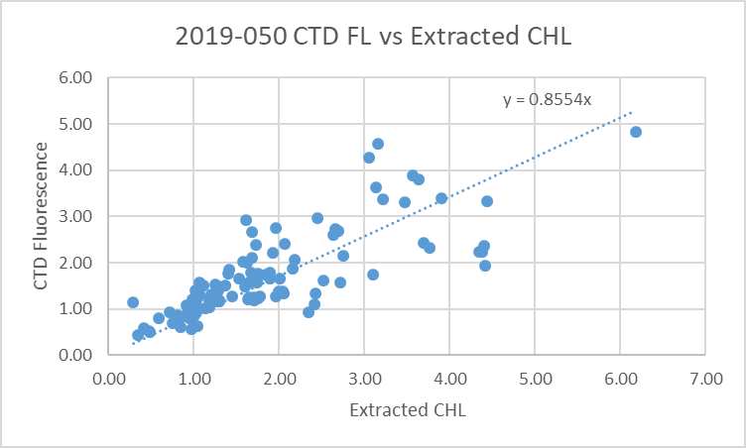
For full details of the comparison see file 2019-050-fl-chl-comp1.xls.

Conversion of Full Files from Raw Data
All files were converted using 2019-050-ctd. The Tau function was selected but not the hysteresis function as there was no deep sampling. Depth was included in the conversion.

A few casts were examined and all expected channels are present. As usual the T, C and Sal channel pairs track well on downcasts while upcasts are much noisier. There were some spikes. The Dissolved Oxygen, transmissivity, fluorescence, pH, PAR and SPAR profiles look normal. The PAR and SPAR values are reasonably close at the surface. The altimetry was fine near the bottom.

WILDEDIT
Program WILDEDIT was run to remove spikes from the pressure, conductivity & temperature only in the
full cast files (*.CNV).
Parameters used were: Pass 1 Std Dev = 2 Pass 2 Std Dev = 5 Points per block = 50
The parameter “Keep data within this distance of the mean” was set to 0 so all spikes would be removed.
Most spikes noted before were removed successfully.

ALIGN DO
When this equipment was used during 2019-003 and 2019-001 the best choice for aligning dissolved oxygen with temperature was found to be +2.5s. A few casts were examined to see if this is the best choice for this cruise. Both temperature channels were noisy during upcasts so the tests were not easy to interpret, but using +2.5s certainly improves the alignment and overall looks like a good choice.
ALIGNCTD was run on all casts using +2.5s.

CELLTM
CELLTM was run using the default setting (α = 0.0245, β=9.5) for both the primary and secondary conductivity. A few casts were checked and this step does improve the data.

DERIVE and Channel Comparisons
Program DERIVE was run on all casts to calculate primary and secondary salinity and dissolved oxygen concentration.

DERIVE was run a second time on 2 of the deeper casts to find differences between the pairs of temperature, conductivity and salinity channels.
Cast # | Press | T1-T0 | C1-C0 | S1-S0 | Descent Rate
2019-050-0053 | 350 | +0.0004 | +0.00006 | 0.0000 | High, Steady
2019-050-0066 | 350 | +0.0006 | +0.00006 | +0.0001 | High, Moderate
2019-050-0101 | 340 | +0.0006 | -0.0003 N | -0.0038 | VHigh, VSteady
There is a significant change in differences between casts #66 and 101 and there is some pressure dependence in the salinity differences for cast #101. Data from the salinity comparison is useful in tracking the differences between salinity channels during stops so those data were extracted from the COMPARE file for sampling below 150db.

Salinity:T1:C1 – Salinity T0:C0 during bottle stops:
Event | Sal0-salbot | Sal1-salbot | Sal1-Sal0
4 | -0.0003 | -0.0012 | -0.0009
8 | -0.0006 | -0.0007 | -0.0001
11 | -0.0014 | -0.0014 | 0.0000
15 | -0.0004 | -0.0001 | 0.0002
18 | -0.0005 | -0.0003 | 0.0003
35 | 0.0040 | 0.0044 | 0.0005
43 | -0.0023 | -0.0027 | -0.0005
47 | 0.0010 | 0.0011 | 0.0001
53 | -0.0002 | -0.0002 | 0.0001
61 | -0.0007 | -0.0004 | 0.0002
73 | -0.0052 | -0.0067 | -0.0014
76 | -0.0052 | -0.0065 | -0.0014
83 | -0.0009 | -0.0041 | -0.0033
88 | -0.0024 | -0.0053 | -0.0029
98 | 0.0005 | -0.0029 | -0.0034

Until cast #73 the two channels are close to each other and to bottles. From cast #73 onwards the differences between channels are higher though the differences between the sensors and bottles decreases. That fact may not be significant given few bottles and variable conditions.
The bottle from cast #79 is not included because it was shallow but it was the most significant outlier in the comparison. Sal1-Sal0 during bottle stops excluding P<150db

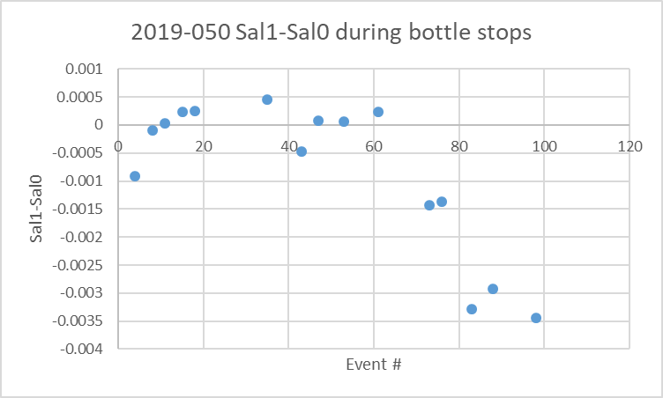

Conversion to IOS Header Format
The IOSSHELL routine was used to convert SEA-Bird 911+ CNV files to IOS Headers.
CLEAN was run to add event numbers and to replace pad values in the pressure channel with interpolated values based on record number.

Checking Headers
The header check was run. No problems were found.
The cross-reference list was printed and checked against the log book. Two discrepancies were found and fixed in the IOS and CLN files:
- The event # for cast #43 should be 46.
- The station name was entered with lower-case letters in cast #92.
The cruise tracks (event #s and stn names) were plotted and added to the end of this report.

The altimeter and water depth readings from the headers of the CLN files were exported to spreadsheets. A check was made by subtracting maximum depth sampled plus altimetry header from the water depth. Where that number exceeded ±4m the readings were checked. There were 15 such cases. In 3 cases the header was removed because the CTD did not get within 15m of the bottom, so a spike in altimetry must have been misinterpreted by the algorithm. In 10 cases replacing the bottom depth in the headers with the one in the log book made an improvement. 2 others looked ok.
Appropriate changes were made to the CLN files.

For the bottle files changes were made to 5 casts including 2 with no near-bottom sampling so the altimetry header could give the wrong notion to users that the deepest samples were near the bottom. These changes were applied to the SAMAVG files and MERGE with MRGCLN1s was rerun.

A surface check was run and shows an average surface pressure for the cruise was 2.0db which is reasonable. The lowest value was 1.3db and the salinity was low for that cast.

Shift
Fluorescence
SHIFT was run on the SeaPoint fluorescence channel in all casts using the usual advance of +24 records. Plots show that the fluorescence offset is reasonably close to the temperature offset after this step.
Dissolved Oxygen
The Dissolved Oxygen voltage channel was aligned earlier. A few casts were checked to see if the alignment looked ok, and it did. No further alignment is needed for the DO concentration channel,
pH
Tests were run on 3 casts to determine the best setting to align pH with temperature. A setting of +35 records looked best.
Conductivity
Tests were run on 4 casts to determine the best setting to align conductivity and temperature by judging the effect on salinity as seen in T-S space. The best choice for the primary channel was -0.7records and for the secondary channel, -0.1records.
SHIFT was run twice on all SBE911 casts using those settings. Salinity was recalculated for both channels.

DELETE
The following DELETE parameters were used:
Surface Record Removal: Last Press Min
Maximum Surface Pressure (relative): 10.00
Surface Pressure Tolerance: 1.0 Pressure filtered over 15 points
Swells deleted. Warning message if pressure difference of 2.00
Drop rates < 0.30m/s (calculated over 11 points) will be deleted.
Drop rate applies in the range: 10db to 10db less than the maximum pressure
Sample interval = 0.042 seconds. (taken from header)
COMMENTS ON WARNINGS: There were no warnings.

Other Comparisons
Previous experience with these sensors –
Only the pressure sensor has been used since the last factory calibration and no problems have been noted.
Historic ranges – Profile plots were made with 3-standard deviation climatology ranges of T and S superimposed. The only excursions in temperature were some high values near the bottom of 2 casts in the northern Strait of Georgia and high surface temperature for one cast at the southern end of that Strait. Salinity values were high near the bottom of 1 cast in the Southern Strait of Georgia. These excursions are likely real and reflect the limitations of the climatology in an area of high variability. There is no evidence of calibration problems.
Repeat Casts – There were no repeat casts and nearby casts are too shallow to provide a reasonable comparison.
Post-Cruise Calibration – There were no post-cruise calibrations available.

DETAILED EDITING
Before choosing which T/S pair to edit and archive a few investigations were made.
First, a general examination of some T-S plots suggests that the secondary data have fewer unstable features than the primary but there are some casts where the opposite is true.

Next, a study was made about what happened between casts #72 and 79 as noted in the salinity bottle comparison. Profile plots of casts were examined:
- The upcast of cast #72 has bad primary T, S and DO up to about 160db when they suddenly snapped back to values close to downcast values. The secondary T and S look ok.
- The upcast for event #76 has noisy primary salinity for both downcast and upcast, and noisy upcast data for the secondary.
- For event 79 the downcast primary salinity is very noisy.
So only one cast had a problem that affects the secondary channels and that was only during the upcast. It was not a rosette cast. And the dissolved oxygen was on the primary pump but recovered after cast #72, while the primary salinity looks rather noisy.

Finally, the bottle comparison showed that the differences between the primary and secondary increased after cast #72 with the secondary becoming lower than the primary by more than it had earlier. So plots were examined during bottle stops for the casts that got below 150db: #73, 76, 83, 88 and 98. There was nothing obviously wrong with either channel except that the differences increase.

Given the issues noted in the primary salinity, that is likely the cause of the increase in differences. It doesn’t look like the problem was one that affected the plumbing, since dissolved oxygen seems unaffected, but possibly whatever caused the problem during cast #72 mostly cleared up but continued to affect primary conductivity somewhat. That channel was quite noisy even before this problem. Overall the secondary T and S channels look like the best choice for editing.
One exception was cast #71 which had noisy data in both channel pairs, but the primary was much better than the secondary.

CTDEDIT was used to remove records that appear to be corrupted by shed wakes or ship effects. Most of the data removed are from near the top and bottom of casts. Salinity was cleaned to remove unstable features that appear to be due to small misalignment or instrumental noise.
Primary channels were edited for cast #71because the secondary salinity looked bad.
Secondary channels were edited for all other casts.
All files required some editing.

After editing T-S plots were examined for all casts. There are some small unstable features which could be real as they come from areas of active mixing. No further editing was applied.

Recalibration
There is no evidence that the pressure channel requires recalibration.
Dissolved Oxygen will be recalibrated by applying the fit found in section 4.

The primary salinity was found to be low by 0.0010psu and the secondary by 0.0022psu. The bottles used in the comparison were selected with the aim of minimizing the error due to incomplete flushing of bottles; however, it is likely that there is some effect so that the CTD salinity looks lower than it really is. Since the primary salinity was chosen for cast #71 and the secondary for the others, the secondary will be recalibrated by adding 0.0012psu. This is roughly the difference observed between the two channels at about the time of cast #71. After calibration both channels will appear to be low by ~0.001psu overall. Allowing for flushing errors this is likely to produce salinity within +/-0.002psu.

File 2019-050-recal1.ccf was prepared to add 0.0012psu to channel Salinity:T1:C1 and apply the following correction to SBE Dissolved Oxygen:
CTD DO Corrected = CTD DO * 1.0352
This correction was first applied to the SAM and MRGCLN2 files.
Checks were made to ensure the salinity calibration was applied correctly and it was.

COMPARE was rerun for dissolved oxygen. When roughly the same data were included as in the original fit, the average of differences in the DO fit was +0.002mL/L and the standard deviation was 0.018mL/L. A plot of differences against pressure showed that most cases of the CTD DO reading higher than bottles by at least 0.2mL/L come from 0 to 20db; this is likely due to incomplete flushing of bottles. See file 2019-050-DO-comp2.xls for details.

CALIBRATE was then run on the EDT files using the same recalibration file.

Final Calibration of DO
The initial recalibration of dissolved oxygen corrects for sensor calibration drift. Alignctd corrects for transit time errors. Those 2 steps may partly correct for response time errors, but to see if a further correction is needed, a comparison is made of downcast CTD data to bottle data from the same pressure. Small differences are expected due to ship drift, temporal changes, incomplete flushing of Niskin bottles and delayed response and noise in CTD data.

Downcast files were bin-averaged to 0.5m bins for the casts with DO bottle samples. Those files were then thinned and compared to the bottle values in the MRG files. COMPARE was run to study the differences between the downcast CTD DO data and the titrated samples from upcast bottles.

When outliers were removed based on differences >0.4mL/L, the CTD DO was lower than the titrated samples by an average of ~0.017mL/L (standard deviation of 0.091mL/L). The outliers all came from above 50db and most from above 20db. This is the area where high gradients lead to the greatest errors due to slow response of the sensor and poor flushing of bottles and the error due to vertical distance between the CTD and bottle when gradients are very high.
No further recalibration is justified. See 2019-050-dox-comp3.xlsx for details.

Fluorescence Processing
A median filter, size 11, was applied to the fluorescence channel in the COR1 files. Plots of a few casts showed that the filter was effective. (Output:*.FIL)

BIN AVERAGE of CTD files
The following Bin Average values were applied to the FIL files (output AVG):
Bin channel = pressure Averaging interval = 1.000 Minimum bin value = .000
Average value will be used. Interpolated values are NOT used for empty bins.
On-screen T-S plots were examined.
Profile plots were examined to see if there any problems. No problems were noted.

Final CTD File Steps (REMOVE and HEADEDIT)
- For all casts except #28 and 71 REMOVE was run to remove the following channels:
Scan_Number, Temperature:Primary, Salinity:T0:C0, Conductivity:Primary, Oxygen:Voltage:SBE, Altimeter, Status:Pump, Descent_Rate and Flag.
- For casts #28 REMOVE was run to remove the following channels:
Scan_Number, Temperature:Primary, Salinity:T0:C0, Conductivity:Primary, Oxygen:Voltage:SBE, pH:SBE, Altimeter, Status:Pump, Descent_Rate and Flag.
- For cast #71 REMOVE was run to remove the following channels:
Scan_Number, Temperature:Secondary, Salinity:T0:C0, Conductivity:Secondary, Oxygen:Voltage:SBE, Altimeter, Status:Pump, Descent_Rate and Flag.

A second SBE DO channel (with umol/kg units) was added.
REORDER was run to get the two DO channels together.
HEADER EDIT was used to fix formats and channel names and to add header comments about the data processing.

The Standards Check routine was run and no problems were found.
The Header Check was run; no problems were found.
Profile and T-S plots were examined. There are some unstable features in T-S space where waters are well-mixed, but those are very small and may be real.
The sensor history was updated.

Dissolved Oxygen Study
As a final check of dissolved oxygen data, % saturation was calculated and plotted. The values ranged from ~65% to 160%. The highest value was in Saanich Inlet, as usual. The lowest values were in well-mixed waters such as most of Juan de Fuca Strait, Haro Strait and tidal channels. Values were somewhat low in the southern Strait of Georgia and increased towards the north. The westernmost Juan de Fuca casts do seem a little lower than usual but titrated surface samples are in agreement with the CTD DO. Large variability is normal for this area and since some values are very low and others very high there is no evidence of a problem with the DO sensor calibration.

Final Bottle Files
The MRGCOR1 files were put through SORT to order on increasing pressure.
For all casts REMOVE was run to remove the following channels:
Scan_Number, Temperature:Primary, Salinity:T0:C0, Conductivity:Primary, Oxygen:Voltage:SBE, Altimeter, Status:Pump, Descent_Rate and Flag.
A second SBE DO channel with mass units was added for both the CTD DO and titrated DO and REORDER was run to get the pairs of DO channels together.
HEADER EDIT was run to ensure formats and units are correct, change the channel name Bottle_Number to Bottle:Firing_Sequence and the name Bottle:Position to Bottle_Number and to add a comment about quality flags and analysis methods and a few notes about the CTD data processing.

Data were exported from the CHE files to file 2019-050-bottles-final.xls. The entries were compared with the rosette log sheets. A problem was found with event #68 – the nutrients, salinity and chlorophyll samples were mislabelled as #72 based on an error in the sampling log. So those samples were lost in the merge process. The merges were redone for event #68 after fixing the errors. The data export was repeated and no further problems were found.

Standards check was run and no problems were found.
The track plot looks ok.
Plots of each file were examined and no problems were found.
A cross-reference listing and header check were produced for the CHE files. No problems were found.

Thermosalinograph Data
There was 1 thermosalinograph file.
There were no loop samples, flow meter or intake thermistor. The intake is at about 2m. The only method to check calibration is to compare with the CTD casts.

a.) Checking calibrations
The configuration file used at sea was checked and no errors were found.

b.) Conversion of Files
The cnv file was converted to IOS HEADER format.
CLEAN was run to add End times and Longitude and Latitude minima and maxima to the headers.
ADD TIME CHANNEL was used to add Time and Date channels.
A time-series plot was produced. There were no obvious problems.
The track plot looks fine and was added to the end of this report.

c.) Checking Time Channel
- The CTD files were thinned to reduce the files to a single point from the downcast at or within 0.5db of 2db. These were exported to a spreadsheet which was saved as 2019-050-ctd-tsg-comp.xls. There were 75 CTD casts with data available from 2m; all overlapped with TSG data.
- The TSG file was opened in EXCEL, median and standard deviations (over 5 records) were calculated for lab temperature and salinity and the files were reduced to the times of CTD files. Those data were added to 2019-050-ctd-tsg-comp.xls.
- To check for problems in the TSG clock or bad matches of TSG and CTD data, the differences between latitudes and longitudes were found. The median and average differences were both <0.0001º though there was one difference as high as 0.0009º. The larger differences were in areas where currents might lead to some drift through the cast so that small mismatches in time could be significant. The TSG clock worked well.

d.) Comparison of T and S from TSG and CTD data
When all casts are included the TSG temperature is higher than the CTD temperature by an average of 0.25 C° and a median of 0.21C° with standard deviation of 0.21C°. Salinity is lower by an average of 0.52 and median of 0.27psu and standard deviation of 1.27psu. Checks on some of the largest differences shows that there were very high near-surface gradients and that possibly the TSG is drawing water from a little higher than 2m.

When 12 casts with very large differences were excluded the average salinity difference was much smaller at 0.30 and the standard deviation was 0.20psu. The median value did not change much.

Many of the outliers come from casts that have large near-surface salinity gradients, but for many casts there are no CTD data shallow enough to know what was happening above 2m.
When outliers are excluded there appear to be differences that fall into 3 different ranges. The Juan de Fuca Strait casts have differences rangin from 0.46 to 0.52psu and the median indicates the TSG salinity is lower than that from the CTD by 0.49psu. The 4 early casts in Haro Strait all have small differences with the TSG low by a median of 0.024psu. For the Strait of Georgia the TSG salinity (excluding outliers) is low by a median of 0.22psu. The Haro Strait casts tend to be the best mixed, so that any error due to a mismatch in depth between the TSG intake and the CTD cast should be minimized. On the other hand the Juan de Fuca casts have the smallest standard deviation in the TSG salinity which suggests well-mixed waters.
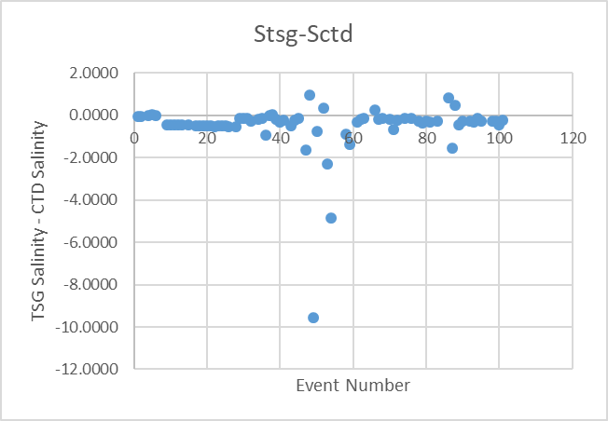

A plot of salinity differences versus the pressure from the CTD data shows more cases of TSG salinity being close to or higher than the CTD salinity when CTD pressures are lower. It takes very little difference in pressure to have a large effect on the comparison if gradients are high.

The temperature differences suggests that the lab temperature is high by between 0.18 and 0.22C with the Haro Strait value close to the median.
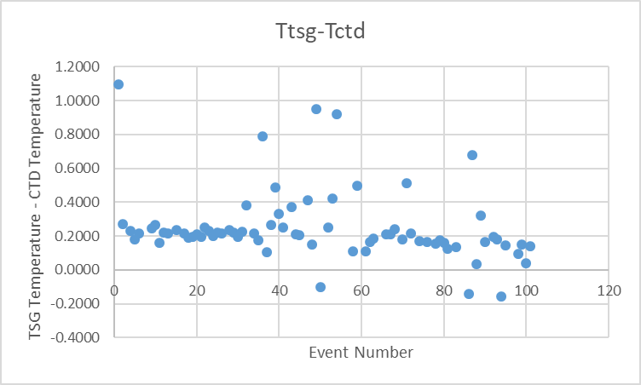
See 2019-050-ctd-tsg-comp.xls for details.

Calibration History
The TSG temperature and conductivity were recalibrated in November 2018 and this is the 2nd known use of it since then. During cruise 2019-016 the TSG Salinity was found to be low by about 0.03psu. The TSG lab temperature was higher than the CTD temperature by about 0.37Cº which was considered unusually high. It was thought that the flow rate must have been lower than usual.

Conclusions
1. The TSG clock worked well.
2. The TSG lab temperature was higher than the CTD temperature by a median of ~0.21Cº excluding outliers. This is a little higher than expected for the Vector but much lower than during the April cruise in the same area. From Haro Strait it was high by ~0.22Cº and from the Strait of Georgia ~0.18Cº. There was less heating in the Strait of Georgia but intake temperatures were higher, so less heating is expected there. Some of the difference may come from the TSG drawing water from a little higher in the water column. So given that for much of the cruise the intake temperature was higher than in Haro Strait and that the TSG may have been drawing water from a little higher in the water column, adding 0.2Cº looks appropriate.
3. The TSG Salinity is low by about 0.02 in Haro Strait, 0.49 in Juan de Fuca and 0.22 in the Strait of Georgia. During the previous cruise the salinity was found to be low by ~0.03psu. The error could be very large if water is being drawn from higher in the water column than the water sampled by the CTD. Surface gradients were high in the Strait of Georgia. The Juan de Fuca comparison is harder to understand. Subtracting 0.03psu from the TSG salinity is a reasonable estimate but it is a warning that TSG data are a very rough measure of surface conditions.

f.) Editing
No editing was needed.

g.) Recalibration
Add Channels was used to add Channel Temperature:Lab with values set equal to Temperature:Primary.
Calibrate was run using file 2019-050-tsg-recal1.ccf to subtract 0.2 from Temperature:Primary and to add 0.03Cº to Salinity:T0:C0.

h.) Preparing Final Files
REMOVE was used to remove the following channels: Scan Number and Flag channels.
HEADER EDIT was used to change the DATA DESCRIPTION to THERMOSALINOGRAPH and add the depth of sampling to the header and to change channel names to standard names and formats.
The TSG sensor history was updated.
As a final check plots were made of the cruise track and time-series and all look fine.
The cruise plot was added to the end of this report.

Particulars
15. Bottles not right on target below 100m due to winch operator display not working
28. pH cap left on
53. Bottle 12 didn’t trip – sticky latch
71. Secondary T/C channels looked poor – primary better.
72. Oxygen profile upcast looked like caught something at depth to block flow
81, 83 and 85. Down to 25m for flush
85. CTD lost connection at 268m on the upcast.
86. Bottom depth determined by altimeter. CTD problem – re-terminate to isolate shorted wire.
88. No altimeter reading; stop at 20m deeper than sounder depth
95, 98, 99, 100. 25m soak.
106. SBE911 failed on start-up. SBE25 used but data lost.
108. SBE 25 used but data lost.

CRUISE SUMMARY – CTD
CTD# | Make | Model |  | Serial# |  | Used with Rosette? |  | CTD Calibration Sheet Competed?
1 | SEABIRD | 911+ |  | 0443 |  | Yes |  | Yes
Calibration Information - 0506
Sensor |  |  |  |  | Pre-Cruise |  |  |  | Post Cruise
Name |  |  | S/N |  | Date |  | Location |  | Date | Location
Temperature |  |  | 4888 |  | 14Feb2018 |  | Factory
Conductivity |  |  | 3531 |  | 06Mar2018 |  | Factory
Secondary Temp. |  |  | 4513 |  | 13Feb2018 |  | Factory
Secondary Cond. |  |  | 3791 |  | 13Feb2018 |  | Factory
Transmissometer |  |  | 983DR |  | 9Aug2017 |  | Factory
SBE 43 DO sensor |  |  | 3791 |  | 13Mar2019 |  | Factory
PAR |  |  | 4565 |  | 16Mar2011 |  | Factory
pH |  |  | 691 |  | 13Dec2018
SPAR |  |  | 20518 |  | 21Mar2016
SeaPoint Fluor. |  |  | 3642
Pressure Sensor |  |  | 0443 |  | 31Aug2017 |  | Factory
Altimeter |  |  | 43281 |  |  |  | Factory

TSG Make/Model/Serial#: SEABIRD/21/2488
Calibration Information
Sensor |  | Pre-Cruise |  | Post Cruise
Name | S/N | Date | Location | Date | Location
Temperature | 2488 | 14Nov18 | Factory
Conductivity | 2488 | 14Nov18 | Factory

