REVISION NOTICE TABLE
DATE | DESCRIPTION OF REVISION
25 March 2025 | Removed original Silicate & Flag:Silicate channels and renamed corrected versions of those channels. G.G.
8July 2019 | Reordered & re-labelled 2 Oxygen:Dissolved:SBE channels in CHE files 52 & 57
26 March 2023 | Added HPLC data. J.R.

PROCESSING NOTES
Cruise: 219-045
Agency: IOS, Ocean Sciences Division, Sidney BC
Chief Scientist: Belton M. Platform: Neocaligus
Location: Strait of Georgia Project: Strait of Georgia Zooplankton
Date: 2 July 2019 –6 July 2019

Processed by: Germaine Gatien
Date of Processing: 25 November 2019 – 3 December 2019
Number of original HEX files: 28
Number of CTD files: 28 Number of BOT files: 16

INSTRUMENT SUMMARY
A SeaBird Model SBE-25 CTD (s/n 0334) was used with temperature sensor #4484, conductivity sensor #2128, Wetlabs ECO Fluorometer #2215, dissolved oxygen sensor #1483 and pressure sensor 0482.

SUMMARY OF QUALITY AND CONCERNS
The log book was in good order with comments about problems encountered.

Header information was entered in the raw files in a format that should enable easy conversion into IOS Header format, but there were some errors in the position data that needed to be corrected first. The proper format is:
Latitude: 49 27.005 N
Longitude: 123 34.431 W
The file names had a small format error with an underscore used instead of a hyphen.

The times in the log book were UTC. The file times were in PST. Processed files have UTC times.

There were surface bottles fired at 16 sites; they were given separate event numbers from the CTD casts. At 5 of those sites there was also a Niskin mounted above the CTD to collect near-bottom samples. In the BOT files all sample data are identified by the event number of the corresponding CTD cast.

Pressures were known to be high for this CTD so the calibration control file was adjusted to subtract 3.2db to the offset. Similarly the dark value for fluorescence was adjusted to obtained reasonable values at depth.

Bottle samples were available for salinity and fluorescence. They suggest that the CTD salinity was reading a little high, but incomplete flushing of Niskin bottles probably explains the differences seen so no recalibration was applied to CTD salinity.

Extracted chlorophyll samples were taken at the surface only. The CTD fluorometer data from 1m to 2m compared reasonably well with the extracted CHL.

PROCESSING SUMMARY
1. Seasave - This step was completed at sea. The file names were in standard format.
As found during 2019-007 and 2019-044, there were problems in the format of the position data. The entries had a minute sign in the latitude and longitude and longitude was misspelled. This prevents proper conversion of the information to IOS Header format, so corrections were made to the HEX files.

2. Preliminary Steps
The Daily Log, rosette logs and a spreadsheet of sampling done were obtained.
The deployment method used was as follows:
- The CTD was switched on, a 2-minute timer was started and the CTD was put in the water. It was taken down to 10m and after 30s returned to the surface where there was a wait until the 2 minutes were up. The full cast was then started. This method can be helpful as by removing the first 960 records the initial soak can be removed in most cases. (Note: for this cruise there was more variation in the start time than usual.)
- Bottle deployments for most stations were taken at 0m only. For 5 stations there was sampling using a Niskin bottle mounted above the CTD frame; there were notes in the log about the distance between the Niskin and CTD frame for each cast.
The cruise summary sheet was completed.

3. Conversion of Raw Data
The configuration file used at sea was correct but the pressure offset was adjusted by entering -3.2db based on results of 2019-044.
An initial conversion showed that surface pressures look good but the deep fluorescence values are high. During 2019-044 fluorescence was recalibrated by subtracting 0.3ug/L leaving deep values at about 0.15ug/L, but they are much higher for this cruise at about 0.7ug/L. So the calibration control file was adjusted by setting an offset of 0.025 (=0.6ug/L / 24 scale factor). Deep values were then found to be ~0.1ug/L except that they were slightly higher right at the bottom of some casts. This may still be a little high but is in the range typically seen in this area.

All HEX files were converted using configuration file 219-045-ctd.xmlcon.
The final 4 files were missing but were eventually found.
A few plots were checked. Where conductivity dropped suddenly pressures were between -0.5 and +0.5db so the pressure offset looks appropriate and fluorescence below 300m is <0.06ug/L except right at the bottom where it is slightly higher.

Plots show that the channels all produced reasonable values.
There is the usual steppy pressure which leads to unusual profiles. The descent rate is extremely noisy, so the conversion was rerun without derivation of that property.

4. WILDEDIT
The only spikes noted in the data occurred at the beginning or end of the casts or included many points, and will be removed in the normal course of editing. So WILDEDIT was not run.

5. FILTER
Normally pressure is filtered later in processing when running DELETE, but the poor resolution of this instrument means it is necessary to do this early to make sense of the other data which update more often than pressure. So program FILTER was used to apply a low-pass filter with a time constant of 0.5 seconds to pressure. The results were excellent.
Next the temperature and conductivity were examined and the usual approach of applying a cosine filter size 5 in routine WFILTER did a good job of removing small reversals.

6. ALIGNCTD
Based on tests run for other cruises in this project using the same DO sensor, ALIGNCTD was run on all casts to advance the DO channel by 2.5s. Plots were examined after this step and the results look good.

7. CELLTM
CELLTM was run on all casts using the SeaBird recommended parameters, (α, 1/β) = (0.04, 8).

8. DERIVE
Program DERIVE was run to calculate salinity and dissolved oxygen concentration (tau correction included). Plots were examined and confirmed that steps 5, 6 and 7 had improved the data.

9. Conversion to IOS Headers
The IOSSHELL routine was used to convert the CNV files to IOS Headers.
One cast was missing latitude and longitude because the hemisphere was missing from the headers and another was missing station name and water depth.
Those details were added and the file was reconverted.

CLEAN was run to add event numbers and replace pad values in the pressure channel with interpolated values.
The next step is to remove the data collected during soaks at 10m. Plots showed a lot of variability in how many records occurred before the full cast, so a list was made and CLIP was run separately on each cast to remove an appropriate # of scans (from 850 to 1300).

10. Checking Headers
A cross-reference list was produced and compared with the log book entries. This turned up the fact that hex files were missing for 4 casts: 52, 55, 57 and 60. Those files were eventually found and put through the same steps as the other casts.
It was also established that the times in the files are in PDT so 8 hours will need to be added.
ADD TIME CHANNEL was run to add 8 hours.
Track plots looked ok so were added to the end of this report.
HEADER CHECK was run. There only negative values found appear to be spikes at the beginning and/or end of casts; most will likely be removed by DELETE. No other problems were noted.
The pressure sensor has a 2800db range so the resolution is only 0.45db and accuracy is ±2.6db so even with surface data it is difficult to assess. The surface check shows an average of 1.3db before CLIP was run. The range was from 0.6 to 1.8db. It looks like the pressure offset adjustment was appropriate.

11. SHIFT
Conductivity
During 2019-044 which used the same equipment showed that a shift of +0.5 records made the best improvement to stability in T-S space. A shift of +0.5 records worked well on these casts as well, so that setting was applied to all casts.
Fluorescence
The fluorometer was not pumped, so a shift in alignment is expected to be small or unnecessary. Profile plots of temperature and fluorescence were examined and confirm that the alignment is good.
Dissolved Oxygen
This channel was aligned earlier, but checks were made by examining plots of temperature and dissolved oxygen. The alignment looks good. No further adjustment was made.

12. DELETE
DELETE was run on all casts using the following parameters:
Surface Record Removal: Last Press Min. Surface Swell Pressure Tolerance: 1.0
Swells deleted. Warning message if pressure difference of 2.00
Drop rates < 0.3m/s (calculated over 5 points) was deleted from 10db to 10db above the maximum pressure.
COMMENTS ON WARNINGS: There were no warnings.

13. DETAILED EDITING
CTDEDIT was used to remove records corrupted by shed wakes and to clean salinity where unstable features looked likely to be caused by misalignment of T and C. 23 out of 28 casts were edited lightly.
Notes of editing details were made in the headers.
T-S plots were examined after this step and no significant problems were found; there are small unstable features but this is an area where some instability is expected.

14. Initial Bottle Data Steps
There was no rosette available for this cruise. There were surface bottles fired at 16 sites; they were given separate event numbers from the CTD casts. At 5 of those sites there was also a Niskin mounted above the CTD to collect near-bottom samples.
BOT files were prepared with the sample data plus CTD gathered at the same site.
The event numbers will be those of the CTD cast at the site.

Each of the analysis spreadsheets were examined to see what comments the analysts wanted included in the header file. These were used to create file 219-045-bot-hdr.txt which will be updated as needed during processing. The spreadsheets for chlorophyll and nutrients include a precision study.
- Extracted chlorophyll and phaeo-pigment data were obtained in file QF 2019-045 CHL*.xlsx.
- Salinity analysis was obtained in spreadsheet QF 2019-045 SAL*.xlsx.
- Nutrient analysis was obtained in spreadsheet QF 2019-045 nuts*.xlsx.

Workbook 219-045-bottle_plus_CTD.xlsx was created. Separate worksheets were created to contain the data from the event log relevant to Niskin sampling, bottle data, CTD data at bottle depths, CTD plus bottle data, CTD plus bottle data in 6-line header format and bottle-CTD comparisons.

Some sampling was done using a Niskin bottle mounted above the CTD but surface sampling was done as a separate event, though at the same time. So there are separate events for the CTD and surface sampling for each site at which sampling occurred. Since CTD data are needed to accompany the bottle data, the event numbers in the spreadsheet were adjusted to match the associated CTD event numbers at each station.

To select CTD data to go with the bottle samples, a list of depths sampled in increasing order was prepared. For the deep samples there is an estimate of height above the CTD frame. 1m was added for the height of the frame. Data were bin-averaged and thinned to the appropriate depths. CTD salinity and fluorescence data were then compared with bottle data in the Comparisons worksheet.

On one worksheet the data were organized with a 6-line header which was saved separately as a CSV file, 219-045-bottle-plus_CTD-6linehdr.csv.

15. Compare
One sheet in workbook 219-045-bottle_plus_CTD.xlsx was used to do a comparison between the bottles and CTD.

Salinity Comparison
For salinity the CTD was found to be higher than bottle salinity by an average of 0.008psu and standard deviation of 0.008psu. When 1 outlier was excluded the CTD salinity was high by an average of 0.005psu and standard deviation of 0.002psu. Any error due to incomplete flushing would lead to the CTD salinity looking higher than bottles since samples would include water from higher in the water column. The one outlier had very noisy salinity near the bottom of the cast, so there may have been significant temporal variation. No recalibration of salinity is justified given that the differences are mostly small and may well be explained by flushing errors and/or temporal variability.

For more details see the “comparisons” worksheet in file 219-045-bottle_plus_CTD.xlsx.

Fluorescence
The only extracted chlorophyll sampling was at the surface while the CTD data are not available above 1m for most casts. Overall the CTD sensor has higher values than the extracted chlorophyll samples but that is mostly due to casts where the chlorophyll values are <1ug/L. Above that level, the fluorescence values are mostly lower than extracted CHL although there are a few exceptions with event #10 having anomalously high CTD fluorescence.

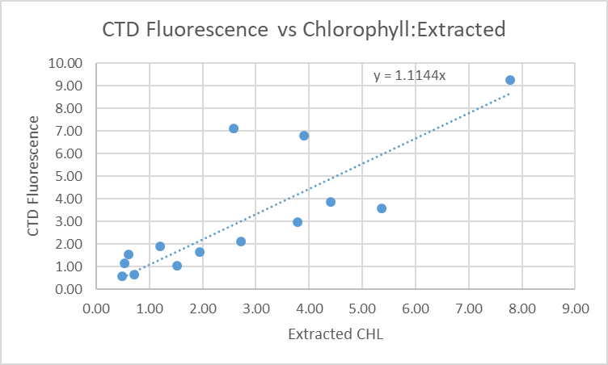

The CTD data are from lower in the water column than the samples. So a rough check was made of upcast fluorescence since they include shallower observations, though the data may be corrupted somewhat by shed wakes. In most cases the values from the upcast are close to those from the downcasts. The only value that was notably different was for event #10 which was the most significant outlier in the plot shown above. The upcast profile shows a large gradient at the surface for that cast.

The comparisons with extracted CHL show that CTD fluorescence was reasonably close to the chlorophyll samples.
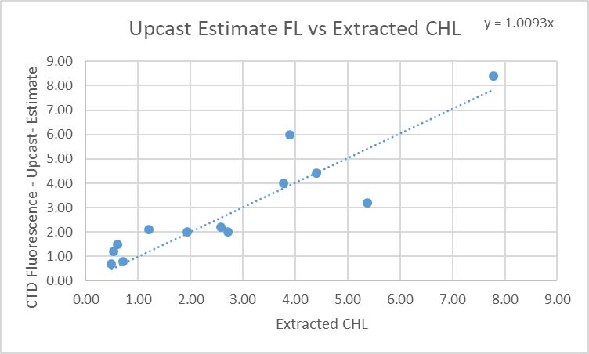

16. Other calibration checks
Sensor History – These sensors have only been used for 2 other cruise since they were last serviced. There was calibration sampling for 1 cruise but the comparison with CTD data was too weak to justify recalibration of salinity or dissolved oxygen. However, pressure was recalibrated by subtracting 2.3db and 3.2db for the 2 cruises. The fluorescence dark value was found to be higher than expected so an offset of 0.3ug/l was subtracted.
Historic Ranges – The only excursions from the climatology came from cast #50. The same thing was noted during 2019-044 at the same site. The data for that site easily fall within the climatology for the southern Gulf Islands and this cast was very close to the boundary between 2 climatology regions.
The excursions do not appear to be indicative of calibration problems.
Post-cruise calibrations – None were available.

17. CALIBRATE
Adjustments to pressure and fluorescence were made upon conversion and no further adjustment appears to be necessary. Salinity and dissolved oxygen will not be recalibrated.

18. Fluorescence Filter
The fluorescence data was not filtered as it had little effect on the data.

19. Bin Average, Remove, Derive DO in mass units, Reorder
The files were bin averaged using 1db bins.
REMOVE was run to remove Scan_Number, Oxygen:Voltage, Descent Rate and Flag channels.

Dissolved Oxygen was derived in mass units and that was used to calculate DO saturation. Plots of near-surface saturation show a range of 65 to 125%, with the lowest value near the Gulf Islands where vertical mixing was strong. The high variability is common in this area and does not suggest any problem with the DO calibration.
REORDER was used to get the 2 dissolved oxygen channels together.

20. HEADER EDIT and final checks of CTD files.
Header Edit was used to fix headers, fix formats and to add comments about processing.
A cross-reference listing was produced.
A header check and standards check were run on the CTD files and no errors were found.
The sensor history was updated.
Plots of CTD casts were examined and no problems were found.

20. Final BOT file preparation
To enable searching of bottle data, BOT casts were created that contain sample data and CTD data from the downcast at the same site. The event number will match the CTD cast.
The values from the *.CTD files were selected for the bottle files.

Adding the bottle data to the CTD data was error-prone so a number of checks were done to ensure that the right correspondence was achieved. A 6-line header was added. The spreadsheet file was converted to IOS Header files for each cast.

The time and date are present as channels as these cannot be converted directly into header entries.
CLEAN was run to add START and END time. The END TIME is identical so the START time so it will be removed later. CLEAN was also used to enter 0 flags where the flag channels are empty and to remove channels with only pad values.
REMOVE was run to remove the DATE and TIME channels.
There was no DO sampling so no need to derive different units.
The files were sorted on pressure.
HEADEDIT was used to add comments and to remove the END time since it is the same as START TIME.
The final files have extensions BOT.

The standards check was run until all errors had been corrected.
A cross-reference list and header check were run on the BOT files and no problems were found.
Plots were made of all BOT casts. No problems were found.
Finally all data from BOT files were extracted to a spreadsheet and compared to the rosette sheets; an error was found and corrected.

PARTICULARS – notes from logs
- All times are UTC in the log book but in PST in the files.
- CTD Deployment method: Timer set to 2 minutes. CTD down to 10m for soak until 1m 30s mark, bought back to surface to sit until 2 minutes are up. Then full cast begins.
- BOTTLES: For most stations there was a single surface bottle fired as a separate event using 1.7L bottles. For 5 casts there was a Niskin bottle mounted 145cm above the CTD frame.

1. Position missing from header.
2-50. Position formats wrong.
52-60. Files missing – later found.

CRUISE SUMMARY

Cruise ID#: 219-045
Dates: Start: 2 July 2019 End: 6 July 2019
Location: Strait of Georgia Zooplankton
Party Chief: Young K.
CTD# | Make | Model | Serial# | Used with Rosette? | CTD Calibration Sheet Competed?
1 | SEABIRD | 25 | 456 | No | Yes

CTD CALIBRATION INFORMATION
Make/Model/Serial#: SEABIRD/SBE25/0334 Cruise ID#: 2019-045

Calibration Information
Sensor |  | Pre-Cruise |  | Post Cruise
Name | S/N | Date | Location | Date | Location
Temperature | 4484 | 22Feb2017 | Factory
Conductivity | 2128 | 23Feb2017 | Factory
ECO Fluorometer | 2215 | 07Mar2017 | Factory
SBE43 Oxygen | 1483 | 2Mar2017 | Factory
Pressure | 0482 | 28Feb2017 | Factory

