REVISION NOTICE TABLE
DATE | DESCRIPTION OF REVISION
25 Feb 2025 | Removed original Silicate & Flag:Silicate channels and renamed corrected versions of those channels. G.G.
27 March 2023 | Added HPLC data. J.R.

PROCESSING NOTES
Cruise: 2019-044
Agency: IOS, Ocean Sciences Division, Sidney BC
Chief Scientist: Belton M. Platform: Neocaligus
Location: Strait of Georgia Project: Strait of Georgia Zooplankton
Date: 29 April 2019 –4 May 2019

Processed by: Germaine Gatien
Date of Processing: 12 November 2019 – 3 December 2019
Number of original HEX files: 28
Number of CTD files: 28 Number of BOT files: 17

INSTRUMENT SUMMARY
A SeaBird Model SBE-25 CTD (s/n 0334) was used with temperature sensor #4484, conductivity sensor #2128, Wetlabs ECO Fluorometer #2215, dissolved oxygen sensor #1483 and pressure sensor 0482.

SUMMARY OF QUALITY AND CONCERNS
The log book was in good order with comments about problems encountered.

Header information was entered in the raw files in a format that should enable easy conversion into IOS Header format, but there were some errors in the position data that needed to be corrected first. The proper format is:
Latitude: 49 27.005 N
Longitude: 123 34.431 W

The times in the log book were identified as local and were in PDT, but the files had PST times. The file header times have been changed to UTC.

For most casts there was 1 bottle fired at 0m. For 3 casts there were also multiple bottles on a wire and in 2 cases a surface bottle taken as a separate event.

Pressures were high by between 3 and 4db; recalibration was applied by subtracting 3.2db.

Calibration samples were available and suggest that the CTD dissolved oxygen is reading a little low, and salinity a little high, but the potential errors in the comparisons could explain much of the differences seen so no recalibration was applied to CTD salinity or dissolved oxygen.

Extracted chlorophyll samples were taken at the surface only. The CTD fluorometer data from about 1m compared reasonably well with the extracted CHL.

PROCESSING SUMMARY
1. Seasave - This step was completed at sea. The file names were in standard format.
As found during 2019-007, there were problems in the format of the position data. The entries had a minute sign in the latitude and longitude and longitude was misspelled. This prevents proper conversion of the information to IOS Header format, so corrections were made to the HEX files.

2. Preliminary Steps
The Daily Log, rosette logs and a spreadsheet of sampling done were obtained.

The deployment method used was as follows:
- The CTD was switched on, a 2-minute timer was started and the CTD was put in the water. It was taken down to 10m and after 30s returned to the surface where there was a wait until the 2 minutes were up. The full cast was then started. This method is helpful as by removing the first 960 records, the initial soak can be removed in most cases.
- Bottle deployments for most stations were taken at 0m only. For 3 stations there was sampling using 5 5L Niskin bottles chained together on a wire with messengers. In 2 cases surface samples were taken at the same sites but with separate event #s.
The cruise summary sheet was completed.

3. Conversion of Raw Data
The configuration file used at sea was correct and was saved as 2019-044-ctd.xmlcon.
The HEX files were converted using configuration file 2019-044-ctd.xmlcon.
Plots show that the channels all produced reasonable values except that fluorescence was ~0.45ug/L at depth which is higher than usually seen.
There is the usual steppy pressure which leads to unusual profiles. The descent rate is extremely noisy, so the conversion was rerun without derivation of that property.
There were problems in the format of the position data. The entries looked like Latitude: 49' 43.583 when they should be Latitude: 49 43.583 N. Sometimes the hemisphere entry N or W was present, sometimes not and the word Longitude was misspelled for all casts. These errors derive from the text file prepared before the cruise.

4. WILDEDIT
The only spikes noted in the data occurred at the beginning or end of the casts or included many points, and will be removed in the normal course of editing. So WILDEDIT was not run.

5. FILTER
Normally pressure is filtered later in processing when running DELETE, but the poor resolution of this instrument means it is necessary to do this early to make sense of the other data which update more often than pressure. So program FILTER was used to apply a low-pass filter with a time constant of 0.5 seconds to pressure. The results were excellent.
Next the temperature and conductivity were examined and the usual approach of applying a cosine filter size 5 did a good job of removing small reversals.

6. ALIGNCTD
Based on tests run for other cruises in this project using the same DO sensor, ALIGNCTD was run on all casts to advance the DO channel by 2.5s. Plots were examined after this step and the results look good.

7. CELLTM
CELLTM was run on all casts using the SeaBird recommended parameters, (α, 1/β) = (0.04, 8).

8. DERIVE
Program DERIVE was run to calculate salinity and dissolved oxygen concentration (tau correction included). Plots were examined and confirmed that steps 5, 6 and 7 had improved the data.

9. Conversion to IOS Headers
The IOSSHELL routine was used to convert the CNV files to IOS Headers. One cast was missing latitude and longitude because the hemisphere was missing from the headers.
That was added and the file was reconverted.

CLEAN was run to add event numbers and replace pad values in the pressure channel with interpolated values.
The next step is to remove the data collected during soaks at 10m. CLIP was run to remove 950 records from each cast. While there are 960 scans in 2 minutes the downcast often starts a few scans earlier or later. Plots were examined to find which casts needed more or fewer records removed. The # of records removed was adjusted for 10 casts to between 900 and 1200 records.

10. Checking Headers
The header times are in PST so ADD TIME CHANNEL was run to add 8 hours. (For event #1 this step was inadvertently run before CLIP but that does not affect results.)
A cross-reference list was produced and compared with the log book entries. There were no significant discrepancies other than time – the log is in PDT – but there were 3 casts with problems with latitude and longitude entries which were fixed.
Track plots looked ok so were added to the end of this report.

HEADER CHECK was run. There only negative values found in fluorescence and dissolved oxygen appear to be spikes at the beginning and/or end of casts; most will likely be removed by DELETE. No other problems were noted. There is 1 case of high speeds, but it involved nearby casts, so a slight time
error could produce a large speed error.

The pressure sensor has a 2800db range so the resolution is only 0.45db and accuracy is ±2.6db so even with surface data it is difficult to assess. The surface check shows an average of 4.3db before CLIP was run. This is unusually deep for this program. The CTD is generally held just below the surface. Downcast data are not very useful for establishing the pressure accuracy since the pumps do not come on for the first 45s and only then if the conductivity reaches a set value. Upcast data are more useful though the low pressure resolution limits the accuracy of any estimate. Conductivity falls sharply when pressure is between 3 and 4db with 3.2db looking like an average value. So subtracting 3.2db looks appropriate.

11. SHIFT
Conductivity
Tests on 4 casts from 2019-044 show that a shift of +0.5 records made the best improvement to stability in T-S space. A shift of +0.5 records was applied to all casts.
Fluorescence
The fluorometer was not pumped, so a shift in alignment is expected to be small or unnecessary. Profile plots of temperature and fluorescence were examined and confirm that the alignment is good.
Dissolved Oxygen
This channel was aligned earlier, but checks were made by examining plots of temperature and dissolved oxygen. The alignment looks good. No further adjustment was made.

12. DELETE
DELETE was run on all casts using the following parameters:
Surface Record Removal: Last Press Min. Surface Swell Pressure Tolerance: 1.0
Swells deleted. Warning message if pressure difference of 2.00
Drop rates < 0.3m/s (calculated over 5 points) was deleted from 10db to 10db above the maximum pressure.
COMMENTS ON WARNINGS: There were no warnings.

13. DETAILED EDITING
CTDEDIT was used to remove records corrupted by shed wakes and to clean salinity where unstable features looked likely to be caused by misalignment of T and C. 27 out of 28 casts were edited lightly.
Notes of editing details were made in the headers.
T-S plots were examined after this step and no significant problems were found; there are small unstable features but this is an area where some instability is expected.

14. Initial Bottle Data Steps
There was no rosette available for this cruise. For 21 casts there was some bottle sampling. For 3 there were 7 or 8 bottles on a wire and sometimes a separate surface sample. For other casts there was surface sampling only.
To enable searching of bottle data, BOT files were prepared.

Each of the analysis spreadsheets were examined to see what comments the analysts wanted included in the header file. These were used to create file 2019-044-bot-hdr.txt which will be updated as needed during processing. All of the spreadsheets included a precision study.
- Extracted chlorophyll and phaeo-pigment data were obtained in file QF2019-044 CHL*.xlsx.
- Salinity analysis was obtained in spreadsheet QF 2019-044 SAL*.xlsx.
- Nutrient analysis was obtained in spreadsheet QF 2019-044 nuts*.xlsx.
- Dissolved Oxygen analysis was obtained in spreadsheet QF 2019-044 OXY*.xlsx.

Workbook 2019-044-bottle_plus_CTD.xlsx was created. Separate worksheets were created to contain the data from the event log relevant to Niskin sampling, bottle data (salinity, DO and CHL), CTD data at bottle depths, CTD plus bottle data, CTD plus bottle data in 6-line header format and bottle-CTD comparisons.

Because it is impossible to do all the sampling in a single cast, there are often 2 or more events noted in the Daily Science log book for a single site. The CHL and HPLC sampling all came from different event #s than the OXY, NUTS, SAL and DIC and the associated CTD casts have different event #s from both. Since CTD data are needed to accompany the bottle data, the event numbers in the spreadsheet were adjusted to match the associated CTD event numbers at each station.

To select CTD data to go with the bottle samples, a list of depths sampled in increasing order was prepared. Before extracting data the pressure and depth channels were recalibrated by subtracting 3.2db. The data were then bin-averaged and THIN was used to select CTD data at the bottle depths. Those data were added to the bottle data in the appropriate worksheet. This sheet was then used to do comparisons between CTD and bottle data. (Later in processing the recalibration was redone after study of what corrections were needed for other channels.)

Later in processing (see §20. Final BOT file preparation were selected from the final downcast files (*.CTD). These include dissolved oxygen in mass units.

The event numbers are those for the CTD cast at the site and often include bottles from 2 BOT events at the same site. A Nominal Depth column was created and filled with rosette sheet entries to aid in users in relating entries to the event log.
On one worksheet the data were organized with a 6-line header which was saved separately as a CSV file, 2019-044-bottle-plus_CTD-6linehdr.csv.

15. Compare
One sheet in workbook 2019-044-bottle_plus_CTD.xlsx was used to do a comparison between the bottles and CTD.

Salinity Comparison
For salinity the CTD was found to be higher than bottle salinity by an average of 0.012psu and standard deviation of 0.069psu. Excluding 3 outliers the CTD salinity was high by a median of 0.008psu and standard deviation of 0.031psu.
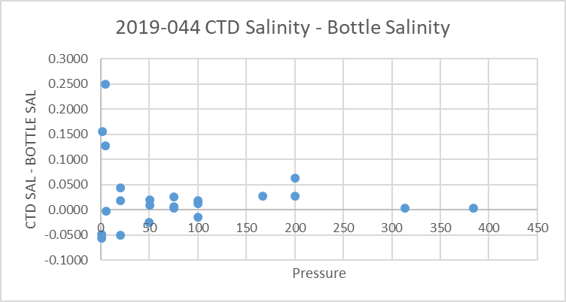
Possible sources of errors are:
- Analysis delay - Analysis was delayed by about 2 months so sample values may be slightly high due to adsorption and/or evaporation. This error is likely no more than 0.003psu but would contribute to the CTD salinity appearing to be too low.
- Incomplete flushing of bottles - There likely is some error due to incomplete flushing of Niskin bottles so that the water in the bottles comes from higher in the water column. This would lead to the CTD salinity appearing to be high. That error would be dependent on local vertical salinity gradients which are usually higher at shallow depths.
- Bottle Depth error – There were no notes about the wire angle being high but it is likely the bottles were a little higher in the water column than the CTD data with which they were compared. This would make the CTD salinity appear to be reading too high. The depth error would increase with depth but the effect on salinity might not increase since salinity gradients usually decrease with depth.
- Temporal change – The time difference between bottle cast and CTD cast varied from about 15 minutes to 1 hour. This may account for some variability but should be a random error.
So 2 of the 3 systematic errors lead to the CTD appearing to be higher than it really is with analysis delay having the opposite effect.
No recalibration of salinity is justified given the scatter and many sources of error in the comparison.
For more details see the “comparisons” worksheet in file 2019-044-bottle_plus_CTD.xlsx.

Dissolved Oxygen
Dissolved Oxygen sampling was done at the same depths as the salinity sampling.
A fit of (CTD DO – Bottle DO) versus CTD DO usually leads to a reasonable linear fit that can be used to recalibrate the CTD DO. However, that is based on sampling with a rosette and with many more samples on which to base a conclusion.

The comparison of CTD DO and titrated samples for this cruise is shown in the following plot.
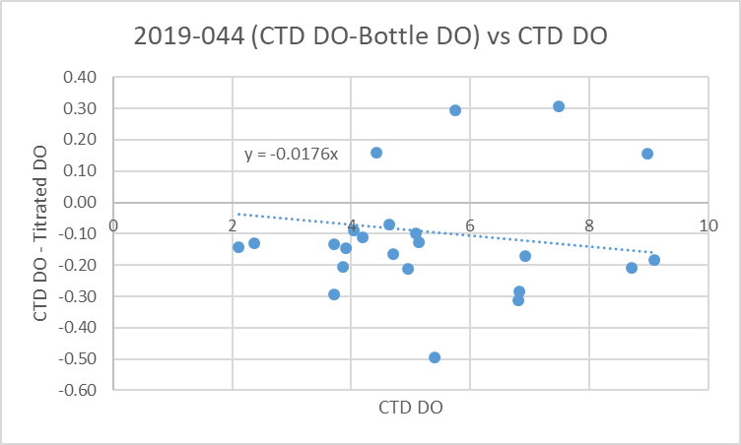

In general this type of DO sensor reads low due to calibration drift. When a rosette is in use bottles are closed during the upcast. Due to incomplete flushing of Niskin bottles the samples tend to come from deeper in the water column than intended, so the sensor appears to be reading a little higher than it really is, offsetting the calibration error somewhat. For this cruise the potential errors are different because the Niskins were deployed on a wire in separate casts from the CTD.

Some of the same possible errors affecting the comparison are:
- Incomplete flushing of bottles - There likely is some error due to incomplete flushing of Niskin bottles so that the water in the bottles comes from higher in the water column. This would generally lead to the CTD DO looking low compared to bottles, thus making the calibration error look larger than it really is. However, the errors would be dependent on local vertical DO gradients and those were quite complex during this cruise with some reversals, so the cumulative effect is likely less severe than that on salinity.
- Bottle Depth error –The bottles were likely somewhat higher in the water column than the CTD data with which it was compared. This would generally make the CTD DO appear to be reading too low. The depth error would increase with depth though the near-bottom DO gradients are generally lower.
- Temporal change – The time difference between bottle cast and CTD cast varied from about 15 minutes to 1 hour. This may account for some variability but should be a random error.

Overall, the errors contribute to the CTD DO looking lower than it really is. With the errors being dependent on local vertical gradients, it is not surprising that the fit of differences versus CTD DO has a lot of scatter. We expect DO to be reading a little low, but it is likely not as low as appears in the comparison given the likely errors. There are not enough data to enable identification of outliers; this fit is too weak to justify recalibration.

For more details see the “comparisons” worksheet in file 2019-044-bottle_plus_CTD.xlsx.

Fluorescence
The only extracted chlorophyll sampling was at the surface while the CTD data are not available above 1m for most casts. There is considerable variation as expected in high-gradient areas. Overall the CTD sensor has higher values than the extracted chlorophyll samples but the scatter is high which is not unexpected at the surface.
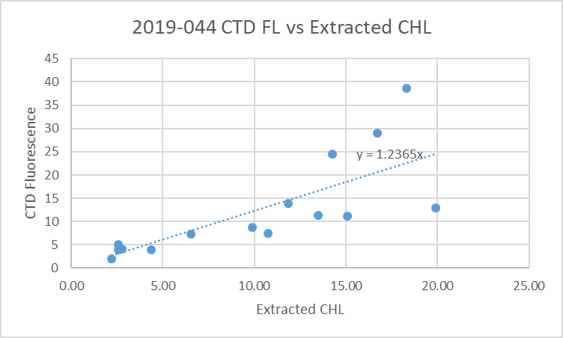
The deep fluorescence values from the CTD are higher than usually seen. There was no recent history for this particular fluorometer with the last known use being in 2017 when it was mounted on a camera.
We do have data from 2 other cruises in spring 2019 that occupied some of the same stations. The other 2 cruises used 2 different SBE type fluorometers.
Cruise | 2019-016 | 2019-044 | 2019-005
Date | Early April | Early May | Late May
Station | Fluorescence Minima |  |  | Approx. depth
59 | 0.3 | 0.9 | 0.3 | 200
42 | 0.1 | 0.5 | 0.2 | 310
GEO1 | 0.1 | 0.45 | 0.15 | 390
CPF1 | 0.05 | 0.45 | 0.16 | 230
FL S/N | SBE3685 | ECO2215 | SBE3640

The early April and late May cruises do not show values as low as seen in early May, so the offset does appear to be inappropriate. It is possible that conditions were very different in late April/early May, but in the absence of any evidence for that, the fluorescence channel will be recalibrated by subtracting 0.3ug/L from all values. This would bring the deep values down to something close to the observations from the other 2 cruises. The near-surface values appear to be reasonably good.

16. Other calibration checks
Sensor History – These sensors have only been used for 1 other cruise since they were last serviced. The previous cruise had no calibration sampling but pressure was recalibrated by subtracting 2.3db.
Historic Ranges – The only excursions from the climatology came from 2 casts:
- Event #5 had slightly high temperature around 20 to 30m; this cast was close to shore.
- Event #55 had high temperature at 50m and high salinity from 70m downwards. The data easily fall within the climatology for the southern Gulf Islands and this cast was very close to the boundary between 2 climatology regions.
The excursions do not appear to be indicative of calibration problems.
Post-cruise calibrations – None were available.

17. CALIBRATE
CTD Salinity will not be recalibrated.
CTD Dissolved Oxygen will not be recalibrated.
The pressure was recalibrated using file 2019-044-recal1.ccf to subtract 3.2db from pressure, 3.2m from depth and to subtract 0.3ug/L from Fluorescence.

18. Fluorescence Filter
The fluorescence data was not filtered as it was not very spiky.

19. Bin Average, Remove, Derive DO in mass units, Reorder
The files were bin averaged using 1db bins.
REMOVE was run to remove Scan_Number, Oxygen:Voltage, Descent Rate and Flag channels.

Dissolved Oxygen was derived in mass units and that was used to calculate DO saturation. Plots of near-surface saturation show a range of 90 to 150%. The highest saturation rates were in the central Strait of Georgia and the lowest in the northern portion of the cruise. Given the region and time of year high variability is expected and does not suggest any problem with the DO calibration.
REORDER was used to get the 2 dissolved oxygen channels together.

20. HEADER EDIT and final checks of CTD files.
Header Edit was used to fix headers, fix formats and to add comments about processing.
A cross-reference listing was produced.
A header check and standards check were run on the CTD files and no errors were found.
The sensor history was updated.
Plots of CTD casts were examined and no problems were found.

20. Final BOT file preparation
To enable searching of bottle data, BOT casts were created that contain sample data and CTD data from the downcast at the same site. The event number will match the CTD cast.
The values from the *.CTD files were selected for the bottle files.

Adding the bottle data to the CTD data was error-prone so a number of checks were done to ensure that the right correspondence was achieved. A 6-line header was added

The 6-line header worksheet from file 2019-044-bottle-plus_CTD.csv was updated by thinning final CTD files and exporting data to a spreadsheet so as to capture the effects of recalibrating fluorescence data and deriving DO in mass units. The new values did not affect the bottle comparison since CTD DO and salinity was not changed and the change in fluorescence is not significant at the surface.
The spreadsheet file was converted to IOS Header files for each cast.

The time and date are present as channels as these cannot be converted directly into header entries.
CLEAN was run to add START and END time. The END TIME is identical so the START time so it will be removed later. CLEAN was also used to enter 0 flags where the flag channels are empty and to remove channels with only pad values.
REMOVE was run to remove the DATE and TIME channels.

CHANGE UNITS was used to derive bottle dissolved oxygen values in mass units.
REORDER was used to get the 2 sample DO channels together

SORT was used to order the files by Depth:Nominal.
HEADEDIT was used to add comments and to remove the END time since it is the same as START TIME. The line concerning HPLC methods was left in the REFERENCES because those data will be added later.
The final files have extensions BOT.

The standards check was run until all errors had been corrected.
A cross-reference list and header check were run on the BOT files and no problems were found.
Plots were made of all BOT casts. No problems were found.
Finally all data from BOT files were extracted to a spreadsheet and compared to the rosette sheets and no further problems were found.

PARTICULARS – notes from logs
- All times are PDT in the log book but in PST in the files.
- CTD Deployment method: Timer set to 2 minutes. CTD down to 10m for soak until 1m 30s mark, bought back to surface to sit until 2 minutes are up. Then full cast begins.
- BOTTLES: For most stations there was a single surface bottle fired as a separate event using 1.7L bottles. For 3 casts there was a full profile of bottles obtained from 5L bottles on a wire; at 2 sites this was followed by a surface bottle with a separate event number. In one case there were 2 surface bottles.

14. Skipped 2 sample numbers.
16. Spike in temperature and salinity ~390m.
26. Profile looks bad after ~260m on down cast – pump shut off?
28. Profiles look fine.
39. Spike in salinity ~220m.
48. Spike in salinity ~230m.

CRUISE SUMMARY

Cruise ID#: 2019-044
Dates: Start: 29 April 2019 End: 4 May 2019
Location: Strait of Georgia Zooplankton
Party Chief: Young K.
CTD# | Make | Model | Serial# | Used with Rosette? | CTD Calibration Sheet Competed?
1 | SEABIRD | 25 | 334 | No | Yes

CTD CALIBRATION INFORMATION
Make/Model/Serial#: SEABIRD/SBE25/0334 Cruise ID#: 2019-034

Calibration Information
Sensor |  | Pre-Cruise |  | Post Cruise
Name | S/N | Date | Location | Date | Location
Temperature | 4484 | 22Feb2017 | Factory
Conductivity | 2128 | 23Feb2017 | Factory
ECO Fluorometer | 2215 | 07Mar2017 | Factory
SBE43 Oxygen | 1483 | 2Mar2017 | Factory
Pressure | 0482 | 28Feb2017 | Factory

