Institute of Ocean Sciences
P.O. Box 6000
9860 West Saanich Road
Sidney, B.C. Canada
V8L 4B2

Field Report:
Canadian Ranger Ocean Watch 2019

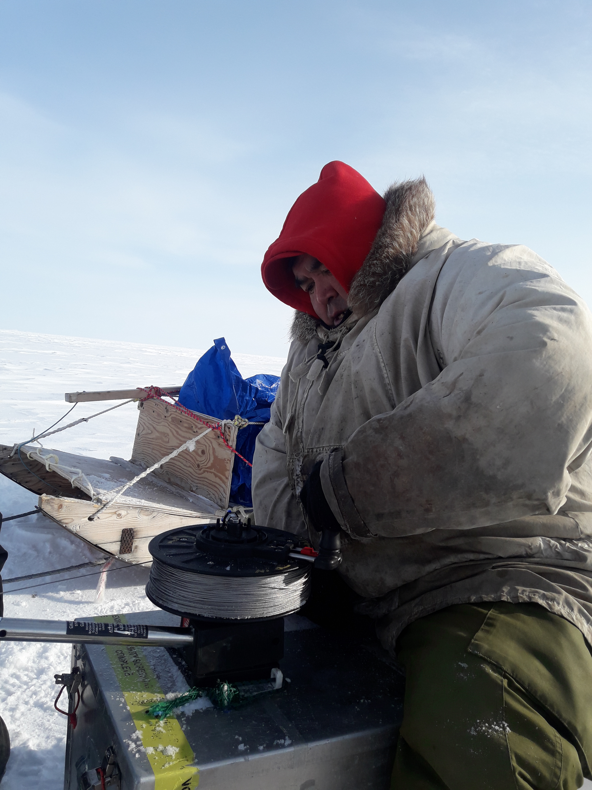

Program Dates: 4 March – 10 April 2019

Reported by: Mike Dempsey, Chris Clarke, Jane Eert and Sarah Zimmermann,
Fisheries and Oceans Canada (DFO) – Institute of Ocean Sciences, Sidney BC

Table of Contents
Overview of the Canadian Ranger Ocean Watch (CROW) activities for 2019 2
Background 3
Trip Summary 3
Method and Measurements 3
Program 6
Cambridge Bay 6
Kugluktuk 7
Paulatuk 9
Conclusion and Notes on Future Programs 11
Data Availability 12
Acknowledgements 12
Associated Researchers 12
Appendix 12
Station Locations 12
Maps of Station locations 15
Data Figures 17

Overview of the Canadian Ranger Ocean Watch (CROW) activities for 2019
In March and April 2019, science advisors from the Institute of Ocean Sciences of Fisheries and Oceans Canada (DFO) visited 3 communities in the Arctic (2 in Nunavut and 1 in Northwest Territories) to continue training and working with Rangers of 1 Canadian Ranger Patrol Group (1 CRPG). The DFO personnel brought oceanographic instrumentation to train Rangers to measure ocean properties. After the DFO visit, the equipment was left in the communities with the Rangers to use during North Warning System (NWS) patrols when possible.
The data collected during the training and NWS patrols will expand our view of the wintertime oceanography of the western Canadian Arctic Archipelago. Data collected by Rangers during CROW in previous years is filling in gaps in studies in Dease and Dolphin and Union Straits as well as Coronation and Queen Maud Gulfs and Darnley Bay. A summary of this year’s data is included in the appendix of this report. A full data report has been produced separately.
For logistical reasons, this year’s CROW training was broken up into 2 trips. In March, CROW training was undertaken in the Kitikmeot communities of Cambridge Bay and Kugluktuk. Later in April, CROW training and water sampling was done in Paulatuk

Background
The objective of the Canadian Ranger Ocean Watch (CROW) is to establish sustainable environmental monitoring in the Northwest Passage, by residents, through a collaboration in which Department of National Defense (DND)-Canadian Rangers are trained by Fisheries and Oceans Canada (DFO) scientists and technicians to collect climate-related data during patrols. The data are then available to the communities and public for education, policy and governance, and scientific use.
CROW encourages discussions with the participating communities about the community’s priorities and concerns relating to the marine environment. DFO’s Institute of Ocean Sciences operates several programs from ships every summer in the arctic. CROW offers an opportunity to collect wintertime data and to talk to people on the ground about ocean research in their regions.
CROW recognizes that northern residents possess unmatched skills of travel and traditional knowledge of their local environment and the need to involve natural scientists in the interpretation and application of traditional knowledge. The Rangers’ keen operational knowledge and observations coupled with science’s larger-picture studies gives new perspective to local conditions. In many instances, traditional knowledge has helped shape and augment DFO research in the Arctic Archipelago. DFO appreciates the capabilities of the Canadian Rangers in carrying out valuable environmental monitoring in demanding winter conditions. The ability to collect a time series over years is extremely valuable and enhances studies conducted during the summer months from ships.

Trip Summary
Science advisors from DFO visited Cambridge Bay, Kugluktuk and Paulatuk for equipment training. Training typically included an indoor session going over the equipment in the kit, data collection protocol, downloading data from instruments to computer, discussion of station locations, current sea-ice conditions and areas of marine-interest. After indoor dry training, Rangers went out on the ice with advisors for a hands-on practical outdoor session at a suitable site on the ocean. The sites for the outdoor practical sessions also collected data to include in long term oceanographic monitoring. Participating Rangers had experience in all parts of the operation.
There was at least one training day per community. Rangers from Cambridge Bay performed two day-trips: the first was a transect near Unihitak Island; and a second transect across Dease Strait. Rangers from Kugluktuk performed a day trip in the bay, including near the outflow of the Coppermine River. They will use their training to collect data later during their NWS patrols across Dolphin and Union Strait. The have planned patrols over ice in May and hopefully again by boat in August. In Darnley Bay, Paulatuk Rangers continued collecting data as a pilot for ocean monitoring in the Anguniaqvia Niqiqyuam Marine Protected Area (ANMPA) and to support DFO ocean/climate modeling. They had two day trips into Darnley Bay.
The ocean measurements collected by the Rangers contribute to long term studies near northern communities. Data collected during these trips provides unmatched winter observations into Arctic ocean properties.

Method and Measurements
The primary instrument for measuring seawater properties is a CTD which gets its name from the three primary properties it measures (conductivity, temperature and depth). Conductivity is used to derive the salinity of the sea water. At each station, an 8” hole in the ice was made using a Strikemaster power head and auger with extension flights. An RBR Concerto CTD was lowered through the hole to 3 metres off the seafloor, raised to the surface and re-lowered for a second cast. The CTDs were equipped to measure:

Depth (through pressure)
Temperature
Salinity (through conductivity)
Dissolved Oxygen (provides information about sea-life, and water circulation)
Fluorescence (gives the concentration of chlorophyll-a, which indicates how much algae is present)

The data were downloaded from the CTD to Panasonic Toughbook computers running free RUSKIN software from RBR after the day trips. The data give a picture of how these ocean properties change every 20 cm from the surface to the sea-floor. Data were converted into a format that the free display software “Ocean Data View” can read. The data are in the process of being posted to the public Ocean Networks Canada website and are also available from DFO.
In 2019, data will also be available on the internet through the SIKU website hosted by the Arctic Eider Society. The website display of the data is still in beta development but should be available late in 2019. The website will display graphic representation of the data collected as well as images and the ability to log feedback and comments.

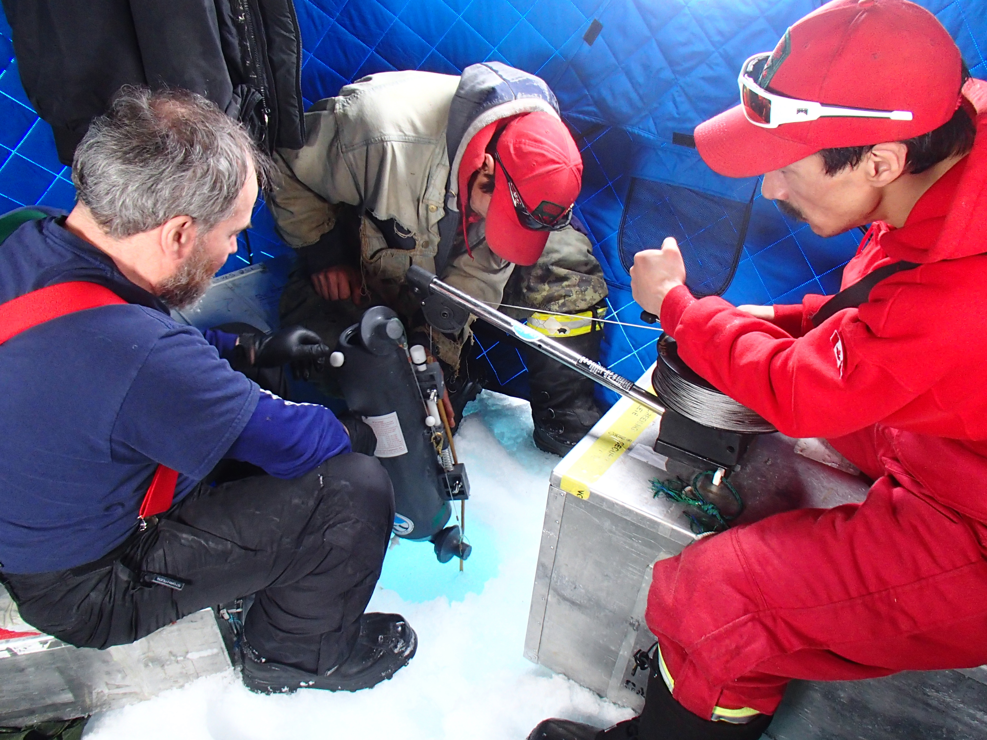
Mike Dempsey, Ryan Green and Johnny Ruben in a tent lowering a Niskin sampler through sea-ice

Additional measurements were taken at each station that provide information about the sea-ice and how isolated (protected) it is from the air.
Total thickness of the sea-ice
Thickness of the sea-ice above the water line (freeboard)
Thickness of the snow covering the ice
Air temperature
The temperature between the snow and sea ice

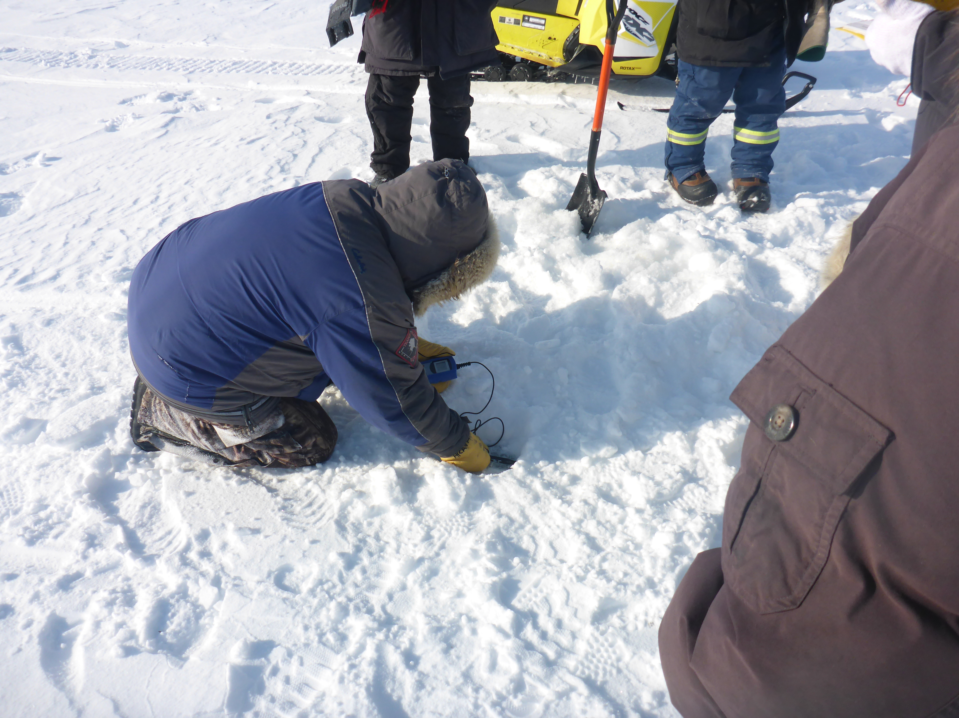
Richard Akana measuring temperature between snow and ice
If time allowed, transects were made away from the station, measuring the snow thickness at five meter intervals for 250 meters. The data collected on the snow depth transects is being supplied to the Canadian Ice Service to help ground-truth satellite imagery.
Oceanetic model 908 thermistor ice buoys were deployed at 2 locations in Dease Strait. The buoys measure temperature at 4 depths below the surface of the ice as well as beneath the snow and the air temperature to an accuracy of +/- 0.01 C. The data from these buoys is sent hourly via Iridium satellite to Ocean Networks Canada for display on the internet (dmas.uvic.ca –Ocean Networks Canada Oceans 2.0). Ice temperature profiles are useful in looking at events during ice accumulation and break up.
At 3 stations in Dease Strait, a folding plankton net, made of 100um mesh, was deployed. The net has a 0.5m mouth diameter when deployed and can be collapsed to pass through an 8” (20cm) diameter hole in the ice. Samples collected will be used to determine what overwintering zooplankton species are present. A year round acoustic instrument (ASL Acoustic Zooplankton & Fish Profiler – AZFP) was deployed from the R/V Martin Bergmann in the summer of 2018 as part of the DFO/Arctic Research Foundation Kitikmeot Sea Science Survey (K3S) to monitor fish and zooplankton in the water. Data from the plankton net deployed during CROW, just above the instrument mooring, will help ground-truth the acoustic data.
At stations near Unahitak Island in Dease Strait and in Darnley Bay, an underwater GoPro camera was used to observe the bottom of the sea ice. The ice is being examined for the presence of ice algae and Arctic Cod fish eggs that both appear later in spring before the ice melts and breaks up in June/July.
At two stations in Darnley Bay, water sampling was conducted inside a tent erected over the hole drilled in the ice. Water was sampled from 4 m, mid water and bottom depth were taken to measure dissolved organic carbon (DIC), alkalinity, salinity, nutrients and O18 oxygen isotope concentration.. These samples were taken for an ice, ocean environment model being run by Nadja Steiner at Institute of Ocean Sciences, DFO. These locations are also sampled in summer from the F/V Frosti conducting research as part of the Canadian Beaufort Sea- Marine Ecosystem Study (CBS-MEA).

The data collection process is explained fully in the manual:

Ranger science manual ver9 2019.pdf

Program

Cambridge Bay

Training
Equipment was taken out of storage and serviced in Cambridge bay. The instrumentation was taken out onto the ice in Cambridge Bay harbor on 6 & 7 March to test and collect data at 4 local sites by DFO advisors. The equipment was confirmed to be working properly for Ranger training.
On 7 March, the DFO science advisors met with Cambridge Bay Rangers at R/Sgt Jimmy Evalik’s house to discuss the next couple of days training. A dry land discussion was held on the methods and areas to be sampled through the sea ice.
On 9 March, Mike Dempsey and Chris Clarke accompanied 3 Rangers on a day trip to Unahitak Island. CTD casts, snow and ice thickness and 250 m snow transects were made at 4 stations. In addition, an ice buoy measuring ice temperature was deployed at station UN20 (for the third year). The buoy will record air, snow/ice interface, ice and water temperatures at 4 depths until break up in late July. One of the stations was located above a year-long deployed bottom mounted acoustic instrument (Acoustic Zooplankton/Fish Profiler or AZFP). A plankton net was deployed at both UN20 and the AZFP station. Samples will be compared with the acoustic data when the mooring is recovered in September 2019. The data will be used as part of the Kitikmeot Sea Science Study (K3S) lead by Bill Williams at DFO. GoPro video was collected of the under surface of the ice at UN20 for detection of early season ice algae and Arctic cod fish eggs (Helen Drost, DFO).

Rangers receiving training and conducting the sampling were :

R/Cpl Allen Elatiak
Rgr Charlie Egotak
Rgr Amy Aknavigak

On 10 March a trip was made across Dease Strait from Cape Colburne and back (100 km return).
CTD casts as well as snow and ice thickness were carried out at 5 stations. Snow depth measurements were made every 5 meters out to 250 m from the augured hole. In the middle of the transect, at DS-3, a plankton net and an ice buoy were also deployed.

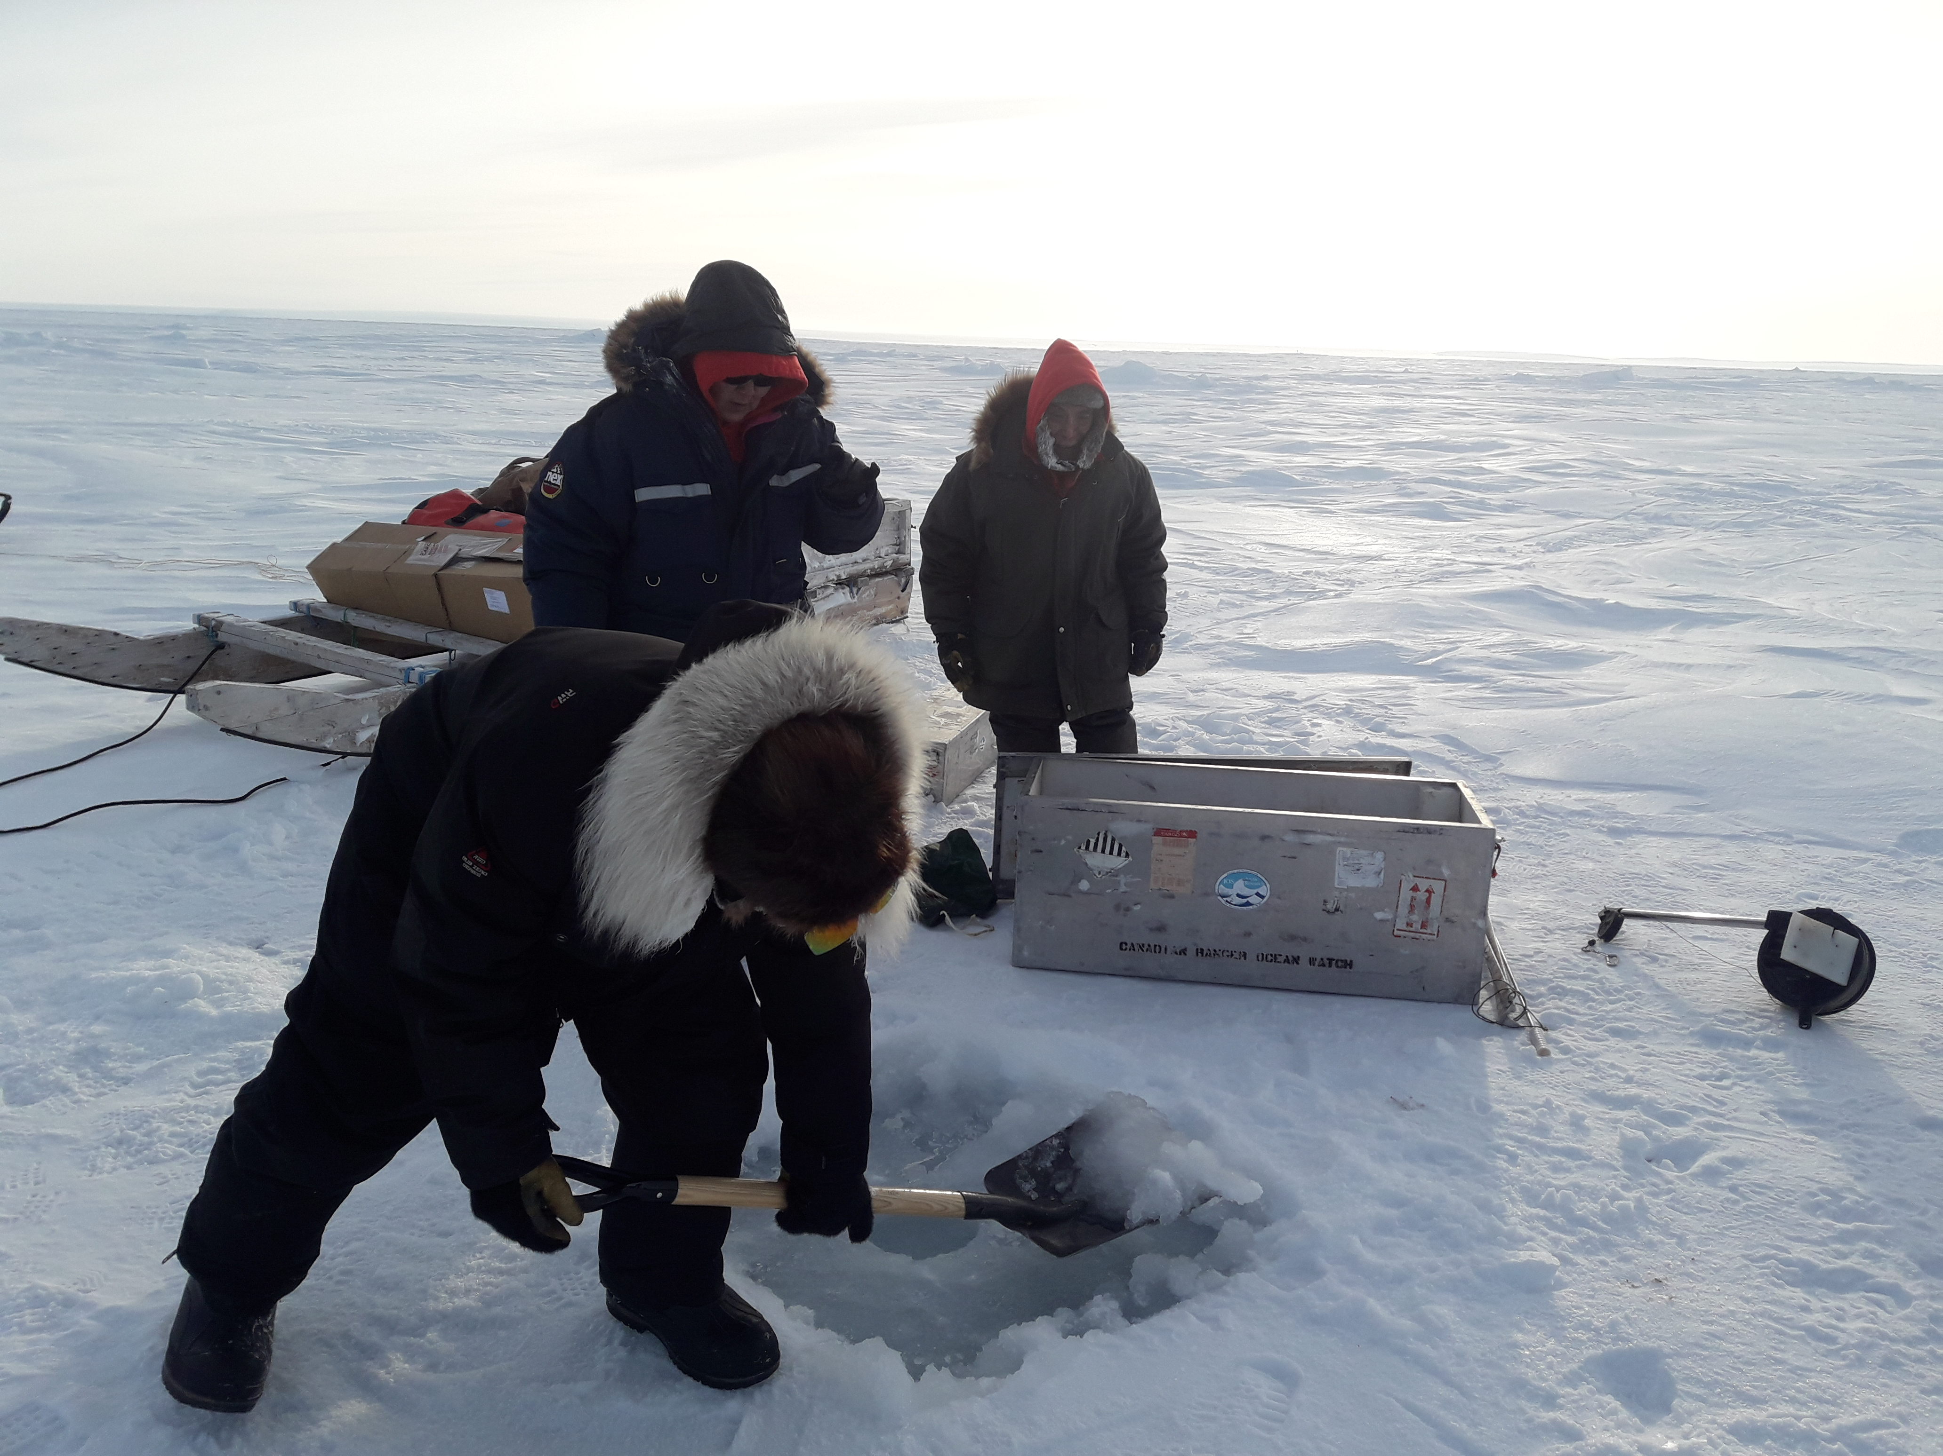
Charlie Egotak, Amy Aknavigak and Allen Elatiak preparing a site

The Dease Strait transect has been done 6 times previously since 2011. The winter data is used to help with monitoring work done in summer by DFO, University of Calgary, University of Manitoba and the Canadian High Arctic Research Station (CHARS).

Rangers receiving training and conducting the sampling were :

R/Cpl Allen Elatiak
Rgr Charlie Egotak
Rgr Amy Aknavigak

In addition to the 2 day trips with the Rangers, Mike Dempsey and Chris Clarke conducted 4 CTD stations within Cambridge bay. Of these, 3 of the stations had been sampled previously on several other CROW trips and provide observations on the circulation within the bay. A fourth station in the east arm was added in 2018 to give more insight into the area influenced by Freshwater Creek in summer. This arm also receives effluent from the hamlet’s sewage treatment lagoons. Effluent causes blooms to occur and the sinking decaying phytoplankton may cause low oxygen concentration in the deep hole at CBay1.

Kugluktuk

Training
On 9 April, the science advisors and four Rangers met at 0900 before going out for training on the sea ice. An indoor meeting was held with the Rangers at R/MCpl Baba Pedersen’s workshop to discuss the science equipment, and the upcoming project. On ice training was performed at stations KUG1, KUG2 and KUG3. These locations are all within 10 nm from Kugluktuk and represent a monitoring time series for the Kugluktuk area covering 2013-2019. CTD casts as well as snow and ice thickness were carried out at 3 stations. Snow depth measurements were made every 5 meters out to 250 m from the augured hole. The GoPro camera was lowered through the ice at KUG 2 and captured video of the underside of the ice. Rangers swapped roles to practice all aspects of the data collection.

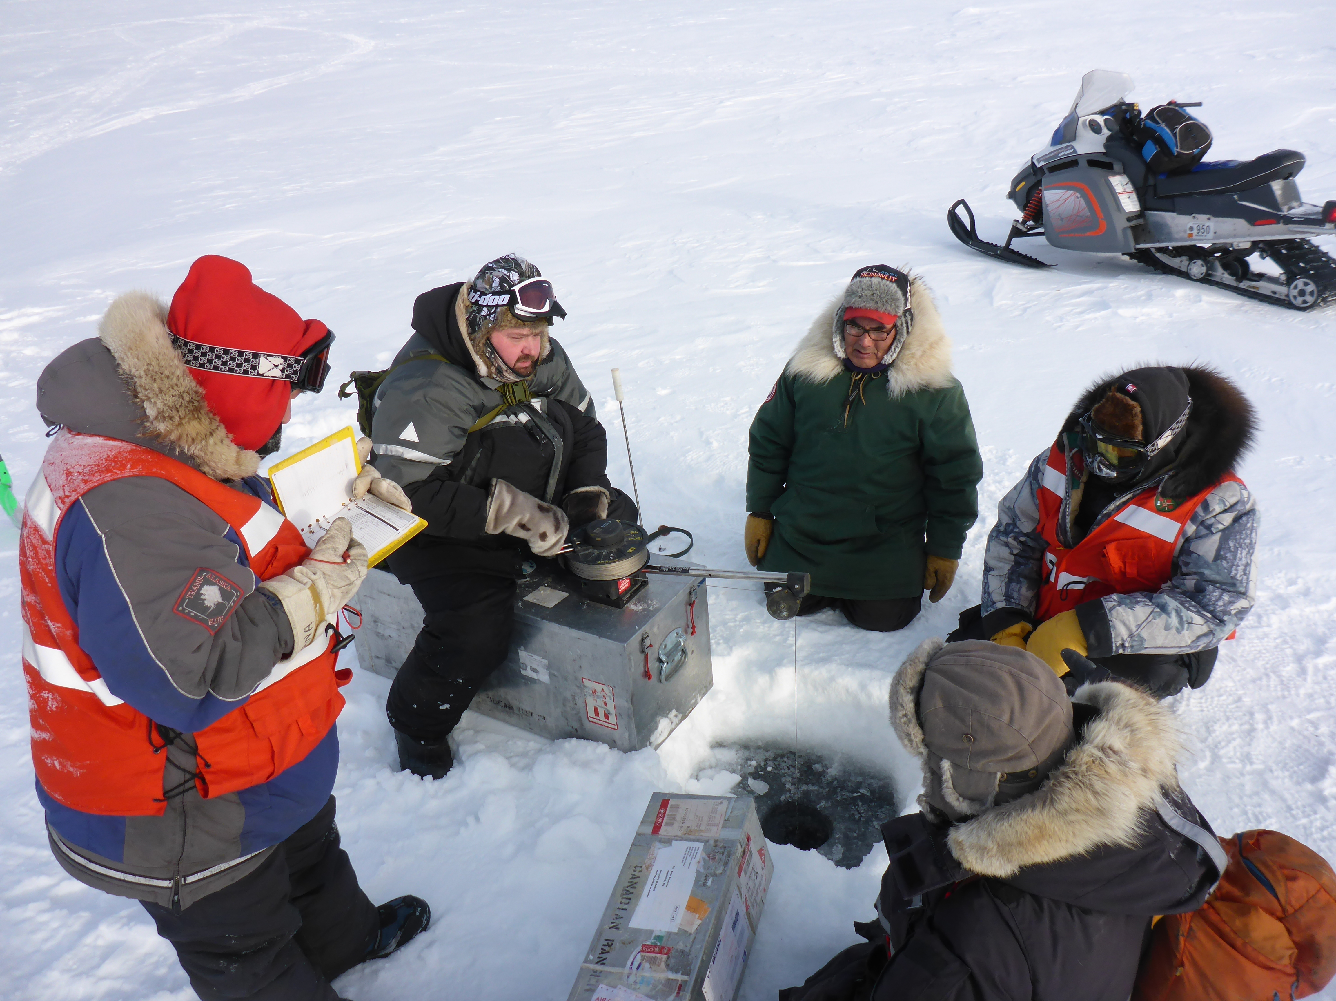

Richard Akana, Cyril Leyte, David Enogaloak, OJ Bernhardt and Mike Dempsey with CTD in water
Rangers receiving training and conducting the sampling were :

R/Cpl David Enogaloak
Rgr Richard Akana
Rgr OJ Berhardt
Rgr Cyril Leyte

The Rangers were shown how to use the computer to download data in the afternoon. The data looked good with no frozen sensors.

Outreach
Mike Dempsey met with Amanda Dumond, the HTO manager. She was asked about any local ocean concerns that DFO may assist with. She mentioned again the reduction in a char run in the Coppermine River around freeze-up and the changing dynamics of the spring river break up. The HTO is working with Kristina Brown’s Coppermine river study and Tracey Loewen’s Chars and Cods project. Kristina Brown works out of DFO’s Institute of Ocean Sciences in Sidney, BC and Tracey Loewen works for DFO’s Freshwater Institute in Winnipeg MB. A meeting was also made with project officer Tannis Bolt at the KIA lands office. She was given an update on CROW. Later, presentations on ocean science and CROW were given to the grades 7, 8 and 9 science classes at Kugluktuk High school.
NWS patrols
The Kugluktuk Rangers took the CROW gear on their May NWS patrol to Lady Franklin Point (PIN-3). They conducted 3 stations across Dolphin and Union Strait on 7 May 2019.
Rangers conducting sampling during NWS patrol were :
Sgt Roger Hitkolok
MCpl David Enogaloak
Cpl Eric Hitkolok
Rgr Gustin Adjun
Information collected here assists with understanding ocean circulation in Coronation and Queen Maud gulfs. This data augments information from a year round subsurface mooring nearby that collects
ocean current, temperature and salinity data. The Rangers have been collecting CROW data, without accompanying science advisors, in this area since 2015.

Paulatuk

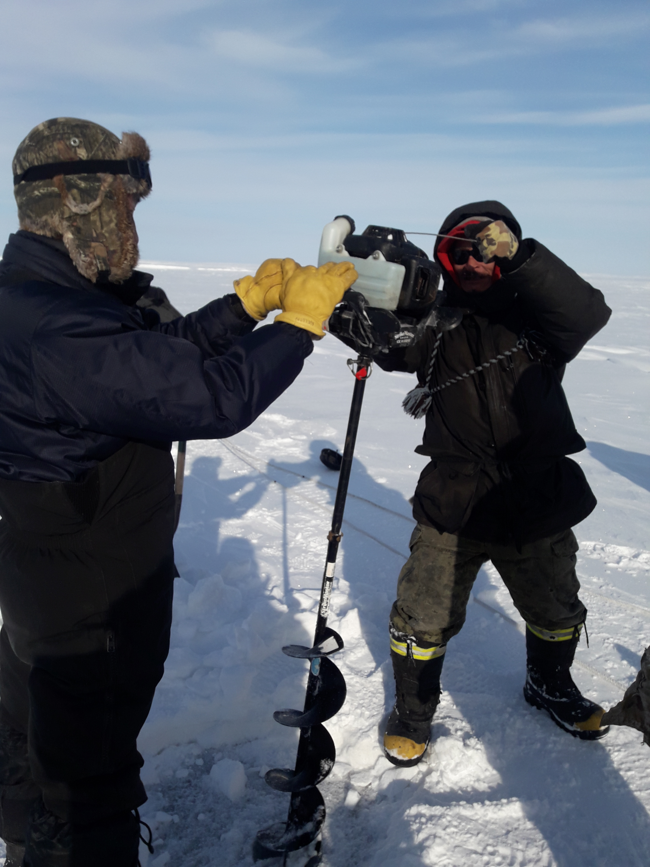

Ryan Green and Nelson Ruben starting ice auger

Training

Science advisors Mike Dempsey and Jane Eert visited Paulatuk 3-9 April. Met with R/Sgt Ryan Green on 3 April at hotel and laid out plans for training and 2 day trips along the eastern shore of Darnley Bay.

On 5 April, 4 Rangers and 2 DFO science advisors travelled across the sea ice to the southern portion of the ANMPA along the SE coast of the Parry peninsula. 6 CTD stations with snow surveys were done in the ANMPA. Data collected at these stations support local winter monitoring efforts in the ANMPA by Karen Dumnall and Darcy McNicoll from DFO’s Freshwater Institute. 2 weeks previously, the 2 most southerly locations were done by the 2 biologists from DFO Winnipeg and 3 residents of Paulatuk using DFO CROW equipment. One of the residents, Nelson Ruben, had been trained by CROW in 2018 and took part in 2019 CROW.
On 7 April, a second day trip was made to the Clapperton Island area east of the Parry Peninsula. After surveying ice conditions , 2 stations used by the CBS-MEA study in summer from the F/V Frosti were chosen. At these stations, after drilling a hole in the sea-ice, a
a 9’ x 9’ Clam insulated ice fishing tent was erected above the hole. CTD casts and snow and ice measurements were made at each station. In addition, 6 casts were made for water sampling. Water was sampled for DIC (dissolved organic carbon – CO2 in solution), alkalinity, salinity, nutrients and O18 at near surface, mid water and near bottom depths. The unique method of collecting DIC samples in beer bottles with crimp bottle caps and using preservative in powder form was used again after successful trials of this method the previous year with the Paulatuk Rangers. The Rangers were trained in the use of the CTD and sampling gear. The skills learned have provided a basis for continuing monitoring for co-management of the ANMPA by DFO, Fisheries Joint Management Committee and the Paulatuk HTC. Further monitoring will be contracted locally by these agencies. The data here complement the summer CBS- MEA studies in Darnley Bay from F/V Frosti.

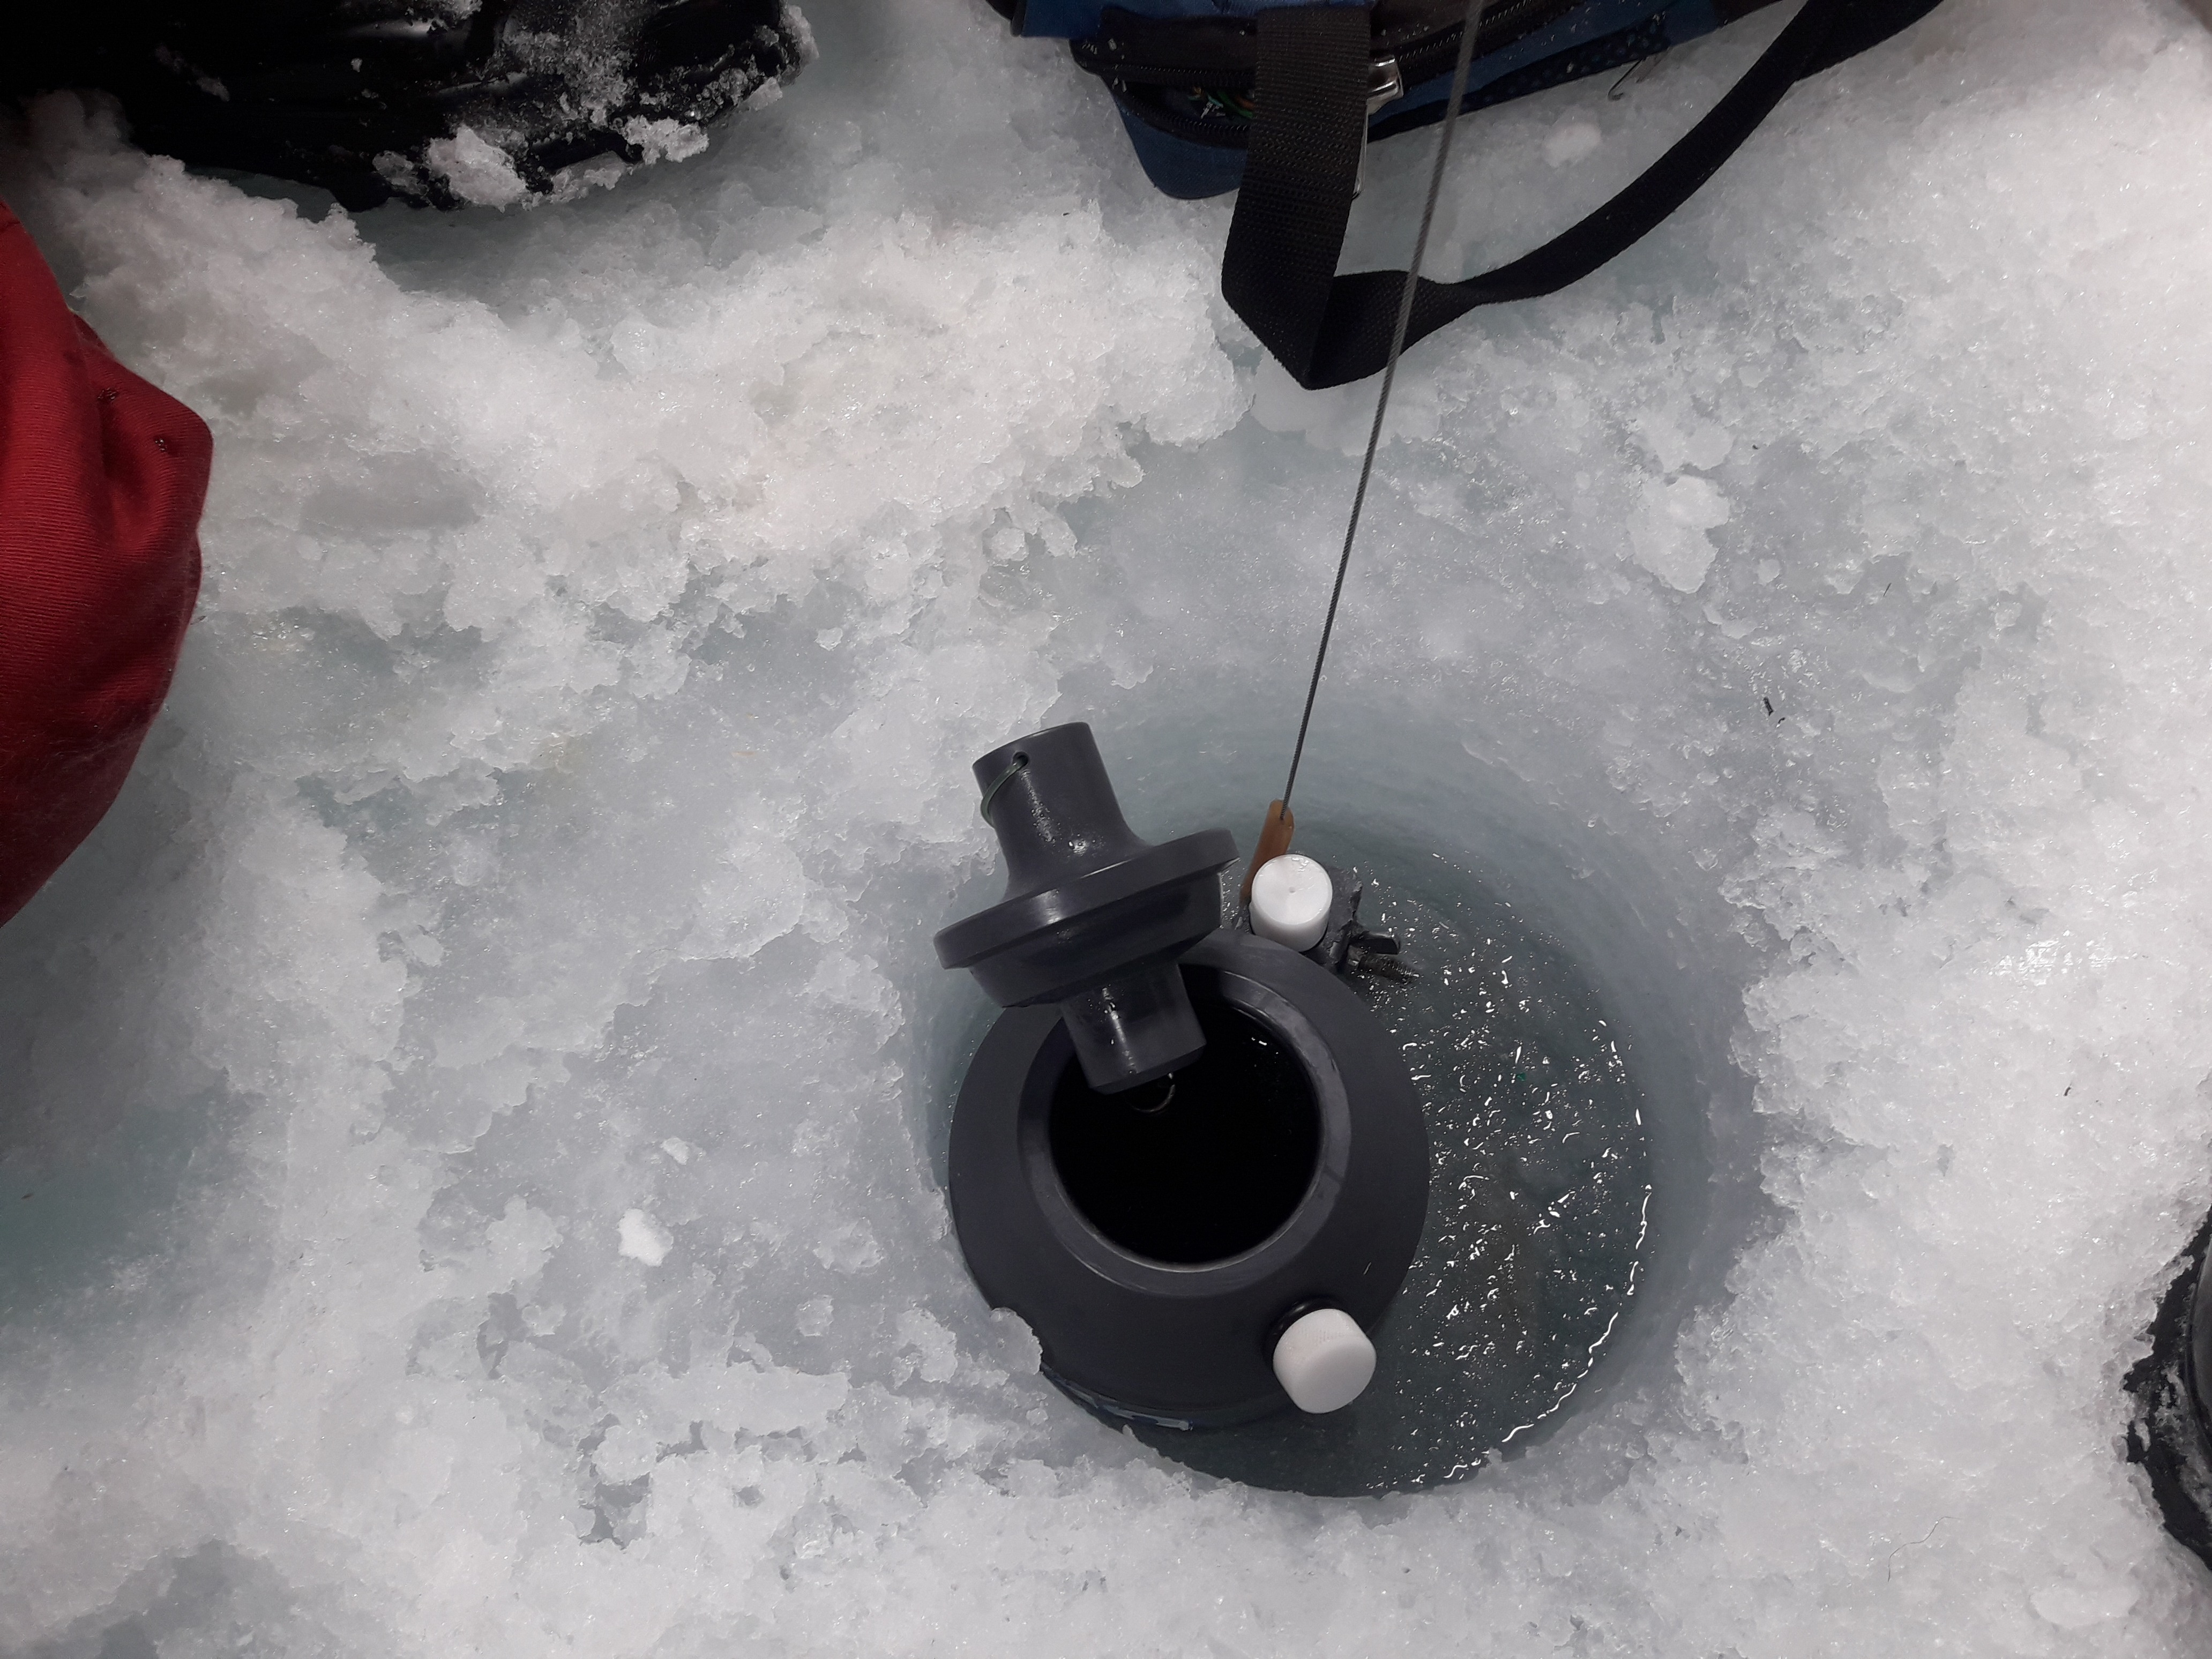

5 litre Niskin sampling bottle being lowered through ice

Rangers receiving training and conducting the sampling were :
R/Sgt Ryan Green
Rgr Nelson Reuben
Rgr Andy Ruben
Rgr Johnny Ruben
Outreach

Attempts were made to talk with DFO and Fisheries Joint management committee personnel in Inuvik. Unfortunately they were not available while the CROW science advisors were in town. A possible school presentation in Inuvik was cancelled due to arriving a day late in Inuvik due to aircraft mechanical problem.
The Paulatuk HTC was not meeting on available days while science advisors were in the hamlet. Individuals on the committee were talked with casually during visit. The results from the previous year were shared with the Rangers.

Conclusion and Notes on Future Programs

The data set from this program continues to give us a view of winter ocean conditions in the western Arctic Archipelago. Due to weather, sea-ice conditions and time constraints, the ability of being able to collect data on a single trip can be quite variable and that having a kit stay in each community for at least two trips per winter would be ideal. DFO greatly appreciates the opportunity of working with the Rangers in collecting ocean and ice data and highly values the cooperation of 1 CRPG in making time in the Rangers’ NWS patrols and training schedules available for CROW. The Rangers skills fit well with ocean data collection methods.
We have been monitoring the deep 83 m hole in Cambridge Bay ( CBay1), since 2011. Concern over the fate of material from the community’s sewage lagoons and freshwater creek and their effect on oxygen levels suggest that this location is necessary for long term monitoring. Since water below 40 m depth in this hole does not regularly circulate, organic material collecting here could use up all the oxygen in water during decomposition. In 2016, a complete flushing event or top to bottom mixing occurred resulting in uniform high oxygen, salinity and near-freezing temperature from surface to bottom. The waters deeper than 40m have gotten progressively lower in oxygen since then. Continued monitoring should give a picture of the time scales for flushing and changes over time. The population of Cambridge Bay is increasing and the demand on the sewage lagoons increases yearly.
In the Unahitak pass area, evidence of tidal mixing was seen clearly in the March 2019 CTD casts. The addition of a fourth station to the east of UN10 showed defined intrusions of warmer water. Some trace of these intrusions was seen to the west at UN10 and the nature of the intrusion is thought to be from the ebb tide moving from the east. The warmer water in the intrusions is not seen in the other Unihitak stations or the Dease Strait transect, but the colder water of the intrusions has the same properties as water in eastern Dease Strait (DS-2 at 28m and DS-3 at 44m).
Kugluktuk monitoring stations showed substantial freshwater in the top to 2-3 m. This river water appears year round from the Coppermine river that does not freeze to the bottom in winter. There is interest in looking at the effect of increasing flow into southern Coronation Gulf during the spring season. Other DFO studies are continuing in the river itself and its changing flow patterns. The monitoring done by the Rangers adds a winter ocean component to these studies. Of major concern is the fate of the fall Char run and the continuing health of the river and its fish which support the people of Kugluktuk. In late 2019/early 2020, DFO will help support community based monitoring efforts in the river and ocean near Kugluktuk. Training from CROW will provide some of the expertise for local community members to continue this monitoring..
Continued CROW sampling and CTD profiling in the Darnley Bay ANMPA.provides a framework for continued monitoring. Skills learned by the rangers provide valuable experience to continue with summer and winter studies in the bay. Profiles made in ANMPA show a good picture of the water mass prior to the spring bloom. The stations farthest out in the bay were just starting to show a chlorophyll signal in the water column during the first week of April. The water sampling off Clapperton Island provides ground truthing for atmosphere/ocean models (Nadja Steiner, IOS/DFO) as well as winter observations to augment CBS-MEA summer studies (Christine Michel, FWI/DFO).
The Rangers are adept at working in difficult and cold winter conditions. Although in its 8th year, CROW equipment is still evolving for ease of use and reliability in cold conditions. Input from the Rangers is invaluable for working in cold conditions and from the sea ice. Normally due to scheduling, CROW training takes place in February or early March. Conditions encountered in March and April this year were much less severe than trips done earlier in the season in past years. As a result of this very cold experience, we now do 3 CTD profiles at each station. For the small incremental amount of time used for a third cast (< 5 minutes), data quality and accuracy are improved. In 2018 this was done experimentally at some stations and in 2019 we performed 3 casts as a standard procedure at each station.

Data Availability

DFO has a mandate to make data available to local communities and to do site visits where data are being collected. During CROW, attempts are made to share with the Rangers, in the schools and to the HTOs information about oceanographic monitoring and research. The Oceans Network Canada website (http://www.oceannetworks.ca/) is currently being modified to allow easy public access to the data collected. Education and outreach is important to Oceans Network Canada.
In addition, the 2019 CROW data will be hosted on the Arctic Eider Society’s SIKU (“sea ice”) website starting in late 2019. Profiles will be available as well as pictures and the capacity to post comments and observations from the community.

Acknowledgements

We thank DND, 1 Canadian Ranger Patrol Group and the Rangers and the communities of Kugluktuk, Cambridge Bay, and Paulatuk for their interest, support and participation in the CROW program. Data collected during CROW provides rare winter oceanographic observations in the Kitikmeot region that would not be otherwise possible.

Associated Researchers
Bill Williams, Institute of Ocean Sciences , DFO Sidney BC
Nadja Steiner, Institute of Ocean Sciences , DFO Sidney BC
Helen Drost, Institute of Ocean Sciences , DFO Sidney BC
Kristina Brown, Institute of Ocean Sciences , DFO Sidney BC
Darcy McNicholl, Freshwater Institute DFO, Winnipeg MB
Karen Dumnall, Freshwater Institute DFO, Winnipeg MB
Tracey Loewen, Freshwater Institute DFO, Winnipeg MB
Christine Michel, Freshwater Institute DFO, Winnipeg MB
Jasmine Brewster, DFO Inuvik NT
Connie Blakeston, DFO Inuvik NT
Kayla Hansen-Craik, Inuvik NT, Joint Secretariat, Fisheries Joint Management Committee
Stéphanie Tremblay-Therrien, Ottawa ON, Environment Canada, Canadian Ice Service

Appendix

Station Locations

Table 1. List of Stations: CTD cast and Snow depth transect performed at all stations.
Patrol Group | Station Name | Area | Date | Latitude (N) |  | Longitude (W) |  | Ice Thickness (cm) | Other sampling
Cambridge Bay | CBay1 | Cambridge bay | 6-Mar-2019 | 69 | 6.248 | 105 | 4.557 | 192
Cambridge Bay | West Arm | Cambridge bay | 7-Mar-2019 | 69 | 6.065 | 105 | 8.451 | 214
Cambridge Bay | CBay2 | Cambridge bay | 7-Mar-2019 | 69 | 5.000 | 105 | 1.005 | 130
Cambridge Bay | CBay6 | Cambridge bay | 7-Mar-2019 | 69 | 6.506 | 105 | 2.508 | 257
Cambridge Bay | AZFP | Unahitak | 9-Mar-2019 | 69 | 1.361 | 105 | 44.056 | 134 | Zooplankton net
Cambridge Bay | UN10 | Unahitak | 9-Mar-2019 | 68 | 1.019 | 105 | 45.833 | 214
Cambridge Bay | UN20 | Unahitak | 9-Mar-2019 | 68 | 59.936 | 105 | 49.011 | 137 | Ice buoy, Zooplankton net
Cambridge Bay | UN30 | Unahitak | 9-Mar-2019 | 68 | 58.872 | 105 | 54.452 | 154
Cambridge Bay | DS19-01 | Dease Strait | 10-Mar-2019 | 68 | 56.199 | 105 | 14.000 | 137
Cambridge Bay | DS19-03 | Dease Strait | 10-Mar-2019 | 68 | 53.106 | 105 | 20.928 | 140 | Ice buoy, Zooplankton net
Cambridge Bay | DS19-05 | Dease Strait | 10-Mar-2019 | 68 | 49.505 | 105 | 31.63 | 141
Cambridge Bay | DS19-04 | Dease Strait | 10-Mar-2019 | 68 | 51.096 | 105 | 25.461 | 210
Cambridge Bay | DS19-02 | Dease Strait | 10-Mar-2019 | 68 | 54.814 | 105 | 16.940 | 134
Kugluktuk | KUG1 | Coronation Gulf | 13-Mar-2019 | 67 | 51.071 | 115 | 7.693 | 115
Kugluktuk | KUG2 | Coronation Gulf | 13-Mar-2019 | 67 | 52.410 | 115 | 1.073 | 126
Kugluktuk | KUG3 | Coronation Gulf | 13-Mar-2019 | 67 | 50.658 | 114 | 54.118 | 167
Paulatuk | CMPA2 | Darnley bay | 5-Apr-2019 | 69 | 37.519 | 123 | 57.401 | 128
Paulatuk | CMPA1 | Argo bay | 5-Apr-2019 | 69 | 37.729 | 124 | 7.787 | 140
Paulatuk | CMPA4 | Darnley Bay | 5-Apr-2019 | 69 | 34.857 | 124 | 4.166 | 131 | GoPro under ice
Paulatuk | CMPA3 | Darnley Bay | 5-Apr-2019 | 69 | 34.904 | 124 | 11.053 | 140
Paulatuk | CMPA5 | Darnley Bay | 5-Apr-2019 | 69 | 29.992 | 124 | 21.673 | 141
Paulatuk | CMPA6 | Darnley Bay | 5-Apr-2019 | 69 | 29.979 | 124 | 17.261 | 127
Paulatuk | BPT_01 | Darnley Bay | 7-Apr-2019 | 69 | 41.881 | 123 | 46.024 | 118 | Water samples at 4 depths: 68,41,12,3.7m; GoPro; Dirty ice sample in O18 vial.
Paulatuk | BPT_HC2 | Darnley Bay | 7-Apr-2019 | 69 | 42.652 | 123 | 38.327 | 118 | Water samples at 3 depths: 91,20,3m
Kugluktuk | DU1-2019 | Dolphin & Union Strait | 7-May-2019 | 68 | 16.996 | 113 | 53.739 | 119
Kugluktuk | DU2-2019 | Dolphin & Union Strait | 7-May-2019 | 68 | 22.921 | 113 | 28.017 | 145
Kugluktuk | DU3-2019 | Dolphin & Union Strait | 7-May-2019 | 68 | 25.446 | 113 | 21.659 | 145

Note on station naming. Most stations have a simple naming such as “Kug 1” where the sea-ice is relatively flat and stations can be reached every year. In Dease and Dolphin & Union Straits, sea-ice ridging is not uniform year to year. Because of this, the station location is often offset to avoid difficult ice. In order to define stations by year, a convention of naming the station such as “DS19-02” is used. Station relocation due to ridging is usually less than a few hundred metres.

Table 2. Ice Buoys

Ice Buoy s/n 019 location : 68° 59.936’ 105° 49.011’ W (station UN20)
Deployed : 9 March, 2019
IMEI ID : 30023406059

Ice Buoy s/n 018 location : 68° 53.106’ 105° 20.928’ W (station DS19-03)
Deployed : 10 March, 2019
IMEI ID : 30023406506

Maps of Station locations
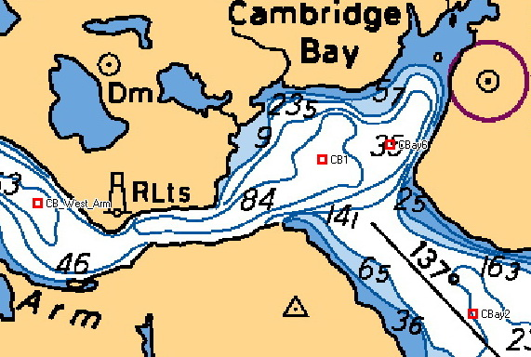

Fig 1.CROW 2019 – Cambridge Bay Inlet stations

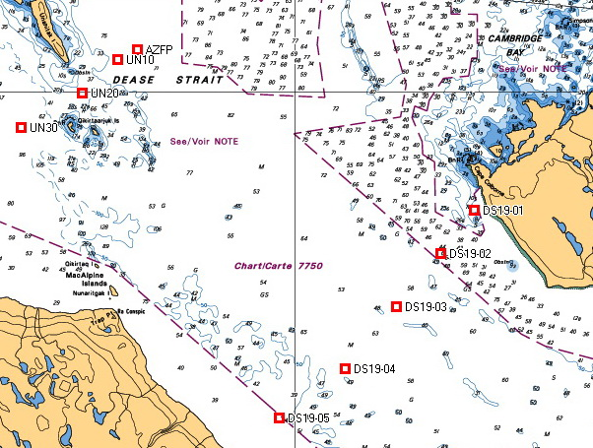

Fig 2. CROW 2019 - Dease Strait stations

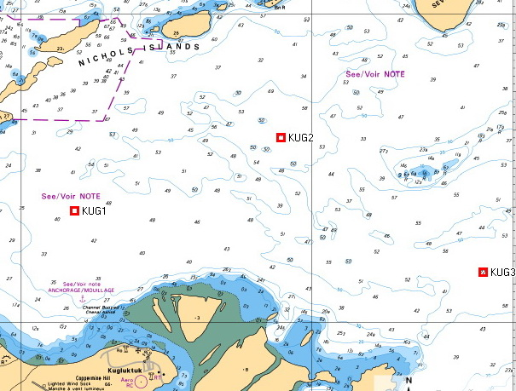

Fig 3. CROW 2019 – Kugluktuk stations

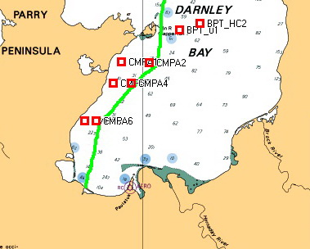

Fig 4. CROW 2019 – Paulatuk stations- ANMPA boundary in green

Data Figures

s –

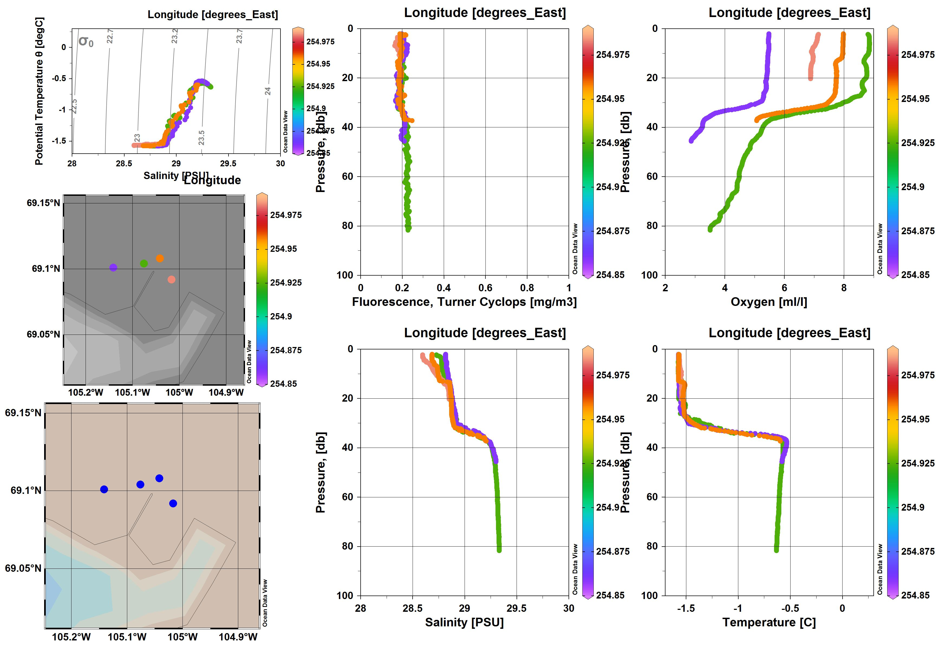

2019 Cambridge Bay stations coloured by longitude

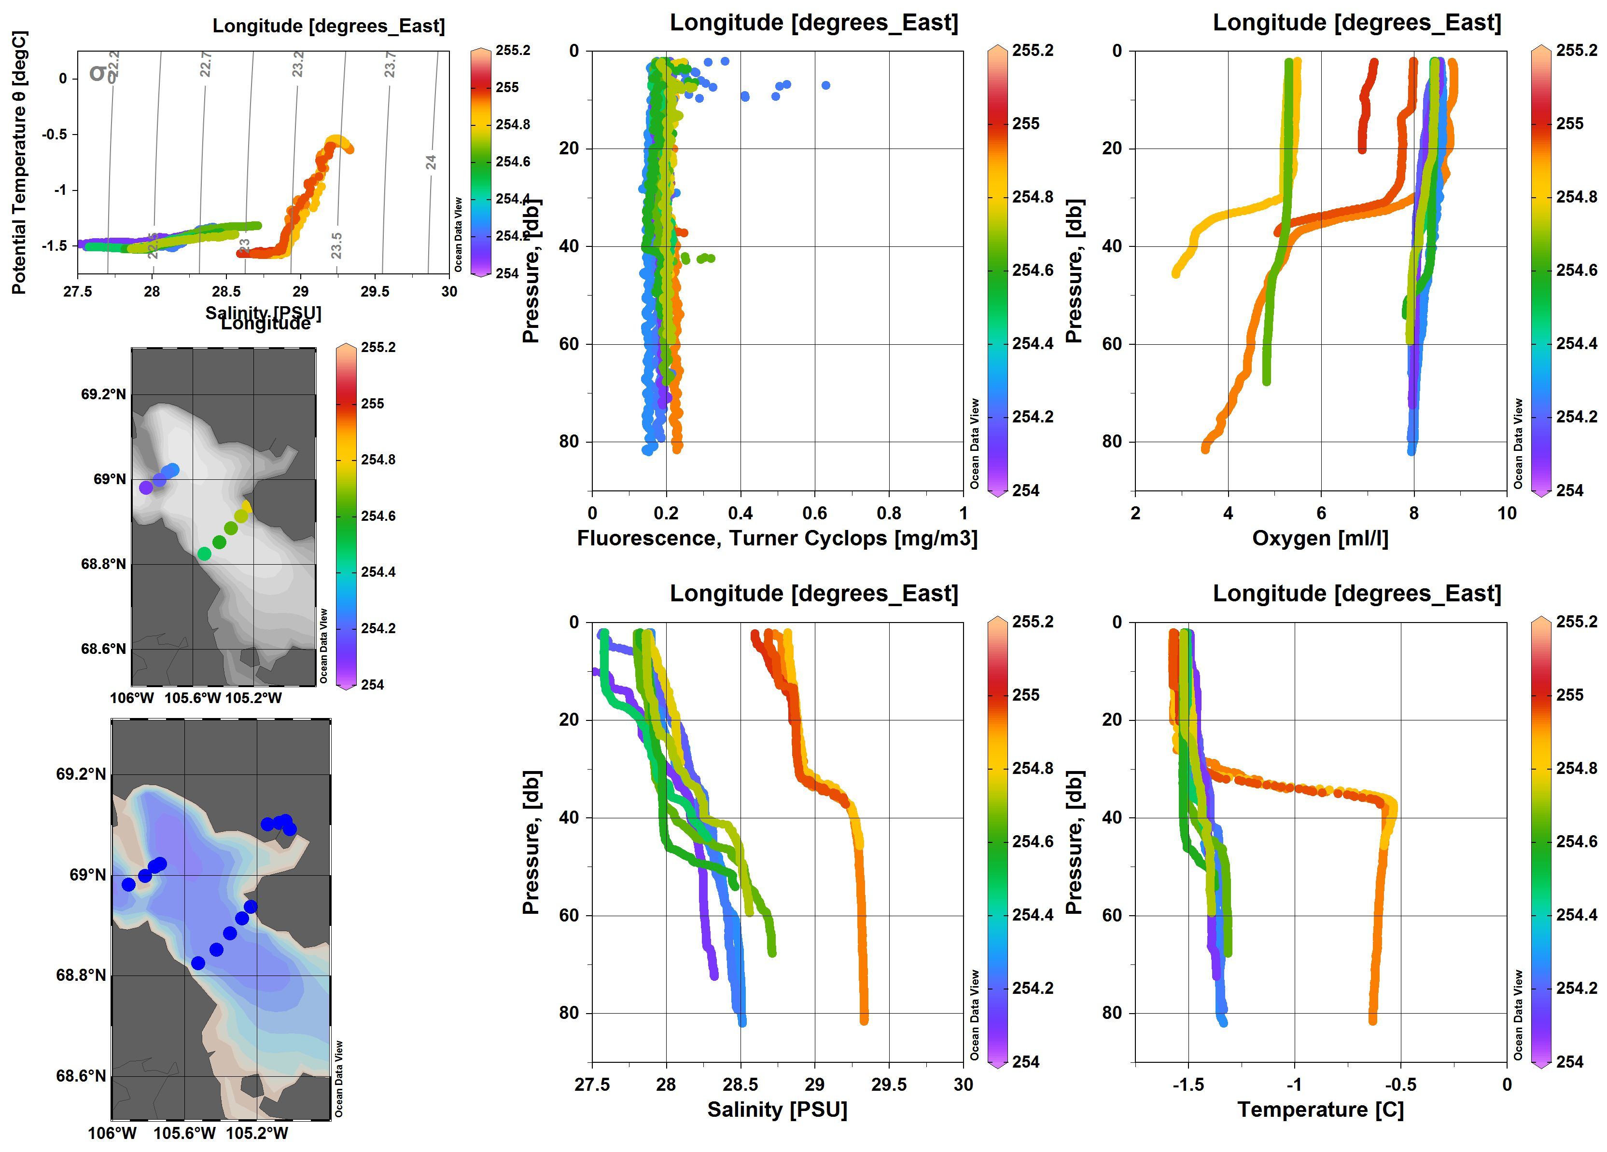

2019 Dease Strait Stations coloured by longitude

2019 Kugluktuk stations coloured by longitude

2019 Dease Strait by Kugluktuk patrol, stations coloured by longitude

2019 Paulatuk stations coloured by longitude

