**CTD Data Processing Notes**

**Sarah Zimmermann, IOS**

**02 May 2019**

**Updates:**

2019-05-27 Added Chem salt and DIC/Alk analysis notes

2019-05-28 Added nutrients data and text

2019-10-24 Processed Dophin and Union data set. Added processing summary for this, updated Program Summary text and in the IOS Archive CTD and Chem files.

**Missing/To do:**

O18 analysis text and data

CROW 2019-031

Contents

Program Summary: 1

Cambridge Bay 3

Kugluktuk 9

Paulatuk 12

Dolphin and Union Strait (Kugluktuk Patrol) May 2019 19

Preparation for IOS Archive 22

Extra Notes from the field and analysis: 23

# Program Summary:

There were three components to this program.

Leg 1, Mike Dempsey and Chris Clarke went to Cambridge Bay and Kugluktuk, traveling from March 5th to March 16th, 2019.

Leg 2 Mike Dempsey and Jane Eert went to Paulatuk from April 1 to April 10th, 2019

On these trips the participants met with Rangers for training and discussion of the program in anticipation of the Ranger’s upcoming patrol exercises. CTD casts were collected in each community.

The Kugluktuk patrol went out to Dolphin and Union Strait two months later and collected data. The data processing steps are discussed below.

5-11 March 2019 In Cambridge Bay (Chris and Mike)

11-16 March 2019 In Kugluktuk (Chris 11 to 14th, Mike 11 to 16th)

1-10 April 2019 In Paulatuk (Jane and Mike)

7 May 2019 Kugluktuk Patrol in Dolphin and Union Strait

For more information see the cruise report: ***CROW 2019 Report final v2019-10-23.docx***

G:\Sorted\myCROW\ODV\Figures - 2019\2019 all stations longitude v2019-04-10.tif

Figure 1. All stations conducted during program.

For more figures see:

2019-31 CROW data.pptx in

N:\SHARE\DATA\2019\2019-31 CROW\Data

# Cambridge Bay

***CTD Data:***

There are 13 stations in three data sets:

6 Mar 2019 Cambridge Bay 1 stations 065543_20190306_2159_data.txt

7 Mar 2019 Cambridge Bay 3 stations 065543_20190307_2356_data.txt

10 Mar 2019 UN Islands 4 stations included in next file

11 Mar 2019 Dease Strait 5 stations 065543_20190311_2052_data.txt

Meta data are recorded in:

N:\SHARE\DATA\2019\2019-31_CROW\Data

***Comments:***

1. CBay2 station shows freezing on first downcast, but the upcast and second cast are fine.
2. The RINKO oxygen looks good for the first station, CBay1, but following stations have lower surface saturation values.

Cbay2, Cbay6, West Arm range from 60 to 90%

The UN islands look good on March 10th with surface at ~98%

On March 11th, the first two stations DS18-01 and DS18-03 are down at 60% but the next 3 stations, located w/in these first two, are back at 98%.

Corrections were made to DS18-01 and DS18-03.

***Equipment: Calibration Dates***

RBR Concerto 65543 w/ 6Hz sampling rate 25 Jun 2018 (RBR) new

w/ Turner Cyclops Fluorometer sensor #2102849 15 Feb 2018 (3pt-check, IOS), Jan 2013 (new)

Fluorometer set for 0 to 5 ug/l range

w/ JFE Advantech RINKO III Oxygen sensor #5 28 Feb 2019 (2pt-cal, IOS), 25 Jan 2009 (new)

Type-A foil, Reporting in % Saturation

Air thermometer SN

Ice Auger# SN3

Downrigger# SN6

Kit # 4

***Data Collection Method:***

Follow protocol laid out in ***Ranger science manual ver7 2015.doc***

Changes to protocol:

Stations typically had a soak then two casts (RBR left in the water). This was changed for the last five stations (March 11th) to three casts per station.

***Processing:***

Calibration issues:

2-pt Oxygen calibration done at IOS prior to data collection.

New G and H terms are: -3.32946282 1.181996051 (RSK C0, C1)

Casts:

Using Matlab, the time v. pressure data were plotted and each direction of each cast was separated and given a cast number.

For each station, the best cast was kept, typically the last downcast (ie second or third).

|  |  |  |  |
| --- | --- | --- | --- |
| **Station** | **Name** | **Cast Number Used** | **File Name** |
| 1 | CBay1 | 3 (2nd downcast) | 065543_20190306_2159 |
| 2 | West Arm | 3 (2nd downcast) | 065543_20190306_2159 |
| 3 | Cbay2 | 7 (2nd downcast) | 065543_20190306_2159 |
| 4 | Cbay6 | 11 (2nd downcast) | 065543_20190306_2159 |
| **5** | AZFP | 3 (2nd downcast) | 065543_20190311_0250 |
| 6 | UN10 | 7 (2nd downcast) | 065543_20190311_0250 |
| 7 | UN20 | 11 (2nd downcast) | 065543_20190311_0250 |
| 8 | UN30 | 15 (2nd downcast) | 065543_20190311_0250 |
| 9 | DS18-01 | 21 (3rd downcast) | 065543_20190311_0250 |
| 10 | DS18-03 | 27 (3rd downcast) | 065543_20190311_0250 |
| 11 | DS18-05 | 33 (3rd downcast) | 065543_20190311_0250 |
| 12 | DS18-04 | 39 (3rd downcast) | 065543_20190311_0250 |
| 13 | DS18-02 | 45 (3rd downcast) | 065543_20190311_0250 |

Pressure:

The top 2m of data were removed from all casts. The top 2 m are influenced by proximity to the edge of the drilled ice-hole, the mix of water and ice slush. This can create falsely fresh water but also with and cooling during the cast further and beginning to freeze and reject brine this can create a density inversion along the TS freezing line.

The bottom 0.2m were removed due to poor data resulting from change of flow rate.

Temperature shift and new Salinity:

1. Applied 3 scan shift to advance temperature after confirming it was better than 2 scans.
2. Smoothed temperature and conductivity to recalculate new salinity. Conductivity smoothing only applied after first 30 scans to prevent overshooting from possible large surface salinity gradients.

Fluorometer

Processed using a low pass filter (pl66.m) with a half amplitude period of 10 scans.

Oxygen (RINKO)

RBR was configured to output percent oxygen saturation (and the unused concentration [mg/l]) and not volts. Calibration coefficients have been installed in the CTD.

Oxygen saturation was advanced by 3 seconds (18 scans) and oxygen

concentration [mL/L] was calculated as full saturation concentration

multiplied by percent saturation (DO [ml/l] = DO at full

saturation [ml/l] * %sat). DO at full saturation was calculated using

Garcia and Gordon (1992,1993) Eq.8 using coeefficients in column 1 from

Table 1 (fit to Benson and Krause (1984) data) and in situ temperature.

The final data set has the adjusted oxygen saturation and oxygen

concentration [mL/L].

REFERENCES:

Benson, B.B., and D. Krause, 1984: The concentration and isotopic

fractionation of oxygen dissolved in freshwater and seawater in

equilibrium with the atmosphere. Limnology and Oceanography, 29,

620-632.

Garcia, H.E., and L.I. Gordon, 1992: Oxygen solubility in seawater:

Better fitting equations. Limnology and Oceanography, 37, 1307-1312.

Garcia, H.E., and L.I. Gordon, 1993: Erratum: Oxygen solubility in

seawater: better fitting equations. Limnology and Oceanography, 38,

656.

Removed all pressure reversals

Interpolated to 0.2db bins. These are NOT centered.

Special edits:

Station Edit

2, 3, 4, 9, 10 Oxygen is lower than expected based on surrounding stations and prior years data. Typically the stations in the bay of Cambridge Bay are similar and those outside the bay are similar. Temperature and Salinity profiles overly on a T-S plot, but oxygen is variable. Oxygen was only adjusted for stations 2, 9 and 10 were it was clearly bad and oxygen recalculated..

2 (WestArm) Oxygen saturation adjusted +36% to match Station 1 (CBay1) (surface and at depth).

3 (CBay2) Oxygen saturation left as is. Surface value of 81% is -19% from Station 1.

4 (CBay6) Oxygen saturation left as is. Surface value of 91% is -9% from Station 1, but at depth it is only -2% from Station 1..

9 (DS18-01) Oxygen saturation adjusted +36% to match the other 7 stations outside the bay.

10 (DS18-03) Oxygen saturation adjusted +36% to match the other 7 stations outside the bay.

Saved this cleaned dataset to matlab *.mat file and an ODV *.o4x file

Used script file ***p_RBR_CROW_2019_CB1.m*** for processing stations 1.

Used script file ***p_RBR_CROW_2019_CB2.m*** for processing stations 2 to 4.

Used script file ***p_RBR_CROW_2019_CB3.m*** for processing stations 5 to 13

***Science:***

No chlorophyll signal yet.

***Suggestions:***

***Figures:***

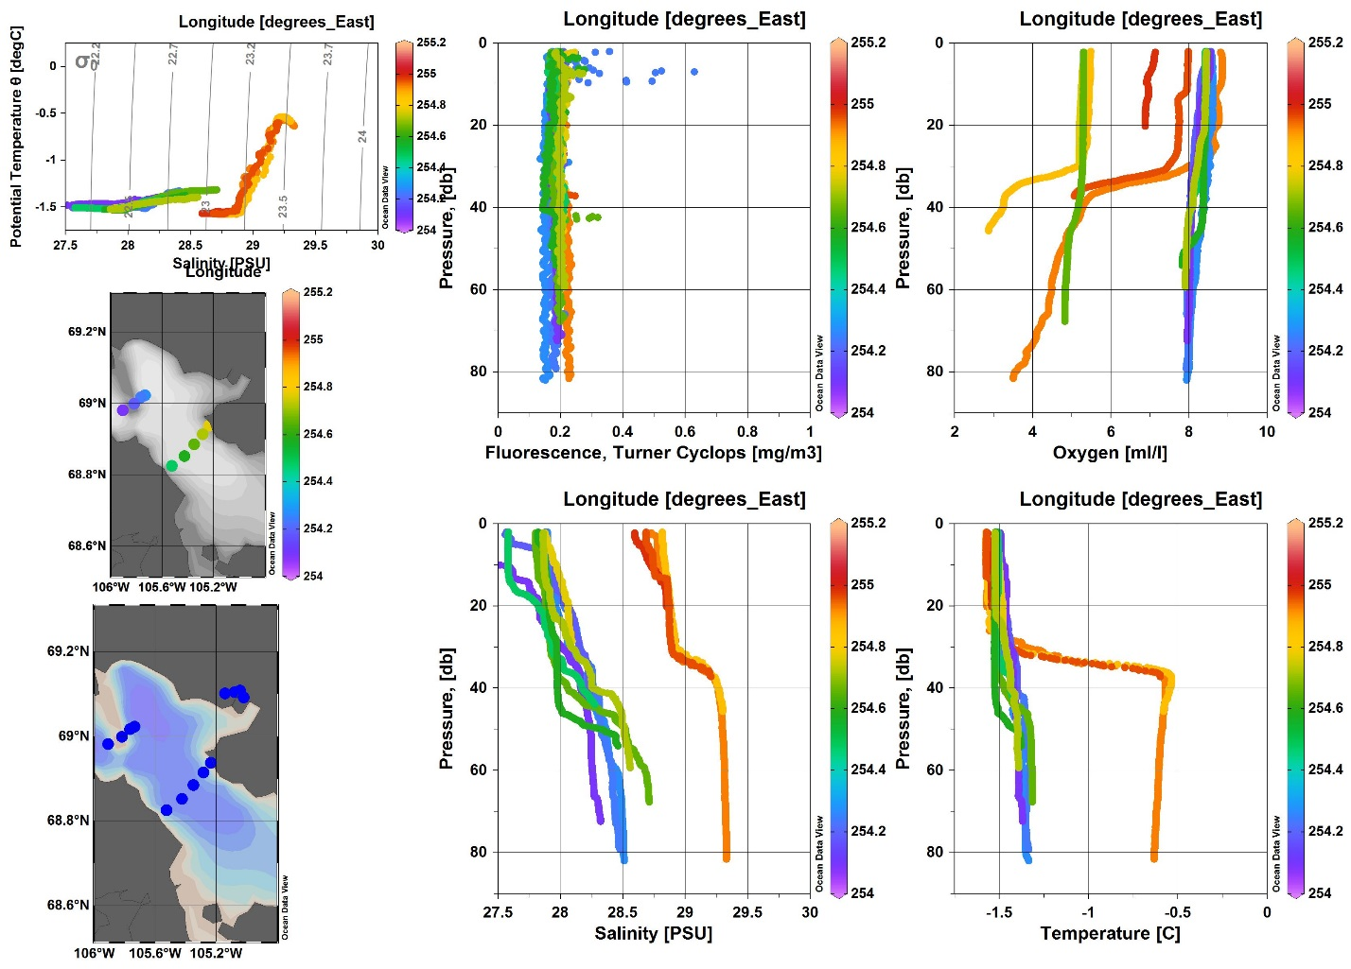

Figure 2. All stations with Cambridge Bay patrol, before oxygen correction

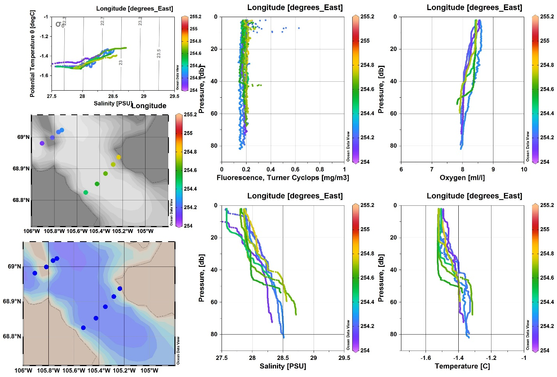

Figure 3. Just Dease St. and Unihitok , before oxygen correction

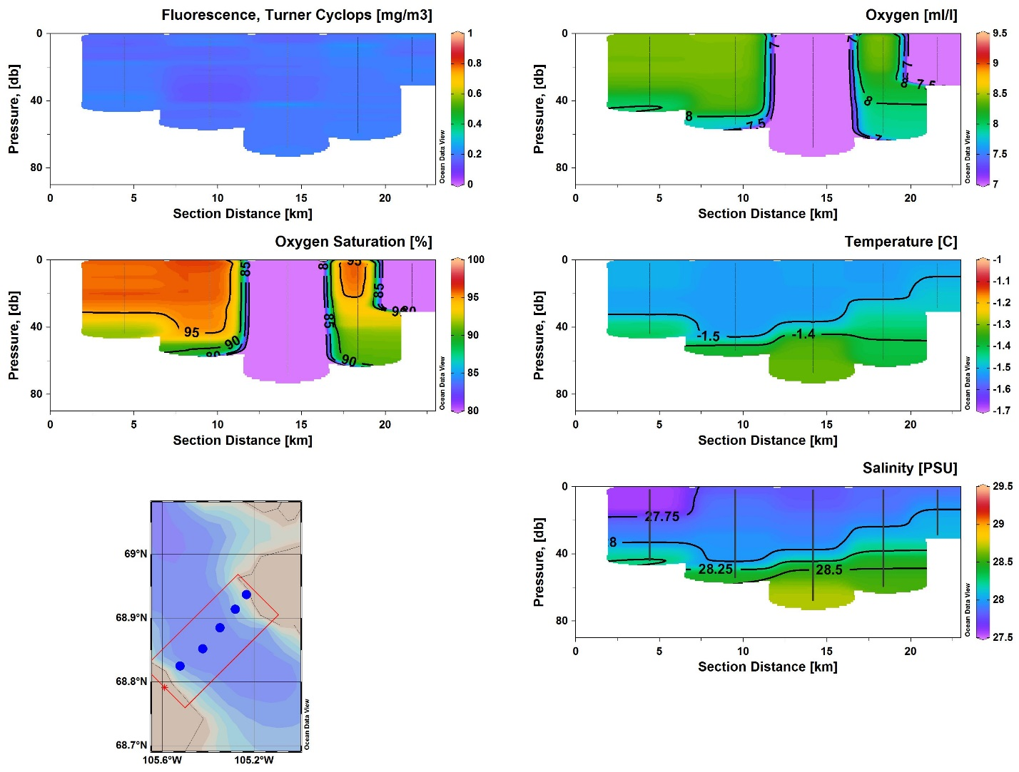

Figure 4. Dease St. Section, before oxygen correction

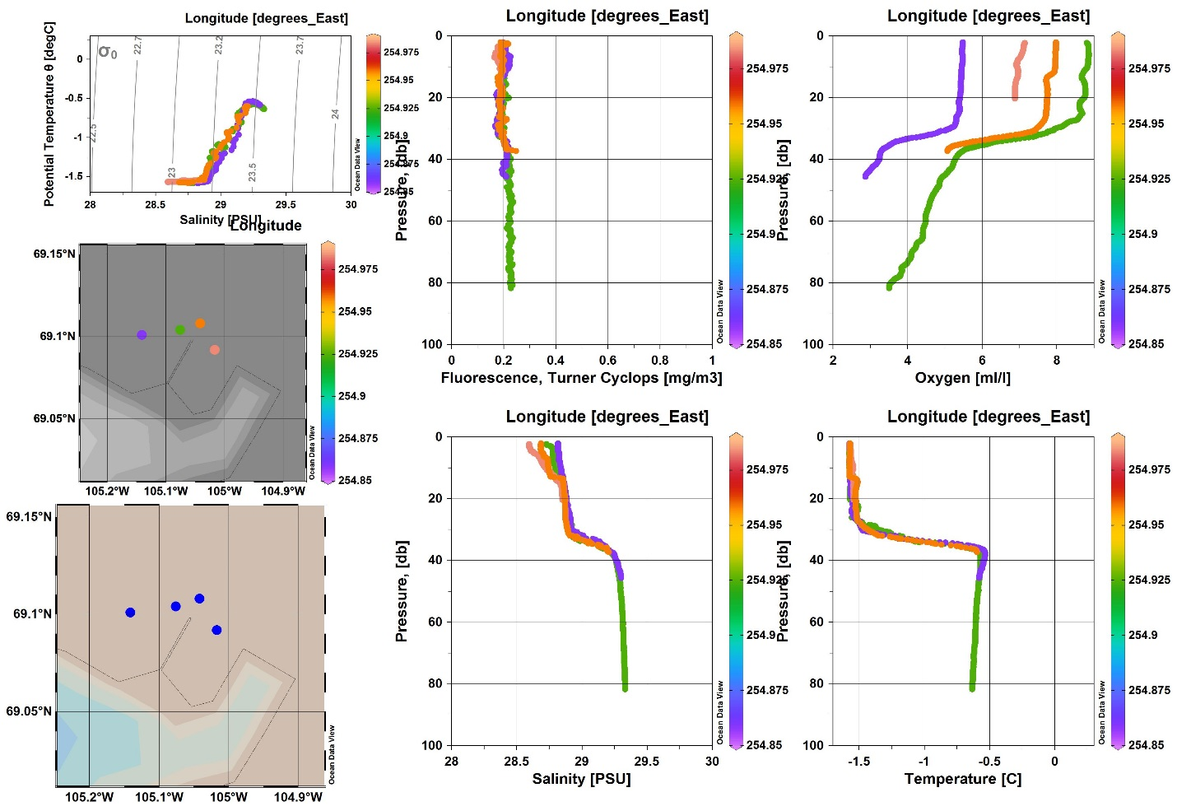

Figure 5. Just Cambridge Bay before oxygen correction

# Kugluktuk

***CTD Data:***

There are 3 stations in 1 data set:

13 Mar 2019 Kugluktuk Bay 3 stations 065579_20190313_2052.rsk

Meta data are recorded in:

N:\SHARE\DATA\2019\2019-31_CROW\Data

***Comments:***

It looks like the sensor may have frozen at the surface before each downcast. The CTD may be freezing a film of fresh water over the sensors as it is measuring the surface 2 to 3 m of fresh water.

Rinko oxygen data are low, 70% oxygen saturation, at 10m compared to all other years that are 92 to 102%. Unclear if this could be real. No correction made.

***Equipment: Calibration Dates***

RBR Concerto 65579 w/ 6Hz sampling rate 02 May 2016 (RBR), May 2013 (new)

w/ Turner Cyclops Fluorometer sensor #2102820 15 Feb 2018 (3pt check), Jan 2012 (new)

Fluorometer set for 0 to 5 ug/l range

w/ JFE Advantech RINKO III Oxygen sensor #323 12-Mar-2019 (2pt cal, in field),

Type-B foil, Reporting in % Saturation 10 Aug 2017 (new)

Air thermometer SN

Ice Auger SN

Downrigger #8

Kit #1

***Data Collection Method:***

Follow protocol laid out in ***Ranger science manual ver7 2015.doc***

Changes to protocol: Change from 2 to 3 casts for each station.

***Processing:***

Calibration issues:

2-pt Oxygen calibration was done in Kugluktuk prior to data collection.

New G and H terms are: 165.4348e-3, 1.1307522

Casts:

Using Matlab, the time v. pressure data were plotted and each direction of each cast was separated and given a cast number.

For each station, the best cast was kept:

|  |  |  |  |
| --- | --- | --- | --- |
| **Station** | **Name** | **Cast Number Used** | **File Name** |
| 14 | KUG-1 | 5 (3rd downcast) | 065579_20190313_2052 |
| 15 | KUG-2 | 11 (3rd downcast) | 065579_20190313_2052 |
| 16 | KUG-3 | 17 (3rd downcast) | 065579_20190313_2052 |

Pressure:

The top 2m of data were removed from all casts. The top 2 m are influenced by proximity to the edge of the drilled ice-hole, the mix of water and ice slush. This can create falsely fresh water but also with cooling during the cast, ice formation and brine rejection there can be a manufactured density inversion along the TS freezing line.

The bottom 0.2m of data removed from all casts. The very bottom data tends to have density inversion and/or spikes. This removes very little data but cleans up the profile.

Temperature shift and new Salinity:

1. Applied a 3 scan shift to advance temperature after confirming this was better than 2 or 4 scans.
2. Smoothed temperature and conductivity to recalculate new salinity. However, due to large surface gradient in salinity, the original conductivity was used for the first 30 scans as the filtered conductivity had artificial spikes due to the filtering ‘overshoot’.

Fluorometer

Processed using a low pass filter (pl66) with a half amplitude period of 10 scans.

Oxygen

The RBR CTD was configured to output percent oxygen saturation (and the unused concentration [mg/l]) from the oxygen sensor and not volts. Calibration coefficients have been installed in the CTD. Coefficients G and H, the ones determined with the regular 2-point calibration, are visible as C0 and C1.

Oxygen saturation was advanced by 3 seconds (18 scans) and oxygen

concentration [mL/L] was calculated as full saturation concentration

multiplied by percent saturation (DO [ml/l] = DO at full

saturation [ml/l] * %sat). DO at full saturation was calculated using

Garcia and Gordon (1992,1993) Eq.8 using coeefficients in column 1 from

Table 1 (fit to Benson and Krause (1984) data) and in situ temperature.

The final data set has the adjusted oxygen saturation and oxygen

concentration [mL/L].

REFERENCES:

Benson, B.B., and D. Krause, 1984: The concentration and isotopic

fractionation of oxygen dissolved in freshwater and seawater in

equilibrium with the atmosphere. Limnology and Oceanography, 29,

620-632.

Garcia, H.E., and L.I. Gordon, 1992: Oxygen solubility in seawater:

Better fitting equations. Limnology and Oceanography, 37, 1307-1312.

Garcia, H.E., and L.I. Gordon, 1993: Erratum: Oxygen solubility in

seawater: better fitting equations. Limnology and Oceanography, 38,

656.

The oxygen is lower than other years. All 3 stations have 72% oxygen saturation at 10m whereas 2011 to 2018 are all in the range of 92 to 102%. No changes were made at this time but it might make sense to adjust this (+20%) in the future.

Salinity

No edits

Removed pressure reversals

Interpolated to 0.2db bins, however these are NOT centered.

Saved this cleaned dataset to a matlab *.mat files and an ODV *.o4x file

***2019-31_CROW_Kug_cleandowncasts.mat*** and ***data_from_*** ***2019-31_CROW_Kug.txt***

Used script file ***p_RBR_CROW_2019_Kug.m*** for processing.

***Science:***

Clearly fresh river water was capping the 3 stations.

***Suggestions:***

***Figures:***

G:\Sorted\myCROW\ODV\Figures - 2019\2019 all stations Kug by long YR2019.tif

Figure 6. All stations w/ Kugluktuk patrol

# Paulatuk

***CTD Data:***

There are 8 stations, all with 3 or more casts per station in 2 data sets:

5 Apr 2019 Paulatuk, South West Darnley Bay 6 stations 065541_20190405_2348.rsk

7 Apr 2019 Paulatuk, Darnley Bay 2 stations 065639_20190408_0132.rsk

Both stations on 7 April have water samples

Meta data are recorded in:

N:\SHARE\DATA\2019\2019-31_CROW\Data

***Comments:***

The first CTD used had problems with external channels and there are no good oxygen and chlorophyll data for stations 1 to 6.

The next field-day used a different CTD with different external sensors. The second CTD had a few dropouts with these external channels at the start of the first cast, but as there were 3 or more casts per station, there was no problem in choosing a good cast without dropouts.

***Equipment: Calibration Dates***

RBR Concerto 65541 w/ 6Hz sampling rate 12 Mar 2018, Jan2013 (new)

w/ Turner Cyclops Fluorometer sensor #21100027 15 Feb 2018 (3-pt check, IOS), Feb 2017 (new)

w/ JFE Advantech RINKO III Oxygen sensor #9 04-Apr-2019 (2pt cal, in field),

Type- Afoil, Reporting in % Saturation 01 Jun 2009 (new)

RBR Concerto 65639 w/ 6Hz sampling rate 27 Mar 2018, Mar2014 (new)

w/ Turner Cyclops Fluorometer sensor #21100322 15 Feb 2018 (3-pt check, IOS), May 2017 (new)

Fluorometer set for 0 to 5 ug/l range

w/ JFE Advantech RINKO III Oxygen sensor #259 1 Mar 2018 (2pt cal, IOS), 24 May 2016 (new)

Type-B foil, Reporting in Volts 9 Apr 2019 (2pt cal, field) confirmed the

current values were good w/in 1 or 2%

Air thermometer SN

Ice Auger# SN

Downrigger# SN

Kit # SN

***Data Collection Method:***

Follow protocol laid out in ***Ranger science manual ver7 2015.doc***

Changes to protocol:

Added water sample collection by hanging one Niskin on the line and closing with a messenger.

Performed 3 casts per station instead of 2.

***Processing:***

Calibration issues:

RINKO III SN9 had a 2-pt oxygen calibration done in Paulatuk prior to data collection.

New G and H terms are: -3.530317,1.032586 (RSK terms C0 and C1)

However, there was some failure with this system and no oxygen data were collected.

RINKO III SN259 also had a 2-pt oxygen calibration the day after it was used for data collection. The calibration agreed within 1 to 2% of the prior (1 Mar 2018) calibration so no changes were made.

Casts:

Using Matlab, the time v. pressure data were plotted and each direction of each cast was separated and given a cast number.

For each station, the best cast was kept which was typically the last downcast (i.e. the third)

**List of Stations**

|  |  |  |  |
| --- | --- | --- | --- |
| **Station** | **Name** | **Cast Number Used** | **File Name** |
| 17 | CMPA2 | 3 (2nd downcast) | 065541_20190405_2348 |
| 18 | CMPA1 | 13 (3rd downcast) | 065541_20190405_2348 |
| 19 | CMPA4 | 19 (3rd downcast) | 065541_20190405_2348 |
| 20 | CMPA3 | 25 (3rd downcast) | 065541_20190405_2348 |
| 21 | CMPA5 | 29 (2nd downcast - deeper than next 2 casts) | 065541_20190405_2348 |
| 22 | CMPA6 | 39 (3rd downcast) | 065541_20190405_2348 |
| 23 | BPT_01 | 9 (4th downcast) | 065639_20190408_0132 |
| 24 | BPT_HC2 | 21 (3rd downcast) | 065639_20190408_0132 |

Pressure:

The top 2m of data were removed from all casts. The top 2 m are influenced by proximity to the edge of the drilled ice-hole with the mix of water and ice slush. This water mix can create falsely fresh water, also cooling during the cast can freeze surface water and reject brine creating density inversions along the TS freezing line.

The bottom 0.2m were removed due to poor data resulting from change of flow rate.

Temperature shift and new Salinity:

1. Applied 3 scan shift to advance temperature after confirming it was better than 2 scans.
2. Smoothed temperature and conductivity conductivity using a low pass filter (pl66) with a half amplitude period of 6 scans to recalculate new salinity. The conductivity smoothing was only applied after first 30 scans to prevent overshooting from possible large surface salinity gradients.

Fluorometer

Missing for first 6 stations due to CTD problems.

For the last two stations, processed using a low pass filter (pl66) with a half amplitude period of 10 scans.

Oxygen (RINKO)

Missing for first 6 stations due to CTD problems.

For the last two stations:

The RBR CTD was configured to output volts. The data were advanced by 3 seconds (18 scans). This is roughly a 1.5m offset at a typical lowering (and raising) speed of 0.5m/sec. This brings the oxygen data in line with temperature.

Factory coefficients A through F and the two determined from the 2-pt calibrations, coefficients G and H, were used to calculate oxygen saturation using RINKO’s provided script for Type-B foil sensors.

Oxygen concentration [mL/L] was calculated as full saturation concentration

multiplied by percent saturation ( DO [ml/l] = DO at full

saturation [ml/l] * %sat). DO at full saturation was calculated using

Garcia and Gordon (1992,1993) Eq.8 using coeefficients in column 1 from

Table 1 (fit to Benson and Krause (1984) data) and in situ temperature.

The final data set has the adjusted oxygen saturation and oxygen

concentration [mL/L].

REFERENCES:

Benson, B.B., and D. Krause, 1984: The concentration and isotopic

fractionation of oxygen dissolved in freshwater and seawater in

equilibrium with the atmosphere. Limnology and Oceanography, 29,

620-632.

Garcia, H.E., and L.I. Gordon, 1992: Oxygen solubility in seawater:

Better fitting equations. Limnology and Oceanography, 37, 1307-1312.

Garcia, H.E., and L.I. Gordon, 1993: Erratum: Oxygen solubility in

seawater: better fitting equations. Limnology and Oceanography, 38,

656.

Removed all pressure reversals

Interpolated to 0.2db bins.

Special edits:

Station Edit

**NA NA**

Saved this cleaned dataset to a matlab *.mat files and an ODV *.o4x file

***2019-31_CROW_Paulatuk1_cleandowncasts.mat***

***2019-31_CROW Paulatuk2_cleandowncasts.mat***

***data_from_2019-31_CROW_Paulatuk1.txt***

***data_from_2019-31_CROW_Paulatuk2.txt***

Used script file ***p_RBR_CROW_2019_Paul1.m*** for processing. Stations 1 to 6

Used script file ***p_RBR_CROW_2019_Paul2.m*** for processing. Stations 7 to 8

These both call ***p_RBR_generic_2019.m*** that uses ‘readtable’ to import data.

***Bottle data:***

At the last two stations, BPT_01, BPT_HC2, water samples were taken at 4 and 3 depths respectively. Depths were essentially at bottom, middle and near surface.

Samples were taken for Nutrients (Nitrate+Nitrate (NO3), Silicate(SiO4), Phosphate (PO4)), Dissolved Inorganic Carbon (DIC), Alkalinity, Oxygen Isotope (δ18O), and Salinity. All samples were collected in duplicate. The duplicate set of salinities may be used for other analysis such as Strontium.

A single 5L Niskin was attached to the line above the RBR CTD. The CTD was lowered to the desired depth, a “messenger” was attached to the line and released, closing the Niskin. The line was pulled up and the Niskin removed and sampled before being put back on the line for the next sample. Bottle depth was determined to be maximum CTD depth minus 1.5 m to account for the distance between Niskin and CTD sensors. The CTD data corresponding to the bottle depth was recorded in a spreadsheet along with the water sample chemistry.

Nutrients:

Nutrient samples were collected, unfiltered, in new 15 mL polystyrene tubes after rinsing 3 times with sample water and then frozen until analysis. Samples accidentally thawed during the flight back to the lab at IOS (1 day) and were refrozen at -20C until analysis. The samples had been with cold packs that had remained frozen so its expected the samples had not warmed much or for very long. Samples thawed for 2 hours at ~28C and let equilibrate to room temperature before analysis 14 May 2019 (5 week after collection). Analysis was performed on a Seal Analytical AA3 with corrections made for salt effects and to the certified reference material (CRM). CRM used was Kanso Lot CA and CD. All samples were taken in duplicate however one tube cracked (sample #5) and was not used. Samples had a precision, calculated as the Standard Pool, of:

NO3: 0.18 µM (n = 6, min = 5.34 µM, max = 8.65 µM)

SiO4: 0.37 µM (n = 6, min = 11.82µM, max = 18.81 µM)

PO4: 0.023 µM (n = 6, min = 1.093 µM, max =1.307 µM)

Salinity:

Salinity samples were collected into 200 mL type II glass bottles with screw caps and

disposable plastic inserts after rinsing 3 times with sample water. Samples were kept unfrozen and brought back to IOS for analysis. Samples were analyzed May 15, 2019 (5 weeks after collection) in a temperature-controlled lab on the Guildline AutoSalinometer Model 8400B (SN: 69086), which was standardized with IAPSO standard seawater, Batch #162, exp 20 May 2022. No replicates as second set of salinities may be run for a separate analysis. Removing 1 outlier, comparison with ctd (n=6): mean -0.002 PSU, standard deviation 0.004 PSU.

O18 Not analysed yet, below is draft text.

O18:

Oxygen Isotopes Samples were collected into 30 ml glass vials after rinsing 3 times with sample water. Once at room temperature, the caps were retightened and kept unfrozen until analysis. Samples were analyzed at Oregon State University using the Thermo DeltaPlusXL mass spectrometer connected to a H2O-CO2 equilibration unit. Samples were analyzed June to July 2010 (10 to 11 months after collection).

DIC and Alkalinity

DIC and Alkalinity were analysed out of the same sample. A glass 330ml (beer) bottle was rinsed three times and filled, head space given, poisoned with about 70ug powdered mercuric chloride and sealed with a metal crimp cap. Samples were kept cool (4C) until analysis at the Institute of Ocean Sciences. DIC was analysed using the VINDTA 84, a coulometer system. Dickson CRM batch 178 standard water was used. Alkalinity samples were analyzed using an automated potentiometric titration system with an open cell type and non-linear least squares endpoint determination for the total alkalinity measurement. Dickson CRM batch 173 standard water was used. Samples were analysed May 2, 2019, less than 4 weeks after collection. All samples had been collected in replicate.

Standard deviation of replicates after removing questionable sample #6:

DIC: 1.05umol/kg, n=6

Alkalinity: 1.60 umol/kg, n=6

Table 1. CTD data at bottle stops

|  |  |  |  |  |  |  |  |  |
| --- | --- | --- | --- | --- | --- | --- | --- | --- |
| **yyyy-mm-dd hh:mm** | **Station and Cast** | **Sample No.** | **CTDPres [dbar]** | **CTDTemp [ITS-90 C]** | **CTDCond [mS/cm]** | **CTDSalt [PSS-78]** | **CTDOxy [mL/L]** | **CTDFluo [mg/m3]** |
| 2019-04-07 | BPT-01 Cast 23 | 1 | 68.4 | -1.671 | 25.665 | 32.254 | 7.65 | 0.45 |
| 2019-04-07 | BPT-01 Cast 23 | 2 | 41.6 | -1.668 | 25.655 | 32.253 | 7.64 | 0.47 |
| 2019-04-07 | BPT-01 Cast 23 | 3 | 12 | -1.682 | 25.605 | 32.216 | 7.80 | 0.71 |
| 2019-04-07 | BPT-01 Cast 23 | 4 | 3.8 | -1.742 | 25.496 | 32.135 | 8.27 | 1.58 |
| 2019-04-07 | BPT-HC2 Cast 24 | 5 | 91.2 | -1.640 | 25.742 | 32.313 | 7.47 | 0.24 |
| 2019-04-07 | BPT-HC2 Cast 24 | 6 | 21.4 | -1.735 | 25.490 | 32.110 | 8.04 | 0.79 |
| 2019-04-07 | BPT-HC2 Cast 24 | 7 | 2.6 | -1.721 | 25.235 | 31.754 | 8.11 | 0.87 |

|  |  |  |  |  |  |  |  |  |  |  |  |  |  |  |  |  |  |
| --- | --- | --- | --- | --- | --- | --- | --- | --- | --- | --- | --- | --- | --- | --- | --- | --- | --- |
| **yyyy-mm-dd hh:mm** | **Station and Cast** | **Sample No.** | **CTDPres [dbar]** | **Salt** | **QF** | **NO3 [mmol/m3]** | **QF** | **SiO4 [mmol/m3]** | **QF** | **PO4 [mmol/m3]** | **QF** | **DIC [umol/kg]** | **QF** | **Alk [umol/kg]** | **QF** | **O18 [‰ VSMOW]** | **QF** |
| 2019-04-07 | BPT-01 Cast 23 | 1 | 68.4 | 32.26 |  | 7.80 | 6 | 17.38 | 6 | 1.282 | 6 | 2201.06 | 6 | 2278.50 | 6.00 |  |  |
| 2019-04-07 | BPT-01 Cast 23 | 2 | 41.6 | 32.26 |  | 7.55 | 6 | 16.89 | 6 | 1.255 | 6 | 2200.06 | 6 | 2279.03 | 6.00 |  |  |
| 2019-04-07 | BPT-01 Cast 23 | 3 | 12 | 32.21 |  | 6.88 | 6 | 15.47 | 6 | 1.212 | 6 | 2196.77 | 6 | 2269.37 | 6.00 |  |  |
| 2019-04-07 | BPT-01 Cast 23 | 4 | 3.8 | 32.14 |  | 5.34 | 6 | 12.28 | 6 | 1.093 | 6 | 2189.16 | 6 | 2288.52 | 6.00 |  |  |
| 2019-04-07 | BPT-HC2 Cast 24 | 5 | 91.2 | 32.32 |  | 8.65 |  | 18.81 |  | 1.307 |  | 2202.62 | 6 | 2269.48 | 6.00 |  |  |
| 2019-04-07 | BPT-HC2 Cast 24 | 6 | 21.4 | 32.11 |  | 6.10 | 6 | 13.44 | 6 | 1.147 | 6 | 2194.23 | 6,3 | 2375.61 | 6,3 |  |  |
| 2019-04-07 | BPT-HC2 Cast 24 | 7 | 2.6 | 31.83 |  | 5.47 | 6 | 11.82 | 6 | 1.101 | 6 | 2155.04 | 6 | 2251.59 | 6.00 |  |  |

Table 2. Chemistry at bottle stops.

***Science:***

***Suggestions:***

***Figures:***

Figure 7. In Paulatuk’s Darnley Bay. G:\Sorted\myCROW\ODV\Figures - 2019\2019 all stations Paulatuk by long v2019-04-10.tif

# Dolphin and Union Strait (Kugluktuk Patrol) May 2019

***CTD Data:***

There are 3 stations in 1 data set:

7 May 2019 Dolphin and Union Strait 3 stations 065579_20190910_2145.rsk

Meta data are recorded in:

N:\SHARE\DATA\2019\2019-31_CROW\Data

***Comments:***

The Kugluktuk Rangers went out in May and collected 3 stations across Dolphin and Union Strait.

***Equipment: Calibration Dates***

RBR Concerto 65579 w/ 6Hz sampling rate 02 May 2016 (RBR), May 2013 (new)

w/ Turner Cyclops Fluorometer sensor #2102820 15 Feb 2018 (3pt check), Jan 2012 (new)

Fluorometer set for 0 to 5 ug/l range

w/ JFE Advantech RINKO III Oxygen sensor #323 12-Mar-2019 (2pt cal, in field),

Type-B foil, Reporting in % Saturation 10 Aug 2017 (new)

Air thermometer SN

Ice Auger SN

Downrigger #8

Kit #1

***Data Collection Method:***

Follow protocol laid out in ***Ranger science manual ver7 2015.doc***

Changes to protocol: Had 2 casts for each station.

***Processing:***

Calibration issues:

2-pt Oxygen calibration was done in Kugluktuk back in March.

The G and H terms are: 165.4348e-3, 1.1307522

Casts:

Using Matlab, the time v. pressure data were plotted and each direction of each cast was separated and given a cast number.

For each station, the best cast was kept:

|  |  |  |  |
| --- | --- | --- | --- |
| **Station** | **Name** | **Cast Number Used** | **File Name** |
| 25 | DU1_2019 | 3 (2nd downcast) | 065579_20190910_2145 |
| 26 | DU2_2019 | 7 (2nd downcast) | 065579_20190910_2145 |
| 27 | DU3_2019 | 11 (2nd downcast) | 065579_20190910_2145 |

Pressure:

The top 2m of data were removed from all casts. The top 2 m are influenced by proximity to the edge of the drilled ice-hole, the mix of water and ice slush. This can create falsely fresh water but also with cooling during the cast, ice formation and brine rejection there can be a manufactured density inversion along the TS freezing line.

The bottom 0.2m of data removed from all casts. The very bottom data tends to have density inversion and/or spikes. This removes very little data but cleans up the profile.

Temperature shift and new Salinity:

1. Applied a 3 scan shift to advance temperature after confirming this was better than 2 or 4 scans.
2. Smoothed temperature and conductivity to recalculate new salinity. However, due to large surface gradient in salinity, the original conductivity was used for the first 30 scans as the filtered conductivity had artificial spikes due to the filtering ‘overshoot’.

Fluorometer

Processed using a low pass filter (pl66) with a half amplitude period of 10 scans.

DU2, Cast 7, interpolated chlorophyll data from 53 to 57 dbar to remove spike.

Oxygen

The RBR CTD was configured to output percent oxygen saturation (and the unused concentration [mg/l]) from the oxygen sensor and not volts. Calibration coefficients have been installed in the CTD. Coefficients G and H, the ones determined with the regular 2-point calibration, are visible as C0 and C1.

Oxygen saturation was advanced by 3 seconds (18 scans) and oxygen

concentration [mL/L] was calculated as full saturation concentration

multiplied by percent saturation (DO [ml/l] = DO at full

saturation [ml/l] * %sat). DO at full saturation was calculated using

Garcia and Gordon (1992,1993) Eq.8 using coeefficients in column 1 from

Table 1 (fit to Benson and Krause (1984) data) and in situ temperature.

The final data set has the adjusted oxygen saturation and oxygen

concentration [mL/L].

REFERENCES:

Benson, B.B., and D. Krause, 1984: The concentration and isotopic

fractionation of oxygen dissolved in freshwater and seawater in

equilibrium with the atmosphere. Limnology and Oceanography, 29,

620-632.

Garcia, H.E., and L.I. Gordon, 1992: Oxygen solubility in seawater:

Better fitting equations. Limnology and Oceanography, 37, 1307-1312.

Garcia, H.E., and L.I. Gordon, 1993: Erratum: Oxygen solubility in

seawater: better fitting equations. Limnology and Oceanography, 38,

656.

Unlike when the sensor was used in Kugluktuk in March, the oxygen saturation was back up from 72%saturation at 10m to 100% saturations.

Salinity

No edits

Removed pressure reversals

Interpolated to 0.2db bins, however these are NOT centered.

Saved this cleaned dataset to a matlab *.mat files and an ODV *.o4x file

***2019-31_CROW_KugDU_cleandowncasts.mat*** and ***data_from_*** ***2019-31_CROW_Kug.txt***

Used script file ***p_RBR_CROW_2019_Kug2.m*** for processing.

***Science:***

***Suggestions:***

***Figures:***

G:\Sorted\myCROW\ODV\2019 all stations D+U by longitude v2019-10-22.tif

Figure 6. Dolphin and Union stations w/ Kugluktuk patrol

# Preparation for IOS Archive

Use matlab scripts from Roy Hourston to convert *.mat files to IOS header format:

C:\Users\Zimmermanns\Documents\Gmatlab\IOSarchivescripts

C:\Users\zimmermannS\Documents\Gmatlab\fromRoyHourston

Use ***prntios_fmts_201931CROW_wrapper.m*** to cycle through the various CTD data sets within 2019-31 (ie Cambridge Bay, Kugluktuk, Paulatuk). This script has a list of the needed variables and file names and then calls the function ***prntios_fmts_201931CROW_single.m*** to write the CTD files.

Using ***prntios_fmts_201931CROW_single.m***

Keep all the variables up at the top to make it easy to change for each data set

Calls (input)

*.mat The processed data in structured array with one cast per station (ie keep best dip)

*.txt The processing information that will be loaded into the IOS Shell header

*.xls Create a page that is easy to pull sensor information from (and clear for Mike to write pre-CROW)

Writes one file per cast as is custom for IOS header format files.

Variables to archive:

Pressure, Depth, Temperature, Conductivity, Salinity, Oxygen %sat, Oxygen ml/l, Fluorometer

0.2 dbar intervals

Tried to follow standard IOS variable names, units and sig figs

Bottom depth was calculated as the max depth plus 5m based on typical cast protocol.

Cruise name changed from 2019-31 to 2019-031

The chemistry has been converted to CHE files and has water sample data as they are available.

For more tips see ***How to Archive CROW data v2019-04-29.docx*** (in *G:\Sorted\RBR_Processing\How to put in IOS Archive*)

# Extra Notes from the field and analysis:

Follow the oxygen processing trail…

1. Do g and h act on percent oxygen saturation and what is the formula? **YES**
2. Is RBR applying g and h to the percent oxygen saturation or only when calculating ml/l? **BOTH**
3. Can I get the same numbers or is something quite diff when I’m using the Garcia and Gordon formula? **YES it’s the same (see:**  *G:\Sorted\myCROW\Data\RINKOCalTest)*

How does Ruskin deli er oxy sat:

Cal terms in the CTD, Rinko is putting out volts and CTD converts.

CTD is set up for a specific RINKO sensor w/ its cal info.

If cal terms are in the RBR CTDs can Rinko be swapped btw CTDs?-NO SWAPPING w/out changing ALL Coef (Xs and C0 cnc C1)

What happens when Type A Rinko and Type B Rinko are swapped? – PROBLEMs Send your data to RBR and see if they can correct this.

**From:** Dempsey, Mike <Mike.Dempsey@dfo-mpo.gc.ca>   
**Sent:** 2019–April-08 8:13 PM  
**To:** Zimmermann, Sarah <Sarah.Zimmermann@dfo-mpo.gc.ca>  
**Cc:** Eert, Jane <Jane.Eert@dfo-mpo.gc.ca>  
**Subject:** RE: CROW log 2019

Hi Sarah,

Some background for the data files in Dropbox.

We had issues with CTD 65541. It was sent to RBR last year for updating to logger 3 mod. Unfortunately it was sent back with the default period set to 11 s. I didn't catch that at IOS before it was sent to Paulatuk last June. ( we had a similar experience in Kugluktuk with a new logger 3 mod. Heidi Swanson was using the CTD and it was stuck at 6s. Ryan Flagg was talking with her there and said he had seen the same problem and set up a Go To meeting with RBR to fix it.) The first file for 65541 which was Darcy Mcnicholl's winter sampling was done at this rate. There are also error7's ( no response received) on channel 4 (Chl a). The CTD had been set up for auto range on the fluorometer which I assumed caused the errors.

I had a Go To meeting with RBR and they set the rate option working again (it was greyed out). I tested it on the bench and did a fresh cal on the Rinko. It appeared to be ok so we used it on 5 April for CMPA1-6. The downloaded data has drop outs on the external channels 4 & 5 (fluor and DO).

we had brought CTD 65639 as a spare. It had been set up as a fast Fl/v with voltage only on channel 5.I tried to get RBR to change ch 5 to DO but they said that it would be a $1500 upgrade, so we used it with channel 5 as voltage only. As a result of this, we used 65639 with Rinko 259 and cyclops 32 2 on 7 April to BPT_01  and BPT_HC2.

RBR has since sent me an email saying they will modify all our remaining Concertos that have ch5 as voltage to DO at no cost as a "goodwill gesture" but will charge for any new orders. We have a Concerto at RBR right now that is being upgraded to logger 3 mod and it will have channel 5 changed to Rinko. Tomorrow early I have arranged a GoTo meeting to reset ch 5 to Rinko. After the GoTo meeting, I ill run a field cal in a bucket to calculate the latest G and H coefficients for Rinko 259.

The data from 7 April also has small drop outs on channel 4 & 5. I am bringing 65541 back for evaluation and repair. Depending on what we find out (possible external voltage card , firmware , other h/w problems, or???), we can swap out 65639 in Paulatuk with a fresh CTD when one is available.

Always interesting.

Thanks.

Mike