|  |  |
| --- | --- |
| Revision Notice Table | |
| **Date** | **Description of Revision** |
| July 24 2023 | Salinity hadn’t been recalculated after Shift. Re-ran from shift then re-converted Oxygen. SH |
| **July 2023, SH** | **Converted Oxgyen:Saturation to Oxgyen:Concenetration. Re-detected casts to capture upper layers missing in a few casts in the first processing. Re-processed using a different CLIP csv. Calibrated Pressure and changed the delete parameters. Manually removed bad data from the bottom of casts 1, 26, 34, 39, 71, 74, 75, 88, 89, 101.** |

**RBR CTD DATA PROCESSING NOTES**

Cruise: 2019-010

Agency: OSD

Locations: Vancouver Harbour

Project: Vancouver Harbour Survey

Party Chief: Roy Hourston

Platform: CME Anderson

Date: January 21, 2019- January 25, 2019

Processed by: Samantha Huntington

Date of Processing: September 29, 2021 – September 31, 2021

Number of Raw files: 129 Number of Processed Files: 129

**Instrument Summary**

Equipment: RBR Concerto CTD (s/n 66024) with a Turner Cyclops Fluorometer (s/n 848) and a JFE Advantech Rinko III oxygen sensor (s/n 300).

Sampling frequency was at 6Hz.

**Summary of Quality and Concerns**

A cast list was provided, Tap Log Export 20190125_corrected.csv as well as the Log Book 2019-010-logbook.pdf.

Many casts started below the surface at around 3m, those that started on the surface had some bad data at the surface.

**Processing Summary**

1. **Conversion to IOS Headers**

File 066024_20190125_1653.rsk contained 129 profiles, and profile csv files were extracted using python function READ_EXCELrsk(). Event numbers were assigned by matching the times and locations of the profiles with those in the logbook and cast list.

A single file (2019-010_CTD_Data.csv) with all the data including event numbers and a single line of headers was prepared using python function MERGE_FILES().

A 6-line header was inserted using python function Add_6Lineheader_2().

File “2019-010_header-merge.csv” was created, based on the information in ‘Tap Log Export 20190125_corrected.csv’.

* Column “File_Name”: entries were derived from the event number.
* Column “LOC:LATITUDE”: latitude was provided and reformatted to “XX XX.XXXX N !(deg min)”.
* Column “LOC:LONGITUDE”: longitude was provided and reformatted to “XX XX.XXXX W !(deg min)”.
* Column “LOC: Event Number”: entries were event numbers.
* Column “LOC: STATION”: stations were derived from the event numbers.

The sampling site was mapped (Figure 1) using from “2019-010_header-merge.csv” using python function Plot_Track_Location() to check the location of all casts.

Prior to conversion to IOS header format, the presence of zero-order holds were checked using Python function Plot_Pressure_Diff(). Zero-order holds were found (Figure 2.) and these values were replaced with Nan using the python function Correct_Hold().

A new csv file was created “2019-010_CSV_DATA-6Linedr_corr_hold.csv” and the corrected values were checked in python function Plot_Pressure_Diff(). Zero-order holds were found to be removed (Figure 3.).

CONVERT Spreadsheet Files was run to produce files with IOS Header format. Header entries of “Administration”, “File” and “Instrument” were filled in this step.

The routine “Merge:CSV Files to headers” was run to add location headers to the IOS files using file 2019-010_header-merge.csv.

Raw data were plotted and examined:

* Temperature looks OK with some bad data at the bottom of casts 110 and 111. The upcasts are noisy for casts 10, 11, 72, 97, 103 and 129. There some bad data at the bottom of casts 2, 26, 27, 39, 69, 73, 4, 76, 77, 88-91, 105, 120-122, 124-129.
* Salinity looks OK with some bad data at the top of casts 2 and 80 and the bottom of casts 1, 32, 54, 57, 68, 46-49, 105.
* Fluorescence looks OK.
* Oxygen has poor alignment with the upcast for the shallower casts. There is some bad data at the bottom of cast 57 and the top of casts 27, 87-92, 105, 120-122, 124-129.
* Conductivity looks ok with some bad data at the bottom of casts 1, 32, 54, 57, 68 and 69.

Next CLEAN was run to add a start time and event numbers to headers.

Then REORDER was run to reorder the channels in all files.

1. **Data processing**

* Correction to Pressure: although there were a few casts with some negative pressures at the surface, corresponding Conductivity measurements were not concerning , so pressure was not calibrated.
* Data despiking: There are no significant spikes in temperature, conductivity and salinity. So there is no need to apply data despiking.
* CLIP: While many casts began below the surface and the CTD descended immediately, some did show that Pressure is steady for a variable number of scans. In those cases initial records were removed until the downcast began using file “2019-010_CLIP.csv”.
* Filter: a Gull-winged filter, size 5, was applied to temperature, conductivity, and pressure. Salinity will be calculated in the next step.
* SHIFT: Based on suggested values in document “Guidelines for processing RBR CTD profiles”, the alignment of temperature and conductivity was corrected by applying a shift of -2 scans in conductivity.
* SHIFT: Better alignment with Oxygen profiles was found by advancing it by 11 scans. The advice given in document “Guidelines for processing RBR CTD Profiles” was that an advance between 2 and 3 seconds is appropriate. T-O plots before and after alignment were compared.
* DELETE was run only to remove swells.
* Profile plots were examined after DELETE and confirm that plots show reasonable values for salinity and conductivity and fluorescence.

1. **Final checks and header editing**

* REMOVE was run to remove the following channels from all casts: Date, Time:UTC and Event.
* BIN AVERAGE was used to metre-average data.
* CALIBRATE was run to convert conductivity units to S/m using file 2019-010-recal2.ccf.
* Header Edit was used to fix channel names and format as listed below:
* Pressure: format F11.2 ==> F7.1
* Salinity:CTD ==> Salinity
* Oxygen==> Oxygen:Dissolved:Saturation:RBR
* mL/L==> %
* Fluorescence ==> Fluorescence:URU
* F11.4==>F8.2
* Conductivity: F10.5 ==> F10.6
* CLEAN was run to reset the header Minimum and Maximum values.
* Header Check was run and no problems were found.

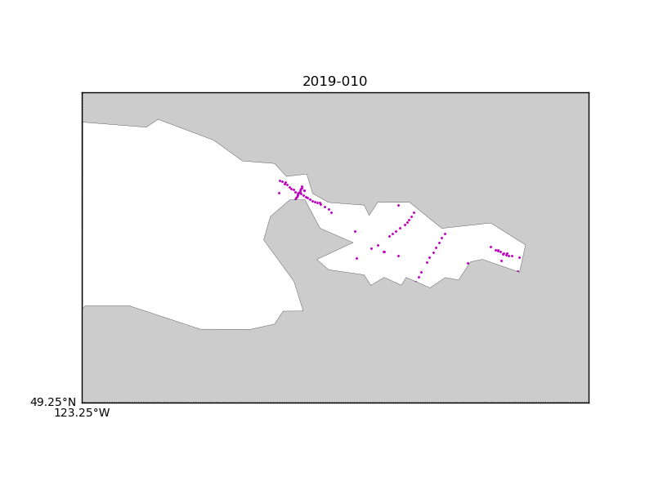

Figure 1 – location of casts.

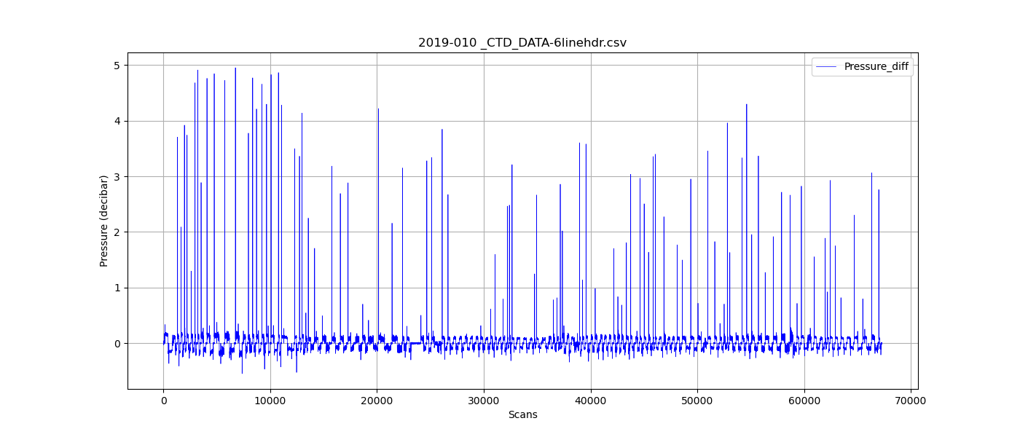

Figure 2 – zero-order holds

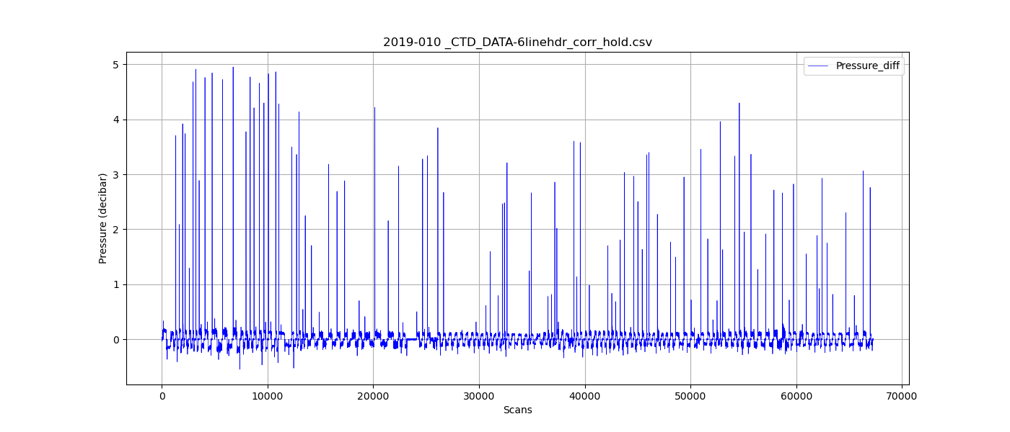

Figure 3 – zero order holds removed