REVISION NOTICE TABLE
DATE | DESCRIPTION OF REVISION
18 March 2025 | Updated channel names & formats in TOB & Loop files. GG & SH
5 Sept. 2024 | Added DOC/TOC data. SH
26 July 2024 | Added Cesium data to 10 casts. SH
19 March 2023 | Added HPLC data. J.R.
20 January 2021 | Transmissivity:Green was recalibration to correct an error in the original conversion. S.H.

PROCESSING NOTES
Cruise: 2019-008
Agency: OSD
Location: North-East Pacific
Project: Line P
Chief Scientist: Robert M.
Platform: John P. Tully
Date: 13 August 2019 – 29 August 2019

Processed by: Germaine Gatien
Date of Processing: 22 January 2020 – 24 March 2020
Number of original HEX files: 55 Number of CTD files: 54
Number of rosette files: 55 Number of bottle casts processed: 54
Number of original TSG files: 3 Number of processed TSG files: 15

INSTRUMENT SUMMARY
CTD #0506 was mounted in a rosette and attached were 2 Wetlabs CSTAR transmissometer (#1883DG & 1185DR), a SBE 43 DO sensor (#3234), a SeaPoint Fluorometer (#3640), a Biospherical QSP-400 PAR sensor (#70613) and an altimeter.

A thermosalinograph (SeaBird 45 S/N 0620) was mounted with a Wetlab/Wetstar fluorometer (WS3S-953P) and flow meter.
Seasave version 7.26.7.107 was used for acquisition.
The data logging computer was the Tully Laptop - Silver.
The deck unit was a Seabird model 11+ #425.
A Guildline model 8400B Autosal serial # 68572 was used to analyze salinity samples.
An IOS rosette with 24 10L bottles was used.

SUMMARY OF QUALITY AND CONCERNS
The Daily Science Log Book and rosette log sheets were in excellent order with comments about problems encountered. Sampling notes were provided by the Chief Scientist which are a great help in processing data.

It was noted at sea that there were problems with the sounder underestimating water depths by up to 20m. However, some of the shallower casts had an overestimate. Changes were made to water depth for some casts based on the sum of the maximum depth sampled plus the altimetry header value. While the altimetry was often noisy at the bottom, values appear to be within ±2m.

There were 2 WetLabs CStar transmissometers in use during this cruise:
Channel Transmissometer refers to sensor #1883DG (530nm - green)
Channel Transmissometer2 refers to sensor #1185DR (650nm - red)
For comparison with other Institute of Ocean Sciences cruises, note that the transmissometer wavelength is 650nm unless otherwise stated.

There was much confusion about which transmissometer was mounted on which voltage. It was noted in the log during cruise 2019-069 that the two sensors were not in the order given in the configuration file and log book. At the end of that cruise the 2 sensors were reversed in position on the CTD. Cruise 2019-008 was the next cruise using the equipment but the log and configuration files do not reflect the switch done at the end of the previous cruise and data look wrong using the con file used at sea. For the next cruise, 2019-023, the log and configuration files are in agreement with the reported configuration at the end of 2019-069. This highlights the need to actually examine the CTD before making entries in the log.

While CTD fluorescence data are expressed in concentration units, they do not always compare well to extracted chlorophyll samples. It is recommended that users check extracted chlorophyll values where available.

The SBE DO sensor has a fairly long response time so data accuracy is not as high when it is in motion as it is during stops for bottles. This will be especially true when vertical DO gradients are large. To get an estimate of the accuracy of the SBE DO data during downcasts (after recalibration) a rough comparison was made between downcast SBE DO and upcast titrated samples. Some of the difference will be due to problems with flushing of Niskin bottles and/or analysis errors and mismatches in small mismatches in depth in the presence of large DO gradients, so the following statement likely underestimates SBE DO accuracy.

Downcast (CTD files) Oxygen:Dissolved:SBE data for this cruise are considered, very roughly, to be:
±0.5 mL/L from 0 to 100db
±0.2 mL/L from 100db to 400db
±0.08 mL/L below 400db

There were many problems with the TSG data. The position data were corrupted and data from other ship files had to be manipulated to provide location information. The fluorescence signal was unusually smooth. The conductivity sensor had begun to drift significantly before this cruise and the cell was replaced during servicing in January 2020.

Comparisons were made between the TSG data and co-incident CTD casts, rosette samples and loop samples. The comparisons indicate that the intake temperature was high by about 0.007C°. Recalibration was applied to the salinity channel based on a fixed offset from August 15 to August 21 and a linear fit for August 22 to August 27. The salinity is given with only 3 decimal places to reflect the large differences and the uncertainty in the calibration method. The error in this correction could be up to 0.02psu for August 22 to August 24 as there were no CTD casts or loop samples from that period. The comparison of TSG fluorescence with CTD fluorescence shows no obvious correspondence between the them. Comparisons with rosette chlorophyll also show no trend so that recalibration was not attempted. The fluorescence channel was removed from all casts.

PROCESSING SUMMARY

Seasave
This step was completed at sea; the raw data files have extension HEX.

Preliminary Steps
The Log Book and rosette log sheets were obtained.
- Nutrients, extracted chlorophyll, dissolved oxygen, salinity, DMS and DMSP data were obtained in QF spreadsheet format from the analysts.
- The cruise summary sheet was completed.
- The histories of the pressure sensor, conductivity and dissolved oxygen sensors were checked. Since their last calibration most of these sensors have been used on 10 previous casts (just 9 for the DO sensor).
- There were 2 transmissometers mounted on the CTD. For several previous cruises the configuration file did not match the way the sensors were actually mounted. After cruise 2019-069 the mounting was adjusted. Unfortunately, it appears someone else reversed the configuration files in order to fix the problem. Doing both adjustments just led to a new version of a bad match. So the configuration files had to be adjusted so that the DG sensor was listed first.
- The calibration control files were checked. The configuration changed after event #8 as the fluorometer gain was adjusted. So 2 files are needed and were saved as 2019-008-ctd1.xmlcon and 2019-008-ctd2.xmlcon.

BOTTLE FILE PREPARATION
The ROS files were created using files 2019-008-ctd1.xmlcon for events 1-8 and 2019-008-ctd2.xmlcon for events 10 to the end. Depth was included.
The ROS files were converted to IOS format.
The IOS files were put through CLEAN to create BOT files.

Events 92 and 93 were part of a single CTD cast. At this point the BOT files for events 92 and 93 were renamed as 92.bota and 92.botb and JOIN was used to create a single file named 2019-008-0092.bot that contains the data from both parts of the cast. The file was opened in Ultraedit so that the bottle numbers could be corrected to match the rosette log.

The dissolved oxygen signal was examined for event #17 because it was noted in the log that the DO looked odd around 600db and was likely to have affected the data collected during the bottle stop. Close examination of the BOT file and comparison of upcast and downcast profiles confirm that the DO data were bad during the 600db bottle. The data were padded using a graphical editor. The bottles above and below look ok.

Temperature and salinity were plotted for all BOT files to check for outliers. A few casts were opened in
CTDEDIT and one or both salinity channels were cleaned in casts 12, 23, 53, 73 and 84.
The output files from both salinity and DO editing were copied to *.BOT.
A preliminary header check was run and no problems were found.

The BOT files were bin-averaged on bottle number.
The output was used to create file ADDSAMP.csv. First, the file was sorted on event number and Bottle Position order. Then sample numbers were added based on the rosette logs.
The file was used to add sample numbers to the BOT files – output *.SAM.
The SAM files were bin-averaged on bottle # and called SAMAVG.
For each of events #27 and 91 one bottle with no sample number was removed and the number of records in the file was adjusted.

The addsamp.csv file was converted to CST files, which will form the framework for the bottle files.

Next, each of the analysis spreadsheets were examined to see what comments the analysts wanted included in the header file. These were used to create file 2019-008-bot-hdr.txt which will be updated as needed during processing.

DISSOLVED OXGYEN
Dissolved oxygen data were provided in spreadsheet QF 2019-008 OXY*.xlsx which includes flags, comments and a precision study. Draw temperatures are available. The spreadsheet page with the final data was simplified and saved as 2019-008oxy.csv. That file was converted into individual *.OXY files.
At this point note was made of all comments in the DO file that had comments starting with “ALL:”. The rosette sheets were checked to note what other samples were taken from the same bottle so the flags will be applied to all samples from the other csv files that are affected by the DO analysts observation.
EXTRACTED CHLOROPHYLL
Extracted chlorophyll and phaeo-pigment data were obtained in file 2019-008 CHL QF*.xlsx. The file included comments and flags and a precision study. A simplified version of the spreadsheet was prepared and saved as 2019-008chl.csv. Flags were changed to 3 for 2 bottles noted as ALL by the DO analyst. The csv file was then converted to individual CHL files.
SALINITY
Salinity analysis was obtained in file QF2019-008SAL.xlsx which included a precision study. The analyses were carried out in a temperature-controlled lab 13 to 25 days after collection. The files were simplified and saved as 2019-008sal.csv. That file was then converted to individual SAL files.
NUTRIENTS
The nutrient data were obtained in spreadsheet NUTS_QF2019-008*.xlsx. This includes a precision study. The file was simplified, saved as 2019-008nuts.csv and converted to individual NUT files.
The flags were changed to 3 for the samples noted by the oxygen analyst as having a problem that would affect all samples.
DMS
DMS data were obtained in spreadsheet DMS summary (2019-008).xls. Details on analysis are in file 2019-008 DMS report.doc which includes duplicate analysis. The file was sorted on sample #. Values < were changed to 0. This file was converted to DMS files.
DMSP
DMSP data were obtained in spreadsheet 2019-008 dmsp QF summary.xls. The comments from DMSP-D and DMSP-T were combined in a single column. This file was simplified by removing blank lines, sorted on sample # and converted to DMSP files.

The SAL, CHL, OXY, NUT, DMS and DMSP files were merged with CST files in 6 steps.
After the 6th step the files were put through CLEAN to reduce the headers to File and Comment sections only.
The files were then put through CLEAN to reduce the headers to File and Comment sections only.
These files are ordered on sample number, but the SAMAVG files are ordered on bottle number, so one or the other set needs to be reordered in order to merge them. The MRGCLN1 files were reordered on Bottle_Number and saved as *. MRGCLN1s.
The MRGCLN1s files were then merged with SAMAVG files using merge channel Bottle_Number.
File 2019-008-0030.samavg needed rearranging on sample number before the merge would work.

The output of the MRG files were exported to a spreadsheet and compared to the rosette log sheets to look for omissions. The only discrepancy was that event #91 had incorrect sample numbers for the DMS data. The original file had sample numbers and Niskin numbers reversed. That was fixed the merge process rerun.

Compare
Salinity
Compare was run with pressure as reference channel.

There is a lot of scatter in the fits, but if data above 100db are excluded the fits are reasonably flat. When 2 obvious outliers were also excluded the primary salinity is found to be low by an average of 0.0083psu and the secondary low by 0.0004psu. The standard deviation in both channels was 0.0010psu. The difference between the 2 results is slightly lower than the differences between channels during downcasts as reported in section 9. This may imply that some of the downcast difference is due to minor differences in sensor alignments.

There were 2 outliers:
- Sample 398 from event #55 at 3499db. The CTD data have low variability during the 10s window and during the whole stop. There is no sign of shed wakes or instrumental noise. There were 2 bottles fired at that depth. From the first there were duplicates (34.6651 and 34.6736 for an average of 34.6693) and from the second a single sample (34.6653). The duplicate samples differ by 0.0085 but were not found to be Chauvenet outliers. The second firing has a bottle value in line with the general fit. There is no note of any problem during collection or analysis.
Sample 398 was listed twice on the QF page with the first flagged as being the average of duplicates but actually being the result for 398b. The second entry had the 398a value.
Sample 398b is in line with 399 (34.6653) which came from a second bottle at the same depth.
Sample 398a has a value higher than the maximum salinity in the full CTD profile, 34.6685psu for the secondary which is believed to be the more accurate channel.
Two corrections were made – removing one entry for #398, choosing the b sample and flagging the entry as 2.

- Sample 716 from event 90 at 1999db. There was no flag on the sample and the CTD data have low variability during the 10s window and during the whole stop. There is no sign of instrumental noise. The descent rate is very noisy and there are signs of shed wakes, but not large enough to explain a difference of ~0.1psu. The value is too low to be from the 2500db bottle so a miss-sample seems unlikely. Poor flushing also seems unlikely as the descent rate was very noisy. Other samples do not look out of line. A flag 3 was added.

A fit against time shows differences growing with time for both sensors, but that change is larger in the primary salinity. However, if P8 is excluded the changes are much flatter. Having different depths of sampling for different casts can lead to misinterpretation. When only bottles from 3000db were plotted the differences got smaller with time. When 1800-3200db bottles are included they get larger. There is too much scatter to read a lot into these results.
For full details for the COMPARE run see file 2019-008-sal-comp1.xls.

Dissolved Oxygen
COMPARE was run with pressure as the reference channel.
When outliers were removed based on residuals the fit was:
CTD DO Corrected = CTD DO * 1.0348 + 0.0182
This is close to the fits found the last 3 times this sensor has been used.

Outliers were investigated. Samples flagged by the analyst with a 3 or 4 were studied as well as outliers from COMPARE:
- Event 1, sample 4 – flagged 36. Not an outlier. The CTD shows the DO values to be ~0, so the lower of the duplicates is more likely. The evidence is strong enough to change the value/flag.
- Event 1, sample 12 – supposed to be duplicate samples but only one labelled as 12. Sample 13 looks out of line with that ID so likely mislabeled and is the really 12b.
- Event 1, sample 13 – this sample looks like the missing duplicate for bottle 12. Way off in COMPARE. Looks close to 75m samples. Nutrients look fine, so not a misfire. Good fit for bottle 12, b sample. Bottle 12 was supposed to have duplicates and only 1 was found so this makes sense.
- Event 1, sample 14 – the b sample is much better fit than the a sample. The other sample is likely from bottle 13, sample 13.
- Event 17, sample 90 – not an outlier – looks ok
- Event 17, 600m -problem in CTD DO. Bottle sample likely fine.
- Event 28, sample 202 – only slightly out of line and, if anything, sample value is low. A flag 3 might be more appropriate.
- Event 39, none of the samples stood out as significant outliers.
- Event 55, samples 403 and 412 look ok.
- Event 71, sample 536 does look too high – out of line but not by a lot.
- Event 71, sample 540 was slightly out of line, but did not look high.
- Event 71 sample 555, was a bit out of line. Sample a (6.617) is a better choice than b.
- Event 90, sample 734 looks too high but at 4m this could be because the Niskin was higher than the CTD, so not completely clear.
- Event 101 – all looked ok.
- Event 117, sample 886 was slightly out of line – both values looks a little low.
The analyst agreed with the recommended changes.

A hysteresis check was done by comparing differences above and below 1000db. The deeper values were in line with shallower ones in the same DO range, though there are outliers on both sides of the fit.

Plots of Titrated DO and CTD DO against CTD salinity were examined. No further outliers were found.

Fluorescence
COMPARE was run with extracted chlorophyll and CTD Fluorescence using pressure as the reference variable.

The ratio of FL/CHL versus CHL had the shape typical of these sensors with fluorescence much higher than CHL for low CHL values and then dropping to lower ratios as CHL rises. Most of the CHL samples had very low values and the ratio is not reliable when comparing small numbers. For FL>2 the ratios are lower than usual at 0.4 to 0.63.
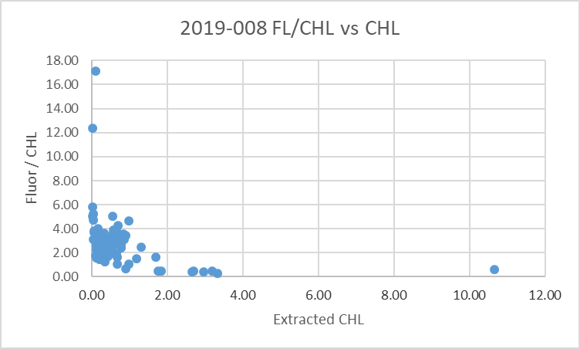
The points in a fit of fluorescence against CHL falls into 2 groups. For CHL>2 the slope is about 0.57 if the origin is forced to =0.
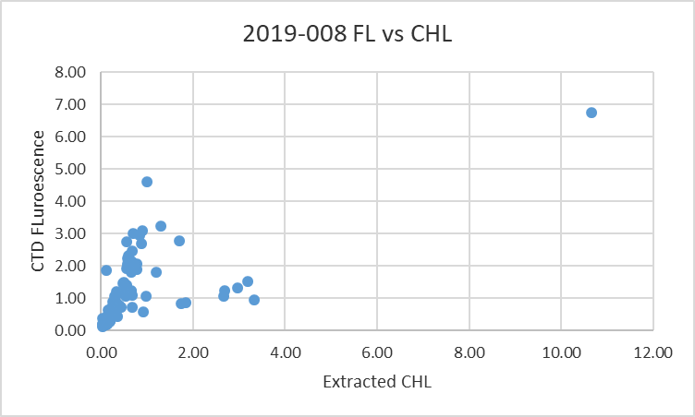

Conversion of Full Files from Raw Data
Files #1-8 were converted using 2019-008-ctd1.xmlcon and #10-117 using 2019-008-ctd2.xmlcon. The Tau function and the hysteresis function were selected since there was deep sampling. Depth was included in the conversion.
A few casts were examined and all expected channels are present. The T and C pairs were reasonably close during downcasts with upcasts quite noisy, as usual. There were some odd feature sin cast #39 but they looked similar in both channels and both up and down. Fluorescence, PAR and Dissolved Oxygen profiles looked normal. The “Green” transmissometer was generally higher than the “Red”; the profiles had similar shapes. The altimetry looked fine near the bottom.

WILDEDIT
Program WILDEDIT was run to remove spikes from the pressure, depth, conductivity & temperature only in the full cast files (*.CNV).
Parameters used were: Pass 1 Std Dev = 2 Pass 2 Std Dev = 5 Points per block = 100
The parameter “Keep data within this distance of the mean” was set to 0 so all spikes would be removed.

ALIGN DO
A few casts were examined; both temperature channels were noisy during upcasts so the tests were not easy to interpret, but using +2.5s certainly improves the alignment and overall looks like a good choice for both sensors. That setting has worked well for many SBE DO sensors in recent years.
ALIGNCTD was run on all casts using +2.5s.

CELLTM
The noise in the upcast data makes tests for the best parameters for this routine very difficult to interpret. In the past when upcast data were not so noisy, the default setting of (α = 0.0245, β=9.5) was generally found to be the best choice. A few casts were checked for this cruise and the default setting does improve the data. CELLTM was run using (α = 0.0245, β=9.5) for both the primary and secondary conductivity.

DERIVE and Channel Comparisons
Program DERIVE was run on all casts to calculate primary and secondary salinity and dissolved oxygen concentration.

DERIVE was run a second time on 3 of the deeper casts to find differences between the pairs of temperature, conductivity and salinity channels. Lines highlighted in grey are from other cruises using the same equipment before and after this one.
Cast # | Press | T1-T0 | C1-C0 | S1-S0 | Descent Rate
2019-005-0051 | 1000 | -0.0010 | +0.00015 | +0.0028 | High, V.Noisy
“ | 1900 | -0.0006 | +0.00015 | +0.0025 | “
2019-005-0159 | 1000 | -0.0009 | +0.00020 | +0.0034 | F.High, Noisy
“ | 1900 | -0.0007 | +0.00018 | +0.0030 | “
2019-006-0032 | 1000 | -0.0007 | +0.00025 | +0.0040 | High, XNoisy
“ | 1900 | -0.0004 | +0.00025 | +0.0035 | “
“ | 2900 | -0.0003 | +0.00026 | +0.0035 | “
2019-006-0077 | 1000 | -0.0007 | +0.00021 | +0.0032 | High, XNoisy
“ | 1900 | -0.0004 | +0.00021 | +0.0030 | “
“ | 2900 | -0.0006 | +0.00021 | +0.0030 | “
 | 3900 | -0.0005 | +0.00022 | +0.0032 | “
2019-014-0002 | 1000 | -0.0008 | +0.00028 | +0.0040 | High, Noisy
“ | 1900 | -0.0003 | +0.00028 | +0.0035 | “
“ | 2500 | -0.0002 | +0.00030 | +0.0048 | “
2019-014-0033 | 1000 | -0.0009 | +0.00034 | +0.0048 | High, Noisy
“ | 1900 | -0.0005 | +0.00033 | +0.0044 | “
“ | 2500 | -0.0002 | +0.00032 | +0.0043 | “
2019-014-0049 | 1000 | -0.0009 | +0.00034 | +0.0050 | High, V.Noisy
“ | 1900 | -0.0003 | +0.00033 | +0.0045 | “
“ | 2500 | -0.0004 | +0.00033 | +0.0045 | “
2019-069-0030 | 1000 | -0.0004 | +0.00041 | +0.0054 | High, Noisy
“ | 1900 | -0.0003 | +0.00040 | +0.0052 | “
2019-069-0051 | 1000 | -0.0009 | +0.00041 | +0.0059 | High, F Noisy
“ | 1900 | -0.0004 | +0.00039 | +0.0053 | “
2019-008-0016 | 1000 | -0.0009 | +0.00063 | +0.0085 | High, F. Noisy
 | 1900 | -0.0004 | +0.00060 | +0.0078 | “
2019-008-0048 | 1000 | -0.0008 | +0.00064 | +0.0085 | High, Noisy
 | 1900 | -0.0004 | +0.00064 | +0.0082 | “
 | 2900 | -0.0004 | +0.00064 | +0.0082 | “
2019-008-0090 | 1000 | -0.0005 | +0.00068 | +0.0088 | High, X Noisy
 | 1900 | -0.0004 | +0.00068 | +0.0086 | “
 | 2900 | -0.0004 | +0.00069 | +0.0088 | “
 | 3900 | -0.0004 | +0.00071 | +0.0090 | “
The temperature differences similar to previous cruises using these sensors. Conductivity and salinity differences are larger, showing a continuing pattern over recent cruises.

Conversion to IOS Header Format
The IOSSHELL routine was used to convert SEA-Bird 911+ CNV files to IOS Headers.
CLEAN was run to add event numbers and to replace pad values in the pressure channel with interpolated values based on record number.

Checking Headers
The cross-reference check and header check were run. No problems were found.
Cruise tracks were plotted and added to the end of this report.
Preliminary files were prepared earlier without running other header checks. The alignments applied proved to be good choices, so the other header checks and the header corrections were applied to the files at a later stage than usual - after running DELETE - so steps did not have to be rerun.
The alignment settings were based on previous cruises using the same equipment, but tests run later showed the choices were good for these data.

Shift
Fluorescence
SHIFT was run on the SeaPoint fluorescence channel in all casts using the usual advance of +24 records. Plots show that the fluorescence offset is reasonably close to the temperature offset after this step.
Dissolved Oxygen
The Dissolved Oxygen voltage channel was aligned earlier. A few casts were checked to see if the alignment looked ok, and it did. No further alignment is needed for the DO concentration channel,
Conductivity
Tests were run on 2 casts to assess whether the same settings used for 2019-005 to align conductivity with temperature (as judged by the effect on salinity as seen in T-S space) were appropriate for this cruise and they were. The best setting for both sensors was -0.7records.
SHIFT was run twice on all SBE911 casts using -0.7 records for the primary and secondary conductivity. Salinity was recalculated for both channels.

DELETE
The following DELETE parameters were used:
Surface Record Removal: Last Press Min
Maximum Surface Pressure (relative): 10.00
Surface Pressure Tolerance: 1.0 Pressure filtered over 15 points
Swells deleted. Warning message if pressure difference of 2.00
Drop rates < 0.30m/s (calculated over 11 points) will be deleted.
Drop rate applies in the range: 10db to 10db less than the maximum pressure
Sample interval = 0.042 seconds. (taken from header)
COMMENTS ON WARNINGS: The only warning concerned cast #93 which contained only upcast data.

Header Checks
The altimeter and water depth readings from the headers of the CLN files were exported to a spreadsheet.
A check value was calculated by subtracting water depth from maximum depth sampled plus altimetry header. The following adjustments were needed:
- The altimetry header was removed from casts 32, 42, 57, 58, 63, 67 and 101 because the CTD did not get close to the bottom and the header reading must have come from spikes.
- As noted at sea there were problems with the sounder underestimating water depths by up to 20m. However, some of the shallower casts had an overestimate. All deep casts had an underestimate except for one which had a good value in the log but not in the header. Changes were made to water depth for casts #13, 17, 22, 55, 64, 71, 79, 86, 90 and 117. The water depths were replaced with the sum of the maximum depth sampled plus the altimetry header value. While the altimetry was often noisy at the bottom altimetry values appear to be within ±2m.
- Altimetry data from the SAM files were also adjusted with the header being removed from casts #23, 32, 47 and 63 as the bottle file contains no data near the bottom and the water depths were changed for casts #17, 22, 55, 64, 71, 79, 86, 90 and 117.

A surface check was run and shows an average surface pressure for the cruise was 3.1db which is reasonable for the Tully.
The minimum pressure measured in the CLN files was 0.206db during cast 25; the pumps were on. The conductivity went off-scale for a few records, first in one sensor, then the other. So it is likely that the CTD was close enough to the surface that as it swayed the sensors may have come out of water very briefly. At 0.3db the CTD is clearly in water. So the pressure appears to be reasonably accurate.

Other Comparisons
Experience with these sensors since last factory service –
The pressure, temperature and conductivity sensors have been used on 10 cruises since they were last serviced. No problems were found in the pressure calibration.
Two of the cruises did not have useful calibration sampling.

Results for salinity were:
- 2018-030 - the primary salinity was found to read low by 0.002 & the secondary by 0.001.
- 2018-032 - there were problems with the salinometer so the comparison was not trusted.
- 2019-003 and 2019-001 - primary salinity low by ~0.002 & secondary low by <0.001psu.
- 2019-016 – Primary low by 0.0008 & secondary high by 0.0005
- 2019-038 – results not trusted
- 2019-005 – Primary low by 0.0023 & secondary very close to bottles
- 2019-006 – Primary low by 0.0032 & secondary low by 0.0006
- 2019-014 – Primary low by 0.0029 & secondary high by 0.0010
- 2019-069 – Primary low by 0.0051 & secondary high by 0.0007
There was 1 other cruise after 2019-008 using these sensors that has been partially processed and the results were:
- 2019-023 - Primary low by 0.0082 & secondary high by 0.0008psu.

The dissolved oxygen sensor was used on 9 previous cruises since the last service and the fits against bottles have not varied much from those with enough DO sampling for a good fit, with corrections having slopes that started at about 1.03 and increased to about 1.035 between May and June 2019. Since then the slope has been quite steady including for this cruise. During 2019-023 which followed this cruise the slope was a little higher at 1.0384. The offsets vary between 0.010 and 0.028 with no regular pattern.

Historic ranges – Profile plots were made with 3-standard deviation climatology ranges of T and S superimposed. All salinity values fell within those ranges. Most temperature values were also within the climatology except for slightly high temperatures around P2 and P3 in the top 25db and also near the surface for a few casts at P26 (but not at all P26 casts).
Repeat Casts –Differences in temperature and salinity along lines of constant σ_{t} for 2 casts at P26 that occurred about 17 hours apart were ~0.001ºC and ~0.0002psu at about 2000db. This is excellent repeatability.
Post-Cruise Calibration – There were no post-cruise calibrations available.

DETAILED EDITING
The primary channels were selected for editing because there was more noise in the secondary channels and more unstable features in T-S space.
All DEL files were copied to *.EDT.

CTDEDIT was used to remove records that appear to be corrupted by shed wakes. Salinity was cleaned to remove spikes that appear to be due to small misalignment or instrumental noise. All files required some editing. Notes about editing applied were added to the files.
The edited files were copied to *.EDT.
After editing T-S plots were examined for all casts. No significant unstable features were found. No further editing was done.

Recalibration
There is no indication of a problem with pressure calibration.

File 2019-008-SBE911-recal.ccf was prepared to recalibrate by adding 0.0083psu to channel Salinity:T0:C0 and 0.0004psu to channel Salinity :T1:C1 and to apply the following correction to channel Oxygen:Dissolved:
CTD DO Corrected = CTD DO * 1.0348 + 0.0182
This correction was first applied to the SAM and MRGCLN2 files.

COMPARE was rerun for salinity to ensure that corrections were appropriate and they were. When the same outliers were removed as in the original comparison, the primary salinity was found to be high by an average of 0.00002psu and the secondary high by 0.00004psu. See file 2019-008-sal-comp2.xls for details.
COMPARE was rerun for dissolved oxygen and shows that the correction was applied properly. When data are excluded using roughly the same points as in the original fit, the CTD DO was high by an average of 0.00004mL/L. This shows that the recalibration was done correctly. See file 2019-008-DO-comp2.xls for details.

CALIBRATE was then run on the EDT files using the same recalibration file.

Final Calibration of DO
The initial recalibration of dissolved oxygen corrects for sensor calibration drift. Alignctd corrects for transit time errors. Those 2 steps may partly correct for response time errors, but to see if a further correction is needed, a comparison is made of downcast CTD data to bottle data from the same pressure. Small differences are expected due to ship drift, temporal changes, incomplete flushing of Niskin bottles and delayed response and noise in CTD data.

Downcast files were bin-averaged to 0.5m bins for the casts with DO bottle samples. Those files were then thinned and compared to the bottle values in the MRG files. COMPARE was run to study the differences between the downcast CTD DO data and the titrated samples from upcast bottles.

When deep Saanich Inlet samples, some cases of high standard deviation in CTD DO and a few large outliers were removed based on residuals the CTD DO was higher than the titrated samples by an average of ~0.006mL/L (standard deviation of 0.04mL/L). This is as good a fit as we are likely to achieve.
No further recalibration was applied. See 2019-008-dox-comp3.xlsx for details.

The plot against pressure shows a lot of variability in the top 400m, likely due to many small reversals in DO. Imperfect matches in pressure and slow response in the DO sensor will limit the accuracy of this comparison. Downcast (CTD files) Oxygen:Dissolved:SBE data for this cruise appear, very roughly, to be:
±0.5 mL/L from 0 to 100db
±0.2 mL/L from 100db to 400db
±0.08 mL/L below 400db

Fluorescence Processing
A median filter, size 11, was applied to the fluorescence channel in the COR1 files. Plots of a few casts showed that the filter was effective. (Output:*.FIL)

BIN AVERAGE of CTD files
The following Bin Average values were applied to the FIL files (output AVG):
Bin channel = pressure Averaging interval = 1.000 Minimum bin value = .000
Average value will be used. Interpolated values are NOT used for empty bins.
On-screen T-S plots were examined.
Profile plots were examined to see if there any problems. No problems were noted.

Final CTD File Steps (REMOVE and HEADEDIT)
For all casts REMOVE was run to remove the following channels:
Scan_Number, Temperature:Secondary, Conductivity:Secondary, Oxygen:Voltage:SBE, Descent_Rate, Status:Pump, Altimeter, Salinity:T1:C1 and Flag.
For casts #39, 48, 55, 64, 66, 67, 71, 79, 84, 86, 88, 90, 98, 99, 101 and 106 channel PAR was also removed.

A second SBE DO channel (with umol/kg units) was added.
REORDER was run to get the two DO channels together.
HEADER EDIT was used to fix formats and channel names, to fix the project name and to add the comments about processing.
The Standards Check routine was run and no problems were found.
The Header Check was run; no problems were found.
Profile and T-S plots were examined. No problems were found.
The sensor history was updated.

Dissolved Oxygen Study
As a final check of dissolved oxygen data, % saturation was calculated and plotted. Values at 2 to 3m ranged mostly between ~103% to 105%. Exceptions were Haro Strait at 60% (normal for this well-mixed site), Saanich Inlet at 140% and P1 at 120% and a few slightly lower values at station P20. These values suggest that the DO recalibration was ok.

Final Bottle Files
For all casts REMOVE was run to remove the following channels:
Scan_Number, Temperature:Secondary, Conductivity:Secondary, Oxygen:Voltage:SBE, Descent_Rate, Status:Pump, Altimeter, Salinity:T1:C1 and Flag.
For casts #39, 48, 55, 64, 66, 67, 71, 79, 84, 86, 88, 90, 98, 99, 101 and 106 channel PAR was also removed.

A second SBE DO channel with mass units was added for both the CTD DO and titrated DO and REORDER was run to get the pairs of DO channels together.

The MRGREO files were set aside for use in 2022 when HPLC data are due to be released. They will be easy to merge with the CHE files as the comments and references about HPLC will already be in the files and the data are in pressure order.
The MRGREO files were copied to MRGREM2 as some files will be missed in the next step because they have no HPLC channels.
REMOVE was run to remove HPLC channels – output MRGREM2.
SORT was run rearrange data in order of increasing pressure. Output: MRGSORT.
HEADER EDIT was run to ensure formats and units are correct, correct the vessel name, change the channel name Bottle_Number to Bottle:Firing_Sequence and the name Bottle:Position to Bottle_Number and to add a comment about quality flags and analysis methods and a few notes about the CTD data processing.
The comments included the line: HPLC data will be available in March 2022.

Data were exported from the CHE files to file 2019-008-bottles-final.xls. The entries were compared with the rosette log sheets. No problems were found.
Standards check and a header check were run. No problems were found.
The track plot looks ok.
Plots of each file were examined and no problems were found.
A cross-reference listing and header check were produced for the CHE files.

Thermosalinograph Data
An IOS TSG45 was used for this cruise. The data were delivered in 12 files but only 3 contained data from the period of this cruise and 1 of those had only a few records.
The IOS SBE TSG45 files were opened in EXCEL.
The files have extensions RAW but are in csv format, so the files were opened in EXCEL and combined in a single CSV file. In opening use DELIMITED, deselect TAB, select COMMA and OTHER (*).
It was necessary to choose TEXT for the time on the 2nd page of the text import wizard.

The spreadsheets were adjusted as follows:
- 2 lines of headers were added – channel names and units.
- The file break column was populated with file names based on date, so separate files could be produced for each day.
- A column with pressure was added with all values set to 4.5 (to enable derivation of salinity).
- A temperature difference column was added (Lab-Intake).
- The fluorescence channel is in volts. It was moved to column M. Then a concentration value was calculated in column F using offset -0.04 and scale 13.1 as determined in the most recent recalibration of the fluorometer.
- Copy/Special Paste was used to save the values and then the voltage channel was removed.
- A file break column was filled with the cruise #-data/time info from the original file name.
- There was only a 2minute gap between the 2 files, so they were combined. Spaces were left for the missing data. In that way users can access all data from a single day and in a single file.
- Time and Date formats are a problem – when converting from RAW choose TEXT but once open in EXCEL set Time Format to HH:MM:SS and save the file again. Using “custom” formats seems to work best.
- Values NaN were replaced with -99.
- After initial attempts to use these data it became clear that the positions were bad. Fortunately, good positions were available from other underway ship data.

Two raw ship files were found that contained position/time data. The files had names GGA-RAW*.RAW. Those files were opened in EXCEL and positions changed to the same format as found in the TSG files. There were records roughly every 1 second. The data were reduced to roughly every 5 seconds. The times and positions were then added to file 2019-008-0001.csv. The times do not match exactly. There was some manipulation required due to mismatch in times and small gaps in the TSG data. Errors in positions should be small as time errors are <5s.

The flow was off at the beginning of the cruise so temperature, conductivity, salinity and fluorescence were replaced with pad values for all records with flow rate = 0 and for a few records after flow was first turned on. More may need to be padded at the editing stage. There are no data other than positions and times until early on August 15th.

The file was then converted to IOS Header format with header info added. There are 15 IOS files though the first contains only time and positions.
CLEAN was run to reset the number of records, min and max values, set the start and end times, and latitude and longitude limits.
Time series plots turned up some errors that were corrected in the CSV file.

ADD TIME CHANNEL was used to add Julian dates – i.e. Decimal Year. (A record number was also added to enable averaging (for use in comparison to CTD files).
DERIVED QUANTITIES was run to derive salinity using the lab temperature.
Time-series plots were produced and turned up a few more errors that were corrected in the csv file. A few discrete salinity spikes were noted in the files for August 16, 19, 20, 22 and 23.
REORDER was run to move the Julian date to after the Time/Date channels and to put salinity and fluorescence after the lab temperature. Also the record # was moved to the end.

a.) Plots
A track plot was produced and added to the end of this report.

b.) Checking Time Channel
The CTD files were thinned to reduce the files to a single point from the downcast at or within 0.5db of 4.5db. These were exported to a spreadsheet which was saved as 2019-008-ctd-tsg-loop-comp.xlsx. There were 48 CTD casts that overlapped with TSG records with flow turned on.

The TSG files were average over 24 records (2 minutes) on record number to reduce the noise and file size. Standard deviations were included. Then records were extracted for the times of CTDs and added to file 2019-008-ctd-tsg-loop—rosette-comp.xlsx.. Comparisons were made of positions to check for good matches; a few errors were found and corrected. The differences in positions are expected to be small despite the averaging because the ship was stopped at these times. There were no differences greater than 0.0004º and the average differences were 0.00001º for latitude and 0.00002º for longitude.

c.) Comparisons
- Comparison of T, S and fluorescence from TSG and CTD data
The initial comparison showed a very large and consistent difference between TSG and CTD salinity while the intake temperature compared reasonably well with the CTD. The derivation of the salinity was revisited and no problem could be found. Conductivity and Lab Temperature were used for the derivation.
Cast #8 did not compare well and the standard deviations in the TSG over 2minutes were very high, so that cast was removed from the comparison.
 | TSG Intake Temp - CTD Temp | TSG Lab Temp - CTD Temp | TSG SAL-CTD SAL | TSG FL / CTD FL
median | 0.0067 | 0.3254 | -0.4084 | 2.31
max | 0.0268 | 0.4363 | -0.4015 | 18.31
min | -0.0124 | -0.0053 | -0.4356 | 0.71
stdev | 0.0075 | 0.0658 | 0.0059 | 2.67

The intake temperature is higher than the CTD temperature by a median of 0.0067C° with standard deviation of 0.0075C°. This is a good correspondence given uncertainties in the level from which the loop water is drawn and the tendency of CTD data to suffer from ship effects.

The heating in the loop (Temp Lab – Temp Intake) had a median value of ~0.32C° which is a little higher than during 2019-014. Small variations in flow rates and intake temperatures will affect this result.

The TSG salinity was low by a median of 0.4084psu. This is much higher than seen in previous cruise, though during 2019-014 it was noted that the difference was increasing with time ending with a difference of about 0.14psu. No data are available yet for 2019-069 due to problems in positions. When the TSG was serviced at the factory in January 2020 it was found that the conductivity calibration had drifted excessively and the cell was replaced.

The fluorescence traces from the TSG are unusually smooth and values decrease slowly for the first half of the cruise, then start increasing. The CTD fluorescence shows an increase towards the end as well, but not the slow decrease earlier. 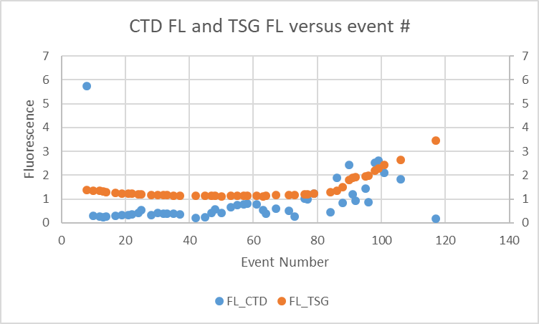

The ratio of TSG fluorescence to CTD fluorescence ranges from 0.25 to 15 with a median value of 2.3. With low fluorescence it is hard to get good matches. In the offshore area there were higher CHL values and the two fluorometers compare fairly well there. However, the TSG fluorescence at P4 on the return trip was high while CTD fluorescence and near-surface chlorophyll values were low which suggests that the TSG fluorescence was not performing well at that stage.

- Comparisons of loop samples and TSG data
There were 20 loop Salinity and 22 CHL samples of which 9 were taken while stopped and the rest while underway.
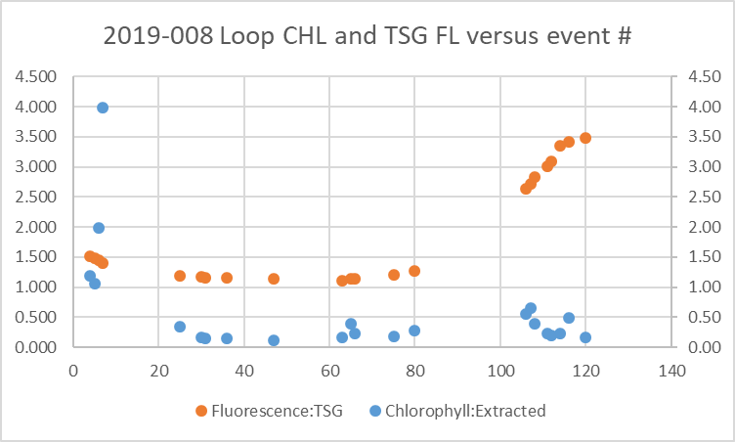
The TSG fluorescence was much higher than the loop CHL when CHL was <1ug/L. The only loops with CHL > 1ug/L come from Juan de Fuca Strait early in the cruise. For the 6 casts with loop samples during rosette casts, the loop CHL is a little lower than rosette CHL, mostly by 0 to 12% and in one case by 25%. The ratio FL/CHL towards the end of the cruise was much higher than near the beginning for similar CHL values. This does suggest that the fluorescence was drifting after leaving P35.

The TSG Salinity was lower than the loop salinity by a median value of 0.408psu excluding 1 outlier, with a range of -0.44 to -0.38psu. The first 4 loops were from Juan de Fuca Strait where near-surface gradients may have been large so imperfect vertical matching of loop and TSG may lead to significant errors. Otherwise, the differences are fairly steady up to event #80 at about -0.407psu. The differences are much larger for the underway sampling on the return journey dropping from -0.4250 for event #107 to -0.4400psu for event #120. During the outward journey there was no significant difference between samples taken while stopped as opposed to moving.

The variations with time suggest that adding 0.407psu is a reasonable adjustment up to the end of August 21st. After that there is a clear temporal change, though it is not known when it started. The cell was found to be damaged later.
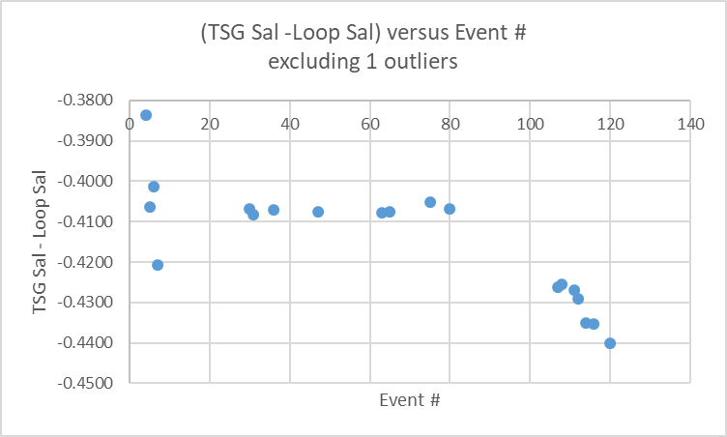
A fit against Julian date from about event #80 to the end produces a reasonable fit. When extrapolated to event 86 on the 22nd of August the correction is +0.4075 which is close to that found for the early part of the cruise. This correction could be too large for August 22 to August 24 but the error is likely <0.015psu based on the difference between this fit and the constant correction used for the earlier part of the cruise.
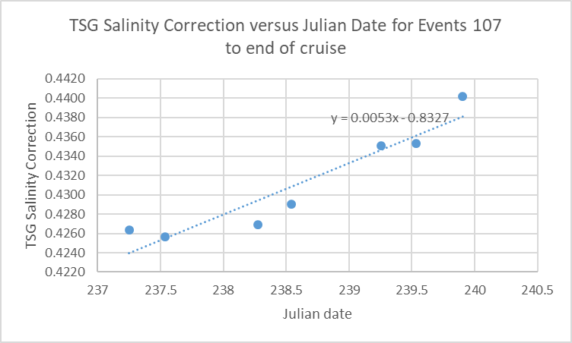

- Comparison of 5m Rosette samples and TSG Salinity and Fluorescence
There was only 1 5m salinity sample from a rosette. The TSG salinity was lower than the rosette CHL by 0.404ug/L.

There were 23 CHL samples from 5m. The comparison looks very odd. For the highest CHL value (10.7ug/L) the TSG fluorescence reads ~1.4 and the CTD fluorescence is 5.7. Usually these sensors read about half the CHL value for high CHL. For cast #13 the CHL is very low at 0.14ug/L, but the TSG fluorescence is 1.3ug/L, almost the same as when CHL was high. The CTD fluorescence is 0.23ug/L. Near the end of the cruise as the CHL values rise a little, the TSG starts rising too but when the CHL falls again the TSG increases steeply. The TSG values do not track the CHL well at all.
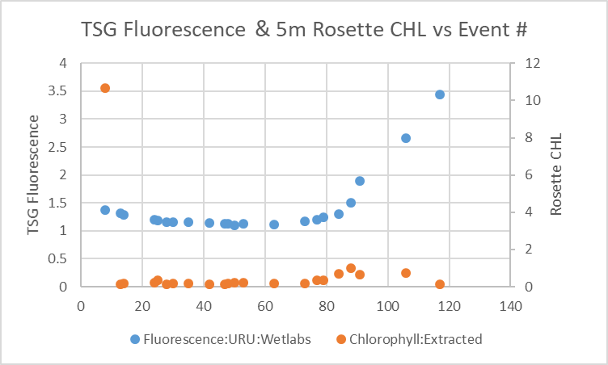

d.) Calibration History
- During 2018-026 this system was used for the first time. The intake temperature sensor read higher than the CTD temperature by a median of 0.03C°. The lab temperature was higher than the intake temperature by more than expected (~0.5) based on previous experience with heating in the loop on the Tully. The salinity traces were quite smooth with only a few very small spikes. Salinity read lower than the CTD by a median of 0.009psu. The differences were not sufficiently consistent to allow recalibration. The data were archived but with a warning that there was insufficient calibration sampling to assess quality.
- The results from 2018-025 suggest that there were problems with flow in the loop.
- During 2018-034 Salinity was lower than the CTD by a median of 0.030psu. Lab temperatures were higher than CTD temperatures by a median of 0.66 C°. The intake temperatures were high by a median of 0.072 C° using all data or 0.058 C° in a “quiet section”. Fluorescence from the TSG was lower than the CTD fluorescence except in areas where CHL was low. The comparisons have a lot of scatter and recalibration was not attempted. The data were archived but with a comment about the intake temperature being further from the CTD data than expected and heating in the loop being higher than when the SBE21 was in use. Because of the limitations only 3 decimal places will be shown for temperature and salinity.
- During 2018-040 the TSG fluorescence was removed as it looked unreliable, starting with values close to the CTD but increasing until it was 60 times the CTD values. Salinity was lower than that from the CTD by a median of 0.032 and lower than loop samples by 0.034psu. The intake temperature was higher than the CTD temperature by a median of 0.0032C°. The lab temperature was higher than the intake temperature by ~0.28 C°.
- During 2019-001 the TSG fluorescence values started unbelievably high, but the values dropped through the cruise getting closer to CTD and loop values. The TSG intake temperature was higher than the CTD by about 0.05C°. The lab temperature was higher than the intake temperature by ~0.5C°. Salinity was lower than CTD and loop by between 0.003 and 0.009psu.
- During 2019-005 the TSG fluorescence values were about 50% of those from the CTD and ~40% of loop extracted chlorophyll samples. The pattern of variability is similar to that from the CTD. The TSG intake temperature was higher than the CTD by about 0.19C°. The lab temperature was higher than the intake temperature by ~0.5C°. Salinity was higher than CTD and loop by 0.4 and 0.34psu, respectively. The salinity is usually lower than the CTD and loop and the two TSG temperature channels are way out of line with expected values. TSG data were not archived.
- During 2019-006 the TSG fluorescence had a large temporal drift that was not related to chlorophyll level. The data were not archived. The TSG intake temperature was higher than the CTD by 0.013C°. The lab temperature was higher than the CTD by ~0.32C° and higher than the intake by ~0.28°. TSG salinity was reading lower than the CTD by about 0.057psu and lower than loop samples by 0.061psu.
- During 2019-014 The TSG intake temperature was higher than the CTD by ~0.057C°. TSG Salinity read lower than the CTD salinity by a median of 0.10psu. The differences grew with time from between ~0.07 and 0.08psu until event #27 after which it rose steadily to 0.14psu. Fluorescence also appeared to be drifting upward relative to CTD values which might be due to biological contamination.

e.) Conclusions re IOS TSG
1. The TSG clock worked well. The position data were unusable but positions from other ship records were manipulated to match the TSG times. The results showed good matches with CTD times.
2. There were 48 points of comparison with CTD, all but one during the outward journey.
3. After an initial period with no flow, the flow rate was quite steady with values 0.9L/min to 1.2L/min.
4. The intake temperature is reading higher than the CTD by a median difference of 0.0067C°.
5. The lab temperature is higher than the CTD temperature by a median of 0.325C° and higher than the intake temperature by a median of ~0.32C°. So heating in the loop is a little higher than during 2019-014 but much lower than during 2019-005 when heating in the loop was 0.5C° with a similar flow rate.
6. Up until August 21st, the TSG Salinity read lower than the CTD by a median of ~0.408psu and lower than loop salinity by a median of 0.407psu until event #80. After that the TSG salinity drifts lower until it is low by 0.44psu near the end of the cruise. A linear fit against Julian Date was derived to be applied to files from August 22nd to the end of the cruise.
7. The history of the instrument shows the intake temperature was reading higher than the CTD by 0.057C° in July and by 0.015C° in June. So there is a better match for 2019-008, perhaps because there is more near-surface vertical mixing. TSG salinity drifted significantly during 2019-014 and was reading low by 0.14psu at the end of that cruise. The TSG data from 2019-069 has not been processed yet due to bad position data in the raw files. The conductivity cell was found to have drifted excessively and was replaced in January 2020.
8. The TSG fluorescence looks unreliable. The traces are suspiciously smooth. The values are higher than the CTD fluorescence; while the CTD sensor was found to be reading a little low compared to CHL rosette samples (for CHL>1) the difference was not enough to explain the difference between the 2 sensors. The comparison between the loop CHL at P4 shows the CTD fluorescence to be slightly higher than CHL on both the outward and inward occupations of that station. The comparison of the TSG fluorescence to the P4 loop samples shows it to be very high on the way out and extremely high on the return. The comparison between the 5m rosette samples and the TSG fluorescence trace shows little evidence that the TSG sensor is tracking CHL. The overall pattern does not look reliable so this channel should be removed.
9. The TSG intake and lab temperatures will not be recalibrated as the differences may well be due to slight mismatches in depth of sampling. Salinity will be recalibrated by the method described above.

g.) Editing
All files were opened in CTDEDIT and for most there was some light cleaning to remove single-point spikes in salinity. It was also used to pad some data in channels Temperature: Lab, Temperature: Intake, Conductivity, Fluorescence and Salinity for a few records on August 16th because flow rates were just being established; most data were padded at an earlier stage. It was also used to pad values from the last 7 records on August 28th because the flow had stopped. A text editor was used for some of the pad value entries.
The file for August 14th contains no data other than positions but was produced just to get a complete track of the cruise.

h.) Recalibration
CALIBRATE was run choosing formula 12 which applies a bi-linear correction:
- Correction = +0.407psu for dates 227-233 (Aug 15 - August 21)
- Correction = +0.0053*Julian Date -0.8327 for dates 234-240 (Aug 22 - August 28)
After this correction Sigma-T was derived.

i.) Preparing Final Files
Bin Average was run to average over 6 records, making the interval 30s; this makes the files small enough to enable plotting them all at once in IOS SHELL time-series plot routine.
REMOVE was used to remove channel Pressure, Fluorescence:URU:Wetlabs, Temperature:Difference , and record #.

HEADER EDIT was used to change the DATA DESCRIPTION to THERMOSALINOGRAPH and add the depth of sampling to the header and to change channel names to standard names and formats and to add comments.
A cross-reference list was prepared.
The TSG sensor history was updated.
As a final check plots were made of the cruise track and time-series an all looks fine.

Loop File
The Chief Scientist provided file 2019-0008 Loop log.xlsx which included event numbers, sample numbers and what was sampled.
Earlier in the processing the loop samples were used to study the TSG calibration. To do that times were added based on the log entries. For loops taken at the same time as 5m rosettes, the times were set to the ends of casts. That data was copied to file 2019-008-loop.xls.
The sampling method column was entered as USW.
The columns were arranged in the order required for the 6-line header used to prepare the loop file.

The CHE files were put through program DERIVE to obtain sigma-t.
Data from those files were exported to file 2019-008-che-surface.csv. The Oxygen:Dissolved and Oxygen:Dissolved:SBE channel in mass units were included and Draw Temperature.
The Start Time was copied into a second column and the first was formatted for date and the second for time.

The times in the files are start times and the samples were actually taken near the end of the cast, so the times were edited to match the End Times in the log book.

An initial line was added with channel names from a 6-line header used for a previous cruise. An extra column was added for the 2nd transmissometer. The data and the 6-line header columns were adjusted due to slightly different channels being available. Then the full 6-line header was inserted.
A sample method column was added. ROS was entered for the method.

Data from below 7m were removed as well as records with no analysis results.
The data were sorted on event number, then pressure.
That file was saved as 2019-001-surface-6linehdr.csv.
The loop data were added to the 6-line header file.
The file break column was filled with value 1 so all data will be in a single file when converted.
The file was sorted on event #, date, time and pressure.

CONVERT was run to produce an IOS Header file.
CLEAN was run to get start and stop times and positions and to add flag 0 to empty flag cells.

A comment file was prepared which was essentially the same as the one used in preparing CHE files but including a description of the loop system and comments on the CTD data processing.

Header Edit was used to correct channel names and formats and to add comments. The final file was renamed as 2019-008-surface.loop. The track plots look reasonable and plots of temperature and salinity versus event numbers, latitude and longitude look reasonable.

General Comments
PAR off: 39, 48, 55, 64, 66, 67, 71, 79, 84, 86, 88, 90, 98, 99, 101, 106.
Casts with bottle fired out of order: 39.
Casts with no Niskin closed: None.

Particulars
1-8. Fluorometer gain 10X.
9-117. Fluorometer gain 3X.
17. DO sensor had strange signal ~600m on upcast which will influence CHE file.
27. Niskin 1 closed by mistake – remove from bottle file.
48. Niskins 3 and 4 closed at wrong depths – 2250 and 2000 instead of 2500 and 2250
64. Niskin 1 spigot open – carbon samples should be flagged.
81/86. Sample #s repeated. Use 9671 to 9682 for cast #81. Leave event #86 as planned.
91. Niskin 9 closed twice – removed 2nd – no sampling.
92/93. Split cast – downcast all in 92, but CHE will need join (1-3 in 92, rest in 93).
101. Niskin 2 closed at wrong depth – 15 instead of 10m.

2019-008
CRUISE SUMMARY – CTD
CTD# | Make | Model |  | Serial# |  | Used with Rosette? |  | CTD Calibration Sheet Competed?
1 | SEABIRD | 911+ |  | 0506 |  | Yes |  | Yes
Calibration Information - 0506
Sensor |  |  |  |  | Pre-Cruise |  |  |  | Post Cruise
Name |  |  | S/N |  | Date |  | Location |  | Date | Location
Temperature |  |  | 2023 |  | 06Sep2017 |  | Factory
Conductivity |  |  | 1763 |  | 06Sep2017 |  | Factory
Secondary Temp. |  |  | 5013 |  | 02Sep2017 |  | Factory
Secondary Cond. |  |  | 3394 |  | 6Sep2017 |  | Factory
Transmissometer |  |  | 1883DG |  | 21Nov2018 |  | Factory
Transmissometer |  |  | 1185DR |  | 16Dec2018 |  | IOS
SBE 43 DO sensor |  |  | 3234 |  | 16Feb2018 |  | Factory
PAR |  |  | 70613 |  | 21Mar2016 |  | Factory
SeaPoint Fluor. |  |  | 3640 |  | Jan 2019
Pressure Sensor |  |  | 0506 |  | 2Sept2017 |  | Factory
Altimeter |  |  | 62355 |  |  |  | Factory

TSG Make/Model/Serial#: SEABIRD/45/0620
Calibration Information
Sensor |  | Pre-Cruise |  | Post Cruise
Name | S/N | Date | Location | Date | Location
Temperature | 0620 | 2Aug17 | Factory
Conductivity | 0620 | 2Aug17 | Factory
Temperature SBE38 | ? | ? | Factory
WETStar Fluorometer | 953 | 5May2017 | Factory

