**Neocaligus Cruise IOS 2019-007**

**4-9 March 2019**

**Crew: Kelly Young, David Costalago Meruelo (UBC), Matt Miller (UVic)**

**Table 1.** Sampling stations – see excel file: “[2019-007 sampling-plan_21feb2019.xlsx](2019-007%20sampling-plan_21feb2019.xlsx)”

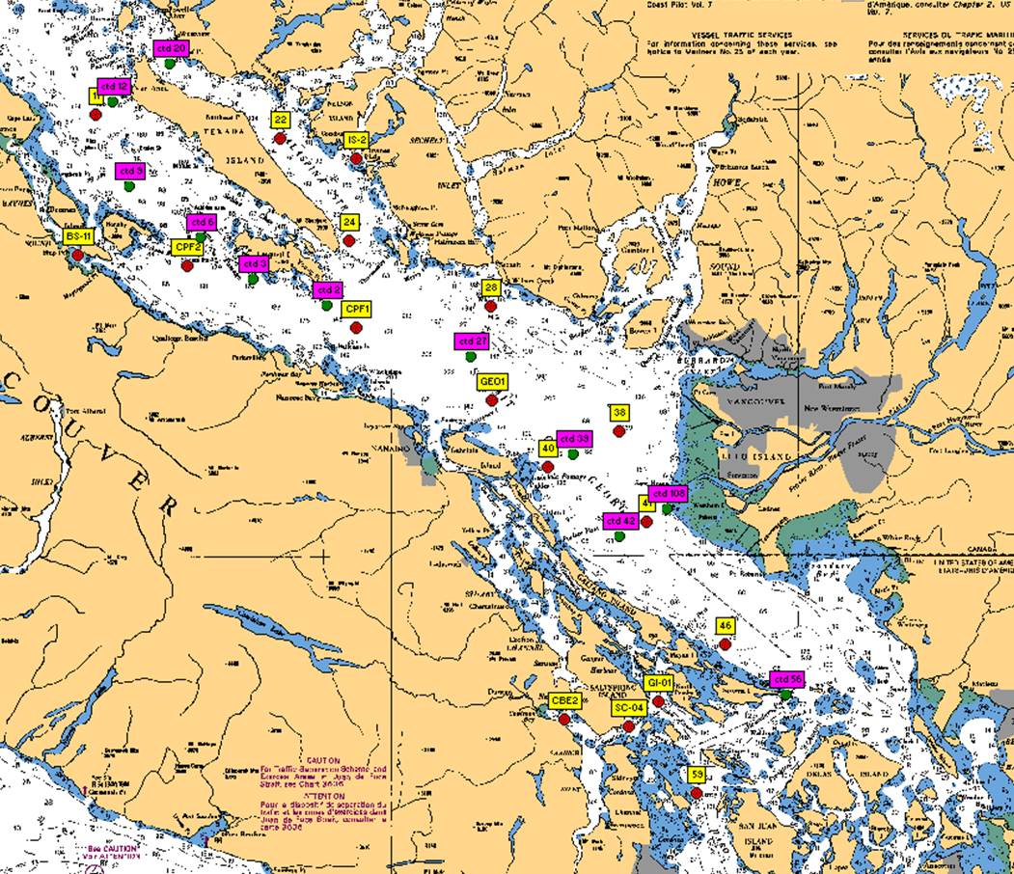

**Figure 1**. Station locations for IOS 2019-007 Strait of Georgia zooplankton survey. Yellow – CTD + zooplankton net stations; Pink – CTD stations.

**At each zooplankton/net station, collect:**

* Full depth (10m off bottom to surface) CTD profile including oxygen and fluorometer, using SBE 25 CTD with SBE 43 DO and Wetlabs fluorometer sensors. May have a pH sensor as well – if so, remove buffer container before deployment, and re-attach immediately after the cast. **2 minute soak at start** (Turn on, down 10m and up, wait remaining time and start). If more time is needed at the start of the cast (attaching a bottle, etc), record how long the CTD was on before start of cast. **Note:** CTD fluorometer usually has an end cap that needs to be removed before the first cast!
* Full depth (10m off bottom to surface) zooplankton tow, using Bongo net with 236um black mesh. One side (non-flowmeter side) preserved in 10% buffered formalin, other (side with the flowmeter) size fractionated (see next point). Upcast speed approx. 1 m/s. Net equipped with a TSK flowmeter and an RBRSolo that logs the net casts (depth and time).
* **For Brian Hunt:** other side of bongo to be processed for fatty acids/stable isotopes. Sample to be size-fractionated (see file “[Zooplantkon_Size fractionating samples_20170512.pdf](Zooplantkon_Size%20fractionating%20samples_20170512.pdf)”) and each fraction transferred to whirlpak and frozen at -80C (large dry shipper).

**At select stations, collect:** (see “[2019-007 sampling-plan_21feb2019.xlsx](2019-007%20sampling-plan_21feb2019.xlsx)” for complete summary per station).

** Record event number(s), sample number on rosette log sheets and in cruise log. Each Niskin gets unique sample number, all samples from that Niskin uses that number. Assign numbers in ascending (bottom to surface) order **

*Salinity (SAL)* – at least one deep water (>200m) salinity sample (in duplicate) per day (approx.), using 1.7 L Niskin attached approx. 1m above CTD (please measure and record in logbook!) to collect a near-bottom salinity sample during CTD cast (CTD sensor check). Record sample number, depth collected in log. 10% duplicates

** Not needed if full DIC cast happens on the same day.

* If needed, to be collected at stations: 41, 38, GEO1, CPF2, 22, 24.

*HPLC –* Surface HPLC sample collected in duplicate. See “[2018-37_NEO_HPLC protocols and equipment.doc](2018-37_NEO_HPLC%20protocols%20and%20equipment.doc)” for full methods. Briefly, 620-1040mL of water (depending on phyto biomass) filtered onto 47 mm GF/F filters, the filters blotted, folded once and rolled into a cryovial, and then frozen in small dry shipper. Remember to fill out HPLC sampling/filtration log sheet.

- To be collected at stations: 59, 56, SC-04, 42, 39, 27, 2, 3, 6, 9, 12, 22, BS-11, GEO1

*Chlorophyll-a (chl-a)* – Chl-a samples taken at surface everywhere HPLC is collected from same Niskin as HPLC and phyto.

Water sampled into 304ml brown bottles and filtered onto 25 mm GF/F filters (IOS standard method, 20% in duplicates). Store filter folded in half in small cryovial in small dry shipper. *Record the sample number with the depth and volumes filtered in the cruise log*. Make sure labels have sample number and volume filtered as well.

- To be collected at stations: 59, 56, SC-04, 42, 39, 27, 2, 3, 6, 9, 12, 22, 28, BS-11, GEO1

*Phytoplankton (phyto)* – surface phyto sample preserved with Lugol’s, collected from same Niskin used for HPLC at surface; for taxonomy. Do not rinse jars (pre-filled with Lugol’s).

* To be collected at stations: 42, SC-04, 27, 2, 22, 12 and BS-11

**Extras for Brian Hunt:**

*Particulate organic matter for isotopes (POM-SI)* – see methods “[POM for Isotopes_2016_07-20.pdf](POM%20for%20Isotopes_2016_07-20.pdf)”

*Particulate organic matter for fatty acids (POM-FA)* – see methods “[POM for Fatty Acids_2016_04_30.pdf](POM%20for%20Fatty%20Acids_2016_04_30.pdf)”

**Extras for Matt Miller (UVic)**

*Limacina helicina* *picking* - pick *Limacina* out of the non-flow (formalin) side bucket into a petri dish, rinse with DI water, transfer onto slides, look at them through the microscope to observe shell condition (only if there’s time), and then leave them to dry in front of a small space heater for about an hour. Record the number of *Limacina* removed in the plankton log book.

*Dissolved Inorganic Carbon* (DIC) – standard IOS sampling. Sampling into 250ml bottles and preserved with 100l mercuric chloride, 10% duplicates. Collect salinity, oxygen and nutrients from the same bottle as all DIC.

*Nutrients* (Nuts) – standard IOS sampling with the DIC samples. 10% duplicates, freeze at -20degC.

*Dissolved oxygen* (Oxy) – sample from same Niskins as the DIC, follow IOS standard sampling procedures, 10% duplicates. Record all information (including draw temperature, sample flask number, etc) on dissolved oxygen log sheets. Samples to be preserved in the field, water-sealed and returned to IOS for analysis. If the Neocaligus comes into IOS near the end of the survey, unload the samples then rather than transport them back by car.

**Housekeeping**

* Run the Oziexplorer program with the GPS puck on the bridge, logging the cruise track and saving one per day. See “Oziexplorer.docx”. If the program is set to record one track per day, it will automatically start a new file each day if left running.
* There are 2 logs to fill out (cruise log and plankton log), plus a rosette log sheet to record sampling information. Each station with water sampling will have one ‘rosette’ log sheet but may have multiple events. Please fill out the cruise log with all events that occur, and give each event a number, and record on the rosette log sheet as well. Record BE, BO and EN time (note what time zone you are using! Eg: use local time if you want, but indicate so in the log and be consistent for the entire trip). **Check that the GPS has the correct time (may need to be manually changed between Daylight ST and PST)
* Plankton log – enter information for all plankton tows.
* Update the electronic cruise log (excel file) daily. Back up all files to USB.
* Make sure the CTD laptop is set up with the correct .con file before uploading the data.
* Upload the CTD data at the end of the day. Make sure the laptop has the correct date and time before uploading. Upload the files individually (don’t do as a batch). When uploading the file, *name them with standard format names using the cruise number-event number, such as 2018-037-0001.hex*(or .xml for SBE25+) for event #1. Put location, station name, and bottom depth in the header (comments box) of the file, using the format in the “CTD Header.txt” file on the CTD laptop (the : plus N and W are needed for processing)
* View the CTD data in Seasave to make sure everything looks good (make sure your CTD config file is correct).
* Also check that the batteries have enough voltage, change if they drop below 10V (for SBE25).
* Provide the “[2019-007 dangerous goods.docx](2019-007%20dangerous%20goods.docx)” to Captain at start of the trip