REVISION NOTICE TABLE
DATE | DESCRIPTION OF REVISION
21 Jan 2021 | Corrections made to comments and flags concerning CHL samples.
27 July 2020 | Corrections made to Oxygen:Dissolved (mL/L) and data for sample 9.
27 March 2023 | Added HPLC data. J.R.

PROCESSING NOTES
Cruise: 2019-007
Agency: IOS, Ocean Sciences Division, Sidney BC
Chief Scientist: Young K. Platform: Neocaligus
Location: Strait of Georgia Project: Strait of Georgia Zooplankton
Date: 4 March 2019 –8 March 2019

Processed by: Germaine Gatien
Date of Processing: 31 October 2019 – 3 December 2019
Number of original HEX files: 28
Number of CTD files: 28 Number of BOT files: 22

INSTRUMENT SUMMARY
A SeaBird Model SBE-25 CTD (s/n 0456) was used with temperature sensor #5130, conductivity sensor #3500, Wetlabs ECO Fluorometer #4185, dissolved oxygen sensor #1592 and pressure sensor 0668.

SUMMARY OF QUALITY AND CONCERNS
The log book was in good order with comments about problems encountered.

Header information was entered in the raw files in a format that should enable easy conversion into IOS Header format, but there were some errors in the position data that needed to be corrected first. The proper format is:
Latitude: 49 27.005 N
Longitude: 123 34.431 W

For most casts there were 2 bottles fired at 0m and 5m. For 3 casts there were also multiple bottles on a wire.

Some records contain only CTD data; these are associated with particulate organic matter sampling.

There was salinity and dissolved oxygen sampling during this cruise. The CTD salinity read higher than the bottles and dissolved oxygen lower than bottles, but there was a lot of scatter in the comparison and several potential errors that could account for the differences. No recalibration was applied.

Extracted chlorophyll samples were taken at the surface only; CTD fluorescence was about 50% of extracted chlorophyll values.

PROCESSING SUMMARY
1. Seasave - This step was completed at sea. The file names were in standard format.

2. Preliminary Steps
The Daily Log, rosette logs and a spreadsheet of sampling done were obtained.

The deployment method used was as follows:
- The CTD was switched on, a 2-minute timer was started and the CTD was put in the water. It was taken down to 10m and after 30s returned to the surface where there was a wait until the 2 minutes were up. The full cast was then started. This method is helpful as by removing the first 960 records, the initial soak can be removed.
- Bottle deployments for most stations were taken at 0m and 5m in separate casts. For 3 stations there was a deeper sampling using 7 or 8 4L Niskin bottles chained together on a wire with messengers. In one case the deeper bottles were split into 2 casts due to a messenger getting stuck. And there were separate casts at those 3 stations for further surface sampling.

The cruise summary sheet was completed.

3. Conversion of Raw Data
The configuration file used at sea was correct and was saved as 2019-007-ctd.xmlcon.
The HEX files were converted using configuration file 2019-007-ctd.xmlcon.
Plots show that the channels all produced reasonable values. The descent rates look high and fairly steady. Fluorescence is very close to 0 in deep water so that instrumental noise leads to very small negative values. After bin-averaging, any negative values will be padded.
There were problems in the format of the position data. The entries looked like Latitude: 49' 43.583 when they should be Latitude: 49 43.583 N. Sometimes the hemisphere entry N or W was present, sometimes not and the word Longitude was misspelled for all casts. These errors derive from the text file prepared before the cruise.

4. WILDEDIT
The only spikes in the data occurred at the beginning or end of the casts, so they will be removed in the normal course of editing. So WILDEDIT was not run.

5. WFILTER
Test were run to find a suitable setting to remove steps in pressure without smoothing the pressure too much. WFILTER was run using a cosine filter, size 5 on the pressure, depth, temperature and conductivity channels.

6. ALIGNCTD
Based on tests run for other cruises in this project using the same DO sensor, ALIGNCTD was run on all casts to advance the DO channel by 2.5s. Plots were examined after this step and the results look good.

7. CELLTM
CELLTM was run on all casts using the SeaBird recommended parameters, (α, 1/β) = (0.04, 8).

8. DERIVE
Program DERIVE was run to calculate salinity and dissolved oxygen concentration (tau correction included). Plots were examined and confirmed that steps 5, 6 and 7 had improved the data.

9. Conversion to IOS Headers
The IOSSHELL routine was used to convert the CNV files to IOS Headers. One cast was missing its latitude header; that was added and the file was reconverted.

CLEAN was run to add event numbers and replace pad values in the pressure channel with interpolated values.

10. Checking Headers
A cross-reference list was produced and compared with the log book entries. There were no significant discrepancies but the times are in PDT.
Track plots looked ok so were added to the end of this report.

The next step is to remove the data collected during soaks at 10m. CLIP was run to remove 980 records from each cast. While there are 960 scans in 2 minutes the downcast often starts a few scans later. Plots were examined to find which casts needed more or fewer records removed. The # of records removed was adjusted for some casts to between 850 and 1260 records.

The header times are in PDT so ADD TIME CHANNEL was run to add 7 hours.

HEADER CHECK was run. There were some negative values in fluorescence and pressure; most will likely be removed by DELETE. This will be checked again later. No other problems were noted.

The surface check shows an average of -0.8db before CLIP was run and most of the associated salinity values were very low. The only ones that appear to be in water are at -0.6db or 0db. The pressure sensor has a 2800db range so the resolution is only 0.45db and accuracy is ±2.6db so the results are well within specifications.

11. SHIFT
Conductivity
During 3 cruises in 2017 when the same sensors were used no adjustment was found to improve the alignment of conductivity with pressure. During 3 other cruises in 2018, a setting of +0.5 records was found suitable to align the conductivity with pressure. Tests on the 3 casts data from 2019-007 show that a shift of +0.5 records made an excellent improvement to stability in T-S space.
A shift of +0.5 records was applied to all casts.
Fluorescence
The fluorometer was not pumped, so a shift in alignment is expected to be small or unnecessary. Profile plots of temperature and fluorescence were examined and confirm that the alignment is good.
Dissolved Oxygen
This channel was aligned earlier, but checks were made by examining plots of temperature and dissolved oxygen. The alignment looks good. No further adjustment was made.

12. DELETE
DELETE was run on all casts using the following parameters:
Surface Record Removal: Last Press Min. Surface Swell Pressure Tolerance: 1.0
Swells deleted. Warning message if pressure difference of 2.00
Drop rates < 0.3m/s (calculated over 5 points) was deleted from 10db to 10db above the maximum pressure.
COMMENTS ON WARNINGS: There were no warnings.

13. DETAILED EDITING
CTDEDIT was used to remove records corrupted by shed wakes and to clean salinity where unstable features looked likely to be caused by misalignment of T and C. 21 out of 28 casts were edited lightly.
Notes of editing details were made in the headers.

T-S plots were examined after this step and no significant problems were found; there are small unstable features but this is an area where some instability is expected.

14. Initial Bottle Data Steps
There was no rosette available for this cruise. For 22 casts there was some bottle sampling. For 3 there were 7 or 8 bottles on a wire, plus some extra surface sampling. For others there were also samples taken at 0m and 5m after the CTD cast. In a few cases there was only surface sampling.

To enable searching of bottle data, BOT files were prepared.

Each of the analysis spreadsheets were examined to see what comments the analysts wanted included in the header file. These were used to create file 2019-007-bot-hdr.txt which will be updated as needed during processing. All of the spreadsheets included a precision study.
- Extracted chlorophyll and phaeo-pigment data were obtained in file QF 2019-007 CHL*.xlsx.
- Salinity analysis was obtained in spreadsheet QF 2019-007 SAL*.xlsx.
- Nutrient analysis was obtained in spreadsheet QF 2019-0070 NUTS*.xlsx.
- Dissolved Oxygen analysis was obtained in spreadsheet QF 2019-007 OXY*.xlsx.

Workbook 2019-007-bottle_plus_CTD.xlsx was created. Separate worksheets were created to contain the data from the event log relevant to Niskin sampling, bottle data (DO, salinity and CHL), CTD data at bottle depths, CTD plus bottle data, CTD plus bottle data in 6-line header format and bottle-CTD comparisons.

Because it is impossible to do all the sampling in a single cast, there are often 2 or more events noted in the Daily Science log book for a single site. It makes most sense to combine them in a single bottle file, corresponding to a single sample/rosette log sheet. The first event number listed on a rosette log sheet corresponded to the CTD event. The analysts used the first event number on the rosette logs.

There was particulate organic matter sampling for many casts with water from 0m or from a mix of 0 and 5m bottles. There was no other sampling from these bottles. Where there were other samples taken near the surface, the researchers can use the CTD values collected at 5m and 0m. For a few events the only sampling was for POM at 0m or 5m so CTD data from near those depths were entered.

To select CTD data to go with the bottle samples, a list of depths sampled in increasing order (including those for the 3 bottles at the bottom of casts) was prepared. THIN was used to select CTD data at those depths. Because near-surface data are required, DEL files were used rather than the usual edited and bin-averaged files. Data were exported and copied to a separate sheet of the workbook and records were removed for which there was no sampling and lines were added for the surface samples.

Those data were added to the bottle data in the appropriate worksheet. The data had to be rearranged to match the bottle samples as there are no CTD files to match some of them and the order of sampling was not always the same. This sheet was then used to do comparisons between CTD and bottle data.

Later in processing (see §20. Final BOT file preparation were selected from the final downcast files (*.CTD). Checks were made to see if there was a significant difference between those 2 sets that would affect the comparisons described in the next section. In 2 cases there were no CTD data available at the bottle levels in the final CTD files. Excluding those 2 cases the differences found were insignificant overall, though there was considerable variability. The differences did not effect conclusions about the calibration. In particular, the fluorescence was only slightly higher overall, so the fit against CHL will not differ much. When cast #24 is excluded where there was no good match in pressure between the two data sets the differences were:

Differences between data from CTD and DEL
 | Pressure | Fluorescence | Salinity | Dissolved Oxygen
median | 0.1 | 0.01 | 0.0000 | 0.000
maximum | 0.5 | 0.86 | 1.0464 | 0.262
minimum | -0.5 | -0.67 | -0.0191 | -0.216

The final CTD values will be selected for the bottle files except for the 1 bottle for which there were no data available at a suitable depth in the final files. Data for those will be obtained from the DEL files.

The event numbers are those for the CTD cast at the site and usually include bottles from several bottle casts at the same site. A Nominal Depth column was created and filled with rosette sheet entries.
On one worksheet the data were organized with a 6-line header which was saved separately as a CSV file, 2019-007-bottle-plus_CTD-6linehdr.csv.

15. Compare
Salinity Comparison
One sheet in workbook 2019-007-bottle_plus_CTD.xlsx was used to do a comparison between the bottles and CTD. For salinity the CTD was found to be higher than bottle salinity by a median of 0.016psu and standard deviation of 0.132psu. Using 7 bottles fired in sections of relatively low vertical salinity gradient were included the CTD salinity was higher by an average of 0.012psu and standard deviation of 0.024psu.

Possible sources of errors are:
- Analysis delay - Analysis was done promptly so negligible error is expected due to adsorption and/or evaporation. Any error would lead to bottle salinity reading a little too high so that the CTD data appears to be reading low.
- Incomplete flushing of bottles - There is likely some error due to incomplete flushing of Niskin bottles so that the water in the bottles comes from higher in the water column. This would lead to the CTD salinity looking high compared to bottles. The errors would be dependent on local vertical salinity gradients which are usually lower at lower depths.
- Bottle Depth error – There were times when the wire angle was noted to be high, and one of those was a cast with salinity and dissolved oxygen sampling. So the bottles were likely somewhat higher than the CTD data with which it was compared. This would make the CTD salinity appear to be reading too high. The depth error would increase with depth but the effect on salinity might not since salinity gradients usually decrease with depth.
- Temporal change – The time difference between bottle cast and CTD cast varied from about 15 minutes to 1 hour. This may account for some variability but should be a random error.
So the systematic errors mostly lead to the CTD appearing to be higher than it really is, with only the analysis delay effect having the opposite effect and that error is considered to be very small.
No recalibration of salinity is justified given the scatter and many sources of error.
For more details see the “comparisons” worksheet in file 2019-007-bottle_plus_CTD.xlsx.

Dissolved Oxygen
Dissolved Oxygen sampling was done at the same depths as the salinity sampling. In general calibration drift in this type of DO sensor leads to lower values. A fit of (CTD DO – Bottle DO) versus CTD DO usually leads to a reasonable linear fit that can be used to recalibrate the CTD DO. However, for this cruise there are too few samples and too many sources of error to expect a good fit.

The following is the fit when the offset is set to 0.

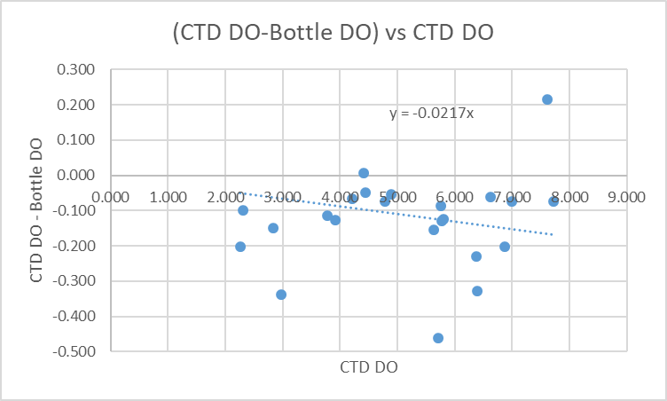

Some of the same possible errors as found for the salinity comparison are seen for DO though the effects are different:
- Incomplete flushing of bottles - There likely is some error due to incomplete flushing of Niskin bottles so that the water in the bottles comes from higher in the water column. This would generally lead to the CTD DO looking low compared to bottles. The errors would be dependent on local vertical DO gradients and those were quite complex with some reversals. The cumulative effect is thus likely less severe than that on salinity.
- Bottle Depth error –The bottles were likely somewhat higher in the water column than the CTD data with which it was compared. This would generally make the CTD DO appear to be reading too low. The depth error would increase with depth though the near-bottom DO gradients are usually lower.
- Temporal change – The time difference between bottle cast and CTD cast varied from about 15 minutes to 1 hour. This may account for some variability but should be a random error.
Cast #63 had the lowest vertical gradients, but likely also had the worst problem with large wire angle. The range of DO values was too small to allow a reasonable fit for that cast.
We expect DO to be reading a little low, but it is likely not as low as appears in the comparison given the likely errors. There are not enough data to enable identification of outliers; this fit is too weak to justify recalibration.
For more details see the “comparisons” worksheet in file 2019-007-bottle_plus_CTD.xlsx.

Fluorescence
Chlorophyll sampling was done only at 0m. Fortunately the CTD data from the surface looked ok, so a comparison was made and fluorescence was an average of 45% of the CHL and a fit through the origin produced a slope of 0.53.
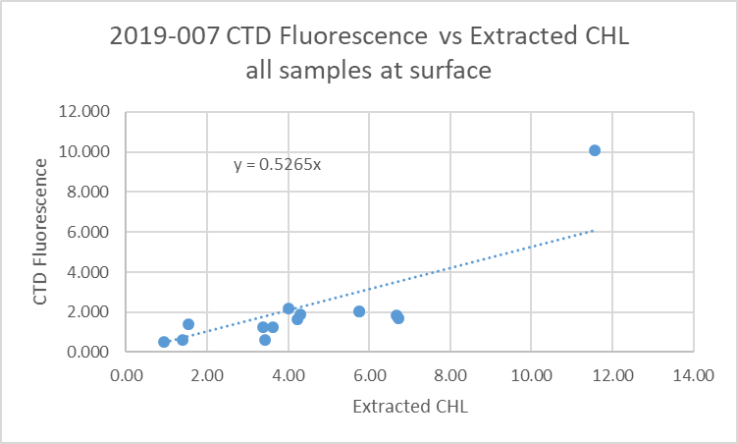

16. Other calibration checks
Sensor History – These sensors were used for 6 previous cruises since they were last calibrated. There was no calibration sampling available. No obvious problems were noted.
Historic Ranges – Many casts in the northern part of the cruise had temperatures below the climatology maxima in the top 5 to 35m. There were no such excursions in the southern half. Salinity values all fell within the climatology. The excursions do not appear to be indicative of calibration problems.
Post-cruise calibrations – None were available.

17. CALIBRATE
No channels were recalibrated

18. Fluorescence Filter
A median filter, size 5, was applied to the fluorescence data.

19. Bin Average and REMOVE
The files were bin averaged using 1db bins.
There are a few negative fluorescence values at depth so CLEAN was run to replace those with pad values.

REMOVE was run to remove Scan_Number, Oxygen:Voltage, Descent Rate and Flag channels.

Dissolved Oxygen was derived in mass units and that was used to calculate DO saturation. Plots of near-surface saturation show a range of 80 to 155%. The highest saturation rates were in the east of Texada Island. Most values were between 90% and 105%. There is too much variability to make a judgment about the calibration of the dissolved oxygen sensor.
REORDER was used to get the 2 dissolved oxygen channels together.

20. HEADER EDIT and final checks of CTD files.
Header Edit was used to fix headers, fix formats and to add comments about processing.

A cross-reference listing was produced.
A header check was run on the CTD files and no errors were found.
The sensor history was updated.
Plots of CTD casts were examined and no problems were found.

20. Final BOT file preparation
To enable searching of bottle data, BOT casts were created that contain sample data and CTD data from the downcast at the same site. The event number will match the CTD cast.

In many cases there were bottles fired at 5 and/or 0m for POM sampling. Where there are already samples at those depths, the firings for POM were removed since the CTD data would be exactly as already in the file for those depths and the POM sample results will not be included in these files.

The values from the *.CTD files were selected for the bottle files except for event #24 for which there were no data available at the depth required in the final files. Data for that event were obtained from files created at an earlier stage of processing (DEL files).

Adding the bottle data to the CTD data was error-prone so a number of checks were done to ensure that the right correspondence was achieved. A 6-line header was added

The 6-line header worksheet from file 2019-007-bottle-plus_CTD.csv was updated by thinning final CTD files and exporting data to a spreadsheet so as to capture the effects of deriving DO in mass units. The new values did not affect the bottle comparison since CTD salinity was not changed.
The spreadsheet file was converted to IOS Header files for each cast.

The time and date are present as channels as these cannot be converted directly into header entries.
CLEAN was run to add START and END time. The END TIME is identical so the START time so it will be removed later. CLEAN was also used to enter 0 flags where the flag channels are empty and to remove channels with only pad values.
REMOVE was run to remove the DATE and TIME channels.

SORT was used to order the files by Depth:Nominal. Files were checked and where depths were equal for 2 records they were in sample number order.
Derived Quantities and REORDER were used to calculate DO in mass units and get the 2 DO channels together in the channel list.
HEADEDIT was used to add comments and to remove the END time since it is the same as START TIME. A reference for HPLC was added since samples were collected and will be added to the files later.
The final files have extensions BOT.

The standards check was run and turned up some errors.
A cross-reference list and a header check were run on the BOT files; no problems were found.
Plots were made of all BOT casts. No problems were found.

PARTICULARS – notes from logs
All times are UTC in the raw files.
CTD Deployment method: Timer set to 2 minutes. CTD down to 10m for soak until 1m 30s mark, bought back to surface to sit until 2 minutes are up. Then full cast begins.
BOTTLES: For most stations there were bottles fired at 0m and 5m as 2 separate events using 1.7L bottles.
For 3 casts there was a full profile of bottles obtained from 5L bottles on a wire; in one case this was split into 2 events because a messenger got hung up.

1. Didn’t clean fluorometer.
5. Diesel slick at station – moved off to clearer waters.
6/7. Sample #s out of order.
12/13. Messenger hung up on 20m bottle. Only 1 to 20m bottles fired 1st try – removed from wire and reset to depth to fire remaining deeper bottles. RBR depths 322 and 320m.
16. CTD switched on for ~5s – empty cast, then cast 16.
27. Had to restart so empty cast, then cast 27. Lots of phyto, brownish surface water.
43. Went to bottom then, back to 128m and stopped. Some mud on edge of cage, don’t see anything in tubes.
67. RBR max depth =165, wire out 172. Wire out 172, CTD max depth 163 for event 63 at same site.
70. High wire angle, added 5m to max pressure in log.
74. High wire angle.
75. 63m wire out.

CRUISE SUMMARY

Cruise ID#: 2019-007
Dates: Start: 4 March 2019 End: 8 March 2019
Location: Strait of Georgia Zooplankton
Party Chief: Young K.
CTD# | Make | Model | Serial# | Used with Rosette? | CTD Calibration Sheet Competed?
1 | SEABIRD | 25 | 456 | No | Yes

CTD CALIBRATION INFORMATION
Make/Model/Serial#: SEABIRD/SBE25/0456 Cruise ID#: 2019-007

Calibration Information
Sensor |  | Pre-Cruise |  | Post Cruise
Name | S/N | Date | Location | Date | Location
Temperature | 5130 | 22Feb2017 | Factory
Conductivity | 3500 | 23Feb2017 | Factory
ECO Fluorometer | 4185 | 07Mar2017 | Factory
SBE43 Oxygen | 1592 | 2Mar2017 | Factory
pH
Pressure | 0668 | 28Feb2017 | Factory
