|  |  |  |
| --- | --- | --- |
|  | **Regional Operations Centre**  **Canadian Coast Guard – Pacific** |  |

PACIFIC REGION CCG VESSEL - POST CRUISE REPORT

Line P Program – Fisheries and Oceans Canada

**NAME OF SHIP/PLATFORM:** John P Tully

**DATE:** **FROM:** 2 June 2019 **TO:** 18 June 2019

**SCIENCE CRUISE NUMBER:** 2019-006 **SHIP’S PATROL NUMBER:** 19-03

**CHIEF SCIENTIST[S]:** Marie Robert

**SCIENTIFIC PERSONNEL:**

|  |  |
| --- | --- |
| **Female** | **Male** |
| Moira Galbraith (IOS) | Nathan Anderson (NOAA) |
| Josianne Haag (UBC) | Michael Arychuk (IOS) |
| Marie Robert (IOS) | William Haskell (MBARI) |
| Robyn Sahota (U Vic) | William Higley (NOAA) |
| Jade Shiller (UBC) | Michael Livingston (UVic) |
|  | Florian Lüskow (UBC) |
|  | Steve Romaine (IOS) |
|  | Kyle Simpson (IOS) |

**AREAS OF OPERATION:** Saanich Inlet, Juan de Fuca and Haro Straits, North East Pacific, Line P, Station P.

**INTRODUCTION/PROGRAM BACKGROUND:** Line P is a long standing program which surveys a 1400 km long section 3 times annually. Data have been collected along this line since 1956 and show evidence of the impact of climate variability on ocean productivity. It is the only Canadian long time-series that allows scientists to monitor climate changes in the Pacific Ocean. It is also the best opportunity for other programs (e.g. Universities) to do research in the Pacific since the Line P data give them background as well as current water properties.

**CRUISE OBJECTIVE/OBJECTIVES:** Repeat hydrography section (physics, chemistry, zooplankton); service NOAA mooring, deploy 8 drifters for NOAA, deploy 9 drifters for IOS, recover an Argo float for MBARI (Monterey Bay Aquarium Research Institute).

**CRUISE DESCRIPTION:** This cruise (2019-006) went really smoothly all along. The loading was facilitated by the fact that a lot of gear was already on board for the La Perouse cruise and the NOAA mooring gear showed up early. The weather was mostly good during the cruise except at P20 and the first day at P26. All in all everything went really well.

**DAYS ALLOCATED:** 16  **DAYS OF OPERATION:** 15

**DAYS LOST DUE TO WEATHER:** ~5 hours at P20

**SAMPLING:**

* The Line P survey was ~98% successful. The ring net was cancelled at P8, no bongo/net casts were done at P20. On the other hand some extra work was done, which still gives the cruise an A++ score card.
* Six “Sponge-Bob” and three OSKER drifters were deployed for IOS at P26.
* Eight drifters were deployed for NOAA (P17, P21x2, P23, P24, P25, P26x2).
* One BioArgo float was recovered for MBARI.
* The samples collected include:

1. Underway: **IOS**: Thermosalinograph (Temperature, Conductivity, Fluorescence), acoustic sounder, pCO2 – **UBC (Izett):** PIGI (O2, total gas tension ~N2) – **MBARI (Haskell):** Nitrate, pH, temperature, salinity.
2. “E-data” from CTD: Pressure, Temperature, Conductivity, Dissolved Oxygen, Transmissivity x2, Irradiance, Fluorescence.
3. From the Rosette: **DFO-IOS:** dissolved oxygen, salinity, nutrients, DMS, DMSP, chlorophyll, pigments (HPLC), dissolved inorganic carbon (DIC), alkalinity, phytoplankton **– UBC (Shiller):** high-resolution bacterial DNA sequencing, number of cells per millilitre, single cell DNA analysis, virus analysis, viral counts – **UBC (Shiller, Lüskow):** methane and nitrous oxide (N2O) – **MBARI (Haskell):** DOC, TOC, CDOM, PIC, POC, Gels – **UVic (Livingston)**: C/N/Si uptake rates (productivity), biogenic silica, size-fractionated chlorophyll, phytoplankton, bacteria, nutrients, dissolved silica, transparent exopolymer particles – **UVic (Sahota):** seston, phytoplankton.
4. From the various nets: **DFO-IOS, UBC and UVic (Galbraith, Lüskow, Sahota):** Zooplankton using vertical net hauls (Bongo to 250 m and 1200 m, single fine-mesh “Ring” net to 250 m, Multinet to 1200 m).
5. From the Go-Flos and Niskin-X: **DFO-IOS (Simpson):** dissolved (<0.2 µm) and total dissolvable (unfiltered) trace elements, nutrients, salinity.

**Radioisotope Use:**

32Si radioisotopes were used during this cruise. Due to problems with the boat davit, and the necessity to bring a different rescue boat, the Rad-van could not be used. The radioisotopes used were of very low activity and quantity hence the work was carried out in the main lab. The lab was decommissioned at the end of the cruise.

**PROBLEMS [SCIENTIFIC GEAR AND OPERATIONS]:**

Several Niskin bottles had problems with leaking. This appears to have something to do with the tension on the end caps and their seating. Niskins 10, 14 and 23 were consistently a problem. There were three instances where we ran out of water from the Niskin in cases where there should have been more than 5 litres of water left. Either the Niskins were leaking a lot or people were wasting the water while rinsing. We lost a few samples because of this lack of water.

Niskin 6 is particularly difficult to open; the tension (the spring) needs to be adjusted.

The main bongo net was ripped at P20 because of the bongo frame falling on the net in bad weather.

The ring net was brought aboard without a flow meter. The flow meter from our spare bongo net was transferred to the ring net (preventing us from using the spare net when needed at P20; see item above). The ring net got ripped beyond repair at P26. (See Zooplankton section in Projects and Results).

Two small kinks appeared in the main CTD conductive wire towards the end of the cruise.

Once again we had to sail with no backup for the CTD laptop. Should this laptop – getting older and older – fail during a cruise, the successful completion of that cruise would be extremely challenging.

The mouse of the CTD laptop stopped working several times.

The TSG stopped working on June 8th. Unfortunately we only realised at the end of the cruise. The cause of the failure could not get identified on board before offloading.

**SUCCESSES [SCIENTIFIC]:**

We managed to complete all the work at Station P early enough to give us time to recover a BioArgo drifter for MBARI.

Many spigots on the Niskin bottles were hard to open or close at the beginning of the cruise. With lots of swapping of the spigots from one Niskin to another most of them are a lot easier to use now.

**PROBLEMS [SHIP’S EQUIPMENT/OPERATIONS/PLATFORM SUITABILITY]:**

The radioactive work had to be done in the main lab because the boat davit isn’t quite fully operational yet. Fortunately the radioisotopes used had very low activity and were of very low quantity.

**SUCCESSES [SHIP]:**

The loading for this cruise happened really smoothly.

The mooring work was done without any problem at all.

**DELAYS [OTHER THAN WEATHER]:**

~3 hours at the beginning and ~3 hours at the end of the cruise for fuelling.

An hour or so on major stations for “Tank breaks”.

**SAFETY CONCERNS:**

None.

**HAZARDOUS OCCURRENCES:**

None involving science personnel.

**EVENT LOG:**

Saturday 1 June: Load DMS container, NOAA mooring gear, and swap winches at the end of the La Perouse cruise.

Sunday 2 June: Start loading scientific gear at 0800. Fuelling from ~1515 to dinner time. Safety meeting at 1530, science meeting at 1630. Departure from the jetty at 1830. Saanich Inlet cast, then off to P1.

Monday 3 June: Stations P1 to P4. Fire and boat drill.

Tuesday 4 June: Stations P4 to P9.

Wednesday 5 June: Stations P10 to P12.

Thursday 6 June: Stations P13 to P16.

Friday 7 June: Stations P16 to P19. Deploy 1 NOAA drifter at P17.

Saturday 8 June: Stations P20 and P21. Bad weather. Deploy 2 NOAA drifters at P21.

Sunday 9 June: Stations P22 to P25. Deploy 1 NOAA drifter each at P23, P24, P25.

Monday 10 June: Station P35. Station P26: Chemistry, Deep, DMS and UBC rosette casts. 350m bongo.

Tuesday 11 June: Station P26: 4 Trace Metal casts, 250m and 1200m bongo. Recovery of the MBARI BioArgo drifter.

Wednesday 12 June: Deployment of mooring PA-013. Post-deployment rosette cast.

Thursday 13 June: Pre-recovery rosette cast. Recovery of mooring PA-012. Start sailing east.

Friday 14 June: Sailing east.

Saturday 15 June: Sailing east.

Sunday 16 June: Revisit Station P4.

Monday 17 June: Arrive at IOS and offload. Fuel truck in the afternoon.

**CRUISE TRACK:**

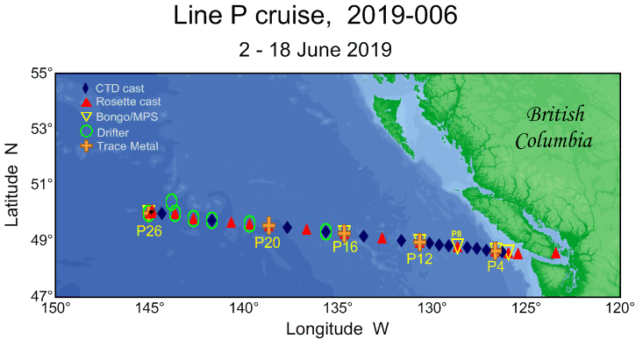

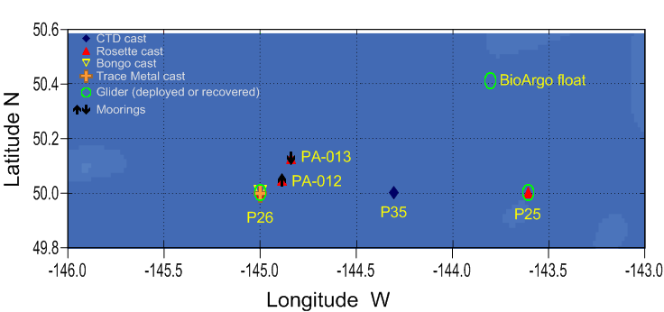

**SUMMARY/FINAL COMMENTS:**

* Many thanks to everyone at IOS and on board who have helped make this cruise a success, as much in the lab getting things ready as on board getting the ship ready and helping with watches. Also a special “thank you” to Germaine who looked at a few casts to make sure our equipment was working well and to Greg Middleton for his help with loading/offloading NOAA gear and dealing with it at the end of the cruise.
* Thanks to Captain Gronmyr for his invaluable help with weather forecasting and station planning. The success of the mooring work at Papa was partly due to the timing with weather.
* Thanks to bosun Bruce Wilson and all his deck crew for the assistance with our work; for being so well prepared to tackle the mooring deployment and recovery; and for looking after our gear with such care particularly during rough weather. The rosette recoveries in high waves were all flawless. Thank you also for keeping such a good eye on the LARS crane without which most of our work would be cancelled.
* Thanks to the engineering department for putting up with all our requests for tank retention.
* A big thank you to the officers for hours and hours of station keeping and adapting to sometimes last minute plans, as well as for sending the Grib files every day.
* Thanks to Chad for looking after our met station.
* Finally, a major thanks to the galley crew for feeding us so well and looking after us in such a wonderful way!

Marie Robert

* Big thanks to the crew and science personnel who helped out with deployment and recovery of Go-Flo’s and Niskin-X bottles.

Kyle Simpson

* Many thanks to the crew of the Tully for dealing with all the idiosynchronicity of net sampling off the aft deck in such a professional manner, very much appreciated. Also many thanks to Kenny Scozzafava for the setup of the oxygen kit and to Nina Nemcek for the hand over, very much appreciated.

Moira Galbraith

* I wish to thank the crew and captain of the *CCGS John P. Tully*, who made the sampling efforts possible.

Florian Lüskow

* I’d like to thank the captain and crew of the *Tully* for their excellent work and their interest in and support of our scientific program. Thanks to the galley crew for keeping us extremely well fed. Thanks to the IOS team and my fellow scientists for their help and their humour on deck and in the lab. And finally, a great big thank-you to Marie for her amazing organization and all of her hard work. Thank you very much also to everyone who helped sample and those who analyzed the samples in Saanich Inlet.

Jade Shiller

* I want to give a big thank you to everyone on the Tully, from the crew to the scientists for making this trip straightforward, welcoming, and also a blast. This small temporary community was always inclusive and supportive of one another which made the whole trip easier.

Josianne Haag

* A thank you is extended to everyone on the ship for making this an efficient, controlled, and successful turnaround of the Papa mooring. The Ocean Climate Stations group would like to extend our sincere gratitude for the provided ship time, as well as the opportunity to collaborate with the scientists and crew of the TULLY. We’d also like to acknowledge IOS for their continued partnership, hard work, and cooperation that make this ocean reference station mooring at Station P possible.

Nathan Anderson and William Higley

* We wish to thank Jade Shiller, Florian Lüskow, Josianne Haag, and everyone else who helped to monitor PIGI and collect discrete gas samples. Their assistance is very much appreciated! We also thank Marie Robert for enabling our participation in this cruise and facilitating the continuation of our time-series measurements. As always, we are very grateful to Marie for accommodating our research objectives.

Robert Izett

**PROJECTS AND RESULTS:**

**Water masses** – Marie Robert, DFO/IOS.

The February 2019 data featured an important temperature anomaly on the offshore section of Line P (fig 1 left) with respect to the 1956-1991 average down to a depth of about 80 m. It seems that the waters have stayed quite warmer than the long term average until now with the anomaly getting deeper, and just a touch of cooling at the surface near the coast (fig 1 right).

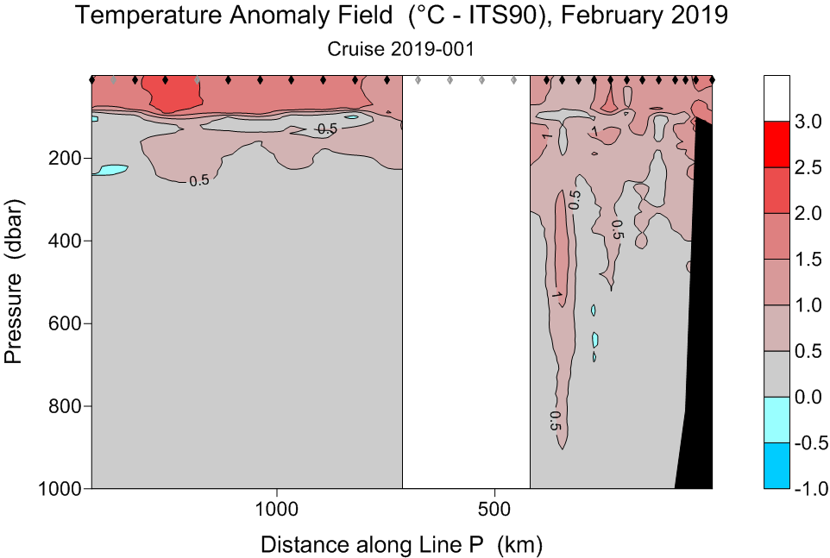 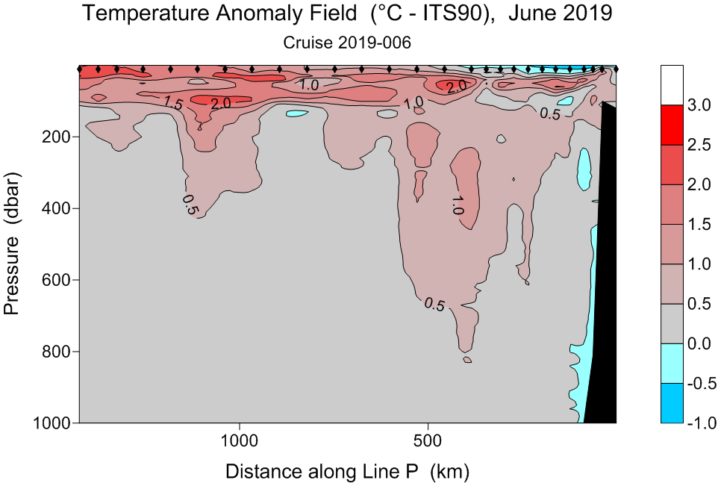

Figure 1: Temperature anomaly field with respect to the 1956 – 1991 averages for February 2019 (left panel) and June 2019 (right panel) showing warmer waters at the offshore end of Line P, with a slight surface cooling near the coast in June.

**Trace Metal sampling** – Kyle Simpson, DFO/IOS.

***Overview***: At all major stations (P4, P12, P16, P20 and P26), samples for the determination of dissolved (<0.2 um) and total dissolvable (unfiltered) trace elements were collected – Note: to avoid potential contamination from high concentration coastal waters, station P4 was sampled last (on the way back).

At the four offshore stations, 12 discrete depths per station were sampled, to a maximum depth of 800m. Station P4 was sampled at eight depths to a maximum of 300m. Target depths were 10m, 25m, 40m, 50m, 75m, 100m, 150m, 200m, 300m, 400m, 600m, and 800m.  Depths were confirmed using RBR Solo-D’s. Confirmed depths were generally within 5% of target depths.

***Sample Collection***: Seawater was collected using Teflon® lined Niskin-X bottles and Go-Flo bottles deployed from the starboard chains on a Kevlar line.  On return to the surface, the Go-Flo bottles were removed from the line and sampled in the wet lab next to a MAC10 type HEPA flow bench – all manipulations of samples (acidifications) took place inside an Airclean® 600 PCR hood with HEPA filtered laminar flow.

-        Samples for dissolved trace metals were filtered through a Millipore Opticap durapore cartridge filter (0.22 μm).

-        Sea-state conditions were not ideal for surface sampling thus the Zodiac was not deployed and true surface water was not collected – CTD casts indicate mixing to ~40m.

-        Bulk “surface” (10m) water was collected (filtered) for both UBC and IOS (approx. 20ℓ each).

-        A calibration cast was conducted at P26, where all bottles were closed at 10m and sampled in duplicate.

All samples were acidified on the day of collection (within 3 hours) with 1ml of 6N Seastar Baseline HCl per 250ml of seawater.

Big thanks to the crew and science personnel who helped out with deployment and recovery of Go-Flo’s and Niskin-X bottles.

**pCO2** – Michael Arychuk, DFO/IOS.

The system worked well with no major problems. There was a leak in the Ultra Zero gas cylinder which was traced to a cracked valve stem. It was, however, detected early by the daily checks and was temporarily repaired with only a minimal loss of gas. The data from the system was biased high by about 0.4 ppm due to the standards not fully flushing from the sample cell of the LiCOR. This was somewhat rectified by increasing the gas flows through the LiCOR but it remains a problem that will have to be addressed back in the laboratory simply because it is a problem that has never been encountered before and the increased gas flows resulted in an increased usage of standards.

**Carbonate Chemistry** – Michael Arychuk, DFO/IOS.

All required samples for DIC/ALK were taken without any problems at stations P1, P2, P4, P12, P20 and P26 for IOS. DIC/ALK/pH samples were also collected for MBARI at stations P21, P22, P24, P25 and P26. Note: the IOS samples were spiked with 100 µℓ of HgCl whereas the MBARI samples were spiked with 200 µℓ of HgCl.

**Zooplankton** – Moira Galbraith, DFO/IOS.

Bongo: vertical net haul from 250m to surface at stations P2, P4, P8, P12, P16 and P26; 1200m to surface at P8, P12, P16 and P26.

SCOR: vertical net haul from 250m to surface at stations P2, P4, P12, P16, P26 (sort of sample)

Multiple Net Sampler (MPS): one vertical nets haul; P4 from 1200m

No pteropods were found in samples on the shelf or offshore but I was able to collect several large *Limacina* from some of the deep tows for DNA and shell morpho-metrics.

The majority of the bongo tows went without a hitch. There was heave slack in the wire on the downward casts during weather stations leading to a slow descent rate, 0.1-0.3m/sec, until at least 100m of wire was out then the winch could speed up to 0.5m/sec. Adding more weight helped to compensate for the swells, still the bongo casts took longer than anticipated. This is probably due to the long run between winch and pulley of the A-Frame, more reactive to the larger swells.

There were several cancellations of net deployments due to high seas; no net samples collected at P20. Unfortunately, at P26, the SCOR net was deployed in less than ideal conditions; not once but twice. The net ripped and will have to be replaced, repair is not an option.

Water pressure for the zooplankton net wash down was solved by moving to the winch water coolant system, taking the pressure off the loop system pumps. This worked well and would like to keep using it for future aft deck plankton work, just remember to turn off water after use.

Many thanks to the crew of the Tully for dealing with all the idiosynchronicity of net sampling off the aft deck in such a professional manner, very much appreciated.

**Dissolved oxygen** – Moira Galbraith, DFO/IOS.

Oxygen profiles were collected for SI03, P1, P2, P4, P8, P12, P16, P20, P25, P26 and again at P4 on the return. SI03 bottom 5 samples were anoxic. Even being run at low O2 detection they were in the negative with a strong sulphur smell. At PA-012 and PA-013, four pairs of samples were collected in conjunction with ONAr samples.

The kit continued to run smoothly, no glitches or hiccups (except operator induced) after being passed off from the La Perouse survey. Many thanks to Kenny Scozzafava for the set up and Nina Nemcek for the hand over, very much appreciated.

**Contribution Cruise Report 2019-006** – Florian Lüskow, UBC.

*Gelatinous zooplankton identification and collection along Line P.*

Data on gelatinous zooplankton (GZ) biomass, abundance, and species composition collected on Line P, La Pérouse and other DFO cruises form the basis of my Ph.D. project. The motivation to join the June Line P survey (2019-006) can be summarised in three points (descending importance): (1) Deepening understanding of plankton sampling procedures and getting in touch with GZ species known from the database; (2) collecting GZ specimens of a variety of species for energy content determination via bomb-calorimetry as part of one of my thesis chapters; (3) supporting plankton collection using SCOR net for Lian Kwong. In total, 52 GZ specimens from 13 species have been collected (individually frozen at -80 °C) on P2, P4, P8, P12, P16, and P26 using vertical Bongo tows (110, 250 or 1,200 m to surface). Only fully intact specimens were picked. The coronate scyphozoan species *Periphylla periphylla* was encountered once, but not collected, similarly to a low number of calycophoran siphonophore nectophores (number of species and specimens not further investigated). Hydromedusae (8 species), salps (1), doliolids (1), pelagic gastropods (3), and ctenophores (1) were caught and frozen, while 61 % of all specimens were represented by a single pelagic tunicate species, *Dolioletta gegenbauri*. Participating in two other cruises this year (including La Pérouse) and one additional cruise next year in a similar area are anticipated to supplement the set of encountered species and extend the number of collected specimens used later for energy content determination. SCOR net samples from this survey will be taken to UBC for size-frequency-analysis by Lian Kwong (together with the broken SCOR net). I wish to thank the crew and captain of the *CCGS John P. Tully*, who made the sampling efforts possible.

**June 2019 Line P** – Jade Shiller, Hallam lab, UBC

**Objectives:**

Continue a decades-long time series studying the microbial diversity and geochemical properties of Saanich Inlet.

Describe the taxonomic and metabolic diversity of the microbial communities in the cycling of major nutrients along Line P, focusing on the communities in the oxygen minimum zone.

**Sampling summary:**

In Saanich Inlet (SI03),

1. At 17 depths, the following samples were collected: oxygens, gases, sulphides, 2 L high-resolution (HR) bacterial DNA sequencing, single amplified genomes (SAGs), cell counts, and filtered nutrients.
2. At 6 of those depths (10, 100, 120, 135, 150, 200), an additional 2 L seawater was collected for bacterial protein sequencing.

At 5 stations (P4, P12, P16, P20, and P26),

1. 2 L seawater samples (at 16 depths) for high-resolution (HR) bacterial DNA sequencing were filtered.
2. 30 mL seawater samples were taken per depth to count microbial population density using flow cytometry and single cell DNA analysis. Samples were aliquoted and preserved using glutaraldehyde and glycerol+trisEDTA, respectively.

Additionally, at 3 major stations (P4, P12, and P26), the following were sampled at four depths: 10, 500, 1000, and 2000 (bottom+10 at P4) across the oxygen minimum zone:

1. Large volumes (20 L; LV) at each depth were filtered to create genomic libraries of the bacterial communities. From each sample, the first 2 L were preserved for RNA sequencing. The remaining 18 L were preserved for DNA.
2. 30 mL seawater samples were collected per depth to count microbial population density using flow cytometry and single cell DNA analysis. Samples were aliquoted and preserved using glutaraldehyde and glycerol+trisEDTA, respectively.

**Comments:**

My sampling objectives for this cruise were fulfilled at all stations. The work area distribution was convenient for my sampling needs.

I very much appreciate the inclusion of SI03 in the sampling plan and IOS’s willingness to collect and process oxygen and nutrient samples at this station. This is vital to maintaining the time series that the Hallam and Tortell labs began more than 10 years ago, so thank you very much to everyone who helped sample and those who analyzed the samples in Saanich Inlet.

I’d like to thank the captain and crew of the *Tully* for their excellent work and their interest in and support of our scientific program. Thanks to the galley crew for keeping us extremely well fed. Thanks to the IOS team and my fellow scientists for their help and their humour on deck and in the lab. And finally, a great big thank-you to Marie for her amazing organization and all of her hard work.

**June 2019 Line P –** Josianne Haag, UBC

**Objectives**

1. Determine nitrification rates in OMZ for future denitrification studies.
2. Determine the distribution of microbes relative to each other and their functions in the water column at P26.

**Sampling summary**

1. Originally, I intended to take a sample from P4 and P12 as both are OMZs, the samples focused at the centre of each OMZ. However, due to being seasick at P4 I decided to do 800 and 1000 m at P12 which allowed me to get nitrification rates in slightly different micromolar concentrations of oxygen.
2. At P26 I sampled at 10, 500, 1000 and 2000 m and filtered the samples, preserving them to be sent to Germany where they will use FISH probes to determine if microbes using each other’s by-products can be found in similar areas/on the same particles.

**Comments**

I want to give a big thank you to everyone on the Tully, from the crew to the scientists for making this trip straightforward, welcoming, and also a blast. This small temporary community was always inclusive and supportive of one another which made the whole trip easier.

**OCS Cruise Report Writeup: Papa Buoy Operations** – Nathan Anderson and William Higley, NOAA.

DEPLOYMENT:

PA013 mooring operations began at 19:48 UTC on June 12, 2019. Subsurface instruments were pre-attached to the top 60m of nilspin flaked out on deck. The TULLY oriented into the prevailing winds/currents, and began approximately 5NM from the anchor drop site. The buoy was deployed off the starboard side using the crane, with line routed aft and up through a block on the A-frame. The remaining nilspin (60 – 325m) was routed around another block attached to the deck and around a capstan. By alternating A-frame positions, instruments were safely attached inboard and moved outboard to clear the fantail.

The nylon was routed similarly, as the ship steamed toward the anchor drop location at 1-2 kts. The mooring was towed just shy of 3 hours, and a Blake Slip with a sacrificial cable was used to release the anchor off the stern at 01:19 UTC. The anchor was dropped at 50° 07.592’N, 144° 50.418’W. As the ship turned around for a buoy fly-by, RF comms were established, and a rosette cast (at 3:00 UTC) was taken at 50° 07.72’N, 144° 50.26’W, within several hundred meters of the buoy. At fly-by, all systems and sensors were returning data.

Triangulation was attempted, but ranges were inconsistent. After positioning near the target anchor location of 50° 7.7’N, 144° 50.0’W and making the ship as quiet as possible, ranging suggested that the anchor had settled near our target position. Overall, this was an incredibly successful operation, and the weather-based decisions to optimize the timing of mooring operations were well-orchestrated.

RECOVERY:

PA012 recovery began at 14:15 UTC on June 13, 2019. The acoustic release was fired early to confirm release by both deckset and buoy drift. By releasing the mooring early, it allowed us time to sample ONAr and prepare for recovery at 10am (local time). A small boat was launched at 17:01 UTC, with the buoy aboard the TULLY by 17:51 UTC. The last of the nylon came on deck by 21:06 UTC, with immediate departure thereafter.

Minimal fouling was noted on the PA012 mooring, and instruments were easily cleaned and downloaded. Nylon was recovered onto the ship’s reels, and spooled back onto PMEL’s wooden reels in the subsequent days. All sensors were retrieved in working condition.

ACKNOWLEDGEMENTS:

A thank you is extended to everyone on the ship for making this an efficient, controlled, and successful turnaround of the Papa mooring. The Ocean Climate Stations group would like to extend our sincere gratitude for the provided ship time, as well as the opportunity to collaborate with the scientists and crew of the TULLY. We’d also like to acknowledge IOS for their continued partnership, hard work, and cooperation that make this ocean reference station mooring at Station P possible.

TULLY White Crew

Science Party – Mooring assistance, photography, documentation, and more

Marie Robert – IOS, Chief Scientist

Steve Romaine – Watch Leader (night), Moira Galbraith – Watch Leader (day)

**Line P Report –** Michael Livingston, UVic

My overall goal on this research cruise was to describe phytoplankton productivity and exopolymer exudation as a function of size class across the spatial gradient in oceanographic conditions along Line P. Ranging from the more productive waters closer to coast to the high nutrient low chlorophyll area of Ocean Station Papa, I measured phytoplankton productivity and potential nutrient limitation by spiking samples of natural assembles with tracer isotopes for carbon (13C), nitrogen (15N) and silica (32Si). I also ‘enhanced’ samples with nitrogen and silica to determine if phytoplankton in any of these stations were limited by either nutrient. After spiking and enhancements, the samples were placed in an incubator for 24h (at the appropriate light levels from which the samples were taken) and filtered. All samples were size fractionated to determine which size classes, if any, were most productive or most limited.

My other measurements included size fractionated biogenic silica and chlorophyll. Additionally, I took samples for nutrients, dissolved silica, bacteria and phytoplankton identification. This provides a more complete description of the water columns at each station to go along with productivity and exopolymer measurements. Finally, I took samples for the presence of exopolymers in the water column, which are known as being carbon-based gels formed from the exudations of primarily diatoms but also other phytoplankton and bacteria. These are officially described as transparent exopolymer particles (TEP).

**Line P (2019-006) Cruise Report –** Robyn Sahota, UVic

Fatty acid biomarkers are useful in elucidating zooplankton trophic connections, life cycle strategies, and reproduction. Fatty acids can yield relatively detailed dietary information, and are powerful tools when paired with stable isotopes, and visual methods such as gut content analysis. However, analysis of the DNA in zooplankton guts indicates that the diet is more diverse than previously thought. Furthermore, the precise identities of particular prey can be determined using resulting DNA sequences and public databases. Although this depth is not possible with fatty acid analysis, lipids may be more useful at determining relative inputs of phytoplankton versus microbial prey (e.g., via ingestion of bacterivorous microzooplankton). Thus, the combination of fatty acid and DNA analyses may yield a deeper understanding of the role of zooplankton in oceanic food webs. The sensitivity of molecular tools may provide information on smaller dietary items that are potentially significant ecologically. The goal of our dual-method approach is to better understand the role of dominant copepods and chaetognaths in NE Pacific food webs.

The Juniper lab, including Drs. Catherine Stevens and Kim Juniper, Kevin Yongblah and Robyn Sahota, at the University of Victoria will compare fatty acid signatures and the DNA in zooplankton guts, in a suite of 27 paired samples collected along Line P. Dominant copepod and chaetognath species were collected at 6 stations along Line P (P2, P4, P8, P12, P16, P26). Zooplankton samples were collected with a bongo vertical net haul towed to a depth of 250m. We chose to focus on both the well-studied herbivorous/omnivorous copepod species *Calanus marshallae* and *Neocalanus spp*., carnivorous copepod species *Paraeuchaeta elongata*, and abundant carnivorous chaetognaths (*Eukrohnia hamata, Parasagitta elegans, Parasagitta euniritica,* and *Pseudosagitta scrippsae*).

**Cruise Report – Robert Izett (Tortell Lab; UBC, Earth, Ocean & Atmospheric Sciences)**

During the June 2019 Line P expedition, we continued our four-year (2016-present) time series of net community production (NCP) estimates along the transect. To this end, we deployed an optode / gas tension device (GTD) system (i.e. the PIGI system) for underway measurements of seawater O2 and N2 concentrations from the *Tully*’s seawater supply line. This instrument ran autonomously and was monitored from land via iridium satellite transmission every six hours. Samples for O2 analysis via Winkler titration were obtained from the seawater loop at major stations (P4, P8, P12, P16, P20 and P26). These data will be used to calibrate the optode. Overall, data quality was good, and the system ran without interruption on both the inbound and outbound transects.

In addition, samples for surface water nitrous oxide (N2O) measurements were obtained at all stations (except P35) from the 5-m Niskin bottle. These data will be used to refine our NCP estimates for the contribution of vertical mixing and entrainment of O2 into the mixed layer.

**Comments and gratitude:**

We wish to thank Jade Shiller, Florian Lüskow, Josianne Haag, and everyone else who helped to monitor PIGI and collect discrete gas samples. Their assistance is very much appreciated! We also thank Marie Robert for enabling our participation in this cruise and facilitating the continuation of our time-series measurements. As always, we are very grateful to Marie for accommodating our research objectives.

**Cruise report: Line P June 2019 –** Fassbender/Haskell

The MBARI group’s goals for the cruise were to collect discrete samples to calibrate the sensor measurements and calculations made by biogeochemical profiling floats deployed in the region of dissolved and particulate organic/inorganic carbon pools. Specific goals were as follows: 1) Take samples collected via Niskin for DOC, TOC, and Gels at predetermined stations/depths for collaborators (Hansell, Johhanssen) and filter samples for POC and PIC at Stations P21, P22, P24, P25, and P26 at predetermined depths, 2) Take discrete DIC/pH/TA bottle samples at the same stations to be analyzed at MBARI, 3) Set up and run an underway sensor system that measures nitrate, pH, temperature and salinity (SUMO) and take discrete bottle samples periodically to calibrate these sensors to also be analyzed at MBARI, and 4) Recover a malfunctioning biogeochemical profiling float that was deployed near Station P26 in August 2018.

All goals were accomplished successfully. Various samples taken via Niskin for DOC/TOC and particulate filtering were accidentally mishandled or lost and detailed notes on each of these samples were taken in my notebook and will be delivered to each PI directly. The float recovery went as smoothly as possible. There was no observed damage to the float upon recovery in the small boat. All deckhands that assisted in the recovery effort were composed, efficient and handled the equipment with deliberate care.