**REVISION NOTICE TABLE**

|  |  |
| --- | --- |
| **DATE** | **DESCRIPTION OF REVISION** |
| 24 Mar 2024 | Corrected DO units in 4 CTD files G.G. |
| 17 Jan 2022 | Changed units of Oxygen:Dissolved:Saturation to %. G.G. |

**PROCESSING NOTES**

Cruise: 2018-106

Agency: OSD

Location: Vancouver Harbour

Project: Vancouver Harbour Survey

Party Chief: Spear D.

Platform: Shoal Seeker

Date: 10 September 2018 – 14 September 2018

Processed by: Germaine Gatien

Date of Processing: September 21 2018 – August 30, 2019

Number of Raw files: 100 Number of Processed Files: 100

# INSTRUMENT SUMMARY

RBR Concerto 1.41 #66024 with a DO sensor and a SeaPoint Fluorometer.

Sampling was at 6Hz.

# SUMMARY OF QUALITY AND CONCERNS

A paper log was available with positions and times of casts.

Many of the casts had a spike at the bottom that is believed to have been caused by the CTD hitting bottom. The spikes were removed in processing but could cause mud to enter the CTD leading to poor data quality.

Data from 15 casts stood out as being out of line with nearby casts, with lower conductivity (by about 0.8S/m) but no obvious problem with temperature. Salinity was lower than nearby casts by about 6psu and in some cases density near the bottom was unstable. The problem could be due to the inductive conductivity cell sampling an area larger than the cell, so any near-by objects such as rope could affect the reading. There was a rope in use during this cruise though it had a weight attached so it should not have come close to the cell. Contamination by debris in the water is a possibility as well as having the CTD hit bottom. Casts with bad downcast conductivity always follow a cast with bad upcast conductivity, so something happening at the bottom is implicated. The fact that the resumption of normal values happens over a few metres does not suggest the gradual clearing expected from such contamination and the near-constant offset is puzzling.

Whatever the cause, the downcast conductivity and salinity data from 15 casts (#8, 10, 12, 67, 68, 72-77, 83, 87- 89) look bad. For 4 of those casts (#8, 10, 77 and 83) the upcast data have reasonable values for conductivity so upcast CTD files were prepared. Since the data quality of those 4 casts are likely to be lower than those from downcasts, different channel names were used such as Salinity:Upcast for all channels except pressure and depth. For the other 11 casts that had no good conductivity in either the downcast or upcast, salinity and conductivity channels were removed from the downcast files; other channels were left as there were no obvious problems with those data.

# PROCESSING SUMMARY

##### Conversion to IOS Headers

The original files are in separate spreadsheets with header information. A single file with all the data and just a single line of headers was provided by Di Wan. These files contained downcast data only. A few adjustments were needed and a 6-line header was inserted. The combined DATE/TIME channels had to be separated. T* was used for the input time format.

CONVERT Spreadsheet was run to produce files with IOS Header format. Many header entries were included in this step but there was not room for everything required. The time interval is critical – other items can be added in the final Head Edit step. A few event numbers came out with the wrong number of digits and were renamed.

Based on information provided in file “2018-106_ctd_cast_log.csv” file “header-merge-final.csv” was prepared containing file names, latitude, longitude, water depth and station name. The formats were adjusted for latitude and longitude including removing the minus sign from longitude. The routine “Merge CSV Files to headers” was run to add those headers to the IOS files. (In future this step could also be used to add header items that didn’t fit in the conversion step.)

Next CLN was run to add a start time and event numbers to the headers.

Track plots and header checks were run and produced reasonable results.

##### Data processing

A number of corrections are suggested for RBR CTD data. These were investigated.

* Corrections for zero-order holds: These casts are too shallow to expect to see if values repeat while a recalibration is done by the instrument once per minute. There is no evidence that pressure has such regular repeats, but a typical cast takes only a few minutes and there are frequent pressure steps caused by irregular descent rates.
* Correction to Pressure: The CTD records total pressure and atmospheric pressure must be removed to obtain sea pressure. This step had already been applied, but a Header Check shows that there are some negative pressures at the surface, up to -0.3db. Plots show that most of those negative values correspond to extremely low conductivity values, with just 1 or 2 records having a pressure of -0.1db while conductivity appears to be registering believable values. So adding 0.1db looks like a reasonable adjustment to ensure that near-surface data are kept. CALIBRATE was used to adjust pressure and depth.
* Data despiking: There are only a few large spikes in conductivity and salinity. It is difficult to find an approach that fixes those few spikes without removing too much data, so this step was skipped. Since only 3 casts were involved a text editor was used to insert pad values in the bad data as they will cause problems with the FILTER routine..
* Reorder: In order to run any routines on pressure it is necessary to put the Pressure Channel ahead of the Pressure:Air channel so the correct one will be selected in IOS Shell routines.
* Filter: A Gull-winged filter, size 5, was applied to temperature, conductivity and pressure. Salinity was recalibrated and looks more stable after this step.
* Alignment: Based on suggested values in document “Guidelines for processing RBR CTD profiles” the following adjustments were made to conductivity and dissolved oxygen channels:
  + The alignment of temperature and salinity looks good. Tests showed no improvement with any choice using SHIFT.
  + In the absence of upcast data this step is a little harder to assess for dissolved oxygen, but aligning downcast features with those in temperature was useful. The advice given in document “Guidelines for processing RBR CTD profiles” was that an advance between 2 and 3 seconds is appropriate. For these data an 10 record (1.7s) advance worked best. Upcast data were later obtained and confirmed the setting was appropriate.
* DELETE was run to remove records with descent rate lower than 0.4m/s over 2 points.
* CTDEDIT was used to remove bad records at the bottom of about half the casts, and a few bad surface records; salinity was cleaned lightly. Many surface records have large changes in salinity in the first 1 or 2 records; most of those were removed as they like look there was a problem with flow to the CTD or that the sensors had not equilibrated. A few records were removed because of corruption due to slow CTD descent rate. Most such cases were removed already by DELETE.
* Profile and T-S plots of near-by casts showed that 15 of the casts had bad conductivity; they were randomly distributed in space and time (though more were late in the cruise than early), and produced a relatively constant salinity difference of ~6psu from other near-by casts and ~8mS/cm in conductivity.  Michael Dunphy had a look at the T/S plots and profiles and confirmed that the conductivity and salinity are bad.
* During this cruise the CTD hit bottom frequently, raising the possibility of contamination  by mud/soil. However, for many of the offset casts there is no indication that the CTD hit bottom on the previous cast. I got access to the upcast data and see that in every case with bad downcast data,  the conductivity was bad on the previous upcast, so it is something that arose at the bottom. However, for many of the offset casts there is no indication that the CTD hit bottom on the previous cast and in many cases when it did hit bottom the conductivity was fine on the upcast. For 2 casts the conductivity switched from bad to good values at the bottom. Sometimes the problem was resolved between casts, but often it persisted for a few casts. It seems obvious to blame contamination of the cell, yet the consistent offset worries me.
* 4 of the 15 problem casts have upcast data that looks ok, so those were put through the same steps as the other files except that they were put through REVERSE before DELETE in order to create upcast files. The downcast and upcast temperatures were compared to ensure that the data were ok on the upcast. Having the upcast in the plots also confirmed that the offset between downcast and upcast dissolved oxygen traces were in good correspondence to that of the temperature.
* The reversed files were of lower quality than downcast files due to more corruption by shed wakes but they look close enough to downcast files to be useful given the advantage of having salinity data. CTDEDIT was used to remove obviously corrupted data.
* The salinity and conductivity channels will be removed from the 11 files where they are clearly bad and no good upcast data are available. We will still archive the temperature, dissolved oxygen and fluorescence as those data seem ok. Given the way the cruise was organized there is still a good distribution of data.

##### Final checks and header editing

* CLEAN was run to add Start Time and End Time to the headers for some files.
* A cross-reference list was produced and checked against the log to ensure no errors were made in the headers. The only error found was in the start/end time of event 14 for which there were 2 deployments and the time of the 2nd deployment should be used. That was fixed in the header.
* Profile plots show reasonable values for fluorescence, temperature and salinity.
* DO saturation values at the surface are mostly ~85% in English Bay and the highest values (90% to 103%) were east of the 2nd Narrows. Between those two areas the lowest values were found, mostly between 80 and 90% but one cast was at 69%. The lower values are associated with better mixed surface waters. There was no calibration sampling and no climatology to enable a judgement about the data reliability.
* REMOVE was run to remove the following channels from all casts: Date, Time and Pressure:Air.

Channels Conductivity and Salinity:CTD were also removed from casts 12, 67, 68, 72, 73, 74, 75, 76, 87, 88 & 89.

* BIN AVERAGE was used to metre-average data.
* CALIBRATE was run to change conductivity units to S/m (using file 2018-106-recal2.ccf).
* Header Edit was used to fix channel names, to add a few header entries, remove END TIME and to add header comments. For casts 10, 13, 77 and 83 the channel names for T, C, S, DO and FL were changed to include Upcast, example “Temperature:Upcast”.
* Header Check was run and a single negative fluorescence value was found; it was replaced with a pad value. No other problems were found.
* A cross-reference file list was produced and looks fine.
* DO concentration was not derived since there are various equations used for this purpose, so it is left to the users to choose one consistent with other data in their studies. If you wish to derive DO concentration using IOS SHELL the following method is available:
* DERIVED QUANTITIES to derive Oxygen Solubility
* CALIBRATE using formula 182 to multiply Saturation X Solubility to get concentration in mass units.
* CHANGE UNITS to get DO concentration in volume units.

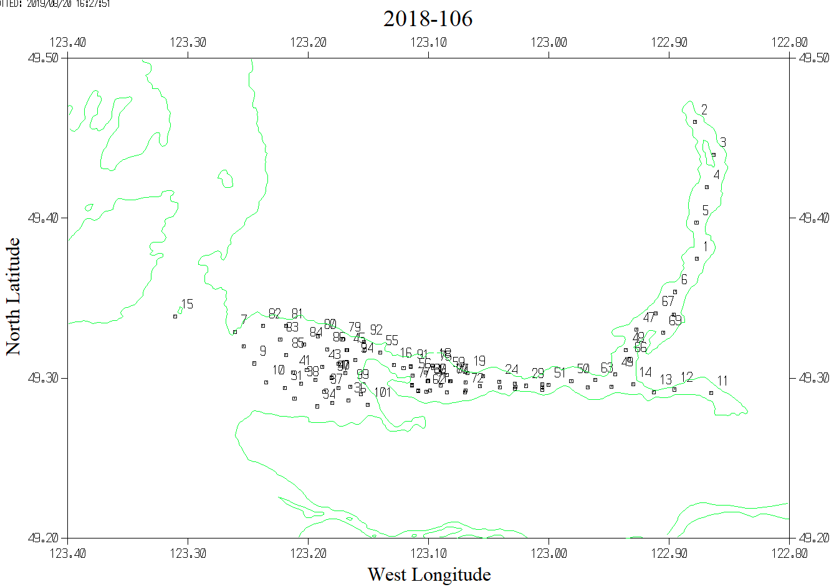

The map above shows all casts. Some had bad conductivity and salinity (See maps below). Note that casts #8, 10, 77 and 83 had bad downcast conductivity and salinity but the upcast data were good and so files were prepared for the archive using upcast data.

