REVISION NOTICE TABLE
DATE | DESCRIPTION OF REVISION

PROCESSING NOTES
Cruise: 2018-093
Agency: IOS, Ecosystem Sciences Division, Sidney BC
Chief Scientist: King J. Platform: Sea Crest
Location: Johnstone Strait/QC Sound Project: Juvenile Salmon Survey
Date: 9 June 2018 –17 June 2018

Processed by: Germaine Gatien
Date of Processing: 6 November 2018 – 9 November 2018
Number of original HEX files: 13
Number of CTD files: 13 Number of BOT files: 13

INSTRUMENT SUMMARY
A SeaBird Model SBE-25 CTD (s/n 0404) was used with temperature sensor #2449, conductivity sensor #1764, Wetlabs ECO Fluorometer #4185, dissolved oxygen sensor #1176, SBE pH sensor 0852 and pressure sensor #464.

SUMMARY OF QUALITY AND CONCERNS
The log book was in good order with many comments about sampling methods and problems encountered. This was a complex cruise on a small boat, and methods varied with time.

Header information was entered in the raw files in a format that permitted easy conversion into IOS Header format. That is very helpful.

A 5L Niskin bottle was used. It was attached with the top of the bottle 2m above the CTD except for event #6 (0.5m above) and event #10 (10m above). Chlorophyll and nutrient samples were taken at about 1m for event #1, 10m for events #2 and #6, at about 18m for event#12 and at about 2m thereafter. Salinity samples were taken at depth at 2 sites. In all cases there is some uncertainty about depth of sampling. This was especially so for one of the salinity samples where there may have been a problem with the Niskin bottle leaking or closing before or after the messenger was sent.

There were only 2 salinity samples taken and the differences between them and CTD values were both large and quite different from each other. The history of this instrument does not show significant calibration drift, though salinity sampling has been very limited. No recalibration was applied.

There was no dissolved oxygen sampling during this cruise or previous cruises using this equipment in 2017 and 2018. An inter-ship comparison of 2 casts from a June 2017 cruise using these sensors with a cast from a cruise that did include calibration sampling, suggested that dissolved oxygen values were likely low by up to 4%. A comparison with an SBE911+ cast at the same site during cruise 2018-05 had a lot of scatter but suggested that dissolved oxygen was reading low by at least 5%. Channel Oxygen:Dissolved:SBE was recalibrated by adding 5% to all values. Given that these sensors tend to drift towards lower values this correction may be an underestimate.

Because there was only 1 Niskin bottle available, 2 casts were required in order to get both a deep salinity sample and near-surface CHL and nutrient samples. This occurred for events 1&2 and 50&52.
The BOT file created to combine CTD and sample data carries the file name associated with the CTD cast. The salinity samples were not included in the BOT files because there is too much doubt about the depth from which the samples originate.

PROCESSING SUMMARY
1. Seasave - This step was completed at sea. The file names were non-standard; they included the station name but lacked the event number.

2. Preliminary Steps
The Daily Log and a spreadsheet of sampling done were provided.
The deployment method varied somewhat but for most casts the CTD was soaked at 10m then returned to the surface and a full cast was then run. For cast 10 there was an 11m soak but the CTD was only returned to 9m before starting the full cast, so no useful CTD data are available from the top 9m.
The cruise summary sheet was completed.

No configuration file was provided but one used for a previous cruise contained the correct information. It was saved as 2018-093-ctd.xmlcon.

3. Conversion of Raw Data
The HEX files were converted using configuration file 2018-093-ctd.xmlcon.
Plots show that the channels all produced reasonable values. The descent rates look fairly high but quite variable. Temperature and conductivity look normal with no large spikes. Fluorescence is very low for some casts and high for others; this is typical for this region with tidal mixing affecting some casts.

4. WILDEDIT
There were no significant spikes in the data, so WILDEDIT was not run.

5. WFILTER
Tests were run to find a suitable setting to remove steps in pressure without smoothing the pressure too much. WFILTER was run using a cosine filter, size 5 on the pressure, depth, temperature and conductivity channels.

6. ALIGNCTD
Based on tests run for other cruises in this project using the same DO sensor, ALIGNCTD was run on all casts to advance the DO channel by 2.5s. Plots were examined after this step and the results look good.

7. CELLTM
CELLTM was run on all casts using the SeaBird recommended parameters, (α, 1/β) = (0.04, 8).

8. DERIVE
Program DERIVE was run to calculate salinity and dissolved oxygen concentration (tau correction included). Plots were examined and confirmed that steps 5, 6 and 7 had improved the data.

9. Conversion to IOS Headers
The IOSSHELL routine was used to convert the CNV files to IOS Headers. One cast was missing its latitude header; that was added and the file was reconverted.
CLEAN was run to add event numbers and replace pad values in the pressure channel with interpolated values.

10. Checking Headers
A cross-reference list was produced and 2 casts had no latitudes entered. Those were entered based on log entries and the check was rerun.
All entries were compared with the log book entries. No other significant discrepancies were found though there are small differences in positions/times.
The track plots looked fine and were added to the end of this report.

The next step is to remove the data collected during soaks at 10m. CLIP was run to remove 1000 records from each cast. Plots were made after this step and casts 1, 10, 12, 17 and 28 had too many or too few records removed, so those were run separately. Cast #10 needs particular attention because the CTD was not brought up to the surface after the soak.

The header times are in PDT so ADD TIME CHANNEL was run to add 7 hours.

HEADER CHECK was run. There were some negative values in fluorescence and pressure; most will likely be removed by DELETE. This will be checked again later. No other problems were noted.
The surface check shows an average of 0.4db before CLIP was run and all the associated salinity values were very low except for cast #28 which had a minimum pressure of 2db and salinity ~30.75psu.

It is difficult to check the accuracy of the pressure sensor but examination of the end of casts as the pressure goes through 0 shows fluorescence and conductivity dropping rapidly as pressure varies from -0.3db to +0.3db. Those values are well within the specifications of ±1db. The minimum pressure recorded was -0.6db.

11. SHIFT
Conductivity
During 7 other cruise when the same sensors were used, a setting of +1.2 records was found suitable to align the conductivity with pressure. During 2018-96 that setting worked for most casts, though no setting seemed to help for a few. For 2018-035 and 2018-037 applying a setting of +1.2 made the alignment between the T and C traces worse and the resulting data looked much worse in T-S plots. A setting of -0.2 records made a slight improvement. Tests on the data from 2018-093 show no improvement with any setting, so SHIFT was not applied to conductivity.
Fluorescence
The fluorometer was not pumped, so a shift in alignment is expected to be small or unnecessary. Profile plots of temperature and fluorescence were examined and confirm that the alignment is good.
Dissolved Oxygen
This channel was aligned earlier, but checks were made by examining plots of temperature and dissolved oxygen. The alignment generally looks good, though as usual there are parts of profiles where a larger or smaller offset is seen in dissolved oxygen relative to temperature. Fine-tuning alignment is unlikely to improve both. No further adjustment was made.
pH
Tests were run on the alignment of the pH traces with temperature. An advance of 10 or 15 records was found to improve the alignment on other 2017/2018 cruises using this equipment. The same was true for this cruise with a setting of +10 records looking slightly better than +15. SHIFT was run to advance the pH signal by 10 records.

12. DELETE
REVERSE was run on cast #10. The output file was renamed 2018-093-8010.rev

DELETE was run on all casts using the following parameters:
Surface Record Removal: Last Press Min. Surface Swell Pressure Tolerance: 1.0
Swells deleted. Warning message if pressure difference of 2.00
Drop rates < 0.3m/s (calculated over 5 points) was deleted from 10db to 10db above the maximum pressure.
DELETE was run on 2018-093-8010.REV with output called *.DEL.
Surface data from this file will be used only to prepare a bottle file; the full file will not be archived.
COMMENTS ON WARNINGS: There were no warnings.

13. DETAILED EDITING
CTDEDIT was used to remove records near the top and bottom of many casts and to clean salinity where unstable features looked likely to be caused by misalignment of T and C. All casts except that from event #1 required some editing.
Notes of editing details were made in the headers.

T-S plots were examined after this step and no significant problems were found; there are small unstable features but this is an area where some instability is expected.

14. Initial Bottle Data Steps
There was no rosette available for this cruise. For 2 casts salinity samples were taken from a Niskin Bottle mounted about 2m above the CTD. Nutrient and extracted CHL samples were also taken at 10m, 18m, 2m or 1m depending on the cast.

Each of the analysis spreadsheets were examined to see what comments the analysts wanted included in the header file. These were used to create file 2018-093-bot-hdr.txt which will be updated as needed during processing. All of the spreadsheets included a precision study.
EXTRACTED CHLOROPHYLL
Extracted chlorophyll and phaeo-pigment data were obtained in file QF2018-093 CHL*.xls
SALINITY
Salinity analysis was obtained in spreadsheet QF2018-093SAL*.xls.
NUTRIENTS
Nutrient analysis was obtained in spreadsheet NUTS_QF2018-93_20*.xlsx.

15. Compare
One sheet in workbook 2018-093-bottle-CTD-comp.XLS was used to do comparisons between the CHL and CTD fluorescence and CTD and salinity bottle samples. This workbook will also be used later to create bottle files.

Salinity Comparison
There were only 2 bottles sampled for salinity though both had duplicates. Both samples were lower than the CTD, one by 0.05psu and the other by 0.30psu. The first cast was one with high variability but small range and the difference could be explained by that variability. The latter has no obvious explanation. The duplicates agreed well so analysis problems are not a likely explanation. It is unlikely that the CTD sensors have drifted that much and the result is out of line with comparisons from other cruises. Perhaps the Niskin bottle leaked or closed early or late. These data are insufficient to inform a decision about recalibration.

Fluorescence
Chlorophyll sampling was done at a variety of depths, but mostly 2m. The depth is not always completely clear, but examination of the depth at which the CTD stopped was used to make a judgment in those cases. The samples were taken immediately after CTD casts so a comparison with upcast CTD data may be most suitable. However, upcast data tend to be noisier so a comparison was done with both downcast and upcast data after they were bin-averaged and thinned to the closest depth available.
The comparisons looked similar. These results are fairly typical of this type of fluorometer which tends to read relatively lower as CHL values rise.

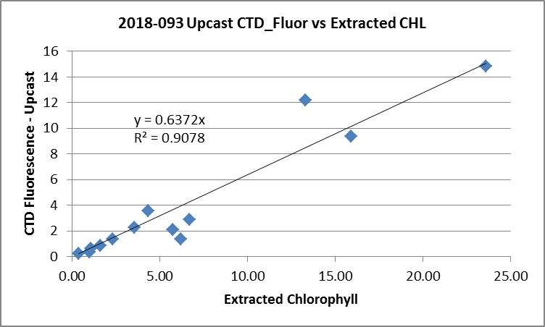
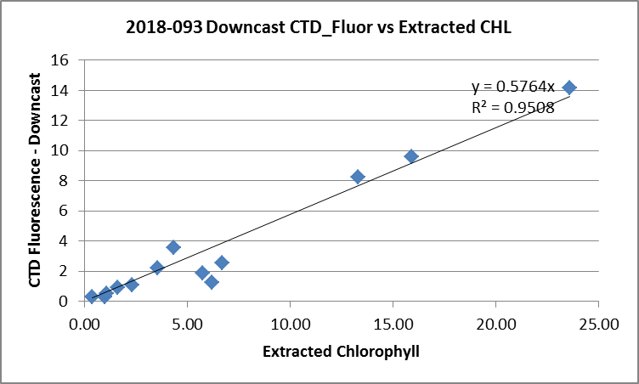

For more details see the comparison worksheet in file 2018-093-bottle-comp.xlsx.

16. Other calibration checks
Sensor History – Since they were last calibrated these sensors were used for 12 previous cruises. No problems were found in the pressure. There was little calibration sampling available but comparisons with nearby SBE911 casts were possible from 2 cruises and they suggested that the salinity was reasonably accurate. There was salinity sampling during 2018-035 and 2018-036 that suggest salinity was within 0.003psu. There was no dissolved oxygen sampling for any of the cruises. Dissolved oxygen was found to be low by at least 5% when compared to an SBE911 cast during 2018-05.
Results of later cruises – Cruise 2018-073 was run about a month after this cruise and used the same equipment but the only sampling was at about 2m, so it is not useful for calibration purposes.
Comparison of repeat casts –There were no repeat casts.
Historic Ranges – There was local climatology for only 8 of the casts. All temperature and salinity values fell within the climatology except for event #28 for which the temperature values were above the maxima between 125 and 250db; salinity values were below the minima at the same depths. This cast is in a narrow passage which may is likely not well represented in the climatology. Moreover, a 3-standard-deviation climatology is not appropriate so close to shore. The excursions are not considered indicative of calibration problems.
Post-cruise calibrations – None were available.

17. CALIBRATE
CTD Salinity will not be recalibrated.
There was no dissolved oxygen sampling but the results of a study on the same sensor during 2018-05 will be applied to these data.
The pressure does not need recalibration.

CALIBRATE was run using file 2018-093-recal1.ccf to apply the following correction to the Dissolved Oxygen: CTD Dissolved Oxygen Corrected = 1.05* CTD Dissolved Oxygen

18. Fluorescence Filter
A median filter, size 5, was applied to the fluorescence data.

19. Bin Average and REMOVE
The files were bin averaged using 1db bins.
There are a few negative fluorescence values at depth so CLEAN was run to replace those with pad values.
REMOVE was run to remove Scan_Number, Oxygen:Voltage, Descent Rate and Flag channels.

Dissolved Oxygen was derived in mass units and that was used to calculate DO saturation. Plots of near-surface saturation show a range of 75 to 125%. The lowest saturation rates were in or close to Johnstone Strait where tidal mixing is likely. The highest values were in Queen Charlotte Sound away from the coast and at one cast in Queen Charlotte Strait. The variability reflects differences seen in temperature gradients. These data tell us nothing useful about the DO calibration.

REORDER was used to get the 2 dissolved oxygen channels together.

20. HEADER EDIT and final checks of CTD files.
Header Edit was used to fix headers, fix formats and to add the following note to the headers:
Conductivity, Fluorescence:URU:Wetlabs and pH:SBE data are nominal and unedited
except that some records were removed in editing temperature and salinity.

Salinity calibration sampling from this cruise was insufficient to determine how
well the sensors were working. Previous cruises had limited sampling but
suggest that salinity is within 0.005psu.

There was no dissolved oxygen sampling during this cruise and most other cruises
using this equipment since it was last serviced. There was an inter-ship comparison
in June 2017 for 1 cast only that suggested that dissolved oxygen values were
likely low by up to 4%. A comparison with an SBE911+ cast at the same site during
a February 2018 cruise was limited to the top 50m but suggested that dissolved
oxygen was reading low by at least 5%.
Channel Oxygen:Dissolved:SBE was recalibrated by adding 5% to all values.

WARNING: The pH:SBE:Nominal data should be used with caution; no field calibration
data were available at the time of processing.
Calibration is required for each cast to get absolute values, although general
trends within a cast are likely real.

Warning: While the CTD fluorescence data are expressed in concentration units, they
do not always compare well to extracted chlorophyll samples. It is recommended that
extracted chlorophyll values be used where available.

For details on the processing see document: 2018-093_Processing_Report.doc.

A cross-reference listing was produced.
A header check was run on the CTD files and it was found that 2 casts (#24 and #28) had slightly negative fluorescence values near the bottom of casts. A return was made to the FILTER stage and CLEAN was run to replace such values with pad values. Bin-average, Remove, Change Units, Reorder and Headedit were rerun.
The header check was rerun and turned up no errors.
The sensor history was updated.
Plots of CTD casts were examined and no problems were found.

21. Final BOT file preparation
To enable searching of bottle data, BOT casts were created that contain sample data and CTD data from the preceding downcast. The event number will match the CTD cast.

A 6-line header worksheet was set up in workbook 2018-093-bottle-comp.xlsx. Data from the upcast at the nominal depths of CHL and Nutrient sampling were combined with the analysis results. Due to the salinity bottle samples looking like they might be from different depths than indicated, those 2 bottles were not included in this process. This is not a serious loss as the principal reason for creating BOT files is to create searchable files for the CHL and Nutrient data and to provide accompanying CTD data when possible.
The file was then saved as 2018-093-bottles_plus_CTD.csv.
The spreadsheet file was converted to IOS Header files for each cast.

The time and date are present as channels as these cannot be converted directly into header entries.
CLEAN was run to add START and END time. The END TIME is identical so the START time so it will be removed later. CLEAN was also used to enter 0 flags where the flag channels are empty and to remove channels with only pad values.
REMOVE was run to remove the DATE and TIME channels.

SORT was not needed since there is only 1 record per file.
HEADEDIT was used to add comments and to remove the END time since it is the same as START TIME. The final files have extensions BOT.

The standards check was run and no problems were found.
A cross-reference list and header check were run on the BOT files. The times were wrong so a return was made to the 6-line header file to correct the date/time formats. All steps were repeated from conversion to Headedit.
No further errors were found when a new cross-reference list was produced and when a header check was run.
Finally all data from BOT files were extracted to a spreadsheet and no further problems were found.

PARTICULARS – notes from logs
All times are local in the raw files.
1. Niskin attached with top 2m above CTD. 2 deep salinity samples
6. Niskin attached with top 0.5m above CTD. Niskin not closed so redeployed to 10m for bottle sampling.
10. Niskin attached 10m above CTD.
12-end – Niskin attached 2m above CTD.
45. Might have gone lower than 140m but did not appear that CTD hit bottom.
50. Deep salinity sampling.
56/57. CHL, nutrients and zooplankton samples were left out overnight.

CRUISE SUMMARY

Cruise ID#: 2018-093
Dates: Start: 9 June 2018 End: 14 June 2018
Location: Juvenile Salmon Survey
Party Chief: King J.
CTD# | Make | Model | Serial# | Used with Rosette? | CTD Calibration Sheet Competed?
1 | SEABIRD | 25 | 404 | No | Yes

CTD CALIBRATION INFORMATION
Make/Model/Serial#: SEABIRD/SBE25/0404 Cruise ID#: 2018-093

Calibration Information
Sensor |  | Pre-Cruise |  | Post Cruise
Name | S/N | Date | Location | Date | Location
Temperature | 2449 | 7Nov2015 | Factory
Conductivity | 1764 | 23Feb2017 | Factory
ECO Fluorometer | 4185 | 07Mar2017 | Factory
SBE43 Oxygen | 1176 | 11Nov2015 | Factory
pH | 0852 | 8Mar2017 | Factory
Pressure | 0464 | 28Feb2017 | Factory
