REVISION NOTICE TABLE
DATE | DESCRIPTION OF REVISION
20 March 2025 | Updated channel names & formats in TOB files. G.G.
13 May 2019 | File 2018-092-0001.TOB prepared with positions from file provided by chief scientist. See note at end of section 19.

PROCESSING NOTES
Cruise: 2018-092
Agency: OSD
Location : Juan de Fuca Strait, Haro Strait
Project: Marine Environmental Quality Program
Party Chief: Vagel S.
Platform: Vector
Date: 26 November 2018 – 2 December 2018

Processed by: Germaine Gatien
Date of Processing: 3 May 2019 –7 May 2019
Number of original HEX files: 43 Number of CTD files: 43
Number of original TSG files: 2 Number of processed TSG files: 1

INSTRUMENT SUMMARY
A SeaBird Model SBE-25 CTD (s/n 0456) was used with temperature sensor #5130, conductivity sensor #3500, WetLabs ECO fluorometer #4185, dissolved oxygen sensor #1592 and pressure sensor 0668.

A thermosalinograph (SeaCat 21 S/N 3411) was used with no intake temperature sensor or flow meter.

Software Version 1.59 was used for acquisition of SBE25 data.
The data logging computer was the Notebook #10.

SUMMARY OF QUALITY AND CONCERNS
The log book was in good order except that it contained no entries in the personnel list.

The file names were non-standard but contain the event number so were easily adjusted. This was done after conversion.

There were entries in the headers for station name, water depth, latitude and longitude. This would have been very helpful by enabling the information to be automatically entered into IOS headers when the data were converted to IOS Header format, but the position formats were wrong. Those items had to be edited to enable successful conversion. There were also errors in longitudes for some of the casts, with 124° entered where it should have been 123° and vice versa.

While CTD fluorescence data are expressed in concentration units, they do not always compare well to extracted chlorophyll samples.

There was no calibration sampling.

The deployment method was to lower the CTD to 10m and soak at that level and then return to the surface before running the full cast. The total soak time ranged from 1 to 4.5 minutes. The first 3 casts had very short soaks but from cast #9 onwards soaks lasted at least 3 minutes.

There were 2 thermosalinograph files. There was some doubt about which TSG was in use. The log and the first configuration file indicate that the TSG was #3411 and that TSG was used on the Vector in January 2019. But the 2nd file indicated the TSG was #3363. The 2nd file was started due to a server crash and it is likely that an error was made in choosing the proper configuration file at that point. The comparison of data with CTD data makes it clear that TSG #3411 was the instrument in use for both files.

There was no NMEA data download for the 1st file (Julian time is available); at the time of processing no other file was found with time/position data for that period. So only the 2nd file has been processed. If a another file is found on the ship computer that contains time and positions, it may be possible in future to add positions to the 1st file. The processed file (with 0 values for latitude and longitude) was saved as 2018-092-0001.HDR.

There was no flow meter, loop sampling or intake temperature sensor and the CTDs with which the TSG data were compared had not had a good calibration check in 1.5 years. Nonetheless, the comparison with the CTD showed a consistent pattern of TSG temperature being higher than the CTD by about 0.19C° and the TSG salinity being lower by ~0.03psu. Errors due to vertical mismatch between the waters sampled by the CTD and TSG data are likely small because the near-surface waters were mostly well mixed and drift in the sensors is unlikely to be large enough to lead to such large differences. So salinity was recalibrated by adding 0.03psu and a proxy for intake temperature was produced by subtracting 0.19C° from channel Temperature:Lab. The proxy channel is called Temperature:Primary.

PROCESSING SUMMARY

Seasave
This step was completed at sea; the raw data files have extension HEX.

Preliminary Steps
- The Log Book was obtained.
- The cruise summary sheet was completed.
- The histories of the pressure sensor, conductivity and dissolved oxygen sensors were checked. There have been 5 previous uses since the last factory check but there was no calibration sampling for any of them.
- The calibration control file was checked. There were no errors.

Conversion of Raw Data
All files were converted using configuration file 2018-092-ctd.xmlcon.
The file names were non-standard but contained the event numbers so were easily fixed.
The times in the files are in PDT, so 7 hours will be added later.

Plots were examined and all expected channels were present. Other than surface spikes the fluorescence values look very low.

The deployment method varied during the early casts, but from cast #10 onwards a standard deployment procedure was used: CTD turned on, put in water, down 10m, wait at least 3 minutes, return to surface and proceed with cast. The total soak time ranged from 1 to 4.5 minutes.

As during 2018-091 the pressures at the end of casts when conductivity approaches zero are about -0.6db, well within the ±1db accuracy quoted by SeaBird for the pressure sensor. Given that there would be some delay in moving water past the conductivity sensor as it lifts out of the water this is as close to 0db as can be expected.

WILDEDIT
Since there are no obvious spikes in the data below the surface, this step was skipped. The near-surface spikes will mostly be removed in the DELETE step.

FILTER
Tests run during 2017-24 and 2017-25 when CTD #0456 was used led to the choice of a filter of width 11. A width of 5 is more usual choice for this type of CTD and that was found best for 2017-060 and 2018-091 and looks best for these data as well.
Windows Filter was run with a cosine filter of width 5 on pressure, depth, temperature and conductivity.

ALIGNCTD
Tests were run to find the best setting to align dissolved oxygen with temperature traces. The best results are generally found when the DO channel is advanced by 2.5s and that worked well for these data.
ALIGNCTD was run to apply a 2.5s advance.

CELLTM
SeaBird recommend the use of (α, 1/β) = (0.04, 8) for CELLTM for the SBE 25 and it has proved appropriate for many data sets. It worked well on these data.
CELLTM was run on all casts using the default setting: (α, 1/β) = (0.04, 8).

DERIVE
Program DERIVE was run to calculate salinity and dissolved oxygen concentration (tau correction included).

As occurred during cruise 2018-092 the position information was entered in the headers with the wrong format so that the positions would not come out right when the files are converted to IOS HEADERS.
- What was entered was:
** Latitude: 48' 17.228
** Longtitude: 123' 37.061
- The correct format is:
** Latitude: 48 17.228 N
** Longitude: 123 37.061 W
So the headers were edited by removing the extra “t” in longitude and the apostrophe after the degrees and adding N or W.

Conversion to IOS Headers
The IOSSHELL routine was used to convert the CNV files to IOS Headers.
CLEAN was run to add event numbers.
A track plot showed that many positions were wrong.

A cross-reference list and details were checked against log entries. This showed that for a few casts the longitude was entered as 124° where it should have been 123° and in other cases the reverse error. Correcting those led to a much more believable track plot.

The start times are in PDT (despite the date), so Add Time Channel was run to add 7 hours to start times.

CLIP was run to remove initial records from each file so that data from the initial drop during the soak period do not get selected when DELETE is run. Plots were used to estimate the number to remove and again after the CLIP run to ensure no useful data were removed.

Checking Headers
Header Check was run and no problems were found.
Surface Values had almost all values at -0.6db with associated near-zero salinity.

SHIFT
Fluorescence
The fluorometer on the SBE25 was not pumped so alignment was not needed.
Conductivity
It has been found during some other cruises using this equipment that no setting improved most casts but for 2018-060 and 2018-091 a setting of +0.5records had a good effect. For this cruise many casts are well mixed with the only unstable features small and most likely real. A few casts did have small unstable features that looked like they might be due to misalignment and they were improved by advancing conductivity by +0.5 records.
SHIFT was applied to all casts to advance conductivity by +0.5 records.
Dissolved Oxygen
This channel was aligned earlier, but checks were made by examining plots of temperature and dissolved oxygen; the alignment looks good. SHIFT was not run on DO.

DELETE
DELETE was run on all casts using the following parameters:
Surface Record Removal: Last Press Min. Surface Swell Pressure Tolerance: 1.0
Swells deleted. Warning message if pressure difference of 2.00
Drop rates < 0.3m/s (calculated over 5 points) was deleted from 10db to 10db above the maximum pressure.
Pressure was not filtered as it had been filtered earlier.
COMMENTS ON WARNINGS: There were no warnings.

DETAILED EDITING
All DEL files were copied to *.EDT.
CTDEDIT was used to remove corrupted records, mostly at the top and bottom of casts. Salinity was cleaned lightly in a few casts. Notes of editing details were made in the headers.
Many files received little or no editing since it is hard to distinguish “real” unstable features from those of instrumental origin, particularly in Haro Strait. Nine files were not edited.

The edited files were copied to *.EDT.
T-S plots were examined after editing. There are many small unstable features but those are expected in regions of active mixing.

Other calibration checks
Sensor History – This CTD has been used for 5 other cruises since it was last serviced at the factory. There was no calibration sampling for any of them. No problems were found with pressure.
Comparison of repeat casts – There were no casts suitable to test repeatability.
Historic Ranges – Profile plots were made with a 3-standard deviation climatology ranges of T and S superimposed. All temperature data fell within the climatology except for the Swiftsure cast which had slightly high temperature at the bottom of the cast. Salinity data were all low at the Swiftsure cast and a little low near the bottom of a few casts near Sooke. Salinity was slightly high near the surface in Haro Strait. These excursions are not systematic and the climatology is not considered appropriate for near-shore casts, so the results are not suggestive of a calibration problem.
Post-cruise calibrations – None were available.

CALIBRATE
There is no information available upon which to base a recalibration of salinity or dissolved oxygen and the pressure looks fine. No recalibration was applied to the files.

Filter
A median filter, size 5, was applied to the 7fluorescence channel in the COR1 files. Plots of a few casts showed that the filter was effective. (Output:*.FIL)

Bin Average and REMOVE and DO saturation study
The files were bin averaged using 1db bins.

Dissolved Oxygen was derived in mass units.
Saturation rates were calculated and plots show near-surface saturation from 50% to 98%. The highest values were off Barkley Sound and at Swiftsure Bank and gradually decrease towards the east with a minimum of <60% in Haro Strait. While these values are low, they are typical of this region of well-mixed casts.

REMOVE was run to remove Scan_Number, Oxygen:Voltage, Oxygen:Dissolved:SBE, Descent Rate and Flag channels.

HEADER EDIT and final checks of CTD files.
Header Edit was used to fix headers, fix formats and channel names and to add the following note to the headers:
Data Processing Notes:
----------------------
Oxygen:Dissolved Conductivity and Fluorescence:URU:Wetlabs are nominal and unedited
except that some records were removed in editing temperature and salinity.

There was no calibration sampling.

Warning: While the CTD fluorescence data are expressed in concentration units, they
do not always compare well to extracted chlorophyll samples.

For details on the processing see document: 2018-092_Processing_Report.doc.

The standards check was run and no problems were found.
A cross-reference listing was produced.
A header check was run including files from both CTDs. No problems were found.
The sensor history was updated.
Plots of CTD casts were examined and no problems were found.

Thermosalinograph Data
There were 2 hex files. There was no flow meter. The sampling interval was 30s.
The 2nd file was started because of a server crash.

The TSG serial number differs in the 2 configuration files, #3411 and #3363 – each has correct configurations for the indicated TSG. There was a con file in the RAW data that appears to be from cruise 2018-089 and has the serial number as 3363, but 3411 was written in the log book and was used in a January 2019 Vector cruise. It is unlikely that the TSG was replaced between the casts due to a malfunction and then put back into use in January.

To be sure test conversions were done using both possibilities, so these can be compared with CTD data. The serial numbers had to be changed in the HDR and HEX files to match the XMLCON file. A further complication is that the first file did not have the NMEA position data added, so that had to be adjusted to enable conversion with different configuration files. An initial comparison suggests that the correct serial number is 3411 for both files. The 2nd file was started because of a server crash and it is possible that the information for the TSG 3363 was entered incorrectly at that point in the rush to get the new file opened.

The second file starts soon after the end of the first, and the change in temperature and salinity values is reasonable for both con file choices, which suggests that the same instrument was used for both.

Pending further information the assumption will be made the TSG 3411 was used throughout. The 1st file will be processed but unless position information becomes available it is not suitable for archival.

a.) Checking calibrations
The configuration file used at sea for the 1st file was checked and all parameters were correct, but the NMEA boxes were not checked. A version of this file was saved with those boxes checked so it could be used for the 2nd file. This TSG file was saved as 2018-092-tsg3411NMEAon.xmlcon

b.) Conversion of Files
The TSG files were converted to CNV files using file 2018-092-tsg3411.xmlcon. This worked for the 1st file but all position values are 0.

c.) Conversion to IOS Header Format and Initial Quality Checks
The CNV files were then converted to IOS HEADER format.
CLEAN was run to add End times and Longitude and Latitude minima and maxima to the headers.
ADD TIME CHANNEL was used to add Time and Date channels.

The time-series plots showed no significant spikes except at the beginning of the 1st file.

A track plot was produced for the 2nd file and looks fine. It was added to the end of this document. There are symbols every 2 hours.

CTD data were thinned to 2db and then exported to a spreadsheet that was saved as 2018-092-ctd-tsg-comp.xlsx. The TSG files were opened in EXCEL and the files were reduced to the times of CTD files.
There were no CTD data from 2db for cast #35 but there data from 1db and 2.9db. The vertical gradient was low, so the 2.9db data were selected.
There were 43 cases of overlap but only 19 cases that include latitude and longitude.

d.) Comparison of T and S from TSG and CTD data
To check for problems in the TSG clock or bad matches of TSG and CTD data, the differences between latitudes and longitudes were found. The median differences between latitude and longitude are both 0.0001° which is good but there are 2 longitude differences ≥0.001°. The time from the TSG files and the CTD files are not exact matches and in an area with strong east-west currents small mismatches in longitude will result.

Temperature and salinity were compared using all casts.
 | Lat diff | Long diff | Ttsg-Tctd | Stsg-Sctd
median | 0.0001 | 0.0001 | 0.1959 | -0.0349
average | 0.0001 | 0.0000 | 0.2061 | -0.0755
max | 0.0006 | 0.0018 | 0.2678 | 0.0868
min | -0.0005 | -0.0014 | 0.1620 | -0.8062
stdev | 0.0003 | 0.0009 | 0.0296 | 0.1346

TSG salinity was low by a median of 0.035psu ± 0.13. When plotted against standard deviation in the TSG data over 5 records (2 minutes) the salinity difference is found to decrease as standard deviations decrease. When only the casts with the 20 lowest TSG standard deviations are included, the TSG reads lower than the CTD by a median of 0.028psu.

TSG temperature was high by a median of 0.196± 0.030. When plotted against standard deviation in the TSG data over 5 records (2 minutes) the temperature difference is found to decrease as standard deviations decrease. When only the casts with the 20 lowest TSG standard deviations are included, the TSG reads higher than the CTD by a median of 0.0189C°.

The differences in temperature imply heating in the loop by about 0.19C°. This is slightly lower than was observed during 2018-091 in October using a different TSG. The intake temperature was just slightly higher in October than for this cruise which would result is less heating, but there were few overlapping CTD casts and very high standard deviations in the comparison from that cruise. Moreover there may have been differences in flow rates. The differences are remarkably close given the many variables.

Finally, a comparison was made between the two files since there is some doubt about which TSG was used for file #2. The 2 files have very similar differences. A test conversion showed that using TSG #3363 configuration file showed TSG temperatures being higher by ~0.60C° which would suggest much larger heating in the loop than is reasonable. It would also produce higher salinity by from 0.41 to 0.60psu which again would compare very poorly with the CTD data.
 | CTD Temp | Ttsg-Tctd | Stsg-Sctd
File 1 - Median | 9.2495 | 0.1969 | -0.0360
File 2 - Median | 9.1975 | 0.1959 | -0.0312

For more details see 2018-092-ctd-tsg-comp.xlsx.

e.) Calibration History
The temperature and conductivity sensors were recalibrated in November 2015 and used for 6 casts with the most recent being in early 2017. Salinity was found to be high by about 0.015psu during a June 2016 cruise. The temperature history is not useful since it was on the Tully which has a longer loop.

f.) Conclusions
- The time and position data from the CTD and TSG agree well.
- The same TSG was used for both files - #3411.
- The TSG lab temperature appears to be reading higher than the CTD temperature by about 0.19C°. We don’t have a lot of experience with the Vector loop system, but this amount of heating is reasonable when intake water temperatures are low.
- The first file has no positions so should not be archived at this time. If position/time data are found in another ship file later, it may be possible to add it.
- TSG salinity is appears to be low by 0.03psu and given that most of the waters sampled are quite well mixed near the surface, that error is likely due primarily to either bubbles in the loop or calibration drift. The TSG salinity will be recalibrated by adding 0.03psu. The CTD salinity has some uncertainty as well as there was no calibration sampling, but the CTD error should be well under 0.03psu. Nonetheless, using only 3 decimal places for T and S is appropriate.
- A proxy for intake temperature will be created by subtracting 0.19Cº from the lab temperature.

g.) Editing
The ATC file #1 was opened in CTDEDIT to pad temperature, salinity and conductivity values for the first 232 records because the flow had not been turned on in the loop until about record #225 and the system would have taken a few minutes to adjust.

h.) Recalibration
Add Channels was used to add Channel Temperature:Lab with values set equal to Temperature:Primary.
Calibrate was run using file 2018-092-tsg-recal1.ccf to subtract 0.190Cº from Temperature:Primary and to recalibrate Salinity:T0:C0 by adding 0.03psu. It should be noted that there was no calibration sampling for the CTD so there is more uncertainty in these corrections than usual.

i.) Preparing Final Files
REMOVE was used to remove the following channels from all casts: Scan Number and Flag.

HEADER EDIT was used to add a comment, change the DATA TYPE to THERMOSALINOGRAPH and add the depth of sampling to the header and to standardize channel names. Formats for temperature and salinity were set to only 3 decimal places to reflect lower confidence in accuracy.
- File #1 was given extension HDR and an extra comment was entered to explain that the data are not suitable for the OSD DATA ARCHIVE.
- File #1 was saved with extension TOB file.
The Standards Check and Header Check were run; no problems were found.
The TSG sensor history was updated.
As a final check time series and cruise track plots were examined and both looked fine.

May 13, 2019: A file with GPS positions was provided by the chief scientist that enable addition of positions to the HDR file described in the previous paragraph. File 2018-092-0001-tsg-positions.csv had 3 records per minute while the TSG file had 2 per minute. The GPS records were assume to be at 20, 40 and 60seconds while the TSG was at approximately 30 and 60s. So the 20s and 40s positions were averaged. That average plus the 60s values were then converted to an IOS file. The start time was entered into the header of that file. ADD TIME CHANNEL was used to add Time:Date with output *.ATC. The HDR file prepared previously was then merged with the ATC file. CLEAN was run to add start and end positions. Remove and Reorder were used to get the channels in the same order as the file for event #2 and the file was saved as *.TOB. A track plot was produced and looks fine except that there are still major sections without positions, so joining positions leads to a straight line across land. A better map is produced by displaying positions every 5 minutes without joining. A time-series plot looked fine.

Particulars (notes from log book)
1. Cast aborted
2. Cast redeployed with weight due to current.
7. Aborted cast early to correct problem with winch.
10. Some differences in deployment between night and day crew. Established standard deployment procedure. CTD turned on, put in water, down 10m, wait 3 min, return to surface and proceed with cast.
12. Stop at 235 on way down due to winch problem.
46. Stopped a few times on way down due to a spooling problem.

CTD CALIBRATION INFORMATION
CTD# | Make | Model | Serial# | Used with Rosette? | CTD Calibration Sheet Competed?
1 | SEABIRD | 25 | 456 | No | Yes

Make/Model/Serial#: SEABIRD/SBE25/0456 Cruise ID#: 2018-092

Calibration Information
Sensor |  | Pre-Cruise |  | Post Cruise
Name | S/N | Date | Location | Date | Location
Temperature | 5130 | 22Feb2017 | Factory
Conductivity | 3500 | 23Feb2017 | Factory
WetLabs Eco Fluorometer | 4185 | 7Mar2017 | Factory
SBE43 Oxygen | 1592 | 02Mar2017 | Factory
Pressure | 0668 | 28Feb2017 | Factory

TSG CALIBRATION INFORMATION
Make/Model/Serial#: SEABIRD/SBE21/3411 Cruise ID#: 2018-092

Calibration Information
Sensor |  | Pre-Cruise |  | Post Cruise
Name | S/N | Date | Location | Date | Location
Temperature | 3411 | 7Nov15 | Factory
Conductivity | 3411 | 7Nov15 | Factory

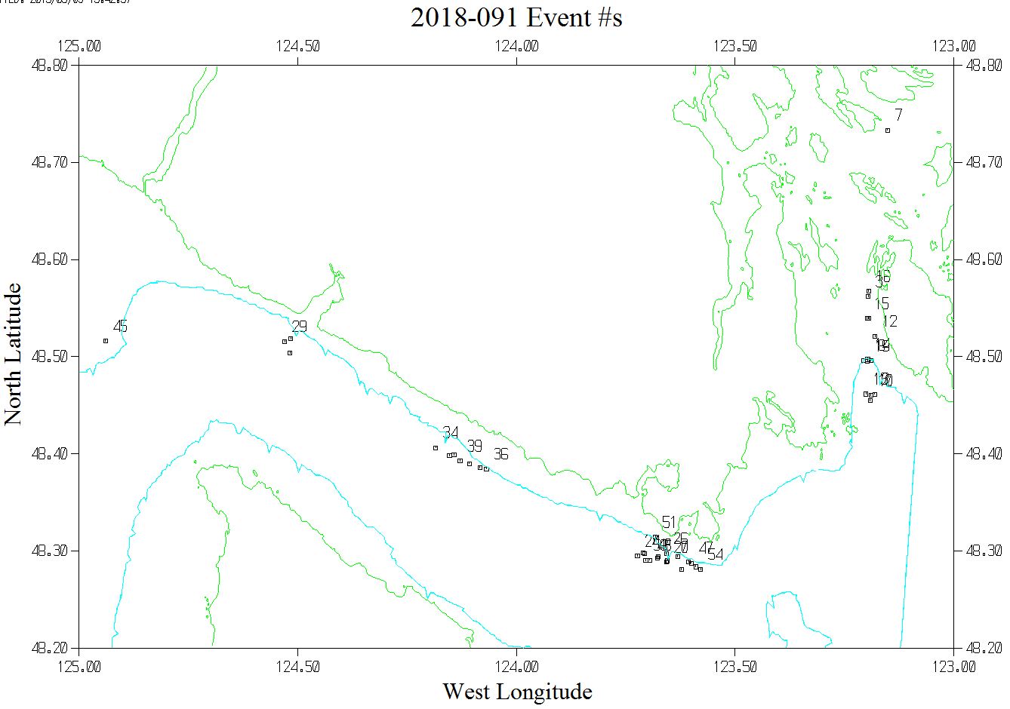
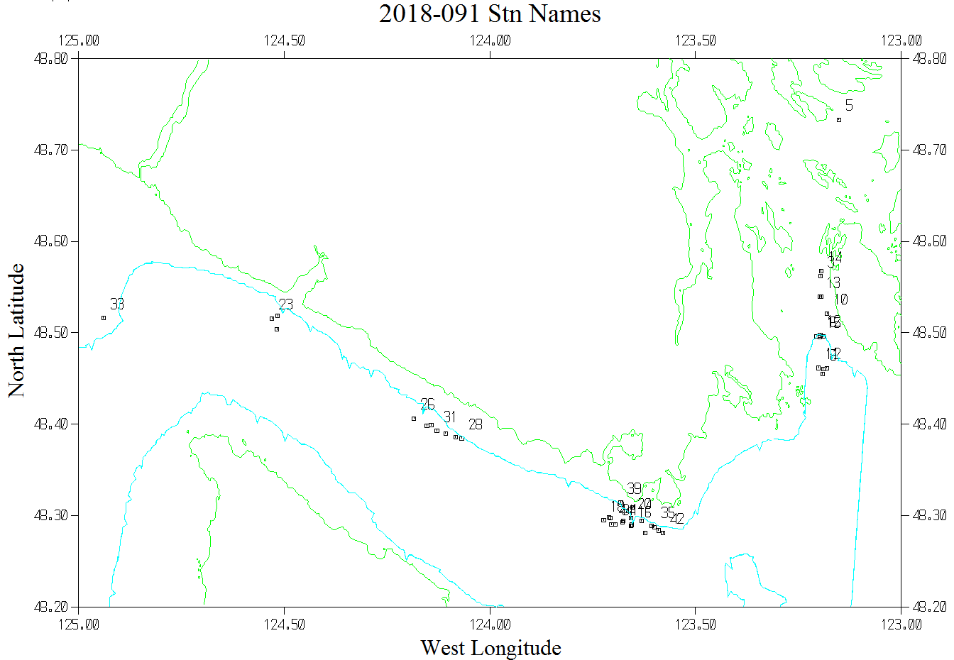
Note: There were no position for file #1 so only file #2 is displayed below.

