REVISION NOTICE TABLE
DATE | DESCRIPTION OF REVISION

PROCESSING NOTES
Cruise: 2018-073
Agency: IOS, Ecosystem Sciences Division, Sidney BC
Chief Scientists: King J. (July 5–17) / Boldt J. (July 18-29)
Platform: Sea Crest
Location: WCVI/NCVI Project: IPEC
Date: 5 July 2018 –29 July 2018

Processed by: Germaine Gatien
Date of Processing: 5 April 2019 – 25 April 2019
Number of original HEX files: 50
Number of CTD files: 49 Number of BOT files: 50

INSTRUMENT SUMMARY
A SeaBird Model SBE-25 CTD (s/n 0404) was used with temperature sensor #2449, conductivity sensor #1764, Wetlabs ECO Fluorometer #4185, dissolved oxygen sensor #1176, SBE pH sensor 0852 and pressure sensor #464.

SUMMARY OF QUALITY AND CONCERNS
The log books had a good record of CTD casts and good notes about problems encountered. There was an error in the equipment list with the wrong number being used for the dissolved oxygen sensor. This was understandable as there can be many numbers on a single sensor. Taking photos of the sensors is highly recommended even if the same equipment was used on the previous cruise as it can resolve issues such as this. There was no configuration file provided which would also have helped.

The data from the first leg had non-standard file names and there were several versions of file names. For the second leg the names were in standard format. The water depth was entered incorrectly in many files with the maximum pressure entered instead; the depths were corrected based on the logs.

For most casts there was a soak at about 4 to 5m for about 2 minutes. This appears to be sufficient for the salinity sensor to equilibrate, but not for the dissolved oxygen sensor which may have values that are too high at the beginning of the full cast. A deeper and/or longer soak is recommended if an oxygen sensor is in use. SeaBird recommend a soak at 10m. For a few casts there was either no return to the surface after the soak or a very short soak.

A 5L Niskin bottle was used. It was attached with the top of the bottle 1 or 2m above the CTD. When the CTD was near the surface the wire was pulled towards the ship in order to attach a messenger. The CTD then dropped to between 4m and 7m, so a rough estimate is made that the Niskin was closed at ~4m.

BOT files contain sample data together with CTD data taken from 4m during the downcast with a few exceptions. For cast #2 upcast CTD data were used. For cast #167 the pump was either off or malfunctioned, so no CTD data are available. For cast #152 there were no good 4db data available from the downcast so 5db downcast data were selected instead.

For most casts there were header entries in the raw files for latitude, longitude, station name and depth in a format that permitted easy conversion into IOS Header format. That is very helpful. However, for CTD events #10 to #72 the information in the files were wrong with each cast containing the information from the previous cast. There were a few casts without header information and there were errors in the first 2 casts that may have been due to NMEA problems. The bridge log was very helpful in sorting out those errors.

The comparison of CTD salinity with near-surface salinity samples has a lot of scatter which is typical of surface samples. The median differences were small, but the standard deviations were 0.17psu for the downcast comparison and 1.02psu for the upcast. When differences >0.1psu were excluded the downcast salinity was found to be higher than bottles by ~0.001psu and the upcast lower by 0.094psu; standard deviations were 0.033psu and 0.530psu, respectively. There were only 6 major outliers in the downcast and 28 in the upcast. So the downcast result looks most reliable and suggests that the CTD salinity is within 0.005psu allowing for some error in the bottle values. The history of this instrument does not suggest significant calibration drift, but salinity sampling has been very limited. No recalibration was applied.

The comparison of downcast SBE Fluorescence data with extracted chlorophyll samples looks good; the comparison using upcast data is much noisier and the sensor reads lower relative to CHL than during the downcast.

There was no dissolved oxygen sampling during this cruise or previous cruises using this equipment in 2017 and 2018. An inter-ship comparison of 2 casts from a June 2017 cruise using these sensors with a cast from a cruise that did include calibration sampling, suggested that dissolved oxygen values were likely low by up to 4%. A comparison with an SBE911+ cast at the same site during cruise 2018-05 had a lot of scatter but suggested that dissolved oxygen was reading low by at least 5%. Channel Oxygen:Dissolved:SBE was recalibrated by adding 5% to all values. Given that these sensors tend to drift towards lower values this correction may be an underestimate.

PROCESSING SUMMARY
1. Seasave - This step was completed at sea. The file names for Leg 1 were non-standard and there were multiple copies of some files with different names. Each file had to be opened to find what event number to include in the file names. For Leg 2 the file names were in standard format.

2. Preliminary Steps
The Daily Log and a spreadsheet of cast details were provided.
The serial number for the dissolved oxygen sensor was given as 87893 but we do not have such a sensor on record. The cruises before and after this one had DO sensor #1176. The number 87893 is present on the sensor but is a factory service number. Taking a photo of the sensors is highly recommended even if the same equipment was used on the previous cruise.

No configuration file was provided but one used for a previous cruise contained the correct information. It was saved as 2018-073-ctd.xmlcon.

3. Conversion of Raw Data
The HEX files were converted using configuration file 2018-073-ctd.xmlcon.

Plots show that the channels all produced reasonable values. The descent rates look fairly high and many are extremely noisy. Temperature, conductivity, fluorescence and pH traces look normal.
File 167 looks very odd – the pumps may have malfunctioned.

4. WILDEDIT
There were no significant spikes in the data, so WILDEDIT was not run.

5. WFILTER
In previous uses of this equipment WFILTER was run using a cosine filter, size 5 on the pressure, depth, temperature and conductivity channels. Tests were run for the data from this cruise to see if those settings would remove steps in pressure without over-smoothing the pressure. Steps were smoothed but some reversals were not. The conditions were fairly rough so some reversals are real and will be removed at the DELETE stage. WFILTER was run on all casts using the usual settings for this equipment.

6. ALIGNCTD
Based on tests run for other cruises in this project using the same DO sensor, ALIGNCTD was run on all casts to advance the DO channel by 2.5s. Plots were examined after this step and the results look good.

7. CELLTM
CELLTM was run on all casts using the SeaBird recommended parameters, (α, 1/β) = (0.04, 8).

8. DERIVE
Program DERIVE was run to calculate salinity and dissolved oxygen concentration (tau correction included). Plots were examined and confirmed that steps 5, 6 and 7 had improved the data.

9. Conversion to IOS Headers
The IOSSHELL routine was used to convert the CNV files to IOS Headers.
CLEAN was run to add event numbers and replace pad values in the pressure channel with interpolated values.

10. Checking Headers
An initial cross-reference listing and header check turned up some problems.

For most casts there were header entries in the raw files for latitude, longitude, station name and depth in a format that permitted easy conversion into IOS Header format. That was a help. But there were a number of errors that found by doing track plots and comparing positions in data files with those in spreadsheet CTDBongoBridgeLog.xlsx. Problems found included:
- Header information was missing from some files
- Cast #2 had header information that was very different from the entry in the Bridge Log though it did match the Daily Science Log.
- There were errors in the headers for casts #6 to 72 – they had the previous cast’s details including station names and depths.
- There was an error in the longitude of event #34 (126° instead of 128°). While the file longitude matches the entry in the Daily Science Log Book, it disagrees with the entry in file CTDBongoBridgeLog.xlsx and requires very high speed between casts. Using 128° produces good results so that was used to correct the file header and a note was entered in the log book.
- Event #38 had the same error in the header though it was correct in the log.
- Many depth entries were wrong – the maximum pressure had been entered instead of bottom depth.
The errors were corrected in the RAW files in folder CORRECTED HEX FILES, and all the previous steps were repeated. The header checks including a track plot were repeated until all errors had been corrected.

The track plots were then added to the end of this report.

The next step is to remove the data collected during soaks at around 4m. Plots were made to estimate how many records should be removed.
CLIP was run to remove records from each cast and plots were examined afterwards to judge effectiveness of the clip.
This is a time-consuming process. If an attempt is made to aim for a certain interval between the file start and the beginning of the full cast (say 2 to 3 minutes) it helps make this process quicker. There are inevitably some variations in the process but if most start at a given time, it is useful.

HEADER CHECK was run. There were some negative values in fluorescence and pressure. The ECO fluorometer gets very close to zero in dark waters so that instrument noise produces small negative values. There are also some surface negative values due to a delayed start to data acquisition from that sensor. Negative values will be replaced with 0s later.

The surface check shows an average of 0.8db before CLIP was run and all the associated salinity values were very low as expected as acquisition starts immediately at deployment.

It is difficult to check the accuracy of the pressure sensor but examination of the end of casts as the pressure goes through 0 shows fluorescence and conductivity dropping rapidly as pressure varies from -0.1db to +0.3db. Those values are well within the specifications of ±1db. The minimum pressure recorded was -0.3db except for one large spike in cast #30.

11. SHIFT
Conductivity
During 7 other cruise when the same sensors were used, a setting of +1.2 records was found suitable to align the conductivity with pressure. During 2018-96 that setting worked for most casts, though no setting seemed to help for a few. For 2018-035 and 2018-037 applying a setting of +1.2 made the alignment between the T and C traces worse and the resulting data looked much worse in T-S plots. A setting of -0.2 records made a slight improvement. Tests on the data from 2018-093 showed no improvement with any setting. For this cruise 3 casts tested all looked worse with a variety of settings from -0.5 to +1.2.
For this cruise, so SHIFT was not applied to conductivity.
Fluorescence
The fluorometer was not pumped, so a shift in alignment is expected to be small or unnecessary. Profile plots of temperature and fluorescence were examined and confirm that the alignment is good.
Dissolved Oxygen
This channel was aligned earlier, but checks were made by examining plots of temperature and dissolved oxygen. The alignment generally looks good, though as usual there are parts of profiles where a larger or smaller offset is seen in dissolved oxygen relative to temperature. Fine-tuning alignment is unlikely to improve both. No further adjustment was made.
pH
Tests were run on the alignment of the pH traces with temperature. An advance of 10 or 15 records was found to improve the alignment on other 2017/2018 cruises using this equipment. The same was true for this cruise with a setting of +10 records looking slightly better than +15. SHIFT was run to advance the pH signal by 10 records.

12. DELETE
DELETE was run on all casts using the following parameters:
Surface Record Removal: Last Press Min. Surface Swell Pressure Tolerance: 1.0
Swells deleted. Warning message if pressure difference of 2.00
Drop rates < 0.3m/s (calculated over 5 points) was deleted from 10db to 10db above the maximum pressure.
COMMENTS ON WARNINGS: There were warnings for 2 casts, Events #30 & #167. Both pertain to spikes at the end of the cast, so will not affect processed files.

13. DETAILED EDITING
CTDEDIT was used to remove records near the top and bottom of many casts and to clean salinity where unstable features looked likely to be caused by misalignment of T and C.
All casts required some editing.
Most casts needed editing near the surface and the bottom of casts.
For many casts the descent rate was very noisy with some complete reversals of direction. Program DELETE removes some corrupted data but not all, so editing was required to remove such bad records.
Notes of editing details were made in the headers.

T-S plots were examined after this step and with 1 exception no significant problem was found.; there are a few small unstable features near the surface but these could be real.

As noted earlier there was a problem with cast #167. When the data were plotted on a T-S surface together with those of 2 nearby casts, this cast looks bad. Both the downcast and upcast look as though the pumps were either turned off or not operating properly. Bottle salinity values confirm that while the CTD data are reasonably close to bottles for casts #164 and #170, there is a large difference for cast #167. Cast #167 will not be processed further.

14. Initial Bottle Data Steps
There was no rosette available for this cruise. For each cast 1 Niskin bottle was mounted above the CTD.
The distance between the CTD and bottle was changed to 1m at cast #123 – it is not known what it was before that, but the firing level is said to be 2m throughout. Plots suggest that this was more likely 4m or there would have been no wait before firing.

Each of the analysis spreadsheets were examined to see what comments the analysts wanted included in the header file. These were used to create file 2018-073-bot-hdr.txt which will be updated as needed during processing. All of the spreadsheets included a precision study.
EXTRACTED CHLOROPHYLL
Extracted chlorophyll and phaeo-pigment data were obtained in file 2018-73 CHL QF*.xls
SALINITY
Salinity analysis was obtained in spreadsheet QF 2018-73 SAL*.xls.
NUTRIENTS
Nutrient analysis was obtained in spreadsheet NUTS_QF2018-93_20*.xlsx.

15. Preparation of spreadsheet combining CTD and Sample Data
To enable searching of bottle data, BOT casts are created that contain sample data. CTD data are added from a suitable depth from the downcast. There is some uncertainty in the sampling depth, but 4m looks like a reasonable estimate based on examination of plots. CTD data are not available for that depth for some casts. Downcast data were selected rather than upcast based on the results of previous cruises; the upcast data tend to be very noisy because the CTD passes through that level shortly after the stop to fire the bottles. The water is stirred up by the equipment and there are shed wakes. It has been found that the CTD upcast values do not compare as well to bottles as those from downcasts. Exceptions:
- Cast #2 has no downcast data close to 4db so upcast data will be selected.
- There was also no good 4db data from the downcast of cast #152, so 5db data will be selected.
- There are no CTD data for event #167 but a line was created because there are bottle data.

A 6-line header worksheet was set up in workbook 2018-073-bottle-plus_CTD-6linehdr.csv.
The edited files were bin-averaged and thinned to 4m in order to obtain preliminary data to add to the file. This will enable comparisons of CTD and bottles.
Separate Date and Time columns are required, so the combined Data/Time column was copied to both columns and then formats for Data and Time were set as needed.
A subset of these data was saved as 2018-073-bottle-CTD-comp.xlsx.

16. Compare
File 2018-073-bottle-CTD-comp.XLS was used to do comparisons between the CHL and CTD fluorescence and CTD and salinity bottle samples. Usually we find better comparisons with downcast data than with upcast because there is less corruption of the CTD data due to moving through the shadow of the equipment. Also, no editing is applied to the upcast data as it is a very time-consuming job and usually removes too much data to enable comparisons. However, the downcast near-surface data is somewhat problematic in that some soaks appear to have been too short for equilibration of sensors, particularly salinity. This shouldn’t affect fluorescence. To test which data were more useful, data were obtained from upcasts by putting files through REVERSE, DELETE, BIN AVERAGE and THIN to get 4m data (using files before the DELETE step).

Salinity Comparison
The downcast CTD salinity was lower than the bottle salinity by a median of 0.0044psu and standard deviation of 0.17psu.
The upcast CTD salinity was lower than the bottle salinity by a median of 0.0002psu but the median difference was 1.02psu.
When differences >0.1psu were excluded the downcast CTD salinity was higher than bottles by 0.001psu while the upcast was lower than bottles by an average of 0.094psu. There were 6 major outliers for the downcast and 28 for the upcast.
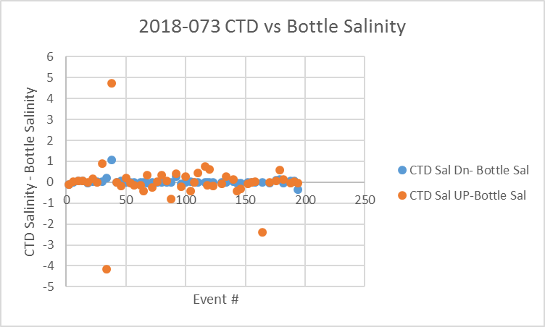
Given the many uncertainties in the comparison the CTD downcast salinity appears to be reasonably close to bottles. Allowing for a small error in salinity bottles, the CTD is considered within 0.005psu.
Downcast CTD will be selected for the bottle files except for cast #2 for which the downcast data are considered poor at 4db.
For more details see the “Sal comp” worksheet in file 2018-073-bottle-comp.xls.

Fluorescence
Chlorophyll sampling was done at about 4db. The CTD was pulled up at first to enable attachment of the messenger, then it drops, so this may help flush the bottle but makes it unclear at what depth the bottle closed. It may have been as deep as 6m for some casts.
Using downcast data, the comparison shows a better correspondence than we normally see with the CTD fluorescence being a little high for CHL<5ug/L and slightly lower above that.

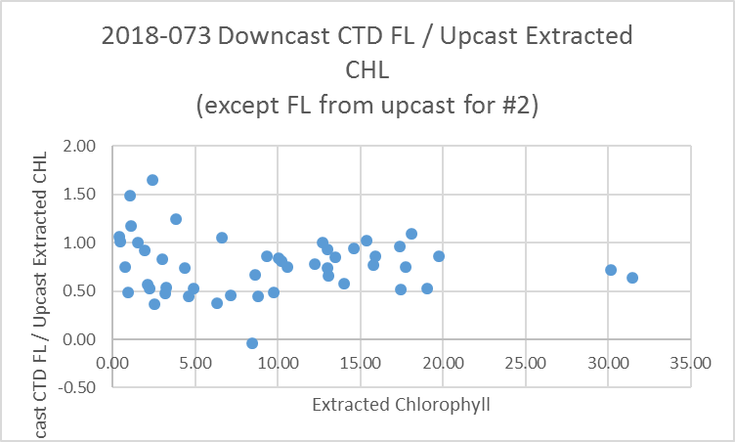

Fluorescence is about 75% of CHL overall.
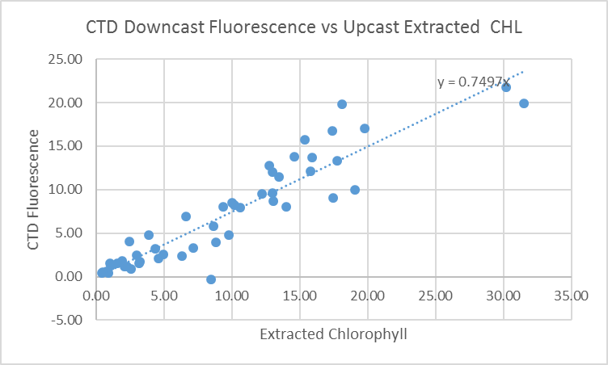

The comparison with upcast fluorescence was extremely noisy and the fluorometer values were 63% of CHL overall. The median ratio of FL/CHL was similar but the standard deviation was very high for the upcast data. So the downcast data look like a better choice for the bottle files.

For more details see the “FL CHL comp” worksheet in file 2018-073-bottle-comp.xls.

17. Other calibration checks
Sensor History – Since they were last calibrated these sensors were used for 14 previous cruises. No problems were found in the pressure. There was little calibration sampling available but comparisons with nearby SBE911 casts were possible from 2 cruises and they suggested that the salinity was reasonably accurate. There was salinity sampling during 2018-035 and 2018-036 that suggest salinity was within 0.003psu. There was no dissolved oxygen sampling for any of the cruises. Dissolved oxygen was found to be low by at least 5% when compared to an SBE911 cast during 2018-05.
Results of later cruises – Cruise 2018-104 was run about a month after this cruise and used the same equipment but there was no calibration sampling.
Comparison of repeat casts –There were no repeat casts.
Historic Ranges – All salinity values fell within the climatology except for event #38 which had low salinity in the top 8db – the upcast showed consistent values so this does not look like evidence of an instrumental problem. Temperatures were a little low at the bottom of event #194 and high between about 10db and 60db at casts #130, 140 and 143. These excursions are not systematic and are not considered indicative of calibration problems.
Post-cruise calibrations – None were available.

18. CALIBRATE
CTD Salinity will not be recalibrated.
There was no dissolved oxygen sampling but the results of a study on the same sensor during 2018-05 will be applied to these data.
The pressure does not need recalibration.

CALIBRATE was run using file 2018-073-recal1.ccf to apply the following correction to the Dissolved Oxygen:
CTD Dissolved Oxygen Corrected = 1.05* CTD Dissolved Oxygen

19. Fluorescence Filter
A median filter, size 5, was applied to the fluorescence data.

20. Bin Average and REMOVE
The files were bin averaged using 1db bins.

There are a few negative dissolved oxygen and fluorescence values at the surface of cast #14 because there was a very short soak and the pumps had not turned on yet. A text editor was used to replace those values with pad values. There are some other small negative fluorescence values in the files that come from the noise level in the instrument when average values are close to 0.
CLEAN was run to replace those with pad values. A header check showed no negative values remain in any channels. However, there was a very high fluorescence value; that was checked and there is no evidence that fluorescence went off-scale.

REMOVE was run to remove Scan_Number, Oxygen:Voltage, Descent Rate and Flag channels.

Dissolved Oxygen was derived in mass units and that was used to calculate DO saturation. Plots of near-surface saturation show a range of 90 to 180%. The lowest saturation rates were close to Johnstone Strait and in the casts near the Juan de Fuca eddy. The highest values were in the southern part of the cruise as well, but further offshore. These observations are not very helpful in establishing the reliability of the dissolved oxygen calibration. The high offshore values are unusual and may be in part due to incomplete equilibration of the DO sensor, but upcast DO and fluorescence also look high.
REORDER was used to get the 2 dissolved oxygen channels together.

21. HEADER EDIT and final checks of CTD files.
Header Edit was used to fix headers, fix formats and to add the following note to the headers:
Conductivity, Fluorescence:URU:Wetlabs and pH:SBE data are nominal and unedited
except that some records were removed in editing temperature and salinity.

All salinity sampling from this cruise came from near the surface, where vertical
salinity gradients and local variability are expected to be high. As a result
there is a high standard deviation in the differences between CTD and bottle
salinity. When a few outliers are removed, the comparison with the downcast CTD
salinity suggests that the CTD is within 0.005psu of bottles. Previous cruises
had limited sampling but also suggested that CTD salinity was within 0.005psu.
For more details see document "2018-073-bottle-CTD-comp.xls".

There was no dissolved oxygen sampling during this cruise and all other cruises
using this equipment since it was last serviced. There was an inter-ship comparison
in June 2017 for 1 cast only that suggested that dissolved oxygen values were
likely low by up to 4%. A comparison with an SBE911+ cast at the same site during
a February 2018 cruise was limited to the top 50m but suggested that dissolved
oxygen was reading low by at least 5%.
Channel Oxygen:Dissolved:SBE was recalibrated by adding 5% to all values.

WARNING: The pH:SBE:Nominal data should be used with caution; no field calibration
data were available at the time of processing.
Calibration is required for each cast to get absolute values, although general
trends within a cast are likely real.

Warning: While the CTD fluorescence data are expressed in concentration units, they
do not always compare well to extracted chlorophyll samples. It is recommended that
extracted chlorophyll values be used where available.

For details on the processing see document: 2018-073_Processing_Report.doc.

A cross-reference listing was produced.
A header check was run on the CTD files no problems were found.
The sensor history was updated.
Plots of CTD casts were examined and no problems were found.

22. Final BOT file preparation
The CTD casts were thinned to 4db and used to replace the CTD data entered in spreadsheet 2018-073-bottles_plus_CTD-6linehdr.csv, including the DO data in mass units. Some adjustments were needed:
- For cast #2 upcast data were entered.
- For cast #152, 5m data were entered.
- For cast #167, no CTD data were entered.

The spreadsheet file was converted to IOS Header files for each cast.

The time and date are present as channels as these cannot be converted directly into header entries.
CLEAN was run to add START and END time. The END TIME is identical so the START time so it will be removed later. CLEAN was also used to enter 0 flags where the flag channels are empty and to remove channels with only pad values.
REMOVE was run to remove the DATE and TIME channels.

SORT was not needed since there is only 1 record per file.
HEADEDIT was used to add comments and to remove the END time since it is the same as START TIME and to remove Time Zero. The final files have extensions BOT.

The standards check was run and the previous step adjusted until no problems were found.
A cross-reference list and header check were run on the BOT files.

The times were wrong so a return was made to the 6-line header file to correct the date/time formats. All steps were repeated from conversion to Headedit.
No further errors were found when a new cross-reference list was produced and when a header check was run.
Finally all data from BOT files were extracted to a spreadsheet and no further problems were found.

PARTICULARS – notes from logs
2. Surface soak and then soak at 7m but no return to the surface before continuing down.
14. Short soak – fluorescence and DO sensors did not produce values until the CTD had been lowered below 5db.
42. Long file – forgot to turn off. Pressure increases while clearly out of water.
62-116, Sample numbers were repeated accidentally – analysts used event numbers as sample numbers instead since they were unique and that is a common approach for this type of survey.
104 & 107. Salinity samples weren’t sealed with insert right away – they were added 2 days later.
120. CTD went under ship so was pulled up, Niskin reset and cast restarted. The beginning section needs to be removed before running DELETE.
123. Niskin position changed to 1m above CTD.
134. Wavy conditions
140. No useful data above 4m during downcast.
146. Wavy conditions
164. Wavy conditions
167. Pump off or malfunctioned throughout cast. No CTD data but BOT exists since there are bottle samples.

CRUISE SUMMARY

Cruise ID#: 2018-073
Dates: Start: 5 July 2018 End: 29 July 2018
Location: Integrated Pelagics Ecosystem Survey
Party Chief: King J. & Boldt J.
CTD# | Make | Model | Serial# | Used with Rosette? | CTD Calibration Sheet Competed?
1 | SEABIRD | 25 | 404 | No | Yes

CTD CALIBRATION INFORMATION
Make/Model/Serial#: SEABIRD/SBE25/0404 Cruise ID#: 2018-073

Calibration Information
Sensor |  | Pre-Cruise |  | Post Cruise
Name | S/N | Date | Location | Date | Location
Temperature | 2449 | 7Nov2015 | Factory
Conductivity | 1764 | 23Feb2017 | Factory
ECO Fluorometer | 4185 | 07Mar2017 | Factory
SBE43 Oxygen | 1176 | 11Nov2015 | Factory
pH | 0852 | 8Mar2017 | Factory
Pressure | 0464 | 28Feb2017 | Factory
