**SWL18 CRUISE REPORT GREBMEIER\_COOPER**

JULY 14-24, 2018

Dutch Harbor to Barrow, Alaska

**1..1.1 Title of project: Distributed Biological Observatory: A Change Detection Array in the Pacific Arctic**

**PI: Jacqueline M. Grebmeier, University of Maryland Center for Environmental Science, Chesapeake Biological Laboratory, PO Box 38, 146 Williams Street, Solomons, MD 20688, USA; Ph. +1-410-326-7334, fax +1-410-326-7302, email:** [**jgrebmei@umces.edu**](mailto:jgrebmei@umces.edu)**; co-PI: Lee W. Cooper, UMCES/CBL; Ph. +1-410-32607359, email:** [**cooper@umces.edu**](mailto:cooper@umces.edu)

**Funding: National Science Foundation, Arctic Observing Network (AON) program; #ARC-**

**1.1.1.1 Summary:** The Distributed Biological Observatory (DBO) and Canada Three Oceans (C3O) program combine efforts by researchers from US and Canadian government institutes and universities to monitor physical, biological and geochemical factors influencing the northern Bering and Chukchi Sea ecosystems. Aboard, the Canadian component collected sensor and flow-through data on the distribution of physical, biological, geochemical parameters from the ocean water column along the ship’s track from Victoria to its Arctic operations area as part of climate monitoring. Our US team boarded the ship in Dutch Harbor, Alaska for oceanographic sampling from the northern Bering Sea to Barrow, Alaska. Hydrographic, phytoplankton and benthic sampling were collected at all DBO time series sites. These studies extend the existing 28-year time-series of benthic biomass and other chemical and biological parameters at productive benthic stations. The time series sites are part of the international DBO program with multi-ship operations sharing collaborative data at the DBO sites (see Moore and Grebmeier 2018). The 2018 SWL cruise was able to occupy 3 of the 5 DBO sites completely due lack of sea ice: (1) south of St. Lawrence Island, SLIP=DBO1, (2) Chirikov Basin north of SLIP called UTBS=DBO2, and (3) the Southern Chukchi Sea including UTN sites in the DBO3 region and the SEC transect line from the benthic hotspot to the Alaskan coast=DBO3. The DBO4new line occuppied 4 of the 6 stations completely for water and sediments (DBO4.6n-4.3n), DBO4.2n partially (water only), and DBO4.1n was not occupied. We had to abort the zooplankton, camera and sediment sampling at DBO4.2n after CTD/rosette work due to engine failure issue and decision by Captain to go directly to Barrow for engine evaluation and the offload. The DBO5 upper Barrow Canyon DBO5 site (BarC) one was also aborted due to the engine cyclone converter failure issues occurring during the cruise and the concern about sea ice cover.. Note the SWL18-Leg 1 cruise was delayed in the Dutch Harbor pickup of US participants by a day due to a last minute CCG activity in Canada.

**CRUISE DATES**: July 14-24, 2018, Dutch Harbor to Barrow, Alaska, USA

[US team arrival to Dutch Harebor on July 11 and planned to board the ship on July 13, but the ship was delayed and we boarded and departed Dutch on July 14. We departed the SWL in Barrow, Alaska on July 24, and departed Barrow by plane on July 25, 2018.

**PERSONNEL**:

1. Dr. Jackie Grebmeier, PI, CBL/UMCES, Solomons, Maryland, USA;[jgrebmei@umces.edu](mailto:jgrebmei@umces.edu), F
2. Dr. Lee Cooper, Co-PI, CBL/UMCES, Solommons, Maryland, USA; [cooper@umces.edu](mailto:cooper@umces.edu), M
3. Christina Goethel, graduate student, CBL/UMCES, Solomons, MD, USA; [cgoethel@umces.edu](mailto:cgoethel@umces.edu), F
4. Chelsea Wegner, graduate student, CBL/UMCES, Solomons, MD, USA; [cwegner@umces.edu](mailto:cwegner@umces.edu), F
5. Ruth Cooper, field assistant, CBL/UMCES, Solomons, MD, USA; [ruthcooper1@alumni.nd.edu](mailto:ruthcooper1@alumni.nd.edu), F
6. Dr. Karen Frey, PI, Clark University, Worcester, MA, USA; [kfrey@clarku.edu](mailto:kfrey@clarku.edu), F
7. Melisha Santiago, graduate student, Clark Univ, Worcester, MA, USA; [msantiago@clarku.edu](https://mail.cbl.umces.edu/src/compose.php?send_to=msantiago%40clarku.edu), F
8. Luisa Young, graduate student, Clark Univ, Worcester, MA, USA; [lyoung@clarku.edu](mailto:lyoung@clarku.edu" \t "_blank)
9. Dr. Sue Moore ([sue.moore@noaa.gov)](mailto:sue.moore@noaa.gov)), PMEL/NOAA, Seattle, WA, USA
10. Elizabeth Labunsky ([Elizabeth\_Labunski@fws.gov](mailto:Elizabeth_Labunski@fws.gov)), US Fish & Wildlife Service, Anchorage, AK, USA

**A. SAMPLING AND METHODOLOGY:**  Water column temperature and salinity measurements were collected at 50 stations during the cruise (**Table 1**). Water column chlorophyll, nutrients, phytoplankton, and O-18 samples were collected at 35 of these stations. Sediment and macrofaunal samples, along with benthic video collections were made collected at 30 benthic stations (Table 2). Seabird surveys, with limited marine mammal surveys were undertaken shipboard during the ship transit periods. Separate cruise reports have been prepared by PI Karen Frey (at sea: Luisa Young and Melishia Santiago), Sue Moore (marine mammals observer) from NOAA, and Kathy Kuletz (seabird collaborator) from USFWS (at sea: Elizaeth Labunski).

The following description briefly outlines the measurements made by our CBL/UMCES benthic team. **Table 2** lists the data parameters collected at each station during SWL18. Designated regions are primarily DBO1-4 stations as well as additional UTN stations within the DBO3 area bounding box. Bering Strait (BRS) stations were also sampled for water column measurements only.

1. **Water column.**

a. We collected seawater for each cast at up to 6 depths into 250 ml volume plastic bottles and filtered 200 ml water column subsamples for chlorophyll over 0.43 µm GFF filer shipboard and placed the filters in the freezer for one hour to fracture the phytoplankton cells. Subsequently 10 ml of 90% acetone was added to the filter samples that were then placed in a refrigerator for 24 hrs to allow extracton of the chlorophyll in the dark. The water column chlorophyll was analyzed shipboard using a Turner Designs AU-20 fluorometer (non-acidification or Welschmeyer method).

b. We collected, filtered and froze seawater subsamples for nutrients at up to 6 designated depth at each station for post-cruise processing at CBL using the CBL plastic vials. Nitrile gloves were used for nutrient collections.

c. Seawater samples were collected at standard depths in 8 mL glass vials for O-18 (a water mass and sea ice melt tracer) at all stations for post-cruise processing at CBL.

d. Seawater samples were collected at standard depths for dissolved organic carbon (DOC) determinations into either acid washed 30 mL teflon bottles or 100 mL HDPE bottles and subsequently frozen for post-crusie analsyse at CBL. See Supplementary file 2b (co-PI Karen Frey Clark University team (also listed in Table 2).

e. DBO collaborator Diana Varela, University of Victoria, undertook primary production and nutrient studies (see her separate cruise report). In addition, her team collected 100 ml of seawater for phytoplankton identifications that were immediately preserved in Lugol’s solution and formaldehyde for post-cruise species identification via NSF DBO support (Grebmeier). The listing of stations for these collection are listed in Table 2. Briefly, 100 ml of seawater from each standard depth was gently mixed in a small container, with a subsequent 100ml aliquot preserved by addition of 2.5 ml of Lugol’s solution and subsequently stored in the refrigerator for 24 hrs. At the end of that period 5 mL of 37% formaldehyde was added to the 100ml seawater sample to a final concentration of ~2% (v/v), gently mixed, and stored for subsequent shipment to Poland for phytoplankton identifications.n=42 samples

f. John Nelson (DBO collaborator, University of Victoria) collected zooplankton for populations parameters, genetics, and food quality (see his separate cruise report).

g. Bill Williams (Sarah Zimmerman at sea), DBO collaborator, IOS/DFO) had the lead on the CTD/rosette collections, providing temperatue and salinity values for our component (see core cruise report of lead CTD personnel on ship, Sarah Zimmerman).

**2. Sediment**

Two to five 0.1 m2 van Veen grab replicate deployments were made at each DBO benthic time series station in the Bering and Chukchi seas: SLIP (DBO1), UTBS (DBO2), SEC (DBO3) and UTN stations in the DBO3 region, DBO4, and BarC (DBO5).

**2a. The first (or last) grab of the replicates** was subsampled for surface sediment parameters: sediment chlorophyll a (chl a), total organic carbon (TOC)/nitrogen (TON) content, and sediment grain-size. These grab samples were subsequently sieved and the dominant retained for genetic analyses (DBO collaborator John Nelson component

Specifically, sediment subsamples were collected from the first grab through a trap door and processed as following:

i. **Surface sediment chlorophyll**. Replicate 0-1 cm surface sediments were collected using cut-off 10 cc syringes, with sediment plugs extruded into tared and labelled falcon tubes for flourometric analyses. 10 mL of 90 acetone were added to each tube, mixed, and then extracted in the refrigerator for 12 hrs. Subsequently measurements for chl a were made on a Turner flourometer at sea.

ii. **Surface sediment for TOC/TON** **and grain size**. A sample was collected from the top 0-1 cm of surface sediments and placed in 4 ounce whirlpak bag, and frozen for post-cruise analyses.

iii. **The remaining sediment in this grab** was sieved through a one mm metal sieve screen boxes with running seawater. The retained macrofauna was placed in a seawater filled 32 ounce cup for post station identification. Dominant infauna were identified to the lowest taxon possible by Chelsea Wegner, packaged, and frozen for post-cruise analyse at CBL for amino acid analyses as part of her PhD study using a mass spectrometer at CBL (PI Cooper).

**b. A majority of stations had** **four replicate grabs** collected for quantitative determination of benthic macrofaunal composition, abundance and biomass determinations. The sediment from each grab wa sieved through one mm metal sieve screen boxes with running seawater, with the animals subsequently placed in small sieve pans (with screen size 1 mm or less) and the retained animals placed in labelled plastic containers and preserved in 10% buffered seawater formalin for post-cruise analyses at CBL. Specifically, four replicate grab samples were collected at the 5 SLIP (DBO1) stations, 7 UTBS/DBO (DBO2) stations, 6 UTN stations in the DBO3 region, 8 SEC (DBO3) stations, and 4 DBO4 stations. DBO4.2 was only sampled for CTD/rosette water sampling and DBO4.1 was abort, along withall of 10 BarC (DBO5) stations due to mechanical issues with one of the engines as well as ice conditions over part of DBO5. Note the historic SEC1 station is the same as the DBO3.8 station designation at the western end of the DBO3 transect line, with DBO3.-7 to DBO3.1 extending eastward on the line, with coincident naming of the SEC line. Post-cruise analyses include identification to lowest taxon possilbe, with counts and biomass determinations, are undertaken at CBL.

**c. Two-three single 0.0133 m2 HAPS benthic core deployments** were used to collect sediment corers for sediment respiration experiments (Christina Goethel, PI Grebmeier).

**Acknowledgments**

We thank the Canadian Coast Guard Captain and crew of the CCGS Sir Wilfrid Laurier for operational aspects and deck assistance during the cruise. We especially thank John Nelson for being Chief Scientist on the cruise and Sarah Zimmerman for CTD/rosette operations. We also thank our DBO/C3O collaborators Diana Varela and John Nelson for phytoplankton and zooplankton collections, respectively, along with their shipboard team for associated data collections for the DBO project. Financial support was provided to PIs Grebmeier and Cooper through the National Science Foundation Arctic Observing Network program (Grant No. grant #NSF-ARC-1704082).

**Note:** Cargo pieces and chemicals from SWL18 are stored at IOS over the winter in metal cages and chemical storage rooms for use during SWL19. Separate cargo and chemical lists provided.

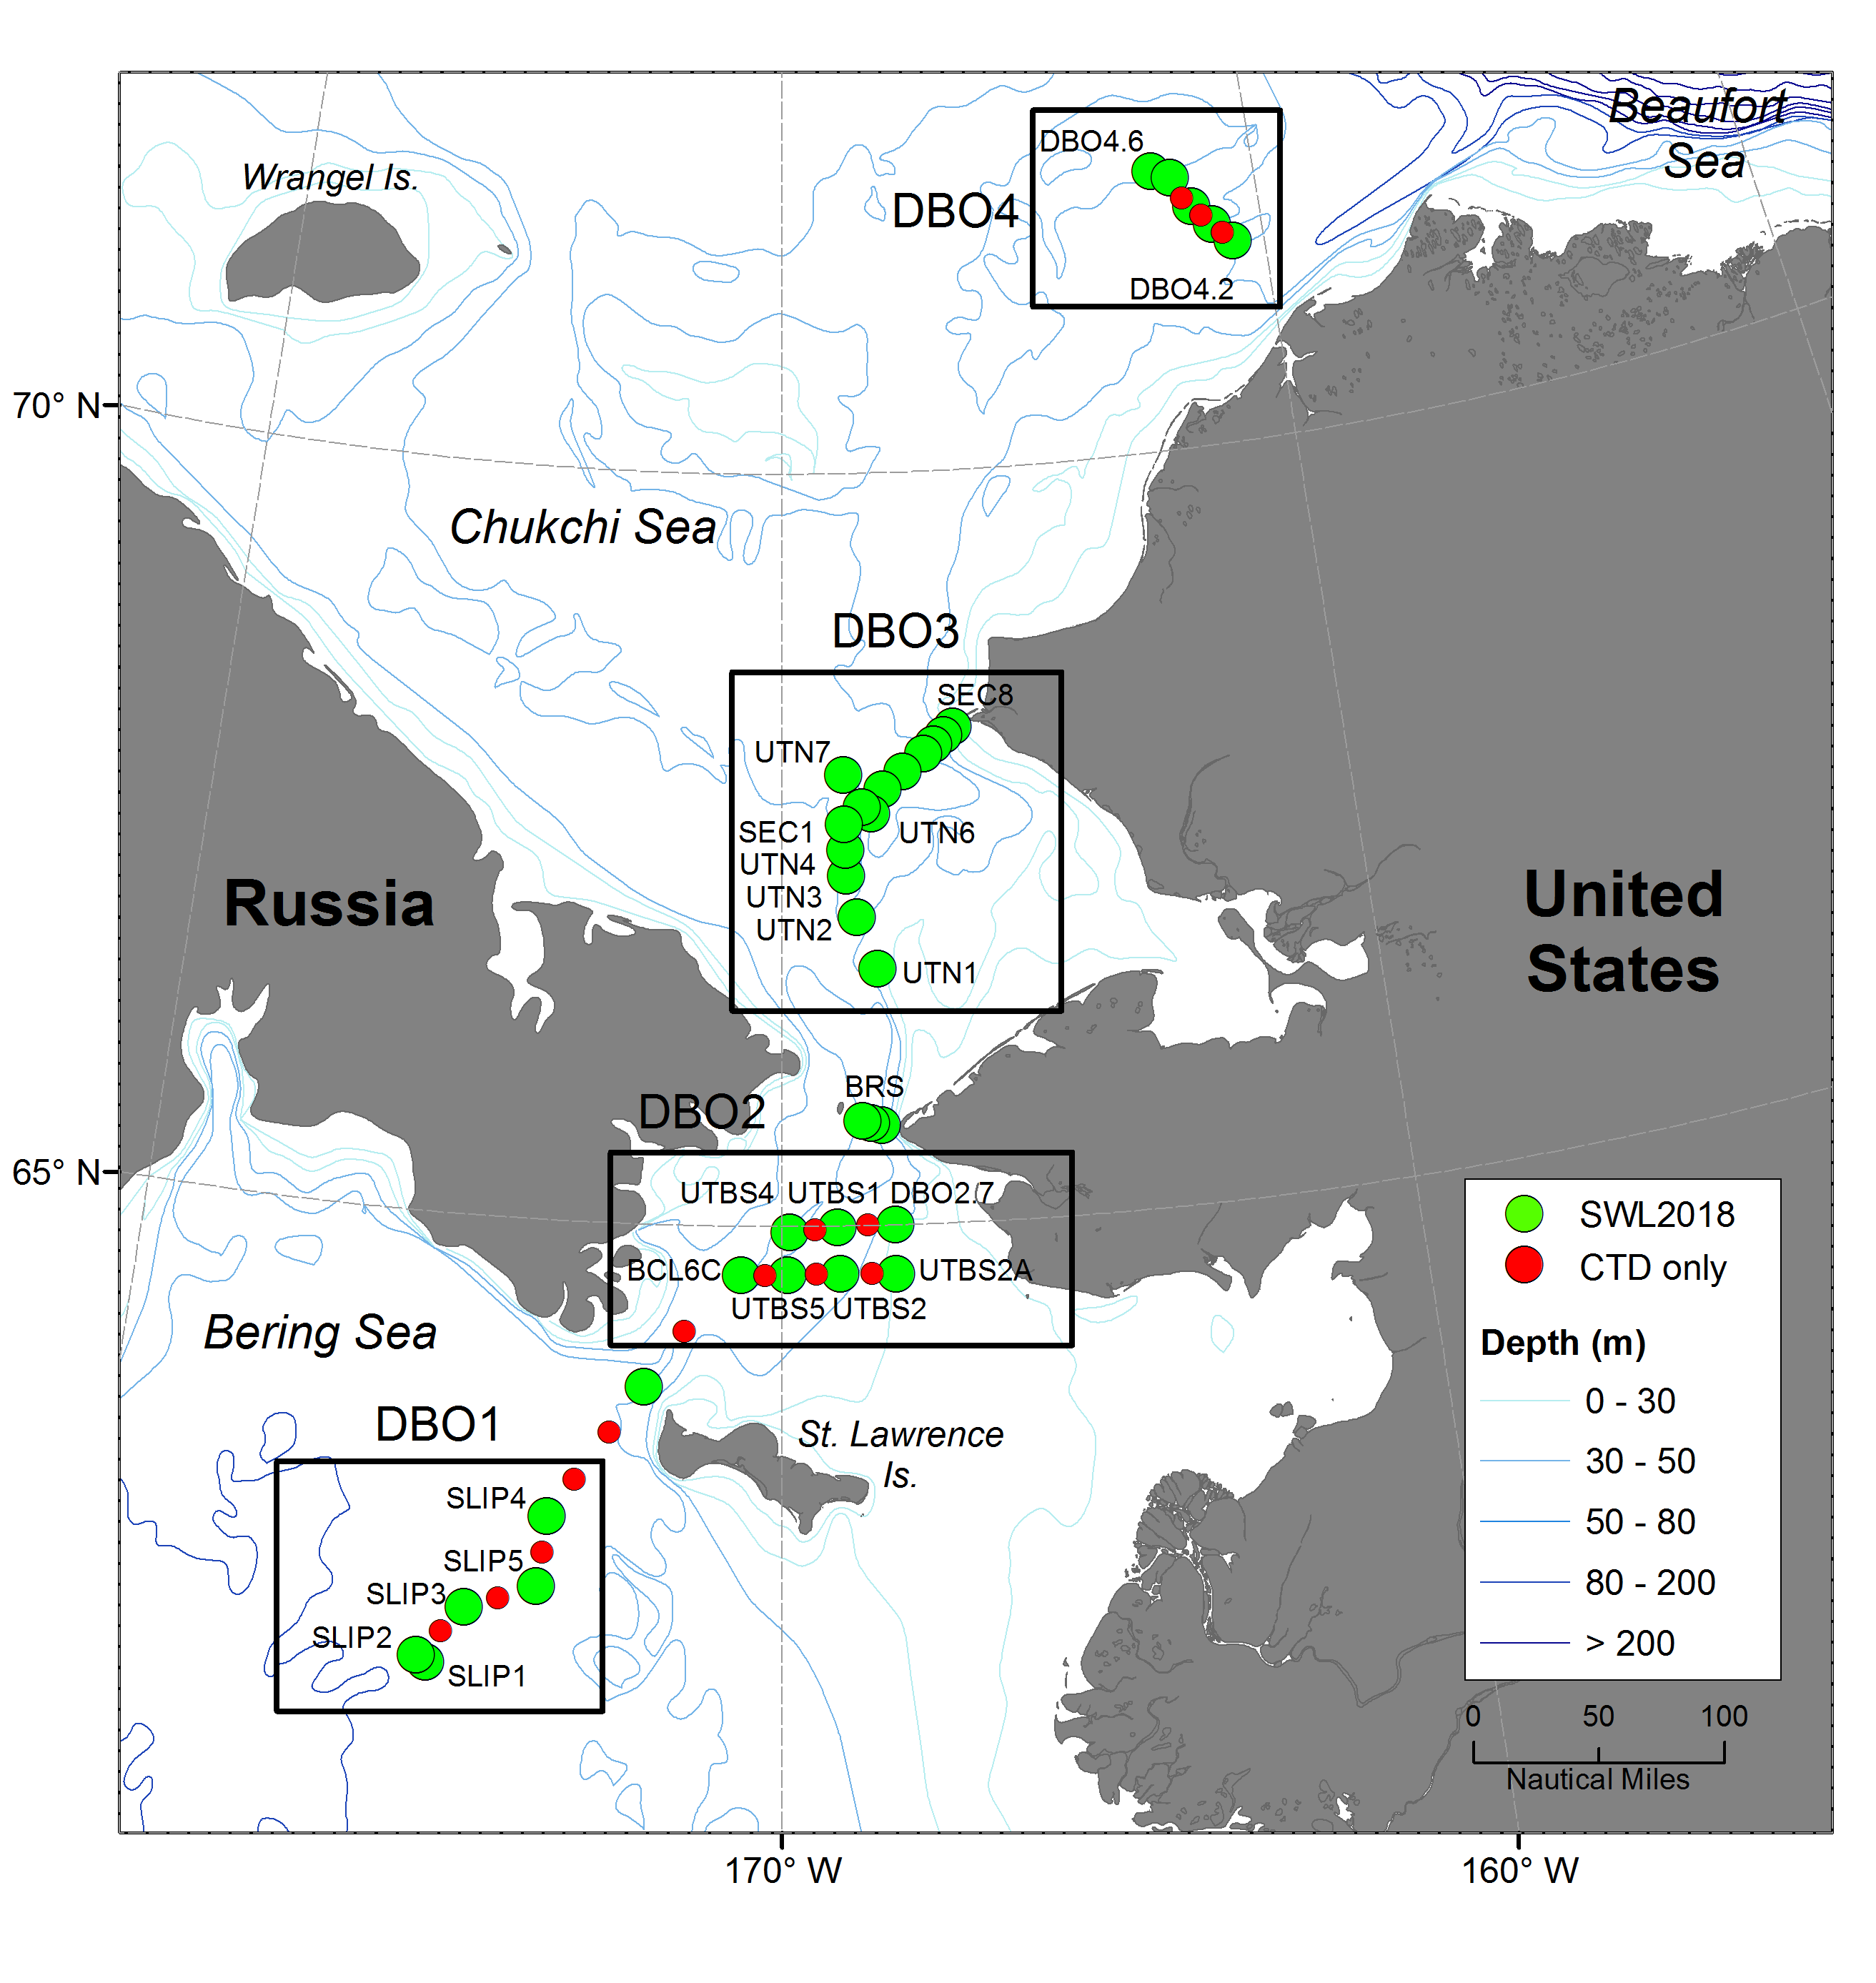

**Figure 1.** Map of stations occupied for SWL18 DBO-C30 sampling plan. Due to engine issue only water column samples were collected at DBO4.2n, with DBO4.1n aborted for the ship could transit directly to Barrow. The DBO5 line (stations BarC1-10) were not occupied both due to engine concerns and projected ice cover.

|  |
| --- |
|  |

**Figure 2.** SWL18 Benthic Team (left to right: Christina Goethel, Jackie Grebmeier, Lee Cooper, Ruth Cooper, Chelsea Wegner).



****

****