## REVISION NOTICE TABLE

|  |  |
| --- | --- |
| DATE | DESCRIPTION OF REVISION |
| 20 March 2025 | Updated channel names & formats in TOB files. G.G. |

## PROCESSING NOTES

Cruise: 2018-063

Agency: OSD

Location: North Pacific / Bering Sea / Chukchi Sea

Project: Canada’s Three Oceans / Distributed Biological Observatory

Party Chief: Nelson J..

Platform: Sir Wilfrid Laurier

Date: July 5, 2018 - July 24, 2018

Processed by: Germaine Gatien

Date of Processing: 9 June 2022 – 18 November 2022

Number of CTD HEX files: 52 (1 test cast, 1 rejected cast)

Number of CTD files: 50 Number of CHE files: 36

Number of TSG HEX files: 11 Number of TOB files: 10

# INSTRUMENT SUMMARY

A SeaBird Model SBE 911+ CTD (#0941) was used for this cruise. It was mounted in a custom-built compact 24-bottle rosette sampler and attached were a Wetlabs CSTAR transmissometer (#1666), an SBE 43 DO sensor (#1117), a SeaPoint Fluorometer (#3575), a Biospherical QSP-200L4S PAR sensor (#70123), a Biospherical Surface PAR (#20281) and an altimeter (#40853).

24 Ocean Test Equipment 10L bottles were mounted on the rosette.

A thermosalinograph (SeaBird 21 S/N 3274) was mounted with a fluorometer (SCF3654) and a remote temperature sensor #0271.

The data logging computer was the WGBCIOS104876.

The data acquisition program was Seasave 7.26.6.26 for the CTD and the TSG.

The deck unit was a Seabird model 11+ (#800).

The salinometer used at IOS was a Guildline model 8400B Autosal, serial # 69086. Bottles were analyzed between 18 January 2019 and 21 January 2019.

# SUMMARY OF QUALITY AND CONCERNS

The Daily Science Log Book and rosette log sheets and TSG log as well as spreadsheets detailing sampling were provided.

The raw file names use the 2-digit cruise number that was standard in 2018. The names were changed to the 3-digit cruise number format in use at the time of processing.

The deployment method for most casts was to lower the CTD to between 7db and 12db, soak for about 2 minutes, then return to the surface where it was soaked again for about 30s; then the full cast began.

Partway through processing it became clear that it was more appropriate to use the post-cruise calibration parameters for temperature and conductivity, despite the sensors having been recently calibrated. Throughout the cruise the difference between temperature sensors was much larger than usually seen. Using the post-cruise calibration brought the primary temperature into much better correspondence with the secondary. Whatever caused the change to the primary temperature sensor appears to have occurred between factory service and use at sea.

The dissolved oxygen data were recalibrated based on the bottle comparison. There was insufficient information to justify recalibration of salinity, but given that the post-cruise calibration parameters were used and the difference between the 2 salinity channels varied little through the cruise, the accuracy appears to be good.

Many of the casts are well mixed in the top 10 to 30db, then shift suddenly to a deeper layer that is fairly well mixed with higher salinity and lower temperature. The sharpness of the interface decreases through the cruise. The sharp interfaces often lead to spikes in salinity, sometimes both salinity channels, sometimes just one. Generally the primary resolves the gradient best, but not always. Dissolved oxygen also has rapid changes in values, but these could be real. Editing was applied by either interpolation or removal of salinity data where the cause of the unstable features is clear.

There are also frequent small unstable features where one salinity channel shifts in one direction and the other channel in the opposite direction. The primary salinity looks better in general and it is clear that there was a major problem in the secondary conductivity and fluorescence for one cast. There are likely some flow problems in both channels from time to time. The noise in salinity generally disappears during bottle stops except when the stop is at an interface.

The SBE fluorometer reads a little higher than the CHL samples at low CHL values, but as CHL rises the fluorescence drops fairly steeply until it is about 50% of the CHL values. This is a typical pattern for these fluorometers.

The thermosalinograph traces were marked by drop-outs in salinity. Examined more closely there are many features where salinity gradually drops followed by a sudden rise to values similar to those before the decrease. This looks like a build-up of bubbles that suddenly are released. It is impossible to remove those features, but large single-point spikes were removed using a despike routine. There were no such features in the Strait of Georgia and Johnstone Strait, but they were very frequent in the Pacific Ocean and Bering Strait. They are present but less frequent and smaller in the Chuckchi Sea.

Comparisons of TSG data to co-incident CTD casts, loop samples and rosette samples were done. The intake temperature compared reasonably well to the CTD temperature, and the lab temperature showed very little drift based on a post-cruise calibration. On average, the TSG salinity was lower than salinity from the CTD, loop samples and rosette samples, but the scatter was very large. The post-cruise calibration indicated that the salinity drift was towards high values, but some of that drift might have occurred after this cruise. The problems with bubbles would mask such drift. There was insufficient evidence to correct salinity. It is likely reading too high when no bubbles are present and too low when they are present. The TSG fluorescence data compares reasonably well with the CTD fluorometer and to extracted chlorophyll loop samples and rosette samples.

The TSG lab temperature reads higher than the CTD by an average of 0.20Cº, ranging from 0.12Cº, to 0.30Cº, depending on the intake temperature. This is a typical result for heating in the loop for this vessel in this region.

The final TSG file showed evidence of flow being off and ship not moving, so was not archived.

# PROCESSING SUMMARY

##### Seasave

This step was completed at sea; the raw data files have extension HEX.

Files had 2-digit cruise numbers so those were changed to the standard format 2018-063-****.

##### Preliminary Steps

The Daily Science Log Book and rosette log sheets were obtained. A post-cruise report is available.

Spreadsheet 2018-063_SWL_Chem and Logs.xlsx contains a sampling log with details on bottles fired and results of analyses.

The cruise summary sheet was completed.

There was no history available for the pressure, conductivity and DO sensors; this was the first cruise on which most sensors were used after the last factory calibration.

The configuration files did not change through the cruise.

The calibration constants were checked for all instruments. The only error found was the date of the transmissometer calibration. A file with that correction was saved as 2018-063-ctd.xmlcon.

It was later discovered that the Post-cruise calibrations for temperature and conductivity produced data that were in better correspondence with the comparison with bottle data and with the differences observed between sensor pairs. A new calibration control file was prepared which kept the pre-cruise parameters for all channels except temperature and conductivity; it was saved as 2018-063-ctd.xmlcon while the version used at sea was renamed 2018-063-precruise-ctd.xmlcon.

For most casts the CTD was lowered to between 7db and 12db, soaked for about 2 minutes, returned to the surface where it was soaked again for about 30s and then the full cast began.

##### BOTTLE FILE PREPARATION

The ROS files were converted including bottle number, bottle position, oxygen concentration and salinity.

The files were then converted to IOS Header files and then put through CLEAN to add event numbers.

Temperature and salinity were plotted for all BOT files. While there was considerable noise in both temperature and salinity, it was generally not a matter of clear outliers that can be edited.

CTDEDIT was used to remove some records and clean salinity in BOT files #108 and 148; there were others with noisy data but it looks real. The ED1 files were copied to *.BOT.

The BOT files were averaged on bottle number and those files were used to prepare an ADDSAMP file.

The ADDSAMP file was sorted on Event 3 and Niskin #. Sample #s were then added. Some bottles were fired with no sample numbers attached, so -99 was entered as sample # for those.

In one case the same sample #was used twice. They were entered as 453 and 453.5; since integral values are required for this channel, the second instance was renamed as 9453, but no samples were found for that bottle. Since some could turn up later, it will be included in the bottle file.

There was a cast called 9122 but this was just the first attempt that was repeated and saved as 122. The bottle file for 9122 will not be processed.

Some casts had bottles fired out of order but the sorting method ensured the correct sample numbers were assigned.

The file was then reordered on Event # / Sample #.

The ADDSAMP file was used to add sample numbers to the BOT files, creating SAM files. Those were bin-averaged on bottle number to create SAMAVG files.

Next, text file 2018-063-bot-hdr.txt was prepared to add an explanation of quality flags and some general comments from analysts.

Final analysis data were found in a general spreadsheet, 2018-063_SWL_Chem and Logs_2020-05-06b.xlsx. The data were simplified and some corrections made to flag channel formats. Comments were edited slightly and combined so there is only one per sample.

There were some channels that had no flags or comments included.

There were many cases of bottles being fired out of order.

The resulting file was saved as 2018-063-IOS-Chem.csv. That file was converted into files with extension NUT.

The Nut files were put through CLEAN to reduce the header to just the File and Comments sections.

SORT was run on channel bottle # and then merged with the SAMAVG files with output MRG.

These files were put through CLEAN to remove SeaBird headers and comments from the secondary file and to add 0 to empty flag channels.

Header Check was run. There ware no negative fluorescence values but there was for Nitrate (event 34).

Data were exported from the MRG files to a spreadsheet to enable comparison with rosette sheets to ensure no data were lost in the conversion/merge process. The only problem noted were some slightly negative NO3 values. The analyst was contacted and it was agreed that those values should be replaced with 0s and it should be noted in the headers what the Minimum Detectable Level is for the nutrients.

##### Compare

Oxygen

COMPARE was run and most data points fall into a tight fit.

Bottle DO = 1.0451 *Oxygen:Dissolved:SBE R2 =0.98

Removing 4 outliers based on residuals made little difference. The 4 outliers had high standard deviations in the CTD Dissolved Oxygen.

Bottle DO = 1.0444 *Oxygen:Dissolved:SBE R2 =0.99

For the only deep cast, event #2, the slope was 1.0458.

For more information see file 2018-063-oxy-comp1.xls.

Salinity

RUN 1 – using pre-cruise calibration for T and C

Compare was run with pressure as reference channel.

The scatter is large which is not unexpected with such shallow sampling. When outliers were excluded based on standard deviation in the CTD salinity during the 10s window being >0.001psu, there remained a few obvious outliers, 2 in the primary and 3 in the secondary, with differences >0.07psu. About half of the samples were excluded. The average difference of those that remained was -0.0001psu for the primary and -0.0029 for the secondary but the standard deviations were large at 0.0064psu and 00.0077psu, respectively.

For event #34 the secondary salinity was lower than bottles by about 0.2psu at all depths. There is no indication of a problem with analysis and the primary differences are not out of line with other casts. During event #49 there was a problems with the secondary sensors and the comparison is out of line for that cast as well, though not by as much as event #34.

A fit of differences for all casts versus time order shows greater scatter in the Arctic section than in the Pacific Ocean.

The long delay before samples were analyzed and the usual problem of bottles not flushing well would usually lead to the CTD salinity appearing to be low relative to bottles even with perfect calibration. The difference is small for the primary which could mean it is actually reading high. However, the careful handling of the bottles during the long wait may have reduced evaporation problems. Desorption errors are still expected to be ~0.003psu over 6 months. A complicating factor is that many of the samples came from the bottom of casts where flushing inefficiency has the effect of making the CTD look higher than it really is.

The absence of more deep samples and high noise level in the comparison and relatively noisy CTD salinity renders recalibration unwise. The comparison does suggest there was no large calibration drift.

This run of COMPARE is saved as 2018-063-comp-pre.xls.

RUN2 using post-cruise calibrations for T and C

The difference in salinity from using the post-cruise calibration parameters is not as large as one might expect with a large change in temperature, because it was partly offset by that in conductivity.

When outliers were excluded based on the standard deviation in the CTD salinity >0.001psu, the primary salinity was found to be high by an average of 0.0006psu (std dev 0.0065psu) and the secondary was found to be high by 0.0005psu. The surprise is that the salinity channels are reading higher than bottles in both cases, and that for the one deep cast, both salinity channels are higher than bottles by ~0.003psu below 50m. This implies that there was little evaporation and flushing was quite good. However, there are a few complicating factors:

* The CTD data are extremely noisy. When the CTD channel alignments were studied there was little to distinguish one choice from another suggesting that alignment is variable. (See section 13.)
* Many of the bottles were fired at the bottom where bottles will contain water of lower salinity than ambient waters if they are incompletely flushed.
* The vertical salinity gradients are generally quite low.
* There were some problems in the secondary system.

When the bottom bottles are excluded from the comparison, the primary salinity is low by an average of 0.0007psu. while the secondary is high by an average of 0.0003psu.

There is no evidence that salinity CTD salinity calibration has changed significantly.

For full details for the Run 2 of COMPARE see file 2018-063-sal-comp1.xls.

Extracted Chlorophyll versus CTD Fluorescence

COMPARE was run using Chlorophyll: Extracted and SBE Fluorescence. When a fit of fluorescence against extracted chlorophyll is forced through the origin had a slope of 0.68.

The SBE fluorometer reads a little higher than the CHL samples at low CHL values, but as CHL rises the fluorescence drops fairly steeply until it is about 50% of the CHL values. This is a typical pattern for these fluorometers. For the one very high CHL sample the fluorometer has a similar value, and that is occasionally noted in other cruises as well.

There were a few outliers that were investigated. No two came from the same cast and are from depths where the vertical gradient was likely high so that small vertical offsets between bottle and CTD can lead to very different conditions.

See 2018-063-fl-chl-comp1.xls for more detail.

##### Conversion of Full files from Raw Data

All files were converted using 2018-063-ctd.xmlcon. The hysteresis correction was selected since there was 1 deep cast. The Tau correction was applied.

All channels were plotted for a few casts to check for problems in the conversion. The SPAR values were generally significantly lower than the PAR values at the beginning and end of casts, with values ~50% to 70% of PAR. All other profiles looked as expected.

The CTD was lowered to between 7db and 12db, soaked for about 2 minutes, returned to the surface where it was soaked again for about 30s and then the full cast began.

##### WILDEDIT

Program WILDEDIT was run to remove spikes from the pressure, conductivity & temperature only.

Parameters used were: Pass 1 Std Dev = 2 Pass 2 Std Dev = 5 Points per block = 50

The parameter “Keep data within this distance of the mean” was set to 0.

A few small spikes were removed by this routine.

##### ALIGN DO

Fine-tuning of the DO sensor alignment is difficult when there are so many stops for bottles, some very sharp gradients and most casts are very shallow. For other cruises using this type of sensor settings between +2.5s to +3.5s worked quite well with 2.5s providing the best results in most cases but a higher setting working best for shallow casts.

ALIGN was run on all casts using an advance of +3.5s.

##### CELLTM

As for ALIGNCTD tests are not helpful with so many stops and high variability, so settings were used that are always found reasonable, and often the best choice.

CELLTM was run using (α = 0.0245, β=9.5) for both the primary and secondary conductivity.

##### DERIVE

Program DERIVE was run on all casts to calculate primary and secondary salinity and dissolved oxygen concentration (using the Tau correction).

##### Tests

This step was run twice – first using pre-cruise calibrations and a second time using post-cruise parameters for temperature and conductivity.

RUN 1

Most casts were in very shallow water with few sampling below 50m. The only cast that sampled deeper than 100m was cast #2 which was in very deep water but only sampled to 500m. Downcast differences between channels were plotted for cast #2 and at 460m they were roughly:

* Temperature:Secondary – Temperature:Primary = ~ +0.002Cº at 460db..
* Conductivity:Secondary – Conductivity:Primary = ~ -0.0002S/m at 460db.
* Salinity:Secondary – Salinity:Primary = ~ -0.0035psu.

The salinity difference is in good agreement with the difference in the 2 channels during the deepest bottle stop at about 500m, which was 0.0032psu.

The temperature difference is much larger than usually observed.

The differences from the shallow casts are extremely noisy so not a useful guide.

RUN 2

Cast #2 at 460m differences were roughly:

* Temperature:Secondary – Temperature:Primary = ~ +0.0005º at 460db..
* Conductivity:Secondary – Conductivity:Primary = ~ -0.0001S/m at 460db.
* Salinity:Secondary – Salinity:Primary = ~ -0.001psu.

These differences are smaller, so some drift must have occurred between the factory service and the beginning of this cruise.

For more detail about the pre/post comparison see section 15.

##### Conversion to IOS Headers

The IOSSHELL routine was used to convert SEA-Bird 911+ CNV files to IOS Headers.

CLEAN was run to add event numbers and to replace pad values in the pressure channel with interpolated values based on record number.

##### Checking Headers

The header check was run. The cast with the highest fluorescence value was examined to see if it had gone off-scale and it did for cast #246. CLEAN was rerun to replace fluorescence values >49.32ug/L with pad values.

File CLIP.csv was prepared by plotting near surface data to determine how many scans from the soak period needed to be removed.

CLIP was run and refinements were made to the settings by examining plots.

Surface check was run and shows an average surface pressure for the cruise was +0.6db with a minimum of -0.1db. Transmissivity suggests the CTD was out of water between -0.1db and +0.1db. When acquisition started can vary; in one case it didn’t start until at about 9db. Pressures were checked at the end of a few files where it appears that the CTD has come out of water with pumps on. The pressures were 0db to -0.4db. It is possible that pressure may be reading slightly low, but it is well within expectations for the sensor.

The altimeter readings and bottom depths from the headers of the CLN files were exported to spreadsheets. To see if the altimetry and/or bottom depth entries are reasonable a check value was calculated:

Check Value = Water Depth – (Altimetry -1)– Max Depth Sampled

The altimetry value is calculated with an algorithm taking data from the bottom 2db sampled, so 1m is subtracted. All values were between -4.4m and +4.4m. The average value is 1.7db. This is a good result showing both altimeter and water depth entries are reasonably reliable.. Perfect values are not expected since water depths can vary through a cast. (See 2018-063-altimeter-ctd.csv.)

The cruise tracks with event #s was plotted and added to the end of this report. No problems were found. The usual plot with station names was too messy to be useful, but a cross-reference list may be found following the event # plot.

##### Shift

Conductivity

Choosing alignment corrections is difficult because the salinity is extremely noisy. Descent rates are variable and some unstable features are clearly due to shed wake corruption, but that doesn’t explain much of the noise. But a lot of the noise looks like is it is due to mis-alignment in the presence of high vertical gradients. Unstable features between 2 layers are common in this region, but the noise extends deeper than usual. It is possible that flow rates varied leading to more variability in alignments than usual, or real variability is possibly greater than in other years.

Tests were run on the one deep cast plus 6 shallow ones. Settings of -0.5 to -0.7 records for the primary conductivity and -0.3 to -0.6 for the secondary made slight improvements. Overall, the best choices were -0.6 for the primary conductivity and -0.5 for the secondary conductivity and SHIFT was run twice to make those changes; salinity was recalibrated.. The reduction in noise by these steps is not great.

Fluorescence

The fluorometer was pumped. There is too much noise and too many bottle stops to make a good estimate of the shift needed. The usual setting applied to 911+ with pumped fluorescence was applied.

SHIFT was run on all casts advancing the SeaPoint fluorescence channel by +24 records. The results look much improved.

FILTER

Both temperature and salinity traces are noisy, especially salinity. Because the salinity is so noisy, a median filter size 7, was run on both salinity channels for all casts as a test. The results were smoother but after running DELETE it was harder to identify corrupted data from data that is probably good.

##### DELETE

The following DELETE parameters were used:

Surface Record Removal: Last Press Min

Maximum Surface Pressure (relative): 10.00

Surface Pressure Tolerance: 1.0 Pressure filtered over 15 points

Swells deleted. Warning message if pressure difference of 2.00

Drop rates < 0.30m/s (calculated over 11 points) will be deleted.

Drop rate applies in the range: 10db to 10db less than the maximum pressure

Sample interval = 0.042 seconds. (taken from header)

COMMENTS ON WARNINGS: The were no warnings.

##### Other Comparisons

Previous experience with these sensors – This was the first known use of the temperature, conductivity and dissolved oxygen sensors since the previous factory calibration.

Post-Cruise Calibration – The deepest cast was converted using the calibrations from late 2018 & early 2019. For dissolved oxygen there were 2 post-cruise calibrations, before and after repairs; the membrane was punctured. The dissolved oxygen sensor had drifted by about 15%, but the comparison with bottle samples suggests that the damage occurred after this cruise, so the pre-cruise calibration is most appropriate to use. The temperature and conductivity calibrations comparisons tell a different story.

Using the pre-cruise calibration we get primary temperatures lower than those using the post-cruise calibration by ~0.0019C° and for the secondary lower by ~0.0002C°.

Using the pre-cruise calibration we get primary conductivity lower than that using the post-cruise calibration by ~0.0002 S/m and the secondary by ~0.0003 S/m.

The pre-cruise primary salinity was lower than the post-cruise salinity by ~0.0007psu and the secondary by ~0.0036psu.

Below is a section from cast #2. The darker lines are from the pre-cruise calibration and the light shades from post-cruise. The green are primary and the blue are secondary. What is obvious from these comparisons is that the primary temperature changed significantly. It is also clear that the secondary data are very noisy,

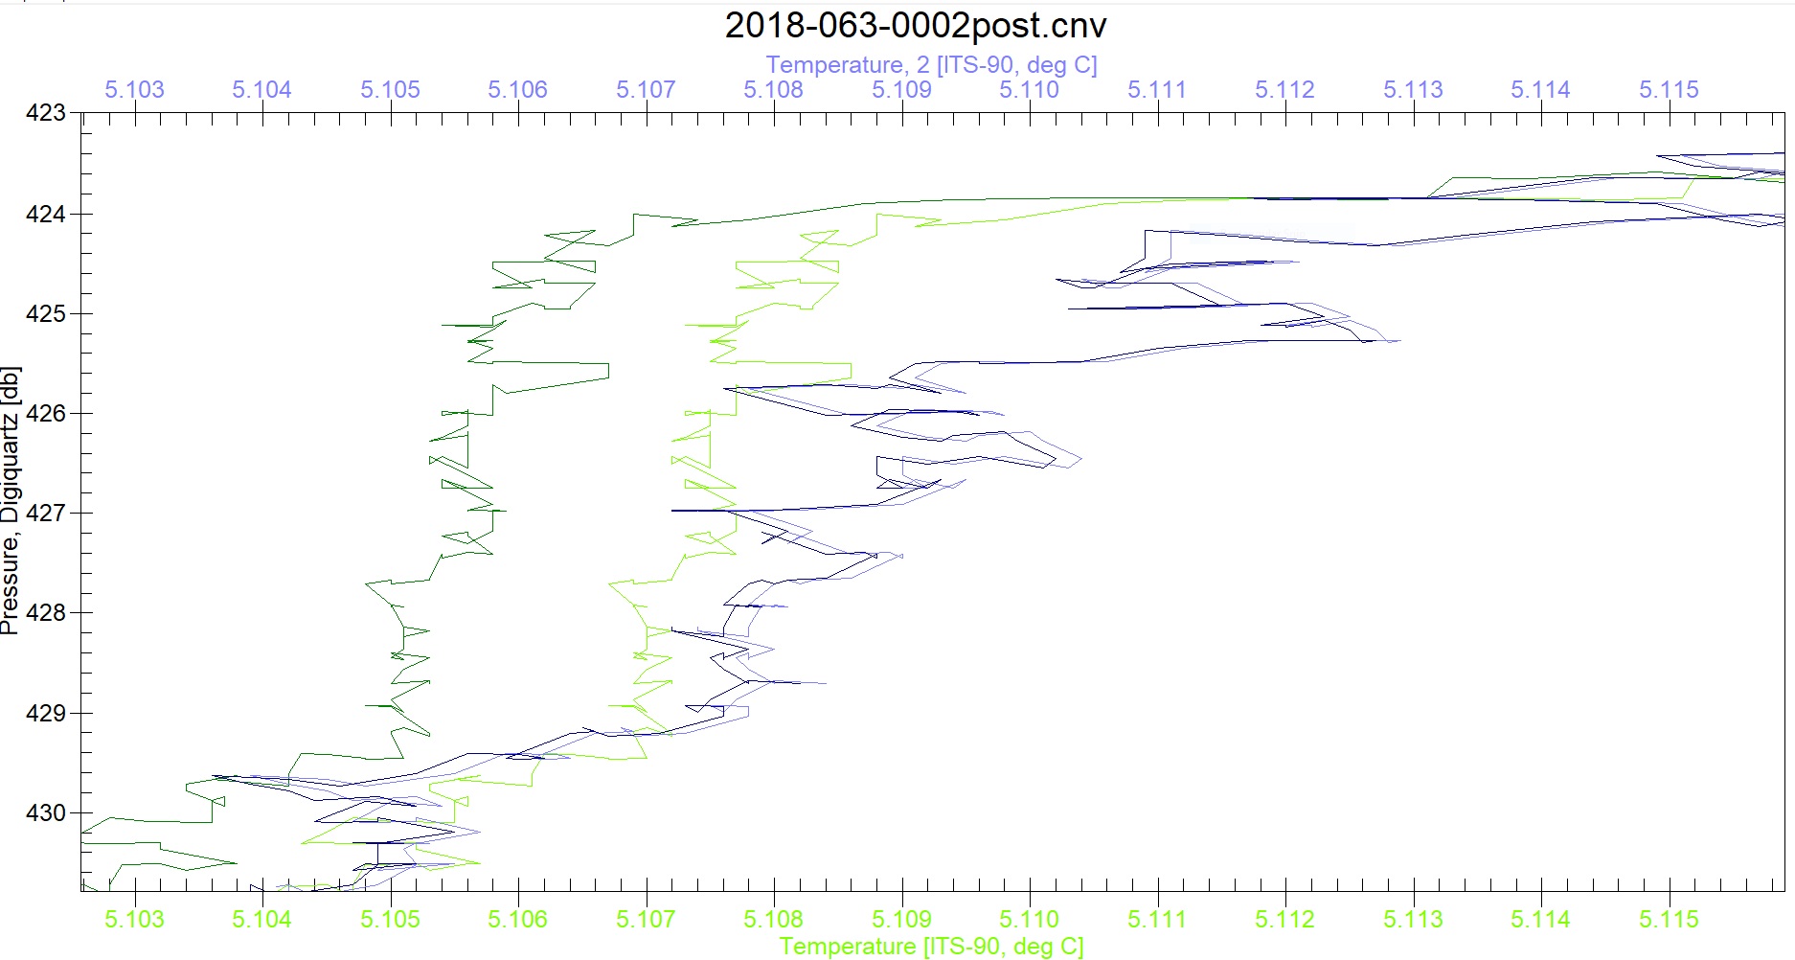

It was noted earlier that the 2 temperature channels were further apart than usual throughout the cruise.

The effect of the temperature reading low is partly offset by the conductivity also reading a little lower so that salinity was not affected much.

The temperature was already reading lower during this early cast and it appears it did not drift further through the cruise.

Normally, choosing the secondary sensors would seem the logical choice, but the data from the secondary sensors had some problems with poor flow and as is obvious in the plot above the data are very noisy. So the primary are the better choice.

The conductivity channels did not drift a lot but the effect on the secondary salinity was to lower it by 0.0036psu.

A finding that the primary salinity was low by 0.0007 and the secondary by 0.0036psu is in good agreement with the comparison with bottles which found that the CTD channels were low by 0.0001psu and 0.0029psu. Incomplete flushing and delay for analysis and the noisiness in the comparison can easily account for such small differences. So the post-cruise calibration looks appropriate.

Event #230 was also studied though it was very shallow. The differences between pre-cruise and post-cruise results were very similar, which suggests that little drift occurred during this cruise.

Historic ranges – Local climatology was not available.

##### DETAILED EDITING

The primary channels were selected for editing and eventual archiving since the salinity compared well with bottles and there were some known problems with the flow to the secondary system.

Both temperature and salinity are noisy, as expected in shallow casts. In some of the areas sampled the CTD is particularly challenged because there is a large gradient in temperature at the base of the mixed layer but salinity varies little. So small mismatches in alignment lead to large spikes in salinity. There may also be some issues arising from the cell thermal mass correction. So editing of salinity is aimed at producing a stable profile, but many small unstable features remain. The Bering Sea casts are especially difficult to edit for that reason. Towards the end of the cruise there were other problems including low descent rates in some areas leading to shed wake corruption and some casts had a very short wait at the end of the 10m soak so that salinity was not sufficiently equilibrated before the full cast started.

CTDEDIT was used to remove records corrupted by shed wakes. Salinity data were cleaned by interpolation or removed from some sections, mostly in areas with high temperature gradients including some areas where the CELLTM adjustment leads to salinity excursions at the top and bottom of the thermocline. Many unstable features remain but most are small and some may be real. All casts required some editing.

Plots were made to see if further editing was required. Many unstable features remain but most are small-scale or would require removal of data where there is no obvious instrumental effect. These were mostly from shallow casts.

##### Initial Recalibration

* The post-cruise results indicate that the primary salinity was low by ~0.0007psu and the secondary high by ~0.0003psu, excluding bottles fired at the bottom and cases where CTD salinity was very noisy. We expect bottles from the upcast to read a little higher than ambient conditions due to incomplete flushing, so it is likely that both salinity channels are actually reading a little higher than the results suggest. There are only 3 bottles below 100db, 1 of which was fired at the bottom and 2 above bottom. Those 3 were in at a site where flushing was likely good and gradients fairly low below 100db. For those the primary was high by between 0.0022 and 0.0035psu and the secondary was high by between 0.0022 and 0.0036psu. There is insufficient evidence to justify recalibration.
* The post-cruise servicing of the oxygen sensor found a punctured membrane and drift in calibration appeared to be on the order of 15%. The comparison with bottles suggests that the damage occurred after this cruise. Calibration will be applied based on the bottle comparison.

Oxygen:Dissolved:SBE = 1.0444 *Oxygen:Dissolved:SBE:Uncorrected

* Pressure does not need recalibration.

CALIBRATE was first run on the MRGCLN2 and SAM files using file 2018-063-recal1.ccf to apply the dissolved oxygen correction described above. COMPARE was rerun on the output files (MRGCOR1 and SAMCOR1) to see if this correction worked well and it did. File 2018-063-dox-comp2.xls shows a flat fit of differences versus SBE DO. The SBE DO was found to be low by an average of -0.0021 mL/L (std. dev. 0.0252) when the bottles excluded from the original fit were also excluded from this fit.

CALIBRATE was then run on the edited CTD files using file 2018-063-recal1.ccf.

##### Final Calibration of DO

The initial recalibration of dissolved oxygen corrects for sensor calibration drift. Alignctd corrects for transit time errors. Those 2 steps may partly correct for response time errors, but to see if a further correction is needed, a comparison is made of downcast CTD data to bottle data from the same pressure. Small differences are expected due to ship drift, temporal changes, incomplete flushing of Niskin bottles and delayed response and noise in CTD data.

Downcast files were bin-averaged to 0.5m bins for the casts with DO bottle samples. Those files were then thinned and compared to the bottle values in the MRG files. COMPARE was run to study the differences between the downcast CTD DO data and the titrated samples from upcast bottles.

The CTD DO was higher than the titrated samples by an average of ~0.068mL/L (standard deviation 0.116mL/L) when the same data were excluded as in the original comparison. But there is variability with depth. At 5m the CTD generally looks a little low which could be due partly to incomplete flushing as oxygen is frequently increasing or steady at that depth. At 25m and 35m there is a lot of variability in the differences and these are the depths at which there was often a DO maximum. Below 35m all CTD DO values are higher than the titrated samples, as expected if flushing is poor and DO is decreasing with depth. Another source of positive differences is response time errors in the downcast data from the SBE sensor. There are very few samples and they all come from the first half of the cruise with only 1 sampling below 100m.

Based on a plot of differences versus pressure a rough estimate of SBE DO accuracy is:

±0.40 mL/L from 0-35db

±0.20 mL/L from 60db to 200db

±0.07 mL/L below 200db

This is likely an underestimate of accuracy particularly in areas of low DO vertical gradient.

##### Special Fluorometer Processing

A median filter, fixed size=11, was applied to the fluorescence channel in the COR1 files to reduce spikiness. A few casts were examined before and after this step and showed that the filter was effective.

##### BIN AVERAGE of CTD files

The following Bin Average values were applied to the FIL files (output AVG):

Bin channel = pressure Averaging interval = 0.5 Minimum bin value = .000

Average value will be used. Interpolated values are NOT used for empty bins.

After averaging, page plots were examined on screen. Some unstable features remain as described in section 16. These are mostly close to the surface and very heavy editing would be needed to remove them; often the unstable feature is due to a very small reversal in salinity. No further editing was applied.

##### Final CTD File Steps (REMOVE and HEADEDIT)

REMOVE was run on the AVG files to remove the following channels (Output *.REM):

Scan_Number, Temperature:Secondary, Salinity:T1:C1, Conductivity:Secondary, Oxygen:Voltage:SBE, Altimeter, Status:Pump, Descent_Rate and Flag

Change Units was run to derive dissolved oxygen in mass units.

Oxygen Saturation was derived and plots made of surface values which ranged from 92% to 120% with the majority between 101% and 106% and only 1 cast <96%. The Pacific Ocean casts were between 104% and 106% and the highest values were along the DB04 line at the end of the cast. Those values look reasonable.

REORDER was run to get the 2 DO channels together.

HEADER EDIT was used to fix formats and channel names and to add comments:

The Standards Check routine was run and no problems were found.

The Header Check was run and no problems were found.

The cross-reference list was produced and no problems were noted.

The final files were named CTD.

Profile plots were made. All variables look reasonable. Near-surface oxygen is often spiky but it is not clear what is real and what is an instrumental artifact.

The track plot looks fine

The sensor history files were updated.

##### Final Bottle Files

The MRGCOR1 files were put through SORT to order on increasing pressure.

REMOVE was run on the MRGSORT files to remove the following channels (Output *.MRGREM):

Scan_Number, Temperature:Secondary, Salinity:T1:C1, Conductivity:Secondary, Oxygen:Voltage:SBE, Altimeter, Status:Pump, Descent_Rate and Flag.

Change Units was run to add Oxygen:Dissolved:SBE in mass units. A second run was made to add Oxygen:Dissolved in mass units using Temperature:Draw.

REORDER was to rearrange the channel order.

EDIT HEADERS was run to fix formats and units, fix a few headers, change the channel name Bottle_Number to Bottle:Firing_Sequence and the name Bottle:Position to Bottle_Number, to fix the platform name and chief scientist’s name and to add a comment about quality flags and analysis methods and a few notes about the CTD data.

This process was particularly tricky due to the large number of channels and variations from cast to cast. A “dummy” file list was found and a few input files were checked against this list and the input channel names and formats had to be adjusted for some channels. Running the standards check was very helpful in tracking down all such problems.

A non-standard format for Phosphate2 was not changed as it reflects the choice of the analyst.

For a final check the CHE bottle data were exported to a spreadsheet and compared to the rosette sheets. No problems were found.

Profile plots were made of a few variables to look for any obvious outliers and none were found.

A Header Check was run and no problems were found.

A cross-reference list turned up no errors

The track plot was produced on screen and no errors were found.

##### Thermosalinograph Data

Date were provided in 11 hex files.

There was an intake thermistor but no flow meter installed.

a.) Checking calibrations

All configuration files were the same. One was saved as 2018-063-tsg.xmlcon. The calibrations were checked and no problems were found.

b.) Conversion of raw files.

Configuration file 2018-063-tsg.xmlcon was used to convert all the files.

The files were then converted to IOS HEADER format.

CLEAN was run to add End times and Longitude and Latitude minima and maxima to the headers.

ADD TIME CHANNEL was used to add Time and Date channels based on the Julian time.

Time-series plots were produced. There are large discrete spikes in salinity that look likely to be produced by bubbles. Fluorescence generally looks fine though all values look suspicious in the final file. It is likely the flow was turned off for most of the time during this file.

c.) De-spiking

All files were put through program Simple Despike to replace simple spikes in salinity of size >0.1psu with the average of adjacent values. This worked well.

d.) Bin-averaging

The files were bin-averaged over 6 scans for the purpose of comparing to CTD data.

The track plot looks fine. It was added to the end of this file.

e.) Checking Time Channel

The CTD data were thinned to reduce the files to a single point from the downcast at or within 0.5db of 5db. Those data were exported to file 2018-063-tsg-ctd-comp.xlsx.

The averaged TSG files were opened in EXCEL and reduced to the times of CTD files.

There were no matches for the first 4 TSG files as CTD casts did not begin until July 9th. There were matches for files 5 and 7 to 10.

There were 47 matches.

To check for problems in the TSG clock or bad matches of TSG and CTD data, the differences between latitudes and longitudes were found. The median differences in latitude and longitude were 0.00001° and 0.00004°, respectively, with maximum differences of 0.0007°. So the clock looks reliable.

This spreadsheet was then used in step (f) to compare temperature (intake and lab), salinity and fluorescence from the CTD and TSG.

f.) Calibration Checks

* T1 vs T2

The lab temperature is higher than the intake temperature by an average of ~0.20C° which is typical of this ship when operating in this region. The fit suggests that the ambient temperature of the lab is ~24C°.

* TSG vs CTD The spreadsheet comparing CTD and TSG files was examined to find the differences between the salinity, fluorescence and temperature channels for the CTD and the TSG.

|  |  |  |  |  |
| --- | --- | --- | --- | --- |
|  | Tint-Tctd | Tlab-Tctd | Stsg-Sctd | FLtsg/FLctd |
| min | -0.1683 | -0.0518 | -0.7650 | 0.8182 |
| max | 1.7471 | 1.9424 | 0.2512 | 2.4815 |
| avg | 0.1623 | 0.3648 | -0.0610 | 1.3108 |
| median | 0.0708 | 0.2969 | -0.0095 | 1.2632 |
| stdev | 0.3193 | 0.3242 | 0.1631 | 0.2910 |

The Intake temperature is higher than the CTD temperature by a median value of 0.07 Cº, but the standard deviation is very high. A few CTD casts were examined in detail. One had a vertical gradient high enough that values differing by 0.07 Cº were found in adjacent records. Another showed a shed wake passing through at 5db, so the CTD data were very noisy. There could also be some heating from the ship. The intake temperature is likely more accurate than the 5m CTD data, though what depth the water is drawn from is uncertain.

The TSG salinity is lower than the CTD salinity by a median of 0.0095psu but the standard deviation is 0.1631psu, with variability especially high in Bering Strait and quite high in the Chukchi Sea.

The TSG fluorometer readings are higher than those from the CTD fluorometer by a median of 26% which may be partly to the TSG drawing water from a little higher in the water column, though there is likely some effect of differences in sensor calibration. The 2 traces are similar in shape when plotted against event #s.

Rosette samples were obtained. While these do not match the TSG in time as they were gathered at the end of casts, they do come from when the ship was stopped. There is a lot of noise in the comparison but, as usual, fluorescence is higher than CHL when CHL is very low but is close to CHL when CHL<2ug/L. It is lower than CHL for higher values of CHL.

(See 2018-063-TSG-CTD-loop-rosette-comp.xls.)

* Loop Bottle - TSG Comparisons

There were 12 salinity loop samples but the times recorded for 4 of them did not relate to the MRK files that were provided. Matching the times to the full TSG files provided results that did not look reasonable.

For the 8 files that were matched to MRK files the TSG salinity was lower than the loops salinity by an average of 0.0191 and a median of 0.0063psu. The range was from being high by 0.009psu to low by 0.069psu. We would expect the TSG salinity to be somewhat low due to bubbles.

* A post-cruise calibration was available from January 2019, so 3 files were converted with those parameters. The maximum and minimum lab temperature, conductivity and salinity for each file were compared using pre- and post-cruise files. The temperature was higher than the post-cruise values by a median of 0.00055 C° (std dev 0.00005 C°) Salinity was high by a median of 0.01045 S/m (std dev 0.00119S/m) and conductivity was high by a median of 0.00107 S/m (std dev 0.00012 S/m). The salinity drift is quite high but some likely occurred between July and January.
* Calibration History

The TSG primary temperature and conductivity were recalibrated before and after this cruise in December 2017 and January 2019. The dissolved oxygen sensor membrane was found to be punctured during the post-cruise calibration.

The TSG was used for 2 other cruises. During 2018-01 salinity was thought to be low by 0.01. During 2018-39 salinity was close to CTD and loops but there was a lot of scatter.

Conclusions

1. The TSG clock appears to have worked well.

2. The intake thermistor worked well and looks reasonably accurate.

3. The TSG lab temperature reads higher than the CTD by an average of 0.20Cº, ranging from 0.12Cº, to 0.30Cº, depending on the intake temperature. This is a typical result for this vessel.

4. The TSG Salinity was found to be reading lower than the CTD by a median of 0.0095psu. It was lower than the loop salinity by 0.006psu but the standard deviation was very high. It was lower than the rosette samples by a median of 0.021psu but the standard deviation was 0.245psu. The high variability in the rosette comparison is likely due to the difference in timing as the TSG record came from the beginning of casts and the rosette samples from the end. The rosette samples may come from a little lower in the water column due to incomplete flushing of bottles, so the TSG is likely not reading as low as suggested. All those comparisons suggest the CTD is reading a little low, while the post-cruise check showed it reading high by 0.01psu. The drift may have come after this cruise or the presence of bubbles in the loop water may offset the calibration drift. Low TSG salinity is especially notable in Bering Strait and quite high in the Chukchi Sea casts; that may be due to increasing presence of bubbles. It is possible that the salinity is reading too high but that bubbles are masking that effect. Normally we apply a correction to offset the “bubble effect” but that is only appropriate when the effect is fairly general, whereas for this cruise it is highly variable.

5. Fluorescence from the TSG was higher than that from the CTD by about 26%. Comparisons with loop and rosette samples looked similar to what is usually observed for this type of sensor.

g.) Recalibration

No recalibration is justified. Bubbles do lower the salinity but the effect is highly variable. The largest spikes in salinity were removed with Despike.

i.) Preparing Final Files

REMOVE was used to remove the following channels from all files: Scan Number, Temperature:Difference and Flag. Those files were copied to *.EDT.

No editing was applied to the files. The salinity traces are full of complex drop-outs that cannot be removed without leaving huge gaps in the data. It is often not clear which data are bad.

File #11 does not appear to contain any useful data. The ship appears to be stopped, the record is short and steadily rising temperatures suggest there was no flow.

REORDER was run to get the intake temperature ahead of the lab temperature.

HEADER EDIT was used to add a comment and add the depth of sampling to the header.

Those files were saved as TOB files.

The TSG sensor history was updated.

As a final check plots were made of the cruise track and time-series and all look fine.

The cruise plot was added to the end of this report.

Particulars

**TSG**

7 July 2018 16:08:00 - Repositioned fluorometer so inlet/outlet tubes are pointing up and connector is pointing down. Voltage jumped up from 0.08 to 1.5V (good). Then swapped back in the 3x gain cable so we can leave it in place for the rest of the cruise. Updated con file with 3x gain cable and saved as 2018-07-07.xmlcon (not quite right but name has todays date in it). Started new Seasave file.

**CTD**

1. Test cast off Quadra Island. All bottles closed. No Bottle file needed.

34. 3 bottles fired for water were not assigned sample #s.

49. Secondary (T,C,FL) bad – likely no flow. Bottom and upcast looks ok.

87. Went down to 1.2m off bottom, then up to 3m before upcast.

93. Lots of jelly strands on CTD rosette -cleaned after cast.

122. Lowered at 0.6m/s. Bottle vents and valves open – cast redone. (First cast saved as 9122.)

124 & 127. Lowered at 0.5m/s.

141. File started bit early. Bottle 13 for formalin, no sample #.

161. First drop “noodles” attached – rerun & overwrote 1st file. Looks like a jellyfish plug in the secondary plumbing, especially fluorometer. Seemed ok during bottle stops. Jelly strands on rosette on recovery. Plumbing was well flushed at end of sampling but no particulates observed.

193. Bottle 6 was sitting low when rosette recovered. Re-positioned and re-tightened the clamps.

230. Wrong position.

252. Top 20m lots of “intrusive” F entries in T, S, OXY. Seen in both channel pairs. Swell and 0.5m/s descent rate.

# Institute of Ocean Sciences

# CRUISE SUMMARY

**CTDs**

|  |  |  |  |  |  |
| --- | --- | --- | --- | --- | --- |
| **CTD#** | **Make** | **Model** | **Serial#** | **Used with Rosette?** | **CTD Calibration Sheet Competed?** |
| 1 | SEABIRD | 911+ | 0941 | Yes | Yes |

|  |  |  |  |  |  |
| --- | --- | --- | --- | --- | --- |
| **Calibration Information CTD #941** | | | | | |
| **Sensor** | | **Pre-Cruise** | | **Post Cruise** | |
| **Name** | **S/N** | **Date** | **Location** | **Date** | **Location** |
| **Temperature** | **5048** | **4Nov2017** | **Factory** | **7Dec2018** | **Factory** |
| **Conductivity** | **3579** | **10Nov2017** | **Factory** | **12Dec2018** | **Factory** |
| **Secondary Temp.** | **5073** | **4Nov2017** | **Factory** | **8Dec2018** | **Factory** |
| **Secondary Cond.** | **3581** | **7Nov2017** | **Factory** | **13Dec2018** | **Factory** |
| **Transmissometer** | **1666** | **14Jun2018** | **Laurier** | **4Jun2019** | **Laurier** |
| **SBE 43 DO sensor** | **1117** | **22Nov2017** | **Factory** | **22Dec2018** | **Factory** |
| **SeaPoint Fluorometer** | **3575** | **Tested**  **15 Feb18** |  |  |  |
| **PAR** | **70123** | **4Apr2016** | **Factory** |  |  |
| **Surface PAR** | **20281** | **4Apr2016** |  |  |  |
| **Pressure Sensor** | **131733** | **6April 2015** | **Factory** |  |  |
| **Altimeter** | **40853** | **12Feb2007** |  |  |  |

# TSG Make/Model/Serial#: SEABIRD/21/3274

|  |  |  |  |  |  |
| --- | --- | --- | --- | --- | --- |
| **Calibration Information** | | | | | |
| **Sensor** | | **Pre-Cruise** | | **Post Cruise** | |
| **Name** | **S/N** | **Date** | **Location** | **Date** | **Location** |
| **Temperature** | **3274** | **16 Dec 2017** | **Factory** | **10 Jan 2019** | **Factory** |
| **Conductivity** | **3274** | **16 Dec 2017** | **Factory** | **10 Jan 2019** | **Factory** |
| **Temperature SBE38** | **0271** | **27May2017** | **Factory** | **28 Dec 2018** | **Factory** |
| **SeaPoint Fluorometer** | **3654** | **Tested**  **15 Feb18** | **Factory** |  |  |

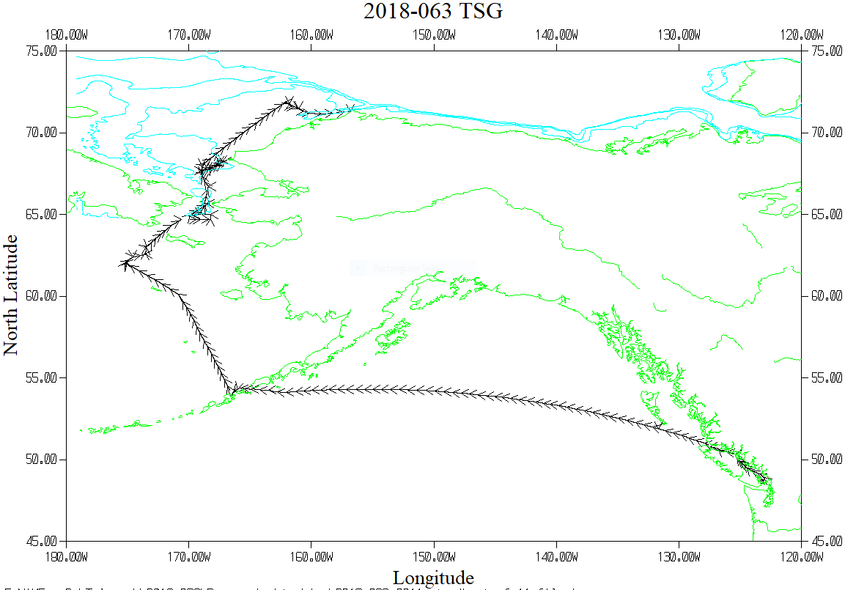

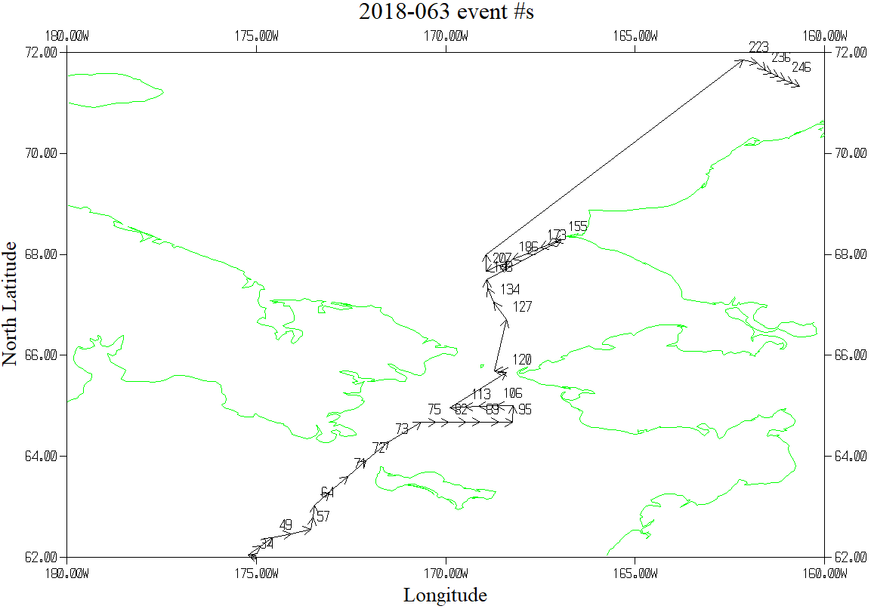

The plot excludes Event #2 which was at 51° 52.45’N 131° 39.36’W.

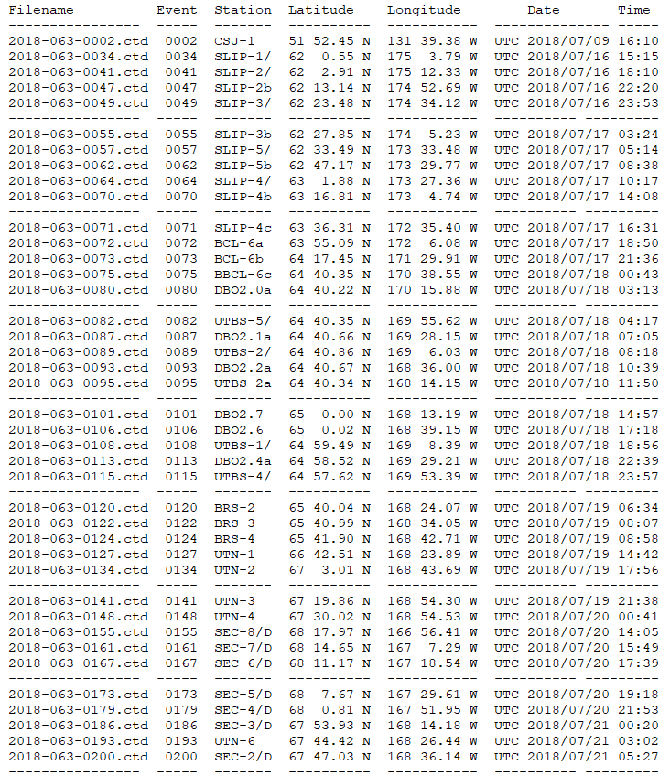

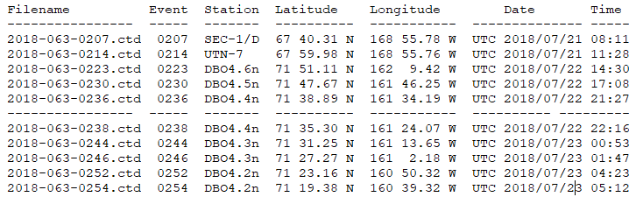

TSG Plot - 12 hours between arrows