REVISION NOTICE TABLE
DATE | DESCRIPTION OF REVISION
27 March 2023 | Added HPLC data. S.H.

PROCESSING NOTES
Cruise: 2018-037
Agency: Ocean Sciences Division
Location: Strait of Georgia Zooplankton
Project: Strait of Georgia
Party Chief: Young K.
Platform: Neocaligus
Date: July 17, 2018 – July 21, 2018

Processed by: Germaine Gatien
Date of Processing: 25 October 2018 – 31 October 2018
Number of original XML files: 27
Number of CTD files: 26 Number of bottle files: 23

INSTRUMENT SUMMARY
A SeaBird Model SBE25+ CTD was used during this cruise; attached were a SBE 43 DO sensor (#766) and a WET labs ECO Fluorometer (#2214).

SUMMARY OF QUALITY AND CONCERNS
The Daily Science Log book was in good order with many useful comments.

A 1.7L Niskin was attached about 1m above the CTD for some deep water samples while a hydro cast with 8 bottles was used for 3 casts. Samples at 5m and 10m were sampled with 5L Niskin bottles. A timer was set to 2 minutes. The CTD was lowered to about 10m then raised and held at the surface until the 2 minutes was up. The full cast was then run. This approach enables easy removal of the data from the soak period by removing a set number of records.

The CTD data file for cast #11 was lost. A file was started that contained preliminary soak data, but the boat had to reposition and an attempt to restart the file failed.

The sampling approach means that several event numbers are assigned for each station. In order to create bottle files, analysis data were combined with associated CTD casts and were given the event number of the CTD cast even for event #11 for which there are no CTD data.

The only extracted chlorophyll samples came from the surface while the shallowest CTD fluorescence data come from about 1.5m. Despite that vertical offset, the comparison of fluorescence with chlorophyll looks typical of these sensors.

Salinity samples were taken at the bottom of a few CTD casts and during 3 hydro casts with 8 bottles each. Unfortunately the CTD data were lost for one of those hydro casts, so only 2 were useful for comparisons. The CTD salinity was found to be high by approximately 0.007psu but incomplete flushing of Niskin bottles is likely so the CTD may be closer to, or even lower than, in situ conditions. The accuracy of the CTD salinity is likely within +/-0.005psu.

There was dissolved oxygen sampling for this cruise, but there was too much scatter in the comparison with CTD DO and too few samples to enable a justifiable method for excluding outliers. Many samples were flagged 3 by the analyst and the range of DO was limited. The comparison suggested a correction of between 4% and 11%. However, incomplete flushing of bottles would lead to the CTD DO looking lower than it really is so those corrections may well be too high. There was an earlier cruise with a comparison to a CTD911+ cast that suggested that the CTD DO should be increased by 6%. While that comparison was also of limited quality, it looks more reliable, so the 6% correction was applied.

Bottle files were prepared combining CTD data and analysis results. Because there are no CTD data to go with surface samples or with samples from station CPF2, Depth:Nominal was added and should be chosen for plotting in order to capture all available data. Each bottle file was given a file name based on the event number of the CTD cast for that station.

PROCESSING SUMMARY

Seasave
This step was completed at sea; the raw data files have extension XML.

Preliminary Steps
The Log Book and rosette log sheets were obtained. There are many notes about problems encountered

There were a variety of deployment types during this cruise:
1. CTD cast with a single Niskin attached to collect a deep salinity sample followed by 1 or 2 surface samples given different event numbers. The Niskin was mounted about 1m above the CTD.
2. CTD cast with no Niskin, a separate hydro cast with up to 8 bottles including a deep sample, sometimes followed by another hydro cast with Niskins fired at 0 and 5m and finally surface samples with a separate event number.
3. No CTD cast – just surface samples.
4. Just a CTD cast.
5. In one case the CTD data was lost so there will be bottle data only.
Each cast was given an event number, but when building the bottle files we will combine CTD data from each station with all bottle samples from that station, using the event number of the CTD.
The sample numbers were assigned in reverse order of depth except at 0 and 5m.
Nominal depths will be needed since there will be no CTD data to go with the surface samples and cast #11, hence no CTD pressure or depth reading.

Nutrients, extracted chlorophyll, dissolved oxygen and salinity data were obtained in QF spreadsheet format from the analysts.

The cruise summary sheet was completed.
The sensor histories for the pressure, conductivity and DO sensors were found.
The raw files were not in standard format with only 3 digits for the event numbers. That was fixed.
The calibration constants were checked for all instruments and all are correct.

Conversion of Full Files from Raw Data
All XML files were converted to create CNV files.
A few casts were examined. All casts were found and had normal profiles. There are some spikes in conductivity. Fluorescence dark values are very close to 0 so some noise in the signal leads to some very slightly negative values. The descent rate was usually high and fairly steady.

WILDEDIT
There were some spikes in conductivity so WILDEDIT was run on temperature, conductivity and depth using parameters: Pass 1 Std Dev = 2 Pass 2 Std Dev = 5 Points per block = 35

WINDOWS FILTER
This routine is sometimes applied to SBE25 data, but does not look necessary for this CTD, perhaps due to the higher sampling rate, 16Hz. Pressure can be filtered in the DELETE process. Temperature and conductivity are noisy, but it is hard to judge whether this is real or instrumental. So the Windows Filter was not run.

ALIGN DO
Tests on a few casts show that an advance of +4s looks appropriate.
ALIGNCTD was run on all casts using +4.0s.

CELLTM
CELLTM was run using the default settings (α = 0.4, β=8) for conductivity. Comparisons before and after this step showed it was effective it making upcast and downcast data closer on a T-S surface..

DERIVE and Channel Comparisons
Program DERIVE was run on all casts to calculate primary salinity and dissolved oxygen concentration.

Conversion to IOS Header Format
The IOSSHELL routine was used to convert all CNV files to IOS Headers.
CLEAN was run to add event numbers and to replace pad values in the pressure channel with interpolated values based on record number.

At this point the 10m soak data were removed. CLIP was run to remove 1920 scans (2 minutes) from all casts. Plots were examined and sufficient (and not too many) data had been removed except for cast #11.
Cast #11 contained only soak data. After the soak the ship needed to reposition so a 2nd file was started. However, the 2nd file has not been found so was likely not actually recorded.

Checking Headers
A cross-reference list was checked against the log book. Two station names were wrong; they were fixed.
The cruise track was plotted and added to the end of this report.
Header Check was run and no problems were found.
The surface check shows an average of 0.04db with a few negative values (between -0.01db and -0.05db) which are associated with salinity values <0.4psu. This is as accurate as can be expected from this type of pressure sensor.

Shift
Fluorescence
The Eco fluorometer on the SBE25 does not usually require alignment since it is not pumped. A few profiles were examined and no alignment appears to be necessary, though the spikiness of the fluorescence makes it hard to judge.
Dissolved Oxygen
The Dissolved Oxygen voltage channel was aligned earlier. A few casts were checked to see if the alignment looked ok, and as usual, there is variability with the up and downcast traces sometimes closer than temperature and sometimes further apart. This is likely due to varying vertical gradients and descent/ascent speeds. Overall the choice made earlier looks appropriate, so no further alignment will be applied to either CTD DO sensor.
Conductivity
Tests were run on 2 casts and a shift of +1.7 records to the conductivity was found to best reduce noise in the salinity as seen on a T-S plot. SHIFT was run on all casts advancing the primary conductivity by 1.7 records. Salinity was recalculated.

DELETE
The following DELETE parameters were used:
Surface Record Removal: Last Press Min
Maximum Surface Pressure (relative): 10.00
Surface Pressure Tolerance: 1.0 Pressure filtered over 7 points
Swells deleted. Warning message if pressure difference of 2.00
Drop rates < 0.30m/s (calculated over 9 points) will be deleted.
Drop rate applies in the range: 10db to 10db less than the maximum pressure
Sample interval = 0.0625 seconds. (taken from header)
COMMENTS ON WARNINGS: The only warning was about cast #11 since there are no data below 10m. The CTD cast will not be processed further.

Other Comparisons
Previous experience with these sensors –
The pressure sensor was used on 12 cruises since it was last recalibrated and no offset was applied to any of them. The temperature and conductivity sensors were used during 2018-039 with no calibration sampling, but a comparison with an SBE911 showed it to have temperature high by about 0.002C° and salinity low by about 0.003psu. The dissolved oxygen sensor has been used for 2 other cruises since it was last serviced but the only comparison was with a CTD cast during 2018-039 and only covered the top 50m. The SBE25 ddissolved oxygen was consistently lower than that from the SBE911. At 16db it was low by about 5.8% and at 35db it was lower by about 6.2%.
Historic ranges – Profile plots were made with 3-standard deviation climatology ranges of T and S superimposed. All salinity data fell within the local climatology except for some high values near the bottom of cast #69 in the southern Strait of Georgia. There were 4 casts with temperature values above the climatology maxima. Cast #7 in Baynes Sound had high values from 35db to the bottom. Casts 65, 79 and 83in the Gulf Islands area had high values in some parts of the top 25 to 40db range. This may be a matter of these areas not being well represented in the climatology as little sampling was done in those areas in the years represented in the climatology. These excursions are unlikely to be due to calibration problems.
Repeat Casts – There were no repeat casts and nearby casts are not close enough or deep enough for useful comparison.

Post-Cruise Calibration - None was available.

DETAILED EDITING
CTDEDIT was used to remove large spikes, remove or clean smaller spikes that appear to be due to instrumental problems and likely to affect the bin-averaged values and records corrupted by shed wakes. All files required some editing, but mostly it was removal of records from near the top and bottom of casts and light cleaning of salinity.

Initial Bottle Data Steps
There was no rosette available for this cruise. To enable searching of bottle data, BOT files were prepared.

Each of the analysis spreadsheets were examined to see what comments the analysts wanted included in the header file. These were used to create file 2018-037-bot-hdr.txt which will be updated as needed during processing.

EXTRACTED CHLOROPHYLL
Extracted chlorophyll and phaeo-pigment data were obtained in file QF 2018-037CHL*.xlsx. The file included comments, flags and a precision study. A simplified version of the spreadsheet was prepared in which some columns were removed and the file was saved as 2018-037chl.csv, event numbers were added, and the file was then converted to individual CHL files.
DISSOLVED OXGYEN
Dissolved oxygen data were provided in spreadsheet QF2018-037oxy*.xlsx which includes flags, and comments. Draw temperatures are available. Data were analyzed at IOS. The spreadsheet page with the final data was simplified and the file was then saved as 2018-037oxy.csv.
That file was converted into individual *.OXY files.
SALINITY
Salinity analysis was obtained in QF2018-037SAL*.xlsx and includes a precision study. The analysis was done within 33-37 days of collection. The files were simplified and saved as 2018-037sal.csv.
That file was then converted to individual SAL files.
NUTRIENTS
The nutrient data were obtained in spreadsheet NUTS_QF2018-037nuts.xlsx. This includes a precision study. The spreadsheet was simplified, reordered on sample numbers and saved as 2018-037nuts.csv.
The file was converted to individual NUT files.

Workbook 2018-037-bottle_plus_CTD.xlsx was created. Separate worksheets were created to contain the data from the event log relevant to Niskin sampling, bottle data, CTD data at bottle depths, CTD plus bottle data, CTD plus bottle data in 6-line header format and bottle-CTD comparisons.

Because it is impossible to do all the sampling in a single cast, there are often 2 or more events noted in the Daily Science log book for a single site. It makes most sense to combine them in a single bottle file, corresponding to a single sample/rosette log sheet. The CTD cast for each station was chosen as the event number for the bottle files.

There was sometimes phytoplankton sampling from bottles from which there was no other sampling, so lines for those samples were added to the sampling list on the bottle data worksheet.

To select CTD data to go with the bottle samples, a list of depths sampled in increasing order was prepared and bin-averaged CTD files were thinned to those depths. Data were exported and copied to a separate sheet of the workbook. Records were removed for which there was no sampling and lines were added for the surface samples. This is the most error-prone part of this task. For a few casts the files contained no data as deep as indicated in the log, so the deepest value was changed to match what was in the CTD file minus 1m. Then the file was edited to remove depths that were not sampled. There was sampling close to the surface, though not at 0m. Where there were data from above 2m it was kept in the file for an initial assessment of whether it might be useful.

The CTD data were then added to the bottle data in the appropriate worksheet. Nominal depths were entered since there are no CTD pressure or depth data for the surface samples or cast #11.

When the final CTD files are ready, this process will be repeated to capture recalibrated CTD data and the DO data in mass units. At that time a 6-line header will be added to enable creation of separate bottle files for each station.

15. Compare
One worksheet was used to do comparisons between sample and CTD values.

Salinity Comparison
There were no CTD data at 0m and the match with CTD data from between 1m and 2m would not be reliable due to high vertical gradients in salinity. So those values were dropped from the comparison.
The CTD was found to be higher than bottle salinity by an average of 0.007psu using the 13 samples available but the standard deviation was 0.073psu.

The methods used for gathering the samples varied.
- For casts #29 and #56, the Niskin was mounted just above the CTD and was closed when the CTD was at the bottom of the cast. Poor flushing of Niskin bottles would lead to samples having lower salinity values than in situ values, though the local gradients were fairly low. This would lead to the CTD looking higher than it really is. Those 2 cases show the CTD salinity being high by 0.006 and 0.007psu. These are the 2 samples collected closest in time to CTD observations.
- For casts #2 and #65 a string of Niskins were deployed on a wire after the CTD cast, so there could be significant changes in the water column between the CTD cast and Niskin closing time. If flushing were poor we would expect the Niskins to contain water from higher in the water column, hence having lower values than in situ salinity. So again we would expect the CTD to look higher than it really is and in many cases the vertical gradients would be high enough to lead to a significant error. There are 2 cases where the CTD reads lower than the bottles. In one case the bottle was flagged due to a leaky insert which could lead to evaporation of sample, so higher salinity. For the other case, the difference is very small, 0.0007psu.

The average of all bottles shows the CTD to be high by 0.007psu but with a standard deviation of 0.073psu. The average of bottles from 100m down was 0.029psu and the average of the 4 bottles fired near the bottom was 0.007psu. There is one outlier at 20m of cast #65. A sharp gradient is seen there during the downcast, so there may have been a change in the profile between the CTD and hydro casts.

A plot of differences against depth of sampling supports a conclusion that the differences are small at depths where vertical gradients are lowest.

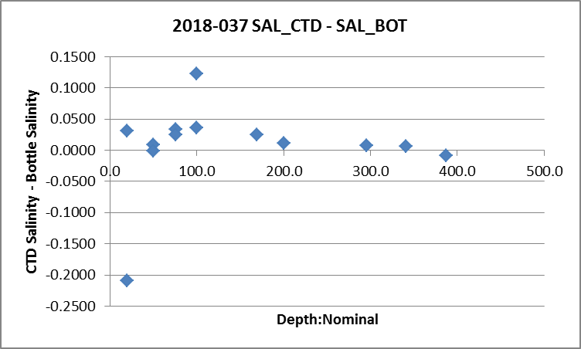

Analysis was done fairly promptly so negligible error is expected due to adsorption and/or evaporation.

While it appears that the CTD was reading slightly high, the likelihood of bottles not flushing completely would imply that the CTD accuracy is good, probably within ±0.005psu.
For more details see the “comparison” worksheet in file 2018-037-bottle_plus_CTD.xlsx.

Fluorescence
Chlorophyll sampling was done only at 0m. A comparison was done with CTD fluorescence data from about 1.5m. The fluorometer read lower than CHL samples with 1 exception. This is typical of fluorometers when CHL is >2ug/L.

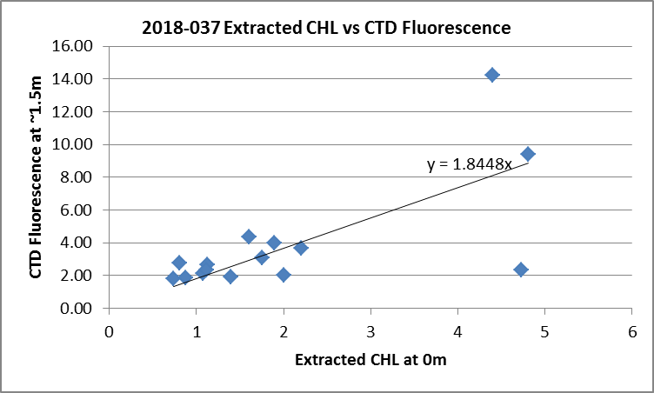

Dissolved Oxygen
Most of the dissolved oxygen samples were flagged 3.
The comparison of CTD DO and Titrated DO looks roughly as expected with the CTD values consistently reading lower than the titrated samples with a trendline:
CTD Dissolved Oxygen Corrected = 1.1903* CTD Dissolved Oxygen -0.4363 (R² = 0.74)

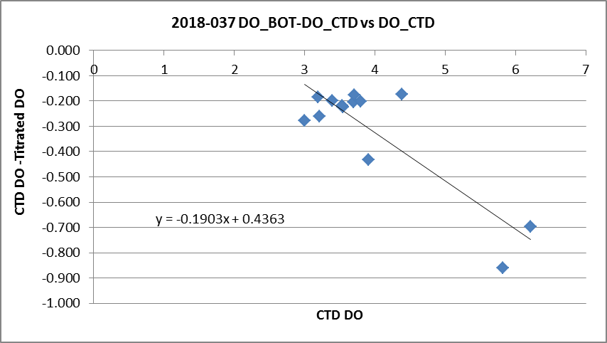

The offset is unusually high and the scatter in the comparison makes it less reliable than our usual comparisons. If the offset is forced to =0, then the fit is:
CTD Dissolved Oxygen Corrected = 1.086* CTD Dissolved Oxygen (R² = 0.50)
A subset of samples that had not been flagged 3 or 4 were compared and the result was:
CTD Dissolved Oxygen Corrected = 1.076* CTD Dissolved Oxygen (R² = 0.37)
The R² values are even lower for these fits, but the corrections are closer to what was applied to data from cruise 2018-039 when all CTD DO values were multiplied by 1.06; that result was based on a comparison of a 50m SBE25 cast with a CTD911 cast at the same station.

There are not enough DO samples from this cruise for a reliable comparison, particularly since most data come from a narrow DO range with no values <3mL/L. The depths are also approximate and many samples were flagged 3 or 4. Moreover, incomplete flushing is likely to make bottle values a little higher than in situ values, so the suggested corrections are likely too large. The 2018-039 inter-comparison with the SBE911+ cast looks more dependable.

Initial Recalibration
- Salinity appears to be within ±0.01psu and probably better than that, but the evidence is weak.
- The pressure appears to be ok.
- CTD Dissolved oxygen is low by at least 6% so CTD DO data were multiplied by 1.06.

File 2018-037-sbe25-recal1.ccf was prepared to apply the following correction to the SBE25 EDT files:
CTD Dissolved Oxygen Corrected = 1.06* CTD Dissolved Oxygen

Fluorescence Processing
A median filter, size 7, was applied to the SBE25 fluorescence channel in the COR1 files.
Plots of a few casts before and after this step showed that the filter was effective. (Output:*.FIL)

BIN AVERAGE of CTD files
The following Bin Average values were applied to the FIL files for both CTDs (output AVG):
Bin channel = pressure Averaging interval = 1.000 Minimum bin value = .000
Average value will be used. Interpolated values are NOT used for empty bins.

On-screen plots were examined. The T-S plots have a few small unstable features, but those are from sites where such features are likely real.

Final CTD File Steps (REMOVE and HEADEDIT)
REMOVE was run on all casts to remove the following channels:
Scan_Number, Conductivity:Primary, Oxygen:Voltage:SBE, Descent_Rate and Flag.

A second SBE DO channel (with umol/kg units) was added.
REORDER was run to get the two DO channels together.

HEADER EDIT was run to fix formats and channel names and to add the following comments:

Data Processing Notes:
----------------------
Conductivity and Fluorescence:URU:Wetlabs are nominal and unedited except that some
records were removed in editing temperature and salinity.

Salinity samples were taken at the bottom of a few CTD casts and during 3 hydro casts
with 8 bottles each. There are CTD data collected before 2 of the hydro casts. The CTD
was found to be higher than bottle samples by approximately 0.007psu but incomplete
flushing of Niskin bottles is likely so the CTD salinity may be closer to, or even lower
than, in situ conditions. The accuracy of the CTD salinity is likely within +/-0.005psu.
No recalibration was applied.

There was dissolved oxygen sampling for this cruise, but there was too much scatter
in the comparison with CTD DO and too few samples to enable a justifiable method for
excluding outliers. Many samples were flagged 3 by the analyst and the range of DO
was limited. The comparison suggested a correction of between 4% and 11%. There was an
earlier cruise with a comparison to a CTD911+ cast that suggested that the CTD DO
should be increased by 6%. While that comparison was also of limited quality, it looks
more reliable, so the 6% correction was applied.

Warning: While the CTD fluorescence data are expressed in concentration units, they
do not always compare well to extracted chlorophyll samples.

For details on the processing see document: 2018-037_Processing_Report.doc.

The Standards Check routine was run and no problems were found.
The Header Check was run and no problems were found.

Dissolved Oxygen Study
As a final check of dissolved oxygen data, % saturation was calculated and plotted. Values ranged from 65% to 135% with lowest values in the Gulf Islands where mixing tends to be strong. In the central part of the Strait of Georgia saturation rates ranged from 95% to 115%. In the northern part of the Strait of Georgia values were slightly higher between 110% and 120%. There was one value in Satellite Channel that was high, at 135%. A check of the full data file shows very high temperature and dissolved oxygen gradients in the top 2m for that cast; there was no associated DO sample. The lowest DO value was checked and the value after recalibration is close to the surface titrated DO sample. This study is inconclusive as to the accuracy of the CTD DO data but the range is typical of this region and season.

Final Bottle Files
The final CTD files were thinned and data exported to file 2018-037-bottle_plus_CTD.xlsx.
On one worksheet the data were organized with a 6-line header which was saved separately as a CSV file, 2018-036-bottle-plus_CTD.csv and that was converted to IOS files, 1 per cast.

CLEAN was run to remove empty channels and add 0 flags to any empty flag channels.
REMOVE was run on all casts to remove the following channels: Date and Time:UTC.
A second SBE DO channel was added for both the CTD DO and bottle DO, with mass units and REORDER was run to get the pairs of DO channels together.
SORT was run to get the files in order of increasing pressure.

Header Check was run to ensure formats and units are correct, to add a comment about quality flags and analysis methods and a few notes about the CTD data processing and to remove the END TIME which is meaningless as it equals the START TIME.
For cast #11 the Data Description was changed from Bottle:Wire plus CTD:Down to Bottle:Wire.

Plots were made of all casts to look for problems and no problems were found.
Standards check and a header check were run on all files. No errors were found.
The track plot looks ok.
Data from the CHE files were exported to a spreadsheet and compared with rosette sheets. No problems were found.

Producing final files
A cross-reference listing was produced for CTD and CHE files.
The sensor history was updated.

Particulars (mostly notes from log)
3. Took long time to sample Niskins and it was hot in the sun – tried to keep things in the shade.
5. HPLC sample labelled #* but should be #11.
11. Cast started, then boat repositioned. Intended to restart 2nd file for data but no file created.
19. Switch turned off, on, off quickly by mistake. Don’t use file started at 20:23 on July 18th.
35. Time, lat, long same as for event 36.

CRUISE SUMMARY
CTDs
CTD# | Make | Model | Serial# | Used with Rosette? | CTD Calibration Sheet Competed?
1 | SEABIRD | 25 | 1123 | No | Yes

Calibration Information SBE25+
Sensor |  | Pre-Cruise |  | Post Cruise
Name | S/N | Date | Location | Date | Location
Temperature | 2968 | 22Feb2017 | Factory
Conductivity | 2173 | 23Feb2017 | Factory
ECO Fluorometer | 2214 | 02Jun2017 | ?
SBE43 Oxygen | 766 | 1Mar2017 | Factory
Pressure | 1123 | 11Nov2015 | Factory
