**Neocaligus Cruise IOS 2018-36**

**~~24-30 May 2018~~ 26 May – 1 June 2018**

**Crew: Mark Belton, Jasmine Wietzke, Kat Doughty**

**Table 1.** Sampling stations – see excel file: “[2018-36 sampling plan.xlsx](2018-36%20sampling%20plan.xlsx)”

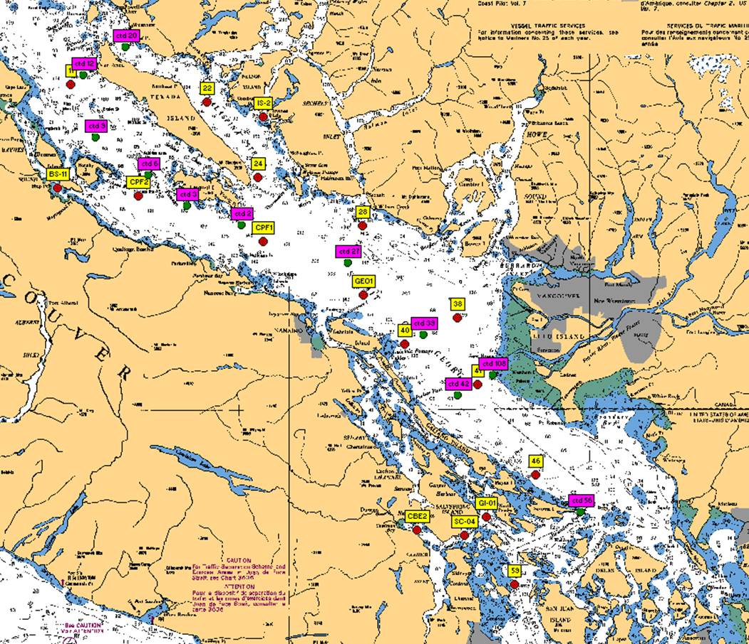

**Figure 1**. Station locations for IOS 2018-36 Strait of Georgia zooplankton survey. Yellow – CTD + zooplankton net stations; Pink – CTD stations.

**At each zooplankton/net station, collect:**

* Full depth (10m off bottom to surface) CTD profile including oxygen and fluorometer, using SBE 25 CTD with SBE 43 DO and Wetlabs fluorometer sensors. **2 minute soak at start** (Turn on, down 10m and up, wait remaining time and start). **Note:** CTD fluorometer usually has an end cap that needs to be removed before the first cast!
* Full depth (10m off bottom to surface) zooplankton tow, using Bongo net with 250um black mesh. One side preserved in 10% buffered formalin, other size fractionated (see next point). Upcast speed approx. 1 m/s. Net equipped with a TSK flowmeter and an RBRSolo that logs the net casts (depth and time).
* **For Brian Hunt:** other side of bongo to be processed for fatty acids/stable isotopes. Sample to be size-fractionated (see file “[Zooplantkon_Size fractionating samples_20170512.pdf](sampling%20methods/Zooplantkon_Size%20fractionating%20samples_20170512.pdf)”) and each fraction transferred to whirlpak and frozen at -80C (large dry shipper).

**At select stations, collect:** (see “[2018-36 sampling plan.xlsx](2018-36%20sampling%20plan.xlsx)” for complete summary per station).

** Record event number, sample number on rosette log sheets and in cruise log. Each Niskin gets unique sample number, all samples from that Niskin uses that number **

*Salinity (SAL)* – at least one deep water (>200m) salinity sample (in duplicate) per day (approx.), using 1.7 L Niskin attached approx. 1m above CTD (please measure and record in logbook!) to collect a near-bottom salinity sample during CTD cast (CTD sensor check). Record sample number, depth collected in log.

* To be collected at stations: 41, 38, GEO1, CPF2, 22, 24.

*HPLC –* Surface HPLC sample collected in duplicate. See “[2018-35_NEO_HPLC protocols and equipment.doc](sampling%20methods/2018-35_NEO_HPLC%20protocols%20and%20equipment.doc)” for full methods. Briefly, 620-1040mL of water (depending on phyto biomass) filtered onto 47 mm GF/F filters, the filters blotted, folded once and rolled into a cryovial, and then frozen in small dry shipper. Remember to fill out HPLC sampling/filtration log sheet.

- To be collected at stations: 59, 56, SC-04, 42, 39, 27, 2, 3, 6, 9, 12, 22, 28, BS-11, GEO1

*Chlorophyll-a (chl-a)* – Chl-a samples taken at surface everywhere HPLC is collected from same Niskin as HPLC and phyto.

Water sampled into 304ml brown bottles and filtered onto 25 mm GF/F filters (IOS standard method, 20% in duplicates). Store filter folded in half in small cryovial in small dry shipper. *Record the sample number with the depth and volumes filtered in the cruise log*. Make sure labels have sample number and volume filtered as well.

- To be collected at stations: 59, 56, SC-04, 42, 39, 27, 2, 3, 6, 9, 12, 22, 28, BS-11, GEO1

*Phytoplankton (phyto)* – surface phyto sample preserved with Lugol’s, collected from same Niskin used for HPLC at surface; for taxonomy. Do not rinse jars (pre-filled with Lugol’s).

* To be collected at stations: 59, SC-04, 42, 27, 22, 12 and BS-11

**Extras for Brian Hunt:**

*Particulate organic matter for isotopes (POM-SI)* – see methods “[POM for Isotopes_2016_07-20.pdf](sampling%20methods/POM%20for%20Isotopes_2016_07-20.pdf)”

*Particulate organic matter for fatty acids (POM-FA)* – see methods “[POM for Fatty Acids_2016_04_30.pdf](sampling%20methods/POM%20for%20Fatty%20Acids_2016_04_30.pdf)”

**Housekeeping**

* Run the Oziexplorer program with the GPS puck on the bridge, logging the cruise track and saving one per day. See “[Oziexplorer.docx](sampling%20methods/Oziexplorer.docx)”
* There are 2 logs to fill out: cruise log and plankton log. Please fill out the cruise log with all events that occur, and give each event a number. Record BE, BO and EN time (note what time zone you are using! Eg: use local time if you want, but indicate so in the log and be consistent for the entire trip). **Check that the GPS has the correct time (may need to be manually changed between Daylight ST and PST)
* Plankton log – enter information for all plankton tows.
* Update the electronic cruise log (excel file) daily. Back up all files to USB.
* Upload the CTD data at the end of the day. Make sure the laptop has the correct date and time before uploading. Upload the files individually (don’t do as a batch). When uploading the file, *name them with standard format names using the cruise number-event number, such as 2017-07-0001.hex*(or .xml for SBE25+) for event #1. Put location, station name, and bottom depth in the header (comments box) of the file, using the format in the “CTD Header.txt” file on the CTD laptop (the : plus N and W are needed for processing)
* View the CTD data in Seasave to make sure everything looks good (make sure your CTD config file is correct).
* Also check that the batteries have enough voltage, change if they drop below 10V (for SBE25+).
* Provide the “[2018-36 dangerous goods zoop.docx](2018-36%20dangerous%20goods%20zoop.docx)” to Captain at start of the trip