REVISION NOTICE TABLE
DATE | DESCRIPTION OF REVISION
20 March 2025 | Updated channel names & formats in TOB files. G.G.
27 March 2023 | Added HPLC data. S.H.
30Jan2019 | Error in CHL values for cast #29 corrected.

PROCESSING NOTES
Cruise: 2018-034
Agency: OSD
Location: WCVI / Strait of Georgia
Project: La Perouse
Party Chief: Perry I.
Platform: John P. Tully
Date: 2 September 2018 – 10 September 2018

Processed by: Germaine Gatien
Date of Processing: 9 November 2018 – 29 November 2018
Number of original HEX files: 91(1 test) Number of CTD files: 90
Number of rosette files: 57(2 tests) Number of bottle casts processed: 55
Number of original TSG files: 11 Number of processed TSG files: 2

INSTRUMENT SUMMARY
CTD #0585 was mounted in a rosette and attached were a Wetlabs CSTAR transmissometer (#1185DR), a SBE 43 DO sensor (#1483) on the primary pump, a SeaPoint Fluorometer (#3641) on the secondary pump, a Biospherical QSP-400 PAR sensor (#70613) and an altimeter (#62355).

A thermosalinograph (SeaBird 45 S/N 0620) was mounted with a Wetlab/Wetstar fluorometer (WS3S-953P) and flow meter.

Seasave version 7.26.7.107 was used for acquisition.
The data logging computer was the Tully Laptop.
The deck unit was a Seabird model 11+ #425.
The salinometer used at IOS was a Guildline model 8400B Portasal, serial # 68572.
An IOS rosette with 24 10L bottles was used.

SUMMARY OF QUALITY AND CONCERNS
The Daily Science Log Book and rosette log sheets were in excellent order with comments about problems encountered. Sampling notes were provided which are a great help in processing data.

There were many spikes in the dissolved oxygen channel. Most were in the upcast and generally not often seen during stops for bottles. There were also many unstable features in the primary T-S plots. The DO sensor was mounted on the secondary pump, so the problems in temperature do not appear to be related to the DO spiking; they occur at different depths with the temperature problems appearing most often in the top 100m though this may just be due to their being more obvious in higher gradients. The DO problem was thought likely to be due to a cable problem.

There were a number of cases where the water depth in the log proved to be lower than the maximum depth sampled. In such casts estimates of actual water depth were made based on altimetry.

There were a few cases during which the CTD was operating on deck with pumps off or very close to the surface with pumps operating. The results are confusing with some showing the pressure to be reading too high by up to 1db while another shows it to be within +/- 0.25db. No recalibration was applied to the pressure channel.

Based on tests run during this cruise it is recommended that the 10m-soak deployment method be amended so that the CTD stays at 10m for at least 30s or until the dissolved oxygen signal is seen to have equilibrated. A longer wait at the surface after the soak may also help but is more difficult in rough seas.

While CTD fluorescence data are expressed in concentration units, they do not always compare well to extracted chlorophyll samples. It is recommended that users check extracted chlorophyll values where available.

Downcast (CTD files) Oxygen:Dissolved:SBE data are considered, very roughly, to be:
±0.25 mL/L from 0 to 100db
±0.15 mL/L from 100db to 200db
±0.10 mL/L from 200db to 500db
±0.03 mL/L below 500db

There was only 1 Thermosalinograph file with useful data. It was very large so was split into 2 files to enable some processing routines to operate properly. There were a lot of errors in positions with extra 0s and/or missing decimal points.

Comparisons were made between the TSG data and co-incident CTD casts, rosette samples and loop samples. These indicate that the intake temperature is higher than the CTD and the salinity lower than CTD, loop samples and rosette samples. However, the standard deviations in the comparisons were very high. Heating in the loop was much higher than expected based on previous experience with heating in the loop on the John P. Tully. This may be due to changes in flow rates and equipment set-up. The comparisons are not sufficiently consistent to justify recalibration.

TSG Fluorescence reads higher than CTD fluorescence at the low end of the range and lower at the high end. The comparison with extracted chlorophyll samples from a rosette show poorer correspondence than a similar comparison with the CTD fluorometer.

PROCESSING SUMMARY
PART I – SBE911

Seasave
This step was completed at sea; the raw data files have extension HEX.

Preliminary Steps
- The Log Book and rosette log sheets were obtained.
- Nutrients, ammonium, extracted chlorophyll, dissolved oxygen and salinity data were obtained in QF spreadsheet format from the analysts.
- The cruise summary sheet was completed.
- The histories of the pressure sensor, conductivity and dissolved oxygen sensors were checked. Since their last calibration they have only been used on 2 casts during 2018-025. Those data have not yet been processed.
- The calibration control file was checked. No errors were found. The file was saved as 2018-034-2018-034-ctd.xmlcon.

TESTS
Three tests of surface pressure were carried out:
- During cast #50 the CTD was turned on while on deck and data recorded for one minute. The transmissivity and conductivity values look like those expected in water. The pumps were not on so the conductivity may be explainable, but the transmissivity is hard to understand and even fluorescence is above dark values. The pressure reading was ~1db.
- During cast #61 acquisition was started while the rosette was in the LARS’ head to study the behaviour of the DO sensor during the down 10 and back. But this cast is also useful to examine the pressure to see when the CTD appears to enter water. In this case the transmissivity shows it was in air at first, then goes through a patch of low transmissivity at about 0.7db to 1.8db. This is likely due to surface debris. It then reaches values that are expected near the surface. So the surface would appear to be at about 0.7db.
- Cast #93 also started on deck and the pressure was ~0.55db before “in-water” values appear in transmissivity.
The initial accuracy of these 6800db range pressure sensors is given as 1db, so these surface values are close to or within specifications. It has also been noticed in the past that deck pressures vary quite a lot, so depending on just a few is not a reliable method. This will be studied further later.

The main purpose of the Cast #61 study was to examine the behaviour of the DO sensor during the “down 10db and back”. All channels were examined to see what can be learned about the value of soaking:
- For dissolved oxygen the values start at about 5.8mL/L with pumps off and possibly out of water, though very close. Values rise quickly but when the pumps come on there is no immediate change so it might look like the DO has equilibrated. When the CTD starts down values rise quickly reaching 8.1mL/L at 5db and 9.4 at 10db. On the way up from the soak the value is ~8.9mL/L at 5m and at the end of the soak it is 7.4mL/L. Values continue to drop for 30s and then looks like the sensor has equilibrated. As the CTD drops again DO is ~5.9mL/L at 5db. The upcast DO sample from 5db has a value of 6.264mL/L. We expect the sensor to read a little low, so this does suggest equilibration had been reached. The increase in oxygen at 10db does not occur during the full downcast – on the contrary, DO drops to ~5.8mL/L at 10db during the full cast. During the upcast there was a stop at about 5.5db at the end of which the sensor read about 5.8mL/L.
- Salinity traces are both noisy with the secondary being extremely so. The two channels are far apart throughout the drop to 10db and partway up, settling only when the CTD is about halfway up to the top.
- Fluorescence values look very high before the pumps come on and they are higher during the drop to 10m than on the way up. The values at 5db on the way back up look similar to values seen at the same depth at the end of the cast.
- Transmissivity values are generally close when depths are matched for soak, full downcast or upcast. This is expected as bubbles are not expected to affect unpumped channels.

Cast #93 also had archiving starting from the deck.
- As for cast #61 changes in dissolved oxygen are the most obvious effect of doing the 10m soak. The values go up notably during the drop to 10m and continue to rise for the first 0.5m of the upcast. DO reaches values of >11mL/L at 10m during the soak. At 6.4db of the full cast the DO value is ~6.4mL/L.
- Salinity and fluorescence traces are similar to those described for event #61.

The conclusion of this study is that the 10m soak is a good way to get better near-surface data from pumped channels. It also shows that at least for dissolved oxygen it is wise to wait at least 30s after soak before starting the full cast. The problems seen are not related to waters getting stirred up by the CTD which would generally cause errors of the opposite sign in DO. If you cannot do the 10m soak, then a longer wait at the surface may help. If using an SBE911 you can tell from the agreement of the two conductivity or salinity channels if conditions have settled down. That may mean the bubbles have cleared, but it appears to take longer for the dissolved oxygen to equilibrate. Starting down too quickly may lead to SBE DO values that are too high. Sub-surface DO maxima can be real, but not on the scale seen during these soaks.

BOTTLE FILE PREPARATION
The ROS files were created using file 2018-034-ctd.xmlcon. Depth was included.
The ROS files were converted to IOS format.
The IOS files were put through CLEAN to create BOT files.
There was a space between the file name and the .ros for 4 files.

Temperature and salinity were plotted for all BOT files to check for outliers and casts 63 and 150 had a few. CTDEDIT was used to clean those outliers and the output files were copied to *.BOT.
A preliminary header check was run and no problems were found.

The BOT files were bin-averaged on bottle number and the output was used to create file ADDSAMP.csv. First, the file was sorted on event number and Bottle Position order. Then sample numbers were added based on the rosette logs.
The file was used to add sample numbers to the BOT files – output *.SAM.
The SAM files were bin-averaged on bottle # and called SAMAVG.

The addsamp.csv file was converted to CST files, which will form the framework for the bottle files.

Next, each of the analysis spreadsheets were examined to see what comments the analysts wanted included in the header file. These were used to create file 2018-034-bot-hdr.txt which will be updated as needed during processing.

EXTRACTED CHLOROPHYLL
Extracted chlorophyll and phaeo-pigment data were obtained in file 2018-34 CHL QF*.xlsx. The file included comments and flags and a precision study. A simplified version of the spreadsheet was prepared and saved as 2018-034chl.csv. The csv file was then converted to individual CHL files.
DISSOLVED OXGYEN
Dissolved oxygen data were provided in spreadsheet 2018-34 OXY*.xlsx which includes flags, comments and a precision study. Draw temperatures are available. The spreadsheet page with the final data was simplified and saved as 2018-034oxy.csv. That file was converted into individual *.OXY files.
SALINITY
Salinity analysis was obtained in file 2018-34SAL.xlsx which included a precision study. The analyses were carried out in a temperature-controlled lab 4 to 14 days after collection. The files were simplified and saved as 2018-034sal.csv. That file was then converted to individual SAL files.
NUTRIENTS
The nutrient data were obtained in spreadsheet NUTS_QF2018-34*.xlsx. This includes a precision study. The file was simplified and the saved as 2018-034nuts.csv. The file was converted to individual NUT files.
AMMONIUM
NH4 data were obtained in spreadsheet 2018-34 QF NH4*.xlsx. This includes a precision study. The file was simplified and saved as 2018-034NH4.csv. This file was converted to NH4 files.

The SAL, CHL, OXY, NUT and NH4 files were merged with CST files in 5 steps.
After the 5th step the files were put through CLEAN to reduce the headers to File and Comment sections only.
The merged files are ordered on sample number, but the SAMAVG files are ordered on bottle number, so one or the other set needs to be reordered in order to merge them. The MRGCLN1 files were reordered on Bottle_Number. The output files were named MRGCLN1s. Those files were then merged with SAMAVG files choosing the Bottle_Number from the SAMAVG files.

The output of the MRG files were exported to a spreadsheet and compared to the rosette log sheets to look for omissions. No problems were found.

The DO analyst noted 3 cases of leaks from Niskin bottles – samples 6, 96, 304 (events 1, 30, 94). These will also affect the nutrients in all cases and CHL in 30 and 94 and NH4 in 30. Those flags were adjusted.

Compare
Salinity
Compare was run with pressure as reference channel.

Five outliers with differences >0.015psu were examined. In 4 cases the CTD was lower than bottles. In 3 of those cases the standard deviation in the CTD salinity was high and there were large changes in salinity during the stop for sampling. So even slightly incomplete flushing of Niskin bottles can readily explain the COMPARE result. For a 4th case there was a similar rapid change in salinity though there is a low standard deviation in the CTD salinity during the 10s window around firing time. Nonetheless the Niskin may not have flushed well. For the 5th case the CTD salinity looks high and standard deviation is low at firing time, but examination of the cast shows that the CTD came up to 138m then dropped to 150m for the bottle stop. So poor flushing would lead to lower salinity in the Niskin bottle rather than the usual result and there were values during the stop that were low enough to explain the outlier.

There are many bottles in the top 200m that are slightly out of line, most showing the CTD to be lower than sample salinity as expected if flushing is incomplete. There are 2 minor outliers at 400m. In both cases the CTD salinity was noisy just before firing and there were salinity values recorded that match the bottle values shortly before firing, though not in the 10s window. From 500m down the results are consistent. The primary salinity is higher than bottles by 0.0009psu with a standard deviation of 0.0007psu. The secondary salinity is higher than bottles by 0.0025psu with a standard deviation of 0.0007psu. The fits against time are of the same slope for both sensor pairs, so are more likely a reflection of depth variations than calibration drift.
For full details for the COMPARE run see file 2018-034-sal-comp1.xls.

Dissolved Oxygen
COMPARE was run with pressure as the reference channel.
Outliers were gradually removed based on residuals. The 3 most extreme outliers came from 3 casts along the LB line at about 10m at near-shore sites; vertical DO gradients are very high at 10m. The result can be either slow response of the sensor which would lead to the SBE DO looking low, or incomplete flushing of Niskin bottles which would make SBE DO look high. Most of the outliers have SBE DO on the high side but one shows it reading significantly low, so it may be that both effects are present.

When bottles are excluded that have a standard deviation in the CTD DO >0.1 and further outliers are excluded based on residuals, the fit was:
CTD DO Corrected = CTD DO * 1.0602 + 0.0529 (R² = 0.95)
The outliers are mostly from close to the surface except for sample #304 from cast #94 at 300db. That sample was flagged by the analyst due to a leak. While not an outlier that would warrant a flag closer to the surface, at 300db it does stand out. The flag was left at 3 but the analyst changed the comment to mention it is an outlier. The largest outliers are associated with very high vertical oxygen gradients.

This sensor has not had a test of the hysteresis parameter settings since it was last recalibrated. Often factor E requires a small correction, but deep samples are needed to test this. There are a few casts with sampling to 2000m but there are not enough samples upon which to base a determination of the best choice for factor E. However, there are enough to get some idea if there is a serious problem. The minimum DO values are found between 800 and 1000m. When bottles below 850m are plotted in a different colour from those above that level there is no obvious difference, though the fit through the deeper bottles suggests a slightly higher correction might be required. The effect of not applying a higher correction would be to make the deep DO values too low by <0.01mL/L.

Plots of Titrated DO and CTD DO against CTD salinity were examined. No further outliers were found.

Fluorescence
COMPARE was run with extracted chlorophyll and CTD Fluorescence using pressure as the reference variable.
The plot of ratio FL/CHL versus Extracted CHL has the shape typically seen from this type of sensor with the ratio dropping as CHL rises. Fluorescence is somewhat higher relative to CHL for higher CHL values than usually seen.

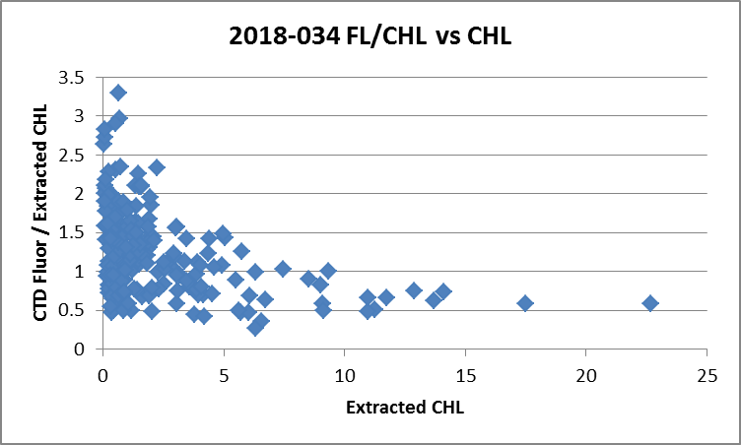

On average, the fluorescence is 74% of CHL
For full details of the comparison see file 2018-034-fl-chl-comp1.xlsx.

Conversion of Full Files from Raw Data
All files were converted using 2018-034-ctd.
The Tau function and the hysteresis function were selected since there was deep sampling. Depth was included in the conversion.
A few casts were examined and all expected channels are present.
The upcast conductivity traces look poor with the primary channel very noisy and further from the downcast than the secondary.

WILDEDIT
Program WILDEDIT was run to remove spikes from the pressure, conductivity & temperature only in the
full cast files (*.CNV).
Parameters used were: Pass 1 Std Dev = 2 Pass 2 Std Dev = 5 Points per block = 100
The parameter “Keep data within this distance of the mean” was set to 0 so all spikes would be removed.
There were some spikes in conductivity that were removed. The spikes in dissolved oxygen channel were wider, with too many records to be removed with this step.

ALIGN DO
A few casts were examined; both temperature channels were noisy during upcasts so the tests were not easy to interpret, but using +2.5s certainly improves the alignment and overall looks like a good choice. That setting has worked well for many sensors in recent years.
ALIGNCTD was run on all casts using +2.5s.

CELLTM
The noise in the upcast data makes tests for the best parameters for this routine very difficult to interpret. In the past when upcast data were not so noisy, the default setting of (α = 0.0245, β=9.5) was generally found to be the best choice. A few casts were checked for this cruise and the default setting does improve the data. CELLTM was run using (α = 0.0245, β=9.5) for both the primary and secondary conductivity.

DERIVE and Channel Comparisons
Program DERIVE was run on all casts to calculate primary and secondary salinity and dissolved oxygen concentration.

DERIVE was run a second time on 3 of the deeper casts to find differences between the pairs of temperature, conductivity and salinity channels. The differences were very noisy so the variability in the results is not surprising. The salinity differences are very close to the difference implied by the results of the bottle comparison, ~0.0016psu. There is too much noise and the casts are not deep enough to see if there is pressure dependence.

Cast # | Press | T1-T0 | C1-C0 | S1-S0 | Descent Rate
2018-34-0038 | 1000 | -0.0006 VN | +0.00013 | +0.0019 | High, Noisy
 | 1900 | -0.0000 | +0.00010 | +0.0017 | “
2018-34-0091 | 1000 | -0.0006 | +0.00011 | +0.0018 | High, Noisy
 | 1900 | -0.0000 | +0.00012 | +0.0017 | “
2018-34-0113 | 1000 | -0.0001 | +0.00010 | +0.0014 | High, X.Noisy
 | 1900 | -0.0001 | +0.00010 | +0.0015 | “

Conversion to IOS Header Format
The IOSSHELL routine was used to convert SEA-Bird 911+ CNV files to IOS Headers.
CLEAN was run to add event numbers and to replace pad values in the pressure channel with interpolated values based on record number.

Checking Headers
The cross-reference check was run. Event #50 had no station name. This cast was run as a test and was not intended to be processed, so it will not be processed further.
The header check was run. The only problem noted was that there are some negative SBE:DO values. These appear to be caused by spikes near the OMZ and are likely all in upcasts.

The cruise track was plotted and added to the end of this report.

The altimeter and water depth readings from the headers of the CLN and SAM files were exported to spreadsheets. A check was made by subtracting maximum depth sampled plus altimetry header from the water depth. Where that number exceeded ±4m the readings were checked. There were many cases where the check value was high. In many cases the depth recorded in the log and header was lower than the maximum depth sampled, so the header depth was replaced with a value that brings the test value to <4m. In 2 cases the altimetry was noisy at the bottom and the header entry was adjusted to a value that brought the test value to <4m. In one case the log depth entry was followed by “?” and in another it was changing through the cast, so values that bring the test value to <4m were chosen for those. The headers were adjusted. See file 2018-034-altimeter-test.xlsx.

The water depth entry in the headers of *.SAM files were also adjusted, as needed, and altimetry was removed from 2 files for which there was no sampling near the bottom. See 2018-034-altimeter-che.xlsx for details. The SAM files were bin-averaged and re-merged with chemistry files to catch the changes.

Three checks of surface pressure:
- During cast #1 the end of the upcast includes some records with negative pressure while the pumps were still on. When the pressure reached +0.2db the transmissivity dropped suddenly and soon afterwards the conductivity channels both dropped to very low values. Transmissivity increased to values that might be right at the surface when pressure was between 0 and -0.25db.
- During cast #50 the CTD was turned on while on deck and data recorded for one minute. The transmissivity and conductivity values look like those expected in water. The pumps were not on so the conductivity may be reasonable as there would be water in the cell, but the transmissivity is hard to understand. The pressure reading was ~1db.
- During cast #61acquisition was started while the rosette was in the LARS’ head to study the behaviour of the DO sensor during the down 10 and back. But this cast is also useful to examine the pressure to see when the CTD appears to enter water. In this case the transmissivity shows it was in air at first, then goes through a patch of low transmissivity at about 0.7db to 1.8db. This is likely a surface slick. It then reaches values that are expected near the surface. So the surface would appear to be at about +0.7db.
- During cast #93 acquisition was started before the 10m soak but not until the CTD was in water, so this is not useful as a pressure check.
The initial accuracy of these 6800db range pressure sensors is 1db and some temporal drift is expected, so all 3 estimates are within specifications. The difference between the two deck measurements and the one reading from the end of the cast may reflect some hysteresis in the pressure sensor during cast #1, or it may just show the variability in the readings, or it may show that the pressure sensor needs to equilibrate in water. When deck pressures are taken for many casts there is usually considerable variation. There is too much variability in these observations to justify pressure recalibration.

A surface check was run and shows an average surface pressure for the cruise was 2.8db which is reasonable for the Tully if the seas are not particularly rough. All readings are associated with in-water salinity values.

Shift
Fluorescence
SHIFT was run on the SeaPoint fluorescence channel in all casts using the usual advance of +24 records. Plots show that the fluorescence offset is reasonably close to the temperature offset after this step.
Dissolved Oxygen
The Dissolved Oxygen voltage channel was aligned earlier. A few casts were checked to see if the alignment looked ok, and it did. No further alignment is needed for the DO concentration channel,
Conductivity
Tests were run on 5 casts to determine the best setting to align conductivity and temperature by judging the effect on salinity as seen in T-S space. The primary traces were extremely noisy towards the end of the cruise.
SHIFT was run twice on all SBE911 casts using -0.6 records for both the primary and secondary conductivity. Salinity was recalculated for both channels.

DELETE
The following DELETE parameters were used:
Surface Record Removal: Last Press Min
Maximum Surface Pressure (relative): 10.00
Surface Pressure Tolerance: 1.0 Pressure filtered over 15 points
Swells deleted. Warning message if pressure difference of 2.00
Drop rates < 0.30m/s (calculated over 11 points) will be deleted.
Drop rate applies in the range: 10db to 10db less than the maximum pressure
Sample interval = 0.042 seconds. (taken from header)
COMMENTS ON WARNINGS: There were no warnings.

The soak-period data need to be removed from casts #61 and #93. The SHFc1 files were edited and saved as 2018-034-0061-red and 2018-034-0093.red.
DELETE was run on this cast to replace the previous version of 2018-034-0061.del.

Other Comparisons
Previous experience with these sensors –
Since these sensors were last calibrated they were used for only 2 casts at the end of cruise 2018-25. That cruise has not yet been processed.
Historic ranges – Profile plots were made with 3-standard deviation climatology ranges of T and S superimposed. All temperature data fell within the climatology. Salinity values were above the climatology maximum at stations LBP1 (25m to bottom) and LBP2 (20-60m); all other salinity values were within the climatology.
Repeat Casts – There were no repeat casts.
Post-Cruise Calibration – There were no post-cruise calibrations available.

DETAILED EDITING
There is a lot of noise in the T-S plots with the primary channels having many more unstable features than the secondary. The primary salinity was closer to bottles. Neither salinity shows significant pressure or time dependence. The secondary sensors were selected for editing.

All DEL files were copied to *.EDT.

CTDEDIT was used to remove records that appear to be corrupted by shed wakes. Salinity was cleaned to remove spikes that appear to be due to small misalignment or instrumental noise. All files required some editing and some required heavy editing due to very noisy descent rates, including complete reversals of direction. Notes about editing applied were added to the files.

The descent rate was sometimes very high, perhaps due to rough conditions. This leads to very high deceleration leading to shed wake corruption and sometimes salinity excursions likely caused by variations in the alignment of T and C.

Cast #93 had very noisy temperature and salinity data in the top 28m. The primary channels were worse than the secondary. The secondary data are mostly stable in T-S space. While they look odd the upcast does show a similar character though with many more instabilities.

The edited files were copied to *.EDT.

After editing T-S plots were examined for all casts. There are some small unstable features but those are near the surface and no instrumental cause was obvious, so they are likely real.

Recalibration
The secondary salinity was found to be higher than bottles by ~0.0025psu; this estimate was based on bottles from below 500m so poor flushing of bottles should have negligible effect.

File 2018-034-SBE911-recal.ccf was prepared to subtract 0.0025psu from channel Salinity:T1:C1 and to apply the following corrections to channels Oxygen:Dissolved:
CTD DO Corrected = CTD DO * 1.0602 + 0.0529
This correction was first applied to the SAM and MRGCLN2 files.

COMPARE was rerun for salinity using the same points as in the fit used for the original COMPARE run to ensure that corrections were appropriate and they were. The secondary salinity was found to be high by 0.00005psu. See file 2018-034-sal-comp2.xls for details.

COMPARE was rerun for dissolved oxygen and shows that the corrections were applied properly. When data are excluded based on residuals, the CTD DO is found to be low by an average of 0.00007mL/L with a standard deviation of 0.025mL/L. See file 2018-034-DO-comp2.xls for details.

CALIBRATE was then run on the EDT files using the same recalibration file.

Final Calibration of DO
The initial recalibration of dissolved oxygen corrects for sensor calibration drift. Alignctd corrects for transit time errors. Those 2 steps may partly correct for response time errors, but to see if a further correction is needed, a comparison is made of downcast CTD data to bottle data from the same pressure. Small differences are expected due to ship drift, temporal changes, incomplete flushing of Niskin bottles and delayed response and noise in CTD data.

Downcast files were bin-averaged to 0.5m bins for the casts with DO bottle samples. Those files were then thinned and compared to the bottle values in the MRG files. COMPARE was run to study the differences between the downcast CTD DO data and the titrated samples from upcast bottles.

When outliers were removed based on residuals the CTD DO was higher than the titrated samples by an average of ~0.033mL/L (standard deviation of 0.093mL/L). Looking at the differences versus pressure shows that the sensor DO tends to be on the high side above 500m, which is likely due to incomplete flushing of Niskin bottles combined with higher gradients.

No further recalibration is justified. See 2018-034-dox-comp3.xlsx for details.

Fluorescence Processing
A median filter, size 11, was applied to the fluorescence channel in the COR1 files. Plots of a few casts showed that the filter was effective. (Output:*.FIL)

BIN AVERAGE of CTD files
The following Bin Average values were applied to the FIL files (output AVG):
Bin channel = pressure Averaging interval = 1.000 Minimum bin value = .000
Average value will be used. Interpolated values are NOT used for empty bins.
On-screen T-S plots were examined.
Profile plots were examined to see if there any problems. No problems were noted.

Final CTD File Steps (REMOVE and HEADEDIT)
For all casts REMOVE was run to remove the following channels:
Scan_Number, Temperature:Primary, Conductivity:Primary, Oxygen:Voltage:SBE, Descent_Rate, Status:Pump, Altimeter, Salinity:T0:C0 and Flag.

A second SBE DO channel (with umol/kg units) was added.
REORDER was run to get the two DO channels together.

HEADER EDIT was used to fix formats and channel names, to fix the project name and to add the following comments:
Data Processing Notes:
----------------------------
Conductivity, Transmissivity, Fluorescence and PAR data are nominal and unedited
except that some records were removed in editing temperature and salinity.

For details on how the transmissivity calibration parameters were calculated
see the document in folder "\cruise_data\documents\transmissivity".

NOTE: While the CTD fluorescence data are expressed in concentration units, they
do not always compare well to extracted chlorophyll samples, particularly for
casts far from shore. It is recommended that users check extracted chlorophyll
values where available.

Dissolved oxygen was calibrated using the method described in SeaBird
Application Note #64-2, June 2012 revision, except that a small
offset in the fit was allowed.

The SBE DO sensor has a fairly long response time so data accuracy is not as high
when it is in motion as it is during stops for bottles. This will be
especially true when vertical DO gradients are large. To get an estimate
of the accuracy of the SBE DO data during downcasts (after recalibration)
a rough comparison was made between downcast SBE DO and upcast titrated
samples. Some of the difference will be due to problems with flushing
of Niskin bottles and/or analysis errors, so the following statement
likely underestimates SBE DO accuracy.

Downcast (CTD files) Oxygen:Dissolved:SBE data are considered, very roughly, to be:
±0.25 mL/L from 0 to 100db
±0.15 mL/L from 100db to 200db
±0.10 mL/L from 200db to 500db
±0.03 mL/L below 500db

For details on the CTD data processing see document: 2018-034_Processing_Report.doc.

The Standards Check routine was run and no problems were found.
The Header Check was run; no problems were found.
Profile and T-S plots were examined and no problems were found. There are some unstable features in T-S space, but those are small, near the surface and possibly real.
The sensor history was updated.

Dissolved Oxygen Study
As a final check of dissolved oxygen data, % saturation was calculated and plotted. The values ranged from ~60% to 180% with the lowest values in Queen Charlotte Strait, Johnstone Strait and northern Strait of Georgia where vertical mixing is likely to be strong. Values were highest at stations near shore on the west coast of Vancouver Island and one cast in the Strait of Georgia. Most offshore values were between 95% and 110%.

Final Bottle Files
The MRGCOR1 files were put through SORT to order on increasing pressure.

For all casts REMOVE was run to remove the following channels:
Scan_Number, Temperature:Primary, Salinity:T0:C0, Conductivity:Primary, Oxygen:Voltage:SBE, Transmissivity, Altimeter, Status:Pump, Descent_Rate and Flag.

A second SBE DO channel with mass units was added for both the CTD DO and titrated DO and REORDER was run to get the pairs of DO channels together.
At this point some records were removed for which there was no sampling. The files for casts #114 and 125were removed as the bottles were fired just for testing bottles; there was no sampling.
CLEAN was then run to reset # of records and header limits.

HEADER EDIT was run to ensure formats and units are correct, correct the vessel name, change the channel name Bottle_Number to Bottle:Firing_Sequence and the name Bottle:Position to Bottle_Number and to add a comment about quality flags and analysis methods and a few notes about the CTD data processing.

Data were exported from the CHE files to file 2018-034-bottles-final.xls. The entries were compared with the rosette log sheets. It was discovered that one cast had been lost due to confusion over event number. That was fixed. No other problems were found.

Standards check and a header check were run. No problems were found.
The track plot looks ok.
Plots of each file were examined and no problems were found.
A cross-reference listing and header check were produced for the CHE files.

Thermosalinograph Data
A new thermosalinograph was in use for this cruise. It was used for the first time during cruise 2018-026 in June 2018. It did not support having a fluorometer attached, so a new method was developed to enable combining the TSG output with that from a fluorometer. There were 11 files produced but most had no data or few data as problems with the new system were worked out at sea. Files of size <5KB were not processed. Those files contain <5 minutes of data.

There were loop samples, a flow meter and intake thermistor. The intake is at about 4.5m.

There were 3 files with at least 39KB of data. The files had been saved with names indicating the date/time. The files have extensions RAW but are in csv format, so the files were opened in EXCEL and saved as CSV files. In opening use DELIMITED, deselect TAB, select COMMA and OTHER - *.
It was necessary to choose TEXT for the time on the 2nd page of the text import wizard.

The columns in the RAW files are:
Date UTC
Time UTC
Identifier – not needed in processing
Remote temperature (SBE38)
Lab (TSG) temperature (SBE45)
Conductivity
Flow in ℓ/minute
Fluorescence in V
Latitude - decimal format
Longitude – decimal format
Checksum, - not needed in processing

Of the 3 files checked, two were relatively short and contain obviously bad data in several columns. They appear to have been tests run before the first CTD event. The 3rd file looks much better, so only that one will be processed. It overlaps with many CTD casts so quality can be checked.

The spreadsheet was adjusted as follows:
- 2 lines of headers were added – channel names and units.
- A column with pressure was added with all values set to 4 (to enable derivation of salinity).
- A temperature difference column was added (Lab-Intake).
- The fluorescence channel is in volts. It was converted to ug/L using offset -0.04 and scale 13.1 as determined in the most recent recalibration of the fluorometer.
- A file break column was filled with the data/time info from the original file name so the name of the converted file will match that of the raw file. Because the file was too large to be edited in CTDEDIT, the file break entry was changed at the beginning of Sept. 7th to create a second file.
- Time is a problem – when converting from RAW choose TEXT but once open in EXCEL set Time Format to HH:MM:SS and save the file again. Any time the file is opened in EXCEL the time format was once again set before saving.

The files were then converted to IOS format with header info added. Problems were found in many latitude and longitude entries. There were 3 types of errors, with an extra 0 before the decimal place or many zeros with no decimal place or 1 extra zero with no decimal point; for example a 480.2 entered instead of 48.2 or 49000001 where 49.01 looks appropriate or 490 where it should be 49.0000. Some were fairly easy to correct, albeit it took a lot of time. Plots of the positions were used to ensure all outlier values were corrected. A quick check was made of a more recent cruise (2018-40) to see if this problem reoccurred and no such errors were found. The flow rate drops to 0 in a patch near the beginning and for a few records near the end of the tile.

An attempt to edit the file to correct latitude and longitude failed because the file was too large. Routine Fracture was used to divide the file into 2 parts. The second file was saved with the start date/time in the name in the same style as the first file.

CLEAN was run to rest the number of records, min and max values, set the start and end times, and latitude and longitude limits.
ADD TIME CHANNEL was used to add Julian dates.
REORDER was run to move the Julian date channel so it is not chosen for time-series plots.
DERIVED QUANTITIES was used to derive salinity using the lab temperature.

a.) Plots
A track plot was produced and added to the end of this document.
Time-series plots were examined on screen. The data look quite smooth, with only a few isolated and small spikes in salinity (up to about ~0.4psu but most are <0.2psu).
The flow rate went to 0 at about 20:25 on September 2nd. For the first file it started at about 1.5l/min and was at ~1 for most of the file. The second file has a flow rate that is quite steady at about 1.25 L/min but it was 0 near the end.

b.) Checking Time Channel
The CTD files were thinned to reduce the files to a single point from the downcast at or within 0.5db of 4.5db. These were exported to a spreadsheet which was saved as 2018-034-ctd-tsg-loop-rosette-comp.xlsx. There were 89 CTD casts that overlapped with the TSG record and one of those started just before acquisition by the TSG so there may be a problem with that one.

The TSG file was opened and median and standard deviations were calculated over 2minutes for intake temperature, lab temperature, salinity and fluorescence data. Data were then extracted to match the times of the CTD files. Those data were added to as 2018-034-ctd-tsg-loop-rosette-comp.xlsx.

To check for problems in the TSG clock or bad matches of TSG and CTD data, the differences between latitudes and longitudes were found. There were no position differences >0.0008º and the median differences were both 0.00000º. So the time and positions in the TSG files are reliable.

c.) Comparisons
- Comparison of T and S from TSG and CTD data and Rosette samples

 | Ti-Tctd | Tlab-Tctd | Stsg-Sctd | FLtsg/FLctd
average | 0.1312 | 0.6968 | -0.0741 | 1.2261
median | 0.0722 | 0.6571 | -0.0295 | 0.6294
stdev | 0.2237 | 0.6162 | 0.2854 | 1.7168
max | 1.1701 | 3.4004 | 0.8348 | 11.1933
min | -0.8853 | -1.6436 | -1.5892 | 0.2176

The intake temperature is higher than the CTD temperature, with a lot of variability in the differences. The few differences that are on the expected scale are scattered in time with no obvious pattern so there is no indication the problem is due to high near-surface gradients. The lab temperature is even more out of line with expectations but that could be related to different plumbing so that heating in the loop is much greater than seen with the SBE21 TSG system used in the past. The salinity difference is somewhat high with a very high standard deviation, but there are sections where the differences are quite steady, most notably between events 76 and 129 with the exceptions of casts near Brooks Peninsula and Cape Scott. This could be due to better mixed near-surface waters in that region so that mismatches between the depth of CTD sampling and the TSG intake are less significant. Salinity differences are largest near the end of the cruise which is likely due to higher vertical gradients. Plots of differences against flow rate do not suggest any useful pattern for any sensors.

We expect heating in the loop to decrease as intake temperature approaches the ambient temperature of the ship. A plot of (Lab Temp – CTD Temp) vs CTD Temp does indicate that differences were higher when the intake temperature was lower. This can explain much of the noise in (Tlab-Tctd). This cruise includes many lines perpendicular to the coast so intake temperature variations with time are complex.

When the 22 casts from the section mentioned above are included the TSG salinity is low by a median of 0.032psu with a standard deviation of 0.018psu. The intake temperature is high by a median of 0.058C° with a standard deviation of 0.254 C° while the lab temperature is high by a median of 0.653 C° and standard deviation of 0.364 C°. So the standard deviations in differences from the CTD are about the same for the intake temperature but about half what they are for the whole cruise for lab temperature.

While the average ratio (TSG fluorescence / CTD fluorescence) is close to 1 this is deceiving. If only casts #1 to 118 are included the ratio is 0.53. Thereafter it starts to grow fairly steadily. To see whether this trend is due to increasing CHL values or whether either TSG or CTD fluorescence is out of line, bottle CHL data were found and compared with TSG and CTD data.

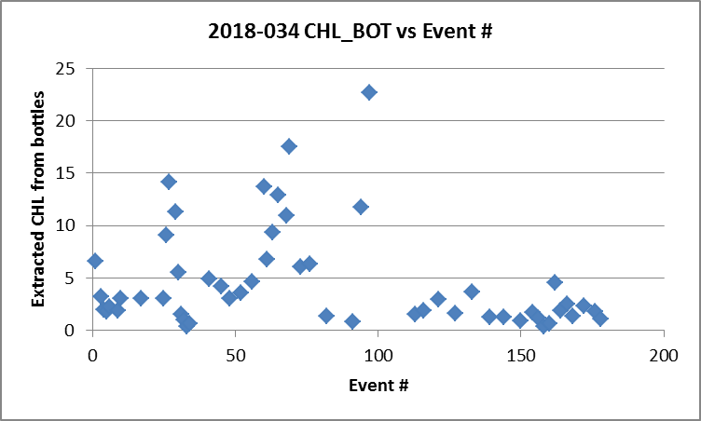
First, it is observed that the extracted CHL values are fairly low towards the end of the cruise. The cases where the TSG fluorescence is much higher than the CTD fluorescence correspond to that time. We generally find that fluorometers are higher than CHL for very low CHL and close to CHL for values between 1 and 3ug/L. The TSG fluorometer seems to be doing worse at low CHL values than that the CTD fluorometer. It does a poorer job at the high end as well, reading even lower than the CTD sensor.

The TSG data were selected to match the beginning of the CTD cast, but the bottles came from the end of the casts, so there is a small mismatch in time but the effect should be random.

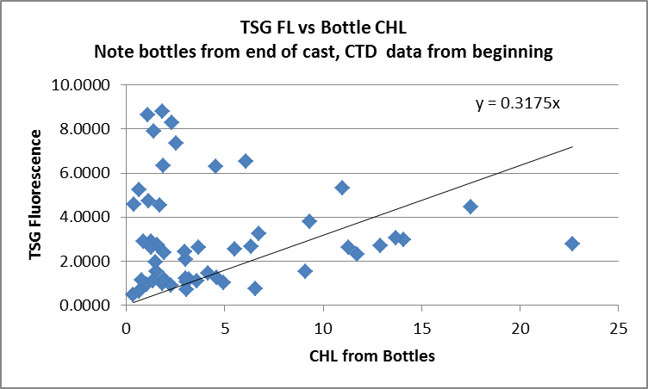
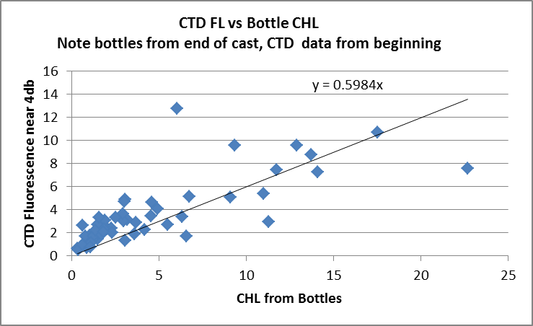

The CTD fluorescence does read higher than CHL at low CHL values, but does a much better job than the TSG fluorometer. Also at high CHL the TSG is lower than CHL but it is much closer than the CTD fluorescence.

So either the fluorometer is not performing well, or the calibration is poor or possibly over time there was a problem with contamination of the loop. A plot of TSG fluorescence vs CTD fluorescence does not suggest that a simple recalibration of TSG fluorometer would help.
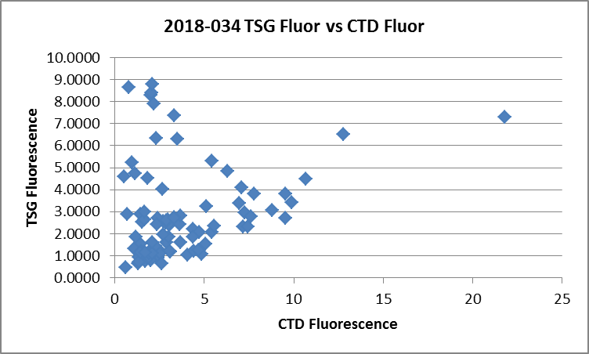

There was a Line P cruise after this one that used the same TSG equipment. The data have not been processed and there may have been some changes in the plumbing set-up. A quick check was made to examine the differences between the intake temperature and the lab temperature and they appear to be much smaller when well offshore, ~0.2 C°, and there appears to be less noise in the intake temperature. Closer to shore there are larger differences but the ambient waters were cooler.

- Comparisons with loop samples
There were 8 loop Salinity and CHL samples. Medians and standard deviations were calculated over 2 minutes in the *.DQT files and data extracted for the times of the loops. All were taken when the ship was underway.
Date | Time | Flow Rate | Salinity:Bottle | Chlorophyll:Extracted | TSG Sal-Loop Sal | TSG FL/CHL
04-Sep | 07:59 | 1.1 | 32.2808 | 0.48 | -0.0094 | 1.04
05-Sep | 04:44 | 1 | 31.4946 | 6.16 | -0.0066 | 0.32
05-Sep | 09:58 | 1.1 | 31.3673 | 11.79 | -0.0233 | 0.35
06-Sep | 03:20 | 0.9 | 32.2649 | 1.53 | -0.0266 | 1.04
06-Sep | 07:04 | 0.8 | 32.4331 | 2.01 | -0.0256 | 0.90
07-Sep | 02:43 | 0.8 | 32.4210 | 4.87 | -0.0415 | 0.63
07-Sep | 07:05 | 1.1 | 32.4857 | 1.99 | -0.0443 | 0.77
09-Sep | 13:02 | 1.4 | 31.2740 | 1.35 | -0.0468 | 2.21
 |  |  |  | median | -0.0261 | 0.84
 |  |  |  | Std dev | 0.0153 | 0.60

The salinity differences are consistent with what was found in the CTD comparison with higher differences for the last 3 samples which came from near-shore areas where vertical gradients are likely to be higher. The differences do not seem to be related to flow rate or standard deviations in the TSG data. Fluorescence values compare reasonably well with extracted CHL loops with the usual pattern of fluorescence being higher when CHL is low and lower for higher CHL.

For details on comparisons see document 2018-034-ctd-tsg-loop-rosette-comp.xls.

d.) Calibration History
During 2018-026 this system was used for the first time. There were only 6 CTD casts and 4 loop samples that overlapped with TSG records. Fluorescence values looked reasonable. The intake temperature sensor read higher than the CTD temperature by a median of 0.03C°, but not in a consistent way so recalibration was not possible. The lab temperature was higher than the intake temperature by more than expected based on previous experience with heating in the loop on the Tully. The salinity traces were quite smooth with only a few very small spikes. Salinity read lower than the CTD. The differences were not sufficiently consistent to allow recalibration. The data were archived but with a warning that there was insufficient calibration sampling to assess quality.

e.) Conclusions
1. The TSG clock worked well.
2. There were 89 points of comparison with CTD. All comparisons between TSG and CTD data were noisy. Salinity was lower than the CTD by a median of 0.030psu but the standard deviation was 0.285psu. However, one quiet section was identified during which salinity differences were fairly consistent, with the TSG reading lower by a median of 0.032psu and a standard deviation of 0.018psu. Lab temperatures were higher than CTD temperatures by a median of 0.66 C° using all data or 0.65 C° using only the “quiet section”. The intake temperatures were high by a median of 0.072 C° using all data or 0.058 C° in the “quiet section”. Fluorescence from the TSG was lower than the CTD fluorescence except in areas where CHL was low. The comparison of the 2 fluorometers has a lot of scatter and does not suggest that recalibration of the TSG sensor would help.
3. The difference in temperature between the intake and lab readings is treated as being due to heating in the loop. It is much larger than past experience from the Tully when a different type of TSG was used. This may be related to the amount of water being drawn which is much lower. As usual the amount of heating is inversely related to intake temperature. Since the salinity comparison is reasonably good, it is likely that the lab temperature is not too far out of line.
4. The comparison with loop samples was consistent with the TSG-CTD comparison. In general the CTD fluorometer compared much better with rosette CHL samples than did the TSG fluorometer, especially at the low CHL end of the scale. The TSG salinity was found to be lower than loop samples by a median of 0.026psu but the differences varied greatly with higher differences for the last 3 loops which were taken in nearshore waters.
5. The data will be archived but with a comment about the intake temperature being further from the CTD data than expected and heating in the loop being higher than when the SBE21 was in use. The quality of the comparison is insufficient to justify recalibration of salinity or intake temperature. Because of the limitations only 3 decimal places will be shown for temperature and salinity.

g.) Editing
CTDEDIT was used to remove values measured in the lab when the flow was very low. Salinity was cleaned to remove some spikes.

h.) Recalibration
No recalibration is justified.

i.) Preparing Final Files
REMOVE was used to remove channel Pressure.

HEADER EDIT was used to change the DATA TYPE to THERMOSALINOGRAPH and add the depth of sampling to the header and to change channel names to standard names and formats and to add the following comment:

TSG Data Processing
-------------------
Comparisons were made between the TSG data and co-incident CTD casts, rosette
samples and loop samples. These indicate that the intake temperature is high by
a median value of ~0.07C° but the standard deviation was 0.22C°. Salinity was
found to be low by a median value of 0.03psu but the standard deviation was
0.29psu. Comparisons with loop salinity samples show values to be low by from
0.01 to 0.05psu.

The lab temperature was higher than the intake temperature by more than expected
based on previous experience with heating in the loop on the John P. Tully.
This may be due to changes in flow rates and equipment set-up.

Fluorescence from the TSG reads higher than CTD fluorescence at low values
and lower at high values. The comparison with extracted chlorophyll samples
from a rosette show poorer corresopndence than a similar comparison with the
CTD fluorometer.

The comparisons are not sufficiently consistent to justify recalibration.

See report 2018-034_Processing_Report.doc for more details.
---------------------------------------------------------------------------
WARNING: THESE DATA WERE COLLECTED WITH A NEW TSG SYSTEM.
The system is undergoing testing and modifications.
The quality of the data are considered low and are provided with fewer
signficant figures than usual. Relative values may be useful.
---------------------------------------------------------------------------
The files were saved as 2018-034-DDMM-HHMMSS.TOB.
The TSG sensor history was updated.
As a final check plots were made of the cruise track and time-series. A problem was found and fixed in the pad values for salinity and NaN entries where pad values were needed.

General Comments
PAR on for all casts.
Casts with bottle fired out of order: 45, 82, 90 & 116.

Particulars
1. Header errors – cruise #, bottom depth should be 223.
7. E1 – format error.
25. Niskin 3 not needed in CHE file.
27. Laptop time set back 3min after this cast.
30. Niskin 5 not needed in CHE file.
31. Spike in DO ~600m.
32. Spike in DO below 750 and lots on way up
33. Spikes in DO upcast
34. Stopped at 125 down to fix wire angle.
36. Greased O2 connections to try to alleviate spikes.
38. Sprayed electrical cleaner into O2 connections in female plugs and regreased male pins.
41. O2 trace is much cleaner now.
42-59 – format errors in filenames
45. LC09 missing 0
50. Test cast – 1 minute reading pressure on deck
61. Archived whole time. Recorded before pump to show DO trace.
66. File should be 65.
77. DO spiky again. Regreased DO and Fluor cables.
79. Greasing affected the fluorescence. Spiky again during upcast.
93. Wrong bottom depth – should be 890. Started archiving from the deck. No DO spikes.
94. Few spikes in sec. sal upcast above 1000.
113. Regreased DO cable.
114. No CHE file needed. DO spikes 300m up.
116. DO spikes 450 up.
123. Stop 86m during downcast for wire angle/
125. No CHE file needed
146. Wait at surface – wire angle.
148. Stop 70 and 115 down – wire angle.
152. Stop 195 down wire angle.
156. Bottom depth should be 300
172. Niskin 21 not needed in CHE file.

CRUISE SUMMARY – CTD

CTD# | Make | Model |  | Serial# |  | Used with Rosette? |  | CTD Calibration Sheet Competed?
1 | SEABIRD | 911+ |  | 0585 |  | Yes |  | Yes
Calibration Information - 0443
Sensor |  |  |  |  | Pre-Cruise |  |  |  | Post Cruise
Name |  |  | S/N |  | Date |  | Location |  | Date | Location
Temperature |  |  | 5724 |  | 02Sep2017 |  | Factory
Conductivity |  |  | 4434 |  | 6Sep2017 |  | Factory
Secondary Temp. |  |  | 5725 |  | 02Sep2017 |  | Factory
Secondary Cond. |  |  | 1118 |  | 6Sep2017 |  | Factory
Transmissometer |  |  | 1185DR |  | 7Aug2017 |  | Factory
SBE 43 DO sensor |  |  | 1483 |  | 30Sep2017 |  | Factory
PAR |  |  | 70613 |  | 21Mar2016 |  | Factory
SeaPoint Fluor. |  |  | 3641
Pressure Sensor |  |  | 0585 |  | 18Sep2017 |  | Factory
Altimeter |  |  | 62355 |  | 21Mar2016 |  | Factory

TSG Make/Model/Serial#: SEABIRD/45/0620
Calibration Information
Sensor |  | Pre-Cruise |  | Post Cruise
Name | S/N | Date | Location | Date | Location
Temperature | 0620 | 2Aug17 | Factory
Conductivity | 0620 | 2Aug17 | Factory
Temperature SBE38 | ? | ? | Factory
WETStar Fluorometer | 953 | 5May2017 | Factory

