REVISION NOTICE TABLE
DATE | DESCRIPTION OF REVISION
26 March 2023 | Added HPLC. S.H.

PROCESSING NOTES
Cruise: 2018-031
Agency: OSD
Location: Strait of Georgia /Juan de Fuca Strait
Project: Strait of Georgia Water Properties Survey
Party Chief: Belton M.
Platform: Vector
Date: 26 September 2018 – 2 October 2018

Processed by: Germaine Gatien
Date of Processing: 7 March 2019 – 28 March 2019
Number of original HEX files: 81 (1 split) Number of CTD files: 80
Number of bottle files: 32 Number of bottle casts processed: 30
Number of original TSG files: 1 Number of processed TSG files: 0

INSTRUMENT SUMMARY
CTD #0506 was mounted in a rosette and attached were a Wetlabs CSTAR transmissometer (#1005DR), a SBE 43 DO sensor (#1119), a SeaPoint Fluorometer (#2356 for casts #1-27 and #2228 for casts #29-105), a Biospherical QSP-400 PAR sensor (#4656), an SBE pH sensor (180852) and an altimeter (1235). A Biosperical/Licor Surface PAR (#20518) was mounted on the boat deck.

A thermosalinograph (SeaCat 21 S/N 3363) was used.

Seasave version 7.23.2 was used for acquisition.
The data logging computer was JN937-DHT411-7KWHR.
The deck unit was a Seabird model 11+ S/N 0619.
The salinometer used at IOS was a Guildline model 8400B Portasal, serial # 68572.
The oxygen kit was SIO (nsB-6009) Kit #1.
An IOS rosette with 24 10L bottles was used.

SUMMARY OF QUALITY AND CONCERNS
The Daily Science Log and Sampling Log sheets were in excellent order with many details about problems encountered.

The configuration file used at sea had many errors. Fortunately, initial cast data were sent to IOS for assessment so that the parameters were corrected by cast #12. While errors in the configuration files can be corrected in processing some errors may affect decisions made at sea.

It was noted early in the cruise that fluorescence looked unusually low so the fluorometer was replaced before cast #29. However, the data from the 2nd sensor looked just as low. The replacement sensor was one noted to malfunction in 2013 and should not have been in service. Both sensors are older models. There were extracted chlorophyll samples and we have experience to show that CTD fluorescence is usually close to extracted CHL values between 1 and 5ug/L and lower than CHL above 5ug/L. But these values are much lower than CHL than usually seen. The fluorescence channel was removed for both sensors since values are <50% of extracted chlorophyll values for 3ug/L <CHL< 6ug/L and <25% for CHL>6ug/L. Most data were well below both criteria.

Secondary temperature and salinity were chosen for all casts due to serious problems in the primary temperature. There was a large vertical offset in the temperature traces that was larger than the conductivity trace offset. Very large alignment adjustments were required to make slight improvements in the primary data.

Salinity samples were taken but there were a series of problems with the salinometer. It was sent to the factory for repairs so the samples sat for about 4 months before they could be analyzed. After they were analyzed the differences from CTD salinity made it clear that the salinometer was not working well. A linearity test confirmed this. A correction method was developed based on tests run comparing 2 salinometers with corroborating information from bottle-CTD comparisons from 4 cruises including this one. Errors due to the analysis involved in the tests are likely <0.002psu. The comparison of the CTD with the corrected values suggests that both sensors are slightly low (by 0.0008 and 0.0017psu) whereas they were thought to be reading slightly high in February 2018. So there may be some effect of evaporation/adsorption of samples during the 4-month wait. However, it is not wise to read too much into this since these data were part of the study supporting the correction method, so no recalibration was applied to CTD salinity. The CTD salinity data are considered +/-0.004psu.

The pH:SBE channel was removed from cast #52. It looks as if the buffer bottle was left on during the cast.

The SBE DO data were recalibrated based on samples collected from the 4 westernmost bottle casts in Juan de Fuca Strait. The conditions there minimize the effects of incomplete flushing of Niskin bottles.

The SBE DO sensor has a fairly long response time so data accuracy is not as high when it is in motion as it is during stops for bottles. This will be especially true when vertical DO gradients are large. To get an estimate of the accuracy of the SBE DO data during downcasts (after recalibration) a rough comparison was made between downcast SBE DO and upcast titrated samples. Some of the difference will be due to problems with flushing of Niskin bottles and/or analysis errors, so the following statement likely underestimates SBE DO accuracy.

Downcast (CTD files) Oxygen:Dissolved:SBE data are considered, very roughly, to be:
±0.40 mL/L from 0 to 50db
±0.25 mL/L from 50 to 150db
±0.10 mL/L from 150 to 300db
±0.02 mL/L below 300db

There was 1 thermosalinograph file. The time-series plot looks normal, but the data are not considered suitable for archival since both the lab temperature and the salinity differ greatly from CTD values. This TSG should be serviced before further use. The track plot is shown as the position data are accurate.

PROCESSING SUMMARY

Seasave
This step was completed at sea; the raw data files have extension HEX.

Preliminary Steps
- The Log Book and rosette log sheets were obtained and were in excellent order.
- Nutrients, extracted chlorophyll, dissolved oxygen and salinity data were obtained in QF spreadsheet format from the analysts.
- The cruise summary sheet was completed.
- The history of the dissolved oxygen , temperature, conductivity and pressure sensors was obtained.
- The configuration files used at sea had many errors that were mostly resolved by cast #12.
- The PAR calibration constant was 1 –it should have been 1855287569.57.
- There were 0 factors in the SPAR calibration parameters that it made it look like it was not working.
- The transmissivity parameters were not the most up-to-date.
- The pH parameters were out of date.
- There were a number of problems in configuration dates (missing or wrong).
- When a change in fluorometer was made before cast #29 the correction of the fluorometer serial number was done correctly, but a small error was introduced to the pH sensor.
- Two versions of the calibration file were prepared with corrections and saved as 2018-031-ctd1.xmlcon (for casts #1-27) and 2018-031-ctd2 (for casts #29-105).

BOTTLE FILE PREPARATION
The ROS files were created using file 2018-031-ctd1.xmlcon and 2018-031-ctd2.xmlcon. Depth was included. No file was produced for cast #68 because there was only a HEX file, no BL file. Using the Bottle Confirm Bit enabled the file to be converted.

The ROS files were converted to IOS format.
They were put through CLEAN to create BOT files.
Temperature and salinity were plotted for all BOT files to check for outliers. No outliers were found, but it was noted that cast #45 has a BOT file but the CTD was in motion throughout the 10s of data for each bottle. There was no note of sampling in the rosette log sheets and no sample numbers in the Daily Science log so this file will not be processed further.

A note in the log says that bottle #3 did not fire during cast #99 so another drop was made and saved as file #100. In fact, the bottle did fire during #99, but it obviously did not close. So the bottle sample data from the second drop are needed. But since the pumps were not on for #100, the CTD data from the first drop are more useful and will be used. The depths are very close in the two BOT files. There is no need to join these two files. The rosette log makes it clear which sample number was used for the samples from the 2nd drop. They are identified as coming from file #99, so no changes are required.

A preliminary header check was run and no problems were found.

The BOT files were bin-averaged on bottle number and the output was used to create file ADDSAMP.csv. First, the file was sorted on event number and Bottle Position order. Then sample numbers were added based on the rosette logs.
The ADDSAMP file was then sorted on event number & then sample number.
It was used to add sample numbers to the BOT files – output *.SAM.
The SAM files were bin-averaged on bottle # and called SAMAVG.
The addsamp.csv file was converted to CST files, which will form the framework for the bottle files.

Next, each of the analysis spreadsheets were examined to see what comments the analysts wanted included in the header file. These were used to create file 2018-031-bot-hdr.txt which will be updated as needed during processing.

EXTRACTED CHLOROPHYLL
Extracted chlorophyll and phaeo-pigment data were obtained in file 2018-031 chl QF*.xlsx. The file included comments and flags and a precision study. A simplified version of the spreadsheet was prepared and saved as 2018-031chl.csv. The csv file was then converted to individual CHL files.
DISSOLVED OXGYEN
Dissolved oxygen data were provided in spreadsheet QF2018-031oxy.xlsx which includes flags, comments and a precision study. Draw temperatures are available. The spreadsheet page with the final data was simplified and saved as 2018-031oxy.csv. That file was converted into individual *.OXY files.
Many bottles were flagged due to problems that will affect other samples as well, so after the bottle samples are merged the relevant flags will be added to the other samples.
SALINITY
Salinity analysis was obtained in file QF 2018-031 SAL*.xlsx; there were no duplicates. The analyses were carried out in a temperature-controlled lab 3 to 9 days after collection. The files were simplified and saved as 2018-031sal.csv. That file was then converted to individual SAL files.
NUTRIENTS
The nutrient data were obtained in spreadsheet NUTS_QF2018-031_*.xlsx. This includes a precision study. The file was simplified and the saved as 2018-031-nuts.csv. The file was converted to individual NUT files.

The SAL, CHL, OXY and NUT files were merged with CST files in 4 steps.
After the 4th step the files were put through CLEAN to reduce the headers to File and Comment sections only.

The merged files are ordered on sample number, but the SAMAVG files are ordered on bottle number, so one or the other set needs to be reordered in order to merge them. The MRGCLN1 files were reordered on Bottle_Number. The output files were named MRGCLN1s. Those files were then merged with SAMAVG files choosing the Bottle_Number from the SAMAVG files.

The output of the MRG files were exported to a spreadsheet and compared to the rosette log sheets to look for omissions. Many problems were found:
- Event #1 had all bottles fired but only Niskins #1-10 had sampling. The lines for Niskins 15 to 24 were removed from the SAM file and the SAMAVG file was recreated.
- Event #2 had all bottles fired but only Niskins #1-15 had sampling. The lines for Niskins 16 to 24 were removed from the SAM file and the SAMAVG file was recreated.
- Event #11 – The nutrient analyst indicated sample 54 was not found; the DO data are also missing, so the flag was applied to that channel as well.
- Event #28 – The sampling log indicated station 63 was event #28 but it was really #27. The nutrient analyst used #28 and the CHL sample was #27. The nutrient event # for the sample was changed.
- Event #36 had 2 bottles fired at 50m; all samples are said to be from bottle 8, so bottle 9 was removed from the SAM and SAMAVG files and MERGE was rerun.
- Event #48 had no sampling – this should have been Event #49. The merge process was repeated after correcting the SAM and SAMAVG files. The sample files all had the correct event #.
- Event #71 – There is a discrepancy between the rosette log and labels for CHL sampling. The analyst used the sample numbers from the labels, but those were wrong. They were changed to match the log.
The export step was rerun and no further problems were found.

At this point the flags that the oxygen analyst indicated should apply to all samples were changed in the other sample files and then the MERGE process was rerun.

Compare
Salinity
Compare was run with pressure as reference channel.
The first attempt failed because one cast has a salinity bottle channel but the only entry is padded.
So a cast list had to be prepared.
The scatter in the fit is large, but what is most striking is that both CTD salinity channels are much lower than bottles and that the differences grow steadily larger with time. 2 samples from 200m early in the cruise show values low by roughly 0.008psu. There are 2 factors that are likely both relevant:
- Samples were analyzed about 4 months after they were collected because of a salinometer malfunction. So some evaporation and adsorption are expected. Those could increase the bottle salinity and make the CTD look low in a random fashion. Errors of up to 0.006psu could occur; in the past worse results have been observed but better seals are now in use.
- The fact that the differences increase fairly steadily and significantly with event # is at first sight puzzling. If it were just 1 of the sensors we might assume there was a major CTD malfunction that got worse with time; but both sensors show the same pattern and that is unlikely.

Because the results were very unusual, data from a later cruise, 2018-032, were examined. The T and C sensors were different, but the results were very similar. A 3rd cruise was given a quick check and appears to show similar results, in fact somewhat worse. Further study showed that what appeared to be related to order of analysis was misleading. The 3 cruises were all in the Strait of Georgia area. The salinity increases from Juan de Fuca Strait, through the Strait of Georgia and gets particularly low in the Discovery Islands and Johnstone Strait. All 3 cruises were run from south to north. So the order of analysis was, by chance, in order of decreasing salinity.
- All 3 cruises show a fairly linear relationship between the differences between CTD and bottle salinity versus CTD salinity.
- The largest errors were from the 3rd cruise which sampled the lowest salinity waters.
- When the data from all 3 cruises were combined the trendline shows a very small error at 35psu. This is the approximate value to which the Autosal is standardized.

These observations led to the conclusion that the Autosal was producing poor results. It had recently been serviced at the factory. Tests were run and are described in document “Salinometer-68572 study_20Mar2019.xlsx”. They established a linear correction to be applied to all salinity analyzed on salinometer 68572 between January and March 2019. The Autosal was returned to the factory in mid-March 2019.
The correction is: Salinity_Corrected = 1.01135 * Salinity measured -0.3976
CALIBRATE was used to apply that correction and COMPARE was rerun. There is a lot of scatter in the result with an unusually large standard deviation in the CTD data. But when bottles are excluded that have standard deviation in the CTD salinity >0.001psu and depth of sample <250db, the average shows the primary salinity to be low by 0.0008psu and the secondary low by 0.0017psu.
The difference between these two is consistent with the bottle differences noted in section 9.

The most satisfying result is that the plot of differences versus time shows no obvious trend.
Since these data were part of the evidence to support the correction, it is not wise to recalibrate based on these results. The results do suggest that the correction was appropriate.

For full details for the COMPARE run see file 2018-031-sal-comp1.xls and salinometer-calibration-study.xls.

Dissolved Oxygen
COMPARE was run with pressure as the reference channel.
There were many outliers. A group that had CTD data looking much too low came from Niskin #5 and were flagged 4 by the analyst because it looked like a misfire.
Another group of outliers had CTD DO looking high and were mostly from close to the surface. Those from Niskin #11 account for many of the outliers.

When bottles were removed that had been flagged 4 by the analyst and other outliers based on residuals the fit is:
CTD DO Corrected = CTD DO * 1.0519 + 0.0548 (R² = 0.82)
When only casts from Juan de Fuca Strait are included the fit is:
CTD DO Corrected = CTD DO * 1.0656 + 0.0409 (R² = 0.87)
The larger correction found in Juan de Fuca Strait is normal for this region; this is assumed to be due to better flushing of bottles in Juan de Fuca so that the match between CTD and bottles is better. In other regions the ascent rate of the CTD tends to be steadier and bottles may contain water from lower in the water column, with lower DO, so the CTD appears to be reading closer to in situ values than it really is. Quiet waters make for an underestimate of DO corrections.

The 3 cruises that preceded this one and used the same DO sensor suggested a steady drift in calibration, but this cruises makes the 2017-65 result look out of line.
The Line P cruise 2017-08 in August 2017 had the fit:
CTD DO Corrected = CTD DO * 1.0514 + 0.0533 (R² = 0.96)
In September 2017 the results from the 2017-09 La Perouse cruise was:
CTD DO Corrected = CTD DO * 1.0620 + 0.0606 (R² = 0.97)
The results for 2017-65 in October 2017 using only casts from Juan de Fuca Strait was:
CTD DO Corrected = CTD DO * 1.0826 + 0.0447 (R² = 0.97)

The Juan de Fuca correction for this cruise is close to that of 2017-09 so is probably appropriate. Why the correction in October was so high is not known – it was assumed at that time that there had been calibration drift, but variations are seen from cruise to cruise that may arise due to different vertical DO gradients and differences in flow to the sensor. This is an imperfect method and having high near-surface gradients may make the vertical offset between the CTD and Niskin bottle sufficient to make the CTD look lower than in situ waters by more than it really is. It may also affect response time of the sensor. If we had more bottles we could analyze cast by cast but even then there would be variable and unpredictable errors due to incomplete flushing of Niskin bottles and varying vertical DO gradients.

For details see document 2018-031-dox-comp1.xlsx.

Plots of Titrated DO and CTD DO against CTD salinity were examined. No further outliers were found.

Fluorescence
COMPARE was run with extracted chlorophyll and CTD Fluorescence using pressure as the reference variable.

Two fluorometers were used during this cruise. It was noted early in the cruise that fluorescence looked unusually low so the fluorometer was replaced before cast #29. However, the data from the 2nd sensor look just as low. The replacement sensor was one noted to malfunction in 2013 and should not have been in service. Both sensors are older models. Extracted chlorophyll (CHL) data were available with values up to 35ug/L to compare with sensor #2356 and 18ug/L for sensor #2228.

The plot of ratio FL/CHL versus Extracted CHL has the shape typically seen from this type of sensor with the ratio dropping as CHL rises. However, the fluorescence values are lower relative to Extracted CHL than usually seen. Note that data from both sensors are combined in this plot.

We usually see fluorescence values close to CHL when CHL is between 1 and 5 ug/L, with the ratio of CTD FL to CHL falling to values on the order of 0.4 at 25ug/L. For these data the ratio is <0.4 for most samples with CHL between 1 and 5ug/L and <0.2 for all samples with CHL>6ug/L
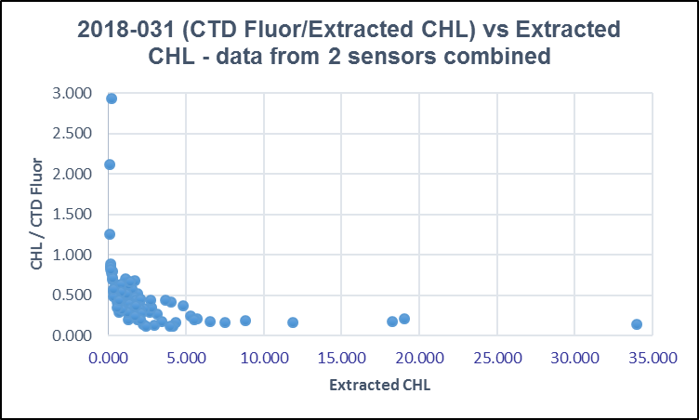

Separating the two sensors the fluorescence versus CHL fits show FL being unusually low for both.

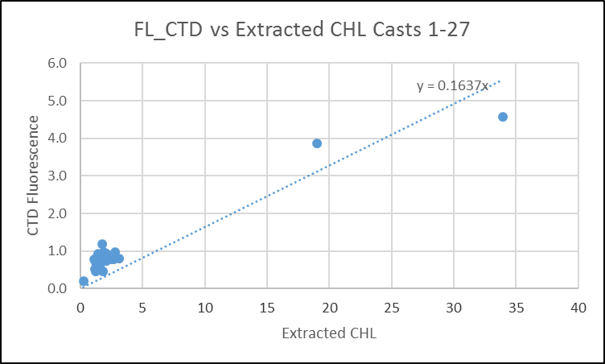

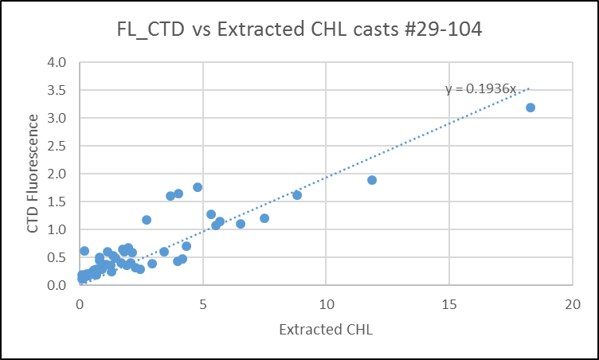
The slightly higher results for sensor #2228 are likely due to lower CHL values, not that the sensor was any better.

It is conceivable that there was a problem with the primary pump and it is not known whether the fluorometer was on the primary or secondary system. But generally poorer flow would lead to high values, not low and most problems of that sort are minimal during a bottle stop.

These data should not be archived. They may provide information on spatial variability but the values are so different from normal as to be totally misleading. There were extracted chlorophyll samples and we have experience to show that CTD fluorescence is usually close to extracted CHL values from 1 to 5ug/L and lower than CHL above 5ug/L. But these values are much lower than CHL than usually seen. The fluorescence channel was removed for both sensors since values are <50% of extracted chlorophyll values for 3ug/L <CHL< 6ug/L range and <25% for CHL>6ug/L. Most data were well below both criteria.

For full details of the comparison see file 2018-031-fl-chl-comp1.xlsx.

Conversion of Full Files from Raw Data
All files were converted using 2018-031-ctd.
The Tau function was selected but not the hysteresis function as there was no deep sampling. Depth was included in the conversion.

A few casts were examined and all expected channels are present. Fluorescence looks like it might have gone off-scale in Saanich Inlet but that isn’t clear – on the upcast it is much lower. This should be checked after DELETE. As usual the T, C and Sal channel pairs track fairly well on downcasts except that they are out of alignment by more than usual. This may be a sign of poor flow for one of them and the primary is noisier. Upcasts are, as usual, much noisier except during stops. The Dissolved Oxygen, pH, altimetry, transmissivity, fluorescence, pH, PAR and SPAR profiles look normal

WILDEDIT
Program WILDEDIT was run to remove spikes from the pressure, conductivity & temperature only in the
full cast files (*.CNV).
Parameters used were: Pass 1 Std Dev = 2 Pass 2 Std Dev = 5 Points per block = 50
The parameter “Keep data within this distance of the mean” was set to 0 so all spikes would be removed.

ALIGN DO
A few casts were examined; both temperature channels were noisy during upcasts so the tests were not easy to interpret, but using +3s certainly improves the alignment and overall looks like a good choice for both DO sensors. ALIGNCTD was run on all casts using +3s.

CELLTM
CELLTM was run using the default setting (α = 0.0245, β=9.5) for both the primary and secondary conductivity. A few casts were checked and this step does improve the data.

DERIVE and Channel Comparisons
Program DERIVE was run on all casts to calculate primary and secondary salinity and dissolved oxygen concentration.

DERIVE was run a second time on 2 of the deeper casts to find differences between the pairs of temperature, conductivity and salinity channels. None of the casts were deep enough to determine if there is any pressure dependence. The temperature differences are small on average, but are very noisy so there are frequent large differences. The data in shaded cells are from previous cruises using the same sensors.

Cast # | Press | T1-T0 | C1-C0 | S1-S0 | Descent Rate
2018-01-0043 | 1000 | -0.0006 | -0.0002 | -0.0021 | High, Noisy
2018-01-0062 | 1000 | -0.0006 | -0.0002 | -0.0021 | High, XNoisy
2018-029-0007 | 300 | +0.0001 | -0.0005 | -0.005 | FHigh, FSteady
2018-029-0059 | 300 | ~0 | -0.0004 | -0.004 | High, V.Steady
2018-029-0093 | 300 | +0.0001 | -0.0004 | -0.0045 | High, V.Steady
2018-029-0105 | 300 | +0.0001 | -0.0004 | -0.004 | High, V.Steady
2018-030-0050 | 300 | -0.0008 | +0.00003 | +0.0009 | High, Steady
2018-030-0056 | 300 | -0.0010 | -0.00002 | +0.0007 | F.High, V.Noisy
2018-030-0086 | 300 | -0.0013 | -0.00003 | +0.0008 | F.High, Noisy
2018-031-0056 | 300 | ~0 XNoisy | -0.0002 | -0.002 VN | High, FSteady
2018-031-0082 | 300 | ~0.0002 VN | -0.0002 N | -0.0015XN | High, Steady
The differences are small but very noisy. Plots of the 2 channels suggest that the differences are mostly due to misalignment in fairly high gradients.

Conversion to IOS Header Format
The IOSSHELL routine was used to convert SEA-Bird 911+ CNV files to IOS Headers.
CLEAN was run to add event numbers and to replace pad values in the pressure channel with interpolated values based on record number.

Checking Headers
The header check was run. A low pH value was found for cast #52 and a check found that all values were low for that cast. This channel should be removed as it is clear that the buffer bottle had been left on the sensor. Plots will be made later to ensure this did not happen on other casts.

A cross-reference list was checked against the log book. Problems found include:
- Cast #40 is said to be at station 49 – that should be station 50. That was fixed in profile files.
- Cast #62 at station 26 is missing. The log indicates it was run and there is a bl file and xmlcon file, but no hex file was found.
- Cast #68 has station # ROS2 – this should be 2. That was fixed in profile and bottle files.

The cruise track was plotted and added to the end of this report.

The altimeter and water depth readings from the headers of the CLN and SAMAVG files were exported to spreadsheets. The depths in the files were frequently different from the log book, but usually by no more than 2m. To check the altimetry header values a check value was calculated as:
Water Depth – Altimetry header – max depth sampled
Where that value was ≥4m the calculation was repeated by using the water depth in the log. If that produced a value <4m, the altimetry was assumed to be ok. Where the log value produced a better result and differed from the file entry by >2m, the log value was substituted in the CLN files. In a few cases there appears to have been some shoaling so the water depth may not reflect what it was when the CTD was at the bottom. Plots show that the altimetry header entries were fine. No change was made.
Changes were made to 13 CLN files and 3 SAM files. A few steps in the merge process were repeated, as needed.

A surface check was run and shows an average surface pressure for the cruise was 1.9db which is typical for the Vector. The lowest pressure measured was 0.55db at the end of cast #87. The salinity was 29.1 which is reasonable.

Shift
Fluorescence
SHIFT was run on the SeaPoint fluorescence channel in all casts using the usual advance of +24 records. Plots show that the fluorescence offset is reasonably close to the temperature offset after this step.
Dissolved Oxygen
The Dissolved Oxygen voltage channel was aligned earlier. A few casts were checked to see if the alignment looked ok, and it did. No further alignment is needed for the DO concentration channel,
pH
Tests were run on 5 casts to determine if the setting of +50 records that was used for the same sensor during 2018-029 worked well. It did so SHIFT was run on all SBE911casts using +50 records.
Conductivity
Tests were run to see if the settings used during the last use of these sensors worked well for fine-tuning the align conductivity and temperature by judging the effect on salinity as seen in T-S space.
- The first conclusion is that only extremely large shifts have any effect on salinity; even then the results are not good.
- Examination of a section of one plot shows that it is not a simple mis-alignment. The primary temperature is very different from the secondary. The secondary T and C are in good alignment even before fine-tuning, but the primary are not. The differences between the sensors were not very high overall, as seen in section 9, but they were extremely noisy and it appears the source of that noise was the primary temperature. This could be due to something in how the sensor was mounted. That sensor has not been used on any later cruises that have yet to be processed, so we have no further evidence about it. When it was last used the whole CTD malfunctioned at one point and was replaced.

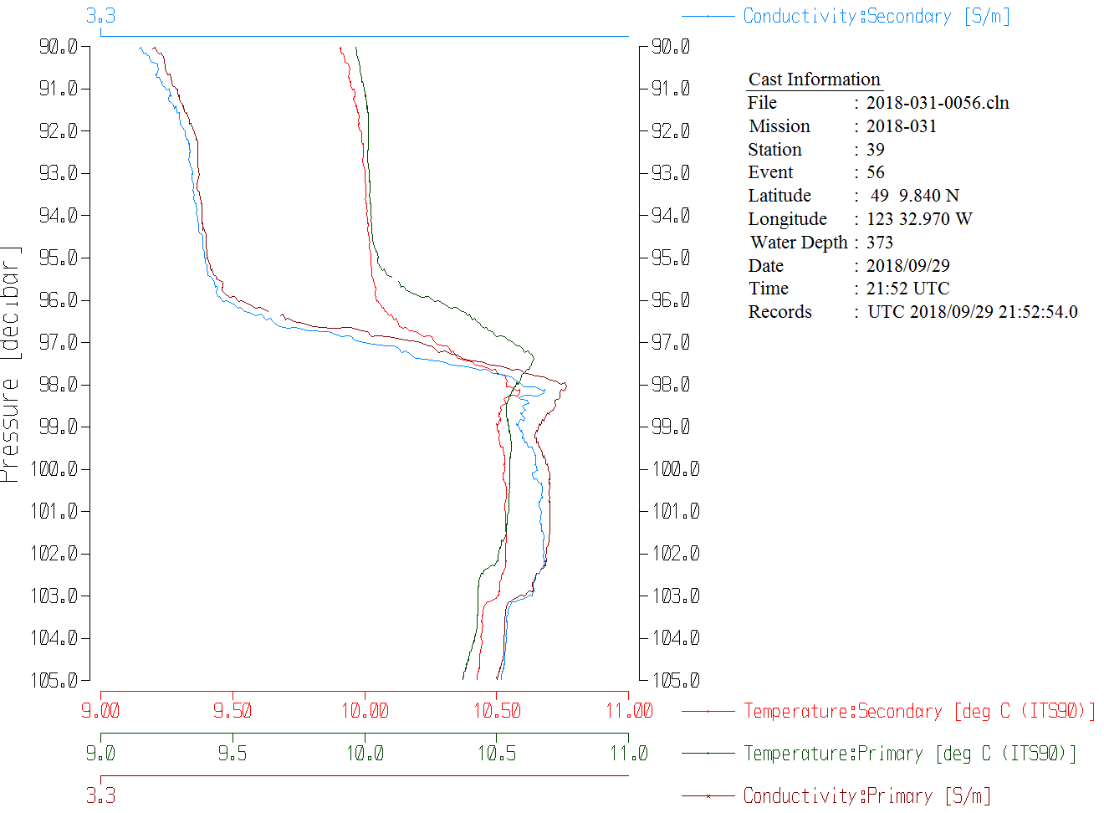

Tests were run on the secondary sensors to see if the alignment used on the previous use (-0.5) worked well, but it didn’t. A setting of -0.8 worked better.
SHIFT was run on all SBE911 casts using -0.5 records the secondary. Salinity was recalculated.

DELETE
The following DELETE parameters were used:
Surface Record Removal: Last Press Min
Maximum Surface Pressure (relative): 10.00
Surface Pressure Tolerance: 1.0 Pressure filtered over 15 points
Swells deleted. Warning message if pressure difference of 2.00
Drop rates < 0.30m/s (calculated over 11 points) will be deleted.
Drop rate applies in the range: 10db to 10db less than the maximum pressure
Sample interval = 0.042 seconds. (taken from header)

COMMENTS ON WARNINGS: There were no warnings.

Other Comparisons
Previous experience with these sensors –
The oxygen and pressure sensors have been used for many cruises, most recently during 2017-08, 2017-09 and 2017-65 in late summer and autumn. The temperature and conductivity sensors have been used twice since there last factory check during 2018-05 and 2018-01 but they were used with a different pressure sensor.

Historic ranges – Profile plots were made with 3-standard deviation climatology ranges of T and S superimposed. There was only one minor excursion in temperature with low values around 30db at a cast east of Texada Island. There were more excursions in salinity with most towards higher values but a few cases of low values. All but 1 were very close to shore where a climatology of this sort is not considered suitable. At stations 4 and 5 salinity was above the range maximum at about 150m while at station 3 it was high at about 100m. A high value was also seen at 25m close to shore south of Victoria. The 2 cases of salinity lower than the range minimum were at 125m in the northern Strait of Georgia and near the surface in the middle of the Strait of Georgia. The only case that looks suspicious was cast #36 (station 56) in the southern Strait of Georgia where all salinity below 40m looks above the range maximum. But this site is close to the division between two climatology areas and the data from #36 fits well within the Gulf Islands climatology but not that of the southern Strait of Georgia climatology. None of the excursions suggest calibration error.

Repeat Casts – There were no repeat casts and nearby casts are too shallow to provide a reasonable comparison.
Post-Cruise Calibration – There were no post-cruise calibrations available.

DETAILED EDITING
The secondary salinity was selected because the primary T, C and S look poor.
All DEL files were copied to *.EDT.

CTDEDIT was used to remove records that appear to be corrupted by shed wakes or ship effects. Most of the data removed are from near the top and bottom of casts. Salinity was cleaned to remove spikes that appear to be due to small misalignment or instrumental noise. There were 2 casts with a section of bad salinity over roughly 1m, too large an excursion to be edited by interpolation; the bad salinity values were removed.
All files required some editing.

After editing T-S plots were examined for all casts. There are some unstable features but those are expected in this region of active mixing. One file was edited a little more, though it was not enough to remove all unstable features.

Recalibration
The bottle salinity data were previously recalibrated based on the study in section 4. The file was renamed as 2018-031-recal1.ccf.

The most reliable dissolved oxygen data appear to be those from the casts nearest the mouth of Juan de Fuca where flushing of bottles appears to be best. The fit has a slightly larger correction than was used when the sensor was last used during Line P in September. This might be related to flow problems suggested by the alignment of the primary channels though there is no record about which pump had the DO sensor mounted on it.

Given the limitations in the bottle comparison no salinity correction is justified.
There is no evidence of an error in pressure calibration.

File 2018-031-recal1.ccf was amended by adding the following correction to channel Oxygen:Dissolved:SBE
CTD DO Corrected = CTD DO * 1.0656 + 0.0409
This correction was first applied to the SAM and MRGCLN2 files.

COMPARE was rerun for Salinity:Bottle previously as described in section 4.

COMPARE was rerun for dissolved oxygen. Using the same data as went into the Juan de Fuca fit, the average difference shows the CTD to be higher than the bottles by 0.00005mL/L with a standard deviation of 0.026. Using all casts and excluding outliers, the DO is found to be high by an average of 0.025mL/L with a standard deviation of 0.026mL/L. The fit looks excellent below 10m. See file 2018-031-DO-comp2.xls for details.

CALIBRATE was then run on the EDT files using the same recalibration file.

Final Calibration of DO
The initial recalibration of dissolved oxygen corrects for sensor calibration drift. Alignctd corrects for transit time errors. Those 2 steps may partly correct for response time errors, but to see if a further correction is needed, a comparison is made of downcast CTD data to bottle data from the same pressure. Small differences are expected due to ship drift, temporal changes, incomplete flushing of Niskin bottles and delayed response and noise in CTD data.

Downcast files were bin-averaged to 0.5m bins for the casts with DO bottle samples. Those files were then thinned and compared to the bottle values in the MRG files. COMPARE was run to study the differences between the downcast CTD DO data and the titrated samples from upcast bottles.

When outliers were removed based on residuals the CTD DO was higher than the titrated samples by an average of ~0.06mL/L (standard deviation of 0.11L/L). This is expected due to the incomplete flushing of Niskin bottles. For the bottles from Juan de Fuca Strait the DO was low by 0.005mL/L with a standard deviation of 0.14mL/L. A plot of differences versus pressure was used to estimate errors. See 2018-031-dox-comp3.xlsx for details.

Fluorescence Processing
A median filter, size 11, was applied to the fluorescence channel in the COR1 files. Plots of a few casts showed that the filter was effective. (Output:*.FIL)

BIN AVERAGE of CTD files
The following Bin Average values were applied to the FIL files (output AVG):
Bin channel = pressure Averaging interval = 1.000 Minimum bin value = .000
Average value will be used. Interpolated values are NOT used for empty bins.
On-screen T-S plots were examined.
Profile plots were examined to see if there any problems.
The PAR values are much lower than PAR:Reference after editing, but that is likely because the shallowest PAR data tend to be removed in editing.
The only pH trace that looks bad is from cast #52, as noted earlier.
No other problems were noted.

Final CTD File Steps (REMOVE and HEADEDIT)
For all casts except #52 REMOVE was run to remove the following channels:
Scan_Number, Temperature:Primary, Salinity:T0:C0, Conductivity:Primary, Oxygen:Voltage:SBE, Altimeter, Status:Pump, Descent_Rate and Flag.
For casts #52 REMOVE was run to remove the following channels:
Scan_Number, Temperature:Primary, Salinity:T0:C0, Conductivity:Primary, pH:SBE, Oxygen:Voltage:SBE, Altimeter, Status:Pump, Descent_Rate and Flag.

A second SBE DO channel (with umol/kg units) was added.
REORDER was run to get the two DO channels together.

HEADER EDIT was used to fix formats and channel names and to add the following comments:

Data Processing Notes:

Conductivity, Transmissivity, Fluorescence:URU:Seapoint, pH:SBE, PAR and PAR:Reference
data are nominal and unedited except that some records were removed in editing
temperature and salinity.

There was a problem with the salinometer used to analyze samples for this cruise. Tests
were run and are described in document “Salinometer-68572 study_20Mar2019.xlsx”.
They established a linear correction to be applied to all salinity analyzed on salinometer
#68572 between January and March 2019. Based on those corrected bottle values and the history
of the sensors, the CTD salinity values are believed to be within +/- 0.004psu.

Two different fluorometers were used during this cruise but both malfunctioned producing very
low values compared to extracted chlorophyll samples. The fluorescence channel was removed
for both sensors since values are <50% of extracted chlorophyll values for 3ug/L < CHL < 6ug/L
range and <25% for CHL > 6ug/L. Most data were well below both criteria.
Dissolved oxygen was calibrated using the method described in SeaBird Application Note
#64-2, June 2012 revision, except that a small offset in the fit was allowed.

The SBE DO sensor has a fairly long response time so data accuracy is not as high when
it is in motion as it is during stops for bottles. This will be especially true
when vertical DO gradients are large. To get an estimate of the accuracy of the
SBE DO data during downcasts (after recalibration) a rough comparison was made
between downcast SBE DO and upcast titrated samples. Some of the difference will
be due to problems with flushing of Niskin bottles and/or analysis errors, so
the following statement likely underestimates SBE DO accuracy.

Downcast (CTD files) Oxygen:Dissolved:SBE data are considered, very roughly, to be:
±0.4 mL/L from 0 to 50db
±0.25 mL/L from 50 to 150db
±0.10 mL/L from 150db to 300db
±0.02 mL/L below 300db

WARNING: The pH:SBE:Nominal data should be used with caution; no field
calibration data were available at the time of processing.
Calibration is required for each cast to get absolute values, although
general trends within a cast are likely real.

Channel pH:SBE was removed from cast #52 because the buffer bottle was left on during
the cast.

For details on the processing see document: 2018-031_Processing_Report.doc.

The Standards Check routine was run and no problems were found.
The Header Check was run; no problems were found.
Profile and T-S plots were examined. There are some unstable features in T-S space where waters are well-mixed, but those are very small and possibly real.
The sensor history was updated.

Dissolved Oxygen Study
As a final check of dissolved oxygen data, % saturation was calculated and plotted. The values ranged from ~40% to 175%. The highest value was in Saanich Inlet. The only other value >120% was at station 39 at 135%. Values ranged from about 95 to 120% in all other parts of the Strait of Georgia. The values look reasonable for this area where variability is usually very high. Near-surface CTD data are noisy and the DO sensor might not have fully equilibrated.

Final Bottle Files
The MRGCOR1 files were put through SORT to order on increasing pressure.

For all casts REMOVE was run to remove the following channels:
Scan_Number, Temperature:Primary, Salinity:T0:C0, Conductivity:Primary, Oxygen:Voltage:SBE, Fluorescence:URU:Seapoint, Altimeter, Status:Pump, Descent_Rate and Flag.

A second SBE DO channel with mass units was added for both the CTD DO and titrated DO and REORDER was run to get the pairs of DO channels together.

HEADER EDIT was run to ensure formats and units are correct, correct the vessel name, change the channel name Bottle_Number to Bottle:Firing_Sequence and the name Bottle:Position to Bottle_Number and to add a comment about quality flags and analysis methods and a few notes about the CTD data processing.

Data were exported from the CHE files to file 2018-031-bottles-final.xls. The entries were compared with the rosette log sheets. No discrepancies were found.

Standards check and a header check were run. No problems were found.
The track plot looks ok.
Plots of each file were examined and no problems were found.
A cross-reference listing and header check were produced for the CHE files.

Thermosalinograph Data
There were no loop samples, flow meter or intake thermistor. The intake is at about 2m. The only method to check calibration is to compare with the CTD casts.

a.) Checking calibrations
The configuration file used at sea was checked and no errors were found.

b.) Conversion of Files
The cnv file was converted to IOS HEADER format.
CLEAN was run to add End times and Longitude and Latitude minima and maxima to the headers.
ADD TIME CHANNEL was used to add Time and Date channels.
A time-series plot was produced. The traces look fine with no spiking in salinity.
The track plot looks fine but covers only the first day of the cruise.

c.) Checking Time Channel
The CTD files were thinned to reduce the files to a single point from the downcast at or within 0.5db of 2.5db. These were exported to a spreadsheet which was saved as 2018-031-ctd-tsg-comp.xls. There were 69 casts with data that overlapped with TSG files and had data from 2m.

The TSG file was opened in EXCEL, median and standard deviations (over 5 records) were calculated for lab temperature and salinity and the files were reduced to the times of CTD files. Those data were added to 2018-031-ctd-tsg-comp.xls.

To check for problems in the TSG clock or bad matches of TSG and CTD data, the differences between latitudes and longitudes were found. There were no position differences >0.0015º and the median differences were both 0.0000º. So the TSG clock worked well.

d.) Comparison of T and S from TSG and CTD data
The comparison looks very different from what we expect from this type of CTD.
The TSG salinity was lower than the CTD salinity by a median value of 0.2685psu (std. dev. 1.2723psu). We expect it to be a little lower based on previous experience, but not by that much. Bubbles in the loop water can explain it reading low but there is no evidence in the traces that this is a major issue. High salinity gradients near the surface are also a possible explanation. However, excluding 10 casts with salinity reading much lower than the CTD (lower by at least -1.4psu) made only a small difference to the result with salinity reading low by a median of 0.2327psu but the standard deviation was much lower at 0.1785psu.

TSG Lab temperature is more puzzling as we expect to be higher than CTD temperature due to heating in the loop; I know of no case in which at least a little heating did not occur and the CTD temperatures at 2m were between 9 and 15ºC. Typically we see a difference between 0.12 and 0.20Cº. In September we would expect a difference at the low end of that range since intake water is warmer so heating in the loop should be reduced. But in this comparison it is lower than CTD by a median of 0.26 Cº (std. dev. 0.39Cº). If there is a large temperature gradient in the top 2m, then there might be significant differences due to slight mismatches in depth of CTD and TSG intake. But in many of these casts the near-surface gradient looks quite low. There is a lot of noise in the temperature differences but they vary in direction, so excluding the outliers that were identified based on salinity differences had no effect on the median temperature differences though the standard deviation was a little lower.

The apparent “cooling” in the loop becomes greater as the intake temperature increases. This either implies that the ship was very cold, or that the TSG temperature is reading low. If we increase the TSG temperature enough to produce “warming” as opposed to “cooling”, then we see reduced warming as intake temperature increases, which is what we expect.

See 2018-031-ctd-tsg-comp.xls.

Calibration History
The TSG temperature and conductivity were recalibrated in December 2015 and have been used for 5 other cruises in 2016 and 2017. The last use was on the Vector in June 2017. During that cruise (2017-64) differences from casts with fairly well-mixed surface waters, as judged from CTD profiles, showed the salinity to be low by a median of about 0.5psu while the temperature was high by a median value of 0.12C°. The cruise that followed this one had no TSG available.

Conclusions
1. The TSG clock worked well.
2. The TSG lab temperature was lower than the CTD temperature by about 0.26Cº. We would expect it to be reading higher by about 0.12Cº. It appears that TSG temperature is low by about 0.38Cº. But the lab temperature was used to calculate salinity.
3. The TSG Salinity is low by about 0.27psu. But if the temperature used to derive that was corrected by adding 0.38Cº, then salinity values would become even lower. A comparison was not done using recalibrated salinity, but a rough estimate is that the TSG salinity would be lower than the CTD salinity by ~0.5psu. While that is a very large difference, it is what was observed during 2017-064.
4. While a correction can be applied, it is based on a number of estimates and with no loop samples or intake temperature to guide us, it seems unwise to archive these data. The CTD salinity could be off a little due to a problem with the salinometer, but the potential error is very small compared to the differences observed here.

f.) Editing
No editing was required.

g.) Recalibration
Add Channels was used to create Channel Temperature:Lab with values set equal to Temperature:Primary.
Calibrate was run using file 2018-031-tsg-recal1.ccf to add 0.38 to Temperature:Lab and add 0.26Cº to Temperature:Primary and to recalculate salinity using Temperature:Lab.

h.) Preparing Final Files
REMOVE was used to remove the following channels: Scan Number, Temperature:Secodnary, Temperature:Difference, Voltage:0, Flag, Pressure and Position:New channels.

HEADER EDIT was used to change the DATA TYPE to THERMOSALINOGRAPH and add the depth of sampling to the header and to change channel names to standard names and formats and to add the following comment:

Sampling System
---------------
The seawater is drawn from a 5cm standpipe which is flush with the hull
and located 2.0 metres below the water line. There is 1.6m of 5cm pipe
from the hull to the Moyno 2L6 SSQ pump and the water is then pumped
approximately 26 metres through a 3.8cm stainless steel pipe up to the
main lab. The system pressure is regulated by a 3.8cm Singer 106RPS valve.

In the lab, the seawater flows directly through the Seabird model 21
Sea-cat thermosalinograph and the exhaust goes directly overboard.

TSG Data Processing
-------------------
There was no loop sampling, intake temperature sensor or flow rate meter.

A comparison of temperature and salinity was made with co-incident CTD casts.
The temperature in the lab was found to be lower than the CTD casts by a median
value of 0.26 C degrees, a most unusual result as heating in the loop is
expected to occur. Temperature:Lab was recalibrated by adding 0.38 C degrees.
Temperature:Primary is a proxy intake temperature that was created by adding
0.26 C degrees to the lab temperature.

The TSG salinity was lower than that from the CTD salinity with a median difference
of about 0.27psu compared to CTD data from 2m. After recalibration of Temperature:Lab
this difference will be larger, on the order of 0.5psu.

Temperature:Primary - The temperature data from the lab after recalibration based
on comparison with CTD data from 2db, minus 0.12 C degrees, an estimaate of heating
in the loop to create a proxy for intake temperature.
Temperature:Lab - The temperature data from the lab were recalibrated based
on comparison with CTD data from 2db.
Salinity:T0:C0: Salinity was recalculated using recalibrated Temperature:Lab data.

See document 2018-031-Processing_Report.doc for more details.
-----------------------------------------------------------------------------------
WARNING: THESE DATA ARE NOT CONSIDERED SUITABLE FOR ARCHIVAL

THESE DATA SHOULD BE USED WITH CAUTION AS THE CALIBRATION OF THE
TEMPERATURE AND CONDUCTIVITY SENSORS IS IN DOUBT.

The file was saved as 2018-031-0001.HDR as it is not intended for archival.
The TSG sensor history was updated.
As a final check plots were made of the cruise track and time-series and all look fine.
The cruise plot was added to the end of this report.

Particulars
TSG started at 3:00 Sept. 27 – some problems with con file. Con file appears to be correct.
1. Fired all bottles for integrity test. Many problems reported on first attempt including oil leak in winch tablet, odd fluorescence, noisy O2– went back to surface and started again. On next attempt there were problems with bottles.
2. fired all bottles for integrity test – Problems with leaks in bottles 13, 15, 24 and O-rings replaced on #1, 3, 4, 5, 7, 11.
11. Misfire of bottle 5 suspected based on DO sample.
12. Changes to con file made but SPAR still looks odd.
13. Delay to fix winch tablet at start of cast.
14. Bottle 5 misfire again.
16. Fluor. connector cleaned and re-seated
17. Trip mechanism on Niskin #5 cleaned, spigot on #11 serviced.
29. Fluorometer replaced with #2228 ( probably – not completely clear
36. Tripped Niskins 8 and 9 together at 50m.
45. Two bottles tripped but the CTD moved throughout. Firing not noted in log and no sample #s. No CHE file was prepared.
48. Event #49 was saved as #48 – it was renamed after conversion.
49. Bottles 13 and 15 replaced with flat-topped Niskins.
62. No hex file – log indicates there was a cast but there are only bl and xmlcon files available.
85. Lots of tar-like grease coming off CTD cable.
92. Rough launch, swell came up during deployment, caused slack and jolt in wire.
99. Surface bottle caught, according to log #3 didn’t fired. In fact, it did fire but did not close.
100. Redeploy to get surface bottle #3. Pump not on. File not needed since firing recorded in #100 and pumps not on for #100 so CTD data not useful.
CRUISE SUMMARY - CTD
CTD# | Make | Model |  | Serial# |  | Used with Rosette? |  | CTD Calibration Sheet Competed?
1 | SEABIRD | 911+ |  | 0506 |  | Yes |  | Yes
Calibration Information - 0506
Sensor |  |  |  |  | Pre-Cruise |  |  |  | Post Cruise
Name |  |  | S/N |  | Date |  | Location |  | Date | Location
Temperature |  |  | 2106 |  | 18Feb2017 |  | Factory
Conductivity |  |  | 2280 |  | 23Feb2017 |  | Factory
Secondary Temp. |  |  | 2663 |  | 18Feb2017 |  | Factory
Secondary Cond. |  |  | 2754 |  | 22Feb2017 |  | Factory
Transmissometer |  |  | 1005DR |  | 21Aug2018 |  | Factory
SBE 43 DO sensor |  |  | 1119 |  | 28Mar2017 |  | Factory
PAR |  |  | 4565 |  | 16Mar2011 |  | Factory
SeaPoint Fluor. |  |  | 2356
SeaPoint Fluor. |  |  | 2228
pH sensor |  |  | 852 |  | 8Mar2017 |  | Factory
Surface PAR |  |  | 20518 |  | 21Mar2016
Pressure Sensor |  |  | 0550 |  | 24Feb2017 |  | Factory
Altimeter |  |  | 1235 |  | ? |  | Factory

CRUISE SUMMARY TSG
Make/Model/Serial#: SEABIRD/21/3363 Cruise ID#: 2018-031

Calibration Information
Sensor |  | Pre-Cruise |  | Post Cruise
Name | S/N | Date | Location | Date | Location
Temperature | 3363 | 17Dec15 | Factory
Conductivity | 3363 | 17Dec15 | Factory

