REVISION NOTICE TABLE
DATE | DESCRIPTION OF REVISION
20 March 2025 | Updated channel names & formats in TOB & Loop files. GG & SH
26 July 2024 | Added Cesium data to 11 casts. SH
18 July 2023 | Corrections to flags and comments in 5CHE files. G.G.
26 March 2023 | Added HPLC. S.H.
20 June 2019 | Added DOC/TOC/TDN/TN to 11 CHE files.
6 Nov2018 | Updated TSG files including formats and header entries. Corrected time in CTD and CHE files for events #1 – 16. See §25 for details.

PROCESSING NOTES
Cruise: 2018-026
Agency: OSD
Location: North-East Pacific
Project: Line P
Party Chief: Robert M.
Platform: John P. Tully
Date: 5 June 2018 – 19 June 2018

Processed by: Germaine Gatien
Date of Processing: 10 August 2018 – 9 October 2018
Number of original HEX files: 51 Number of CTD files: 49
Number of rosette casts: 47 Number of bottle casts processed: 47
Number of original TSG files: 47 (most empty) Number of processed TSG files: 11

INSTRUMENT SUMMARY
CTD #0443 was mounted in a rosette and attached were a Wetlabs CSTAR transmissometer (#1185DR), a SBE 43 DO sensor (#997) on the primary pump, a SeaPoint Fluorometer (#3641) on the secondary pump, a Biospherical QSP-400 PAR sensor (#70613) and an altimeter (#62355).

A new thermosalinograph (SBE45 S/N 0620) was mounted with a remote temperature sensor, a WETStar fluorometer (#3654) and a flow meter.

Seasave version 7.26.7.107was used for acquisition.
The data logging computer was the Tully Laptop.
The deck unit was a Seabird model 11+ #425.
The Oxygen Kits were DOSIMAT 865-3 (model #19 - Kit #2) outside and DOSIMAT 876-3 (Model #21 – Kit #2) inside.
The salinometer used at IOS was a Guildline model 8400B Portasal, serial # 68572.
An IOS rosette with 24 10L bottles was used.

SUMMARY OF QUALITY AND CONCERNS
The Daily Science log book and sampling logs were in good order. Notes from the chief scientist about problems encountered during the cruise were very helpful in processing the data.

During the previous cruise using this equipment, 2018-039, there were many problems reported with leaking Niskin bottles, primarily due to the end caps not sealing properly. Similar problems were noted during this cruise, though many fewer than during the earlier cruise.

While the CTD fluorescence data are expressed in concentration units, they do not always compare well to extracted chlorophyll samples, particularly for casts far from shore. It is recommended that users check extracted chlorophyll values where available.

The SBE DO sensor has a fairly long response time so data accuracy is not as high when it is in motion as it is during stops for bottles. This will be especially true when vertical DO gradients are large. To get an estimate of the accuracy of the SBE DO data during downcasts (after recalibration) a rough comparison was made between downcast SBE DO and upcast titrated samples. Some of the difference will be due to problems with flushing of Niskin bottles and/or analysis errors, so the following statement likely underestimates SBE DO accuracy.

Downcast (CTD files) Oxygen:Dissolved:SBE data are considered, very roughly, to be:
±0.3 mL/L from 0 to 100db
±0.15mL/L from 100 to 300db
±0.10 mL/L from 300db to 500db
±0.04 mL/L below500db (mostly low below 1500db)

A new TSG was being tested during this cruise. There were only 6 CTD casts and 4 loop samples that overlap with TSG records so the comparisons are more limited than usual. Fluorescence values look reasonable. The intake temperature sensor read significantly higher than the CTD temperature, but not in a consistent way so recalibration is not possible. The lab temperature was higher than the intake temperature by more than expected based on previous experience with heating in the loop on the Tully. The salinity traces were quite smooth with only a few very small spikes. Salinity read lower than the CTD. The differences were not sufficiently consistent to allow recalibration. The data were archived but with a warning that there was insufficient calibration sampling to assess quality.

PROCESSING SUMMARY
PART I – SBE911

Seasave
This step was completed at sea; the raw data files have extension HEX.

Preliminary Steps
- The Log Book and rosette log sheets were obtained.
- Nutrients, DMS, extracted chlorophyll, dissolved oxygen and salinity data were obtained in QF spreadsheet format from the analysts.
- The cruise summary sheet was completed.
- The history of the pressure sensor, conductivity and dissolved oxygen sensors was checked. They were all used during 3 other cruises, 2018-001, 2018-029 and 2018-039, since they were last calibrated.
- The calibration control file was checked. The only error was in factor E in the dissolved oxygen sensor parameters. The value entered was 0.0362 but 0.0363 was found best during a hysteresis tests during 2018-01. The corrected file was saved as 2018-026-ctd.xmlcon.

BOTTLE FILE PREPARATION
The ROS files were created using file 2018-026-ctd.xmlcon. Depth was included.
The files for events #1 and #87 will not be processed further since there was no sampling and no CHE file is needed.
The ROS files were converted to IOS format.
They were put through CLEAN to create BOT files.
Temperature and salinity were plotted for all BOT files to check for outliers. CTDEDIT was used to clean the primary salinity lightly in casts #31 and #62. A few other files were examined but the noise in salinity was quite general, not suitable for editing. The edited files were copied to *.BOT.

A preliminary header check was run and no problems were found.

The BOT files were bin-averaged on bottle number and the output was used to create file ADDSAMP.csv. First, the file was sorted on event number and Bottle Position order. Then sample numbers were added based on the rosette logs.

The ADDSAMP file was then sorted on event number & then sample number.
It was used to add sample numbers to the BOT files – output *.SAM.
The SAM files were bin-averaged on bottle # and called SAMAVG.

The addsamp.csv file was converted to CST files, which will form the framework for the bottle files.

One cast at station P26 was split into 2 files. The second contains only upcast data, so no action is needed to merge the full profile processing, but the bottle files need to be joined. The Niskin numbers (bottle position) in the 2nd file are correct but the bottle numbers (order of firing) are not.
Files 2018-0026-0076.sam and 2018-026-0077.sam were renamed as 2018-026-0076.sama and samb.
File 2018-026-0076.samb was opened in Ultraedit and the firing order numbers were adjusted to match the position numbers. The files were joined and the output file was bin averaged.

Next, each of the analysis spreadsheets were examined to see what comments the analysts wanted included in the header file. These were used to create file 2018-026-bot-hdr.txt which will be updated as needed during processing.

EXTRACTED CHLOROPHYLL
Extracted chlorophyll and phaeo-pigment data were obtained in file QF2018-26chl*.xlsx. The file included comments and flags and a precision study. A simplified version of the spreadsheet was prepared and saved as 2018-026chl.csv. The csv file was then converted to individual CHL files.
DISSOLVED OXGYEN
Dissolved oxygen data were provided in spreadsheet QF2018-26oxy.xlsx which includes flags, comments and a precision study. Draw temperatures are available. The spreadsheet page with the final data was simplified and saved as 2018-026oxy.csv. That file was converted into individual *.OXY files.
SALINITY
Salinity analysis was obtained in file 2018-26SAL.xlsx which included a precision study. The analyses were carried out in a temperature-controlled lab 10 to 20 days after collection. The files were simplified and saved as 2018-026sal.csv. That file was then converted to individual SAL files.
NUTRIENTS
The nutrient data were obtained in spreadsheet QF2018-26_nutrients*.xlsx. This includes a precision study. The file was simplified and the saved as 2018-026nuts.csv. The file was converted to individual NUT files.
DMS
DMS data were obtained in spreadsheet DMS summary (2018-26).xls. Details on analysis are in file 2018-26DMS report.doc which includes duplicate analysis. An error in station name was found – cast 44 was the DMS cast, not 43. This file was converted to DMS files.

The SAL, CHL, OXY, NUT and DMS files were merged with CST files in 5 steps.
After the 5th step the files were put through CLEAN to reduce the headers to File and Comment sections only.

The merged files are ordered on sample number, but the SAMAVG files are ordered on bottle number, so one or the other set needs to be reordered in order to merge them. The MRGCLN1 files were reordered on Bottle_Number. The output files were named MRGCLN1s. Those files were then merged with SAMAVG files choosing the Bottle_Number from the SAMAVG files.

The output of the MRG files were exported to a spreadsheet and compared to the rosette log sheets to look for omissions. A few problems were found:
- The ADDSAMP file had not been changed to combine events 76 and 77 so the samples from 77 were missing. The file was fixed and the merge process rerun for that cast.
- The bottles fired at the end of cast 105 but with no sampling were in the file. The SAMAVG file was edited to remove those lines and the merge with bottle data was rerun.

Compare
Salinity
Compare was run with pressure as reference channel.

There was one major outlier. Sample 574, event 76 looks like a misfire. The value matches CTD values near 75m. The samples from this bottle will all be padded with flag 5.
There are other outliers from event #76 but those affect only the secondary comparison and are caused by a malfunction in the CTD secondary conductivity during the upcast. No flags are appropriate.

The near-surface samples almost all have the CTD reading lower than bottles, which is expected when incomplete flushing of Niskin bottles occurs in high vertical salinity gradients. Between 50 and 250metres the differences show CTD being higher than bottles, but there are only 3 bottles and they all come from cast #46; standard deviations in CTD salinity during those stops were high. Plots against scan number show that CTD salinity did not equilibrate but fell steadily during the stop. Both channels are very noisy and temperature reverses during the stop. No flags are appropriate for these bottles as there is no evidence of a problem in sampling or analysis.

When bottles with pressure <500db and standard deviations in CTD salinity >0.0008psu are excluded the primary salinity was found to be low by an average of 0.0012 and the secondary low by 0.0039psu.
For full details for the COMPARE run see file 2018-026-sal-comp1.xls.

Dissolved Oxygen
COMPARE was run with pressure as the reference channel.
When outliers are removed based on residuals the following fit is found:
CTD DO Corrected = CTD DO * 1.0234 + 0.0526 (R² = 0.92) Fit #1

This is very different from the results from cruise 2018-39 when the same instrument was used and the fit was:
CTD DO Corrected = CTD DO * 1.0698 + 0.0494 (R² = 0.97)
During that cruise there were many reports of Niskin bottle leaks. This would result in bottle contents having higher DO than expected which would make the CTD look like it was reading lower than it actually was. The differences are most striking nearer the surface which is surprising since deeper bottles had more time to leak, but the most troublesome Niskin bottle was #11 and the results from bottles #10 and 16 were poor as well. The deeper bottles were fired a lot and had only a few reports of leaks. There were a few bottles from below the OMZ where leaks would have complex effects, but they mostly used bottles with few reports of leaks.

The initial 2018-026 result is closer to the results of 2018-001 which was:
CTD DO Corrected = CTD DO * 1.0283 + 0.0491 (R² = 0.93)

For 2018-026 the near-surface data mostly fall above the general fit, but not in as distinctive a grouping as seen during 2018-001. The data that look most out of line are those with values >6mL/L. If bottles with DO>6mL/L are excluded the fit becomes:
CTD DO Corrected = CTD DO * 1.0276 + 0.0477 (R² = 0.89) Fit #5
This is very close to the 2018-001 result. The reason why the high values fit poorly is likely due to the subsurface DO maximum

The comparison for DO < 3mL/L produces a higher correction than when the full range is included. This is likely due to the near-surface bottles having a larger error due to incomplete flushing in the presence of high DO gradients. The fits below the OMZ and above the OMZ for DO < 3mL/L were
Below OMZ CTD DO Corrected = CTD DO * 1.0331 + 0.0393 (R² = 0.88) Fit #2
Above OMX CTD DO Corrected = CTD DO * 1.0289 + 0.0477 (R² = 0.79) Fit #3
Given the few data in the fits these are not significantly different considering that flushing errors below the OMZ would lead to the CTD DO values looking even lower than they really are and above the OMZ the opposite effect would occur. So the difference between the two is not likely to be due to hysteresis.

There continued to be reports of leaks but not nearly as many as during 2018-026. Nonetheless, there might have been small leaks that went unnoticed which would have a complex effect when there is sampling above and below the OMZ, but overall might be expected to make the CTD data look a little higher than it really is. Hence the correction suggested by the fit might be an underestimate.

For full details see report 2018-026-dox-comp1.xls. The fit #s referred to above match the plots in that report.

There are 4 cases where flag changes were recommended:
- Sample 8, event #2 – This is out of line in profile but nutrients don’t show evidence of a problem though it might be hard to see at this level. There are no CTD DO reversals at that level. The value looks high by about 0.5mL/L. There may be a small DO reversal at that level but it wouldn’t seem large enough to explain such a large outlier. The analyst changed the flag to 3 with comment “Outlier in comparison to CTD.”
- Sample 11, event #2 – The DO sample looks low by about 0.4mL/L. Poor flushing could explain this but the other samples are not out of line (nutrients, CHL). The analyst changed the flag to 3 with comment “Outlier in comparison to CTD.”
- Sample 344, event #52 – This sample appears to be high by about 0.4mL/L. There were no reversals in CTD DO at that level and no other samples look out of line. The analyst changed the flag to 3 with comment “Outlier in comparison to CTD.”
- Event 10 sample 31 –The analyst requested a check of the 2 samples because this was a replicate outlier. The OXY-2 value 2.025mL/L was a much better fit in the comparison than the OXY-1 value (2.124) or the average. The analyst changed the flag from 6 to 2 and entered only the OXY-2 value.
Plots of Titrated DO and CTD DO against CTD salinity were examined. No further outliers were found.

Fluorescence
COMPARE was run with extracted chlorophyll and CTD Fluorescence using pressure as the reference variable.
The plot of ratio FL/CHL versus Extracted CHL has the general shape typically seen from this type of sensor with the ratio dropping as CHL rises, though there is more scatter than usual around CHL=1ug/L.

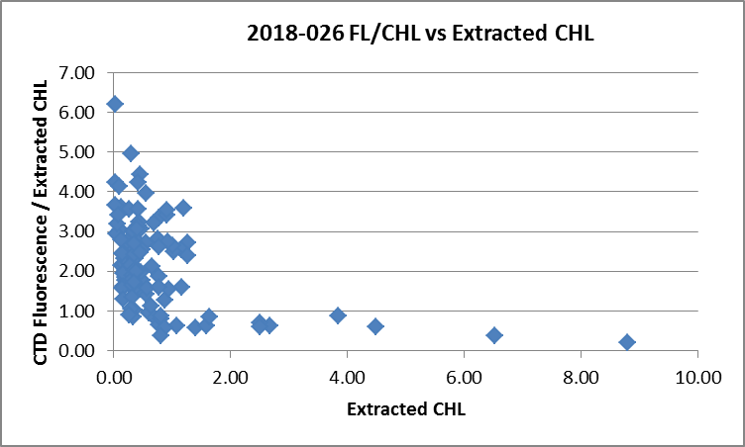

Plots of fluorescence against chlorophyll showed the slopes falling roughly into 2 groups:
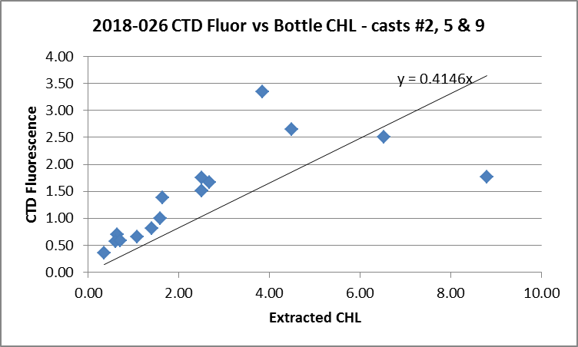
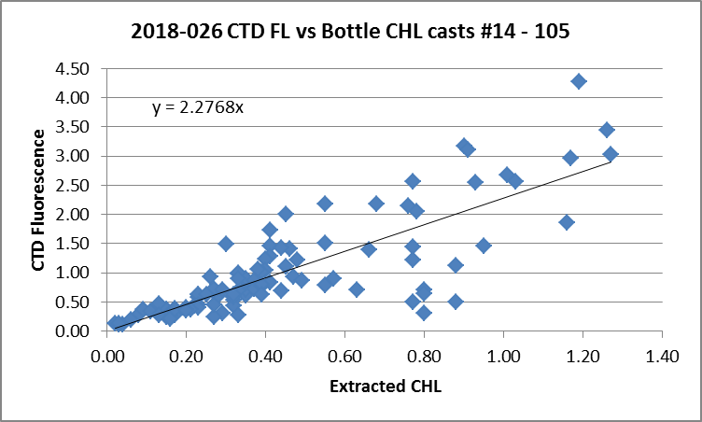

There was an unusually sharp transition from a regime of fairly high chlorophyll to one where most values were <1ug/L. Cast #9 had the highest CHL.
For full details of the comparison see file 2018-026-fl-chl-comp1.xlsx.

Conversion of Full Files from Raw Data
All files were converted using 2018-026-ctd.
The Tau and hysteresis functions were selected. Depth was included in the conversion.
A few casts were examined and all expected channels are present.
- There was a lot of noise in the temperature and conductivity, especially the primary, but it is mostly in the upcast and there are some spikes in the secondary too.
- The Dissolved Oxygen, transmissivity, fluorescence, and PAR profiles look normal
- The altimetry looks reasonable near the bottom though there are frequent spikes so values will need to be checked.

WILDEDIT
Program WILDEDIT was run to remove spikes from the pressure, conductivity & temperature only in the
full cast files (*.CNV).
Parameters used were: Pass 1 Std Dev = 2 Pass 2 Std Dev = 5 Points per block = 50
The parameter “Keep data within this distance of the mean” was set to 0 so all spikes would be removed.

ALIGN DO
In recent cruises using this sensor dissolved oxygen was aligned using a setting of +2.5s.
ALIGNCTD was run on all casts using +2.5s.
The results were examined after the DERIVE step and was found to have worked well.

CELLTM
The noise in the upcast data makes tests for the best parameters for this routine very difficult to interpret. In the past when upcast data were not so noisy, the default setting of (α = 0.0245, β=9.5) was generally found to be the best choice. A few casts were checked for this cruise and the default setting does improve the data. CELLTM was run using (α = 0.0245, β=9.5) for both the primary and secondary conductivity.

DERIVE and Channel Comparisons
Program DERIVE was run on all casts to calculate primary and secondary salinity and dissolved oxygen concentration.

DERIVE was run a second time on 4 of the deeper casts to find differences between the pairs of temperature, conductivity and salinity channels. Results from other recent uses of this equipment are included with shading. Note that one of the temperature sensors was changed since this equipment was last used, so a small change is not unexpected.
Cast # | Press | T1-T0 | C1-C0 | S1-S0 | Descent Rate
2018-01-0043 | 1000 | -0.0006 | -0.0002 | -0.0021 | High, Noisy
2018-01-0062 | 1000 | -0.0006 | -0.0002 | -0.0021 | High, XNoisy
 | 1900 | -0.0007 | -0.0001 | -0.0010 | “
 | 2900 | -0.0013 | -0.0001 | -0.0000 | “
 | 3900 | -0.0019 | -0.0001 | +0.0011 | “
2018-01-0072 | 1000 | -0.0005 | -0.0002 | -0.0023 | High, XNoisy
 | 1900 | -0.0008 | -0.0001 | -0.0012 | “
 | 2900 | -0.0015 | -0.0001 | +0.0000 | “
 | 3900 | -0.0020 | +0.0000 | +0.0010 | “
2018-029-0007 | 300 | +0.0001 | -0.0005 | -0.005 | FHigh, FSteady
2018-029-0059 | 300 | ~0 | -0.0004 | -0.004 | High, V.Steady
2018-029-0093 | 300 | +0.0001 | -0.0004 | -0.0045 | High, V.Steady
2018-029-0105 | 300 | +0.0001 | -0.0004 | -0.004 | High, V.Steady
2018-039-0044 | 1000 | -0.0009 | -0.0005 | -0.0047 | High, XNoisy
“ | 1900 | -0.0008 | -0.0003 | -0.0036 | High, XNoisy
2018-039-0088 | 1000 | -0.0003 | -0.0004 | -0.0043 | High, VNoisy
“ | 1900 | -0.0006 | -0.0003 | -0.0030 | High, VNoisy
2018-039-0110 | 1000 | -0.0002 | -0.0006 | -0.0065 | High, VNoisy
“ | 1900 | -0.0003 | -0.0004 | -0.0040 | High, VNoisy
2018-026-0031 | 1000 | -0.0007 | -0.0004 | -0.004 | High, XNoisy
 | 1900 | -0.0005 | -0.0003 | -0.003 | High, XNoisy
2018-026-0043 | 1000 | -0.0004 | -0.0004 | -0.004 | High, VNoisy
 | 1900 | -0.0005 | -0.0003 | -0.003 | High, VNoisy
 | 2900 | -0.0005 | -0.00025 | -0.0025 | High, VNoisy
2018-026-0062 | 1000 | -0.0002 | -0.00035 | -0.004 | High, XNoisy
 | 1900 | -0.0004 | -0.00025 | -0.003 | High, XNoisy
 | 2900 | -0.0006 | -0.00025 | -0.0025 | High, XNoisy
 | 3900 | -0.0006 | -0.0002 | -0.002 | High, XNoisy
2018-026-0072 | 1000 | -0.0004 | -0.0003 | -0.004 | High, VNoisy
 | 1900 | -0.0004 | -0.0003 | -0.003 | High, VNoisy
 | 2900 | -0.0007 | -0.00025 | -0.002 | High, VNoisy
 | 3900 | -0.0006 | -0.0002 | -0.002 | High, VNoisy
There is no evidence of temporal drift except in temperature. During 2018-01 deep temperature differences were much higher, so the replacement of the primary sensor appears to have been a good choice. The salinity differences are consistent with the bottle comparison which showed the 2 CTD channels to differ by an average of 0.0027psu below 500m.

Conversion to IOS Header Format
The IOSSHELL routine was used to convert SEA-Bird 911+ CNV files to IOS Headers.
CLEAN was run to add event numbers and to replace pad values in the pressure channel with interpolated values based on record number.

At this point the start time was corrected in casts up to #16 since the chief scientist reported that the computer clock was running approximately 12 minutes ahead. First all CLN files were copied to ATC.
Then CLN files #1 to 16 were put through ADD TIME CHANNEL to subtract 0.2 hours.
*See note in §25 – This correction was later reversed as original header times were correct.

Checking Headers
The header check was run and no problems were found.
A cross-reference list was checked against the log book. No errors were found.
The cruise track was plotted and added to the end of this report.
The altimeter and water depth readings from the headers of the CLN and SAMAVG files were exported to spreadsheets. A check was made by subtracting maximum depth sampled plus altimetry header from the water depth. Where that number exceeded ±4m the readings were checked. Based on those checks the following changes were made:
- For the profile data, the water depth was changed to match the log book entry for cast #105. For casts #15 and 68 the header depths matched the log but look wrong, so they were changed to equal the altimetry header value plus the maximum depth sampled. For events #21, 22, 35 and 66 the altimetry header entry was based on spikes: the CTD obviously did not get within 15m of the bottom so the header entry was removed.
- The same changes were made to bottle files (*.sam) for casts: 15, 21, 22, 68 and 105 and then the necessary steps in the merge process were repeated to the MRGCLN2 stage.

A surface check was run and shows an average surface pressure for the cruise was 2.5db which is reasonable for the Tully.

A preliminary header check was run. No problems were found but it was noted that some negative pressures were recorded during cast#27. These were investigated. They occurred during the upcast with the pumps on. The group of negative values occurred for only 1 second and the pumps were on. There are a few pad values in the conductivity between +0.09m and -0.15m and overall values drop significantly during that 1s. Transmissivity values are ~55%/m at 0.25db then drop rapidly to 0% and stayed at 0% while the CTD rose to -0.28db until it dropped back to +0.25db. Do these low transmissivity values indicate the instrument is in a surface slick or affected by waves? The salinity does not go to zero but the low pressures probably don’t last long enough for that, especially if water is splashing around the intake. It appears that the pressure is accurate to within ±0.2db.

Shift
Fluorescence
SHIFT was run on the SeaPoint fluorescence channel in all casts using the usual advance of +24 records. Plots show that the fluorescence offset is reasonably close to the temperature offset after this step.
Dissolved Oxygen
The Dissolved Oxygen voltage channel was aligned earlier. A few casts were checked to see if the alignment looked ok, and it did. No further alignment is needed for the DO concentration channel,
Conductivity
Tests were run on 4 casts to determine the best setting to align conductivity and temperature by judging the effect on salinity as seen in T-S space.
SHIFT was run twice on all SBE911 casts using -0.2 records for the primary conductivity and -0.5 records the secondary. Salinity was recalculated for both channels.

DELETE
The following DELETE parameters were used:
Surface Record Removal: Last Press Min
Maximum Surface Pressure (relative): 10.00
Surface Pressure Tolerance: 1.0 Pressure filtered over 15 points
Swells deleted. Warning message if pressure difference of 2.00
Drop rates < 0.30m/s (calculated over 11 points) will be deleted.
Drop rate applies in the range: 10db to 10db less than the maximum pressure
Sample interval = 0.042 seconds. (taken from header)

COMMENTS ON WARNINGS: The only warning was that pressure was <10db for cast #77. That file contained only upcast data. The downcast is entirely in cast #76, so #77 will not be processed further.

Other Comparisons
Previous experience with these sensors –
The secondary temperature sensor, pressure sensor and both conductivity sensors were used during 2018-01, 2018-029 and 2018-039. The primary temperature sensor was thought to have some pressure dependence likely to affect deep performance, so that sensor was replaced before this cruise. The bottle comparisons from 2018-029 and 2018-039 were not trusted due to flushing problems for the former and problems with Niskin bottles for the latter. During 2018-001 the primary salinity was found to be high by ~0.0017 but that was with a different temperature sensor. The secondary salinity was found to be low by low by ~0.0007. The dissolved oxygen was recalibrated using slope 1.0283 and offset 0.0491
Historic ranges – Profile plots were made with 3-standard deviation climatology ranges of T and S superimposed. The only excursions from the climatology were some cases of salinity around 50-80m at P8 and from about 70 to130m at P20 being higher than the maximum. The mixed layer appears to be shallower than in the climatology. Some nearby casts have values close to the salinity maxima at those depths (P4 to P7, P9 and P18 to P19.) Given both salinity channels have values outside the climatology these are likely good values, not caused by calibration drift. All other T and S data fell within the climatology.
Repeat Casts – There were many repeat casts. Two casts that sampled to about 2000m at P26 were selected for comparison. There were 11 hours between the casts. AT about 1900m and σ_{t}=27.62 the temperatures varied along constant density lines by no more than 0.002C° and 0.0003psu. This is good agreement.
Post-Cruise Calibration – There were no post-cruise calibrations available.

DETAILED EDITING
The choice of which T-S pair to choose for editing and eventual archiving is not obvious. The secondary conductivity malfunctioned during cast #76. The primary salinity is closer to bottle values but has more pressure dependence. Looking at the two channel pairs in T-S space shows some sections looking better in the primary and others in the secondary, so there is no obvious best choice from the point of view of which would need more editing. While the secondary was chosen for the past 3 cruises, the temperature sensor has been switched since then. The primary sensors look like the best choice overall.

All DEL files were copied to *.EDT.

CTDEDIT was used to remove records near the top and bottom of casts that appear to be corrupted by shed wakes or ship effects. Salinity was cleaned to remove spikes that appear to be due to small misalignment or instrumental noise. All files required some editing.

The edited files were copied to *.EDT.

After editing T-S plots were examined for all casts. There are a few near-surface unstable features but only in areas of active mixing. No further editing was applied.

Recalibration
File 2018-026-SBE911-recal.ccf was prepared to add 0.0012psu to channel Salinity:T0:C0, to apply the following corrections to channels Oxygen:Dissolved:
CTD DO Corrected = CTD DO * 1.0276 + 0.0477
This correction was first applied to the SAM and MRGCLN2 files.

COMPARE was rerun for salinity using the same points as in the fit used for the original COMPARE run to ensure that corrections were appropriate and they were. The salinity was found to be low by an average of 0.00005psu. See file 2018-026-sal-comp2.xls for details.

COMPARE was rerun for dissolved oxygen. When roughly the same data were included as in the original fit, the average of differences in the DO fit was +0.0013mL/L and the standard deviation was 0.016mL/L. Cases with CTD DO>6mL/L were not included in the before and after fits. After recalibration those comparisons indicated that the CTD is reading higher than bottles by between 0 and 0.6mL/L; this likely to be due to incomplete flushing of bottles though there may also be complications due to subsurface DO maxima. See file 2018-026-DO-comp2.xls for details.

CALIBRATE was then run on the EDT files using the same recalibration file.

Final Calibration of DO
The initial recalibration of dissolved oxygen corrects for sensor calibration drift. Alignctd corrects for transit time errors. Those 2 steps may partly correct for response time errors, but to see if a further correction is needed, a comparison is made of downcast CTD data to bottle data from the same pressure. Small differences are expected due to ship drift, temporal changes, incomplete flushing of Niskin bottles and delayed response and noise in CTD data.

Downcast files were bin-averaged to 0.5m bins for the casts with DO bottle samples. Those files were then thinned and compared to the bottle values in the MRG files. COMPARE was run to study the differences between the downcast CTD DO data and the titrated samples from upcast bottles.

When outliers were removed based on residuals the CTD DO was higher than the titrated samples by an average of ~0.028mL/L (standard deviation of 0.044mL/L). The differences are depth dependent with near-zero values near the oxygen minimum, CTD higher than bottles above the OMZ and slightly lower below the OMZ. This is consistent with errors expected from incomplete flushing of Niskin bottles. The flushing errors are largest in the higher vertical DO gradients so the differences are highest in the top 400m leading to a positive average difference.

No further recalibration is justified. See 2018-026-dox-comp3.xlsx for details.

Fluorescence Processing
A median filter, size 11, was applied to the fluorescence channel in the COR1 files. Plots of a few casts showed that the filter was effective. (Output:*.FIL)

BIN AVERAGE of CTD files
The following Bin Average values were applied to the FIL files (output AVG):
Bin channel = pressure Averaging interval = 1.000 Minimum bin value = .000
Average value will be used. Interpolated values are NOT used for empty bins.
On-screen T-S plots were examined.
Profile plots were examined to see if there any problems. No problems were noted.

Final CTD File Steps (REMOVE and HEADEDIT)
For all casts REMOVE was run to remove the following channels:
Scan_Number, Temperature:Secondary, Conductivity:Secondary, Oxygen:Voltage:SBE, Descent_Rate, Status:Pump, Altimeter, Salinity:T1:C1 and Flag.
PAR was removed from casts43, 46, 52, 58, 62, 68, 72, 76 and 80.

A second SBE DO channel (with umol/kg units) was added.
REORDER was run to get the two DO channels together.

HEADER EDIT was used to fix formats and channel names and to add the following comments:

Data Processing Notes:
----------------------
Conductivity, Transmissivity, Fluorescence:URU:Seapoint, pH:SBE, PAR and PAR:Reference
data are nominal and unedited except that some records were removed in editing
temperature and salinity.

Dissolved oxygen was calibrated using the method described in SeaBird Application Note
#64-2, June 2012 revision, except that a small offset in the fit was allowed.

The SBE DO sensor has a fairly long response time so data accuracy is not as high when
it is in motion as it is during stops for bottles. This will be especially true
when vertical DO gradients are large. To get an estimate of the accuracy of the
SBE DO data during downcasts (after recalibration) a rough comparison was made
between downcast SBE DO and upcast titrated samples. Some of the difference will
be due to problems with flushing of Niskin bottles and/or analysis errors, so
the following statement likely underestimates SBE DO accuracy.

Downcast (CTD files) Oxygen:Dissolved:SBE data are considered, very roughly, to be:
±0.3 mL/L from 0 to 100db
±0.15mL/L from 100 to 300db
±0.10 mL/L from 300db to 500db
±0.04 mL/L below500db (mostly low below 1500db)

Warning: While the CTD fluorescence data are expressed in concentration units, they
do not always compare well to extracted chlorophyll samples, particularly for
casts far from shore. It is recommended that users check extracted chlorophyll
values where available.

For details on the processing see document: 2018-026_Processing_Report.doc.

The Standards Check routine was run and no problems were found.
The Header Check was run; no problems were found.
Profile and T-S plots were examined and no problems were found.
The sensor history was updated.

Dissolved Oxygen Study
As a final check of dissolved oxygen data, % saturation was calculated and plotted. The offshore values ranged from ~102% to 112% with the highest value was in Saanich Inlet at ~140% and values were near 90% in in Juan de Fuca Strait, Haro Strait and at P1. The values look reasonable.

Final Bottle Files
The MRGCOR1 files were put through SORT to order on increasing pressure.

For all casts REMOVE was run to remove the following channels:
Scan_Number, Temperature:Secondary, Salinity:T1:C1, Conductivity:Secondary, Oxygen:Voltage:SBE, Transmissivity, Altimeter, Status:Pump, Descent_Rate and Flag.
PAR was removed from casts 43, 46, 52, 58, 62, 68, 72, 76 and 80.

A second SBE DO channel with mass units was added for both the CTD DO and titrated DO and REORDER was run to get the pairs of DO channels together.

HEADER EDIT was run to ensure formats and units are correct, correct the vessel name, change the channel name Bottle_Number to Bottle:Firing_Sequence and the name Bottle:Position to Bottle_Number and to add a comment about quality flags and analysis methods and a few notes about the CTD data processing.

Data were exported from the CHE files to file 2018-026-bottles-final.xls. The entries were compared with the rosette log sheets. One problem was found: Niskin bottle numbers 20 – 24 were closed but not sampled. They were removed from the MRGREO file and HEADEDIT was rerun.

Another problem is that the dissolved oxygen samples had often been flagged due to an open vent or other major leak issue but usually other samples were not flagged. The flags for other samples were changed to 2 for minor leaks and 3 for major leaks. The comment was changed from DO to ALL.
This practice was discussed with all analysts who agree to this approach for this cruise and future cruises.

The time had not been corrected in files 2 to 16 as was done for the CTD files, so times were changed in the relevant CHE files.

Standards check and a header check were run. No problems were found.
The track plot looks ok.
Plots of each file were examined and no problems were found.
A cross-reference listing and header check were produced for the CHE files.

PART II - TSG

Thermosalinograph Data
A new thermosalinograph was in use for this cruise. It did not support having a fluorometer attached, so a new method was developed to enable combining the TSG output with that from a fluorometer. There were 48 files produced but most had no data or few data as problems with the new system were worked out at sea. Files of size <10KB were not processed. Those files contain <9 minutes of data.
There were loop samples, a flow meter and intake thermistor. The intake is at about 4.5m.

There were 14 files with at least 10KB of data, but the first 3 of those did not contain positions. The files had been saved with names indicating the date/time. The files have extensions RAW but are in csv format, so the files were opened in EXCEL and saved as CSV files. In opening use DELIMITED, deselect TAB, select COMMA and OTHER - *. A bunch of files can be opened at once to simplify the operation.
A file was created with headers and formulas that can be used to get formats right in the CSV files.

The columns in the RAW files are:
Date UTC
Time UTC
Identifier – not needed in processing
Remote temperature (SBE38)
Lab (TSG) temperature (SBE45)
Conductivity
Flow in ℓ/minute
Fluorescence in mV
Latitude - DegMin.mm combined – this needs adjusting
Longitude – DegMin.mm combined – this needs adjusting
Checksum, - not needed in processing

The spreadsheets were adjusted as follows:
- A row of headers was added
- A second row with units was added.
- Some format changes were needed – time (simple format change but needs to be made every time the csv file is opened), latitude (requires calculation), longitude (requires calculation), fluorescence (from mV to V and then to ug/L using slope/offset 13.1/-0.04). Note that in future, some of these steps will not be needed when adjustments are made to the acquisition program.
- A column with pressure was added with all values set to 4 (to enable derivation of salinity).
- A file break column was filled with the data/time info from the original file name so this can be used in naming the converted file.
- The date is in non-standard format – so the conversion routine has to be set to deal with that.
- Time didn’t convert unless the format was specified every time the spreadsheet was opened.
- Note: In future add Temperature Difference Channel (Lab-Intake) as it is useful in study – for these data that was calculated later.

The files were then converted to IOS format with header info added.
CLEAN was run to rest the number of records, min and max values, set the start and end times, and latitude and longitude limits.
ADD TIME CHANNEL was used to add Julian dates.
DERIVED QUANTITIES was used to derive salinity.
DERIVED QUANTITIES was then run a second time to calculate sigma-t.

ADD CHANNEL was used to add channel Temperature:Difference which was set equal to Temperature:Lab. CALIBRATE (formula 11) was then used to subtract Temperature:Lab from the new channel. This channel was used for study but is not needed for the final files.

a.) Plots
A track plot was produced which led to finding and correcting errors in positions in 1 file.
Time-series plots were examined on screen. The data look quite smooth, with only a few isolated and small spikes in salinity (~0.01psu).
The flow rate looks very steady at about 1.7 L/min.

c.) Checking Time Channel
The CTD files were thinned to reduce the files to a single point from the downcast at or within 0.5db of 4.5db. These were exported to a spreadsheet which was saved as 2018-026-ctd-tsg-comp.xls. There were only 6 CTD casts that overlapped with the TSG record and one of those started just before acquisition by the TSG so there may be a problem with that one.

The TSG file was opened and data were extracted matching the times of the 6 CTD files. Those data were added to as 2018-026-ctd-tsg-comp.xls.

To check for problems in the TSG clock or bad matches of TSG and CTD data, the differences between latitudes and longitudes were found. There were no position differences >0.0002º and the median differences were both 0.00000º. So the time and positions in the TSG files are reliable.

d.) Comparisons
- Comparison of T and S from TSG and CTD data
The following table contains data from only 6 CTD casts.
 | TSG-CTD | TSG-CTD | TSG - CTD | TSG-CTD | TSG FL/
 | Intake Temp | Lab Temp | Salinity | Cond | CTD Fl
average | 0.06513 | 0.53200 | -0.01625 | 0.04542 | 0.76922
median | 0.03180 | 0.52330 | -0.00920 | 0.04536 | 0.73395
Std Dev | 0.11889 | 0.11690 | 0.01819 | 0.01166 | 0.17136

Fluorescence is in reasonable agreement – the 2 systems are close at lower values and the TSG FL a little lower than the CTD FL as values rise. CTD fluorescence ranged from 0.25ug/L to 0.95ug/L.

Five of the overlaps were at or near Station P where the TSG salinity was lower than the CTD by about 0.01psu. For the last one, at P4 it was low by 0.05psu. A loop sample at P4 confirms that the CTD value is reliable, so the TSG salinity is really reading low.

The intake temperature does not agree very well with the CTD but in a random way, sometimes much higher, sometimes lower.
The lab temperature also shows a lot of variability compared to the CTD and shows heating in the loop to be much larger than usual for the Tully.

- Comparison of TSG and Loop samples
Loop Sample # | Type | TSG FL / Loop CHL | TSG Sal -Loop Sal
101 | Underway | 2.02 | -0.0161
102 | Underway | 0.97 | -0.0138
104 | Underway | 1.44 | -0.0256
105 | Stopped | 0.94 | -0.0170

There is remarkably good agreement between the loop CHL and both CTD and TSG fluorescence during the stop at station P4. The loop CHL values ranged from 0.18 to 0.40ug/L so are in a range where we expect fluorometers to be higher than or close to CHL values. So the comparison, though based on few data, suggests the fluorometer was working well and the flow through the loop was satisfactory.

- Study of temperature differences between intake and lab

Tlab-Tintake Median | 0.379
Tlab-Tintake Std Dev | 0.294
Up to June 17 18:45 Median | 0.370
Up to June 17 18:45 Std Dev | 0.052
After June 17 18:45 Median | 0.536
After June 17 18:45 Std Dev | 0.506

The lab temperature is higher than the intake temperature by more than we used to see with the old system. It implies heating in the loop by about 0.37C° for most of the time, where we would normally see heating by 0.2 C°. And after 18:45 on the 17th of June that rises to a median of 0.5 C° with a standard deviation of the same size. This was a time when the ship would have been passing through areas of rapid change such as Juan de Fuca and Haro Straits. Nonetheless, the variations look unusually large.
Perhaps there was a reduction in flow in the loop leading to more heating although there is no reason to believe that happened. Moreover, that does not explain why the intake temperature is so much higher than that from the CTD.
When we have a cruise with more CTD comparisons we can explore the temperature issues more. Loops don’t help with that.

For details on comparisons see document 2018-026-ctd-tsg-loop-comp.xls.

e.) Calibration History
This is a new system so there is no history.

f.) Conclusions
1. The TSG clock worked well.
2. There were only 6 points of comparison with CTD and 4 with loop samples – 1 while stopped and 3 while underway. This is a new instrument and much more study is needed.
2. The TSG lab and intake temperatures and conductivity were higher than the corresponding CTD data by more than expected, especially later in the cruise. The apparent heating in the loop was much higher than noted on previous Tully cruises over many years.
3. Salinity was lower than the CTD salinity and loop salinity. The salinity traces are mostly very smooth.
4. Fluorescence data appear to be more reliable than temperature and conductivity though there are insufficient comparisons to state that with confidence.
5. The data will be archived but with a comment about there being insufficient calibration sampling to assess quality.

g.) Editing
No editing was required. There are a very few small spikes, but not large enough to affect median values.

h.) Recalibration
No recalibration is justified.

i.) Preparing Final Files
REMOVE was used to remove channel Pressure.

HEADER EDIT was used to change the DATA TYPE to THERMOSALINOGRAPH and add the depth of sampling to the header and to change channel names to standard names and formats and to add the following comment:

TSG Data Processing
-------------------
This was the first use of a SBE45 TSG on the John P. Tully.
The times and positions compared well with CTD records.

There were only 6 CTD casts and 4 loop samples that overlap with TSG records
so the comparisons are more limited than usual.
Fluorescence values look reasonable.
The intake temperature sensor read significantly higher than the CTD temperature,
but not in a consistent way so recalibration is not possible.
The lab temperature was higher than the intake temperature by more than expected
based on previous experience with heating in the loop on the John P. Tully.
The salinity traces were quite smooth with only a few very small spikes.
Salinity read lower than the CTD. The differences were not sufficiently consistent
to allow recalibration.

See report 2018-026_Processing_Report.doc for more details.

---------------------------------------------------------------------------
WARNING: THESE DATA WERE COLLECTED WITH A NEW SYSTEM AND WITHOUT SUFFICIENT CALIBRATION SAMPLING TO ASSESS QUALITY.

The files were saved as 2018-026-DDMM-HHMMSS.TOB.
The TSG sensor history was updated.
As a final check plots were made of the cruise track and time-series and no problems were found.

PART III – SURFACE (LOOP) FILE

Loop File
The Chief Scientist provided file 2018-026 Loop log.xlsx which included event numbers, sample numbers and what was sampled. The lines for CS sampling only were removed. Times and dates, latitude and longitude were added to this file based on the log entries, selecting the end time of samples taken during rosette casts.
Data from the analysts were then added to this file which was saved as 2018-026-loop data.csv.
The sampling method column was entered as USW.

The CHE files were put through program DERIVE to obtain sigma-t.
Data from those files were exported to file 2017-08-che-surface.csv.
The Oxygen:Dissolved and Oxygen:Dissolved:SBE channel in mass units were included and Draw Temperature.
Data from below 7m were removed.
A sample method column was added. ROS was entered for the method.
The Start Time was copied into a second column and the first was formatted for date and the second for time.
Times were corrected for rosette samples to match the end of casts.
The data were sorted on event number, then pressure.
A model 6-line header was added to the file and columns were rearranged as needed.
That file was saved as 2018-26-surface-6linehdr.csv.

The loop data file was rearranged to match the columns in the 6-line header file.

The file break column was filled with value 1 so all data will be in a single file when converted.
The file was sorted on date, time, sample method and pressure.

(Note For future reference: On another occasion this step failed several times and no cause could be found. Closing and reopening IOS SHELL and doing a reboot did not help. Closing all EXCEL files and opening and closing some convert spreadsheet routines in other projects but not actually running them eventually worked – the program conversion program seemed to remember an input file that had since been fixed.)

CONVERT was run to produce an IOS Header file.
CLEAN was run to get start and stop times and positions and to add flag 0 to empty flag cells.
A comment file was prepared which was essentially the same as the one used in preparing CHE files but including a description of the loop system and comments on the CTD data processing.

Reorder was run to get channel names in the usual order.

Header Edit was used to correct channel names and formats and to add comments. The final file was renamed as 2017-026-surface.loop. The track plots looks reasonable and a plot of temperature and salinity versus longitude looks reasonable.

Particulars
PAR not on for casts: 43, 46, 52, 58, 62, 64, 72, 76, 77 & 80
Casts with bottle fired out of order: None.
Casts that need joining: Cast #77 starts at Niskin 10 for the 2nd half of #76.

1. Test cast – 24 Niskins closed but no sampling. Bottle file not prepared.
2. File name missing – entered 59
5. File name wrong – Changed to JF2
9. File misnamed as 6. Changed
2-16 computer clock 12 minutes ahead. Files thereafter are ok. Final files have times corrected.
14. Major leak – sample 40
16. Chl sample lost sample 69
20. Loop system leak repaired after this cast.
24. Depth in file wrong. Change to 2082
31. Repairs to Niskin 18
38. Depth wrong in file – sounder not set up properly – changed to 3233
44. Top valve open sample 274
58. Depth wrong in file – changed to 3834
68. Depth wrong in file – change to 3940
76. Depth wrong in file – change to 4250
76. Problem in secondary conductivity starting at about 710m of downcast. Pumps were on.
76. Sample 574 – looks like bottle closed at wrong depth. All samples flagged 5 and values padded.
81. Closed but empty bottle sample 622 – caps not sitting right – always dripping.
87. 24 Niskins closed but no CHE file needed – no samples taken. Stop @267 to adjust positioning of ship.
105. Station name wrong format in file – change to P4.
105. All Niskins closed but only 19 needed as per rosette log.

Corrections – 6 November 2018
TSG Files – Format changed for Fluorescence data, Time Increment added, TIME ZERO corrected, header comments amended.
CTD files – The times in files #1 to 16 had been changed incorrectly in original processing using routine Add Time Channel. Times were corrected using a text editor and a note was added to the headers explaining that the original correction had been incorrect. Corrections were based on NMEA time.
CHE files – The times in files #2 to 16 had also been adjusted but just by using a text editor on the final files. Those times were restored to the originals using a text editor.
CRUISE SUMMARY - CTD
CTD# | Make | Model |  | Serial# |  | Used with Rosette? |  | CTD Calibration Sheet Competed?
1 | SEABIRD | 911+ |  | 0443 |  | Yes |  | Yes
Calibration Information - 0443
Sensor |  |  |  |  | Pre-Cruise |  |  |  | Post Cruise
Name |  |  | S/N |  | Date |  | Location |  | Date | Location
Temperature |  |  | 4484 |  | 15Feb2018 |  | Factory
Conductivity |  |  | 2128 |  | 14Sep2017 |  | Factory
Secondary Temp. |  |  | 4752 |  | 02Sep2017 |  | Factory
Secondary Cond. |  |  | 2399 |  | 14Sep2017 |  | Factory
Transmissometer |  |  | 1185DR |  | 7Aug2017 |  | Factory
SBE 43 DO sensor |  |  | 0997 |  | 2Sep2017 |  | Factory
PAR |  |  | 70613 |  | 21Mar2016 |  | Factory
SeaPoint Fluor. |  |  | 3641
Pressure Sensor |  |  | 0443 |  | 31Aug2017 |  | Factory
Altimeter |  |  | 62355 |  | 21Mar2016 |  | Factory

CRUISE SUMMARY TSG
Make/Model/Serial#: SEABIRD/45/0620 Cruise ID#: 2018-026

Calibration Information
Sensor |  | Pre-Cruise |  | Post Cruise
Name | S/N | Date | Location | Date | Location
Temperature | 0620 | 2Aug17 | Factory
Conductivity | 0620 | 2Aug17 | Factory
Temperature SBE38 | ? | ? | Factory
WETStar Fluorometer | 953 | 5May2017 | Factory
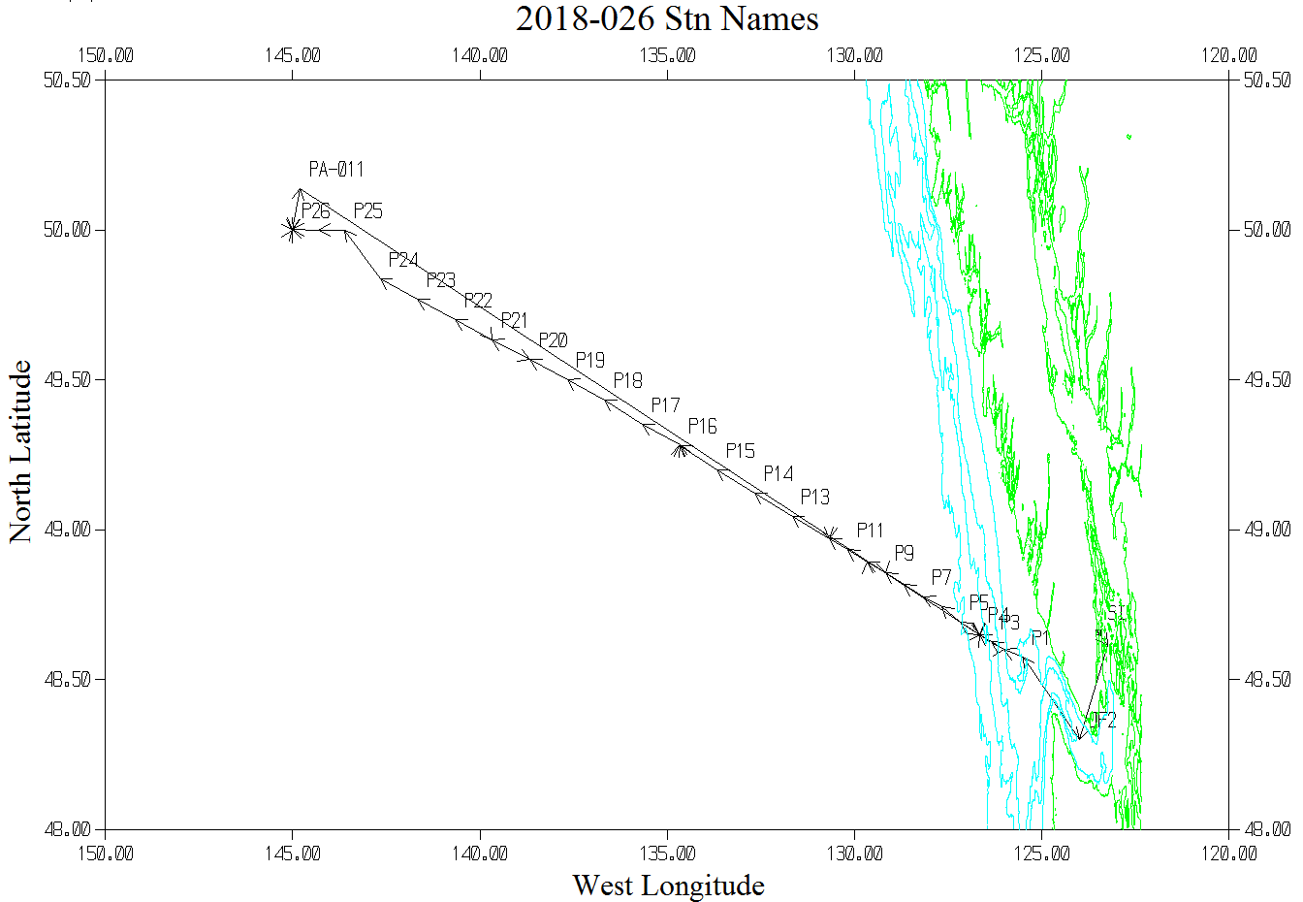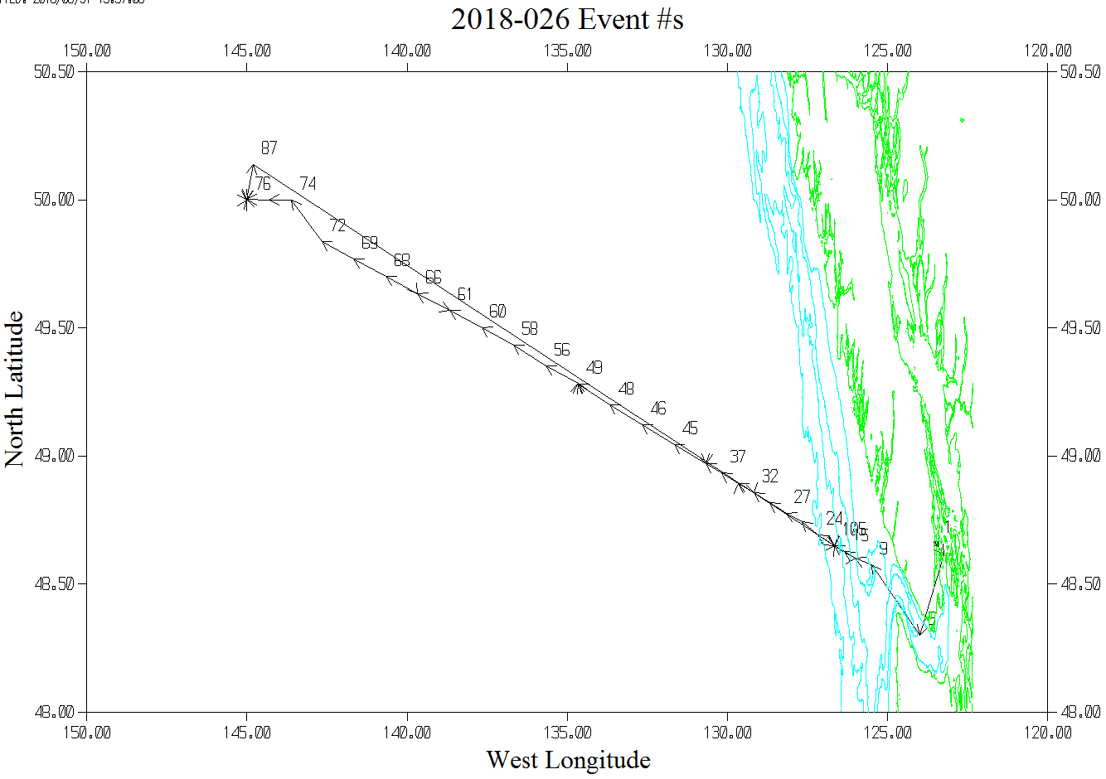

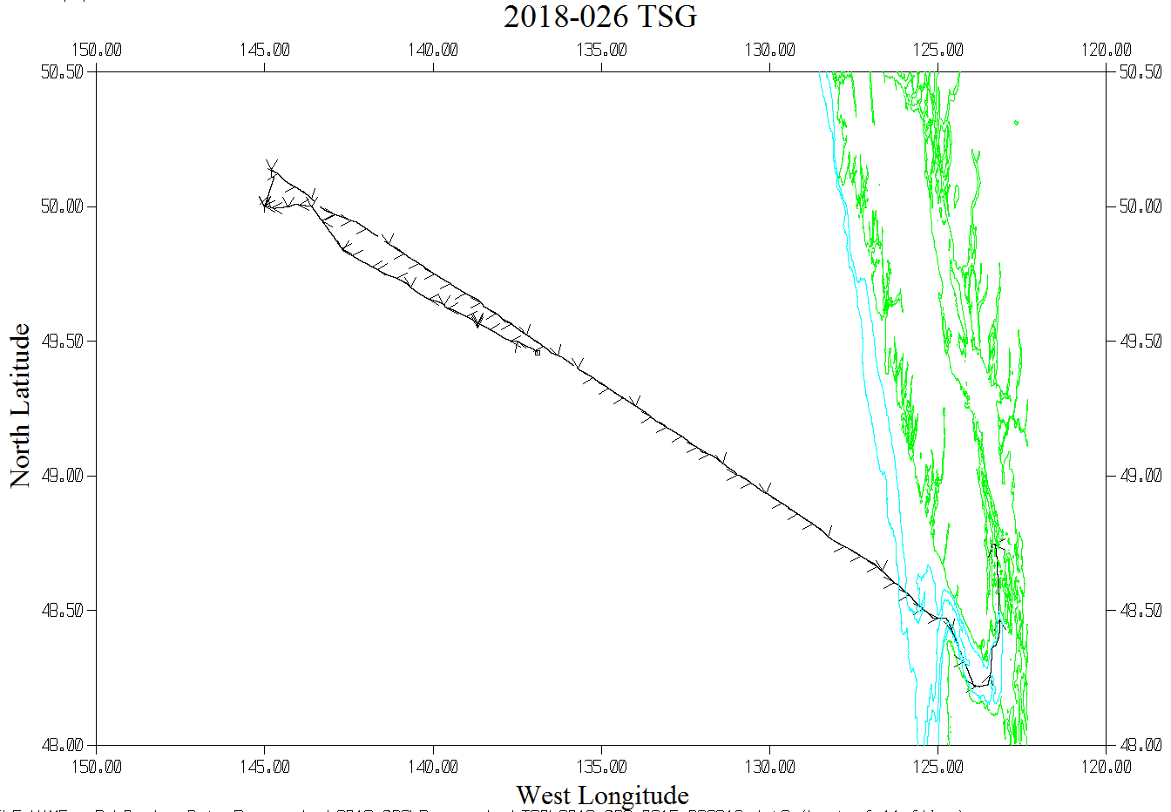

Symbols are plotted every 2 hours.

