REVISION NOTICE TABLE
DATE | DESCRIPTION OF REVISION

PROCESSING NOTES
Cruise: 2018-025
Agency: OSD
Location: B.C. Coast
Project: Moorings
Party Chief: Spear D.
Platform: John P. Tully
Date: 15 August 2018 –1 September 2018

Processed by: Germaine Gatien
Date of Processing: 4 December 2018 – 9 January 2019
Number of original HEX files: 158 (includes 1 test) Number of CTD files: 150
Number of rosette files: 99 (some split casts) Number of bottle casts processed: 94
Number of original TSG files: 9 Number of processed TSG files: 0

INSTRUMENT SUMMARY
CTD #0443 was mounted in a rosette and attached were a Wetlabs CSTAR transmissometer (#1185DR), a SBE 43 DO sensor (#997) on the primary pump, a SeaPoint Fluorometer (#3641) on the secondary pump, a Biospherical QSP-400 PAR sensor (#70613) and an altimeter (#62355).

CTD #0585 was mounted in a rosette and attached were a Wetlabs CSTAR transmissometer (#1185DR), a SBE 43 DO sensor (#1483) on the primary pump, a SeaPoint Fluorometer (#3641) on the secondary pump, a Biospherical QSP-400 PAR sensor (#70613) and an altimeter (#62355). This CTD was used for the 2 final casts only.

A new thermosalinograph (SBE45 S/N 0620) was mounted with a remote temperature sensor, a WETStar fluorometer (#3654) and a flow meter.

Seasave version 7.26.7.107was used for acquisition.
The data logging computer was the Tully Laptop.
The deck unit was a Seabird model 11+ #425.
The Oxygen Kit was Scripps Kit #2.
The salinometer used at IOS was a Guildline model 8400B Portasal, serial # 68572.
An IOS rosette with 24 10L bottles was used.

SUMMARY OF QUALITY AND CONCERNS
The Daily Science log book was in good order with many notes about problems encountered. Notes from Cindy Wright were very helpful.

There were 3 cases where 2 files were merged to create a full bottle file (events #102, 125 and 154.) There were notes in the log book about what happened. It was good to see that the pumps were on for the second file in each case; this is a step that is often forgotten.

There were many errors on the rosette log sheets. Some of these occurred because a sample number was skipped on the rosette log sheet but not in the sample labels. Electronic preparation of log sheets would have prevented the confusion that resulted. It is important to check that sample labels match the log sheet before starting the cast. Some errors occurred when extra samples were added or planned ones skipped; the corrections made on the log sheet were sometimes wrong. When the changes involve skipping some planned bottles, it is worth taking the time to prepare a new log sheet before the cast to ensure there is a good record of sampling.

The paper rosette logs have been annotated to indicate known errors or sample number adjustments, and a revised digital version was created. Flag 2 and comments have been added to samples in the CHE files with adjusted sample numbers.

Salinity sampling was not very useful for calibration purposes because there were so few deep samples. Typically, bottles were fired at the bottom, 50 m and near the surface. More bottles below 200m would have been helpful, particularly more bottles from the few deep casts so we can detect pressure dependence. If only one deep sample is taken, it is best to avoid taking it at the bottom; coming up at least 10m above the bottom is suggested.

For CTD #0443 the primary temperature and salinity were chosen for archiving except for 2 casts with bad primary data. The primary salinity was noisy, particularly near the surface. Adjusting the alignment of conductivity with temperature made only slight improvements with many unstable features in T-S plots. There were problems with the secondary conductivity sensor late in the cruise and the calibration appears to have been drifting significantly in that channel. The secondary signal was very noisy, especially late in the cruise, but that noise was 2-sided and may be less significant after bin-averaging. The secondary salinity was recalibrated to bring it into closer correspondence to the primary salinity.

For CTD #0585 the secondary temperature and salinity channels were selected.

There was no initial soak at 10m. While the dissolved oxygen comparison might suggest that downcast CTD values are too high in the top 10 to 20m, this could also be the result of poor flushing of Niskin bottles. Noisy salinity channels would also mask any problems in salinity due to incomplete equilibration. In many cases acquisition started before the pumps came on, so it can be seen that the downcast frequently started less than a minute after the pumps came on. There are often unstable features in the top 15m and it is possible these are the result of incomplete equilibration of pumped sensors. A soak of at least 2 minutes (with pumps running) is recommended if there is no 10m soak.

While the CTD fluorescence data are expressed in concentration units, they do not always compare well to extracted chlorophyll samples, particularly for casts far from shore. It is recommended that users check extracted chlorophyll values where available.

A second fluorometer was mounted half-way up the rosette during events #96 to #182. The sensor was unpumped and the data were not filtered. They are provided for information only and the channel name is Fluorescence:URU:Seapoint:2.

The SBE DO sensor has a fairly long response time so data accuracy is not as high when it is in motion as it is during stops for bottles. This will be especially true when vertical DO gradients are large. To get an estimate of the accuracy of the SBE DO data during downcasts (after recalibration) a rough comparison was made between downcast SBE DO and upcast titrated samples. Some of the difference will be due to problems with flushing of Niskin bottles and/or analysis errors, so the following statement likely underestimates SBE DO accuracy.

Downcast (CTD files) Oxygen:Dissolved:SBE data are considered, very roughly, to be:
±0.5 mL/L from 0 to 50db
±0.25mL/L from 50 to 100db
±0.15 mL/L from 100db to 400db
±0.05 mL/L below 400db (mostly low below 1500db)

A new TSG was being tested during this cruise. The data from the flow meter are bad, with very low or negative values. Comparisons with CTD data provide evidence that the flow in the loop had either stopped or was extremely low for 2½ days. Comparisons with CTD data give reasonable median differences at other times, but standard deviations are very large and traces look odd, both while stopped and when underway. The salinity traces have large steps up and down rather than the small-scale variability we usually see. This behaviour was not seen in the cruises before and after this one. The data will not be archived, but files are available upon request to the Ocean Sciences Division Data Manager.

PROCESSING SUMMARY

Seasave
This step was completed at sea; the raw data files have extension HEX.

Preliminary Steps
- The Log Book and rosette log sheets were obtained.
- Nutrients, ammonium, extracted chlorophyll, dissolved oxygen and salinity data were obtained in QF spreadsheet format from the analysts.
- The cruise summary sheet was completed.
- The history of the pressure sensor, conductivity and dissolved oxygen sensors was checked. There were 2 CTDs in use. The one used for most casts was CTD #443 and had been used on 5 previous cruises since it was last serviced. CTD #0585 was used for only 1 cast and this was the first use since it was last serviced.
- The calibration control files were checked. There are 3 versions of the file for CTD #0443 and 1 version for CTD #0585. The only error was in factor E in the dissolved oxygen sensor parameters for CTD #0443. The value entered was 0.0362 but 0.0363 was found best during a hysteresis tests during 2018-01. The 3 files were corrected. The 2nd CTD has not been used since its last service so the default value of factor E was used; this cruise does not have sufficiently deep sampling to allow for fine-tuning of factor E. The files were saved as:
- 2018-025-0443-ctd1.xmlcon – For casts 1-94
- 2018-025-0443-ctd2.xmlcon – For casts 96-182
- 2018-025-0443-ctd3.xmlcon – For casts 183-214
- 2018-025-0585-ctd.xmlcon – For cast 217

Many files had non-standard names (missing a 0 or having an extra 0) so the names were corrected in the RAW files.
The files with a “b” after the file name were not renamed at this point. They will be examined first.

There was a hex file named 2018-003 that was from station Scott1. This looks like it was the first try at running this cast when there was no NMEA available. It will be converted just to be sure all the data needed for that cast are in file 2018-0039.hex.

One file has station name LB08 but is not close to the site of that name as used for the La Perouse surveys. There was a change of plans that led to the new site. As it was intended to gather blank water for ammonium analysis, the station name was changed to “na”.

BOTTLE FILE PREPARATION
The ROS files were created using the configuration files as noted in the previous section. Depth was included.
The ROS files were converted to IOS format.
They were put through CLEAN to create BOT files.
Temperature and salinity were plotted for all BOT files to check for outliers. CTDEDIT was used to clean the both salinity channels lightly in casts #53, 59, 65, 67, 72 and #128.
The edited files were copied to *.BOT.
A preliminary header check was run and no problems were found.

At this point the split casts were joined. For casts #102 and #125 the “b” files were opened in Ultraedit to change the Bottle Number from 1 to the appropriate firing order for each file. The data from the “b” files were then copied and added to the main file and the bottle number in the header was adjusted. CLEAN was run to fix the header limits. The resulting file was then copied to BOT.

The BOT files were bin-averaged on bottle number and the output was used to create file ADDSAMP.csv. First, the file was sorted on event number and Bottle Position order. Then sample numbers were added based on the rosette logs.
This was a very complex process due to several incidents of repeated sample numbers or no sample number entered on the rosette log sheet but samples taken. Several problems were especially tricky:
- Events #47, 53 and 56 had repeated sample numbers, with 1 number used 3 times. The analysts renumbered affected samples of event #53 by adding a leading 9 and event #56 with a leading 8.
- Events #102 and 103 both had a sample #336 but no sampling was done for the event #102 bottle so no sample number was entered for that case.
- Event #116 had log notes indicating that bottles 2, 3 and 4 were not fired, but the bottles that didn’t fire were 4, 5, 6. However, bottles 2 and 3 were fired at 50db and 30db which differs from the original plan. The nutrient samples for bottles 2 and 3 were labelled as 471 and 472 while the rosette sheet shows them as 474 and 475. Since there was only nutrient sampling, the nutrient analyst’s sample numbers were used.
- Event #182 – sample 809 was skipped on the rosette sheet but not on the labels. One analyst noted this and adjusted the numbers to match the rosette log but the others didn’t. Going with the sample labels was deemed safest given the number of sample types. Flags will be added to the CHE file.
- Events #186 and 188 had only a single sample each with the sample #s being ones also used for other casts. They were each renamed with a leading 9.

The ADDSAMP file was then sorted on event number & then sample number.
It was used to add sample numbers to the BOT files – output *.SAM.
The SAM files were bin-averaged on bottle # and called SAMAVG.

The addsamp.csv file was converted to CST files, which will form the framework for the bottle files.

Next, each of the analysis spreadsheets were examined to see what comments the analysts wanted included in the header file. These were used to create file 2018-025-bot-hdr.txt which will be updated as needed during processing.

EXTRACTED CHLOROPHYLL
Extracted chlorophyll and phaeo-pigment data were obtained in file QF2018-25chl*.xlsx. The file included comments and flags and a precision study. A simplified version of the spreadsheet was prepared and saved as 2018-025chl.csv. The csv file was then converted to individual CHL files.
DISSOLVED OXGYEN
Dissolved oxygen data were provided in spreadsheet QF2018-25oxy.xlsx which includes flags, comments and a precision study. Draw temperatures are available. The spreadsheet page with the final data was simplified and saved as 2018-025oxy.csv. That file was converted into individual *.OXY files.
SALINITY
Salinity analysis was obtained in file 2018-25SAL.xlsx which included a precision study. The analyses were carried out in a temperature-controlled lab 10 to 30 days after collection. The files were simplified and saved as 2018-025sal.csv. That file was then converted to individual SAL files.
NUTRIENTS
The nutrient data were obtained in spreadsheet QF2018-25_nutrients*.xlsx. This includes a precision study. The file was simplified and the saved as 2018-025nuts.csv. The file was converted to individual NUT files.
AMMONIUM
NH4 data were obtained in spreadsheet 2018-25 QF NH4*.xlsx. This includes a precision study. The file was simplified and saved as 2018-025NH4.csv. This file was converted to NH4 files.

The SAL, CHL, OXY, NUT and NH4 files were merged with CST files in 5 steps.
After the 5th step the files were put through CLEAN to reduce the headers to File and Comment sections only.

The merged files are ordered on sample number, but the SAMAVG files are ordered on bottle number, so one or the other set needs to be reordered in order to merge them. The MRGCLN1 files were reordered on Bottle_Number. The output files were named MRGCLN1s. Those files were then merged with SAMAVG files choosing the Bottle_Number from the SAMAVG files.

The output of the MRG files were exported to a spreadsheet and compared to the rosette log sheets to look for omissions. Problems were found in events:
- 1 – There was no sampling from Niskin bottles 2 to 23 so those lines were removed from the SAMAVG file and the final merge was repeated.
- 2 – Blank water collected for ammonium analysis only – no need for a CHE bottle, so won’t be processed further.
- 53 – There was an error in the addsamp file so that was fixed. Also found a DO sample not indicated on the rosette sheet, but it is clear in the DO analysis log sheet and no other sample is missing.
- 56 – The renaming of duplicate/triplicate sample #s was inconsistent among different analyses. These were changed so all affected samples have a leading 8 to avoid confusion. There was a value missing from the dissolved oxygen file. This was lost en route to the final spreadsheet. The value was found & the analyst informed.
- 102 – Sample #335 has replicate CHL samples but this is not shown on the rosette sheet. On the CHL spreadsheet is shown as #336 and that fits better as this was one of the split casts. This arose due to an error in the ADDSAMP file. The sample is not shown on the rosette log but might have been forgotten in the process – the Daily Science log indicates that there was a return to 7m specifically to get a CHL sample.
- 136 – NH4 is shown on the rosette sheet for samples 607, 609, 611 – the labels confirm that what is shown as 602 on the analysis spreadsheet should be 607.
- 144 – The rosette sheet shows 5 DO samples while analysts report only 5 nutrients – presume wrong column entered. No change to spreadsheets.
- 182 – Sample 810 nutrients missing – This cast had errors in the sample numbers with one number skipped. The ADDSAMP file needed adjustment to match sample labels.
- 212 – Samples 926 – changed comment to Bottle not fired instead of samples missing.
For most of these corrections there were a number of files that need amendment and then the merge process had to be repeated.
Next DO samples were found that were flagged due to leaks. The comment was marked ALL and other samples from the same bottles were flagged as well. The merge process was repeated.

Compare
Salinity
Compare was run with pressure as reference channel.

The data from the 2 CTDs were examined separately.
The comparisons are extremely noisy. This is likely because most casts were shallow and many of the shallow samples were bottom bottles. Any errors due to poor flushing would be of opposite signs for bottom bottles and non-bottom bottles. At depth there is less noise but all the bottles below 400m are bottom bottles. Separate plots were made of bottom and non-bottom bottles with standard deviations of <0.001psu for CTD salinity. These show clearly that the bottom bottles lead to CTD salinity looking high while non-bottom bottles suggest it is low. This confirms that most of the noise in the plots is due to incomplete flushing.

For CTD #0443 the primary salinity was found to be low by an average of 0.0002psu with a standard deviation of 0.0022 when only data below 400m were included. When 1 outlier with a fairly high standard deviation in the CTD salinity was excluded the primary was low by an average of 0.0010 with a standard deviation of 0.0009psu. The secondary salinity was found to be low by 0.0086 with a standard deviation of 0.0024. There were 3 outliers with high standard deviation in the CTD salinity (2 from the end of the cruise when the secondary conductivity was very noisy); when they were excluded it was low by 0.010psu with a standard deviation of 0.010. Excluding the outliers made little difference to the result.

For CTD #0585 there were no samples below 350m. Below 200m it is clear that flushing of bottles is poor since the differences decrease as pressure increases and vertical gradients likely decrease. The differences seem to settle down at about 200m so the 3 bottles below 200m were examined.
The bottles at 250m and 300m have primary salinity low by 0.0014psu and 0.0017psu while the bottom bottle shows it to be high by 0.0039psu. Given that flushing is still likely significant, a reasonable guess is that the CTD salinity is reading a little high, but likely within 0.002psu. Similarly, for the secondary salinity 2 bottles above the bottom show it to be low by 0.0001psu and high by 0.0005psu while the bottom bottle shows it to be high by 0.0019psu. So the secondary is likely high but within 0.002psu.

For full details for the COMPARE run see file 2018-025-sal-comp1.xls.

Dissolved Oxygen
COMPARE was run with pressure as the reference channel.
The first run failed because all bottles for cast #183 had been padded. The comparison was rerun with that cast removed from the list.

There were 2 different sensors in use.
- DO sensor 997 on CTD 0443
When outliers are removed based on residuals the following fit is found:
CTD DO Corrected = CTD DO * 1.0121 + 0.0282 R² = 0.314
During 2018-026 using the same equipment 2 months earlier the fit was
CTD DO Corrected = CTD DO * 1.0276 + 0.0477 R² = 0.895
Many outliers in the fit are from the top 100m where gradients are high so that poor flushing would lead to an underestimate of the differences because water in the bottles would come from deeper waters with lower DO. The fit is much noisier than usual. Usually, most outliers are found at the high end of the range, DO>4mL/L, because vertical DO gradients are lower when DO is low. But for this cruise there are low DO values in many of the inlets, associated with high vertical gradients.

- DO sensor 1483
There was only 1 cast available using this sensor with 11 bottles. There was one clear outlier. None of the bottles were flagged by the analyst. The fit excluding the 1 outlier was:
CTD DO Corrected = CTD DO * 1.0392 + 0.0588 R² = 0.625
This sensor was used during cruise 2018-045 which followed this cruise and the fit used for correction was:
CTD DO Corrected = CTD DO * 1.0602 + 0.0529 R² = 0.949
The same explanation as for the other sensor likely explains the difference from the earlier cruise.

There are no outliers that are obviously due to problems with bottles, so no changes to flags were recommended.
For full details see report 2018-025-dox-comp1.xls.

Plots of Titrated DO and CTD DO against CTD salinity were examined. No further outliers were found.

Fluorescence
COMPARE was run with extracted chlorophyll and CTD Fluorescence using pressure as the reference variable. The plot of ratio FL/CHL versus Extracted CHL has the general shape typically seen from this type of sensor with the ratio dropping as CHL rises.

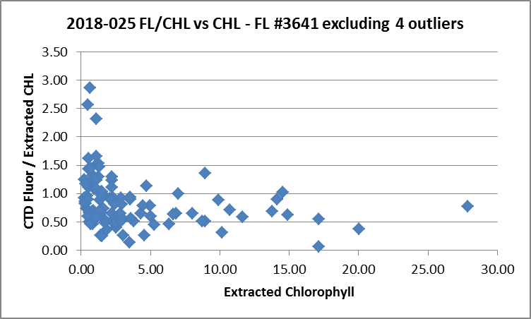
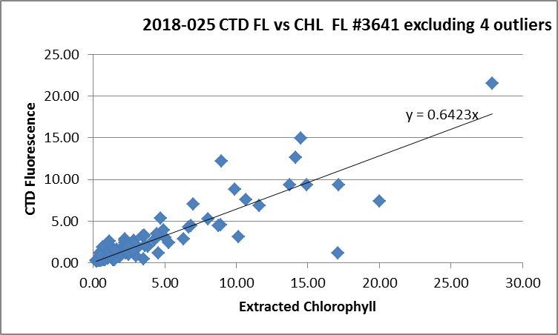
The fit of fluorescence against chlorophyll has a slope of 0.64.

Fluorometer #3642 was not used for as many casts. It has a smaller range of values and plots fell within the range of the plots for #3641.
For full details of the comparison see file 2018-025-fl-chl-comp1.xlsx.

Conversion of Full Files from Raw Data
All files were converted using 2018-025-ctd.
The Tau and hysteresis functions were selected. Depth was included in the conversion.
A few casts were examined and all expected channels are present.
- There was a lot of noise in the temperature and conductivity.
- The Dissolved Oxygen, transmissivity, fluorescence, and PAR profiles look normal.
- The altimetry looks reasonable near the bottom though there are frequent spikes so values will need to be checked.
File 2018-025-003.cnv will not be processed further as it was from an initial attempt at the event 39 file.
It does not contain any useful data.

WILDEDIT
Program WILDEDIT was run to remove spikes from the pressure, conductivity & temperature only in the
full cast files (*.CNV).
Parameters used were: Pass 1 Std Dev = 2 Pass 2 Std Dev = 5 Points per block = 50
The parameter “Keep data within this distance of the mean” was set to 0 so all spikes would be removed.

ALIGN DO
In recent cruises using both the DO sensors dissolved oxygen was aligned using a setting of +2.5s.
ALIGNCTD was run on all casts using +2.5s.
The results were examined after the DERIVE step and was found to have worked well.

CELLTM
The noise in the upcast data makes tests for the best parameters for this routine very difficult to interpret. In the past when upcast data were not so noisy, the default setting of (α = 0.0245, β=9.5) was generally found to be the best choice. A few casts were checked for this cruise and the default setting does improve the data. CELLTM was run using (α = 0.0245, β=9.5) for both the primary and secondary conductivity.

DERIVE and Channel Comparisons
Program DERIVE was run on all casts to calculate primary and secondary salinity and dissolved oxygen concentration.

There were few deep casts for this cruise. DERIVE was run a second time on 4 of the deeper casts for CTD #0443 and one cast from CTD #0585 though it is quite shallow..
Cast # | Press | T1-T0 | C1-C0 | S1-S0 | Descent Rate
2018-01-0043 | 1000 | -0.0006 | -0.0002 | -0.0021 | High, Noisy
2018-01-0062 | 1000 | -0.0006 | -0.0002 | -0.0021 | High, XNoisy
 | 1900 | -0.0007 | -0.0001 | -0.0010 | “
 | 2900 | -0.0013 | -0.0001 | -0.0000 | “
 | 3900 | -0.0019 | -0.0001 | +0.0011 | “
2018-01-0072 | 1000 | -0.0005 | -0.0002 | -0.0023 | High, XNoisy
 | 1900 | -0.0008 | -0.0001 | -0.0012 | “
 | 2900 | -0.0015 | -0.0001 | +0.0000 | “
 | 3900 | -0.0020 | +0.0000 | +0.0010 | “
2018-029-0007 | 300 | +0.0001 | -0.0005 | -0.005 | FHigh, FSteady
2018-029-0059 | 300 | ~0 | -0.0004 | -0.004 | High, V.Steady
2018-029-0093 | 300 | +0.0001 | -0.0004 | -0.0045 | High, V.Steady
2018-029-0105 | 300 | +0.0001 | -0.0004 | -0.004 | High, V.Steady
2018-039-0044 | 1000 | -0.0009 | -0.0005 | -0.0047 | High, XNoisy
“ | 1900 | -0.0008 | -0.0003 | -0.0036 | High, XNoisy
2018-039-0088 | 1000 | -0.0003 | -0.0004 | -0.0043 | High, VNoisy
“ | 1900 | -0.0006 | -0.0003 | -0.0030 | High, VNoisy
2018-039-0110 | 1000 | -0.0002 | -0.0006 | -0.0065 | High, VNoisy
“ | 1900 | -0.0003 | -0.0004 | -0.0040 | High, VNoisy
2018-026-0043 | 1000 | -0.0004 | -0.0004 | -0.004 | High, VNoisy
 | 1900 | -0.0005 | -0.0003 | -0.003 | High, VNoisy
 | 2900 | -0.0005 | -0.00025 | -0.0025 | High, VNoisy
2018-026-0072 | 1000 | -0.0004 | -0.0003 | -0.004 | High, VNoisy
 | 1900 | -0.0004 | -0.0003 | -0.003 | High, VNoisy
 | 2900 | -0.0007 | -0.00025 | -0.002 | High, VNoisy
 | 3900 | -0.0006 | -0.0002 | -0.002 | High, VNoisy
2018-025-0045 | 775 | -0.0004 | -0.0007 | -0.0076 | High, Steady
2018-025-0047 | 1000 | -0.0003 | -0.0006 | -0.0074 VN | High, X Noisy
 | 1900 | -0.0004 | -0.0006 | -0.0064 VN | “
2018-025-0206 | 700 | -0.0006 XN | -0.0010 | -0.0114 | High, V Noisy
2018-025-0208 | 1000 | -0.0003 XN | -0.0010 VN | -0.011 XN | High, V Noisy
 | 1900 | -0.0002 | -0.0009 VN | -0.011 XN | High, X Noisy
2018-025-0217 | 300 | +0.0001 | -0.0002 | -0.0014 | High, F Steady

The temperature differences are small. Conductivity differences are a little high and rise during the cruise. Salinity differences are much higher than during the previous use in June and rose markedly between events #47 and #206. Unfortunately, there were no deep casts between those events. The COMPARE results give a hint that trouble may have started around cast #190 and since cast 206 had very noisy secondary salinity that may be an indicator. The secondary salinity is slightly noisier than the primary through the early part of the cruise, but not noisy enough to be noteworthy. Cast #190 is noisier and casts after that seem noisier though not at all times. The noise continues during the bottle stops. There are too few bottles to determine if there is any pressure dependence with the only level frequently sampled being 50db and an examination of those bottles shows far too much variability to identify a significant trend.

A different CTD was used for cast 217 and the results are much better, though being a shallow cast the results are not as reliable.

In the course of doing the difference study a few problems were noted:
- 2018-025-0045 - Serious problem was found in the conductivity at the bottom. At about 810db during the downcast, the primary conductivity trace looks bad and does not recover until the CTD is at about 805db of the upcast.
- 2018-025-0208 - Sal2 very noisy.

Conversion to IOS Header Format
The IOSSHELL routine was used to convert SEA-Bird 911+ CNV files to IOS Headers.
The first 9451 scans were removed from cast #148. They were from an initial drop that had the pumps turned off. The CTD was returned to the surface and the full cast rerun without starting a new file.
Event #33 contains only surface data and is listed as a Mooring event in the log; it will not be processed further.
Events #155 and 186 were run just to collect surface samples to accompany the casts that preceded them, and contain no data suitable for the downcast file, so they will not be processed further.

CLEAN was run to add event numbers and to replace pad values in the pressure channel with interpolated values based on record number.

A few casts were examined in more detail to see if there were any problems caused by the surface soak being short and the 10m soak being skipped;
- A number of casts had soaks as short as 5 to 10s, so that the 2 salinity channels had not settled to similar values.
- During event #110 archiving didn’t start until the CTD was at about 8m. The CTD was stopped at about 18m and brought back to the surface. After a 1-minute wait the full cast was run. The DO values (before recalibration) at ~8m were 5.51mL/L on the initial downcast and ~5.23mL/L on the full cast. During the 4s stop at 18.6m DO values rose from 4.76 to 4.92mL/L. These changes suggest that DO values were rising at depth due to bubbles being released. Salinity also falls during that time. This is not certain as local variability may be present, but it is what is expected from these sensors.
- A few other casts were examined to see if there is evidence of high DO values near the surface, but frequent sub-surface DO maxima are seen in many of the areas sampled, so it is not possible to distinguish real from instrumental sources of local DO maxima. Unfortunately, the DO bottle comparison is not much help since incomplete flushing of bottles can lead to the impression that the CTD DO is reading higher than it really is. DO values near the surface may be slightly high especially for casts with a short surface soak.
There is no reliable evidence of a problem with DO due to the lack of a 10m soak during this cruise. A study during cruise 2018-026 does suggest that DO values do rise markedly during a 10m soak then gradually drop.

Checking Headers
The header check was run and no problems were found. There were no negative fluorescence values.

A cross-reference list was checked against the log book. A few errors were found in station names and station name formats. Those were fixed in the IOS and CLN files. No bottle files were affected.
The cruise track was plotted and added to the end of this report.

The altimeter and water depth readings from the headers of the CLN and MRG files were exported to spreadsheets. A “Check Value” was calculated (altimetry header value + maximum depth sampled – water depth in header). Where that number exceeded ±4m the readings were checked. Based on those checks the following changes were made to the CLN files and produced better Check Values:
- The altimeter setting was changed for 2 casts based on plots at the bottom.
- Bottom depths were changed to those entered in the log for 22 casts.
- The bottom depth for 1 cast was changed to that for another event at the same site.
The same changes were made to the SAM files plus altimetry was removed from a few casts that had no near-bottom sampling. (The SAM files were averaged again and merged with the MRGCLN1s files after those changes.)

A surface check was run and shows an average surface pressure for the cruise was 1.7db which is low for the Tully but not for this particular project.

A few deck pressure measurements were available. During event #49 data were acquired for almost 4 minutes before the CTD entered the ocean. During that time pressure dropped from +0.38 to +0.05db. This shows that these pressure sensors do need a little time to equilibrate so that deck pressures taken immediately after turning the system on may not be reliable. Similarly for event #32 the pressure dropped from +0.12db to +0.02db before entering the water. For event #137 the range reported was +0.11db to 0.06db. There were other data recorded at the end of casts that were obviously collected very close to the surface with pressure ~-0.1db. The best evidence available is from event #139 when there is clear evidence from transmissivity about when the CTD entered the water; the pressure reading was +0.04db though it may not have finished equilibrating, so that may be a little high. These observations are all within the specifications for the pressure sensor. No recalibration is needed.

At this point a copy was made of cast #144 for the use of Dr. Johannessen. The data below 10m were removed and it was put through CLEAN 4 times to remove pumped channels for all records with Status:Pump = 0. (Temperature:Primary, Conductivity:Primary, Fluorescence and Oxygen:Dissolved:SBE) Note that there is a second fluorescence channel that was not pumped and salinity will be recalculated in the SHIFT step. The file was named 2018-025-9144 to distinguish it from the other files. It was put through all steps to DELETE and CALIBRATE, then the data were exported to a spreadsheet, 2018-025-9144-surface.csv.

Shift
Fluorescence
SHIFT was run on the SeaPoint fluorescence channel in all casts using the usual advance of +24 records. Plots show that the fluorescence offset is reasonably close to the temperature offset after this step.
Dissolved Oxygen
The Dissolved Oxygen voltage channel was aligned earlier. A few casts were checked to see if the alignment looked ok, and it did. No further alignment is needed for the DO concentration channel,
Conductivity
Tests were run on a few deeper casts to determine the best setting to align conductivity and temperature by judging the effect on salinity as seen in T-S space. The settings used for cruise 2018-026 when the same sensors were found to be appropriate.
SHIFT was run twice on all SBE911 casts using -0.2 records for the primary conductivity and -0.5 records the secondary. Salinity was recalculated for both channels.
Cast #110 had to be edited before running DELETE to remove data from an initial drop before the full cast.

DELETE
The following DELETE parameters were used:
Surface Record Removal: Last Press Min
Maximum Surface Pressure (relative): 10.00
Surface Pressure Tolerance: 1.0 Pressure filtered over 15 points
Swells deleted. Warning message if pressure difference of 2.00
Drop rates < 0.30m/s (calculated over 11 points) will be deleted.
Drop rate applies in the range: 10db to 10db less than the maximum pressure
Sample interval = 0.042 seconds. (taken from header)

COMMENTS ON WARNINGS: There were no warnings.
The special file, 9114, was put through DELETE; as it is <10m in range no records were removed due to low descent rate which is appropriate for this study.

Other Comparisons
Previous experience with these sensors –
CTD #0443: The secondary temperature sensor, pressure sensor and both conductivity sensors were used during 2018-01, 2018-029, 2018-039 and 2018-026. The primary temperature sensor was thought to have some pressure dependence likely to affect deep performance, so that sensor was replaced before 2018-026. The bottle comparisons from 2018-029 and 2018-039 were not trusted due to flushing problems for the former and problems with Niskin bottles for the latter. During 2018-001 the primary salinity was found to be high by ~0.0017 but that was with a different temperature sensor. The secondary salinity was found to be low by low by ~0.0007. The dissolved oxygen was recalibrated using slope 1.0283 and offset 0.0491. During 2018-026 the primary salinity was found to be low by 0.0012psu and the secondary low by 0.0039psu. Dissolved oxygen was recalibrated using slope 1.0276 and offset 0.0477.
CTD #0585: This CTD had not been used before but cruise 2018-034 that followed has been processed and the primary salinity was found to be high by 0.0009 and the secondary by 0.0025psu. The dissolved oxygen sensor was recalibrated using slope1.0602 and offset 0.0529.

Historic ranges – Profile plots were made with 3-standard deviation climatology ranges of T and S superimposed. There were excursions from the climatology in areas close to shore that are not likely to be represented in the climatology. There were no excursions in salinity that look like they are due to calibration problems. Temperature values were higher than the range maxima around 50db for many casts in Queen Charlotte Sound just south of Haida Gwaii and in the southern part of Hecate Strait. This looks like a case of deeper mixed layers. This does not look like a problem with calibration.

Repeat Casts – There were no repeat casts.

Post-Cruise Calibration – There were no post-cruise calibrations available.

DETAILED EDITING
The choice of which T-S pair to choose for editing and eventual archiving is not obvious.

For CTD #0443 the secondary sensors were chosen during 2018-026 because there were fewer unstable features in T-S plots and that is true for these data as well. However, the secondary conductivity looked bad late in the cruise and the calibration appears to have drifted since the previous use. The noise in the secondary conductivity is intermittent and one section was found during event 3 with secondary salinity suddenly shifting for a while and then coming back closer to the primary. This problem is too serious to outweigh the noise in T-S space for the primary. There was at least one case of bad primary conductivity near the bottom of one cast. The difference between sensors was larger late in the cruise and may be related to the noisy secondary conductivity becoming more persistent. With few deep casts to help establish if there was calibration drift, the primary sensors will be selected with a few exceptions:
- Event #46 – The primary T-S plots shows large unstable sections not seen in the secondary pair.
- Event #56 – The near-surface data was very noisy down to about 30m. Primary salinity was very bad. The secondary is also noisy but not nearly as bad. The dissolved oxygen values are extremely high in the top 15db. The CTD came out of the water briefly and the soak after that was short.

For CTD #0585 the secondary sensors were chosen during 2018-034 because there were fewer unstable features in T-S plots and that is true for these data as well.

All DEL files were copied to *.EDT.

CTDEDIT was used to remove records that appear to be corrupted by shed wakes or ship effects. Salinity was cleaned to remove spikes that appear to be due to small misalignment or instrumental noise. All files required some editing.

In many cases acquisition started before the pumps came on, so it can be seen that the downcast frequently started less than a minute after the pumps came on. There are often unstable features in the top 15m and it is possible these are the result of incomplete equilibration of pumped sensors. A soak of at least 2 minutes is recommended if there is no 10m soak. It was frequently impossible to establish whether unstable features in the top 10m were due to real conditions or noisy CTD data.

The edited files were copied to *.EDT.

After editing T-S plots were examined for all casts. There are a few near-surface unstable features but these may well be real as they are in areas of active mixing. No further editing was applied.

Recalibration
Incomplete flushing of Niskin bottles renders the comparison with bottle samples unreliable for calibration purposes. The results of cruise 2018-026 look appropriate for the primary sensors on CTD #0443. Since the primary data were very poor for a few casts, an estimate has to be made on how to recalibrate the secondary sensors. During event #47 the secondary was lower than the primary by about 0.0092psu during the bottle stop and lower by 0.0067psu during the downcast. Salinity will be recalibrated by adding 0.0080psu more than the correction for the primary salinity. For CTD #0585 the results of cruise 2018-034 are suitable.

File 2018-025-SBE911-recal.ccf was prepared to apply the following:
- For casts 1 – 214
To add 0.0012psu to channel Salinity:T0:C0, 0.0092psu to channel Salinity:T1:C1 and to apply the following corrections to channel Oxygen:Dissolved:
CTD DO Corrected = CTD DO * 1.0276 + 0.0477
- For casts 217-219
To subtract 0.0025psu from the secondary salinity and to apply the following corrections to channel Oxygen:Dissolved:
CTD DO Corrected = CTD DO * 1.0602 + 0.0529

This correction was first applied to the SAM and MRGCLN2 files.

COMPARE was rerun for salinity using the same points as in the fit used for the original COMPARE run to ensure that corrections were appropriate and they were.
See file 2018-025-sal-comp2.xls for details.

COMPARE was rerun for dissolved oxygen. For DO sensor #0997, when roughly the same data were included as in the original fit, the average of differences in the DO fit was +0.075mL/L and the standard deviation was 0.044mL/L. This is higher than usual and may be due to incomplete flushing of bottles which is generally a more serious problem in quiet areas such as inlets where the CTD does not move much during stops and local vertical gradients tend to be high. Another factor may be the lack of a 10m soak, leading to higher DO values near the surface. However, excluding the top 15m does not improve the results much, perhaps because almost half of the near-surface data had already been excluded as outliers in the original fit.

The results for DO sensor #1483 were similar with the CTD DO high by an average of 0.064mL/L when the same outlier was excluded as in the original fit.
See file 2018-025-DO-comp2.xls for details.

CALIBRATE was then run on the EDT files using the same recalibration file.

Final Calibration of DO
The initial recalibration of dissolved oxygen corrects for sensor calibration drift. Alignctd corrects for transit time errors. Those 2 steps may partly correct for response time errors, but to see if a further correction is needed, a comparison is made of downcast CTD data to bottle data from the same pressure. Small differences are expected due to ship drift, temporal changes, incomplete flushing of Niskin bottles and delayed response and noise in CTD data.

Downcast files were bin-averaged to 0.5m bins for the casts with DO bottle samples. Those files were then thinned and compared to the bottle values in the MRG files. COMPARE was run to study the differences between the downcast CTD DO data and the titrated samples from upcast bottles.

For CTD #0997When outliers were removed based on residuals the CTD DO was higher than the titrated samples by an average of ~0.13mL/L (standard deviation of 0.06mL/L). The differences are much higher than usual, which is most likely due to incomplete flushing of Niskin bottles with the issue being more severe in inlets. Below 500db the differences were <+0.05mL/L. When only deep casts were included the differences were somewhat lower but still relatively high if data from the top 400m were included.
The only cast using CTD #1483 was shallow and showed similar results.
No further recalibration is justified.
See 2018-025-dox-comp3.xlsx for details.

Fluorescence Processing
There were 2 fluorometers mounted on the CTD for casts #96-182, one pumped and in the usual position and another mounted above that with no pump. The main purpose of the pump is to avoid the effects of unsteady descent rates masking real variations. For most of these casts the descent rate is quite steady. It is noted that the pumped sensor “sees” peaks before the other does and there are often higher values in the pumped peaks. The delay is presumed to be because of the difference in position, while the lower peaks are likely due to the effects of the rosette package creating a wake that mixes the ambient waters a little. The pumped channel was aligned with temperature to minimize the delay due to pumping.

The CTD data from file 9144 were extracted to a spreadsheet and prepared for the use of Dr. Johannessen. Only file 144 was processed for the archive.

A median filter, size 11, was applied to the fluorescence channel in the COR1 files. Plots of a few casts showed that the filter was effective. (Output:*.FIL)

BIN AVERAGE of CTD files
The following Bin Average values were applied to the FIL files (output AVG):
Bin channel = pressure Averaging interval = 1.000 Minimum bin value = .000
Average value will be used. Interpolated values are NOT used for empty bins.
On-screen T-S plots were examined.
Profile plots were examined to see if there any problems. No problems were noted.

Final CTD File Steps (REMOVE and HEADEDIT)
For most casts REMOVE was run to remove the following channels:
Scan_Number, Temperature:Secondary, Conductivity:Secondary, Oxygen:Voltage:SBE, Descent_Rate, Status:Pump, Altimeter, Salinity:T1:C1 and Flag.
For casts 46, 56, 217, 219 REMOVE was run to remove the following channels:
Scan_Number, Temperature:Primary, Conductivity:Primary, Oxygen:Voltage:SBE, Descent_Rate, Status:Pump, Altimeter, Salinity:T0:C0 and Flag.

A second SBE DO channel (with umol/kg units) was added.
REORDER was run to get the two DO channels together.

HEADER EDIT was used to fix formats and channel names and to add the following comments:

Data Processing Notes:
----------------------
Conductivity, Transmissivity, Fluorescence and PAR data are nominal and unedited
except that some records were removed in editing temperature and salinity.

NOTE: While the CTD fluorescence data are expressed in concentration units, they
do not always compare well to extracted chlorophyll samples, particularly for
casts far from shore. It is recommended that users check extracted chlorophyll
values where available.

Dissolved oxygen was calibrated using the method described in SeaBird Application
Note #64-2, June 2012 revision, except that a small offset in the fit was allowed.

The SBE DO sensor has a fairly long response time so data accuracy is not as high
when it is in motion as it is during stops for bottles. This will be especially
true when vertical DO gradients are large. To get an estimate of the accuracy of
the SBE DO data during downcasts (after recalibration) a rough comparison was made
between downcast SBE DO and upcast titrated samples. Some of the difference will
be due to problems with flushing of Niskin bottles and/or analysis errors, so the
following statement likely underestimates SBE DO accuracy.

Downcast (CTD files) Oxygen:Dissolved:SBE data are considered, very roughly, to be:
±0.5 mL/L from 0 to 50db
±0.25mL/L from 50 to 100db
±0.15 mL/L from 100db to 400db
±0.05 mL/L below 400db (mostly low below 1500db)

For details on the processing see document: 2018-025_Processing_Report.doc.

The Standards Check routine was run and no problems were found.
The Header Check was run; no problems were found.
Profile and T-S plots were examined.
The transmissivity is very low in the top 30m of cast #146. The upcast has higher values but that could be due to the ship drifting to an area with higher transmissivity and/or the rosette entraining deeper water. Given the location at the head of Alice Arm, the low values could well be correct, so no editing is justified. No other problems were found.
The sensor history was updated.

Dissolved Oxygen Study
As a final check of dissolved oxygen data, % saturation was calculated and plotted. Inshore values are highly variable, ranging from 55% to 155%. Such variability is not unusual when sampling includes areas with both very low and very high vertical gradients. The higher saturation values may be partly due to the lack of a 10m soak so that the release of bubbles leads to high DO values. A more reliable check of DO performance is found in offshore areas where near-surface gradients are generally low and tidal mixing is not a factor; in such areas the surface saturation is usually about 100% - 103%. There were few offshore casts during this cruise. For the 5 deepest casts the saturation values ranged from ~103% to 106%. Those values are slightly higher than usually observed offshore. Near-surface data are subject to larger errors due to equilibration of equipment, ship effects and vertical and horizontal variability. For these data there is also the possibility of inadequate soaking of the DO sensor. This study is not useful in determining whether the calibration of the DO sensor is reliable.

Final Bottle Files
The MRG files were put through CLEAN to update header limits and to add flag “0” where those channels are empty.
The records for bottles 2 to 23 were removed from cast #1.
The MRGCOR1 files were put through SORT to order on increasing pressure.

For most casts REMOVE was run to remove the following channels:
Scan_Number, Temperature: Secondary, Conductivity: Secondary, Oxygen:Voltage:SBE, Descent_Rate, Status:Pump, Altimeter, Salinity:T1:C1 and Flag.
For casts 46, 56, 217, 219 REMOVE was run to remove the following channels:
Scan_Number, Temperature:Primary, Conductivity:Primary, Oxygen:Voltage:SBE, Descent_Rate, Status:Pump, Altimeter, Salinity:T0:C0 and Flag.

A second SBE DO channel with mass units was added for both the CTD DO and titrated DO and REORDER was run to get the pairs of DO channels together.

HEADER EDIT was run to ensure formats and units are correct, correct the vessel name, change the channel name Bottle_Number to Bottle:Firing_Sequence and the name Bottle:Position to Bottle_Number and to add a comment about quality flags and analysis methods and a few notes about the CTD data processing.

Data were exported from the CHE files to file 2018-025-bottles-final.xlsx. The entries were compared with the rosette log sheets and no problems were found. Checks were made that where were flags applied to dissolved oxygen values because of an issue that would affect all samples, flags were also applied to the other channels. No problems were found.

Standards check and a header check were run. No problems were found.
The track plot looks ok.
Plots of each file were examined and no problems were found.
A cross-reference listing and header check were produced for the CHE files.

Thermosalinograph Data
A new thermosalinograph was in use for this cruise. It has been used during one cruise prior to this one and one after.
There were 9 files produced, one of which covers about 8 days and the others 1 day each.
The file names include the start date and time. This is a useful naming convention so 2018-025- was entered in place of TSG-_ with resulting names in format “2018-25-YYYYMMDD-HHMMSS.raw.

There were 4 loop salinity samples, a flow meter and intake thermistor. The intake is at about 4.5m.

The files have extensions RAW but are in csv format, so the files were opened in EXCEL and saved as CSV files. In opening use DELIMITED, deselect TAB, select COMMA and OTHER - *. A bunch of files can be opened at once to simplify the operation.
A file was created with headers and formulas that can be used to get formats right in the CSV files.

The columns in the RAW files are:
Date UTC
Time UTC
Identifier – not needed in processing
Remote temperature (SBE38)
Lab (TSG) temperature (SBE45)
Conductivity
Flow rate– this is expected to be in ℓ/minute. The pump was changed about half-way through the cruise.
Fluorescence in mV -This needs conversion to ug/La.
Latitude - DegMin.mm combined – this needs adjusting using formulae like:
=LEFT(H3,2)+RIGHT(H3,5)/60
Longitude – DegMin.mm combined – this needs adjusting
=LEFT(I3,4)+(I3-LEFT(I3,4)*100)/60
Checksum, - not needed in processing- exclude in creating the CSV file.

The spreadsheets were adjusted as follows:
- A row of headers was added
- A second row with units was added.
- Some format changes were needed – time (simple format change but needs to be made every time the csv file is opened), latitude (requires calculation), longitude (requires calculation), fluorescence (from mV to V and then to ug/L using slope/offset 13.1/-0.04). Note that in future, some of these steps will not be needed when adjustments are made to the acquisition program.
- A column with pressure was added with all values set to 4 (to enable derivation of salinity).
- A file break column was filled with the data/time info from the original file name so this can be used in naming the converted file.
- The date is in non-standard format – so the conversion routine has to be set to deal with that.
- Time didn’t convert unless the format was specified every time the spreadsheet was opened.
- Temperature Difference Channel (Lab-Intake) was added.

The files were then converted to IOS format with header info added.

CLEAN was run to rest the number of records, min and max values, set the start and end times, and latitude and longitude limits.
ADD TIME CHANNEL was used to add Julian dates.
DERIVED QUANTITIES was used to derive salinity.
DERIVED QUANTITIES was then run a second time to calculate sigma-t.
REORDER was run to get Date/Time ahead of Time:Day_of_Year

a.) Plots
A track plot was produced and added to the end of this document.
Time-series plots were examined on screen. The flow rate has mostly negative values. Salinity is sometimes very noisy which may be related to local conditions or the flow rate. Editing of all files will be necessary to remove 0 flow sections. It will be interesting to include flow rate as a factor in comparing TSG and CTD data.

b.) Flow rate - The flow rate starts with very low values and drops to negative values, settling to values of about -1.5 for most of the cruise. The loop pump was changed at some point perhaps that is when the flow drops to -1.5. There is no obvious effect on heating in the loop, so the flow was likely reasonable, but there is a problem with either the meter or the data recovery from the meter.

c.) Checking Time Channel
The CTD files were thinned to reduce the files to a single point from the downcast at or within 0.5db of 4.5db. These were exported to a spreadsheet which was saved as 2018-025-tsg-ctd-loop-comp.xls. There were 147 CTD casts that overlapped with the TSG record.

Bin Average was used to average channels over 12 records (1 minute) and standard deviations were calculated.
Head Edit was used to change the format of the standard deviations to a format that can be exported to a spreadsheet.
The data needed for comparison with the CTD data were then exported to a spreadsheet (Time, positions, intake and lab temperatures, salinity, fluorescence and flow rates plus the standard deviations for all except time and positions.)

The spreadsheets were opened and data were extracted matching the times of the CTD files. Those data were added to as 2018-025-ctd-tsg-comp.xls.
TSG data were also extracted to match the times of the loop samples.

To check for problems in the TSG clock or bad matches of TSG and CTD data, the differences between latitudes and longitudes were found. There were no position differences >0.0001º which is excellent correspondence given up to 0.5-minute time mismatches.

d.) Calibration History
During 2018-026 this system was used for the first time. There were only 6 CTD casts and 4 loop samples that overlapped with TSG records. Fluorescence values looked reasonable. The intake temperature sensor read higher than the CTD temperature by a median of 0.03C°, but not in a consistent way so recalibration was not possible. The lab temperature was higher than the intake temperature by more than expected based on previous experience with heating in the loop on the Tully. The salinity traces were quite smooth with only a few very small spikes. Salinity read lower than the CTD. The differences were not sufficiently consistent to allow recalibration. The data were archived but with a warning that there was insufficient calibration sampling to assess quality.

e.) Result from cruise 2018-034 run after this one
1. All comparisons between TSG and CTD data were noisy. Salinity was lower than the CTD by a median of 0.030psu but the standard deviation was 0.285psu. In one quiet section the TSG read lower by a median of 0.032psu and a standard deviation of 0.018psu. Lab temperatures were higher than CTD temperatures by a median of 0.66 C° using all data or 0.65 C° using only the “quiet section”. The intake temperatures were high by a median of 0.072 C° using all data or 0.058 C° in the “quiet section”. Fluorescence from the TSG was lower than the CTD fluorescence except in areas where CHL was very low. The comparison of the 2 fluorometers has a lot of scatter and does not suggest that recalibration of the TSG sensor would help.
2. Heating in the loop was much larger than past experience from the Tully when a different type of TSG was used, maybe because the amount of water being drawn is much lower. The amount of heating was inversely related to intake temperature, as usual. Since the salinity comparison was reasonably good, it is likely that the lab temperature was not too far out of line.
3. The comparison with loop samples was consistent with the TSG-CTD comparison. In general the CTD fluorometer compared much better with rosette CHL samples than did the TSG fluorometer, especially at the low CHL end of the scale. The TSG salinity was found to be lower than loop samples by a median of 0.026psu but the differences varied greatly with higher differences for the last 3 loops which were taken in nearshore waters.
4. The data were archived but with a comment about the intake temperature being further from the CTD data than expected and heating in the loop being higher than when the SBE21 was in use. The quality of the comparison was insufficient to justify recalibration of salinity or intake temperature. Because of the limitations only 3 decimal places were entered for temperature and salinity in the archive.

f.) Comparisons
- Comparison of TSG and CTD fluorescence
Fluorescence from the TSG was lower than the CTD fluorescence except in areas where CHL was low. There is an unusual split of data into 2 groups with TSG fluorescence much lower in one than in the other and lower than usually seen from this equipment. The group with low readings are found between events #103 and 164, though not all events in that range look notably low.
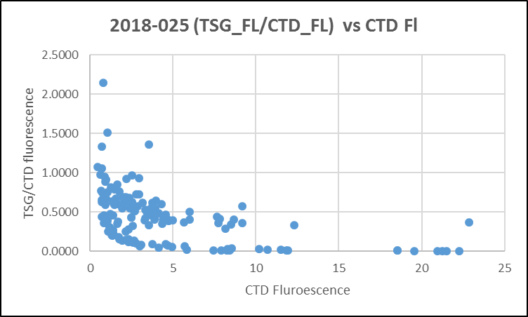
Since this could be due to flow rate variability, a plot was made of (TSG fluorescence / CTD Fluorescence) vs Heating in the loop (TSG Lab temeprature – TSG Intake temperature). All of the cases with a low TSG/CTD FL ratio occur when heating in the loop is particularly high. This does suggest that flow rate variability accounts for both the low TSG fluorescence and larger differences between intake and lab temperatures.
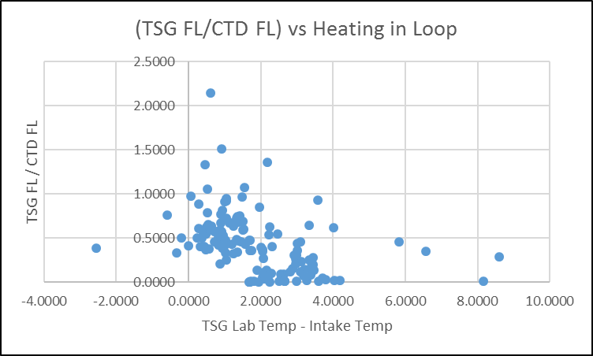

When casts #103 to #164 are excluded the fit between TSG Fl and CTD FL is fairly tight:

- Comparison of T and S from TSG and CTD data
The differences between TSG and CTD temperatures are highly variable, but when displayed against event number there is clearly a section between events #103 and #164 that has much higher values. This is the same section that turned up as odd in the TSG fluorescence study and is likely also due to very low flow in the loop. It is a little surprising that this should affect the intake temperature so much., but perhaps with very low flow rates water moves very slowly even at the intake.

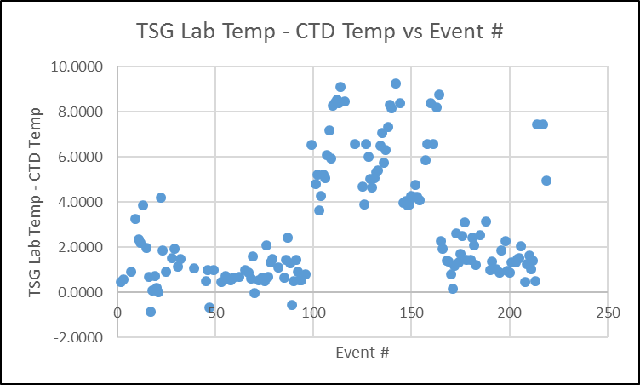

Examination of time-series plots shows that during that time period temperature, salinity and fluorescence showed little variability. Lab temperatures vary a little but that could be due to ambient temperatures varying. Salinity varies very slightly. Since that variable is not affected by the ambient temperature, it does give a good indication that there is very little, if any, flow in the loop.

When all data are included the following differences were found:
 | TSG-CTD | TSG-CTD | TSG - CTD | TSG/CTD
 | Intake Temp | Lab Temp | Salinity | Fluor
average | 1.1851 | 3.0275 | -0.9467 | 0.4336
median | 0.2898 | 1.8532 | -0.0411 | 0.4097
Std dev | 1.7377 | 2.6710 | 4.1640 | 0.3363

Data were then selected excluding casts #103 to 164. The differences found for those casts were:
 | TSG-CTD | TSG-CTD | TSG - CTD | TSG/CTD
 | Intake Temp | Lab Temp | Salinity | Fluor
average | 0.2597 | 1.5430 | -0.6332 | 0.5888
median | 0.0681 | 1.2497 | -0.0275 | 0.5432
Std dev | 0.9137 | 1.4658 | 2.5125 | 0.2930
Note that the standard deviations are very high especially in the salinity even using this limited data set.

- Comparison of TSG and Loop samples
There were only 4 salinity samples from the loop and no chlorophyll samples. The differences (TSG salinity - loop salinity) ranged from -0.03 to +0.08psu. All samples were taken while the ship was underway and not during the period when the flow appeared to be 0. Both TSG and loop salinity did vary, but there are insufficient data to conclude any more than that there must have been some flow in the loop.
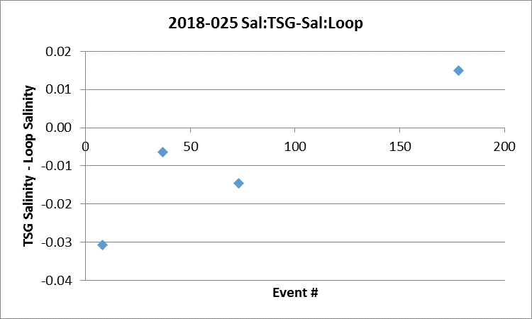

- Study of temperature differences between intake and lab
Generally the differences between intake and lab vary with intake temperature. When only the casts #103-0#164 are included, the pattern is similar to those seen in the past with heating in the loop approaching 0 as temperatures intake temperatures rise.
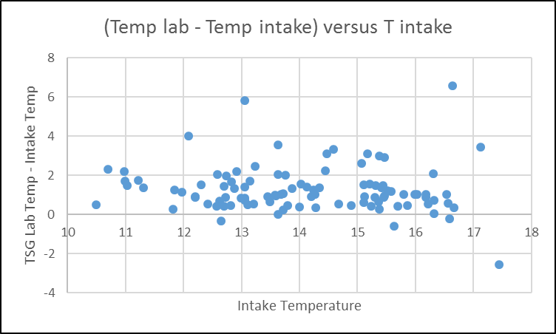

For details on comparisons see document 2018-025-ctd-tsg-loop-comp.xls.

e.) Calibration History
This is a new system so there is no history.

f.) Conclusions
1. The TSG time and position information were drawn from the same source as the CTD data, so an excellent comparison is expected and was found.
2. This is a new instrument and fine-tuning of the flow is needed before we can obtain reliable calibration information. For this cruise the flow meter and/or the flow itself failed for all or part of the cruise.
3. Data from casts #103 to 164 are not useful as the flow likely stopped or was extremely low. This affects 3 complete files and part of another file.
4. Data from the other casts look better but the salinity traces are very odd with sudden drops and rises of up to 0.7psu. This could be due to flow problems and/or bubbles. Fluorescence is very noisy.
5. The TSG intake temperature appears to be higher than that from the CTD by a median value of about 0.07C° and salinity is low by a median of about 0.03psu. These differences are similar to those found during 2018-034 in September 2018 but the standard deviations are much higher than during the later cruise. There is too much variability in the loop comparison to be useful.
6. Given no information on flow and some very odd traces, these data are not suitable for archiving.

g.) Editing
No editing was applied

h.) Recalibration
No recalibration is justified.

i.) Header Edit
The REO files were put through Header Edit to add header information and some comments about the data.
The output files *.TSG are not to be archived but are available upon request.

Notes on Problems
General Issues:
- The deployment scheme varied. For some casts acquisition started as soon as the computer was started and include “in air” data. For others acquisition started in water. There was no 10m soak.
- Some rosette samples were planned but not taken as the water depth varied from that in the plan.
- There were a number of stops during casts due to USB port dropouts.

Particulars:
2. Station Name is given as LB8 with a log note saying not really “LB08”. It isn’t remotely close to LB08 so this name is misleading. It was renamed as station na.
7. Stopped @117m to correct wire angle.
32. Archiving started immediately.
39. Initial file start saved as 2018-025-003 – not needed. Full cast saved with correct name. Deck pressure 0.31db. According to log no NMEA feed until CTD was on way up; there are NMEA data are in HDR file.
46. Primary channels bad; secondary used.
47/53/56/102/103. Sample numbers repeated. Renumbered samples in 53, 56 & 102 to avoid duplication.
49. Deck pressure 0.36db.
56. Operator pulled CTD out of water instead of going down at the start. Problems in primary channels in top 30m – chose secondary channels for archive. Bad DO data was removed from 0-16db.
59. Moved deep
85. Pause to fix wire angle
86b. Turned off archiving before turned off pump. Started new event to turn pump on and off properly. Do not process.
92. Went back to 5m for bot#9. Re Ammonia analysis – ship was burning garbage during sampling.
96. 2nd fluorometer in use. Sample 300 out of sequence.
96 – 182. Fluorometer 3642 mounted mid-way up the rosette on the outside and used without a pump.
102b. Went back down to 7m to sample CHLa max and O2 max – had already turned system off, so turned back on and preceded.
102. Most Niskin bottle vents were not tightened properly. All bottles failed integrity test. Sampled nutrients anyway. Sample # repeat – use 9336.
104. Forgot to fix surface bottle.
109. Bottles 3-8 not fired.
110. Started cast without archiving – stopped at 18m, back to surface, waited 1 min, then did cast 0 to 60m.
116. Bottles 4, 5, 6 not tripped, not needed. Logs have errors – show bottles 2, 3, 4 not fired. Rosette log sheet has errors. Corrections noted on paper copy.
125. Forgot bottle 8 – done on cast 125B.
125B. Run for bottle 8.
128. Log says number of bottles fired 12, but there were really 13 as shown on rosette log.
137. Deck pressure 0.06-0.11db.
144. Special file required with surface data for S. Johannessen.
148. Pumps not on – did 2nd cast with pumps on.
154/155. 2nd cast just to fire bottle 9 – No CHE file prepared for 155.
177 - 181. These event numbers were used twice – This has no impact on CTD processing but does affect Loop #178.
180. Fluorometer trace odd – reset cable connections for 181.
182. Sample #809 was skipped on the rosette sheet but not in the labels, so the samples from Niskin 5 to 15 are wrong on the rosette sheet. The analysts mostly stuck to the label sample #s, but the salinity analyst used the rosette log numbers.
183. Fluorometer 3641 replaced by 3642 on the CTD.
185. Channel 0/1 cable replaced. DO and Fluor changed due to damaged pins on the Fluor side.
186. Water collected from surface only – no bottle file prepared.
201. No 30s wait before firing surface bottle – sample 878
211. Bottle 9 not fired at 10m, but 9 and 10 fired at surface – ignore bottle #10.
214. Waits for wire angle adjustment @40m and 92m of downcast
217. Switched to CTD #0585 due to conductivity cell drift on CTD #0443.

CRUISE SUMMARY - CTD
CTD# | Make | Model |  | Serial# |  | Used with Rosette? |  | CTD Calibration Sheet Competed?
1 | SEABIRD | 911+ |  | 0443 |  | Yes |  | Yes
2 | SEABIRD | 911+ |  | 0585 |  | Yes |  | Yes
Calibration Information - 0443
Sensor |  |  |  |  | Pre-Cruise |  |  |  | Post Cruise
Name |  |  | S/N |  | Date |  | Location |  | Date | Location
Temperature |  |  | 4484 |  | 15Feb2018 |  | Factory
Conductivity |  |  | 2128 |  | 14Sep2017 |  | Factory
Secondary Temp. |  |  | 4752 |  | 02Sep2017 |  | Factory
Secondary Cond. |  |  | 2399 |  | 14Sep2017 |  | Factory
Transmissometer |  |  | 1185DR |  | 7Aug2017 |  | Factory
SBE 43 DO sensor |  |  | 0997 |  | 2Sep2017 |  | Factory
PAR |  |  | 70613 |  | 21Mar2016 |  | Factory
SeaPoint Fluor. |  |  | 3641
Pressure Sensor |  |  | 0443 |  | 31Aug2017 |  | Factory
Altimeter |  |  | 62355 |  | 21Mar2016 |  | Factory

Calibration Information - 0585
Sensor |  | Pre-Cruise |  | Post Cruise
Name | S/N | Date | Location | Date | Location
Temperature | 5724 | 02Sep2017 | Factory
Conductivity | 4434 | 6Sep2017 | Factory
Secondary Temp. | 5725 | 02Sep2017 | Factory
Secondary Cond. | 4448 | 6Sep2017 | Factory
Transmissometer | 1185DR | 7Aug2017 | Factory
SBE 43 DO sensor | 1483 | 30Sep2017 | Factory
PAR | 70613 | 21Mar2016 | Factory
SeaPoint Fluor. | 3641
Pressure Sensor | 0585 | 18Sep2017 | Factory
Altimeter | 62355 | 21Mar2016 | Factory

CRUISE SUMMARY TSG
Make/Model/Serial#: SEABIRD/45/0620 Cruise ID#: 2018-025

Calibration Information
Sensor |  | Pre-Cruise |  | Post Cruise
Name | S/N | Date | Location | Date | Location
Temperature | 0620 | 2Aug17 | Factory
Conductivity | 0620 | 2Aug17 | Factory
Temperature SBE38 | ? | ? | Factory
WETStar Fluorometer | 953 | 5May2017 | Factory

