## REVISION NOTICE TABLE

|  |  |
| --- | --- |
| DATE | DESCRIPTION OF REVISION |
|  |  |
| 20 March 2025 | Updated channel names & formats in TOB files. G.G. |
| 25 May 2022 | Added 0 to empty flag channels. G.G. |

## PROCESSING NOTES

Cruise: 2017-093

Agency: OSD

Location: North Pacific / Bering Sea / Chukchi Sea

Project: Canada’s Three Oceans / Distributed Biological Observatory

Party Chief: Vagle S.

Platform: Sir Wilfrid Laurier

Date: July 4, 2017 - July 22, 2017

Processed by: Germaine Gatien

Date of Processing: 18 June 2021 – 22 July 2021

Number of CTD HEX files: 73

Number of CTD files: 73 Number of CHE files: 57

Number of TSG HEX files: 4 Number of TOB files: 4

# INSTRUMENT SUMMARY

A SeaBird Model SBE 911+ CTD (#0941) was used for this cruise. It was mounted in a custom-built compact 24-bottle rosette sampler and attached were a Wetlabs CSTAR transmissometer (#CST-1050-DR), an SBE 43 DO sensor (#1117), a SeaPoint Fluorometer (#2745), a Biospherical QSP-200L4S PAR sensor (#70123), a Biospherical Surface PAR (#20281) and an altimeter (#41098).

24 Ocean Test Equipment 10L bottles were mounted on the rosette.

A thermosalinograph (SeaBird 21 S/N 3274) was mounted with a fluorometer (SCF2841) and a remote temperature sensor #0870.

The data logging computer was the IOS ARCTIC computer.

The data acquisition program was Seasave 7.26.6.26 for the CTD and the TSG.

The deck unit was a Seabird model 11; it included a NMEA board to automatically add GPS positions into the header of the data files.

The salinometer used at IOS was a Guildline model 8400B Autosal, serial # 68572. Bottles were analyzed between 5 December 2017 and 8 December 2017.

# SUMMARY OF QUALITY AND CONCERNS

The Daily Science Log Book and rosette log sheets and TSG log as well as spreadsheets detailing sampling were provided. There are many deck pressure measurements recorded. The log has no entry to show which external sensors (DO and Fluorometer) were mounted on which pumps. None of the logs has a record of which TSG was used. The TSG log had incomplete information on loop sampling, but among the many documents it was possible to pull together what was needed.

The raw file names use the 2-digit cruise number that was standard in 2017. The names were changed to the 3-digit cruise number format in use at the time of processing. The event numbers were in 3-digit format so had to be changed to 4-digit numbers.

The deployment method was to lower the CTD to about 8m, keeping it there for 1.5 to 3 minutes then return to near the surface. Usually it was kept at the surface for about 30s and then the full cast began. Pumps were usually turned on just before lowering for the soak. Pumps were not on for the downcast of event 147, coming on only after Niskin #2 was fired. The pumped channels were removed from the file for event 147. The upcast data were not suitable for archiving.

Neither salinity nor pressure were found to need recalibration. The primary salinity agreed well with bottle samples and at the time of a post-cruise service, the conductivity calibration had not drifted significantly. Dissolved oxygen was recalibrated based on a comparison with samples taken for the North Pacific casts; no samples were available from the Bering Sea and Chukchi Sea.

Comparison of loop samples and TSG data were made much easier by being supplied with MRK files. While those files contained TSG salinity they did not have fluorescence; however by having the scan numbers provided it was easy to find the missing data. A few loops did not have MRK files but times were recorded. Most of the loop data came mostly from the North Pacific. This is unfortunate as there is some evidence that significant drift in salinity calibration may have occurred after that. More loop sampling is recommended for cruises in areas with large near-surface vertical gradients as comparisons with the CTD are less reliable there.

TSG lab temperature values were higher than those from co-incident CTD data from 5m depth by a median of 0.36 C degrees overall, but the standard deviation in the fit was very high. In the North Pacific section, where near-surface waters were well mixed, the TSG temperature was high by 0.27 C degrees and the standard deviation was smaller. A post-cruise calibration shows only slight drift in temperature by December 2017, so most of the temperature difference is likely due to heating in the loop. There was no intake temperature sensor, so Temperature:Primary was created as a proxy by applying a fit of Lab Temperature vs Intake Temperature from C3O cruise 2016-017 when the same TSG was used.

TSG salinity was lower than CTD salinity by a median of 0.058psu overall, but higher by 0.003psu when only the Pacific Ocean casts were included. This difference may be partly due to larger vertical gradients in the Arctic section if the TSG is drawing water from slightly higher than the CTD data with which it was compared. However, from the post-cruise factory check it appears that salinity was reading low by 0.02psu by December 2017. The comparisons with CTD and loops were both extremely noisy so any shift or general trend is not obvious. There is no way to determine when the calibration drift occurred. It could have happened after this cruise. No recalibration was applied to salinity but it should be kept in mind that the values may be low.

The TSG fluorescence data compares reasonably well with the CTD fluorometer and to the many extracted chlorophyll loop samples.

# PROCESSING SUMMARY

##### Seasave

This step was completed at sea; the raw data files have extension HEX.

Files had cruise numbers that were standard in 2016 but that has changed, and the event numbers had only 3 digits, so the files were renamed with 2017-093 and a 4-digit event number.

##### Preliminary Steps

The Daily Science Log Book and rosette log sheets were obtained. A post-cruise report is available.

Spreadsheet 2016-93_SWL_Chem and Logs.xlsx contains a sampling log with details on bottles fired and results of analyses.

The cruise summary sheet was completed.

There was no history available for the pressure, conductivity and DO sensors; this was the first cruise on which most sensors were used after the last factory calibration.

The configuration files did not change through the cruise.

The calibration constants were checked for all instruments. No errors were found. One file was saved as 2017-093-ctd.xmlcon.

For most casts the CTD was held at the surface for 30s, lowered to around 7 or 8m for a soak of about 1.5 to 3 minutes after which it was returned to about 2.5m. Usually there was a brief stop (usually ~20 to 30seconds) after which the full cast was run. The stop before the full cast was occasionally very brief, presumably because conditions were rough or ice was present.

There were a number of deck readings of pressure that were all between -0.1db and +0.3db which is within the specifications for the sensor.

There was no sampling below 1000db, so no hysteresis tests were done.

##### BOTTLE FILE PREPARATION

The ROS files were converted including bottle number, bottle position, oxygen concentration and salinity.

The pumps were off during the bottles fired at the bottom of event #147. The pumped CTD channels should be padded after initial comparisons.

The files were then converted to IOS Header files and then put through CLEAN to add event numbers.

Temperature and salinity were plotted for all BOT files. Plots were examined to check for outliers and 8 files required light editing of salinity channels; notes were entered in the headers of what editing was applied (Events 7, 31, 40, 92, 131, 162, 174, 179). The edited files were then copied to the BOT files.

The BOT files were averaged on bottle number and those files were used to prepare an ADDSAMP file.

That file was edited to add sample numbers. Some casts had bottles fired out of order and in some cases a bottle was fired but no sample number was needed. The ADDSAMP file was edited to match the rosette sheet notes. The file was then reordered on Event # / Sample #.

The ADDSAMP file was used to add sample numbers to the BOT files, creating SAM files. Those were bin-averaged on bottle number to create SAMAVG files.

For event #147 the pumped CTD channels are not usable for the first 2 bottles fired since the pumps were not turned on. Those channels were replaced with pad values in the SAMAVG file. A comment was made in the header to explain what happened.

Next, text file 2017-093-bot-hdr.txt was prepared to add an explanation of quality flags and some general comments from analysts.

Final analysis data were found in separate sheets for analysis done at IOS (Salinity, Nutrients, Dissolved oxygen, Chlorophyll, DIC/Alk and HPLC). A general spreadsheet, 2017-093_SWL_UMCES + Frey data v2019-02-14.xlsx, was provided with variables analyzed at other institutions (Nutrients2, Chlorophyll2, Chlorophyll3, O18, Ammonium, SPM and CDOM). After some corrections to file names, channel names and addition of event numbers to some sheets, they were each converted to individual cast files (with extensions SAL, CHL, OXY, NUT, DIC, HPLC and GEN).

There were many channels that had no flags or comments included.

The data were converted in 7 groups to ensure comments from all columns were transferred to the headers. (extensions *.mrg1, mrg2…..mrg7)

The MRG7 files were put through CLEAN to reduce the header to just the File and Comments sections.

SORT was run on channel bottle # and then merged with the SAMAVG files with output MRG.

For event #147 the pumped CTD channels are not usable for the first 2 bottles fired since the pumps were not turned on. Those channels were replaced with pad values in the SAMAVG file.

These files were put through CLEAN to remove SeaBird headers and comments from the secondary file.

Data were exported from the MRG files to a spreadsheet to enable comparison with rosette sheets to ensure no data were lost in the conversion/merge process. A few problems were found:

* Event 20, Sample 116 – A CHL sample was listed on the rosette sheet but no such sample was found in the analysts notes and no label was found for it. Since there is no note of a change of plan and there is an HPLC sample, it is assumed the CHL sample was lost. An entry was made with flag 1 and comment.
* Silicate values that were rejected and flagged 5 were missed in the spreadsheet output because there were no pad values entered. This did not affect the merged files but made it hard to check in the spreadsheet, so the NUT.csv file was adjusted and re-converted.

##### Compare

Oxygen

COMPARE was run and most data points fall into a reasonably tight fit. However, there are some outliers that appear to have a different fit. They all come from event #13. The following plot shows (SBE DO – Bottle DO) vs SBE DO for 3 consecutive casts with the red points coming from #13.

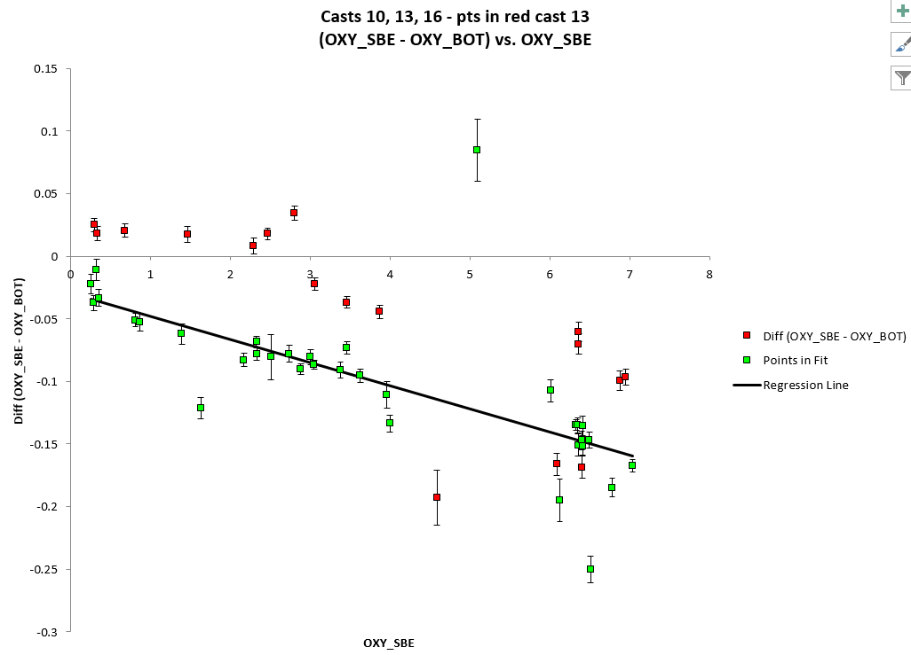

A check was made to see if there were errors in the sample numbers but none were found. The salinity data comparison was ok, so this is not a matter of misidentification of sample #s. Shifting values to the next bottle does not have good results so drawing from the wrong Niskins does not look like a reasonable explanation. The CTD data look ok with up and down profiles similar, just slightly offset as usual.

One other explanation is that the bottles didn’t flush well, but 3 things argue against that explanation:

* The CTD was moving around quite a bit which should help flushing.
* The salinity comparison does not look out of line for that cast.
* The deepest sample has a lower DO value than the CTD DO reading and for a bottle at the bottom of a cast poor flushing should lead to the sample reading higher than expected relative to the CTD, not lower.

To see if the issue could be that the CTD DO is reading too high for that cast rather than bottles being too low, oxygen saturation was derived for the Pacific casts. At 5m the saturation ranged from 101% to 104.5% for casts #3 to #26. Cast #13 was ~102% at the surface both for downcast and upcast. After recalibration it would be ~104%. That value is within the expected range in well-mixed offshore waters. Also the range of DO values and the profile for #13 is intermediate between the 2 casts to the south and the 2 to the north. There is no sign of a problem with the CTD DO. So, it is assumed that there was some problem in analysis or sampling on one day. The replicates looked fine and there are no log notes of problems except for 1 bottle having a leaky end cap. The slope of the fit for Event #13 does look close to the other casts but the offsets differ by ~0.08mL/L.

The fit found when all bottles from cast #13 were excluded plus outliers based on gradually removing points based on residuals was:

Bottle DO = 1.0203 *Oxygen:Dissolved:SBE + 0.0271 mL/L R2 =0.89

Quality flag 3 was assigned to all DO samples from cast #13 with the comment that it was an outlier but no problem was found to explain it.

Outliers were removed based on residuals. The largest outliers (other than cast #13) were examined to see if quality flags should be added:

* Event 10,Sample 53 at 75m is higher than expected but the CTD data are noisy and it is at a depth where DO vertical gradient was high and incomplete flushing of the bottle can explain the difference. No flag is needed as the bottle contents may well reflect the bottle contents.
* Event 20, Sample 109 at 124db – Bottle value higher than CTD by more than expected. Not a flushing issue. CTD data is noisy around firing time with a shed wake passing through with lower DO. No flag needed.
* Event 23, Sample 133 at 125db – The bottle value is higher than the CTD by less than expected and the local vertical gradient is large, so flushing error is likely. No flag needed.
* Event 26, Sample 152 at 100db – The CTD data was extremely noisy, the local gradient is high and can explain the difference. No flag needed.
* Event 26, Sample 147 at 224db – The CTD data was extremely noisy, the local gradient is high and can explain the difference. No flag needed.

There was no DO sampling for the shallow casts in the Bering and Chukchi Seas. Those areas had low vertical DO gradients so the fits from the deeper Pacific casts should provide a reasonably good estimate.

For more detail see file 2017-093-dox-comp1.xls.

Salinity

Compare was run with pressure as reference channel.

When outliers were excluded (differences >0.1psu or standard deviation in CTD salinity > 0.001psu) the primary salinity was found to be low by 0.0015psu and the secondary high by 0.0055psu (standard deviations for both were 0.011psu.) But there is evidence of flushing errors in the shallow water with CTD salinity lower relative to bottle salinity compared to in deeper water. When only bottles below 300db were included the average differences were -0.0010 for the primary and +0.0065 for the secondary. Excluding bottles above 400db made little difference to that result, with differences -0.0007psu and +0.0063psu.

The only outliers with differences >0.1psu were from shallow casts and either near the bottom or close to a large vertical salinity gradient so that incomplete flushing would lead to large errors. No flags are justified since the bottle salinity likely reflect the bottle contents, just not ambient conditions.

There may have been some evaporation/adsorption of bottle samples, though care was taken to prevent this. So the CTD salinity could be higher than it appears, but there is no way to determine how big an effect this would have.

A fit of differences for all casts versus time order shows greater scatter in the Arctic section than in the Pacific Ocean, as expected due to larger vertical gradients for most levels sampled.

For full details for the COMPARE run see file 2017-093-sal-comp1.xls.

Extracted Chlorophyll versus CTD Fluorescence

COMPARE was run using Chlorophyll: Extracted and SBE Fluorescence but CHL samples were analyzed in 3 different labs. The data from the North Pacific were analyzed at IOS. They have a small range of CHL – from 0.01 to 2.36ug/L, with only 2 values >1.7ug/L. As is usually observed, the SBE fluorometer reads higher than the CHL samples at low CHL values. Similar results were seen in 2016.

See 2017-093-fl-chl-comp1.xls for more detail.

The other 2 sets of CHL data were collected at the same stations but not always from the same bottles; they were analyzed at 2 different labs.

Set 2 had a range of CHL from 0.07 to 45.92ug/L and was analysed at the Chesapeake Biological Laboratory of the University of Maryland Center for Environmental Science. CTD fluorescence is lower compared to CHL than in the IOS samples, but this is primarily due to the higher values of CHL. This result is similar to observations in 2016 with fluorescence higher than CHL at very low CHL values but lower than CHL for most samples since CHL was relatively high.

For more detail see 2017-093-chl2-chl3-fl-comp1.xls.

The 3rd set of CHL data was analyzed at Clark University in conjunction with CDOM analysis and provided K. Frey. The range of CHL values was 0.02 to 28.80ug/L. There was one negative value, ‑0.1ug/L (sample 472). The CTD Fluorescence was 1.1 and the UMCES extracted chlorophyll was 1.17. That value was changed to -99 in the bottle files. There was another very low value, 0.01ug/L (sample 475) from a different bottle but at the same depth as a UMCES sample of value 1.11; the corresponding CTD fluorescence was 0.91ug/L so that CHL3 value was also padded. It appears some corruption of those records had occurred. After rejecting those two samples, the comparison showed good correspondence between CHL and CTD fluorescence for CHL<5 and fluorescence looking low for higher CHL. In 2016 the fluorometer read lower relative to CHL3 than seen here.

For more information see file 2017-093-fl-chl.comp.xls.

A comparison between the 2 sets of CHL was attempted but a few cases were found where differences were large. Most of those were at 5m where the 2 sets came from different Niskin bottles but at the same depth. In those cases the Frey values were often very low compared to the UMCES and HPLC Tchl-a values. When the 5m cases and a few others were excluded the correspondence between them was good overall with the Frey data reading about 93% of the UMCES data. The outliers were cases of very low CHL in the Frey data near the surface. The CTD fluorescence agrees better with the UMCES data for those cases. Given there were some problems with negative values in the Frey data there may be a small offset that causes large differences for low values, though that does not explain all the differences. Fortunately, HPLC Tchl-a values are available at the surface.

For more information see file 2017-093-chl2-chl3-fl-comp1.xls and for a summary of the 3 CHL data sets plus HPLC:TChl-a see file 2017-093-fl-chl-data.xlsx.

##### Conversion of Full files from Raw Data

All files were converted using 2017-093-ctd.xmlcon. The hysteresis correction was not selected since the maximum sampling depth was 1000m. The Tau correction was applied.

All channels were plotted for a few casts to check for problems in the conversion and none were found.

##### WILDEDIT

Program WILDEDIT was run to remove spikes from the pressure, conductivity & temperature only.

Parameters used were: Pass 1 Std Dev = 2 Pass 2 Std Dev = 5 Points per block = 50

The parameter “Keep data within this distance of the mean” was set to 0.

A few small spikes were removed by this routine.

##### ALIGN DO

Fine-tuning of the DO sensor alignment is difficult when there are so many stops for bottles. For other cruises using this type of sensor settings between +2.5s to +3.5s worked quite well, so tests were run using 3 settings in that range. There was little difference among them but +3s looked especially good for the shallow casts.

ALIGN was run on all casts using an advance of +3s.

##### CELLTM

As for ALIGNCTD tests are not helpful with so many stops and high variability, so settings were used that are always found reasonable, and often the best choice.

CELLTM was run using (α = 0.0245, β=9.5) for both the primary and secondary conductivity.

##### DERIVE

Program DERIVE was run on all casts to calculate primary and secondary salinity and dissolved oxygen concentration (using the Tau correction).

##### Tests

The differences between channels were plotted for 3 deep casts and are, roughly:

* Temperature:Secondary – Temperature:Primary = ~ - 0.0001Cº at 1000db..
* Conductivity:Secondary – Conductivity:Primary = ~ +0.00054S/m at 1000db.
* Salinity:Secondary – Salinity:Primary = ~ +0.0066psu.

The salinity differences are in good agreement with the differences in the 2 channels from the salinity comparison with bottles, which was ~0.0071psu.

The later casts are very shallow and differences are noisy so estimates are pointless.

The salinity differences seem rather large for sensors that were recently recalibrated, especially as the comparisons are from the beginning of the cruise.

##### Conversion to IOS Headers

The IOSSHELL routine was used to convert SEA-Bird 911+ CNV files to IOS Headers.

File #207 would not convert. The error message mentioned that there were 160 bad data flags in 160 records and that the array size was exceeded in subroutine ALTIMETER. No bad flags could be found in the file and the altimetry appears normal though there were spikes but none exceeded the 0 to 100 range.

A few methods were attempted to fix this:

* The altimetry was plotted on a fine scale to ensure there were no values outside the 0-100 range and there were none.
* The altimetry was put through WILDEDIT. This did not help.
* The altimetry channel was deleted. This worked but at the cost of the altimetry data.

Given no other solution the file for 207 has no altimetry but an estimate was made by examining a plot and that value was entered in the header.

CLEAN was run to add event numbers and to replace pad values in the pressure channel with interpolated values based on record number.

##### Checking Headers

The header check was run. The cast with the highest fluorescence value was examined to see if it had gone off-scale but it appears it was close to the limit but only 1 record was >49ug/L and many were between 48 and 49ug/L with some variability in the profile, so if the sensor went off-scale it was likely for only a few scans.

Surface check was run and shows an average surface pressure for the cruise was +0.3db with a minimum of -0.2db with associated low salinity values. The pressure values look to be accurate – frequent pressure checks on deck were between -0.1 and +0.3db.

The cross-reference check was compared with the log book and no errors were found.

The 8m-soak data need to be removed so that DELETE will select the most appropriate data.

For the Pacific Ocean casts the pumps were not turned on until the CTD was at the soak depth, so CLIP was run to remove the data until the pumps came on.

For the other casts the pumps were on for the initial drop, so plots were made to determine how many records should be removed. A table was prepared for this purpose but a problem was encountered when >10000 records had to be removed, so such casts were put through 2 runs of CLIP, first to remove 10,000 records and using an adjusted table to remove the # of records in an adjusted table. Plots were made to see if the appropriate # of records were removed from each cast and many were reprocessed until the plots looked right.

The altimeter readings and bottom depths from the headers of the CLN files were exported to spreadsheets. To see if the altimetry and/or bottom depth entries are reasonable a check value was calculated:

Check Value = Water Depth – Altimetry – Max Depth Sampled

The altimetry value is calculated with an algorithm taking data from the bottom 2db and water depths vary during a cast, so we can’t expect the check value to be exact. There were 3 casts with Check value >4m and all were corrected by entering the values found in the log book:

* Event 51 – Header 75, Log 73 - change to header to match log.
* Event 97 – Header 38, Log 45 – change header to match log.
* Event 251 – Header 115, Log 111 (obviously had been changed) – change header to match log.

The same changes were made to the profile files and bottle files

The cruise tracks (with event #s and station names) were plotted and added to the end of this report. No problems were found.

##### Shift

Conductivity

Choosing alignment corrections is difficult because the salinity is very noisy in the top 50m or more and for many casts there is no deeper data. For many casts the instabilities are likely not due primarily to alignment problems. Shed wake corruption and real variability are possible cause. For the deeper casts it is possible to do some tests to see what setting works well below the surface waters. Those settings appear to make some improvement near the surface but leave many unstable features. It varies from one cast to another whether the primary or secondary has smoother features.

Tests were run on a few deeper casts and the best setting for the primary conductivity was found to be -0.7s. There were a few shallow casts for which a higher shift value made some further improvement but it is not at all obvious that this is due to an alignment issue and DELETE may well remove the problematic features. For the secondary conductivity -0.5s shift improved T-S plots for the deep casts, but this did not seem to work as well for some of the shallow casts. This is related to some sharp gradients and adjusting the shift to work well there made other features look worse. The editing phase can fix some of these excursions that do appear to be due to mismatch in T and C. Some of these unstable features may be real.

Fluorescence

There is no indication in the log book as to whether the fluorometer was pumped or not. However, plots suggest that it was, with a larger offset between fluorescence traces than is seen in temperature. SHIFT was run on all casts using the standard setting advancing the SeaPoint fluorescence channel by +24 records. The results look better.

##### DELETE

The following DELETE parameters were used:

Surface Record Removal: Last Press Min

Maximum Surface Pressure (relative): 10.00

Surface Pressure Tolerance: 1.0 Pressure filtered over 15 points

Swells deleted. Warning message if pressure difference of 2.00

Drop rates < 0.30m/s (calculated over 11 points) will be deleted.

Drop rate applies in the range: 10db to 10db less than the maximum pressure

Sample interval = 0.042 seconds. (taken from header)

COMMENTS ON WARNINGS: The were no warnings.

##### Other Comparisons

Previous experience with these sensors – This was the first known use of the temperature, conductivity and dissolved oxygen sensors since the previous factory calibration.

Post-Cruise Calibration – 1 deep cast was converted using the calibration from late 2017. No record was available for readings before service, but after servicing the primary temperature was lower by ~0.0004, the secondary higher by 0.0003, the primary conductivity higher by 0.00005 and the secondary lower by 0.00045, the primary salinity higher by 0.001psu and the secondary lower by 0.006psu. Dissolved oxygen had drifted lower by roughly 2.5% to 6%, with the largest drifts at higher DO values.

Historic ranges – Local climatology was only available for stations NP-1 to NP-7 in the Pacific. All temperature and salinity fell within the climatology except for slightly low salinity at 25m for event #3.

Repeat Casts – There were no repeat casts; nearby casts are too shallow to test repeatability.

##### DETAILED EDITING

The primary channels were selected for editing and eventual archiving since the salinity compared well with bottles and the post-cruise calibration indicated drift of ~0.001psu as of November 2017.

CTDEDIT was used to remove some near-surface records that look like they are affected by shed wakes

or ship effects and other records corrupted by shed wakes. Salinity was cleaned, mostly in areas with high temperature gradients including some areas where the CELLTM adjustment leads to high salinity at the base of the thermocline. All casts required some editing except for event #147 – the pumps were off so temperature and salinity data will not be archived.

Plots were made to see if further editing was required. Many unstable features remain but most are fine-scale or would require removal of data where there is no obvious instrumental effect. These were mostly from shallow casts. A few casts were re-examined in CTDEDIT to see if further editing would be useful but in no case was extra editing applied.

##### Initial Recalibration

* The post-cruise results indicate that the primary salinity was low by ~0.001 and the secondary high by ~0.006, while the comparison with bottles indicates the primary was low by ~0.0007psu and the secondary high by 0.0063. The bottle comparison is based on casts early in this cruise. The post-cruise calibration is from 4 months after this cruise so there could have been drift either later in this cruise, on another cruise or on the shelf, but it agrees with the salinity bottle comparisons by within 0.001psu. The primary salinity will not be recalibrated and the secondary salinity will not be archived.
* The post-cruise calibration of dissolved oxygen sensor shows some drift downwards in values by from 2.5% to 6%, while the bottle comparison suggests it is low by about 2%. The servicing of the DO sensor may well have affected this result and there was another cruise after this one but before servicing. All DO sampling was from early in this cruise, so it is possible that further drift occurred during the later part. A study of surface oxygen saturation shows values of between 100% and 105% in the North Pacific and Southern Bering Sea. As the ship moved into shallow water the surface waters are less well mixed, fluorescence higher and saturation values are highly variable. The North Pacific fit will be applied to all data.
* Pressure does not need recalibration.

CALIBRATE was first run on the MRGCLN2 and SAM files using file 2017-093-recal1.ccf to apply the dissolved oxygen correction described above. COMPARE was rerun on the output files (MRGCOR1 and SAMCOR1) to see if this correction worked well and it did. File 2017-093-dox-comp2.xls shows a flat fit of differences versus SBE DO. The SBE DO was found to be low by an average of -0.0003mL/L when the bottles excluded from the original fit were also excluded from this fit.

CALIBRATE was then run on the edited CTD files using file 2017-093-recal1.ccf.

##### Final Calibration of DO

The initial recalibration of dissolved oxygen corrects for sensor calibration drift. Alignctd corrects for transit time errors. Those 2 steps may partly correct for response time errors, but to see if a further correction is needed, a comparison is made of downcast CTD data to bottle data from the same pressure. Small differences are expected due to ship drift, temporal changes, incomplete flushing of Niskin bottles and delayed response and noise in CTD data.

Downcast files were bin-averaged to 0.5m bins for the casts with DO bottle samples. Those files were then thinned and compared to the bottle values in the MRG files. COMPARE was run to study the differences between the downcast CTD DO data and the titrated samples from upcast bottles.

The CTD DO was higher than the titrated samples by an average of ~0.08mL/L (standard deviation 0.09mL/L) when data were excluded based on high standard deviations in the CTD data or having been identified as outliers in the upcast-vs-bottle comparison. The differences are small at depth (~+0.013 at 1000m) and gradually rise towards the surface. There are some cases where the CTD is lower than bottles; a few of those were investigated and came from areas where there were local DO reversals. There were many such reversals at mid-depths. The positive differences are likely due primarily due to incomplete flushing of Niskin bottles, an error that would grow larger as local gradients increase. Another source of positive differences is response time errors in the downcast data from the SBE sensor.

Based on a plot of differences versus pressure a rough estimate of SBE DO accuracy is:

±0.40 mL/L from 0-100db

±0.30 mL/L from 100db to 300db

±0.15 mL/L from 300db to 500db

±0.04 mL/L below 500db

This is likely an underestimate of accuracy particularly in areas of low DO vertical gradient.

##### Special Fluorometer Processing

A median filter, fixed size=11, was applied to the fluorescence channel in the COR1 files to reduce spikiness. A few casts were examined before and after this step and showed that the filter was effective.

##### BIN AVERAGE of CTD files

The following Bin Average values were applied to the FIL files (output AVG):

Bin channel = pressure Averaging interval = 0.5 Minimum bin value = .000

Average value will be used. Interpolated values are NOT used for empty bins.

After averaging, page plots were examined on screen. Some unstable features remain as described in section 16. These are mostly close to the surface and very heavy editing would be needed to remove them; often the unstable feature is due to a very small reversal in salinity. No further editing was applied.

##### Final CTD File Steps (REMOVE and HEADEDIT)

REMOVE was run on the AVG files to remove the following channels (Output *.REM):

Scan_Number, Temperature:Secondary, Salinity:T1:C1, Conductivity:Secondary, Oxygen:Voltage:SBE, Altimeter, Status:Pump, Descent_Rate and Flag

Change Units was run to derive dissolved oxygen in mass units.

Oxygen Saturation was derived and plots made of surface values which ranged from 90% to 155% with the majority between 103% and 110%. The Pacific Ocean casts were mostly between 103% and 108% but after station NP-7 values began to increase as the ship moved northwards.

REORDER was run to get the 2 DO channels together.

HEADER EDIT was used to fix formats and channel names and to add comments:

The Standards Check routine was run and no problems were found.

The Header Check was run and no problems were found.

The cross-reference list was produced and no problems were noted.

The final files were named CTD.

Profile plots were made. All variables look reasonable. Near-surface oxygen is often spiky but it is not clear what is real and what is an instrumental artifact. PAR values near the surface are close to PAR:Reference values when the minimum pressure in the files is ≤2m.

The track plot looks fine

The sensor history files were updated.

##### Final Bottle Files

The MRGCOR1 files were put through SORT to order on increasing pressure.

REMOVE was run on the MRGSORT files to remove the following channels (Output *.MRGREM):

Scan_Number, Temperature:Secondary, Salinity:T1:C1, Conductivity:Secondary, Oxygen:Voltage:SBE, Altimeter, Status:Pump, Descent_Rate and Flag.

Change Units was run to add Oxygen:Dissolved:SBE in mass units. A second run was made to add Oxygen:Dissolved in mass units using Temperature:Draw.

REORDER was to rearrange the channel order.

EDIT HEADERS was run to fix formats and units, fix a few headers, change the channel name Bottle_Number to Bottle:Firing_Sequence and the name Bottle:Position to Bottle_Number, to fix the platform name and chief scientist’s name and to add a comment about quality flags and analysis methods and a few notes about the CTD data.

This process was particularly tricky due to the large number of channels and variations from cast to cast. A “dummy” file with a list of all possible channels and a Channel Table was prepared and downloaded to the EDIT Header routine. A few input files were checked against this list and the input channel names and formats had to be adjusted for some channels. Running the standards check was very helpful in tracking down all such problems. This dummy file should prove useful in future for this type of cruise.

A non-standard format for Phosphate3 was not changed as it reflects the choice of the analyst.

For a final check the CHE bottle data were exported to a spreadsheet and compared to the rosette sheets. Problems were found in a 5 casts that arose because the SAM files had not been averaged again AFTER correcting some sample number errors. That step and those that follow were repeated and data exported again. No further problems were found.

Profile plots were made of a few variables to look for any obvious outliers and none were found.

A Header Check was run and no problems were found.

A cross-reference list turned up no errors

The track plot was produced on screen and no errors were found.

##### Thermosalinograph Data

Date were provided in many hex files but only 4 coincided with this cruise.

The TSG files have non-standard names with the format TSG_YYYMMDD but the contents are clear from the file names so they will not be changed.

There was an intake thermistor or flow meter installed.

a.) Checking calibrations

All configuration files were the same. One was saved as 2017-093-tsg.xmlcon. The calibrations were checked and the only error found and corrected was the date of the fluorometer calibration.

b.) Conversion of raw files.

Configuration file 2017-093-tsg.xmlcon was used to convert all the files.

The files were then converted to IOS HEADER format.

CLEAN was run to add End times and Longitude and Latitude minima and maxima to the headers.

ADD TIME CHANNEL was used to add Time and Date channels based on the Julian time.

A post-cruise calibration was available so one cast was converted with those parameters.

Time-series plots were produced. There are discrete spikes in salinity that look likely to be produced by bubbles. Fluorescence looks fine.

c.) De-spiking and Editing

All files were put through program Simple Despike to replace simple spikes in salinity of size >0.05psu with the average of adjacent values. This worked very well except for a deep spike in the 3rd file.

d.) Bin-averaging

The files were bin-averaged over 6 scans for the purpose of comparing to CTD data.

The track plot looks fine. It was added to the end of this file.

e.) Checking Time Channel

The CTD data were thinned to reduce the files to a single point from the downcast at or within 0.5db of 5db. Those data were exported to file 2017-093-tsg-ctd-comp.xlsx.

The averaged TSG files were opened in EXCEL and reduced to the times of CTD files. There were 70 matches.

To check for problems in the TSG clock or bad matches of TSG and CTD data, the differences between latitudes and longitudes were found. The median differences in latitude and longitude were 0.00001° and 0.00003°, respectively, but there were many cases of significant differences especially in the longitude. Looking at the ship’s track this is understandable since the times of the 2 data sets are not exactly the same. The small average differences suggest that the variations are not due to a clock problem but more likely significant ship drift during some stops. Along the SEC line the differences are very small.

This spreadsheet was then used in step (f) to compare temperature, salinity and fluorescence from the CTD and TSG.

f.) Comparison of T, S and Fl from Loop and Rosette samples and TSG and CTD data

Differences were calculated. The Pacific Ocean casts were well mixed at the surface so they were assessed as a group.

* T1 vs T2 There was no intake temperature available. From a study during 2016-017 when the same equipment was used but an intake temperature was available, we can estimate that heating in the loop varied from about 0.20Cº from the early part of the cruise to 0.30Cº given ambient sea temperatures of 3 to 14ºC. In 2015 similar results were found.

For 2017 the only way to estimate heating in the loop is to look at the differences between the CTD and TSG; this had a median value of 0.36ºC overall and 0.27ºC in the Pacific, suggesting more heating in the loop than in the 2 previous years. However, the intake temperature is usually higher than the CTD temperature, perhaps due to some heating near the ship. In 2016 there was a median difference between Intake Temperature and CTD Temperature of ~0.04Cº in the Pacific and 0.13ºC in the northern section and in 2015 it was ~0.24Cº with all casts in the north. So the actual heating in the loop is probably not out of line with other years. There is a lot of noise in this comparison every year and many variables to consider such as the amount of ice, flow rates in the loop, ambient temperature of the ship and near-surface vertical temperature gradients.

A reasonable proxy for intake temperature cannot be derived from the TSG-CTD comparison because the fits are too noisy for an objective identification of outliers. The fit for heating in the loop that was found from 2016 data will be applied to recalibrate the lab temperature which will be renamed as Temperature:Primary and serve as a proxy for intake temperature:

Temperature:Primary = 1.0120 * Temperature: Lab – 0.3113

This is a very rough substitute for intake temperature.

* TSG vs CTD The spreadsheet comparing CTD and TSG files was examined to find the differences between the salinity, fluorescence and temperature channels for the CTD and the TSG.

|  |  |  |  |  |  |  |  |
| --- | --- | --- | --- | --- | --- | --- | --- |
| All casts |  |  | Lat diff | Long diff | Tlab-Tctd | Stsg-Sctd | FLtsg/FLctd |
|  |  | average | 0.00002 | -0.00014 | 0.6604 | -0.1407 | 2.5 |
|  |  | median | -0.00001 | -0.00003 | 0.3637 | -0.0575 | 1.9 |
|  |  | stdev | 0.00054 | 0.00227 | 0.9050 | 0.3265 | 2.0 |
|  |  | max | 0.00176 | 0.00709 | 4.4675 | 0.9872 | 10.1 |
|  |  | min | -0.00219 | -0.00707 | -0.2290 | -1.3817 | 0.4 |
|  |  |  |  |  |  |  |  |
| Pacific Casts | |  | Lat diff | Long diff | Tlab-Tctd | Stsg-Sctd | FLtsg/FLctd |
|  |  | average | 0.00015 | -0.00295 | 0.3430 | 0.0045 | 1.5 |
|  |  | median | 0.00013 | -0.00249 | 0.2733 | 0.0031 | 1.5 |
|  |  | stdev | 0.00030 | 0.00238 | 0.2326 | 0.0238 | 0.3 |
|  |  | max | 0.00082 | 0.00008 | 0.8111 | 0.0471 | 2.1 |
|  |  | min | -0.00026 | -0.00707 | 0.0687 | -0.0394 | 1.1 |

The TSG lab temperature is higher than the CTD temperature by a median of 0.36 Cº and for the Pacific Ocean casts it was higher by 0.27 Cº. The TSG salinity was lower than the CTD salinity by a median of 0.0575psu for the whole cruise (std dev 0.33psu) but higher by only 0.0031psu for the Pacific Ocean section but the standard deviation was high at 0.23psu even in the Pacific section.

The TSG fluorometer readings are higher than those from the CTD fluorometer. The 2 traces are similar in shape against event #s. Given that the CTD fluorometer values are generally higher than CHL in the Pacific but lower in the Arctic, the TSG fluorometer values will be closer to CHL in the Arctic.

Rosette samples were obtained. While these do not match the TSG in time as they were gathered at the end of casts, they do come from when the ship was stopped. The ship drift appeared to be fairly large in the Pacific section but waters were well mixed, which should minimize errors. The picture that emerges from this comparison is much the same as that with the downcast CTD data with no clear picture due to the noise in the comparison. The differences towards the end are mostly too large to explain by calibration drift.

(See 2017-093-TSG-CTD-comp.xls.)

* Loop Bottle - TSG Comparisons There were 10 salinity loop samples and 35 chlorophyll samples.

MRK files were available that contain scan numbers and salinity data from when most of the loops samples were drawn. Where those data are not available the sampling time was recorded. Fluorescence was not recorded but the scan number or time was used to obtain data for comparison with the loops.

File 2017-093-TSG-loop-comp.xlsx was prepared to compare TSG salinity and fluorescence with the loop samples.

The TSG Salinity was found to be high by an average of 0.005psu and median of ~0.0025psu, but the standard deviation was 0.035psu. When 1 outlier was excluded the TSG was low by ~0.003psu and the standard deviation was 0.0003psu. Most of the loops were gathered in the Pacific Ocean section of the cruise. Two loops taken late on the 19th and on the 22nd of July show the TSG to have salinity low by 0.029 and 0.037psu but there other large differences earlier in the cruise as well. There are not enough loops to indicate a trend especially since there are no data between the 12th and 19th.

The TSG fluorescence was higher than the loop CHL for all CHL<0.45ug/L. For CHL>0.45 the ratio varied greatly with an average ratio of about 1. It is typical of this type of fluorometer to read high when CHL values are low. Where CHL was high the TSG fluorometer is much closer to CHL than the fluorometer on the CTD was.

See 2017-093-TSG-Loop-comp.xls.)

* Calibration History

The TSG primary temperature and conductivity were recalibrated before and after this cruise in December 2016 and December 2017. There is no indication of any repairs made during either service. One file was converted using the post-cruise calibration and the temperature had drifted up by ~0.0005Cº and the conductivity down by ~0.002 with a resultant increase in salinity of ~0.02psu.

Conclusions

1. The TSG clock appears to have worked well.

2. There was no intake temperature available so heating in the loop can only be estimated by comparing with CTD temperature.

3. The TSG lab temperature reads higher than the CTD by a median of 0.36Cº but the standard deviation is 0.91Cº. When only Pacific Ocean casts are included the difference is 0.27Cº (std dev 0.23Cº). The post-cruise calibration shows a drift upwards of only 0.0005Cº. So the median difference likely reflects mismatches in the levels from which the CTD and TSG data came or ship effects on either of the 2 systems.

4. The TSG Salinity was found to be reading lower than the CTD by a median of 0.058psu when all casts were included and higher by 0.003psu when only the Pacific Ocean casts are included. A comparison with a file converted using the post-cruise calibration shows TSG salinity using the pre-cruise calibration is lower by about 0.02psu. Establishing when the calibration drift occurred is impossible with so much noise in the comparison. The loop samples also have a lot of variability and there are no loops between July 12th and July 19th so detecting a trend is not possible. A few casts with well-mixed surface waters were found in that interval that suggest the TSG was reading low but the evidence is weak in the light of the large variability.

5. The fluorescence from the TSG looks reasonably close to that from the CTD and to loop extracted chlorophyll samples.

g.) Recalibration

ADD CHANNEL was run to add Temperature:Lab which was set equal to Temperature;Primary.

CALIBRATE was used to apply equation:

Temperature:Primary = 1.0120* Temperature: Lab – 0.3113

i.) Preparing Final Files

REMOVE was used to remove the following channels from all files: Scan Number and Flag. Those files were copied to *.EDT.

CTDEDIT was used to edit the 3rd file with output *.edt. 35 salinity points were removed from a spiky section that appears to have been caused by a mismatch between T and C.

HEADER EDIT was used to add a comment and add the depth of sampling to the header and to change the units for the 2nd Time channel to days. Those files were saved as TOB files.

The TSG sensor history was updated.

As a final check plots were made of the cruise track and time-series and all look fine.

The cruise plot was added to the end of this report.

Particulars

Many on-deck pressure readings ranging from +0.1db to +0.3db.

20. Endcap on bottle 1 leaky.

64. Rosette covered in jelly fish.

147. Pumps off for downcast and first 2 bottles – pumps on for most of upcast but many stops for bottles so data not useful for creating a CTD file. A CHE file was prepared.

240. Note in log: Interesting unstable water layers.

251. Touched bottom. Noted in log and confirmed by altimetry and transmissivity.

# Institute of Ocean Sciences

# CRUISE SUMMARY

**CTDs**

|  |  |  |  |  |  |
| --- | --- | --- | --- | --- | --- |
| **CTD#** | **Make** | **Model** | **Serial#** | **Used with Rosette?** | **CTD Calibration Sheet Competed?** |
| 1 | SEABIRD | 911+ | 0941 | Yes | Yes |

|  |  |  |  |  |  |
| --- | --- | --- | --- | --- | --- |
| **Calibration Information CTD #941** | | | | | |
| **Sensor** | | **Pre-Cruise** | | **Post Cruise** | |
| **Name** | **S/N** | **Date** | **Location** | **Date** | **Location** |
| **Temperature** | **5048** | **3Mar2017** | **Factory** | **4Nov2017** | **Factory** |
| **Conductivity** | **3579** | **29Dec2016** | **Factory** | **12Dec2017** | **Factory** |
| **Secondary Temp.** | **5073** | **31Dec2016** | **Factory** | **4Nov2017** | **Factory** |
| **Secondary Cond.** | **3581** | **29Dec2016** | **Factory** | **13Dec2017** | **Factory** |
| **Transmissometer** | **1050DR** | **12Apr2016** | **Factory** | **17Jun2018** |  |
| **SBE 43 DO sensor** | **1117** | **21Dec206** | **Factory** | **22Nov2017** | **Factory** |
| **SeaPoint Fluorometer** | **2745** |  |  |  |  |
| **PAR** | **70123** | **4Apr2016** |  |  |  |
| **Surface PAR** | **20281** | **4Apr2016** |  |  |  |
| **Pressure Sensor** | **941** | **6April 2015** | **Factory** |  |  |
| **Altimeter** | **40853** | **12Feb2007** |  |  |  |

# TSG Make/Model/Serial#: SEABIRD/21/3274

|  |  |  |  |  |  |
| --- | --- | --- | --- | --- | --- |
| **Calibration Information** | | | | | |
| **Sensor** | | **Pre-Cruise** | | **Post Cruise** | |
| **Name** | **S/N** | **Date** | **Location** | **Date** | **Location** |
| **Temperature** | **3274** | **21Dec2016** | **Factory** | **16 Dec 2017** | **Factory** |
| **Conductivity** | **3274** | **21Dec2016** | **Factory** | **16 Dec 2017** | **Factory** |
| **Temperature SBE38** | **0870** | **3Dec2015** | **Factory** |  | **Factory** |
| **WETStar Fluorometer** | **2841** | **June 2014** | **Factory** |  |  |

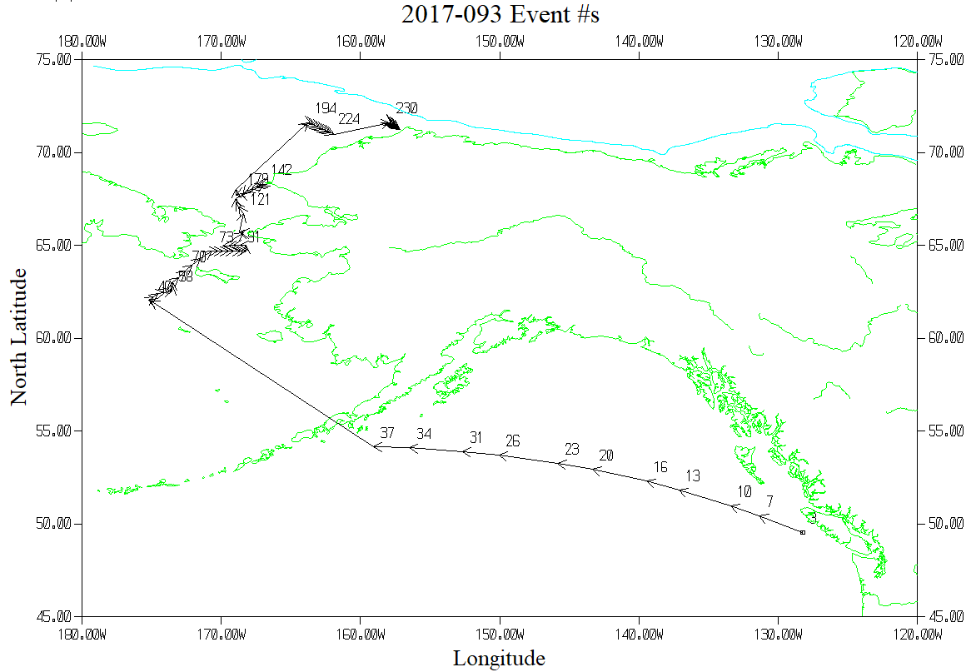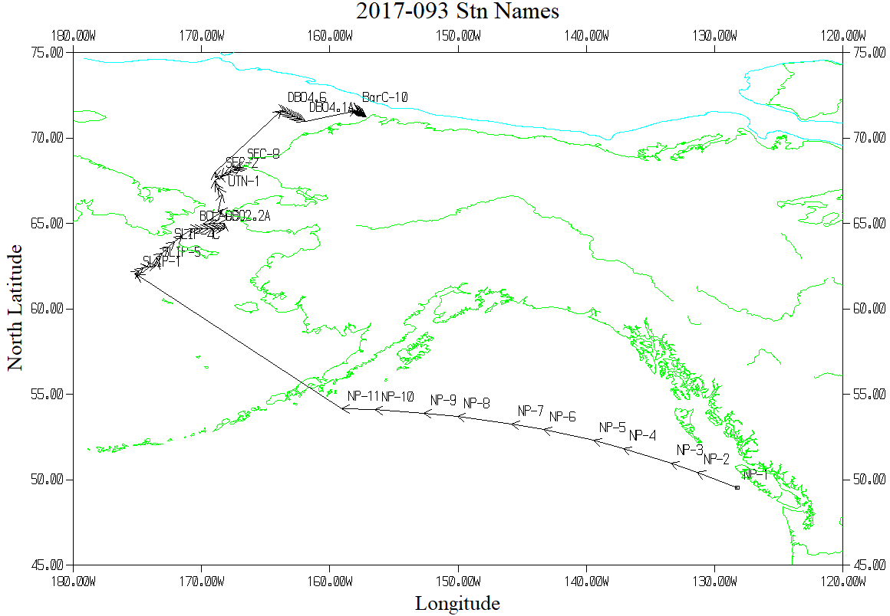

TSG Plot - 12 hours between arrows

