REVISION NOTICE TABLE
DATE | DESCRIPTION OF REVISION

PROCESSING NOTES
Cruise: 2017-52
Agency: PBS, Ecosystem Sciences Division, Nanaimo, B. C.
Party Chief: Neville C. Location: Discovery Islands
Project: Discovery Islands Purse Seine
Platform: Sea Crest
Date: 20 June 2017 – 4 July 2017

Processed by: Germaine Gatien
Date of Processing: 26March 2018 – 29 March 2018
Number of original HEX files: 39 (+ one empty file) Number of CTD files: 39

INSTRUMENT SUMMARY
A SeaBird Model SBE-25 CTD (# 0404) was used with temperature sensor #2449, conductivity sensor #1764, Wetlabs ECO Fluorometer #4185, dissolved oxygen sensor #1176, pH sensor #0852 and pressure sensor #0464.

SUMMARY OF QUALITY AND CONCERNS
A scan of the log book and a spreadsheet giving station names, water depths, positions and times of all casts were provided.

The deployment method was to soak the CTD at the surface for from 1.7 minutes to 4 minutes. A wait of at least 2 to 3 minutes is suggested if you are doing a surface soak, and longer in low salinity water or if a dissolved oxygen sensor is being used. The pumps are turned on 45s after deployment only if the minimum conductivity has been experienced. The DO sensor does not register a signal until about 10s later and the conductivity and DO sensors require some further time to equilibrate, so 3 minutes is a minimum in those conditions. For this cruise there was some loss of dissolved oxygen data despite most of the soaks being fairly long. The greatest loss was from event #166 when there was no soak before the CTD was lowered. For that file the upcast data were selected in order to get a complete profile.

In order to remove bubbles from the conductivity cell SeaBird recommend lowering the CTD to 10m, waiting a minute then returning it to near the surface. This will also ensure that the pumps turn on so you can get good near-surface data. A further short wait at the surface is a good idea before running the full cast to allow turbulence created by CTD rise to dissipate. This process takes about 2 or 3 minutes, so does not add to the wait time.

There was no salinity or dissolved oxygen calibration sampling. However, events #71 and #115 were taken at a site shortly after it was sampled during cruise 2017-64. Comparisons show a lot of variability with the 2017-64 cast looking most like the later 2017-52 cast. Salinity values along constant sigma-t lines in deeper water suggest that the salinity calibration is good and that dissolved oxygen is likely low by 2 to 4 %, but there is too much variability in the comparisons to justify recalibration of dissolved oxygen.

As is generally the case for small boat cruises, the headers do not contain position information or water depths and station names. This slows down processing of the data and the entry of the information is error-prone, though the spreadsheet provided was very helpful in that step. To enter such details in the headers in a way that gets converted properly into IOS Header files, use a format like the following when prompted by the acquisition routine:
Latitude: 49 3.345 N
Longitude: 123 22.372 W
Station: 41
Depth: 245 m

PROCESSING SUMMARY

Seasave
This step was completed at sea. The file names were standard.

Preliminary Steps
The file names were in standard format.
A scan of the Daily Log was obtained.
The cruise summary sheet was completed.
The configuration file used at sea was checked and the only correction made was to the offset for the fluorometer. The file was saved as 2017-52-ctd.xmlcon.

Conversion of Raw Data
All files were converted using configuration file 2017-52-ctd.xmlcon.

Plots were examined and show that all expected channels are present and the data look reasonable except for the fluorescence which looks bad for most casts with almost no variability with depth and unreasonably high values in deep water. Similar profiles and values were seen during 2015-41 but those casts were shallow and in well-mixed waters so it was not quite so obvious though high values were suspicious. From this cruise there were 11 casts (46 to 100) that looked normal. All others do not. It is likely that the protective cap was not removed for most casts. This channel will be removed from all except casts #46 to #100.

The deployment method was to soak at the surface between 0.7db to 1.7db. The length of the soak varied greatly from 1.1 to 4 minutes. In one case, event #166, there was no soak and conductivity does not show in-water values until the CTD was at 24db and would not have equilibrated immediately. SeaBird recommend lowering the CTD to 10m, keeping it there for 1 minute, then returning to the surface. It is a good idea to wait a short time before the full cast to allow the turbulence from the CTD rise to dissipate. This process takes about 2 to 3 minutes. If you don’t do the 10m soak, then SeaBird advise a 3 to 5 minute wait at the surface.

The pressures where conductivity just starts to register non-zero values varies from about -0.4 to +0.5db, well within the ±1db accuracy quoted by SeaBird for the pressure sensor.

WILDEDIT
Since there are no obvious spikes in the data below the surface, this step was skipped. The near-surface spikes will be removed in the DELETE step or using CTDEDIT.

FILTER
WFILTER with cosine file width 5 worked well on the pressure, depth, temperature and conductivity during past cruises using this equipment. The resulting salinity looks improved.

ALIGNCTD
During 2016-40 and 2017-41 when this sensor was used the DO channel was advanced by 2.5s.
That setting looks appropriate for these data as well.
ALIGNCTD was run to apply a 2.5s advance.
Plots made after this step show some improvement in matching features in downcasts.

CELLTM
SeaBird recommend the use of (α, 1/β) = (0.04, 8) for CELLTM for the SBE 25 and it has proved appropriate for many data sets.
CELLTM was run on all casts using the default setting: (α, 1/β) = (0.04, 8).
Casts were examined after this step and CELLTM worked well in bringing upcast and downcast T-S traces closer.

DERIVE
Program DERIVE was run to calculate salinity and dissolved oxygen concentration (tau correction included).

Conversion to IOS Headers
The IOSSHELL routine was used to convert the CNV files to IOS Headers.
CLEAN was run to add event numbers and replace pad values in the pressure channel with interpolated values.

Spreadsheet “2017-52 CTD-Bongo Data.xlsx” provided information missing from the headers, namely, positions, station names and water depth. The spreadsheet was simplified and formats adjusted. The entries were compared with the log entries and 1 position entry and 2 water depth entries had small errors which were corrected. Then program “Merge CSV file to Headers” was used to add the information to the IOS Header files.

CLIP was used to remove initial records from the soak period to ensure that data are only kept from after the pumps came on and the sensors were able to equilibrate. Plots were made to determine how many records to remove from each file. The number of records removed varied from 225 to 1200.

Checking Headers
The cross-reference check was run. The times differ from the log times by 7 hours for all events except #64. The 7 hours is because the system time in the files was in PDT. For cast #64 the spreadsheet time agrees with the log but the log time seems unlikely as it only allows about 25 minutes for the SET before the CTD casts. The time in the cast file looks more believable, so it was not changed.

ADD TIME CHANNEL was re-run to add 7 hours to the header time.

Track plots were produced using event numbers and station names. They were added to the end of this report. Two sites look wrong as they are in the middle of Texada Island:
- According to the log event #115 was at station 12 of the Strait of Georgia Water Properties Survey program. The longitude is given as 124° 32.71W, but is presumed to actually be about 124° 40W. The field sheet was found and gives 124° 40.723W. Longitude was corrected.
- Event 57 of 2017-52 had position 49° 36.528N in the log while the SET and NET before and after the CTD have 49° 24.585N and 49° 26.528N. The position entered is clearly wrong. It is assumed to actually be 49° 26.528N. No field sheet was available at the time of processing.

HEADER CHECK was run. Negative values are seen in several channels, but those are likely from the surface and should be removed by DELETE and/or CTDEDIT. No other problems were noted.

The surface check shows an average of 0.9db on files before CLIP was applied. The associated salinity values are mostly extremely low.

SHIFT
Conductivity
Tests were run on a few casts using a variety of shifts to align conductivity. No difference could be found with any of the choices, which is presumably due to filtering of the data. Similar results were found for other cruises using these sensors.
Dissolved Oxygen
This channel was aligned earlier, but checks were made by examining plots of temperature and dissolved oxygen; there is no evidence that further adjustment is needed but it is really impossible to judge due to very low vertical variability.
pH
Tests were run on the alignment of the pH traces with temperature. An advance of 10 records improved the alignment.
SHIFT was run to advance the pH signal by 10 records.

DELETE
DELETE was run on all casts using the following parameters:
Surface Record Removal: Last Press Min. Surface Swell Pressure Tolerance: 1.0
Swells deleted. Warning message if pressure difference of 2.00
Drop rates < 0.3m/s (calculated over 5 points) was deleted from 10db to 10db above the maximum pressure.
Pressure was not filtered as it had been filtered earlier.
COMMENTS ON WARNINGS: There were no warnings.

DETAILED EDITING
Plots show that editing will be needed near the surface.
All DEL files were copied to *.EDT.
CTDEDIT was used to remove records near the top and/or bottom of many casts and a few records corrupted by shed wakes. It was also used to clean salinity for a few casts.
Editing was applied for all events except for #104 and 151.
For cast #166 the downcast was not usable until about 20 to 30db, so the file was put through REVERSE and DELETE and the upcast was edited.

Notes of editing details were made in the headers.
The edited files were copied to *.EDT.

T-S plots were examined and no significant problems were found; there are many small unstable features but this is an area where they are expected.
Profile plots show that all non-zero or clearly bad near-surface dissolved oxygen data had been removed.
The pH traces look fine.
The fluorescence traces showed that values were all much too high except for casts 46 through 100 which had normal values. For casts #46 through #100 the dark value was ~0.06ug/L, so the sensor was performing properly. For the other casts it is assumed that the protective cap had not been removed for the cast.

Other calibration checks
Sensor History – The sensors were used on 1 other cruise since they were calibrated at the factory. There was no calibration sampling during that cruise.
Comparison of repeat casts –There were 2 casts close in position although they occurred 3 days apart. They were chosen to be close to station 12 of the Strait of Georgia Water Properties Survey project. Cast 2017-64-0085 occupied that site about 8 hours before cast #71 of 2017-52 casts while event #115 occurred about 3 days later. 2017-64 used a SBE 911+ CTD and there was calibration sampling.

The T-S plot below shows the deepest data (metre-averaged) from the 3 casts at station 12.
The 2017-52 casts only went to 250db while 2017-64 went to about 350db. There is good correspondence along σ_{T}-lines between the first 2017-64 cruise and the first visit during 2017-52 below about 170db. While significant differences are seen after 3 days, the data from the bottom 15db of event #115 are very close to that from 2017-64-0085 below 270db. So it appears that the temperature and salinity accuracy is good for the 2017-52 data. It is also clear that conditions are highly variable with significant density change along isobars in a few days.
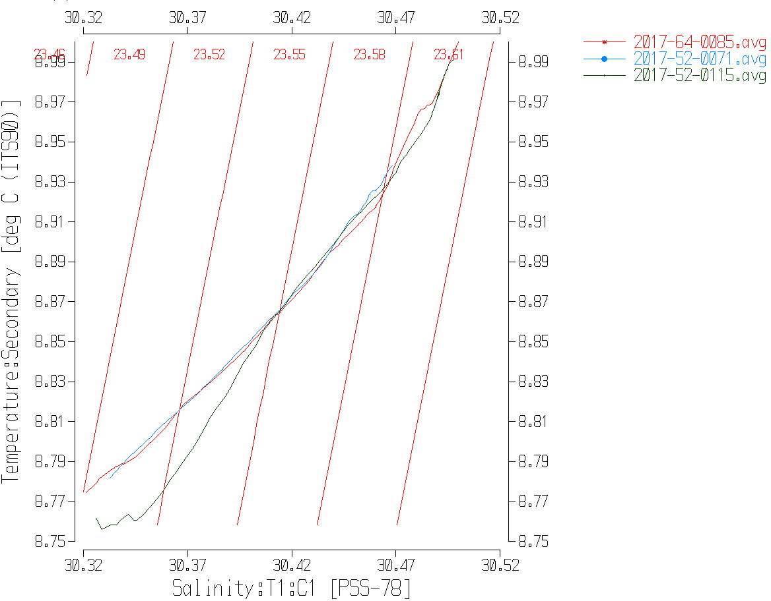
Dissolved oxygen data were also compared but it is harder to make a judgment on the calibration. Surface DO concentration and surface % DO saturation from 2017-64-0085 and 2017-52-0015 are very close, but the values from 2017-52-0071 are lower. Comparison along sigma-t lines gives a similar result at the surface. Below the surface the 2017-64 values are all higher than the 2017-52 values, so the latter are likely reading low. We expect that DO drift will lead to lower values. But with only 2 casts to compare from this cruise it is a big step to suggest a recalibration, particularly when the surface dissolved oxygen values may be less accurate than usual due to short soaks. We can just confirm that values are likely low by between 2 and 4%.

Historic Ranges – The temperature data were all within the local climatology except for 4 near-shore casts that had high temperatures near the surface (as deep at 30db for one cast, 20db for others). Salinity had low values at many of the same places. These excursions are to be expected in near shore data as the climatology is not well suited to near-shore areas and it is somewhat out of date.
Post-cruise calibrations – None were available.

CALIBRATE
There was no salinity sampling during this cruise. The comparison to 2017-64 salinity at one cast suggests that the data are accurate.
There was no dissolved oxygen sampling during this cruise. The comparison to 2017-64 dissolved oxygen at one cast suggests values are low but the results are not clear enough to justify recalibration.
The pressure does not need recalibration.
No recalibration was applied.

Bin Average and REMOVE and DO saturation study
The files were bin averaged using 1db bins.
REMOVE was run to remove Scan_Number, Conductivity:Primary, Oxygen:Voltage, Descent Rate and Flag channels.
Channel Fluorescence:URU:Wetlabs was removed from all except casts 46 to 100.
Dissolved Oxygen was derived in mass units and that was used to calculate DO saturation. Plots of near-surface saturation show values between 88% and 125%. The values do not look unreasonable for this region with the low values mostly from near-shore areas where vertical mixing may be strong.

REORDER was used to get the 2 dissolved oxygen channels together.

HEADER EDIT and final checks of CTD files.
Header Edit was used to fix headers, fix formats and channel names and to add the following note to the headers:
Data Processing Notes:
--------------------------------------------
Dissolved Oxygen and pH:SBE data are nominal and unedited, except that some
records were removed in editing temperature and salinity.

Channel Fluorescence:URU:Wetlabs was removed from most casts because the
protective cap had not been removed. The data that remain are nominal.

There was no calibration information available but the sensors had been
recalibrated at the factory fairly recently so little drift is expected.
Comparison with a cast from another cruise suggest that the salinity
values are accurate but that dissolved oxygen values may be low by 2-4 %.

The length of the surface soaks varied greatly, with many being long enough
for the pumps to come on and equilibration of pumped channels to be achieved.
For some the soak was too short for equilibration to occur until the CTD had
started the downcast.

For details on the processing see processing report: 2017-52-Processing_Report.doc.
A cross-reference listing was produced.
A header check was run on the CTD files. The only problem found was one very small negative number which was replaced with a 0. The program was rerun and no further errors were found.
The sensor history was updated.
Plots of CTD casts were examined and no problems were found.

CRUISE SUMMARY

Cruise ID#: 2017-52
Dates: Start: 20 June2017 End: 4 July 2017
Location: Strait of Georgia
Party Chief: Neville C.
CTD# | Make | Model | Serial# | Used with Rosette? | CTD Calibration Sheet Competed?
1 | SEABIRD | 25 | 0404 | No | Yes

CTD CALIBRATION INFORMATION
ake/Model/Serial#: SEABIRD/SBE25/0404 Cruise ID#: 2017-52
Sensor |  | Pre-Cruise |  | Post Cruise
Name | S/N | Date | Location | Date | Location
Temperature | 2449 | 16Dec2015 | Factory
Conductivity | 1764 | 23Feb2017 | Factory
pH | 0852 | 8Mar2017 | Factory
ECO Fluorometer | 4185 | 7Mar2017 | Factory
SBE43 Oxygen | 1176 | 2Mar2017 | Factory
Pressure | 482 | 28Feb2017 | Factory

