**Neocaligus Cruise IOS 2017-49**

**12-16 July 2017**

**Table 1.** Sampling stations

|  |  |  |  |  |  |  |
| --- | --- | --- | --- | --- | --- | --- |
| **Station** | **lat** | **lat mins** | **long** | **lon mins** | **Depth (m)** | **Samples** |
| CBE2 | 48 | 44.22 | -123 | 34.45 | 65 | CTD, net |
| SC-04 | 48 | 43.50 | -123 | 25.00 | 90 | CTD, net, phyto, chl-a |
| GI-01 | 48 | 45.86 | -123 | 20.53 | 65 | CTD, net |
| 46 | 48 | 51.4 | -123 | 10.8 | 176 | CTD, net |
| 41 | 49 | 3.3 | -123 | 22.3 | 245 | CTD, net, phyto, chl-a, SAL* |
| 40 | 49 | 8.6 | -123 | 36.8 | 146 | CTD, net |
| 38 | 49 | 12 | -123 | 26.4 | 300 | CTD, net, SAL* |
| GEO1 | 49 | 15 | -123 | 45 | 400 | CTD, net, phyto, chl-a, SAL* |
| CPF1 | 49 | 22 | -124 | 5 | 245 | CTD, net |
| 28 | 49 | 24.1 | -123 | 45.3 | 134 | CTD, net, chl-a |
| CPF2 | 49 | 28 | -124 | 30 | 325 | CTD, net, SAL* |
| BS-11 | 49 | 29 | -124 | 46 | 58 | CTD, net |
| 24 | 49 | 30.3 | -124 | 6 | 425 | CTD, net, SAL* |
| 22 | 49 | 40.2 | -124 | 16.3 | 353 | CTD, net, SAL* |
| 11 | 49 | 42.4 | -124 | 43.4 | 290 | CTD, net, phyto, chl-a |
| IS-2 | 49 | 38.2 | -124 | 5 | 30 | CTD, net |
| If timing allows: | |  |  |  |  |  |
| 59 | 48 | 36.96 | -123 | 14.978 | 225 | CTD, net |

*Note: really only need one deep SAL reference sample per day, but 5 locations indicated where it’s deep enough for a good reference. Where the SAL is taken *depends on the route taken during the cruise.*

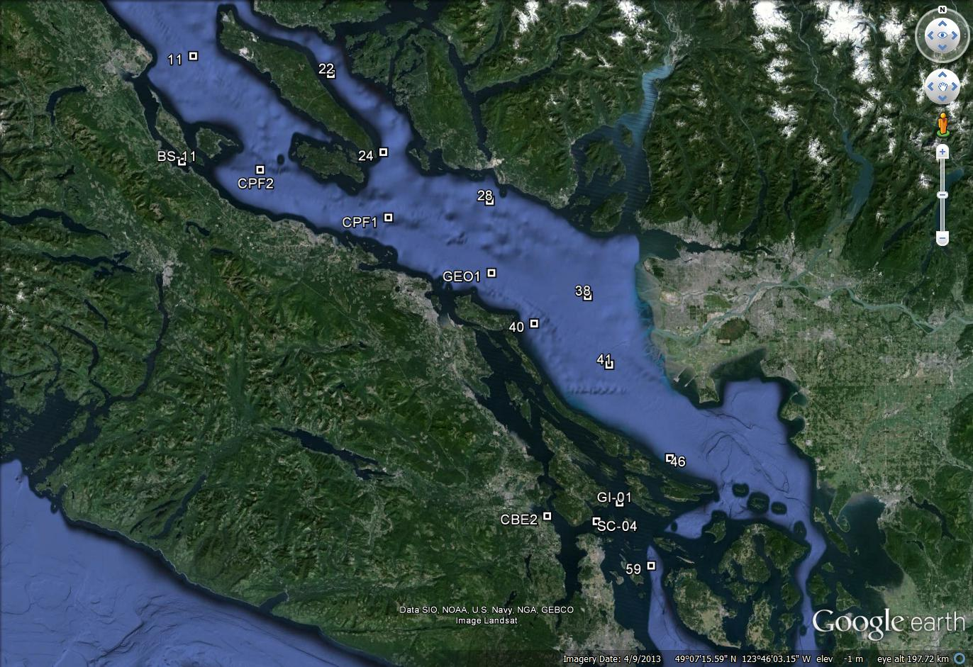

IS-2

**Figure 1**. Station locations for IOS 2017-47 Strait of Georgia zooplankton surveys.

**At each station, collect:**

* Full depth CTD profile including oxygen and fluorometer, using SBE 25+ CTD with SBE 43 DO and Wetlabs fluorometer sensors. **2 minute soak at start** (Turn on, down 10m and up, wait remaining time and start). **Note:** CTD fluorometer usually has an end cap that needs to be removed before the first cast!
* Full depth (10m off bottom to surface) zooplankton tow, using Bongo net with 250um black mesh. Preserved in 10% buffered formalin. Upcast speed approx. 1 m/s (with electric winch, will be slightly slower. Should not be less than 0.5 m/s). Net equipped with a TSK flowmeter and a RBRSolo that logs the net casts (depth and time).
* **NEW for Brian Hunt:** one side of bongo to be preserved in 10% buffered formalin, the other side to be processed for fatty acids/stable isotopes. Sample to be size-fractionated and each fraction transferred to whirlpak and frozen at -80C (dry shipper).

**At select stations, collect:**

*Salinity (SAL)* – at least one deep water (>200m) salinity sample (in duplicate) per day (approx.), using 1 L Niskin attached 1m above CTD to collect a near-bottom salinity sample during CTD cast (CTD sensor check). Record sample number, depth collected in log.

* To be collected at stations: 41, 38, GEO1, CPF2, 22, 24.

*Phytoplankton (phyto)* – surface phyto sample preserved with Lugol’s, collected with 1 L Niskin at surface; for taxonomy. Do not rinse jars (pre-filled with Lugol’s). Record event number, sample number in log.

* To be collected at stations: SC-04, 41, GEO1, 11
* Stations chosen because: SC-04- close to Lou Hobson’s station (historical site); 41 in plume; GEO1 for central; 11 for northern

*Chlorophyll-a (chl-a)* – Chl-a samples taken at surface and 5 m, at same stations as the phyto plus at Halibut Bank buoy (49.34,-123.72, near station 28). For comparison with Wetlabs fluorometer and for satellite and buoy data comparisons.

Water sampled with 1 L Niskin, 60-240 ml water (depending on how much phytoplankton is in the water; need some colour on the filter) filtered (in duplicate) with 140 ml syringe and 25 mm GF/F filters (same method as Citizen Science program). Store filter in scintillation vial and freeze at -20 °C (fridge freezer) until analyzed. *Record the sample number with the depth and volumes filtered in the cruise log*. Make sure labels have sample number and volume filtered as well.

* To be collected at stations: SC-04, 41, GEO1, 11, 28

**Housekeeping**

* There are 2 logs to fill out: cruise log and plankton log. Please fill out the cruise log with all events that occur, and give each event a number. Record BE, BO and EN time (note what time zone you are using! Eg: use local time if you want, but indicate so in the log and be consistent for the entire trip). **Check that the GPS has the correct time (needs to be manually changed between Daylight ST and PST. Plankton log – enter information for all plankton tows.
* Upload the CTD data at the end of the day. Make sure the laptop has the correct date and time before uploading. Upload the files individually (don’t do as a batch). When uploading the file, name them with standard format names such as 2017-07-0001.hex (or .xml for SBE25+) for event #1. Put location, station name, and bottom depth in the header (comments box) of the file, using the format in the “CTD Header.txt” file on the CTD laptop (the leading * and following : plus N and W are needed for processing)
* View the CTD data in Seasave to make sure everything looks good.
* Also check that the batteries have enough voltage, change if they drop below 10V (for SBE25+).
* Update the electronic cruise log (excel file) daily. Back up all files to USB.
* Run the Oziexplorer program with the GPS puck on the bridge every day, logging the cruise track and saving one per day.