REVISION NOTICE TABLE
DATE | DESCRIPTION OF REVISION

PROCESSING NOTES
Cruise: 2017-49
Agency: IOS, Ocean Sciences Division, Sidney BC
Party Chief: Belton M . Platform: Neocaligus
Location: Strait of Georgia Project: Strait of Georgia Zooplankton
Chief Scientist: Young K. Date: 12 July 2017 –16 July 2017

Processed by: Germaine Gatien
Date of Processing: 29 November 2017 – 1 December 2017
Number of original HEX files: 17
Number of CTD files: 17 Number of BOT files: 8 (1 contains no CTD data)

INSTRUMENT SUMMARY
A SeaBird Model SBE-25 CTD (s/n 1123) was used with temperature sensor #4888, conductivity sensor #3396, Wetlabs ECO Fluorometer #2214, dissolved oxygen sensor #3234, pump #8377 and pressure sensor 1123.

SUMMARY OF QUALITY AND CONCERNS
This cruise was part of a larger project that includes cruises 2017-07 (6 legs), 2017-26, 2017-47, 2017-48 and 2017-49. The same equipment was used for all 10 legs except for the conductivity sensor which was changed in late May 2017, between 2017-26 and 2017-48.

The log book was generally in good order though the equipment list was incomplete. No problems with equipment were reported.

The CTD was lowered to 10m, raised and held at 2m for until least 2 minutes had passed. The full cast was then run. This approach enables easy removal of the data from the soak period by removing 1920 records. This worked for all but 2 casts for which the initial drop was delayed so 3000 records had to be removed.

For most 2017 cruises run for this project, header information was entered in the raw files in a format that permitted easy conversion into IOS Header format. This is very helpful.

There were salinity samples gathered near the bottom from 4 casts. The comparisons from this cruise and 2017-47 and 2017-48 and cruise 2017-07 (last 3 legs) indicate that the CTD salinity is as close to bottles as we can expect given few samples, a lot of scatter in the comparison and uncertainties in how well the Niskin bottles flushed. Salinity is likely good to ±0.005psu.

Extracted chlorophyll samples were taken at the surface and 5m, on separate casts run shortly after CTD casts. There are not enough data in the comparison to see a clear relationship, but the usual pattern is seen of CTD fluorescence reading too high when extracted chlorophyll values are low and dropping relative to CHL as CHL increases.

There was no dissolved oxygen calibration sampling, so recalibration was based on the results of cruise 2017-01 when the same sensor was used and there was extensive calibration sampling.

Bottle files were produced combining CTD data with analysis results using a different approach for the different types of samples:
- The salinity samples were taken when the CTD was at the bottom of casts, about 1m above the CTD. CTD data were taken from the bottom values of the final files. Some bottom data are removed in editing the CTD files, reducing the 1m offset.
- The extracted CHL samples were taken following the CTD casts at 0m and 5m. There are no CTD data available from 0m, so data from 1m and 5m were used for the comparison.

PROCESSING SUMMARY
1. Seasave - This step was completed at sea. One file name had an extra digit; that was fixed.

2. Preliminary Steps
The Daily Log was obtained. The CTD pressure and fluorometer serial numbers were recorded but not those for the conductivity, temperature and DO sensors.

The deployment method used was as follows: The CTD was switched on, a 2-minute timer was started and the CTD was put in the water. It was taken down to 10m, up to the surface, wait at the surface at least until the 2 minutes were up. The cast was then started. If a salinity sample was needed a Niskin bottle was attached 1m above the CTD. The CTD was taken to 10m off the bottom where a Niskin was fired if needed. The CTD was then brought up and switched off as it was taken out of the water. This method is helpful as by removing the first 1920 records, the initial soak can be removed. In 2 cases there was a delay so more records will need to be removed for those. This is a quicker process then having to deal with every cast separately.

The cruise summary sheet was completed.

The parameters in the configuration provided were checked and were all correct. The file was saved as 2017-49-ctd.xmlcon.

3. Conversion of Raw Data
The XML files were converted using configuration file 2017-49-ctd.xmlcon.
Plots show that the channels all produced reasonable values.

4. WILDEDIT
Since there are no obvious spikes in the data, this step was skipped.

5. WFILTER
Based on tests run for other cruises in this project using the same equipment WFILTER was run using a cosine filter, size 7 on the pressure, depth, temperature and conductivity channels.

6. ALIGNCTD
Based on tests run for other cruises in this project using the same DO sensor, ALIGNCTD was run on all casts to advance the DO channel by 2s. Plots were examined after this step and the results look good.

7. CELLTM
SeaBird recommend the use of (α, 1/β) = (0.04, 8) for CELLTM for the SBE 25 and it proved best when this equipment was used during 2017-07.
CELLTM was run on all casts using (α, 1/β) = (0.04, 8).

8. DERIVE
Program DERIVE was run to calculate salinity and dissolved oxygen concentration (tau correction included). Plots were examined confirmed that steps 5, 6 and 7 had improved the data.

9. Conversion to IOS Headers
The IOSSHELL routine was used to convert the CNV files to IOS Headers.
CLEAN was run to add event numbers and replace pad values in the pressure channel with interpolated values.

10. Checking Headers
An initial track plot looked ok.

A cross-reference list was produced and compared with the log book entries. The only discrepancy was the position for event #31, station 59. Both are positions that are found for that site over the years, the log entry being the “new” position, the header the “old” position. The chief scientist determined that the log position was correct, so that information was corrected in the header of the IOS and CLN files and in the files in the DERIVE and CONVERT folders.

HEADER CHECK was run. There were a few slightly negative values in pressure and fluorescence, but they occur in sections of files that will likely be removed by DELETE. This will be checked again later.

The surface check shows an average of 0. 02db; values ranged from -0.02 to +0.06db. Salinity values were all very close to 0. Given that some data are acquired just as the CTD comes out of water, this result shows that the pressure sensor calibration was excellent.

The next step is to remove the data collected during soaks at 10m. For most casts, removing 1920 scans will do this since the downcast was usually started after 2 minutes. As long as data from the initial downcast are removed, then the rest of the soak will be removed by DELETE.
CLIP was run to remove 1920 records from each cast.
After this step plots were produced to check that there are no data left from the initial drop to the soak depth. For casts #20 and #38 the soak started late, so CLIP was rerun on those casts only to remove 3000 records.

11. SHIFT
Conductivity
During 2017-07, 2017-47 and 2017-48 when the same sensors were used, a setting of +1.2 records was found suitable to align the conductivity with pressure. Applying the same setting worked very well on these data as well.
SHIFT was run on all casts to apply a shift of +1.2 records.
Fluorescence
The fluorometer was not pumped, so a shift in alignment is expected to be small or unnecessary. Profile plots of temperature and fluorescence were examined and confirm that the alignment is ok.
Dissolved Oxygen
This channel was aligned earlier, but checks were made by examining plots of temperature and dissolved oxygen; no further adjustment was found appropriate.

12. DELETE
DELETE was run on all casts using the following parameters:
Surface Record Removal: Last Press Min. Surface Swell Pressure Tolerance: 1.0
Swells deleted. Warning message if pressure difference of 2.00
Drop rates < 0.3m/s (calculated over 7 points) was deleted from 10db to 10db above the maximum pressure.
COMMENTS ON WARNINGS: There were no warnings.

13. Initial Bottle Data Steps
There was no rosette available for this cruise. Samples were taken from a Niskin Bottle mounted about 1m above the CTD and then CHL samples were taken at 0m and 5m after the CTD cast. To enable searching of bottle data, BOT files were prepared. The samples at Halibut Bank have no corresponding CTD cast.

Each of the analysis spreadsheets were examined to see what comments the analysts wanted included in the header file. These were used to create file 2017-49-bot-hdr.txt which will be updated as needed during processing.
EXTRACTED CHLOROPHYLL
Extracted chlorophyll and phaeo-pigment data were obtained in file QF2017-49 CHL*.xls which included comments, flags and a precision study.
SALINITY
Salinity analysis was obtained in spreadsheet QF2017-49SAL*.xls.

Next, spreadsheet 2017-49-bottle_plus_CTD.csv was prepared. This will enable comparison of CTD data with salinity and chlorophyll samples. Data from the analysts’ spreadsheets were entered including sample numbers, event numbers and analysis results. Note that the DO data have not been recalibrated at this stage and there has been no graphical editing, so the extraction of CTD data will be repeated at a later stage. An initial comparison was done as a quality check and to guide recalibration of salinity.

A cast list of events with bottle samples was prepared. The DEL files for those casts were metre-averaged and thinned to 1m, 5m, and the bottom of the casts. They were exported to a spreadsheet and sample numbers were added. The order was changed to match the sample order – namely bottom, 1m, 5m. Lines were removed for which there was no sampling and then the data were added to the spreadsheet. Lines were added for the Halibut bank samples for which there are no CTD data available.

14. Compare
Salinity Comparison
The spreadsheet described in the previous section was saved as 2017-49-CTD-bottle-comparisons.xlsx. The 4 rows with salinity bottle samples were selected. A comparison was done between the bottle salinity and CTD salinity recorded at the bottom. The CTD was found to be higher than bottle salinity by an average of 0.0093psu with a standard deviation of 0.013psu.

The descent rate of the CTD was very steady for these casts so incomplete flushing of Niskin bottles is likely. This would be particularly significant if the vertical salinity gradient is high near the bottom as it was for many of these casts. So CTD salinity was measured also measured at 5 and 10m above the bottom to see what the effect on the comparison would be.
- For casts #1 and 7 the differences are smallest if the value at 10m above the CTD is used.
- For cast #18 the salinity at the bottom is closer to the bottle than those from higher in the water column. If the water did come from 10m above then the CTD is reading high by 0.01psu.
- For cast #24 the best match is with CTD data from 5m above the bottom.

Overall the CTD is reading high by an average of 0.009psu if we use the bottom value, low by an average of 0.0004psu if we use the 5m data and low by 0.0037psu if we use the 10m data. The standard deviation in those differences is lowest at 5m. Since the gradients are fairly high and flushing is unlikely to be perfect, it is unlikely that the CTD is high by as much as 0.009psu. If flushing is poor the CTD could be reading low by as much as 0.005psu. The CTD salinity is estimated to be reading within 0.005psu.

For more details see file 2017-49-CTD-bottle-comparisons.xlsx.

Fluorescence
The comparison of fluorescence with extracted chlorophyll is done for information only, not to assist in recalibration. Since there are some large spikes in the near-surface fluorescence, it is wise to wait until after the editing stage before attempting a comparison. So this step was done based on the final metre-averaged files.

The CHL samples were taken at 0m and 5m right after CTD casts. Since there are no reliable CTD data from 0m, the 1m data have been used for the comparison. For Halibut Bank there are no CTD data so no comparison is possible there.

Extracted CHL values ranged between 0.3 and 3.9ug/L. The fluorescence value for cast #1 at 1m was extremely high so was dropped from the comparison; it was about 27ug/L, while the CHL value was about 0.6ug/L. No other cast shows such an odd spiky surface character. In editing this file, the surface CTD fluorescence was removed. When that value is excluded, a plot of Fluorescence versus Chlorophyll has a slope of ~1.3 when forced through the origin. That is a typical result for this type of sensor when the chlorophyll values are mostly between <4ug/L.

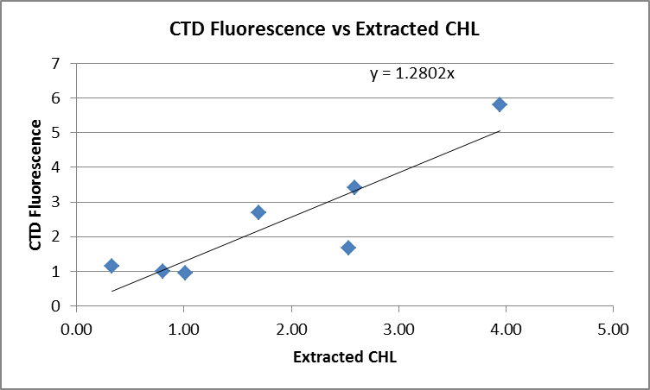

The plot of ratio FL/CHL vs CHL has the usual pattern with the fluorometer reading much higher than the extracted CHL when the latter values are very low and then dropping relative to CHL as CHL increases.

The ratio CTD FL/CHL is about 2 at 1m and 1.2 at 5m, probably reflecting the better match in depths at 5m.
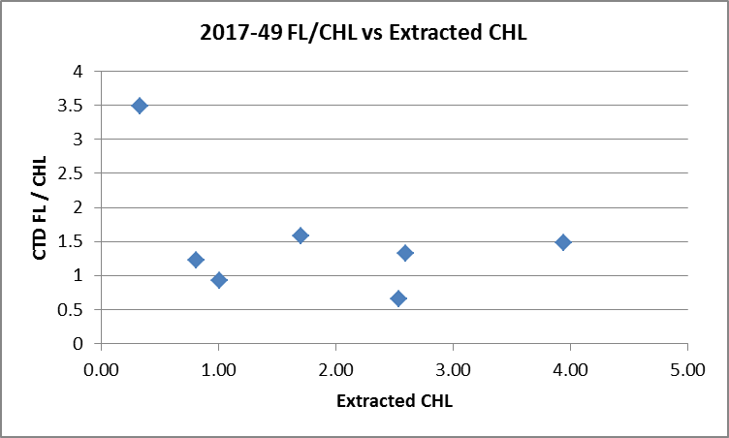

15. DETAILED EDITING
CTDEDIT was used to remove records near the top and bottom of many casts and records corrupted by shed wakes. It was also used to clean salinity where unstable features looked likely to be caused by misalignment of T and C. All casts required some editing.
Notes of editing details were made in the headers.
A second pass through CTDEDIT was run to examine the fluorescence data for event #1 based on what was observed in section 14. The data in the top 1m look unbelievably high in light of chlorophyll samples from the surface and observations for other casts in this project.

T-S plots were examined and no significant problems were found; there are small unstable features but this is an area where they are expected.

16. Other calibration checks
Sensor History – These sensors were used for 4 legs of cruise 2017-07. The CTD was found to read higher than bottles by about 0.0025psu. Descent rates varied from quiet to very noisy, so these data would include some well-flushed bottles while others were likely affected by inefficient flushing. During 2017-48 there were only a few bottles and conditions suggested flushing could be poor; salinity was thought to be within 0.005psu but evidence was weak. The only correction applied was to the DO sensor based on results from cruise 2017-01.

Comparison of repeat casts –There were no repeat casts.

Historic Ranges – The local climatology is not representative of some of the sites occupied during this study and they are mostly close to shore where a 3-standard deviation climatology is not suitable. The climatology is somewhat out of date and it is in an area subject to very high variations. All in all, it is not a very useful criterion to apply. However, finding systematic errors might alert us to trouble. All the temperature data fell within the climatology while salinity was slightly low at the bottom of Baynes Sound and at the surface near the Fraser River outflow. These excursions likely reflect real conditions rather than calibration problems.

Post-cruise calibrations – None were available.

17. CALIBRATE
CTD Salinity will not be recalibrated. The comparisons from this cruise and 2017-07 and 2017-48 indicate that the CTD salinity is as close to bottles as we can expect given the scatter in the comparison and uncertainties in how well the Niskin bottles flushed.
There was no dissolved oxygen sampling but the same sensor was used during 2017-01 with extensive off-shore calibration sampling so the results for that cruise will be applied to this one.
The pressure does not need recalibration.

CALIBRATE was run using file 2017-49-recal1.ccf to apply the following correction to the Dissolve Oxygen:.
CTD Dissolved Oxygen Corrected = 1.0484* CTD Dissolved Oxygen + 0.0413

18. Fluorescence Filter
A median filter, size 5, was applied to the fluorescence data.

19. Bin Average and REMOVE
The files were bin averaged using 1db bins.

REMOVE was run to remove Scan_Number, Conductivity:Primary, Oxygen:Voltage, Descent Rate and Flag channels.

Dissolved Oxygen was derived in mass units and that was used to calculate DO saturation. Plots of near-surface saturation show values between 100% and 135%. These data are not useful in assessing the accuracy of the dissolved oxygen data, but do not look unreasonable.

REORDER was used to get the 2 dissolved oxygen channels together.

20. HEADER EDIT and final checks of CTD files.
Header Edit was used to fix headers, fix formats and to add the following note to the headers:
Data Processing Notes:
----------------------
Dissolved Oxygen and Fluorescence are nominal and unedited, except
that some records were removed in editing temperature and salinity.

While the CTD fluorescence data are expressed in concentration units, they
do not always compare well to extracted chlorophyll samples, particularly for
casts far from shore. It is suggested that extracted chlorophyll values be
checked where available.

Comparison with 4 bottles had a lot of scatter and conditions suggest that
the Niskin bottles may not have flushed well. From previous cruises it is
thought that the CTD salinity may be reading slightly high, but is probably
within +/-0.005psu. There is insufficient evidence to justify recalibration.

There was no dissolved oxygen calibration sampling, so the recalibration used for
cruise 2017-01 was applied to these data since the same sensor was used and
calibration sampling was extensive.

For details on the processing see processing report: 2017-49-Processing_Report.doc.

A cross-reference listing was produced.
A header check was run on the CTD files and no further errors were found.
The sensor history was updated.
Plots of CTD casts were examined and no problems were found.

20. Final BOT file preparation
To enable searching of bottle data, BOT casts will be created that contain sample data and CTD data from the preceding downcast. The event number will match the CTD cast except for Event #4 at Halibut Bank which has no corresponding CTD data. For event #4 Depth:Nominal is entered since Depth:CTD is unavailable.

File 2017-49-bottle_plus_CTD.csv (which has a 6-line header) was updated by thinning final CTD files and exporting data to a spreadsheet so as to capture the effects of recalibrating DO data and applying graphical editing.

The new values were also entered into the bottle comparisons.
The spreadsheet file was converted to IOS Header files for each cast.
The time and date are present as channels as these cannot be changed directly into header entries.

CLEAN was run to add START and END time. The END TIME is identical so the START time so it will be removed later. CLEAN was also used to enter 0 flags where the flag channels are empty and to remove channels with only pad values.

REMOVE was run to remove the DATE and TIME channels.

HEADEDIT was used to add comments and to remove the END time and TIME ZERO.

The final files have extensions BOT.
A cross-reference list and header check were run on the BOT files. No problems were found.
Plots were made of all BOT casts and no problems were found.

PARTICULARS
33 & 34 – events listed in log after event 35.

CRUISE SUMMARY

Cruise ID#: 2017-49
Dates: Start: 21 May 2017 End: 24 May 2017
Location: Strait of Georgia
Party Chief: Romaine S.
CTD# | Make | Model | Serial# | Used with Rosette? | CTD Calibration Sheet Competed?
1 | SEABIRD | 25 | 1123 | No | Yes

CTD CALIBRATION INFORMATION
Make/Model/Serial#: SEABIRD/SBE25/1123 Cruise ID#: 2017-49

Calibration Information
Sensor |  | Pre-Cruise |  | Post Cruise
Name | S/N | Date | Location | Date | Location
Temperature | 4888 | 7Nov2015 | Factory
Conductivity | 3396 | 22Dec2015 | Factory
ECO Fluorometer | 2214 | 02Jun2017 | ?
SBE43 Oxygen | 3234 | 11Nov2015 | Factory
Pressure | 1123 | 23May2014 | Factory

