REVISION NOTICE TABLE
DATE | DESCRIPTION OF REVISION

PROCESSING NOTES
Cruise: 2017-48
Agency: IOS, Ocean Sciences Division, Sidney BC
Party Chief: Romaine S. Platform: Neocaligus
Location: Strait of Georgia Project: Strait of Georgia Zooplankton
Chief Scientist: Young K. Date: 21 May 2014 – 24 May 2017

Processed by: Germaine Gatien
Date of Processing: 19 June 2017 – 29 November 2017
Number of original HEX files: 16
Number of CTD files: 16 Number of BOT files: 7

INSTRUMENT SUMMARY
A SeaBird Model SBE-25 CTD (s/n 1123) was used with temperature sensor #4888, conductivity sensor #3396, Wetlabs ECO Fluorometer #2214, dissolved oxygen sensor #3234, pump #8377 and pressure sensor 1123.

SUMMARY OF QUALITY AND CONCERNS
This cruise was part of a larger project that includes cruises 2017-07 (6 legs), 2017-26, 2017-47, 2017-48 and 2017-49. The same equipment was used for all 10 legs except for the conductivity sensor which was changed in late May 2017, between 2017-26 and 2017-49.

The log book was in good order.

The CTD was lowered to 10m, raised and held at 2m for until least 2 minutes had passed. The full cast was then run. This approach enables easy removal of the data from the soak period by removing 1920 records. This worked for all but 1 cast for which the initial drop was delayed so 2500 records had to be removed.

For most 2017 cruises run for this project, header information was entered in the raw files in a format that permitted easy conversion into IOS Header format. That was not done for this cruise, so header information had to be added in a separate step.

There were salinity samples gathered near the bottom from 3 casts. The comparisons from this cruise and cruise 2017-07 (last 3 legs) indicate that the CTD salinity is as close to bottles as we can expect given few samples, a lot of scatter in the comparison and uncertainties in how well the Niskin bottles flushed.

Extracted chlorophyll samples were taken at the surface and 5m, on separate casts run shortly after CTD casts. There are not enough data in the comparison to see a clear relationship, but it does show the usual pattern of CTD fluorescence reading too high at low CHL and too low at higher CHL.

There was no dissolved oxygen calibration sampling, so recalibration was based on the results of cruise 2017-01 when the same sensor was used and there was extensive calibration sampling.

Bottle files were produced combining CTD data with analysis results using a different approach for the different types of samples:
- The salinity samples were taken when the CTD was at the bottom of casts, about 1m above the CTD. CTD data were taken from the bottom values of the final files. Some bottom data are removed in editing; this plus bin-averaging probably means the CTD data come from close to the sampling depth.
- The extracted CHL samples were taken following the CTD casts at 0m and 5m. There are no CTD data available from 0m, so data from 1m and 5m were used for the comparison.

PROCESSING SUMMARY
1. Seasave - This step was completed at sea.

2. Preliminary Steps
The Daily Log was obtained.

The deployment method used was as follows: The CTD was switched on, a 2-minute timer was started and the CTD was put in the water. It was taken down to 10m, up to the surface, wait at the surface at least until the 2 minutes were up. The cast was then started. If a salinity sample was needed a Niskin bottle was attached 1m above the CTD. The CTD was taken to 10m off the bottom where a Niskin was fired if needed. The CTD was then brought up and switched off as it was taken out of the water. This method is helpful as by removing the first 1920 records, the initial soak can be removed.

The cruise summary sheet was completed.

The parameters in the configuration provided were checked and were all correct. The file was saved as 2017-48-ctd.xmlcon.

3. Conversion of Raw Data
The XML files were converted using configuration file 2017-48-ctd.xmlcon.
Plots show that the channels all produced reasonable values.

4. WILDEDIT
Since there are no obvious spikes in the data, this step was skipped. Once the data are converted to IOS SHELL, plotting should be done to ensure that spikes are not a problem.

5. WFILTER
Based on tests run for other cruises in this project using the same equipment WFILTER was run using a cosine filter, size 7 on the pressure, depth, temperature and conductivity channels. Plots were made before and after this step.

6. ALIGNCTD
Based on tests run for other cruises in this project using the same DO sensor, ALIGNCTD was run on all casts to advance the DO channel by 2s. Plots were examined after this step and the results look good.

7. CELLTM
SeaBird recommend the use of (α, 1/β) = (0.04, 8) for CELLTM for the SBE 25 and it proved best when this equipment was used during 2017-07.
CELLTM was run on all casts using (α, 1/β) = (0.04, 8).

8. DERIVE
Program DERIVE was run to calculate salinity and dissolved oxygen concentration (tau correction included). Plots were examined confirmed that steps 5, 6 and 7 had improved the data.

9. Conversion to IOS Headers
The IOSSHELL routine was used to convert the CNV files to IOS Headers.
CLEAN was run to add event numbers and replace pad values in the pressure channel with interpolated values.

The latitude, longitude, station names and bottom depths were not in the headers. Spreadsheet 2017-48-header-merge.csv was prepared with information taken from file 2017-48_event_log.xlsx which was provided by the chief scientist. Formats were adjusted and then program MERGE: CSV file to Headers was run to add the information to the headers. For all other cruises in this program, this step was avoided by entering the information in the headers of the raw files using a standard format. Some of these files had the required information but the format did not allow automatic conversion to IOS Headers.

10. Checking Headers
An initial track plot looked ok.

A cross-reference list was produced and compared with the log book entries. Two errors were found:
- Event 10 has a start time that is 1 hour later than found in the log book and in the event spreadsheet and is clearly wrong based on the order of events. The start time was changed in the header.
- Event 15 should have been event 14, so the file name was changed at all stages of processing and event number was fixed in the MRH file. Spreadsheets were also updated, as needed.

HEADER CHECK was run. There were a few slightly negative values in pressure and fluorescence, but they occur in sections of files that will be removed by DELETE. This will be checked again later.

The surface check shows an average of 0. 02db; values ranged from -0.04 to +0.08db. Salinity values were all very close to 0. Given that some data are acquired just as the CTD comes out of water, this result shows that the pressure sensor calibration was good.

The next step is to remove the data collected during soaks at 10m. For most casts, removing 1920 scans will do this since the downcast was usually started after 2 minutes. As long as data from the initial downcast are removed, then the rest of the soak will be removed by DELETE.
CLIP was run to remove 1920 records from each cast.
After this step plots were produced to check that there are no data left from the initial drop to the soak depth. For cast #12 the soak started late, so CLIP was rerun on that cast only to remove 2500 records.

11. SHIFT
Conductivity
During 2017-07 when the same sensors were used, a setting of +1.2 records was found suitable to align the conductivity with pressure. Applying the same setting worked very well on these data as well.
SHIFT was run on all casts to apply a shift of +1.2 records.
Fluorescence
The fluorometer was not pumped, so a shift in alignment is expected to be small or unnecessary. Profile plots of temperature and fluorescence were examined and confirm that the alignment is ok.
Dissolved Oxygen
This channel was aligned earlier, but checks were made by examining plots of temperature and dissolved oxygen; no further adjustment was found appropriate.

12. DELETE
DELETE was run on all casts using the following parameters:
Surface Record Removal: Last Press Min. Surface Swell Pressure Tolerance: 1.0
Swells deleted. Warning message if pressure difference of 2.00
Drop rates < 0.3m/s (calculated over 7 points) was deleted from 10db to 10db above the maximum pressure.
COMMENTS ON WARNINGS: There were no warnings.

13. Initial Bottle Data Steps
There was no rosette available for this cruise. Samples were taken from a Niskin Bottle mounted about 1m above the CTD and then CHL samples were taken at 0m and 5m after the CTD cast. To enable searching of bottle data, BOT files were prepared.

First, each of the analysis spreadsheets were examined to see what comments the analysts wanted included in the header file. These were used to create file 2017-48-bot-hdr.txt which will be updated as needed during processing.
EXTRACTED CHLOROPHYLL
Extracted chlorophyll and phaeo-pigment data were obtained in file QF2017-48 CHL*.xls which included comments, flags and a precision study.
SALINITY
Salinity analysis was obtained in spreadsheet QF2017-48SAL*.xls.

Next, spreadsheet 2017-48-bottle_plus_CTD.csv was prepared. This will enable comparison of CTD data with salinity and chlorophyll samples. Data from the analysts’ spreadsheets were entered including sample numbers and event numbers plus the analysis results.

The DEL files were metre-averaged and thinned to 1m, 5m, and the bottom of the casts. They were exported to a spreadsheet and the order changed to match the sample order – namely bottom, 1m, 5m. Lines were removed for which there was no sampling and then the data were added to the spreadsheet. Note that the DO data have not been recalibrated at this stage and mass units have not been derived. Also there has been no graphical editing, so this step should be repeated at a later stage. For now, it is only used to do comparisons before the recalibration step.

14. Compare
Salinity Comparison
The DEL files were metre-averaged and thinned to a bottom value and exported to a spreadsheet. They were combined with the salinity bottle data described in the previous section and saved as 2017-48-CTD-bottle-comparisons.xlsx.

There were 3 bottle samples taken from a Niskin bottle mounted about 1m above the CTD. A comparison was done between these values and CTD values recorded at the bottom. The CTD salinity was found to be higher than the bottle salinity by 0.0201 (event #1), 0.0043 (event #8) and 0.0147psu (event #16). The descent rate of the CTD was quite steady for these casts so incomplete flushing of Niskin bottles is likely. The salinity profiles near the bottom show that the local vertical salinity gradient was highest for event #1 and smallest for event #8. The pattern suggests that part of the differences between bottle and CTD salinity is due to poor flushing. If those bottles contained water collected 10m above the level at which they were closed we would expect the CTD salinity to read higher by 0.015, 0.002 and 0.0045psu. With only 3 bottles and a large scatter, recalibration of salinity is not justified, but it looks likely that the CTD is reading within 0.005psu.

For more details see file 2017-48-CTD-bottle-comparisons.xlsx.

Fluorescence
The CHL samples were taken at 0m and 5m right after CTD casts. Since there are no reliable CTD data from 0m, the 1m data have been used for the comparison.

Extracted CHL values ranged between 0.4 and 5.7ug/L. The CTD fluorescence values show the usual pattern of the fluorometer reading much higher than the extracted CHL when the latter values are low. The fluorescence drops relative to CHL as CHL increases. For this cruise the fluorometer is reading slightly lower than expected for CHL values between 1 and 5ug/L, but given so few points of comparison this is not considered significant as there is usually a large scatter. The absence of duplicates for some of the CHL data increases the uncertainty.

There is little difference between the 1m and 5m comparisons, so having to choose CTD data from 1m does not appear to a serious problem.

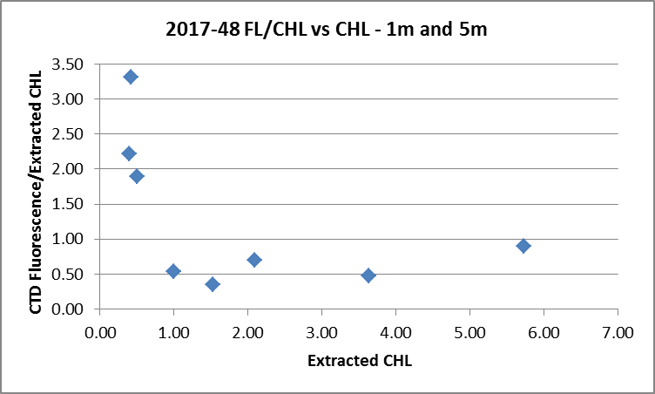

The fit of CTD fluorescence versus Extracted chlorophyll has a slope of 0.77 when forced through the origin.
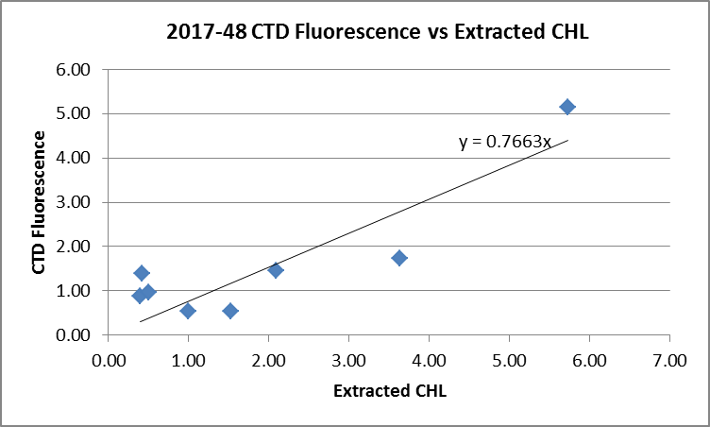

15. DETAILED EDITING
CTDEDIT was used to remove records near the top and bottom of many casts and records corrupted by shed wakes. It was also used to clean salinity where unstable features looked likely to be caused by misalignment of T and C. All casts required some editing.

A few casts required extensive editing due to sections where there may have been some problems with the plumbing. A test was made to see if small adjustments to the SHIFT setting would help but they did not. Upcasts were even worse than downcasts. Editing of salinity was more extensive for casts #20 to #32, with the worst problems being seen in cast #22.
Notes of editing details were made in the headers.

T-S plots were examined and no significant problems were found; there are small unstable features but this is an area where they are expected.

16. Other calibration checks
Sensor History – These sensors were used for 4 legs of cruise 2017-07. The CTD was found to read higher than bottles by about 0.0025psu. Descent rates varied from quiet to very noisy, so these data would include some well-flushed bottles while others were likely affected by inefficient flushing. The only correction applied was to the DO sensor based on results from cruise 2017-01.

Comparison of repeat casts –There were no repeat casts.

Historic Ranges – The local climatology is not representative of some of the sites occupied during this study and they are mostly close to shore where a 3-standard deviation climatology is not suitable. The climatology is somewhat out of date and it is in an area subject to very high variations. All in all, it is not a very useful criterion to apply. However, finding systematic errors might alert us to trouble. All the temperature and salinity data below 50m fell within the climatology but there were many excursions towards low salinity and high temperature in the top 20m to 50m. Given there are both temperature and salinity excursions at the same depths, they likely reflect real conditions rather than calibration problems.

Post-cruise calibrations – None were available.

17. CALIBRATE
CTD Salinity will not be recalibrated. The comparisons from this cruise and 2017-07 indicate that the CTD salinity is as close to bottles as we can expect given the scatter in the comparison and uncertainties in how well the Niskin bottles flushed.
There was no dissolved oxygen sampling but the same sensor was used during 2017-01 with extensive off-shore calibration sampling so the results for that cruise will be applied to this one.
The pressure does not need recalibration.

CALIBRATE was run using file 2017-48-recal1.ccf to apply the following correction to the Dissolve Oxygen:.
CTD Dissolved Oxygen Corrected = 1.0484* CTD Dissolved Oxygen + 0.0413

18. Fluorescence Filter
A median filter, size 5, was applied to the fluorescence data.

19. Bin Average and REMOVE
The files were bin averaged using 1db bins.

REMOVE was run to remove Scan_Number, Conductivity:Primary, Oxygen:Voltage, Descent Rate and Flag channels.

Dissolved Oxygen was derived in mass units and that was used to calculate DO saturation. Plots of near-surface saturation show values between 95% and 140%. This is close to the results of 2017-26 which was earlier in May. These data are not useful in assessing the accuracy of the dissolved oxygen data, but do not look unreasonable.

REORDER was used to get the 2 dissolved oxygen channels together.

20. HEADER EDIT and final checks of CTD files.
Header Edit was used to fix headers, fix formats and to add the following note to the headers:
Data Processing Notes:
----------------------
Dissolved Oxygen and Fluorescence are nominal and unedited, except
that some records were removed in editing temperature and salinity.

While the CTD fluorescence data are expressed in concentration units, they
do not always compare well to extracted chlorophyll samples, particularly for
casts far from shore. It is suggested that extracted chlorophyll values be
checked where available.

Comparison with 3 bottles suggests that the CTD salinity may be reading slightly
high. There is insufficient evidence to justify recalibration.

There was no dissolved oxygen calibration sampling, so the recalibration used for
cruise 2017-01 was applied to these data since the same sensor was used and
calibration sampling was extensive.

For details on the processing see processing report: 2017-48-Processing_Report.doc.
A cross-reference listing was produced.
A header check was run on the CTD files and no further errors were found.
The sensor history was updated.
Plots of CTD casts were examined and no problems were found.

20. Final BOT file preparation
To enable searching of bottle data, BOT casts will be created that contain sample data and CTD data from the preceding downcast.

File 2017-48-bottle_plus_CTD.csv (which has a 6-line header) was updated by thinning final CTD files and exporting data to a spreadsheet so as to capture the effects of recalibrating DO data and applying graphical editing.

Checks were made to see if using the new values were had much effect on the bottle comparisons. The new salinity had no significant effect on the comparison with bottles. The updated fluorescence values had a greater effect on the comparison at 1m, likely because some near-surface data was removed in editing so the depth match is poorer. The 5m comparison did not differ greatly.

The spreadsheet file was converted to IOS Header files for each cast.
The time and date are present as channels as these cannot be changed directly into header entries.

CLEAN was run to add START and END time. The END TIME is identical so the START time so it will be removed later. CLEAN was also used to enter 0 flags where the flag channels are empty and to remove channels with only pad values.

REMOVE was run to remove the DATE and TIME channels.

HEADEDIT was used to add comments and to remove the END time and TIME ZERO.

The final files have extensions BOT.
A cross-reference list and header check were run on the BOT files. No problems were found.
Plots were made of all BOT casts and no problems were found.

PARTICULARS

1. Sal samples at bottom 1m above CTD – Fluorometer cap left on.
8. Sal samples at bottom – 1m above CTD.
16. Sal samples at bottom – 1m above CTD
24. Rough seas

CRUISE SUMMARY

Cruise ID#: 2017-48
Dates: Start: 21 May 2017 End: 24 May 2017
Location: Strait of Georgia
Party Chief: Romaine S.
CTD# | Make | Model | Serial# | Used with Rosette? | CTD Calibration Sheet Competed?
1 | SEABIRD | 25 | 1123 | No | Yes

CTD CALIBRATION INFORMATION
Make/Model/Serial#: SEABIRD/SBE25/1123 Cruise ID#: 2017-48

Calibration Information
Sensor |  | Pre-Cruise |  | Post Cruise
Name | S/N | Date | Location | Date | Location
Temperature | 4888 | 7Nov2015 | Factory
Conductivity | 3396 | 22Dec2015 | Factory
ECO Fluorometer | 2214 | 02Jun2017 | ?
SBE43 Oxygen | 3234 | 11Nov2015 | Factory
Pressure | 1123 | 23May2014 | Factory
