REVISION NOTICE TABLE
DATE | DESCRIPTION OF REVISION

PROCESSING NOTES
Cruise: 2017-47
Agency: IOS, Ocean Sciences Division, Sidney BC
Chief Scientist: Young K. Platform: Neocaligus
Location: Strait of Georgia Project: Strait of Georgia Zooplankton
Date: 6 March 2017 – 1 September 2017

Processed by: Germaine Gatien
Date of Processing: 20 November 2017 – 24 November 2017
Number of original XML files: 17
Number of CTD files: 17 Number of BOT files: 7

INSTRUMENT SUMMARY
A SeaBird Model SBE-25 CTD (s/n 1123) was used with temperature sensor #4888, conductivity sensor #4513, Wetlabs ECO Fluorometer #2214, dissolved oxygen sensor #3234, pump #8377 and pressure sensor 1123.

SUMMARY OF QUALITY AND CONCERNS
This cruise was part of a larger project that includes cruises 2017-07 (6 legs), 2017-26, 2017-47, 2017-48 and 2017-49. The same equipment was used for all 10 legs except for the conductivity sensor which was changed in late May 2017, between 2017-26 and 2017-48.

The log book was in good order.

The CTD was generally lowered to 10m, raised and held at 2m until about 2 minutes had passed. The full cast was then run. This approach enabled easy removal of the data from the initial drop period by removing the first 1850 records.

There were salinity samples gathered near the bottom of 3 casts, but in one case the Niskin clearly closed well above the target depth. The 2 available samples suggest that the CTD was reading slightly low, but if we allow for poor flushing of Niskin bottles it may be reading somewhat lower than it appears. Nonetheless, it is unlikely that the CTD salinity is reading low by more than 0.005. Damage was noted in the conductivity sensor in mid-May, so it is good to see evidence that it was working reasonably well for this cruise.

Extracted chlorophyll samples were taken at the surface and 5m, on 7 casts run shortly after CTD casts. The comparison with CTD fluorescence is noisy but shows the usual pattern of CTD fluorescence reading too high at very low CHL and too low at high CHL.

There was no dissolved oxygen calibration sampling. Recalibration was applied based on the results of cruise 2017-01 when there was extensive calibration sampling for this DO sensor.

Bottle files were produced combining analysis results with appropriate CTD data.

PROCESSING SUMMARY
1. Seasave - This step was completed at sea. Two files were downloaded with non-standard names but they had also been saved with standard names.

2. Preliminary Steps
- The Daily Log was obtained.
- The deployment method used was as follows: The CTD was switched on, a 2-minute timer was started and the CTD was put in the water. It was taken down to 10m, up to the surface with a wait at the surface at least until the 2 minutes were up. The cast was then started. If a deep sample was needed the Niskin bottle was attached above the CTD (1m above for cast 1 and 4m for cast 18). The CTD was taken to 10m off the bottom where a Niskin was fired if needed. The CTD was then brought up and switched off as it was taken out of the water. This method is helpful as by removing the first 1920 records, the initial soak can be removed. If CHL samples were needed they were collected immediately after the CTD cast.
- The cruise summary sheet was completed.
- The parameters in the configuration file provided were checked and were all correct. The file was saved as 2017-47-ctd.xmlcon.

3. Conversion of Raw Data
The XML files were converted using configuration file 2017-47-ctd.xmlcon.
Plots of a few casts show that the channels all produced reasonable values. Descent rates were very steady. Fluorescence looks “steppy” as noted during Legs 1 & 2 of cruise 2017-07.

4. WILDEDIT
Since there are no obvious spikes in the data, this step was skipped.

5. WFILTER
In processing 2017-07 with the same sensors in use, a filter of size 7 was found best. Plots for this cruise show small steps in pressure but no reversals. Tests were run on a few casts using cosine filters of size 3, 5, 7, 9 and 11. Increasing the filter size reduces unstable features in T-S space, but those features mostly look like a result of misalignment of the temperature and conductivity rather than jitter in the original signals. Using a filter size 3 looks sufficient to make the pressure increase steadily, but tests show that even after aligning conductivity small instabilities in T-S space occur. When a size 7 filter is applied those mostly disappear after alignment. So the windows filter is clearly useful.
WFILTER was run using a cosine filter, size 7 on the pressure, depth, temperature and conductivity channels.

6. ALIGNCTD
Tests were run on a few casts to see what alignment made the offset between the upcast and downcast DO traces resemble that for the temperature traces. An advance of 2s produced the best results.
ALIGNCTD was run on all casts to advance the DO channel by 2s.

7. CELLTM
SeaBird recommend the use of (α, 1/β) = (0.04, 8) for CELLTM for the SBE 25 and it has proved best in the past. A few tests proved were run using other settings, but there was little difference, so the default setting was used.
CELLTM was run on all casts using (α, 1/β) = (0.04, 8).

8. DERIVE
Program DERIVE was run to calculate salinity and dissolved oxygen concentration (tau correction included). Plots were examined confirmed that steps 5, 6 and 7 had improved the data.

9. Conversion to IOS Headers
The IOSSHELL routine was used to convert the CNV files to IOS Headers.
CLEAN was run to add event numbers and replace pad values in the pressure channel with interpolated values.

10. Checking Headers
- A cross-reference list was produced and used to check against the log records. This showed there was an error in the latitude for event #4, which was confirmed by a track plot check. The latitude was changed to match the log book entry, after which the track plot looks fine. The log entry is close to positions for that site during 2017-07. The latitude entry was correct in the original file except that there was no space between the number and hemisphere entry; so the exact format for these entries is critical.
- Track plots were produced for event #s and station names and added to the end of this report.
- HEADER CHECK was run. There were many negative and off-scale values that are likely due to spikes during the soak period.
- The surface check shows an average of 0.8db.
- The next step is to remove the data collected during soaks at 10m. For most casts, removing 1900 scans will do this since the downcast was usually started at the 2 minute mark and the data were acquired at 16Hz. As long as data from the initial downcast are removed, then the rest of the soak will be removed by DELETE.
- Plots were made to identify casts for which removing 1920 records will be appropriate to remove the soak period for all casts, and to record a setting that will work. It was found that 1920 worked well for all but a few casts, but using 1850 will work for all casts without leaving any data that will not be removed by DELETE.

CLIP was run to remove 1850 records from all casts.

After this step plots were produced to check that there are no data left from the initial drop to the soak depth. No problems were found.

11. SHIFT
Conductivity
During 2017-07 when the same sensor was used a setting of +1.2 records was found suitable to align the conductivity with pressure. Applying the same setting worked very well on these data as well. One unstable feature was found in a T-S plot that could be improved by using a slightly higher setting, but that seemed to overcorrect other features.
SHIFT was run on all casts to apply a shift of +1.2 records.
Fluorescence
The fluorometer was not pumped, so a shift in alignment is expected to be small or unnecessary. Profile plots of temperature and fluorescence were examined and confirm that the alignment is ok.
Dissolved Oxygen
This channel was aligned earlier, but checks were made by examining plots of temperature and dissolved oxygen; no further adjustment was found appropriate.

12. DELETE
DELETE was run on all casts using the following parameters:
Surface Record Removal: Last Press Min. Surface Swell Pressure Tolerance: 1.0
Swells deleted. Warning message if pressure difference of 2.00
Drop rates < 0.3m/s (calculated over 7 points) was deleted from 10db to 10db above the maximum pressure.
COMMENTS ON WARNINGS: There were no warnings.
Plots were made of pressure versus scan number to ensure there are sufficient surface data and no problems were found.

13. Initial Bottle Data Steps
There was no rosette in use during this cruise. Salinity samples were taken from a Niskin Bottle mounted either 1m or 4m above the CTD. Chlorophyll samples were taken at 0m and 5m on a separate cast. To enable searching of bottle data, BOT files were prepared.

First, each of the analysis spreadsheets were examined to see what comments the analysts wanted included in the header file. These were used to create file 2017-47-bot-hdr.txt which will be updated as needed during processing.
EXTRACTED CHLOROPHYLL
Extracted chlorophyll and phaeo-pigment data were obtained in file QF2017-47chl*.xls which included comments, flags and a precision study.
SALINITY
Salinity analysis was obtained in spreadsheet file QF2017-47 SAL*.xlsx.

Next, spreadsheet 2017-47-bottle_plus_CTD.csv was prepared with a 6-line header. This will enable comparison of CTD data with salinity and chlorophyll samples. The data from the analysis spreadsheets were copied into that file. For CHL, the only CTD data available are from the cast that had just finished when the samples were taken, so the associated CTD event numbers were entered for the chlorophyll samples. Those event numbers will be used later when the BOT files are created.

14. Compare
The spreadsheet data were separated into two groups, one containing the salinity samples and the other the extracted chlorophyll samples.
To obtain suitable CTD data for comparison with the samples, the DEL files were bin-averaged.
- The binned files were then thinned to 1m and 5m for the chlorophyll. Since there are few data above 1m, that value was used instead of 0m. Data were then extracted from those files and added to the respective comparison spreadsheets.
- For the salinity samples there were only 3 samples and one was clearly not from the intended depth. There are extensive notes in the log about a problem with the messenger getting caught on wire marking during event #1 and the bottle salinity shows that the sample came from well above the level of the CTD when the messenger was sent. Since there was no other sampling from that cast and the salinity is of no value, the line was removed from the spreadsheet. For Event #8 the Niskin bottle was attached 4m above the CTD while for Event #18 it was at the usual level, 1m above the CTD.
The spreadsheet was saved as 2017-47-bottle-comparisons.xlsx.

Salinity Comparison
There are only 2 bottles suitable for comparison. They indicate that the CTD was reading lower than bottles by 0.0001 and 0.0012. Conditions were calm, so we expect that the CTD should read a little higher than bottles if calibration is perfect since the bottles likely did not flush perfectly so they would contain water from a little higher in the water column where salinity is lower. The vertical gradient was lower for cast #18 than #8 so that difference is likely the more reliable one. So the CTD salinity may be reading a little low, but likely by no more than 0.005psu. The evidence is too weak to justify recalibration. The conductivity sensor was found to be damaged in mid-May 2017, so this result is important in establishing that it was performing well during this cruise.

Fluorescence
The CHL samples were taken at 0m and 5m right after CTD casts.
The binned files were thinned to 1 and 5m, since there are few reliable CTD data from 0m. The thinned files were exported to a spreadsheet file and added to the bottle comparison spreadsheet.

The average and median values of ratio FL/CHL was ~0.6. The standard deviation was ~0.3. These ratios are a little lower than usual, but the extracted chlorophyll values were relatively high.
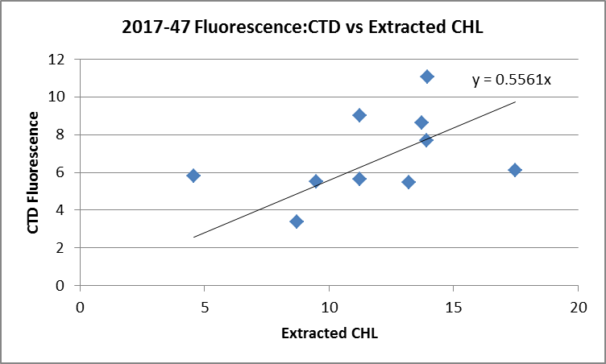

Based on past experience with these fluorometers, we expect the CTD fluorescence to read higher than CHL when CHL<1ug/L and fairly close to CHL between 1 and 5ug/L. For CHL>5ug/L the CTD sensors generally read lower approaching values about 50% of the CHL. These data fit that pattern.

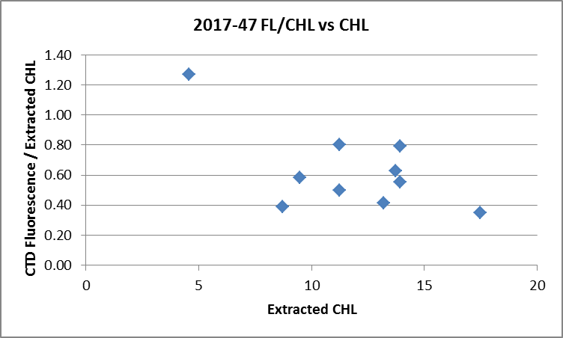

The results are very similar to others found using CTD fluorometers.
For more details see file 2017-47-bottle-comparisons.xlsx.

15. DETAILED EDITING
CTDEDIT was used to remove records near the surface and records corrupted by shed wakes mostly near the bottom of casts. It was also used to clean salinity where unstable features looked likely to be caused by misalignment of T and C. All casts required some editing.
Notes of editing details were made in the headers.
T-S plots were examined and no significant problems were found; there are small unstable features but in areas where vertical mixing is strong so that is expected.

16. Other calibration checks
Sensor History – The pressure sensor was used during 2016-29 and 2017-07; no problems were detected. The temperature and conductivity sensors were used during 2016-29 but for only 4 casts with no calibration sampling and during 2017-07 when salinity compared well with the CTD. The only use of the DO sensor with good calibration sampling since the last factory check was during 2017-01.
Comparison of repeat casts –There were no repeat casts.
Historic Ranges – The local climatology is not representative of some of the sites occupied during this study and they are mostly close to shore where a 3-standard deviation climatology is not suitable. Despite that, the temperature data all fell within the climatology and the only excursions in the salinity data were some low values in the top 20m in the north-east section of the cruise.
Post-cruise calibrations – None were available.

17. CALIBRATE
CTD Salinity will not be recalibrated as it appears to be as close to bottles as we can expect given the scatter in the comparison.
There was no dissolved oxygen sampling so the results from 2017-01 will be applied.
The pressure does not appear to need recalibration.

CALIBRATE was run using file 2017-47-recal1.ccf to apply the following correction to the Dissolved Oxygen channel:
CTD Dissolved Oxygen Corrected = 1.0484* CTD Dissolved Oxygen + 0.0413

18. Fluorescence Filter
A median filter, size 5, was applied to the fluorescence data as they are spiky.

19. Bin Average and REMOVE
The files were bin averaged using 1db bins.

REMOVE was run to remove Scan_Number, Conductivity:Primary, Oxygen:Voltage, Descent Rate and Flag channels.

Dissolved Oxygen was derived in mass units and that was used to calculate DO saturation. Plots of near-surface saturation show values between 85% and 135%; the only value <100% was from a cast that was very well mixed vertically. The highest values are associated with high near-surface DO gradients. The values look reasonable.

REORDER was used to get the 2 dissolved oxygen channels together.

20. HEADER EDIT and final checks of CTD files.
Header Edit was used to add or fix headers, fix formats and channel names and to add the following note to the headers:
Data Processing Notes:
----------------------
Dissolved Oxygen and Fluorescence are nominal and unedited, except
that some records were removed in editing temperature and salinity.

While the CTD fluorescence data are expressed in concentration units, they
do not always compare well to extracted chlorophyll samples, particularly for
casts far from shore. It is suggested that extracted chlorophyll values be
checked where available.

Comparison with 2 bottles suggests that the CTD salinity may be reading slightly
low. There is insufficient evidence to justify recalibration.

There was no dissolved oxygen calibration sampling, so the recalibration used for
cruise 2017-01 was applied to these data since the same sensor was used and
calibration sampling was extensive.

For details on the processing see processing report: 2017-47-Processing_Report.doc.
A cross-reference listing was produced.
A header check was run on the CTD files and no further errors were found.
The sensor history was updated.
Plots of CTD casts were examined and no problems were found.

20. Final BOT file preparation
To enable searching of bottle data, BOT casts will be created that contain sample data and CTD data from associated downcasts.

File 2017-47-bottle_plus_CTD.csv file was created earlier to do comparisons between bottles and CTD data. The spreadsheet CTD data used for the comparisons were extracted from a stage before graphical editing, recalibration of dissolved oxygen and derivation of dissolved oxygen in mass units. So the CTD values were extracted again from fully processed files and inserted in the file.

The file was converted. It is important at this stage to enter at least one item for each Header Section such as ADMINISTRATION, INSTRUMENT – these can be amended later but will end up at the bottom of the header section rather than where they are usually seen.
The time and date are present as channels as these cannot be moved directly into headers.

CLEAN was run to add START and END time. The END TIME is identical so the START time so it will be removed later. CLEAN was also used to enter 0 flags where the flag channels are empty and to remove channels with only pad values.

REMOVE was run to remove the DATE and TIME channels.
HEADEDIT was used to add comments and to remove the END time and TIME ZERO and to add Data Type more details on the instrument.
The final files have extensions BOT.
A cross-reference list and header check were run on the BOT files.

PARTICULARS
The CTD was generally lowered to 10m, raised and held at 2m until about 2 minutes had passed. The full cast was then run. This approach enables easy removal of the data from the initial drop by removing about 1920 records. Checks are made later to ensure that too many data are not removed and clipping1850 records worked best; it is not important to remove all the 2m soak data, just the initial drop. Salinity samples are taken at the bottom of the cast with the Niskin bottle 1m above the CTD unless noted otherwise. Chlorophyll samples are taken after the CTD cast.

1. Note from log: CTD came out of water during 2m soak. Problems with messenger getting caught on wire markings. Messenger released at 240m but need to calculate at what depth bottle fired as CTD may have been rising.
8. Note from log: Sal 4m above

CRUISE SUMMARY
Cruise ID#: 2017-47
Dates: Start: 22 April 2017 End: 27 April 2017
Location: Strait of Georgia
Party Chief: Young K.
CTD# | Make | Model | Serial# | Used with Rosette? | CTD Calibration Sheet Competed?
1 | SEABIRD | 25 | 1123 | No | Yes

CTD CALIBRATION INFORMATION
Make/Model/Serial#: SEABIRD/SBE25/1123 Cruise ID#: 2017-47

Calibration Information –
Sensor |  | Pre-Cruise |  | Post Cruise
Name | S/N | Date | Location | Date | Location
Temperature | 4888 | 7Nov2015 | Factory
Conductivity | 4513 | 28Oct2015 | Factory
ECO Fluorometer | 2214 | 02Jun2017 | ?
SBE43 Oxygen | 3234 | 11Nov2015 | Factory
Pressure | 1123 | 23May2014 | Factory

