REVISION NOTICE TABLE
DATE | DESCRIPTION OF REVISION

PROCESSING NOTES
Cruise: 2017-41
Agency: PBS, Ecosystem Sciences Division, Nanaimo, B. C.
Party Chief: Neville C. Location: Discovery Islands
Project: discovery Islands Purse Seine
Platform: Nordic Queen
Date: 14 June 2017 – 30 September 2017

Processed by: Germaine Gatien
Date of Processing: 23 March 2018 – 26 March 2018
Number of original HEX files: 27
Number of CTD files: 27

INSTRUMENT SUMMARY
Two CTDs were used during this cruise:
- For events #2 to 26
A SeaBird Model SBE-25 CTD (# 0404) was used with temperature sensor #2449, conductivity sensor #1764, Wetlabs ECO Fluorometer #4185, dissolved oxygen sensor #1176, pH sensor #0852 and pressure sensor #0464.
- For events #31 to 82
A SeaBird Model SBE-25 CTD (s/n 0456) was used with temperature sensor #5130, conductivity sensor #3500, dissolved oxygen sensor #1592 and pressure sensor 0668.

SUMMARY OF QUALITY AND CONCERNS
A scan of the log book and a spreadsheet giving station names, water depths, positions and times of all casts were provided. There was no list in the log book of equipment used for legs 2 and 3 of the cruise.

The deployment method was to soak the CTD at the surface for from 1.7 minutes to 4 minutes. A wait of at least 2 to 3 minutes is suggested if you are doing a surface soak, and longer in low salinity water or if a dissolved oxygen sensor is being used. The pumps are turned on 45s after deployment only if the minimum conductivity has been experienced; for some of the September casts that took about 2 minutes. The DO sensor does not register a signal until about 10s later and the conductivity and DO sensors require some further time to equilibrate, so 3 minutes is a minimum in those conditions. For this cruise there was some loss of dissolved oxygen data despite most of the soaks being fairly long. The greatest loss was from event #61 when the pumps did not come on until the CTD was at about 18db and data were not usable until it was at about 35db.

In order to remove bubbles from the conductivity cell SeaBird recommend lowering the CTD to 10m, waiting a minute then returning it to near the surface. This will also ensure that the pumps turn on so you can get good near-surface data. A further short wait at the surface is a good idea before running the full cast to allow turbulence created by CTD rise to dissipate. This process takes about 2 or 3 minutes, so does not add to the wait.

Two CTDs were used during this cruise. CTD #404 was used for the June sampling, while #456 was used in July and September. The choice of CTD #456 with pressure sensor #668 was not the best for this region as the pressure range was set to 2800db which is required for offshore work. Better resolution can be obtained in shallow water by using a CTD with a 1000db range, as was the case for the June leg. For the July and September legs, pressure was filtered but poor resolution does reduce data quality.

There was no salinity calibration sampling.

There was no dissolved oxygen calibration sampling, so no correction was possible. Based on previous experience with such sensors the CTD DO values are likely a little low, though likely by no more than 2% given that both DO sensors were calibrated at the factory in March.

The fluorescence data were removed because it appears that the protection cap was not removed.

As is generally the case for small boat cruises, the headers do not contain position information or water depths and station names. This slows down processing of the data and the entry of the information is error-prone, though the spreadsheet provided was very helpful in that step. To enter such details in the headers in a way that gets converted properly into IOS Header files, use a format like:
* Latitude: 48 39.53 N
* Longitude: 123 29.96 W
* Station:ABCD
* Depth: 171

PROCESSING SUMMARY

Seasave
This step was completed at sea. The file names were standard.

Preliminary Steps
- The file names were in standard format.
- A scan of the Daily Log was obtained.
- The deployment method was to soak just under the surface at about 0.6db for from 1.7 to 4 minutes. SeaBird recommend lowering the CTD to 10m, keeping it there for 1 minute, then returning to the surface. It is a good idea to wait a short time before the full cast to allow the turbulence from the CTD rise to dissipate. This process takes about 2 to 2.5 minutes. If you don’t do the 10m soak, then SeaBird advise a 3 to 5 minute wait at the surface.
- The cruise summary sheet was completed.
- Two CTDs were used during this project, so there were 2 configuration files used at sea; the parameters were checked and the only correction made was to the offset for the fluorometer used on CTD #0404. The files were saved as 2017-41-ctd1.xmlcon and 2017-41-ctd2.xmlcon.

Conversion of Raw Data
All files were converted using configuration file 2017-41-ctd1.xmlcon for events 2 to 26 and 2017-41-ctd2.xmlcon for casts 31 to 82.

Plots were examined and show that all expected channels are present..

Some of the soak periods were very long and they illustrate why a long wait is a good idea and why an initial soak at 10m might improve the data. For cast #67 the surface salinity was very low. The CTD pump was set to come on after 45s AND after conductivity frequency exceeded a minimum value. The latter condition was not met until after 150s. It then took about 75s for the conductivity to equilibrate and a little longer for the oxygen values to settle down after some huge swings to higher and lower values. Fortunately, the downcast did not start until after almost 4 minutes of soaking; even at that the dissolved oxygen sensor data looks like it had not totally equilibrated.

In contrast the cast with the shortest wait at the surface, event #61, started after 1.7 minutes. At that point the conductivity had not fully equilibrated and no dissolved oxygen data was acquired until the CTD was at 25db. Not until the CTD was at 35db did DO and salinity traces look believable.

Except for cast #61, plots show that the channels all produced reasonable values except during the soak period.

The pressures where conductivity is near zero vary:
- For CTD 0404 from -0.2 to +0.5db,
- For CTD 456 from about -1db to +0.6db
So pressures for both are well within the ±1db accuracy quoted by SeaBird for the pressure sensor.

For CTD #0456 which was used for casts 31 to 82 the pressure resolution is low with steps on the order of 0.6db with an updated value every 6 scans. For CTD #0404 the steps occur every 2 scans with steps as small as 0.14db. The pressure sensor on CTD #0456 is one with a high pressure range. This is not an ideal choice for shallow water work.

WILDEDIT
Since there are no obvious spikes in the data below the surface, this step was skipped. The near-surface spikes will be removed in the DELETE step or using CTDEDIT.

FILTER
Different filter choices were required for the 2 CTDs:
- CTD #0404
WFILTER with cosine file width 5 worked well on the pressure, temperature and conductivity and the resulting salinity looks improved.
- CTD #0456
Tests run during 2017-24 and 2017-25 when CTD #0456 was used led to the choice of a cosine filter of width 11 on pressure, depth, temperature and conductivity. Plots show that this choice worked well.

ALIGNCTD
There is little variation in dissolved oxygen in these shallow casts, so it is difficult to judge what setting makes the offsets between downcast and upcast DO traces similar to those for temperature. So the settings used for previous use of the sensors were applied.
CTD #0404: During 2016-40 when this sensor was last used the DO channel advanced by 2.5s.
CTD #0456: For cruises 2017-24 and 2017-25 the DO channel was advanced by 2.5s.
ALIGNCTD was run on all casts to advance the DO channel by 2.5s.
Plots made after this step show some improvement in matching features in downcasts.

CELLTM
SeaBird recommend the use of (α, 1/β) = (0.04, 8) for CELLTM for the SBE 25 and it has proved appropriate for many data sets.
CELLTM was run on all casts using the default setting: (α, 1/β) = (0.04, 8).
Casts were examined after this step and CELLTM worked well in bringing upcast and downcast T-S traces closer.

DERIVE
Program DERIVE was run to calculate salinity and dissolved oxygen concentration (tau correction included).

Conversion to IOS Headers
The IOSSHELL routine was used to convert the CNV files to IOS Headers.

The dissolved oxygen data are very noisy during the soak period including some zero values and spikes to high values. In processing 2017-24 it was found useful to remove the first 735 records from all casts, except for a few for which the downcast had started early so that a smaller CLIP setting was needed. This step is intended to remove oxygen data that have zero values or spikes as the signal first starts. This cruise used a longer soak than the earlier ones, so CLIP was run to remove the first 1000 records. Plots were made to check that too many data were not removed and only cast #61 was identified as a problem. CLIP was rerun to remove only 800 records from that cast. This step removed most clearly bad data; however, there remain bad data in cast #61 and it is likely that there are other data collected before the DO sensor had fully equilibrated.

CLEAN was run to add event numbers and replace pad values in the pressure channel with interpolated values.

Spreadsheet “2017-41 CTD-Bongo Data.xlsx” provided information missing from the headers, namely, positions, station names and water depth. The spreadsheet was simplified and formats adjusted. The entries were compared with the log entries and 1 position entry and 2 water depth entries had small errors which were corrected. Then program “Merge CSV file to Headers” was used to add the information to the IOS Header files.

Checking Headers
The cross-reference check was run. The times differ from the log times by 7 hours for events 2 through 57, so those are in PDT. The log times are sometimes in PDT and sometimes in UTC; that is noted in the log. For events 61 through 82 it appears that the time stamp in the CTD files had changed to UTC since the times agree with the log. A spreadsheet provided confirms this since it gives both UTC and local times. There were no other problems noted.
.
ADD TIME CHANNEL was re-run to add 7 hours to the header time. (This was intended to be applied to events 2 through 57 only, but it was accidentally applied to all. So Add Time Channel will be run again near the end of processing to subtract 7 hours from casts 61 to 82 only.)

Track plots were produced using event numbers and station names. They were added to the end of this report. Since the sites are very close together the plots did not look very useful so they were not broken down into individual legs.

HEADER CHECK was run. Negative values are seen in several channels, but those are likely from the surface and should be removed by DELETE and/or CTDEDIT. No other problems were noted.

The surface check shows an average of 0.5db with slightly higher values for CTD#0404 than for CTD #0456. The only cases with pressures <0 have very low salinity values.

SHIFT
Conductivity
For casts 2 to 26 tests were run using a variety of shifts to align conductivity. No difference could be found with any of the choices, which is presumably due to low vertical gradients.
Based on tests run for cruise 2017-24 no shift was applied to casts #31 to 82.
Dissolved Oxygen
This channel was aligned earlier, but checks were made by examining plots of temperature and dissolved oxygen; there is no evidence that further adjustment is needed but it is really impossible to judge due to very low vertical variability.
pH
The pH sensor was only on for casts 2 to 26. There is so little vertical variability that alignment is both impossible to judge and of no significance. This step was skipped.

DELETE
DELETE was run on all casts using the following parameters:
Surface Record Removal: Last Press Min. Surface Swell Pressure Tolerance: 1.0
Swells deleted. Warning message if pressure difference of 2.00
Drop rates < 0.3m/s (calculated over 5 points) was deleted from 10db to 10db above the maximum pressure.
Pressure was not filtered as it had been filtered earlier.
COMMENTS ON WARNINGS: There were no warnings.

DETAILED EDITING
Plots show that editing will be needed near the surface.
All DEL files were copied to *.EDT.
CTDEDIT was used to remove records near the top and bottom of many casts and a few records corrupted by shed wakes. It was also used to clean salinity for a few casts. Editing was applied for all events except for #54.
Event #61 had bad data down to about 33db because the downcast started before the pumps came on. The CTD was at about 18db when the pumps came on and at about 34db before the salinity suggests that the conductivity had equilibrated. The same depth looks appropriate for dissolved oxygen being usable.

Notes of editing details were made in the headers.
The edited files were copied to *.EDT.

T-S plots were examined and no significant problems were found; there are many small unstable features but this is an area where they are expected.
The casts from June fall into a tighter group in T-S space than those from July and September, but that is probably due to the sites being closer together in June.

Profile plots show that all non-zero or clearly bad near-surface dissolved oxygen data had been removed.
DO levels were highest in June, a little lower in July and lowest in September with low vertical gradients in all months.

The pH and fluorescence traces were available only for June and they also show little variation with depth or position. The fluorescence values are very high. (Examination of the next cruise that used this sensor made it clear that the high fluorescence values were due to the protective cap being left on the sensor. The channel was removed later.)
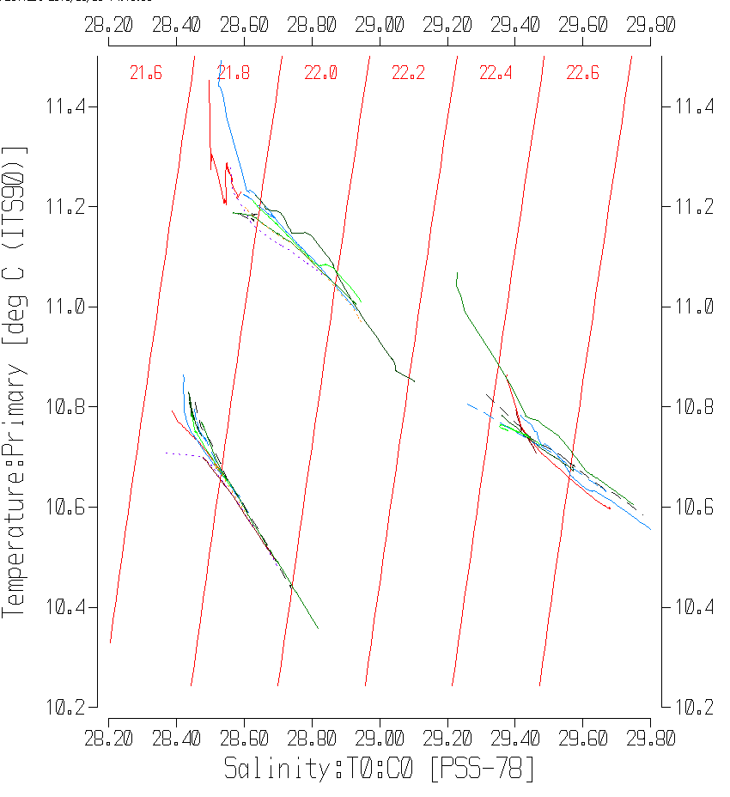
T-S plots for 2017-41feel into 3 groups:
June – lower-left
July – upper
September – right

Other calibration checks
Sensor History – This was the 3rd use of these sensors after factory calibration; there was no calibration sampling during the previous uses.
Comparison of repeat casts –While the casts are often close in position and time they are too shallow to expect good repeatability, though they show reasonable correspondence in T-S space.
Historic Ranges – There was no local climatology available.
Post-cruise calibrations – None were available.

CALIBRATE
There was no dissolved oxygen or salinity sampling during this cruise and we have no calibration history for this instrument since it was last serviced at the factory.
The pressure does not need recalibration.
No recalibration was applied.

Bin Average and REMOVE and DO saturation study
The files were bin averaged using 1db bins.

REMOVE was run to remove Scan_Number, Conductivity:Primary, Oxygen:Voltage, Descent Rate and Flag channels.

A few problems were discovered late in the processing and were corrected as follows:
- ADD TIME CHANNEL was run to subtract 7 hours from the start times for casts #61 to 82 thus correcting the error in time mentioned in section 10.
- All variables are well mixed vertically, but the high values of fluorescence at all depths are suspicious. Cruise 2017-52 used the same sensor in deeper water. Examination of those data show that most casts had near-constant and high values even at 200db. There were a few casts that looked normal. This is evidence that the protective cap was left on the ECO fluorometer for most casts of 2017-52 and the sensor was working fine when the cap was removed. It is assumed that the cap was also left on for all casts of 2017-41.
REMOVE was run to remove channel Fluorescence:URU:Wetlabs:ECO-AFL from events 2-26.

Dissolved Oxygen was derived in mass units and that was used to calculate DO saturation. Plots of near-surface saturation show values between 65% and 82% and there was little variation with depth. The values do not look unreasonable for this region of strong vertical mixing.

REORDER was used to get the 2 dissolved oxygen channels together.

HEADER EDIT and final checks of CTD files.
Header Edit was used to fix headers, fix formats and channel names and to add the following note to the headers for events 1 to 26:
Data Processing Notes:
--------------------------------------------
Dissolved Oxygen and pH:SBE data are nominal and unedited, except that some
records were removed in editing temperature and salinity.

The cap was left on the ECO fluorometer so channel Fluorescence:URU:Wetlabs
was removed.

There was no calibration information available but the sensors had been
recalibrated at the factory just before the cruise, so little drift is
expected.

The soak at the surface was generally long enough for the pumps to come on and
equilibration of pumped channels to be achieved.

For details on the processing see processing report: 2017-41-Processing_Report.doc.

Header Edit was used to fix headers, fix formats and channel names and to add the following note to the headers for events 31 to 82:
Data Processing Notes:
--------------------------------------------
Dissolved Oxygen data are nominal and unedited, except that some records were
removed in editing temperature and salinity.

There was no calibration information available; little drift is expected for
the May casts since the sensors had been very recently recalibrated at the
factory. For the July and September casts there may have been some drift.

The soak at the surface was sometimes shorter than recommended for good dissolved
oxygen equilibration, so the near-surface data may be of lower quality than usual.

For details on the processing see processing report: 2017-41-Processing_Report.doc.

A cross-reference listing was produced.
A header check was run on the CTD files and no errors were found.
The sensor history was updated.
Plots of CTD casts were examined and no problems were found.

CRUISE SUMMARY

Cruise ID#: 2017-41
Dates: Start: 5 June2017 End: 30 September 2017
Location: Discovery Islands
Party Chief: Neville C.
CTD# | Make | Model | Serial# | Used with Rosette? | CTD Calibration Sheet Competed?
1 | SEABIRD | 25 | 0404 | No | Yes
2 | SEABIRD | 25 | 0456 | No | Yes

CTD CALIBRATION INFORMATION
ake/Model/Serial#: SEABIRD/SBE25/0404 Cruise ID#: 2017-41
Sensor |  | Pre-Cruise |  | Post Cruise
Name | S/N | Date | Location | Date | Location
Temperature | 2449 | 16Dec2015 | Factory
Conductivity | 1764 | 23Feb2017 | Factory
pH | 0852 | 8Mar2017 | Factory
ECO Fluorometer | 4185 | 7Mar2017 | Factory
SBE43 Oxygen | 1176 | 2Mar2017 | Factory
Pressure | 482 | 28Feb2017 | Factory

CTD CALIBRATION INFORMATION
Make/Model/Serial#: SEABIRD/SBE25/0456 Cruise ID#: 2017-41

Calibration Information
Sensor |  | Pre-Cruise |  | Post Cruise
Name | S/N | Date | Location | Date | Location
Temperature | 5130 | 2Feb2017 | Factory
Conductivity | 3500 | 23Feb2017 | Factory
SBE43 Oxygen | 1592 | 02Mar2017 | Factory
Pressure | 0668 | 28Feb2017 | Factory

