REVISION NOTICE TABLE
DATE | DESCRIPTION OF REVISION
26 Nov 2021 | Corrected the Salinity:Bottle precision lost during HPLC addition. S.H.
5 March 2020 | Added HPLC data. S.H.

PROCESSING NOTES
Cruise: 2017-36
Agency: Ecosystem Sciences Division
Location: North-East Pacific
Project: Seamounts
Party Chief: Norgard T.
Platform: John P. Tully
Date: July 28, 2017 – August 1, 2017

Processed by: Germaine Gatien
Date of Processing: 30 January 2018 – 22 February 2018
Number of CTD files: 35 Number of bottle casts: 23*
Number of Boots CTD files: 12 Number of Dive files processed: 12
*There were 3 other casts with bottles fired but there was no DFO sampling; these were not processed.

INSTRUMENT SUMMARY
A SeaBird Model SBE 911+ CTD (#0550) was used for this cruise. It was mounted in a rosette and attached were a Wetlabs CSTAR transmissometer (#1201DR), a SBE 43 DO sensor (#1119) on the primary pump, a SeaPoint Fluorometer (#3685) on the secondary pump and an altimeter (#62355).

SeaBird Model SBE25 Sealogger CTD (#0482) was mounted on a camera and attached were a SBE43 DO sensor (#0766 or #3038) and a WetLabs ECO_AFL/FL fluorometer (#2215).

Seasave version 7.26.1.8 was used for acquisition.
The data logging the Tully laptop
The data acquisition program was Seasave.
The CTD deck unit was an SBE model 11+, serial number 0425.
There were 24 10L bottles mounted on an IOS Rosette.

SUMMARY OF QUALITY AND CONCERNS
The Daily Science Log book was in good order with useful comments.

There are two sets of CTD files. The SBE911+ was mounted on a rosette. The SBE25 was mounted on a drop-camera frame. The SBE25 files have non-standard names which were not changed since the original names are useful to the researchers; the data files have event numbers in the headers which correspond to log book entries. The SBE25 files were processed for the use of the researchers with no records removed and are not intended to be placed in the main OSD data archive.

The descent rate of the CTD was generally kept high, but as is often the case in open waters it was highly variable with some complete reversals of direction, particularly late in the cruise. A graphical editor was used to remove data that were obviously corrupted by the resulting shed wakes. Both salinity channels had noisy profiles in the top 100m or so. The primary temperature and salinity were selected for editing and archiving for most casts, but for events #36 and #41 the secondary channels looked better, so they were chosen.

Between 200 and 275m salinity varied little with depth and between sites for the Union Seamount casts. The Dellwood Seamount data had a similar character, but there was more variability among the casts.

There was excellent dissolved oxygen sampling and the comparison between the CTD dissolved oxygen sensor data and titrated bottles samples looked very close to those observed during the cruise that followed.

The dissolved oxygen surface saturation was extremely high (~195%) for event #2 at Finger Bank. Bottle samples are in agreement with the CTD dissolved oxygen values. There is a sharp peak in fluorescence at 11m. Temperature and salinity are within the climatology. The surface saturation values for the offshore casts are all in the expected range.

The Oxygen:Dissolved:SBE data from the SBE911+ are considered, very roughly, to be:
±0.4 mL/L from 0 to 300db
±0.1 mL/L from 300db to 500db
±0.06 mL/L from 500db to 1000db
±0.05 mL/L from 1000db to 3000db
±0.01 mL/L below 3000db

The water depths in the headers were often inconsistent with the sum of the maximum depth sampled plus the altimetry measurement at the bottom. The altimeter traces show that it was working well. It is likely that the water depth was varying significantly as the ship drifted in seamount regions. Water depths were removed from the headers since they appear to be unreliable.

A thermosalinograph was available but was not used due to drain flooding.

PROCESSING SUMMARY
NOTE: Details about the processing of the SBE25 that was mounted with the Dive Camera may be found in §244.

SBE911+ Processing

Seasave
This step was completed at sea; the raw data files have extension HEX.

Preliminary Steps
The Log Book and rosette log sheets were obtained.
Nutrients, salinity, dissolved oxygen and extracted chlorophyll data were obtained in QF spreadsheet format from the analysts.
The cruise summary sheet was completed.
The history of the pressure sensor, conductivity and DO sensors were checked.

The XMLCON files did not change through the cruise. The calibration constants were checked for all instruments and the only correction made was to factor E in the dissolved oxygen calibration. A value of 3.75 was found to correct hysteresis better during cruise 2017-08 which followed this cruise.
The corrected file was saved as 2017-36-ctd.xmlcon.

Conversion of Full Files from Raw Data
All SBE911 hex files were converted using 2017-36-ctd.xmlcon to create CNV files.
There was a note in the log about one station name that was entered wrong, so that was fixed. There were 2 others that were entered with long names that were shortened to match the log entries, CS**.

A few casts were examined. The stops for bottles lasted at least 30s.
- All expected channels are present.
- The upcast and downcast temperature and conductivity channels track in the usual way, with the upcasts generally noisier and the channel pairs further apart than during downcasts. There are a few spikes in both conductivity channels.
- Dissolved oxygen profiles look normal.
- During the 2 cruises after this one, the fluorescence dark values were too high and getting higher with time, ranging from to 0.055 to 0.075ug/L. An initial examination does not indicate a problem with the dark values.
- The altimetry profiles look normal.
- The descent rate was kept high but was often very noisy with some complete reversals of direction.
- Transmissivity has the “steppy” look observed in other recent cruises using this sensor. The profiles look reasonable but values get stuck for a few scans, then change, then get stuck again.
- Stops for bottles lasted at least 30s.

BOTTLE FILE PREPARATION
The ROS files were created using file 2017-36-ctd.xmlcon.
The ROS files were converted to IOS format.
They were put through CLEAN to create BOT files.
A preliminary header check was done and no problems were found. Fluorescence did not go off-scale.

Temperature and salinity were plotted for all BOT files to check for significant outliers. Both salinity channels had a few spikes. CTDEDIT was used to clean salinity from casts #9, 49 and 52. The output files were copied to *.BOT.

The BOT files were bin-averaged on bottle number and the output was used to create file ADDSAMP.csv. Sample numbers were added to the file based on the rosette log records.
The addsamp.csv file was converted to CST files, which will form the framework for the bottle files.
SAM files were created using the Add Sample Number routine. Those files were bin averaged on bottle number.

Next, each of the analysis spreadsheets were examined to see what comments the analysts wanted included in the header file. These were used to create file 2017-36-bot-hdr.txt which will be updated as needed during processing.

EXTRACTD CHLOROPHYLL
The extracted chlorophyll data were provided in spreadsheet QF2017-36chl.xlsx which includes flags and comments and a duplicate study. The spreadsheet was simplified and saved as 2017-36chl.csv.
That file was converted to individual *.CHL files.

DISSOLVED OXGYEN
Dissolved oxygen data were provided in spreadsheet QF2017-36oxy.xls which includes flags, comments and a precision study. Draw temperatures are available. The spreadsheet page with the final data was simplified and the file was then saved as 2017-36oxy.csv.
That file was converted into individual *.OXY files.

NUTRIENTS
The nutrient data were obtained in spreadsheet QF2017-36nuts.xls which includes flags, comments and a precision study. The file was simplified, reordered on sample numbers and saved as 2017-36-nuts.csv. The file was converted to individual NUT files.

SALINITY
Salinity analysis was obtained in file 2017-36 SAL*.xlsx which includes flags, comments and a precision study. The analyses were carried out in a temperature-controlled lab within 20 to 30 days after collection.
The files were simplified and saved as 2017-36sal.csv.
File 2017-36sal.csv was then converted to individual SAL files.

The SAL, CHL, OXY and NUT files were merged with CST files in 4 steps. After the 4th step the files were put through CLEAN to reduce the headers to File and Comment sections only.

The merged files are ordered on sample number, but the SAMAVG files are ordered on bottle number, so one or the other set needs to be reordered in order to merge them. The MRGCLN1 files were reordered on Bottle_Number. The output files were named MRGCLN1s. Those files were then merged with SAMAVG files choosing the Bottle_Number from the SAMAVG files.
CLEAN was run on the MRG files to add 0 flags to empty flag channels and to update header limits.

The output of the MRG files were exported to a spreadsheet and compared to the rosette log sheets to look for omissions. No errors were found.

Compare
Salinity
COMPARE was run with pressure as the reference channel.
There were 2 extreme outliers:
- Event 2 – 30m, sample #8. The standard deviation in the CTD salinity was high. The bottle is higher than the CTD salinity by about 0.28psu but the local vertical salinity gradient is very high so that is not significant. The sample was flagged due to a chipped neck on 1 of the duplicates and it was an outlier in the precision study. The analyst had assigned flag 3 which is appropriate.
- Event 73 – 201m, sample #496. The standard deviation in the CTD salinity was low. The bottle value was higher than the CTD salinity by 0.35psu. Sample #496 was marked on the rosette sheet as one where salinity was to be gathered, but no such sample number was found in the raw data. However, a sample #491 was found in the raw data with the value assigned to #496 in the final sheet. The salinity value is a good match for #491, so presumably the sample really came from 750m. The analyst changed the sample number to 491, assigned a flag 2 and comment to explain this.
Other outliers were identified based on large standard deviations in the CTD salinity. Such outliers are likely due to large local gradients or spikes in CTD data.

The primary salinity was found to be low by an average of 0.0028psu and the secondary high by 0.0033psu with a standard deviation of 0.0017psu for both. The secondary fits against pressure and time were both slightly flatter than the primary. Below 1000m the primary is low by an average of 0.0027 and the secondary high by 0.0033 and standard deviations of 0.0003 and 0.0004, respectively. These differences are close to the differences between salinity channels shown in section 9.

Incomplete flushing of Niskin bottles is not expected to be a major problem for a cruise in open waters. For this cruise the descent rate of the CTD usually suggests the rosette would have moved vertically during stops which would likely lead to good flushing. But it is likely still a small factor in making the bottle contents have salinity that is slightly higher than ambient conditions.

24 bottles were fired during cast #35. The fits for that cast look similar with the primary low by an average of 0.0031 and the secondary high by 0.0032psu.
For more detail see document 2017-36-sal-comp1.xlsx.

Fluorescence
COMPARE was run using pressure as the reference channel. Using the data in the fit, plots were made of CTD Fluorescence versus extracted chlorophyll and the ratio CTD Fluor/CHL vs CHL.
The fits look similar to what we usually see with fluorescence reading higher than CHL for low CHL and close to CHL for the few high CHL values. However, there was a small group of casts that had a FL/CHL ratio of about 3 to 4 for CHL values between 0.8 and 3.5ug/L. We would normally expect values closer to 1or 2. Most of these outliers were from around 20m and there is a maximum value at about the level for many of the casts. So this may be due to unusually high gradients so that slight inefficiency in the flushing of Niskin bottles would lead to lower CHL values than expected.
For more detail see document 2017-36-fl-chl-comp1.xlsx.

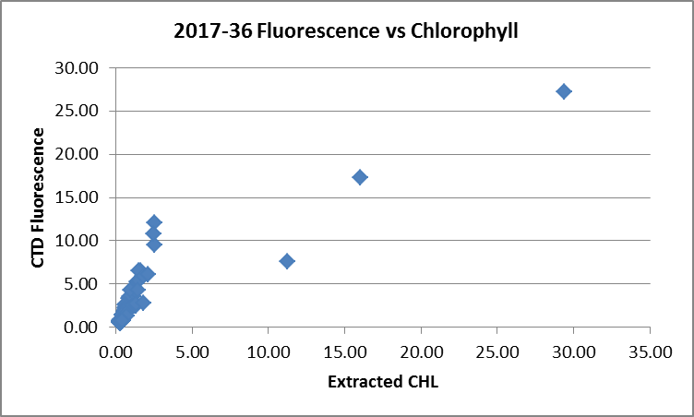

Dissolved Oxygen
COMPARE was run with pressure as the reference channel.

There were no major outliers. When outliers were excluded based on residuals the fit is:
CTD DO Corrected = CTD DO * 1.0518 +0.0544 (R² = 0.99)
This is remarkably close to the fit used for 2017-08 which followed this cruise:
CTD DO Corrected = CTD DO * 1.0514 + 0.0533 (R² = 0.96)
A second fit was done with data from below 1000m excluded to check if there is any sign of hysteresis and there was not.
A few outliers were examined; they came from areas with fairly high vertical DO gradients, so incomplete flushing of bottles would explain titrated DO values that looked a little too low.
For more detail see document 2017-36-dox-comp1.xlsx.

Plots of Titrated DO and CTD DO against CTD salinity were examined. No significant outliers were found.

WILDEDIT
Program WILDEDIT was run to remove spikes from the pressure, conductivity & temperature only in the full cast files (*.CNV).
Parameters used were: Pass 1 Std Dev = 2 Pass 2 Std Dev = 5 Points per block = 50
The parameter “Keep data within this distance of the mean” was set to 0 so all spikes would be removed.

ALIGN DO
For 5 cruises run before this one a setting of +2.5s was used to align the DO signal with temperature. ALIGNCTD was run on all casts using +2.5s. Plots were made to check that it worked well and it did improve the alignment, but the noisy descent rates make it difficult to judge as the temperature response to shed wake corruption is so much quicker than for the oxygen sensor.

CELLTM
The noise in the upcast makes the tests for the best parameters for this routine very difficult to interpret.
CELLTM was run using the default setting, α = 0.0245, β=9.5, for both conductivity sensors.

DERIVE and Channel Comparisons
Program DERIVE was run on all casts to calculate primary and secondary salinity and dissolved oxygen concentration.
DERIVE was run a second time on a few deep casts to examine differences between sensor pairs.

Differences from some deep casts are entered in the table below. For comparison, differences from two other cruises with deep sampling using the same equipment are also shown with shading.
Cast # | Press | T1-T0 | C1-C0 | S1-S0 | Descent Rate
2017-05-0038 | 1000 | +0.0001 | +0.0004 | +0.0046 | High, X Noisy
 | 1900 | +0.0003 | +0.0004 | +0.0040
2017-05-0101 | 1000 | +0.0006 | +0.0005 | +0.0055 | High, Moderate
 | 1900 | +0.0004 | +0.0005 | +0.0052 | “
2017-05-0139 | 1000 | +0.0002 | +0.0005 | +0.0051 | High, X Noisy
 | 1900 | +0.0004 | +0.0005 | +0.0055 | “
2017-06-0036 | 1000 | +0.0002 | +0.0004 | +0.0047 | High, X.Noisy
 | 1900 | +0.0004 | +0.0004 | +0.0045 | “
 | 2900 | +0.0003 | +0.0004 | +0.0042 | “
2017-06-0064 | 1000 | ~0 | +0.0004 | +0.0047 | High, Noisy
 | 1900 | +0.0003 | +0.0004 | +0.0042 | “
 | 2900 | +0.0004 | +0.0003 | +0.0038 | “
2017-06-0085 | 1000 | +0.0002 | +0.0004 | +0.0043 | High, V Noisy
 | 1900 | +0.0002 | +0.0003 | +0.0040 | “
 | 2900 | +0.0002 | +0.0003 | +0.0036 | “
2017-36-0021 | 1000 | +0.0002 | +0.0005 | +0.0060 | High, V Noisy
 | 1900 | +0.0004 | +0.0005 | +0.0055 | “
 | 2900 | +0.0005 | +0.0004 | +0.0050 | “
2017-36-0039 | 1000 | ~0 | +0.0005 | +0.0056 | High, Moderate
 | 1900 | +0.0003 | +0.00045 | +0.0053 | “
 | 2900 | +0.0004 | +0.0004 | +0.0049 | “
2017-36-0077 | 1000 | ~0 | +0.00045 | +0.0056 | High, V Noisy
 | 1900 | +0.0002 | +0.0004 | +0.0051 | “
 | 2700 | +0.0003 | +0.0004 | +0.0048 | “
2017-08-0047 | 1000 | +0.0002 | +0.00007 | +0.0009 | High, V Noisy
 | 1900 | +0.0002 | +0.00005 | +0.0005 | “
 | 2900 | +0.0004 | +0.00004 | -0.0001 | “
2017-08-0074 | 1000 | -0.0002 | +0.00008 | +0.0011 | High, V Noisy
 | 1900 | +0.0000 | +0.00005 | +0.0005 | “
 | 2900 | +0.0003 | +0.00002 | +0.0001 | “
2017-08-0082 | 1000 | -0.0001 | +0.00009 | +0.0011 | High, V Noisy
 | 1900 | +0.0002 | +0.00005 | +0.0006 | “
 | 2900 | +0.0002 | +0.00001 | +0.0000 | “

The differences in temperature are small and vary little among the cruises. The conductivity and salinity differences are similar to the 2 previous cruises but higher than for 2017-08.

Conversion to IOS Header Format
The IOSSHELL routine was used to convert SEA-Bird 911+ CNV files to IOS Headers.
CLEAN was run to add event numbers and to replace pad values in the pressure channel with interpolated values based on record number.

Checking Headers
A cross-reference list was checked against the log book. Some of the station names have the wrong format, so those were changed to match the log entries. The bottle files were adjusted as well.

An initial header check was run. There are clearly some huge spikes in at least one cast, but they are likely to be removed when DELETE is run.

Cruise tracks (with event #s and station Names) were plotted and added to the end of this report.

Surface check was run and shows an average surface pressure for the cruise was 2.5db with a minimum of 1.5db which looks normal for Tully operations. For cast #72 acquisition was not started until the CTD was at about 200db.

Plots of altimetry near the bottom were examined to see if the header entries are reasonable. Despite many spikes, the algorithm worked well except for cast #29 where it appears that the CTD got within 10m of the bottom but no entry went into the header. The altimetry was very noisy and quite likely the bottom was shoaling, so no header entry will be added.

Header entries of bottom depths and bottom altimeter readings were exported to spreadsheets. The bottom depths were checked against the log book and there were many discrepancies. A check was made by calculating:
Check Value = CTD Maximum Depth Sampled + Bottom Altimeter Reading – Water Depth
This should produce values close to 0, but for this cruise most values were >10m and many were much larger than that. Since the altimetry looks ok, it is apparent that the bottom depths entered in the headers are unreliable. This is not surprising in the area of seamounts where depths will vary through the cast. Since they may be misleading the depth readings will be removed from the headers.

Because the fluorometer dark values were found to be drifting higher during the 2 Tully cruises that followed this one and used the same sensors, a study was made to see if the values had drifted during this cruise as well. The later casts have a slightly higher dark value than the early ones, but both values are fairly low and the difference is not significant enough to require recalibration.

Shift
Fluorescence
SHIFT was run on the SeaPoint fluorescence channel in all casts using the usual advance of +24 records. Examination of plots after this step shows that the fluorescence offset is reasonably close to the temperature offset.

Dissolved Oxygen
The Dissolved Oxygen voltage channel was aligned earlier. A few casts were checked to see if the alignment looked ok, and as usual, there is a lot of variability with the up and downcast traces sometimes closer than temperature and sometimes further apart. This is likely due to varying vertical gradients. Where there are distinct features in T and DO profiles, they line up well. Overall the choice made earlier looks appropriate, so no further alignment will be applied.

Conductivity
For the past 4 cruises using this equipment the best settings to improve conductivity alignment with temperature was -0.6 records for both sensors. Tests were run by comparing T-S plots to see if small adjustments to those settings removed more salinity noise, but once again -0.6 looked best.
SHIFT was run on all casts applying a shift of -0.6 records to both conductivity channels. Salinity was recalculated.

DELETE
The following DELETE parameters were used:
Surface Record Removal: Last Press Min
Maximum Surface Pressure (relative): 10.00
Surface Pressure Tolerance: 1.0 Pressure filtered over 15 points
Swells deleted. Warning message if pressure difference of 2.00
Drop rates < 0.30m/s (calculated over 11 points) will be deleted.
Drop rate applies in the range: 10db to 10db less than the maximum pressure
Sample interval = 0.042 seconds. (taken from header)
COMMENTS ON WARNINGS: There was a warning for cast #19, but it concerned upcast data from near the surface so is of no concern for CTD files. The bad data occurred after the last bottle stop.

Other Comparisons
Previous experience with these sensors –
All sensors were used during 6 earlier cruises in 2017.
- 2017-63 in early April was a cruise in the Strait of Georgia and Juan de Fuca Strait. The bottles from Juan de Fuca were trusted more than those from the Strait of Georgia because conditions were better for flushing Niskin bottles; they indicated that the primary salinity was close to bottles while the secondary was high by about 0.0045. The dissolved oxygen comparison from 2017-63 was also based on Juan de Fuca bottles.
- Cruise 2017-03 was in Baynes Sound and the Strait of Georgia, with shallow sampling and poor flushing of bottles, so the results were not considered reliable enough to use for recalibration.
- Cruise 2017-05 was mostly off the west coast of Vancouver Island where flushing was good at depth. The comparison between the bottles and CTD salinity was quite tight; the primary salinity was found to be very close to bottles and the secondary was high by 0.0054psu. The dissolved oxygen comparison was also quite tight and led to a calibration of slope 1.0448 and offset +0.0527.
- Cruise 2017-06 was mostly well offshore and showed the primary salinity to be low by ~0.0012 and the secondary high by ~0.0032. The dissolved oxygen was recalibrated using slope 1.0399 and offset 0.0645.
- Cruise 2017-64 showed primary and secondary salinity low by 0.0012psu and high by 0.0034psu in Juan de Fuca Strait. The dissolved oxygen comparison in Juan de Fuca was very close to that of 2017-06, so those results were used for 2017-64.
- Cruise 2017-56 included only near-shore shallow casts so 2017-06 results were used for recalibration.
- Cruise 2017-23 comparisons were not trusted as much as the 2017-06 results, so the latter were used for recalibration.

Later experience with these sensors -
- Cruise 2017-08 was mostly well offshore and showed the primary salinity to be low by 0.0002 and the secondary high by 0.0004. The dissolved oxygen was recalibrated using slope 1.0514 and offset 0.0533. Fluorescence was recalibrated.
- Cruise 2017-09 included offshore and inland waters. The salinity channels were low by 0.0029 and 0.0006 though part of that was considered to be due to incomplete flushing. The dissolved oxygen was recalibrated using slope 1.0620 and offset 0.0606. Fluorescence was recalibrated.

Historic ranges – Profile plots were made with 3-standard deviation climatology ranges of T and S superimposed. All data fell within the climatology.

Repeat Casts – There was one pair of casts at the same station and about 2 hours apart. From 1400db downward the differences along σ_{t}-lines are ≤ 0.002C° and ≤ 0.0003psu and usually much closer than that. This is excellent repeatability.

Post-Cruise Calibration
None was available.

DETAILED EDITING
Plots were examined to determine which sensor pair looked most suitable for editing. The results were puzzling as some casts showed the primary sensors had fewer unstable features while others favoured the secondary. Overall, the primary seems better and they were chosen for the cruise that followed, so those channels were selected for editing.

The primary T and S channels were selected for editing but for casts 36 and 41 the primary salinity was extremely noisy, so the secondary channels were edited.

CTDEDIT was used to remove large spikes, remove or clean smaller salinity spikes that appear to be due to misalignment of T and C or other instrumental problems likely to affect the bin-averaged values and to remove records corrupted by shed wakes including some records from near the top and bottom of the casts. For a few casts some bad salinity points were also removed that are associated with rapid decelerations of the CTD. All files required some editing.

The noisiest-looking salinity was found in the Union Seamount area between 200m and 275m (about σ_{t} 26.7). This section forms a very tight group on a T-S surface; it was very well-mixed in salinity so in the editing window small spikes stand out more, but are not significant. The near-surface water is quite well mixed in salinity while from about 50m to 200m (about σ_{t} 25.6 to 26.4) there is a section of active mixing with a lot of variability among the various casts near the Seamount. The Dellwood Seamount casts showed a similar section between 200m and 300m, though at higher salinity and higher temperature, and slightly lower density, and not as tight a grouping in T-S space.

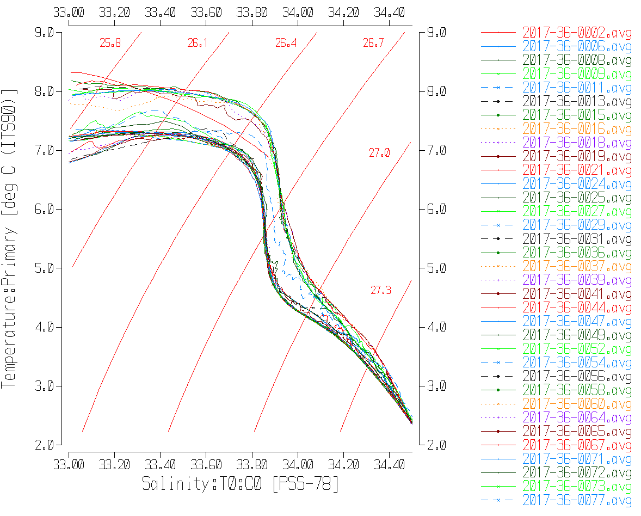

Initial Recalibration
Pressure will not be recalibrated.
Salinity and dissolved oxygen data will be recalibrated using the results of §5.
CALIBRATE was run using file 2017-36-recal1.ccf to add 0.0027 to channel Salinity:T0:C0, to subtract 0.0033psu from channel Salinity:T1:C1 and to correct the Oxygen:Dissolved:SBE channel in the SAM and MRGCLN2 files using:
CTD DO Corrected = CTD DO * 1.0518 +0.0544

COMPARE was rerun for salinity and dissolved oxygen using the recalibrated values.
- When outliers are excluded based on residuals the dissolved oxygen is found to be low by an average of 0.001mL/L (standard deviation 0.018mL/L) ranging from being high by 0.0003mL/L for DO=0mL/L and low by 0.0025mL/L at DO=7mL/L.
- When the same outliers were removed as in the original fit Salinity:T0:C0 is low by an average of 0.00007psu and Salinity: T1:C1 is high by an average of 0.0003psu; the standard deviation is 0.0022psu for both channels.
These results confirm that the recalibration was applied properly. See files 2017-36-sal-comp2.xlsx and 2017-36-DO-comp2.xlsx for details.

CALIBRATE was then run on the edited files, *.EDT.

Final Calibration of DO
The initial recalibration of dissolved oxygen corrects for sensor calibration drift. Alignctd corrects for transit time errors. Those 2 steps may partly correct for response time errors, but to see if a further correction is needed, a comparison is made of downcast CTD data to bottle data from the same pressure. Small differences are always expected due to ship drift, temporal changes, incomplete flushing of Niskin bottles and noise in CTD data.

Downcast files were bin-averaged to 0.5m bins for the casts with DO bottle samples. Those files were then thinned and compared to the bottle values in the MRG files. COMPARE was run to study the differences between the downcast CTD DO data and the titrated samples from upcast bottles. The scatter in the comparison is high in the top 400m. When outliers were removed based on residuals and bottom bottles were removed, the CTD DO was found to be high by an average of 0.007mL/L with a standard deviation of 0.046mL/L. The CTD DO is generally higher than bottles down to the oxygen minimum, which is what we expect if flushing is incomplete as the bottles contain water from deeper in the water column where DO is lower. Below that, the CTD DO is close to or lower than bottles which is again expected below the Oxygen Minimum Zone. Bottom bottles tend to be out of line as poor flushing has the opposite effect. When differences are plotted against CTD DO the fit shows that the CTD DO is high by ~0.002mL/L at the low end of the range and by ~0.013mL/L at the top of the range.
These differences are most likely due to incomplete flushing and no further calibration of CTD DO is justified. For more details see document 2017-36-dox-comp3.xlsx.

Fluorescence Processing
A median filter, size 11, was applied to the fluorescence channel in the COR1 files. Plots of a few casts showed that the filter was effective. (Output:*.FIL)

BIN AVERAGE of CTD files
The following Bin Average values were applied to the FIL files (output AVG):
Bin channel = pressure Averaging interval = 1.000 Minimum bin value = .000
Average value will be used. Interpolated values are NOT used for empty bins.

On-screen T-S and profile plots were examined. No problems were found.

Final CTD File Steps (REMOVE and HEADEDIT)
REMOVE was run on all casts except casts #36 and #41 to remove the following channels:
Scan_Number, Temperature:Secondary, Salinity:T1:C1, Conductivity:Primary, Conductivity:Secondary, Oxygen:Voltage:SBE, Altimeter, Status:Pump, Descent_Rate and Flag.
REMOVE was run on casts #36 and #41 to remove the following channels:
Scan_Number, Temperature:Primary, Salinity:T0:C0, Conductivity:Primary, Conductivity:Secondary, Oxygen:Voltage:SBE, Altimeter, Status:Pump, Descent_Rate and Flag.

A second SBE DO channel (with umol/kg units) was added.
REORDER was run to get the two DO channels together.

HEADER EDIT was used to fix formats and channel names, to remove Water Depth from the headers and to add the following comments:

Data Processing Notes:
----------------------

Transmissivity and Fluorescence data are nominal and unedited except that some
records were removed in editing temperature and salinity.

NOTE: While the CTD fluorescence data are expressed in concentration units, they
do not always compare well to extracted chlorophyll samples, particularly for
casts far from shore. It is recommended that users check extracted chlorophyll
values where available.

Dissolved oxygen was calibrated using the method described in SeaBird
Application Note #64-2, June 2012 revision, except that a small
offset in the fit was allowed.

The SBE DO sensor has a fairly long response time so data accuracy is not as high
when it is in motion as it is during stops for bottles. This will be
especially true when vertical DO gradients are large. To get an estimate
of the accuracy of the SBE DO data during downcasts (after recalibration)
a rough comparison was made between downcast SBE DO and upcast titrated
samples. Some of the difference will be due to problems with flushing
of Niskin bottles and/or analysis errors, so the following statement
likely underestimates SBE DO accuracy.

Downcast (CTD files) Oxygen:Dissolved:SBE data are considered, very roughly, to be:
±0.4 mL/L from 0 to 300db
±0.1 mL/L from 300db to 500db
±0.06 mL/L from 500db to 1000db
±0.05 mL/L from 1000db to 3000db
±0.01 mL/L below 3000db

For details on the processing see document: 2017-36_Processing_Report.doc.

The Standards Check routine was run and no problems were found.
The Header Check was run and no problems were found.
The track plot looks fine.

Dissolved Oxygen Study
As a final check of dissolved oxygen data, % saturation was calculated and plotted. All offshore casts had surface saturations between 102% and 109%, as expected. The one nearshore cast, event #2, had extremely high surface saturation, at 195%. The temperature and salinity were within the climatology, so those look fine and the CTD DO agreed reasonably well with the 5m and 10m bottles. Fluorescence is high and transmissivity low. It appears that the DO data are correct, just reflecting unusual conditions.

Final Bottle Files
CALIBRATE was run on the MRGCLN2 files and then the MRGCOR1 files were put through SORT to order on increasing pressure.

REMOVE was run on all casts except #36 to remove the following channels:
Scan_Number, Temperature:Secondary, Salinity:T1:C1, Conductivity:Primary, Conductivity:Secondary, Oxygen:Voltage:SBE, Altimeter, Status:Pump, Descent_Rate and Flag.
REMOVE was run on cast #36 to remove the following channels:
Scan_Number, Temperature:Primary, Salinity:T0:C0, Conductivity:Primary, Conductivity:Secondary, Oxygen:Voltage:SBE, Altimeter, Status:Pump, Descent_Rate and Flag.

A second SBE DO channel was added for both the CTD DO and bottle DO, with mass units and REORDER was run to get the 2 SBE DO channels together.

HEADER EDIT was run to ensure formats and units are correct, change the channel name Bottle_Number to Bottle:Firing_Sequence and the name Bottle:Position to Bottle_Number and to add a comment about quality flags and analysis methods and a few notes about the CTD data processing. Water Depth was removed from the headers.

Data from the CHE files were exported to a spreadsheet and compared with rosette sheets. No problems were found. The spreadsheet was saved as 2017-36-bottles_final.xlsx.

Plots of each file were examined. No problems were found.

Producing final files
A cross-reference listing was produced for CTD and CHE files.
The sensor history was updated.
As a final check plots were made of the cruise track and it looks fine.
The cruise plot was added to the end of this report.

SBE25 Data
NOTE: A separate processing report was prepared concerning the SBE25 Data with introductory comments not included in this report: 2017-36-BOOTS_Processing_Reeport.docx.

The SBE25 was mounted on a dive camera.

These data are not suitable for the OSD Data Archive, but for use of the chief scientist in conjunction with the dive camera. No records were removed.

The file names were in format DIVE_** with ** being the consecutive dives. These names correspond to station names rather than event numbers but since they are not destined for the OSD Data Archive that is not important, so the names were left in the original form. The only exception is that there were many different names given to the configuration files for the first 6 dives as the science crew struggled to get a configuration that worked properly. The raw files were moved to a separate directory choosing only the versions of the configuration files considered correct. The first 6 configuration files were renamed with names matching the HEX file names.

The only error in the configuration files was the date of the calibration of sensor 3038. This was corrected in the files for Dives 25 to 32.

- CONVERT
All casts were converted using the configuration file with the same name as the hex file. For Dives 25 to 32 the fluorescence channel was included.

The first attempt produced extremely noisy descent rates but this was traced to the use of a 1s window in the calculation which is not suitable for data collected at 1Hz. A larger window doesn’t reduce the noise much and is too crude to be useful. Since reversals are often intentional for this project, the descent rate is just not a useful calculation.
There was obviously a change of deployment procedure after Dive 25. For the first 4 dives acquisition began at 20m and there was a long soak at that depth. Starting with Dive 25 it appears that acquisition started at the surface though the pressure is unreliable until it has soaked so it is not clear.

Plots show that the other channels all produced reasonable profiles, though there are some problems with the dissolved oxygen voltage:
- The signal is very noisy in the downcast for Dive 25 and Dive 26. There are 2-sided spikes that are not seen during the upcasts. This may be related to the low sampling rate though it was not seen in other casts.
- For DO sensor #3038 the DO values are 0 in the top 20m or so. This does not seem to be due to the low sampling rate since it was not seen for the other DO sensor in the first 4 dives.
Some of the usual processing steps will be inappropriate for 1HZ sampling.

- WILDEDIT
This step was run using a variety of settings but no setting was found removed large spikes without removing too much data

- WFILTER
There are no obvious reversals in pressure except where planned, which is expected given the 1Hz sampling. This step was skipped.

- ALIGNCTD
Tests were run on a few casts to see what alignment made the offset between the upcast and downcast DO traces resemble that for the temperature traces. There was very little effect from an advance of 2s. An advance of 20s had a slight effect, but that large an advance seems physically unjustified.
ALIGNCTD was run on all casts to advance the DO channel by 2s.

- CELLTM
This step was not run.

- DERIVE
Program DERIVE was run to calculate salinity and dissolved oxygen concentration (tau correction included).

- Conversion to IOS Headers
The IOSSHELL routine was used to convert the CNV files to IOS Headers.

Spreadsheet 2017-36_merge_headers.csv was prepared to add event numbers, station names and start and end positions. Depths are not entered since they vary through the cast. Positions were not available from the log for Dives 24 onwards. Some NMEA start positions were available. Katie Gale provided the missing position information:
Dive 24 end: -132.71222, 49.52928
Dive 25 start: -132.64247, 49.55691
Dive 25 end: -132.70281, 49.54687
Dive 26 start: -132.82076, 49.57074
Dive 26 end: -132.72203, 49.55022
Dive 27 end: -132.1149, 49.88317
Dive 28 end: -130.88844, 50.74357
Dive 29 end: -130.89143, 50.75489
Dive 31 end: -130.91842, 49.93304
Dive 32 end: -129.21103, 49.91754

Program MERGE:CSV FILE TO HEADERS was run to add that information to the headers of the IOS files.

- Checking Headers
A cross-reference listing was produced and the entries look reasonable.
Track plots were produced and added to the end of this report.
HEADER CHECK was run. There are some negative pressures and very low and very high dissolved oxygen values. The latter are likely spikes at the beginning and/or end of the files.

The surface check will not be reliable since the pressures at the beginning of some files are almost certainly wrong. Upcast pressures look good, given the limited accuracy of the Strain Gauge sensors.

- DELETE
DELETE was not run. The full record is required for this project.

- Study of CTD Pressure
The near-surface data are confusing.
- For casts Dive21 to Dive 26 the deployment method was clearly to lower the CTD to about 20m to soak (much deeper for the first cast only). Archiving was started at the soak level.
- For Dive 27 to Dive 32 the opening pressures are negative, as low as -4db. The near-surface temperature and salinity data look reasonable at the beginning of files. Dissolved oxygen and fluorescence are zero until 15 to 25db, perhaps because those sensors are programmed to only turn on when pressures are positive. It is likely that the pressure sensor has not equilibrated, but it has to be kept in mind that the SBE25 pressure is not very accurate – presuming this sensor was set to at least 3500db range, the accuracy is considered ±3.5db though the precision is much better than that. The steps in pressure are on the order of 1.2db. There is no apparent stop to soak near 20m but that could be because the pressure was still equilibrating so values change even when stopped.
- The upcast pressures look similar in the casts before Dive 27 and after, so this does not appear to be a change in the pressure calibration. Comparing upcast temperature, salinity and other variables with downcast is not helpful because the equipment drags deeper water with it.
- A comparison with data from the SBE911+ CTD was not very helpful in assessing where the data become reliable. The casts are not close enough in space or time given near-surface variability.

In the absence of better evidence it is wisest to remove data above 20m for the last 6 dives.

- Final Steps
REMOVE was run to remove channels Conductivity:Primary, Descent Rate, Oxygen:Voltage:SBE and Flag.
DERIVED QUANTITES was run to calculate Theta and Sigma-Theta.

HEADER EDIT was run to change the format for Pressure and Depth and to add the following comments to the headers of the first 6 casts:
Data Processing Notes:
These data were processed for the use of the researchers and are not intended
to go into the IOS DATA ARCHIVE. They will be archived elsewhere.
The CTD was an SBE25 mounted on a drop-camera frame.
No data were removed in processing.
File names are based on station names.
Event numbers are entered in the headers.
---------------------------------------------------------------------------------

CLIP was run to remove the initial 20m of data from the last 6 casts; this involved removing a different number of initial records for each of the 6.

HEADER EDIT was run to change the format for Pressure and Depth and to add the following comments to the headers of the last 6 casts:
Data Processing Notes:
These data were processed for the use of the researchers and are not intended
to go into the IOS DATA ARCHIVE. They will be archived elsewhere.
The CTD was an SBE25 mounted on a drop-camera frame.
Due to doubts about the accuracy of the near-surface pressure data, records were
removed from the initial section of this cast until pressure reached 20db.
The deployment method differs from that used in the first 6 dives.
No record was found of whether there was a soak at the surface or not, and
while pressure is equilibrating a stop would not be obvious.
File names are based on station names.
Event numbers are entered in the headers.
The same comments were entered in the last 6 casts except that the statement about data removal was adjusted to say how much data was removed and why.
A cross-reference listing was produced. .

These files were then sent to Katie Gayle for her use. The files are not suitable for the OSD Data Archive, given low and highly variable descent rates and many stops and gaps.

Particulars

36. Wait at 326 on way up for wire angle.

47. Station name entered wrong in raw file.
49. Chip on top of Niskin 23; O-ring leaky. Replaced O-ring, but likely Niskin needs replacement.
52. Bottle 22 inside tubing snapped before the cast – tied tubing together and reset, but needs replacing.
64. No bottles closed.
72. Bottle test 1-4. Archiving not started until 200m of downcast.
77. Bottle fired for Elaine at UVic – no sample numbers assigned.
CRUISE SUMMARY
CTDs
CTD# | Make | Model | Serial# | Used with Rosette? | CTD Calibration Sheet Competed?
1 | SEABIRD | 911+ | 0550 | Yes | Yes
2 | SEABIRD | 25 | 0482 | No | Yes

Calibration Information SBE911+ CTD
Sensor |  | Pre-Cruise |  | Post Cruise
Name | S/N | Date | Location | Date | Location
Temperature | 4054 | 16Dec2017 | Factory
Conductivity | 1766 | 19Dec2017 | Factory
Secondary Temp. | 4484 | 22Feb2017 | Factory
Secondary Cond. | 3531 | 30Mar2017 | Factory
Transmissometer | 1396DR | 27Apr2016 | Factory
SBE 43 DO sensor | 1119 | 28Mar2017 | Factory
SeaPoint Fluor. | 3685 | 13Mar2017
Pressure Sensor | 0550 | 24Feb2017 | Factory
Altimeter | 62355 | n/a | Factory

Calibration Information SBE25 CTD
Sensor |  | Pre-Cruise |  | Post Cruise
Name | S/N | Date | Location | Date | Location
Temperature | 2968 | 22Feb2017 | Factory
Conductivity | 2173 | 23Feb2017 | Factory
SBE 43 DO sensor | 0766 | 1Mar2017 | Factory
SBE 43 DO sensor | 3038 | 24Mar2017 | Factory
WetLabs Eco Fluor. | 2215 | 7Mar2017 | IOS
Pressure Sensor | 0482 | 22Feb2017 | Factory

TRACK PLOTS FOR SBE911+ CTD

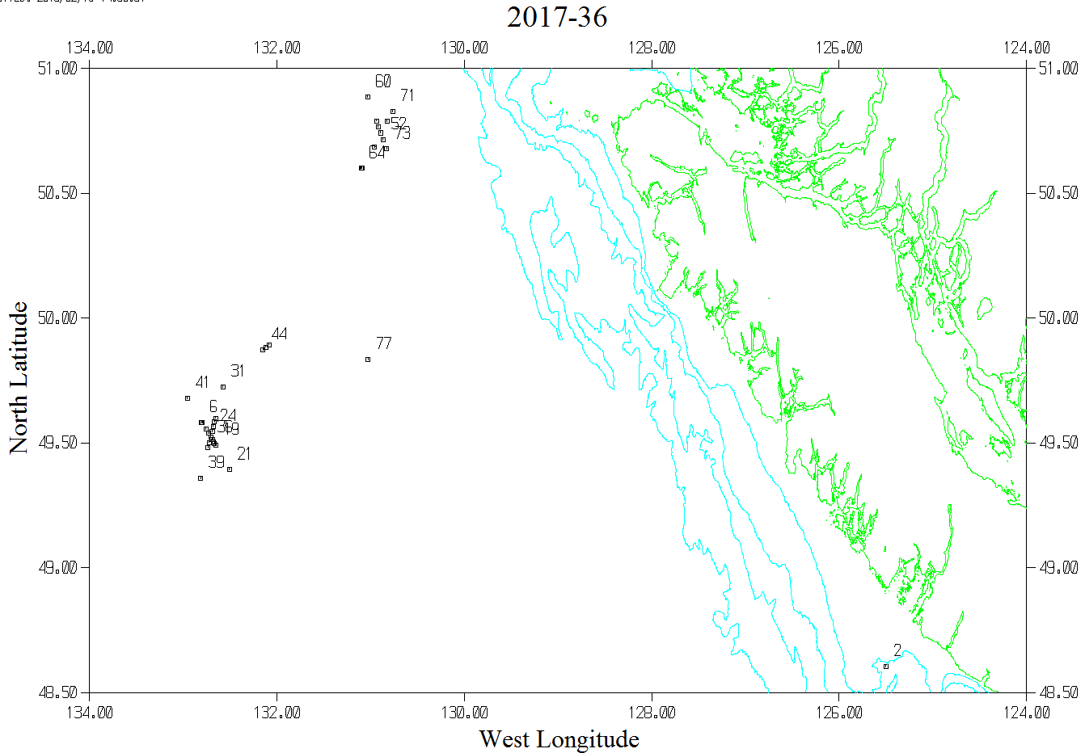

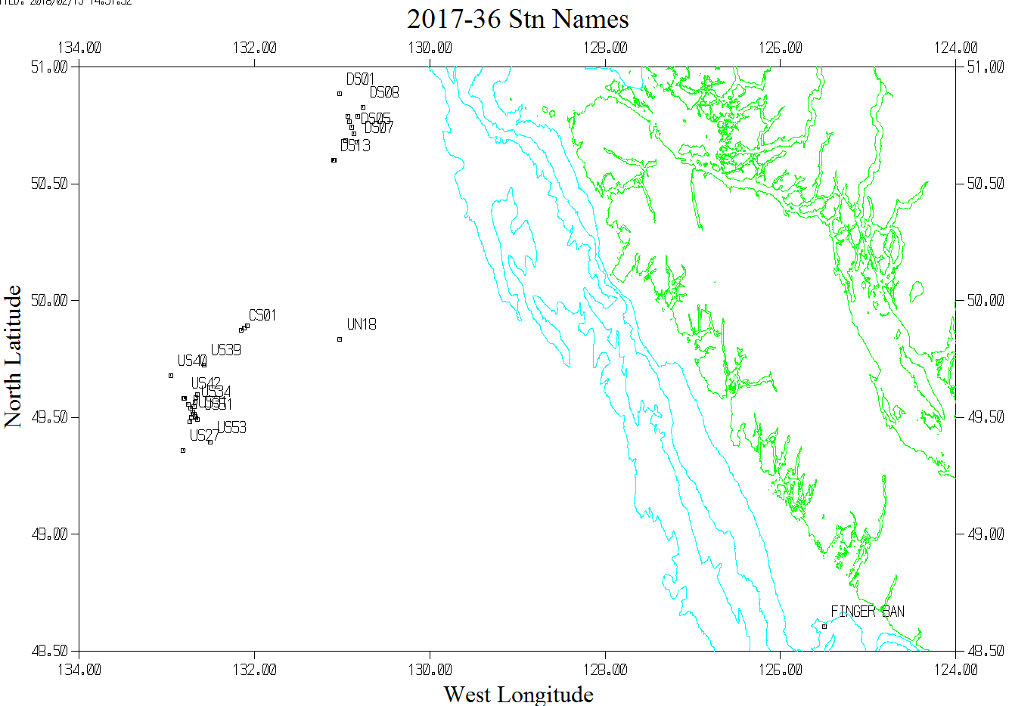

TRACK PLOTS FOR BOOTS CTD - MOUNTED ON CAMERA

