**Zodiac Cruise 2017-26**

**Table 1.** Sampling stations

|  |  |  |  |  |  |  |
| --- | --- | --- | --- | --- | --- | --- |
| **Station** | **lat** | **lat mins** | **long** | **lon mins** | **depth** | **Samples** |
| 59 | 48 | 36.96 | -123 | 14.978 | 225 | CTD, net |
| CBE2 | 48 | 44.22 | -123 | 34.45 | 65 | CTD, net |
| SC-04 | 48 | 43.50 | -123 | 25.00 | 90 | CTD, net |
| GI-01 | 48 | 45.86 | -123 | 20.53 | 65 | CTD, net |
| 46 | 48 | 51.4 | -123 | 10.8 | 176 | CTD, net. Low priority |
| 41 | 49 | 3.3 | -123 | 22.3 | 245 | CTD, net |
| 40 | 49 | 8.6 | -123 | 36.8 | 146 | CTD, net |
| 38 | 49 | 12 | -123 | 26.4 | 300 | CTD, net |
| GEO1 | 49 | 15 | -123 | 45 | 400 | CTD, net |
| CPF1 | 49 | 22 | -124 | 5 | 245 | CTD, net |
| 28 | 49 | 24.1 | -123 | 45.3 | 134 | CTD, net |
| CPF2 | 49 | 28 | -124 | 30 | 325 | CTD, net |
| BS-11 | 49 | 29 | -124 | 46 | 58 | CTD, net |
| 24 | 49 | 30.3 | -124 | 6 | 425 | CTD, net |
| 22 | 49 | 40.2 | -124 | 16.3 | 353 | CTD, net |
| 11 | 49 | 42.4 | -124 | 43.4 | 290 | CTD, net |

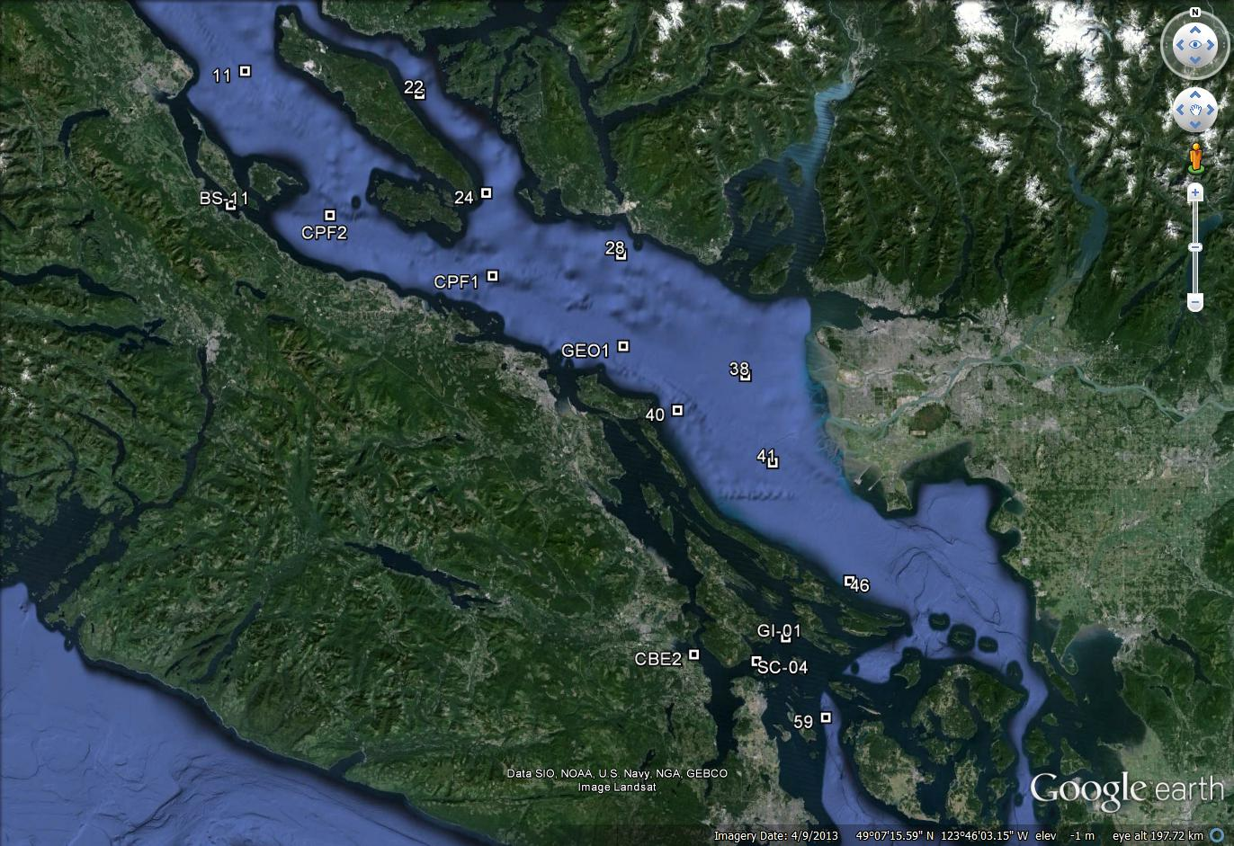

**Figure 1**. Station locations for IOS 2017 Strait of Georgia zooplankton surveys.

**At each station, collect:**

* Full depth CTD profile including oxygen and fluorometer, using SBE 25 CTD with SBE 43 DO and Wetlabs fluorometer sensors. **2 minute soak at start** (Turn on, down 10m and up, wait remaining time and start). **Note:** CTD fluorometer usually has an end cap that needs to be removed before the first cast!
* Full depth (10m off bottom to surface) zooplankton tow, using SCOR net with 236um black mesh. Preserved in 10% buffered formalin. Upcast speed approx. 1 m/s (with electric winch, will be slightly slower. Should not be less than 0.5 m/s). Net equipped with a TSK flowmeter and a RBRSolo that logs the net casts (depth and time).

Other potential stations in Baynes Sound (if needed)

|  |  |  |  |  |  |
| --- | --- | --- | --- | --- | --- |
| **Station Name** | **Latitude Degrees** | **Latitude Minutes** | **Longitude Degrees** | **Longitude Minutes** | **Bottom Depth (m)** |
| BS2 | 49 | 38.46 | -124 | 53.61 | 34.00 |
| BS5 | 49 | 35.83 | -124 | 51.51 | 40.00 |
| BS8 | 49 | 34.13 | -124 | 51.44 | 47.00 |
| BS11 | 49 | 32.17 | -124 | 50.50 | 42.00 |
| BS15 | 49 | 31.10 | -124 | 48.71 | 47.00 |
| BS14 | 49 | 28.34 | -124 | 44.80 | 38.00 |

**Housekeeping**

* There are 2 logs to fill out: cruise log and plankton log. Please fill out the cruise log with all events that occur, and give each event a number. Record BE, BO and EN time (note what time zone you are using! Eg: use local time if you want, but indicate so in the log and be consistent for the entire trip). **Check that the GPS has the correct time (needs to be manually changed between Daylight ST and PST. Plankton log – enter information for all plankton tows.
* Upload the CTD data at the end of the day. Make sure the laptop has the correct date and time before uploading. Upload the files individually (don’t do as a batch). When uploading the file, name them with standard format names such as 2017-07-0001.hex (or .xml for SBE25+) for event #1. Put location, station name, and bottom depth in the header (comments box) of the file, using the format in the “CTD Header.txt” file on the CTD laptop (the leading * and following : plus N and W are needed for processing)
* Also check that the batteries have enough voltage, change if they drop below 9.5V (for SBE25+).
* Update the electronic cruise log (excel file) daily. Back up all files to USB.