REVISION NOTICE TABLE
DATE | DESCRIPTION OF REVISION

PROCESSING NOTES
Cruise: 2017-26
Agency: IOS, Ocean Sciences Division, Sidney BC
Chief Scientist: Young K. Platform: Zodiac
Location: Strait of Georgia Project: Strait of Georgia Zooplankton
Date: 8 May 2017 – 12 May 2017

Processed by: Germaine Gatien
Date of Processing: 24 November 2017 –27 November 2017
Number of original XML files: 18 (1 empty) Number of CTD files: 17

INSTRUMENT SUMMARY
A SeaBird Model SBE-25 CTD (s/n 1123) was used with temperature sensor #4888, conductivity sensor #4513, Wetlabs ECO Fluorometer #2214, dissolved oxygen sensor #3234, pump #8377 and pressure sensor 1123.

SUMMARY OF QUALITY AND CONCERNS
This cruise was part of a larger project that includes cruises 2017-07 (6 legs), 2017-26, 2017-47, 2017-48 and 2017-49. The same equipment was used for all 10 legs except for the conductivity sensor which was changed in late May 2017, between 2017-26 and 2017-48.

The log book did not have a complete equipment list, just a note that it was the same as for a previous cruise. It is recommended that the full information be recorded. Otherwise the log book was in good order.

The CTD was generally lowered to 10m, raised and held at 2m until about 2 minutes had passed. The full cast was then run. This approach enabled easy removal of the data from the initial drop period by removing the first 1850 records.

There was no salinity calibration sampling during this cruise. There was such sampling during previous cruises using the same sensors and the CTD salinity compared well with bottles. The conductivity sensor used for this cruise was discovered to be malfunctioning and obviously damaged in mid-May 2017. The salinity from deep water for 2 casts (early and late in the cruise) compare well with a cruise run about 2 weeks later in the same area using a different conductivity sensor. The calibration appears to be good, so the damage likely occurred in off-loading or transport after this cruise.

There was no dissolved oxygen calibration sampling for this or any of the other cruises run for this project. Recalibration was based on the results of cruise 2017-01 which had the same equipment and extensive sampling. Some tubing was found to be dislodged after the cruise so investigations were made to ensure that the sensor had been pumped. The data quality suggests the sensor was pumped normally. It is likely the damage occurred at the same time as the conductivity cell was damaged.

PROCESSING SUMMARY
1. Seasave - This step was completed at sea. Two files were downloaded with non-standard names but they had also been saved with standard names.

2. Preliminary Steps
- The Daily Log was obtained.
- The deployment method used was as follows: The CTD was switched on, a 2-minute timer was started and the CTD was put in the water. It was taken down to 10m, up to the surface with a wait at the surface at least until the 2 minutes were up. The cast was then started and the CTD was switched off as it was taken out of the water. This method is helpful as by removing a fixed number of records, the initial soak can be removed. .
- The cruise summary sheet was completed.
- The parameters in the configuration file provided were checked and were all correct. The file was saved as 2017-26-ctd.xmlcon.

3. Conversion of Raw Data
The XML files were converted using configuration file 2017-26-ctd.xmlcon. The file for event 29 at station 11 could not be converted; as noted in the log no data were acquired. The raw file contains header information only.
Plots of a few casts show that the channels all produced reasonable values. Descent rates were kept reasonably high and varied from noisy to quite steady.
The fluorescence looks “steppy” as noted during 2017-07 (Legs 1 & 2 only) and 2017-47. The values look ok. The same sensor produced normal traces for the later legs of cruise 2017-07 and for 2017-48, so it is likely that the sampling rate of the sensor was adjusted in mid-May at the same time that the conductivity sensor was switched.

4. WILDEDIT
Since there are no obvious spikes in the data, this step was skipped.

5. WFILTER
In processing 2 legs of 2017-07 and cruise 2017-47 with the same sensors in use, a filter of size 7 was found best. Plots for this cruise show small steps in pressure but no reversals.
WFILTER was run using a cosine filter, size 7 on the pressure, depth, temperature and conductivity channels.
Checks were made later in processing that show the results of this step to be satisfactory.

6. ALIGNCTD
Tests were run on for cruises 2017-07 and 2017-47 to see what DO alignment setting did the best job of making the offset between the upcast and downcast DO traces resemble those for the temperature traces. For both cruises an advance of 2s produced the best results.
ALIGNCTD was run on all casts to advance the DO channel by 2s.
Checks were made after this step and the results look good.

7. CELLTM
SeaBird recommend the use of (α, 1/β) = (0.04, 8) for CELLTM for the SBE 25 and it has proved best in the past. That setting worked well for other cruises using this equipment.
CELLTM was run on all casts using (α, 1/β) = (0.04, 8).

8. DERIVE
Program DERIVE was run to calculate salinity and dissolved oxygen concentration (tau correction included).

9. Conversion to IOS Headers
The IOSSHELL routine was used to convert the CNV files to IOS Headers.
CLEAN was run to add event numbers and replace pad values in the pressure channel with interpolated values.

10. Checking Headers
- A cross-reference list was produced and used to check against the log records. No errors were found.
- Track plots were produced for event #s and station names and added to the end of this report.
- HEADER CHECK was run. There were a few slightly negative values in pressure and fluorescence, but they occur in sections of files that will be removed by DELETE.
- The surface check shows an average of 0.7db. The ends of casts when the CTD would be out of water have pressures between -0.12db and +0.06db, so the pressure calibration looks excellent.

Plots were made to judge whether removing 1850 records will be appropriate to remove the data acquired during the initial drop for all casts and it was.
CLIP was run to remove 1850 records from all casts.

After this step plots were produced to check that there are no data left from the initial drop to the soak depth. No problems were found.

11. SHIFT
Conductivity
During 2017-07 and 2017-47 when the same sensor was used a setting of +1.2 records was found suitable to align the conductivity with pressure. Applying the same setting worked very well on these data as well.
SHIFT was run on all casts to apply a shift of +1.2 records.
Fluorescence
The fluorometer was not pumped, so a shift in alignment is expected to be small or unnecessary. Profile plots of temperature and fluorescence were examined and confirm that the alignment is ok.
Dissolved Oxygen
This channel was aligned earlier, but checks were made by examining plots of temperature and dissolved oxygen; no further adjustment was found appropriate.

12. DELETE
DELETE was run on all casts using the following parameters:
Surface Record Removal: Last Press Min. Surface Swell Pressure Tolerance: 1.0
Swells deleted. Warning message if pressure difference of 2.00
Drop rates < 0.3m/s (calculated over 7 points) was deleted from 10db to 10db above the maximum pressure.
COMMENTS ON WARNINGS: There were no warnings.
Plots were made of pressure versus scan number to ensure there are sufficient surface data and no problems were found.

15. DETAILED EDITING
CTDEDIT was used to remove records near the surface and records corrupted by shed wakes mostly near the bottom of casts. It was also used to clean salinity where unstable features looked likely to be caused by misalignment of T and C. All casts required some editing.
Notes of editing details were made in the headers.
T-S plots were examined and no significant problems were found; there are small unstable features but in areas where vertical mixing is strong so that is expected.

12. Calibration and DO pump checks
There was no calibration sampling during this cruise. After the cruise some damage was found: the conductivity cell was damaged and the tubing was knocked off the oxygen sensor so it was not connected to the pump. It is likely that the damage occured during offloading and transport after the cruise, but it is possible it occurred at some point during the cruise. A few checks were made to see if there were any signs of trouble in either of these channels during the cruise.

Comparison of salinity with other cruises – Unfortunately there were no other cruises that visited the same sites at roughly the same time. There were 2 other cruises that we can look at though they are several weeks after this one.
- For cruise 2017-05 there is just one cast that is a match, at station 59 in Haro Strait during 2017-05 on May 24th. The same site was visited during this cruise on May 8th. Even a few hours can make a big difference in Haro Strait, so we do not expect to see a very good comparison. Comparisons on a T-S plot showed considerable change. However, the change in the salinity trace over that time looks quite similar to that in temperature. We have little doubt about the quality of the temperature calibration, so this does suggest that the conductivity data were reasonably reliable at the beginning of this cruise.

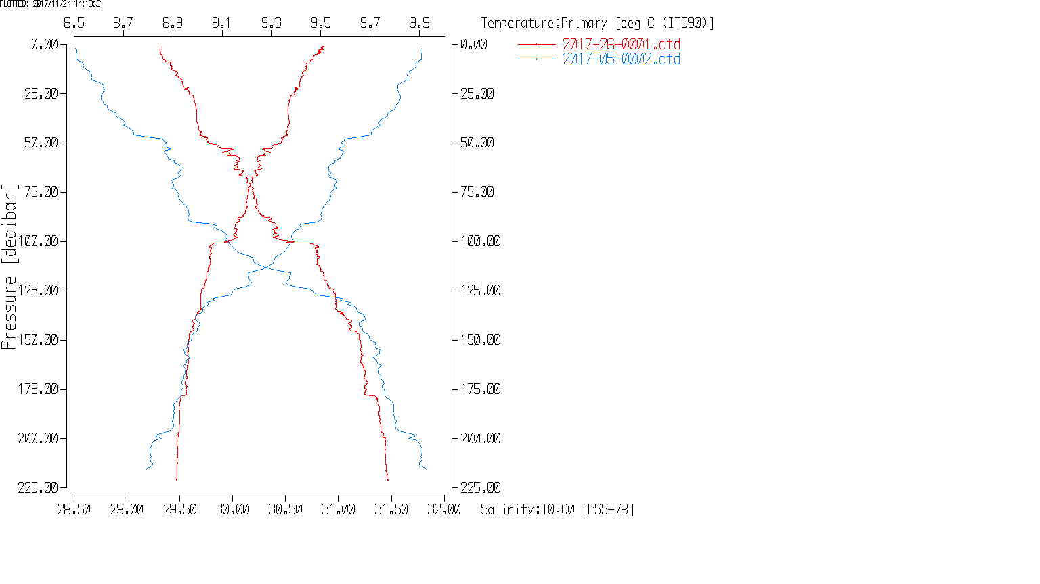
- 2017-48 sampled many of the same sites 8 to 14 days later. A comparison was made at a selection of sites (Stations 41, 38, GEO1, CPF1, 28 and 24) which showed the two sets being close at the bottom except at station 41. The 2 deepest of these casts showed a good correspondence in T-S space below 310m for GEO1 and below 380m for station 24.
- For GEO1 the largest differences in temperature along lines of constant σ_{t} below 310m depth are on the order of 0.005C° while salinity differences are mostly very small and all are <0.002psu. This was event #11.

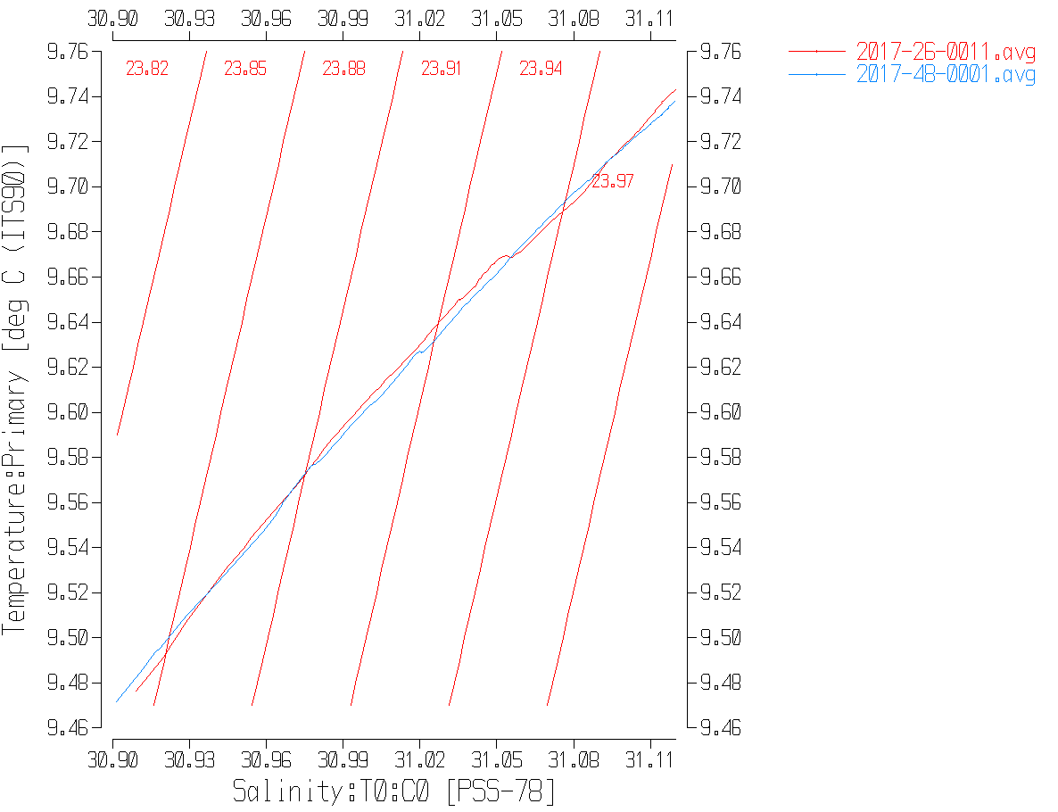

- For station 24 the maximum differences along lines of constant σ_{t} below 380m were a little larger at 0.01C° and 0.003psu. Since temperature differences are larger than those seen for event #11, larger salinity differences are also expected. It appears that the conductivity sensor had not been seriously damaged up until this point. This was event #24, so near the end of the cruise.

Study of dissolved oxygen profiles
Comparing Dissolved Oxygen profiles is not very helpful to determine if the pumps were working. A better way to assess DO will be to look at complete profiles to ensure that the upcast and downcast profiles track in the usual way, with just a small offset. If the pumps were not working the down and up profiles would not match as well as usual and would not look as similar to temperature profiles as usual.

Plots were examined for all casts to see if the up/down correspondence looked normal. All did including a deep one from near the end of the cruise which included reversals in dissolved oxygen that match similar features in temperature. So it looks like the oxygen sensor was pumped throughout the cruise. Since there is a reasonable chance that the DO tubing and conductivity cell damage happened at the same time, this lends a little more confidence in the integrity of the conductivity cell during the cruise.
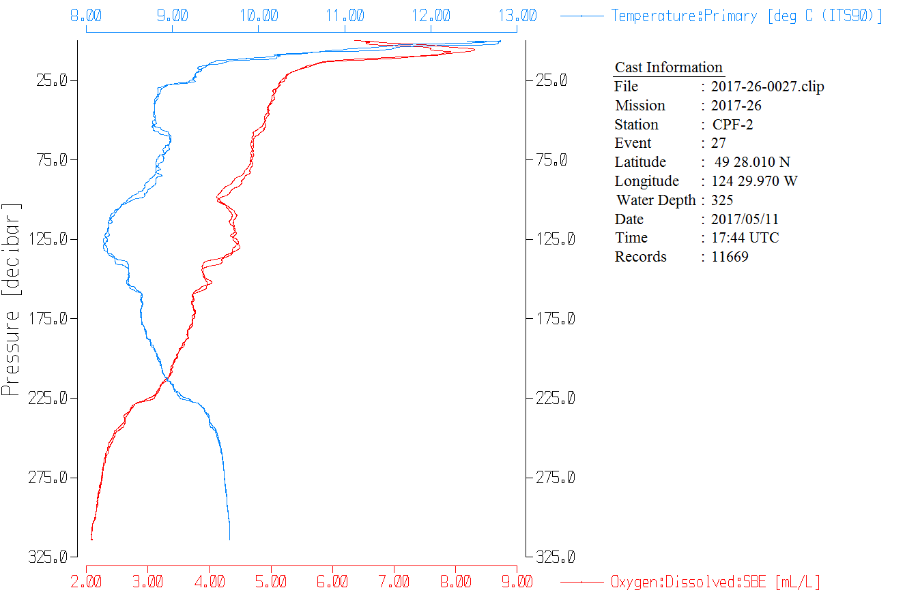

Historic Ranges – The local climatology is not representative of some of the sites occupied during this study and they are mostly close to shore where a 3-standard deviation climatology is not suitable. The climatology is somewhat out of date and it is in an area subject to very high variations. All in all it is not a very useful criterion to apply. However, finding systematic errors might alert us to trouble. All the temperature data all fell within the climatology and the only excursions in the salinity data were some low values in the top 20m to 30m. This likely reflects the very wet spring of 2017 rather than a calibration problem. Other spring cruises have noted low salinity near the surface in parts of the Strait of Georgia.

Sensor History – The pressure sensor was used during 2016-29, 2017-07 and 2017-47; no problems were detected. The temperature and conductivity sensors were used during 2016-29 but for only 4 casts with no calibration sampling and during 2017-07 and 2017-47 when salinity compared well with the CTD. The only use of the DO sensor with good calibration sampling since the last factory check was during 2017-01.

Comparison of repeat casts –There were no repeat casts.

Post-cruise calibrations – None were available.

17. CALIBRATE
We have no evidence of a problem with the CTD conductivity and the sensor performed well on previous cruises.
There was no dissolved oxygen sampling so the results from 2017-01 will be applied.
The pressure does not appear to need recalibration.

CALIBRATE was run using file 2017-26-recal1.ccf to apply the following correction to the Dissolved Oxygen channel:
CTD Dissolved Oxygen Corrected = 1.0484* CTD Dissolved Oxygen + 0.0413

18. Fluorescence Filter
A median filter, size 5, was applied to the fluorescence data as they are spiky.

19. Bin Average and REMOVE
The files were bin averaged using 1db bins.

REMOVE was run to remove Scan_Number, Conductivity:Primary, Oxygen:Voltage, Descent Rate and Flag channels.

Dissolved Oxygen was derived in mass units and that was used to calculate DO saturation. Surface saturation values ranged between 85% and 140% which is very close to the results in early March during 2015-47. The lowest value was from a cast that was well-mixed vertically and the highest values were from casts with large near-surface temperature gradients. The values look reasonable.

REORDER was used to get the 2 dissolved oxygen channels together.

20. HEADER EDIT and final checks of CTD files.
Header Edit was used to add or fix headers, fix formats and channel names and to add the following note to the headers:
Data Processing Notes:
----------------------
Dissolved Oxygen and Fluorescence are nominal and unedited, except
that some records were removed in editing temperature and salinity.
Fluorescence was removed from file #1 because the cap was left on.

While the CTD fluorescence data are expressed in concentration units, they
do not always compare well to extracted chlorophyll samples, particularly for
casts far from shore.

There was no salinity calibration sampling during this cruise. There was such
sampling during previous cruises using the same sensors and the CTD salinity
compared well with botttles. Damage to the conductivity cell was discovered after
this cruise. The salinity from 2 deep casts compares well with a cruise run
about 2 weeks later in the same area using a different conductivity sensor.
The calibration appears to be good, so the damage likely occurred in off-loading
or transport after this cruise.

There was no dissolved oxygen calibration sampling, so the recalibration used for
cruise 2017-01 was applied to these data since the same sensor was used and
calibration sampling was extensive.

For details on the processing see processing report: 2017-47-Processing_Report.doc.

A cross-reference listing was produced.
A header check was run on the CTD files and no further errors were found.
The sensor history was updated.
Plots of CTD casts were examined and no problems were found.

PARTICULARS
The CTD was generally lowered to 10m, raised and held at 2m until about 2 minutes had passed. The full cast was then run. This approach enables easy removal of the data from the initial drop by removing about 1920 records. Checks were made to ensure that too many data are not removed and for one cast that was the case. Clipping1850 records works for all casts; it is not important to remove all the 2m soak data, just the initial drop.

7. CTD got turned on while on deck between stations.
23. Depth entered from plan, not sounder.

CRUISE SUMMARY
Cruise ID#: 2017-26
Dates: Start: 6 May 2017 End: 12 May 2017
Location: Strait of Georgia
Party Chief: Young K.
CTD# | Make | Model | Serial# | Used with Rosette? | CTD Calibration Sheet Competed?
1 | SEABIRD | 25 | 1123 | No | Yes

CTD CALIBRATION INFORMATION
Make/Model/Serial#: SEABIRD/SBE25/1123 Cruise ID#: 2017-26

Calibration Information –
Sensor |  | Pre-Cruise |  | Post Cruise
Name | S/N | Date | Location | Date | Location
Temperature | 4888 | 7Nov2015 | Factory
Conductivity | 4513 | 28Oct2015 | Factory
ECO Fluorometer | 2214 | 02Jun2017 | ?
SBE43 Oxygen | 3234 | 11Nov2015 | Factory
Pressure | 1123 | 23May2014 | Factory

