REVISION NOTICE TABLE
DATE | DESCRIPTION OF REVISION

PROCESSING NOTES
Cruise: 2017-020
Agency: IOS, Ocean Sciences Division, Sidney, B.C.
Location: Beaufort Sea
Project: Canadian Beaufort Sea Marine Ecosystem Assessment
Party Chief: Eert J., Majewski A.
Platform: Frosti
Date: 1 August 2017 – 12 September 2017

Processed by: Germaine Gatien
Date of Processing: 19 July 2018 - 8 August 2018
Number of original HEX files: 117 (110 SBE911 -some split casts/test casts & 6 SBE 25)
Number of CTD files: 114 (108 SBE911 & 6 SBE25) Number of bottle casts: 74

INSTRUMENT SUMMARY
Two CTDs were used during this cruise:
- SeaBird Model SBE 911+ CTD (Arctic #1189) was mounted in a rosette and attached were a Wetlabs CSTAR transmissometer (#SCST1666DR), a SBE 43 DO sensor on the primary pump (#1202), a SeaPoint Fluorometer on the secondary pump (#SCF3651), a Biospherical PAR sensor (#70501), a surface PAR sensors (#20279), a SeaPoint turbidity meter (#11074) and an altimeter (#40853). For casts #76-474 an SBE18 pH sensor (#1287) was attached.
- SeaBird Model SBE19plusv2 (#6009) was run on internal batter power. It was mounted with a SBE 43 DO sensor (#3491), a SeaPoint Fluorometer (#SCF3253) for the whole cruise, a second SeaPoint Fluorometer (#SCF3741) for casts 71-336, a SeaPoint turbidity meter (#11432) and an altimeter (#60142). An SBE18 pH sensor (#1287) was present for casts # 63 and 67 only; it was then moved to the SBE911+.

SUMMARY OF QUALITY AND CONCERNS
The Daily Science Log book and rosette log sheets were not available, but electronic versions were. No cruise report was available at the time of processing.

A fluorometer mounted on the SBE19+ for all casts had drop-outs and values that were noisy and unbelievably high in deep waters, so the channel was removed; a second fluorometer was added before cast #71 and it performed normally. The fluorometer on the SBE911+ produced believable profiles, but the extracted chlorophyll samples were not available for comparison at the time of processing.

A pH sensor was mounted on the SBE19+ up to cast #76 when it was moved to the SBE911+. Individual profiles looked ok, but repeat casts showed significantly different values. The data were removed from the data to be archived as values are unreliable.

There was no dissolved oxygen sampling but post-cruise calibrations were available for both sensors. For the 911+ sensor the deepest cast was processed using the two calibration and then compared; this was used to create a linear recalibration equation. While this is an estimate, the amount of drift was reasonable for a 2.5 year interval.

A similar comparison was done for the SBE911+ temperature and conductivity and showed little drift in the temperature sensors and the primary conductivity, but the secondary conductivity showed a large drift. The two salinity channels were very close throughout the cruise and the comparison with salinity bottle data showed both channels to be within ±0.002psu, so it is believed that the problem with the secondary conductivity arose after this cruise. Secondary channels were only selected for one cast, 2017-020-0445.

For the SBE19+ a comparison between a file converted using pre-cruise and post-cruise calibrations showed insignificant drift in temperature, conductivity and pressure. The dissolved oxygen comparison was complex, but suggested that values derived from the pre-cruise calibration were low by at least 1%., so all values were multiplied by 1.01. DO surface saturation rates compared well with those found nearby that used the SBE 911+ CTD.

Only the salinity samples are included in the CHE files. Nutrients, extracted chlorophyll and DIC/Alkalinity samples were collected for and analyzed by Dr. Christine Michel of the Freshwater Institute. For information about those data contact: Dr. Christine Michel, Christine.Michel@dfo-mpo.gc.ca, (204) 984-8726.

PROCESSING SUMMARY
PART I – SBE911

Seasave
This step was completed at sea; the raw data files have extension HEX.

Preliminary Steps
The file names were changed to standard format including a 3-digit cruise number.
There are 112 SBE911 HEX files but a few appear to be from split casts.
There are 2 distinct XMLCON files:
2017-020-ctd1-SBE911.xmlcon – for casts #1 to #75
2017-020-ctd2.SBE911.xmlcon – for casts #76 to #476 – pH sensor added
The calibration parameters were checked for all sensors except the pH for which the factory information was unavailable; no errors were found.

The rosette log sheets were obtained as well as the salinity analysis spreadsheet.
The cruise summary sheet was completed.
There was no history available for the pressure, temperature, conductivity and DO sensors.
There were post-cruise calibrations for some of the sensors, but no drift estimates were provided. A comparison will be made later by converting a deep file using the post-cruise. However, it is not known how often the sensors were used over the 22 months between those 2 events.

Conversion of Full Files from Raw Data
Hex files from events #1-71 were converted using 2017-020-ctd1-SBE911.xmlcon to create CNV files.
Hex files from events #76-476 were converted using 2017-020-ctd2-SBE911.xmlcon to create CNV files.
A few casts were first run with all voltages converted to ensure nothing was missed in the channel list – all correspond to channels converted. All casts were then run without the voltage channels.

Some files have “a” or “b” or “test” added to the file names. These are discussed in the rosette file conversion section that follows. For the downcast files casts 96, 94b, 151b, 159test and 175test contain no downcast data and will not be processed further. Cast 454a was more confusing because it contains no downcast data, but neither does 454. File 454.CNV looks like a hex file. This is similar to what happened with file 94b which needed adjusting to produce a rosette file. Investigation showed that the raw HDR and HEX files were corrupted with the header information interrupted by some data lines (not the usual length), then after the 2nd section of header data there were some corrupted records of non-standard length. We don’t expect any data in the HDR file. When the data found in the middle of the headers plus the next 2 records were removed, conversion worked and produced a full downcast and upcast. The file was renamed 454.

A few casts were examined and all expected channels are present. A few problems were noted:
- The pH profile looks poor for cast #63, with lower values than expected on the downcast. The following cast, #67, looked ok.
- The fluorescence looks odd for cast 63, dropping suddenly during the downcast at 10m and values staying very low throughout. For cast #67 there is sudden drop at about 10m.
- For SBE19+ casts 71, 73. 333 and 336 there are two fluorometers; the one used for 63 and 67 continues to look problematic, sometimes giving values close to the 2nd sensor, but often having lower values and for cast #336 having higher values, significantly higher in deeper water. This fluorometer looks unreliable. Both traces are very spiky for casts 333 and 336.
- Altimetry is spiky at the bottom of cast 72.
Turbidity, transmissivity, fluorescence, pH, temperature, conductivity, PAR and dissolved oxygen look ok. The SPAR traces have a lot of one-sided spikes. Values are usually < PAR but not always.
The descent rates are highly variable with some very noisy, some steady, with rates between 0.5m/s and 1m/s.

Pressures are between -0.15 and +0.05db when conductivity dropped suddenly at the end of casts, so the pressure appears to be accurate.

BOTTLE FILE PREPARATION
The ROS files were created using file 2017-020-ctd*.xmlcon. (*=1 or 2)

Cast #94b did not convert properly. Investigation showed that the raw HDR and HEX files were corrupted with the header information interrupted by some data lines (not the usual length), then after the 2nd section of header data there were some corrupted records of non-standard length. We don’t expect any data in the HDR file. When the data found in the middle of the headers plus the next 4 records were removed, conversion worked. There were 2 bottles in file 94 and 5 in file 94b but the first 2 in 94b were obviously fired to get the Niskin numbers to match the log. The first 2 should be dropped.
To enable a join of these two file, 94.ros was renamed 94a.ros.

There were 5 other cases of non-standard file names:
9b - The first file contains data from Niskin 1 and 2. The second contains Niskins 1 to 9, but the first two of those were fired just to get Niskin #s in line, so they will not be needed. The first file was renamed 9a to enable a JOIN.
151b – There was only Niskin 1 in file 151 and there was no sampling from that bottle. File 151b contains Niskin 1 as well, but that was obviously to get the Niskin bottle order correct in the file. Only file 151b is needed and Niskin 1 should be dropped from it. File 151.ros was deleted and 151b.ros was renamed as 151.ros
159test – No sampling – no rosette file produced
175test – No sampling – no rosette file produced
454a – Nothing in 454, so 454a was renamed as 454.ros

So only files 9 and 94 require a join and no renumbering of bottle numbers should be necessary.

The files were converted to IOS format.
CLEAN was run to create BOT files.
To enable joining of the files 9a.abot and 9b.bot were renamed 9.bota and 9.botb. The same was done to file 94a and 94b.
The first two records were removed from the “b” files and the header limits changed.
JOIN was run to produce files 9 and 94. The file list was updated.

Temperature and salinity were plotted for all BOT files. A little noise was found in the secondary salinity near the bottom of casts #142 and 205; CTDEDIT was used to clean those records. The resulting files were copied to 2017-020-0450.BOT.

A preliminary header check turned up a few problems:
- Cast #151: the station name and water depth were missing
- Casts #9 and 94: event numbers were missing.
- Cast #46: depth was entered as station name.
- Casts #1-53 had a different format for station names than the rest of the cruise, so they were changed in the SAM files. This included removing the “b” when it was the second cast at a station.
The information was added based on the log entries. Where appropriate the same changes were made to the CNV files after initial conversion.

JOIN was run to join the BOT and SAMAVG files for events 9 and 94. First the unneeded records were removed from the “b” files.

The BOT files were bin-averaged on bottle number and the output was used to create file ADDSAMP.csv. Sample numbers were added to the file based on the rosette log records.
Cast #365 had sample numbers that were used during the previous cast, so they were changed from 417- 422 to 9417-9422.

The addsamp.csv file was converted to CST files, which will form the framework for the bottle files.
SAM files were created using the Add Sample Number routine and those files were then bin-averaged. Output was SAMAVG.

Next, the salinity analysis spreadsheet was examined to see what comments should be included in the header file. These were used to create file 2017-020-bot-hdr.txt; it may need further editing to reflect problems found during processing.

SALINITY
Salinity analysis was obtained in Frosti 2017-20 Salinity Data for Merging*.xlsx. The analysis was done in late November 2017 which was about 4 months after the first casts and 2.6 months after the end of the cruise. The files were simplified and saved as 2017-020sal.csv. There were no event numbers so those were added. There was some repetition of sample numbers that affected casts 358, 365 and 367. There is no overlap between the 2nd and 3rd of these casts, so renaming the samples of cast 358 by adding a leading “9” is the simplest method and having all sample numbers in increasing order within a cast simplifies processing.

The spreadsheet was then converted to individual SAL files.
The SAL files were merged with CST files.
The files were put through CLEAN to reduce the headers to File and Comment sections only.

The merged files are ordered on sample number, but the SAMAVG files are ordered on bottle number, so one or the other set needs to be reordered in order to merge them. The MRGCLN1 files were reordered on Bottle_Number. The output files were named MRGCLN1s. Those files were then merged with SAMAVG files choosing the Bottle_Number from the SAMAVG files, to produce MRG files.
Add Channel was used to add channel Flag:Bottle_Number to follow Bottle Position. The latter will be renamed Bottle Number later.
The MRG files were put through CLEAN to produce MRGCLN2 files; 0s were entered into any empty flag channels.

Compare
Salinity
Compare was run with pressure as reference channel.
The plot of differences against pressure turned up some major outliers:
- Event #1, Sample #4 – There is a very high standard deviation in the CTD salinity and it is a surface sample where that is not unusual. There is no evidence of a problem in the bottle value. No flag is justified.
- Event #27, Sample #42 - The standard deviation in the CTD salinity is fairly high and it is a 10m sample where high variability is usual. There is no evidence of a problem in the bottle value; incomplete flushing of the Niskin bottle likely explains part of the difference. No flag is justified.
- Event #149, Samples #211 and 212 - The standard deviations in the CTD salinity are low. Error found in the ADDSAMP file.
- Event #215, Sample #296 - The standard deviation in the CTD salinity is very high. Three bottles were fired at the surface and they show very different values with salinity going down with time. The wait before firing was long enough but conditions were varying. No flag is justified.
- Event #266, Sample #310 and 314- These samples are clearly mislabelled. Renaming 310 as 314 and 314 as 310, produces good results. Flag 3 and a comment were added.
- Event #365, Sample #419 – The duplication of some sample numbers led to an error in the salinity spreadsheet. Sample 419 was used twice. The same bottle value was entered for both of them in the final spreadsheet. The raw values were found and the sample from this cast had value 33.9726, so that was entered in the salinity data used in the merge. Flag 2 and comment added.

Also investigated was the duplicate pair that was flagged 36 due to outlier replicates. The average is closer to the CTD salinity than either of the replicates.

The Addsamp file and the Salinity spreadsheet were reconverted, the merge process repeated and COMPARE rerun. The results were much better. There are many outliers, mostly in the top 200m with the CTD mostly reading lower than bottles. This is likely due to incomplete flushing of Niskin bottles. When bottles above 210db and those with a standard deviation in the CTD salinity are >0.0008psu are excluded, both sensors are reading high, the primary by an average of 0.0014psu and the secondary by 0.0018psu. The standard deviation was 0.0027psu for both. There were 30 bottles for the primary comparison and 31 for the secondary. Since the majority of the bottles included were fired at the bottom of casts, the effect of incomplete flushing would be to make the CTD appear to be reading higher than bottles. But the vertical gradients are very low for the deeper bottles, so this is unlikely to be a significant error and any flushing errors for bottles fired during the upcast are likely to be compensating. There are too few deep bottles to examine that in detail, but there does not appear to be a significant difference between results from Niskin #1 and Niskin #2.

One other factor is that there was some delay in analysis which could lead to bottle values reading a little high. However, the wait was not long for those samples collected late in the cruise. A comparison of differences versus time shows no significant difference with time of cast; the trend is towards the sensors reading slightly higher relative to bottles early in the cruise. So evaporation/adsorption of samples appears to be insignificant. This is not conclusive since there are few samples and the gradients also vary with time, but if there were large errors due to the analysis delay, they should stand out.

The accuracy of both CTD sensors is likely within ±0.002psu. No recalibration appears necessary.

For full details for the COMPARE run see file 2017-020-sal-comp1.xls.

The salinity comparison was also used to investigate whether there was damage to the CTD when it had a hard hit during cast #273. A comparison was done excluding data from below 210db plus all casts after #273. There are not many deep records from that time, but all show small differences between the CTD and bottle samples.

Two rosette casts were missing when the original processing was done. They were found and put through the same steps as other casts. Deep bottles from 1 cast were in good agreement with the CTD salinity. Agreement for the other cast was poor, but all sampling was from shallow waters, so this is not significant. These data are not in the COMPARE file.

WILDEDIT
Program WILDEDIT was run to remove spikes from the pressure, conductivity & temperature only in the full cast files (*.CNV).
Parameters used were: Pass 1 Std Dev = 2 Pass 2 Std Dev = 5 Points per block = 50
The parameter “Keep data within this distance of the mean” was set to 0 so all spikes would be removed.

ALIGN DO
Tests were run on 3 casts for DO sensor #1189. The best setting varied from feature to feature, but a setting of +3s looked best overall.
ALIGNCTD was run using a setting of +3s to the dissolved oxygen channel.

CELLTM
The usual tests for the best settings for this routine are difficult to interpret because of the noisy upcast data, so the default settings was used.
CELLTM was run using (α = 0.0245, β = 9.5) for the primary and secondary conductivity.

DERIVE and Channel Comparisons
Program DERIVE was run on all casts to calculate primary and secondary salinity and dissolved oxygen concentration.

The differences between sensor pairs were studied from a few casts, but most were too shallow to be useful.
Cast # | Press | T1-T0 | C1-C0 | S1-S0 | Descent Rate
2017-020-0051 | 450 | +0.0002 | +0.00004 | +0.0003 | F.High, Steady
” | 950 | +0.0002 | +0.00002 | +0.0001 | F.High, Steady
2017-020-0264 | 450 | +0.0001 | +0.00005 | +0.0005 | Moderate, Noisy
2017-020-0365 | 450 | +0.0002 | +0.00007 | +0.0007 | F.High, F.Steady
The differences are very small.

Conversion to IOS Header Format
The IOSSHELL routine was used to convert SEA-Bird 911+ CNV files to IOS Headers.
CLEAN was run to add event numbers and to replace pad values in the pressure channel with interpolated values based on record number.
At this point plots were examined to see how many scans needed to be removed from the start of each cast to remove the soak data.
CLIP was run to remove the data from the soak period for each cast. Plots were made to ensure an appropriate number of scans were removed; a few casts were rerun.

Checking Headers
An initial cross-reference list was examined and 7 more casts were found with a ’b’ after the station name for a 2nd cast at the same site. The b’s were removed from the station names in the IOS and SAM files and subsequent steps were repeated for those casts. It was also found that the station name had not been entered for cast #151, so that was added.

At this stage the SBE19 casts were included in some checks:
- Cross-reference list: The times, station names and locations were checked against the event log.
  - Station name errors were found and corrected in the CLIP files for events 8, 164, 403 and 405.
  - Formats were changed in station names in many CLIP files to make them consistent with the Event log.
  - The raw data for casts #324, #328, #385 and #387 were missing but were eventually recovered from the ship computer and put through all the same steps as the other files.
  - Errors were found in the event log: Event 102 has latitude 70° 9.34’ and should be 70° 39.34’. Event 365 has longitude 119° should be 118°. Event 328 longitude 118° should be 117°.
- Header check – No obvious problems were found.
- Track plots – The cruise track was plotted and looks ok.
- The surface check was run on the files before CLIP was applied. For the SBE911 the average was +0.24db. When 7 casts were excluded that had salinity >25psu the average is 0.03db. The 7 with salinity >25 was 3.2db. There is no evidence of significant pressure calibration drift.

The altimeter readings from the headers of the CLIP files were exported to spreadsheets. A check was made by calculating: Check Value = Max Depth Sampled + Altimetry header – Water depth
If that value was very large it was usually due to spikes in altimetry being misinterpreted. Plots were examined and where they confirmed this, the entry was removed from the header. For other casts with the check value >4m, the water depth was checked against the event log. Often changing that produced a good result. Where that did not explain the difference plots of altimetry were examined and for a few casts a small adjustment in the value was made as spikes had affected the algorithm. Where there is a significant difference the depth recorded at the bottom was used as long as it led to a better Check Value.

The same changes were applied to any affected SAM files. Then the merge process was repeated.

Shift
Fluorescence
SHIFT was run on the fluorescence channel in all casts using the usual advance of +24 records. Plots made after this step were hard to interpret due to noisy fluorescence and many stops for bottles but there is clearly some improvement in matching the fluorescence offset to the temperature offset.
Dissolved Oxygen
The Dissolved Oxygen voltage channel was aligned earlier. A few casts were checked to see if further alignment is needed for the DO concentration channel; it is difficult to judge but the alignment looked reasonable.
Conductivity
Tests were run on 4 casts using a variety of shifts and the best results were found with the settings -0.5s for the primary and -0.4s for the secondary. SHIFT was run twice using those settings.
pH
As the data from this sensor have been found to be unreliable, they will not be archived. No tests were run on alignment.

DELETE
The following DELETE parameters were used:
Surface Record Removal: Last Press Min
Maximum Surface Pressure (relative): 10.00
Surface Pressure Tolerance: 1.0 Pressure filtered over 15 points
Swells deleted. Warning message if pressure difference of 2.00
Drop rates < 0.30m/s (calculated over 11 points) will be deleted.
Drop rate applies in the range: 10db to 10db less than the maximum pressure
Sample interval = 0.042 seconds. (taken from header)
COMMENTS ON WARNINGS: The only warnings concern upcast surface data from 2 casts, so are of no concern to the downcast files.
The output files were copied to *.EDT.

Other Comparisons
Previous experience with these sensors –
There was no history available for the pressure, temperature, conductivity and DO sensors.
Historic ranges – Local climatology was not available.
Repeat Casts – There were many repeat casts, but one of the two was always shallow where variability is too high to enable a useful comparison.
Post-Cruise Calibration – There were post-cruise calibrations in December 2017 for the temperature and conductivity channels. No drift estimate was included. The dissolved oxygen sensor was recalibrated in October 2017. Since there was no calibration sampling for DO, a comparison was made as described in section 16. Temperature, conductivity and salinity comparisons are also described there.

DETAILED EDITING
The primary temperature and salinity channels were edited for most casts since they looked a little smoother overall in T-S space than the secondary channels and were slightly closer to bottles.
For cast #445 there was corruption of the primary salinity channel at about 8db which did not clear until the CTD was at about 50db. It is possible that the secondary salinity was affected slightly, but if so, it recovered quickly. Comparison with a second cast at the same site confirms that the primary salinity is bad, but the dissolved oxygen appears to be ok; there is some variability between casts so this is not completely clear.

CTDEDIT was used to remove large spikes, remove or clean smaller spikes that appear to be due to instrumental problems and records corrupted by shed wakes including some records from near the top and bottom of the casts. For most casts the editing was mostly at the top and bottom of casts.
For some casts on the DUS line heavier editing was required due to very noisy descent rates with some complete reversals of the CTD which leads to shed wake corruption.
All files were edited.
The output files were copied to EDT.

T-S plots were examined and the results looked ok; there are some small unstable features in a few casts. There was no obvious instrumental cause of some of these features so they may be real. In other cases the descent rate is low and T and S values reflect small variations in descent rate; it is impossible to determine which data are better. The instabilities disappear upon metre-averaging.

Post-cruise calibration study
There were post-cruise calibration data available for the temperature, conductivity and dissolved oxygen sensors on the SBE911. They were from October, November and December of 2017. A study was made of the differences between the data found using the pre-cruise and post-cruise parameters. File #51 was selected for the study as it was the deepest cast. The file was converted using the post-cruise calibration and the data were put through steps 6, 7, 8 and 8; the word POST was included in the file name. For temperature, conductivity and salinity comparisons were made by extracting some values and by looking at plots.
- The pre-cruise primary temperature was lower than the post-cruise by ~0.0003C° while the secondary was lower by ~0.0005C°. There was no significant pressure dependence.
- The primary conductivity was lower by ~0.000029S/m while the secondary was high by 0.000118S/m.
- The primary salinity was higher than the post-cruise values by ~0.0004psu and the secondary was higher by ~0.0021psu.
The salinity, temperature and conductivity channel pairs were very close to each other using the pre-cruise calibrations. That was not the case for conductivity and salinity when the post-cruise calibration is applied. It looks as though the secondary conductivity drifted significantly after this cruise. A check of late casts does not indicate that the problem arose during this cruise.

This comparison suggests that the primary channels have not drifted significantly. We can only assume that since the two salinity channels and temperature channels are very close, that the secondary have not drifted much either.

For dissolved oxygen a more rigorous check is necessary because calibration drift is usually DO-dependent. So the CNV file for cast #51 was converted to IOS header format, put through CLEAN, CLIP and DELETE. The file was then metre averaged as was file 2017-020-0051.DEL and then put through THIN to reduce the size to 50 records each. COMPARE was run using files THN and THNPOST.

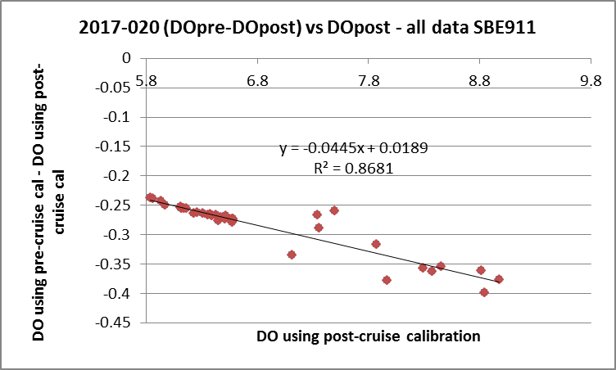

Using all the data in the thinned files, the fit was:
DO-Post = 1.0445 * DO-Pre – 0.0189 R²=0.8681
The fit was poor for high DO values. When data with DO>7mL/L were removed the fit was:
DO-Post = 1.0479 * DO-Pre – 0.0393 R²=0.9527
The outliers may be due partly to there being small differences in the temperature and conductivity calibrations. The outliers are in a region of high vertical gradients so small differences may cause more variability than would be seen elsewhere. While it is not always obvious that the post-cruise calibration is more suitable than the pre-cruise values, we do expect drift on this scale after 2.5 years and there was no report of damage to the sensor. The correction may be slightly high, but is the best estimate we can get in the absence of DO bottle sampling. The fit with all data will be used for recalibration.

Initial Recalibration
No pressure recalibration is needed.
Based on the post-cruise calibration check of dissolved oxygen, CALIBRATE was run using file 2017-020-recal1.ccf to apply the following correction in the MRGCLN2 files and the EDT files:
DO corrected = 1.0445 * DO – 0.0189
Checks were made and the corrections were made as planned .

Fluorescence Processing
A median filter, size 11, was applied to the fluorescence channel in the COR1 files. Plots of a few casts showed that the filter was effective. (Output:*.FIL)

Plot Checks
Header edit was run to check for any negative values where they are unrealistic and there were none.
Plots were made of all variables to check for off-scale values or signal drop-out.
Fluorescence values have a minimum of 0.045ug/L and no unrealistic drop-outs.
Transmissivity at depths 10-50m or around 100m are very low for a few casts, but upcast and downcast and nearby casts agree, so these features are presumed to be real.
Turbidity traces mirror those of transmissivity overall, though turbidity has a few more spikes.
The PAR traces all look ok. There was a mention in the log that it might not have been working for cast #103; the trace has the right shape but the values are lower than a repeat cast at the same site. There is also a note about the cap being left on for cast #205. Again there is a sensible shape but the values are lower than a repeat cast at the same site. The channel will be removed from these 2 casts as they are likely unreliable.
For many casts there is no signal in the SPAR channel. The log mentions this for cast #1, but there are also no data for casts #17, 18, 37-46, 79-474, though cast #103 had a few sections with a signal but mostly 0 values. SPAR will be removed from most casts.

While individual pH channels look reasonable, repeat casts suggest that the values are not reliable. The plot below shows a case where the first two casts are fairly close while the 3rd has much higher values. Most often the 2nd cast has higher pH than the 1st, but there are other cases where the opposite is true. Temperatures are plotted to show that while there are variations the differences are very small between the last 2 casts while the pH is closer between the first 2. The pH data will not be placed in the OSD Data Archive.

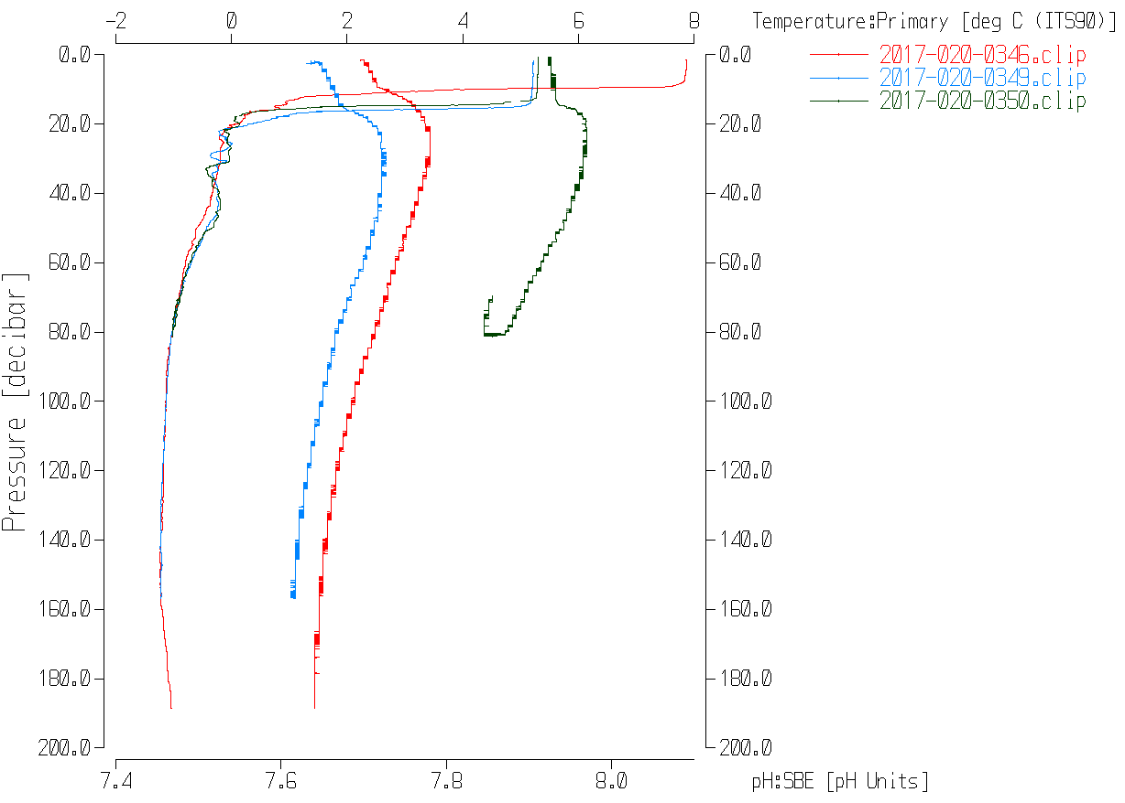

BIN AVERAGE of CTD files
The following Bin Average values were applied to the FIL files (output AVG):
Bin channel = pressure Averaging interval = 1.000 Minimum bin value = .000
Average value will be used. Interpolated values are NOT used for empty bins.

Final CTD File Steps (REMOVE and HEADEDIT)
REMOVE was run to remove the following channels:
- primary T, S and C for cast 445
- secondary T, S and C for all casts except #445
- SPAR from casts 1, 17-18, 37-46 and 79-474
- PAR from cast 103 and 205
- Scan_Number, pH:SBE, Oxygen:Voltage:SBE, Altimeter, Status:Pump, Descent_Rate and Flag from all casts
A second SBE DO channel (with umol/kg units) was added.
REORDER was run to get the two DO channels together.

HEADER EDIT was used to fix formats and channel names and to add the following comments:

---------------------------------------------------------------------------------
Data Processing Notes:
----------------------
Transmissivity, Fluorescence, Turbidity, PAR and Surface PAR data are nominal
and unedited, except that some records were removed in editing
temperature and salinity.

Surface PAR was removed from many casts due to sensor malfunction.
PAR was removed from 2 casts due to cap left on sensor.

For details on how the transmissivity calibration parameters were calculated
see the document in folder "\cruise_data\documents\transmissivity".

SBE Dissolved oxygen was recalibrated based on a comparison of the deepest
cast derived using the pre-cruise and post-cruise calibrations.

Similarly, the temperature and conductivity were compared using pre-cruise and
post-cruise calibrations. There was no significant drift in the temperature
channels or the primary conductivity. There was significant drift in the
secondary conductivity most of which is believed to have occurred after this
cruise.

Secondary temperature and salinity channels were selected for only 1 cast; no
recalibration was found necessary since the temperature and conductivity
channel pairs were very close overall during the cruise.

Channel pH:SBE was removed because values at repeat casts varied greatly.

NOTE: While the CTD fluorescence data are expressed in concentration units, they
do not always compare well to extracted chlorophyll samples, particularly for
casts far from shore. It is recommended that users check extracted chlorophyll
values where available.

For details on the processing see the report: 2017-020_Processing_Report.doc.

The Standards Check routine was run and no problems were found.
Final quality checks will be made with the SBE19 casts and will be reported on at the end of Part II of this report.

Dissolved Oxygen Study
As a final check of dissolved oxygen data, % saturation was calculated and plotted. All values were between 95% and 103% with only a few > 100%. The highest values were close to shore.

Final Bottle Files
CALIBRATE was run on the MRGCLN2 files using 2017-020-recal1.ccf to correct the DO channel.
The MRGCOR2 files were put through SORT to order on increasing pressure.

REMOVE was run to remove the same channels as for the profile files:
Remove primary T, S and C for cast 445.
Remove secondary T, S and C for all casts except #445.
Remove SPAR from casts 1, 17-18, 37-46 and 79-474.
Remove PAR from cast 103 and 205.
Remove Scan_Number, pH:SBE, Oxygen:Voltage:SBE, Altimeter, Status:Pump, Descent_Rate and Flag from all casts.

A second SBE DO channel was added to the CTD DO with mass units and REORDER was run to get the 2 SBE DO channels together.

HEADER EDIT was run to ensure formats and units are correct, change the channel name Bottle_Number to Bottle:Firing_Sequence and the name Bottle:Position to Bottle_Number and to add a comment about quality flags and analysis methods and a few notes about the CTD data processing.
A note was added to mention that other chemistry samples were collected for and analyzed by Dr. Christine Michel of the Freshwater Institute. Dr. Christine Michel, Christine.Michel@dfo-mpo.gc.ca, (204) 984-8726

Standards check was run on all files and no errors were found.

A header check was run on the final files. A few problems were found:
- Wrong header items were found in the 2 rosette casts that were processed late; they were fixed and the check rerun.
- The flag channel for the bottle number was missing –it had been dropped inadvertently.
- The flag channel had never been added for the 2 rosette casts that were processed late.
- The sample numbers for cast #149 were wrong and the line that should have been dropped from cast #151 had not been. These errors derive from sample 212 having been entered on the log for two casts, but only cast #149 had samples with that ID.
- Raw file #175 should have been changed to #176 – the IOS file had been changed and the salinity sample was listed as #175, but the ROS file had the wrong name. So the merge failed and had to be redone.
After those problems were fixed, the header check was rerun and no further problems were found.
The track plot looks ok.
Plots of each file were examined and no further problems were found.

Data from the CHE files were exported to a spreadsheet. The file was saved as 2017-020-bottles-final.csv.

Producing final files
A cross-reference listing was produced for the CHE files.
The sensor history was updated for the DO sensor on the SBE911. The SBE19+ CTD belongs to the Freshwater Institute.

PART II – SBE25

Seasave
This step was completed at sea. There were only 6 files; the names were changed to the new standard format including a change to cruise number from 20 to 020.

Preliminary Steps
The cruise summary sheet was completed.
There were 2 configurations used so files 2017-020-ctd1-sbe19-ctd.xmlcon (casts 63 and 67) and 2017-020-ctd2-sbe19-ctd.xmlcon (casts 71, 72, 333 and 336) were prepared.

The calibration parameters were checked for the temperature, conductivity and pressure sensors; no errors were found. Only a post-cruise calibration was found for the Dissolved Oxygen sensor and none for the pH sensor. The equipment belongs to the Freshwater Institute.

Conversion of Raw Data
Files for events #63 and 67 were converted using configuration file 2017-020-ctd1-sbe19-ctd.xmlcon and for the other 4 SBE19 casts using 2017-020-ctd2-sbe19-ctd.xmlcon.

Plots were examined and all expected channels were present. Temperature, conductivity and dissolved oxygen look normal. The altimetry looks good although there is a spike at the bottom of cast #72. The pH trace looks bad for cast #63.
Fluorescence from the first fluorometer looks odd with drop outs and sometimes downcast and upcast looking quite different. The data at depth for the first cast is extremely noisy. The second fluorometer looks more believable with less noise, better correspondence between upcast and downcast and between nearby casts. There are no nearby casts using the SBE911; the closest is cast #318 which has values similar to the data from the second fluorometer during casts #333 and #336. The values from the first fluorometer often look too high at depth.

The deployment method was to lower the CTD to about 10m and return to the surface, a process taking about 1.6 minutes.

The pressure at which conductivity drops suddenly during upcasts was about -0.1db to -0.2db; ±1db is the accuracy quoted by SeaBird for the pressure sensor so this looks reasonable. The downcast data has conductivity rise at about the same pressure. Recalibration is not justified.

WILDEDIT
Since there are no obvious spikes in the downcast data below the surface, this step was skipped. The near-surface spikes will be removed in the DELETE step or using CTDEDIT.

FILTER
There are frequent small steps in the pressure and some small reversals. Tests were run during 2018-05 to see if just filtering pressure was sufficient to improve the salinity and it was not. A variety of filters were tested and the best choice was found to be a Windows cosine filter size 9.
WFILTER was run on pressure, depth, temperature and conductivity with cosine file width 9.

ALIGNCTD
During 2016-40, 2017-41, 2017-52, 2017-53 and 2018-05 when this DO sensor was also used the DO channel was advanced by 2.5s. That setting looks best for these data as well.
ALIGNCTD was run to apply a 2.5s advance.

CELLTM
SeaBird recommend the use of (α, 1/β) = (0.04, 8) for CELLTM for the SBE 25 and it has proved appropriate for many data sets.
CELLTM was run on all casts using the default setting: (α, 1/β) = (0.04, 8).

DERIVE
Program DERIVE was run to calculate salinity and dissolved oxygen concentration (tau correction included).

Conversion to IOS Headers
The IOSSHELL routine was used to convert the CNV files to IOS Headers.
Station names, locations and water depth were not included in the CNV file headers, so a text editor was used to add the information based on the event log.
CLEAN was run to add event numbers.

Checking Headers
CLIP was used to remove initial records from the soak period to ensure that data are only kept from after the pumps came on and the sensors were able to equilibrate. In some cases the CTD was soaked at 5m and returned to the surface, so the # of records removed will ensure the shallowest post-equilibration data are captured. Plots were made after this step to ensure the results were appropriate and 2 casts were rerun as too many records had been removed.
Plots were examined and show the number of records removed were appropriate

Surface check was run on the files before CLIP was applied. The average was –0.18db with extremely low salinity associated with all 6 casts. The associated salinity values are extremely low.
There is no evidence of significant pressure calibration drift.

Track plot and Header Check were run together with the SBE911 data and no problems were found.

SHIFT
Fluorescence
The fluorometer on the SBE19 was not pumped and plots confirm no alignment is needed.
Conductivity
Tests showed an improvement in the data using a shift of -1.7records to the conductivity.
SHIFT was applied to advance conductivity by -1.7 records for all SBE19 files. Salinity was recalculated.
Dissolved Oxygen
This channel was aligned earlier, but checks were made by examining plots of temperature and dissolved oxygen; the alignment looks good. SHIFT was not run on DO.
pH
The pH data are not going to be archived, so no shift was applied.

DELETE
DELETE was run on all casts using the following parameters:
Surface Record Removal: Last Press Min. Surface Swell Pressure Tolerance: 1.0
Swells deleted. Warning message if pressure difference of 2.00
Drop rates < 0.3m/s (calculated over 5 points) was deleted from 10db to 10db above the maximum pressure.
Pressure was not filtered as it had been filtered earlier.
COMMENTS ON WARNINGS: There were no warnings.

DETAILED EDITING
All DEL files were copied to *.EDT.
CTDEDIT was used to clean salinity in 2 files and remove a few records near the bottom of one cast. The other 3 files did not require editing. Notes of editing details were made in the headers.
The edited files were copied to *.EDT.
T-S plots were examined and no problems were found.

Other calibration checks
Sensor History – There was no history available for other uses of these sensors..
Comparison of repeat casts – None were available.
Historic Ranges – There was no local climatology available.
Inter-comparison of the 2 CTDs – There were no SBE911 casts near the SBE19 sites.

Post-cruise calibrations – There were post-cruise calibration data available for the temperature, conductivity and dissolved oxygen. So those were used to convert file 2017-020-0336 and put it through Filter, Alignctd, Celltm and Derive. Then the data using pre-cruise and post-cruise calibrations were both metre-averaged and combined in an EXCEL file.
- Temperature, Salinity and conductivity differences were highly variable above 40m, but below that the differences are very small with pre-cruise temperatures being lower by 0.0006C° while salinity is higher by 0.0001psu, so calibration drift is minimal.
- The differences between pre-cruise and post-cruise pressures are 0 at the surface and steady rise with depth, so that post-cruise pressures are higher by 0.031db at 340db. These differences are very small, but may explain why the matches are poor near the surface where temperature and salinity gradients are very high.
- This file was also used to compare the 2 fluorometers. This confirmed that channel Fluorescence:URU:Seapoint was reading too high with dark values ~0.20ug/L. Channel Fluorescence:URU:Seapoint2 looks much better with values ~0.05ug/L below 200m.
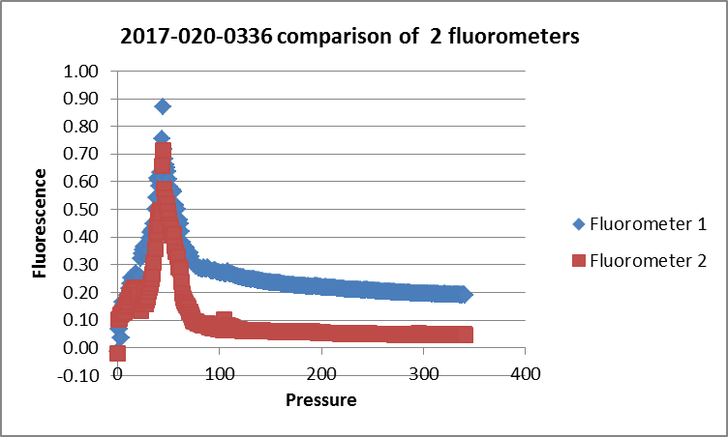
- Comparing DO is more complex because of the expectation of DO-dependence in the fit. So the data were converted to IOS format so they could be examined in COMPARE We normally look at differences between bottles and pre-cruise CTD DO and find a fairly linear fit against CTD DO. In this fit of differences between pre-cruise and post-cruise CTD DO against pre-cruise CTD DO, there is a similar pattern, but the scatter is very large. To get a reasonable fit requires removing most of the data from the top 100m. Removing just a few outliers produced the following:
DO-Post = 1.0206 * DO-Pre – 0.00624 R²=0.6558

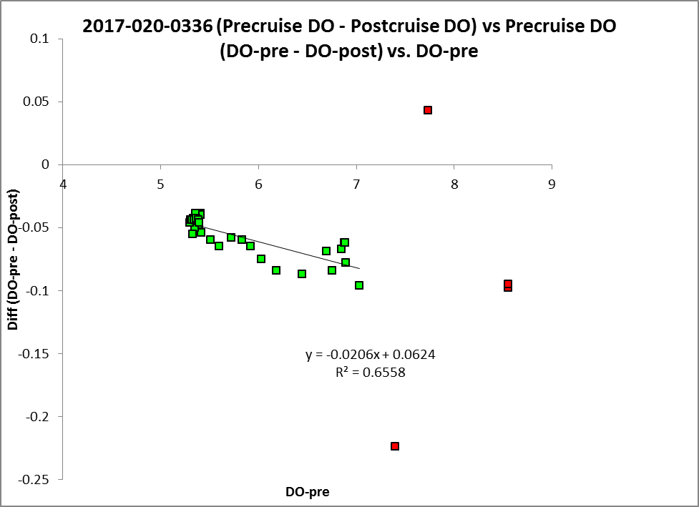

The DO range is limited in all the casts, with no values <5mL/L, so that errors in establishing the offset will be large. The % correction at different values of DO ranges from 0.8% to 1.3%.
Pre-cruise | Post-cruise | Difference | % correction
5 | 5.041 | 0.041 | 0.81
6 | 6.061 | 0.061 | 1.02
7 | 7.082 | 0.082 | 1.17
8 | 8.102 | 0.102 | 1.28
The comparison is very rough but it does show that values from the pre-cruise calibration are a little low. Recalibration by adding 1% looks like a reasonable estimate.

CALIBRATE
The only SBE19 variable for which we have sufficient evidence to justify recalibration is dissolved oxygen. It is likely low by at least 1%, so file 2017-020-sbe911-recal.ccf was prepared to multiply all DO
values by 1.01.

Filter
A median filter, size 5, was applied to channel Fluorescence:UR:SBE:2..

Bin Average and REMOVE and DO saturation study
The files were bin averaged using 1db bins.
REMOVE was run to remove Scan_Number, Fluorescence:URU:SBE , Oxygen:Voltage, pH:SBE, Altimeter, Descent Rate and Flag channels.
The altimetry header readings were checked and found to be reasonable.

Dissolved Oxygen was derived in mass units.
Saturation rates were calculated and plots show near-surface saturation at 97% to 100%. These compared well with other the closest casts found that used the SBE911+ CTD.

HEADER EDIT and final checks of CTD files.
Header Edit was used to fix headers, fix formats and channel names and to add the following note to the headers:
Data Processing Notes:
----------------------
Turbidity data are nominal and unedited, except that some records were removed
in editing temperature and salinity.

SBE Dissolved oxygen was recalibrated based on a comparison of one cast derived
using the pre-cruise and post-cruise calibrations.

Similarly, temperature and conductivity were compared using pre-cruise and
post-cruise calibrations. There was no significant drift in either.

Channel pH:SBE was removed because values at repeat casts varied greatly.

Fluorometer S/N 3253 malfunctioned so channel Fluorescence:URU:Seapoint was removed.
A second fluorometer was added after event #67 and provided good data.

NOTE: While the CTD fluorescence data are expressed in concentration units, they
do not always compare well to extracted chlorophyll samples, particularly for
casts far from shore. It is recommended that users check extracted chlorophyll
values where available.

For details on the processing see the report: 2017-020_Processing_Report.doc.

The standards check was run and no problems were found.
A cross-reference list was produced.
The Header Check was run and no problems were found.
Profile plots were made and look ok.
The track plot looks fine and was added to the end of this report.

Particulars – mostly notes from log
SBE19
63-72 – CTD19+ casts – fluorescence signal dropping out for fluorometer 3253.
71. Second fluorometer added to CTD19+. pH sensor removed.
Fluorometer #3253 malfunctioned.
Fluorometer #3741 was added for casts 71, 72, 333 and 336.

SBE911
1. SPAR not working
76. pH sensor added to CTD911+ ; close to bottom but rosette clean
86. Rosette up to 100m then back to 125 to fire Niskin 1
94. Computer restart during upcast – need to join for CHE file – full profile in 1st file so ok for CTD
95. Computer crash at beginning of cast.
103. Check PAR – might have not been working
114. Oxygen spiky on upcast
131. Variable depth
175/176. File called 175 but log says should be 176.
205. PAR cover left on
207. Repeat of 205 with PAR cover off
273. Hard hit on the side of the ship going in
296. Hex file with some surface data, but not a planned CTD or ROS cast; not processed.
328. Listed as ROS in event log but no CTD raw files found; no rosette log sheet found. Assume acquisition failed.
367. Lost pH buffer bottle
447. CHL max 50, 30; mixed layer 15-30m; 2 layer system (Pacific and strong river influence)

CRUISE SUMMARY - CTD
CTD# | Make | Model |  | Serial# |  | Used with Rosette? |  |  | CTD Calibration Sheet Competed?
1 | SEABIRD | 911+ |  | 1189 |  | Yes |  |  | Yes
2 | SEABIRD | 19 |  | 6009 |  | No |  |  | Yes
Calibration Information - 1189
Sensor |  |  |  |  | Pre-Cruise |  |  |  |  | Post Cruise
Name |  |  | S/N |  | Date |  | Location |  |  | Date |  | Location
Temperature |  |  | 5830 |  | 18Dec2014 |  | Factory |  |  | x
Conductivity |  |  | 4327 |  | 17Dec2014 |  | Factory |  |  | 10Nov2017 |  | Factory
Secondary Temp. |  |  | 5831 |  | 23Dec2014 |  | Factory |  |  | x
Secondary Cond. |  |  | 4339 |  | 18Dec2014 |  | Factory |  |  | 10Nov2017 |  | Factory
Transmissometer |  |  | 1666 |  | 27May2016 |  |  |  |  | 14Jun2018 |  | Laurier
SBE 43 DO sensor |  |  | 1202 |  | 6June2015 |  | Factory |  |  | 25Oct2017 |  | Factory
PAR |  |  | 70501 |  | 4Apr2016 |  | Factory
SeaPoint Fluor. |  |  | 3651 |  | June 2104 |  | Factory
pH sensor (casts 76-474) |  |  | 1287 |  | 28Nov2016 |  | Factory
Surface PAR |  |  | 20279 |  | 4Apr2016 |  | Factory
Pressure Sensor |  |  | 0130015 |  | 23Dec2014 |  | Factory
Altimeter |  |  | 40853 |  | 12Feb2007 |  | Factory
Turbidity Meter |  |  | 11074 |  | 23Mar2007 |  | Factory
Calibration Information - 6009
Sensor |  |  |  |  | Pre-Cruise |  |  |  |  |  | Post Cruise
Name |  | S/N |  |  | Date |  |  | Location |  |  | Date |  | Location
Temperature |  | 6009 |  |  | 24Dec2014 |  |  | Factory
Conductivity |  | 6009 |  |  | 24Dec2014 |  |  | Factory
SeaPoint Fluorometer |  | 3253 |  |  | May2015 |  |  | Factory
SeaPoint Fluorometer |  | 3741 |  |  | 22Feb2016 |  |  | Factory
SBE43 Oxygen |  | 3491 |  |  | 7Feb2017 |  |  | Factory |  |  | 25Oct2017 |  | Factory
SBE18 pH |  | 1287 |  |  | 28Nov2016
Pressure |  | 6009 |  |  | 24Dec2014 |  |  | Factory
Datasonics Altimeter |  | 60143 |  |  | 10May2013 |  |  | Factory
Turbidity Meter |  | 11432 |  |  |  |  |  | Factory
