**Charter Cruise (Salacia) IOS 2017-07**

**Table 1.** Sampling stations

|  |  |  |  |  |  |  |
| --- | --- | --- | --- | --- | --- | --- |
| **Station** | **lat** | **lat mins** | **long** | **lon mins** | **depth** | **Samples** |
| 59 | 48 | 36.96 | -123 | 14.978 | 225 | CTD, net |
| CBE2 | 48 | 44.22 | -123 | 34.45 | 65 | CTD, net |
| SC-04 | 48 | 43.50 | -123 | 25.00 | 90 | CTD, net, phyto, chl-a |
| GI-01 | 48 | 45.86 | -123 | 20.53 | 65 | CTD, net |
| 46 | 48 | 51.4 | -123 | 10.8 | 176 | CTD, net |
| 41 | 49 | 3.3 | -123 | 22.3 | 245 | CTD, net, phyto, chl-a, SAL* |
| 40 | 49 | 8.6 | -123 | 36.8 | 146 | CTD, net |
| 38 | 49 | 12 | -123 | 26.4 | 300 | CTD, net, SAL* |
| GEO1 | 49 | 15 | -123 | 45 | 400 | CTD, net, phyto, chl-a, SAL* |
| CPF1 | 49 | 22 | -124 | 5 | 245 | CTD, net |
| 28 | 49 | 24.1 | -123 | 45.3 | 134 | CTD, net, chl-a (for buoy) |
| CPF2 | 49 | 28 | -124 | 30 | 325 | CTD, net, SAL* |
| BS-11 | 49 | 29 | -124 | 46 | 58 | CTD, net |
| 24 | 49 | 30.3 | -124 | 6 | 425 | CTD, net |
| 22 | 49 | 40.2 | -124 | 16.3 | 353 | CTD, net, SAL* |
| 11 | 49 | 42.4 | -124 | 43.4 | 290 | CTD, net, phyto, chl-a |

*Note: really only need one deep SAL reference sample per day, but 5 locations indicated where it’s deep enough for a good reference. Where the SAL is taken depends on the route taken during the cruise.

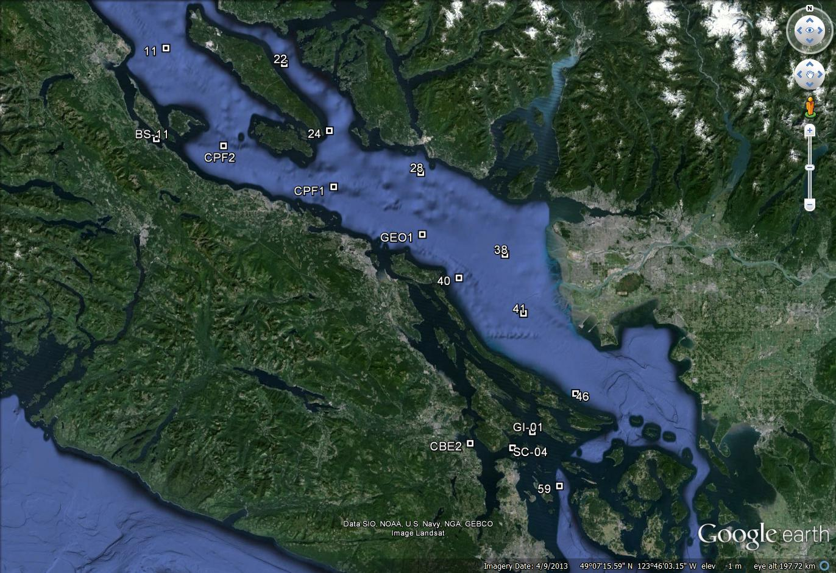

**Figure 1**. Station locations for IOS 2017-07 Strait of Georgia zooplankton surveys.

**At each station, collect:**

* Full depth CTD profile including oxygen and fluorometer, using SBE 25 CTD with SBE 43 DO and Wetlabs fluorometer sensors. **2 minute soak at start** (Turn on, down 10m and up, wait remaining time and start). **Note:** CTD fluorometer usually has an end cap that needs to be removed before the first cast!
* Full depth (10m off bottom to surface) zooplankton tow, using SCOR net with 236um black mesh. Preserved in 10% buffered formalin. Upcast speed approx. 1 m/s (with electric winch, will be slightly slower. Should not be less than 0.5 m/s). Net equipped with a TSK flowmeter and a RBRSolo that logs the net casts (depth and time).

**At select stations, collect:**

*Salinity (SAL)* – at least one deep water (>200m) salinity sample (in duplicate) per day (approx.), using 1 L Niskin attached 1m above CTD to collect a near-bottom salinity sample during CTD cast (CTD sensor check). Record sample number, depth collected in log.

* To be collected at stations: 41, GEO1, CPF2, 22.

*Phytoplankton (phyto)* – surface phyto sample preserved with Lugol’s, collected with 1 L Niskin at surface; for taxonomy. Do not rinse jars (pre-filled with Lugol’s). Record event number, sample number in log.

* To be collected at stations: SC-04, 41, GEO1, 11
* Stations chosen because: SC-04- close to Lou Hobson’s station (historical site); 41 in plume; GEO1 for central; 11 for northern

*Chlorophyll-a (chl-a)* – Chl-a samples taken at surface and 5 m, at same stations as the phyto plus at Halibut Bank buoy (49.34,-123.72, near station 28). For comparison with Wetlabs fluorometer and for satellite and buoy data comparisons.

Water sampled with 1 L Niskin, 60-240 ml water (depending on how much phytoplankton is in the water; need some colour on the filter) filtered (in duplicate) with 140 ml syringe and 25 mm GF/F filters (same method as Citizen Science program). Store filter in scintillation vial and freeze at -20 °C (fridge freezer) until analyzed. *Record the sample number with the depth and volumes filtered in the cruise log*. Make sure labels have sample number and volume filtered as well.

* To be collected at stations: SC-04, 41, GEO1, 11, 28/Halibut Bank buoy

**Proposed 2017 Schedule:**

|  |  |  |
| --- | --- | --- |
| Trip | **Date** | **Crew** |
| 1 | 6-10 Mar | Kelly |
| 2 | 20-24 Mar | Mark |
| 3 | 5-9 Jun | Tamara |
| 4 | 31 Jul-4 Aug | Glenn |
| 5 | 14-18 Aug | Steve |
| 6 | 28 Aug-1 Sep | Nina |

**Housekeeping**

* ***There are 2 logs to fill out: cruise log and plankton log***. Please fill out the cruise log with all events that occur, and give each event a number. Events numbers run sequentially for all trips together - know the starting event number and sample number for your trip. Record BE, BO and EN time (note what time zone you are using! Eg: use local time if you want, but indicate so in the log and be consistent for the entire trip). **Check that the GPS has the correct time (needs to be manually changed between Daylight ST and PST. Plankton log – enter information for all plankton tows.
* Upload the CTD data at the end of the day. Make sure the laptop has the correct date and time before uploading. Upload the files individually (don’t do as a batch). When uploading the file, ***name them with standard format names such as 2017-07-0001.hex (or .xml for SBE25+) for event #1***. Put location, station name, and bottom depth in the header (comments box) of the file, ***using the format in the “CTD Header.txt” file*** on the CTD laptop (the leading * and following : plus N and W are needed for processing). ***Plot your files in the Seabird Seasave program to make sure data is good.***
* Also check that the batteries have enough voltage, change if they drop below 13V (for SBE25+).
* Update the electronic cruise log (excel file) daily. Back up all files to USB.
* Submersible hose: make sure it is in the water before plugging in. Plug in when the net is on its way up (at 50m) to avoid drawing too much power. Unplug before pulling it out. Leave the hose on when the pump is running. Don’t flood John’s cabin below the deck.
* After the cruise: rinse all equipment with freshwater, including: net, flowmeter, sprayer, submersible pump, sieves, CTD
* Unloading samples: zooplankton to Zooplankton lab (1317); chl-a into -80 in Nina’s lab, bottom drawer; phyto into phyto fridge (Nina’s lab); salinities to Salinity lab (record on log sheet on lab door)
* Logbooks and USB **with all electronic files completed, CTD files labelled properly – see above** to Kelly
* CTD and computer back to CTD workshop **Make sure all files have been backed up to USB** Do not delete files from laptop or CTD memory
* Rest of equipment to hanger

Labels to be printed (should be pre-printed before the trip)

|  |  |  |  |
| --- | --- | --- | --- |
| Sample labels, in duplicate (except phyto) | | | |
| **Station** | **Chl-a** | **phyto** | **SAL** |
| SC-04 | 0m | 0m |  |
|  | 5m |  |  |
| 41 | 0m | 0m | deep |
|  | 5m |  |  |
| GEO1 | 0m | 0m | deep |
|  | 5m |  |  |
| 11 | 0m | 0m |  |
|  | 5m |  |  |
| HaliBank | 0m |  |  |
|  | 5m |  |  |
| 38 |  |  | deep |
| CPF2 |  |  | deep |
| 22 |  |  | deep |
| **TOTAL** | **20** | **4** | **10** |