REVISION NOTICE TABLE
DATE | DESCRIPTION OF REVISION

PROCESSING NOTES
Cruise: 2017-07
Agency: IOS, Ocean Sciences Division, Sidney BC
Chief Scientist: Young K. Platform: Salacia
Location: Strait of Georgia Project: Strait of Georgia Zooplankton
Date: 6 March 2017 – 1 September 2017

Processed by: Germaine Gatien
Date of Processing: 19 June 2017 – 22 November 2017
Number of original XML files: 90
Number of CTD files: 86 Number of BOT files: 41

INSTRUMENT SUMMARY
This cruise consists of 6 legs using two configurations. A SeaBird Model SBE-25 CTD (s/n 1123) was used with temperature sensor #4888, conductivity sensor #4513 for legs #1 and #2 and 3396 for legs #3, #4, #5 and #6, Wetlabs ECO Fluorometer #2214, dissolved oxygen sensor #3234, pump #8377 and pressure sensor 1123.

SUMMARY OF QUALITY AND CONCERNS
The 6 legs of this cruise form part of a larger project that includes 4 other cruises. In time order they are:
2017-07 – Legs 1 & 2
2017-47
2017-26
2017-48
2017-07 – Leg 3
2017-49
2017-07 – Legs 4, 5 & 6
The same equipment was used for all 10 legs except for the conductivity sensor which was changed in late May 2017, between 2017-26 and 2017-48.

Battery problems during Leg 3 led to most files being incomplete; only 5 full downcasts were acquired.

Processing of data (from all legs except #5) was simplified by having positions, station names and bottom depths entered in the headers using a format that ensured automatic entry in the file headers when they were converted to IOS Header format.

The log book was in reasonable order though some of the notes about problems are not clear about which casts were affected.

The CTD was generally lowered to 10m, raised and held at 2m until about 2 minutes had passed. The full cast was then run. This approach enables easy removal of the data from the soak period by removing 960 records. There were a few cases of longer or slightly shorter waits, so some fine-tuning of the method was necessary.

There were salinity samples gathered near the bottom from 21 casts. There were 2 different conductivity sensors and there were problems with the CTD for Leg 3. There are likely to be some random problems with incomplete flushing of Niskin bottles as well, so it is not surprising that there is a lot of scatter in the comparison. While the comparison is too rough to make an estimate of accuracy, the median differences between CTD and bottle salinity are consistent with good sensor calibrations. The conductivity sensor used for Legs 1 and 2 was found to be damaged in mid-May 2017, but this comparison shows there were no serious problems during this cruise.

Extracted chlorophyll samples were taken at the surface and 5m, on separate casts run shortly after CTD casts. The comparison with CTD fluorescence is very noisy but shows the usual pattern of CTD fluorescence reading higher than CHL when CHL<1ug/L and fairly close to CHL between 1 and 5ug/L. For CHL>5ug/L it reads lower approaching a ratio of ~0.5.

There was no dissolved oxygen calibration sampling, so recalibration was based on the results of a February 2017 cruise which included extensive sampling in open waters where flushing of the Niskin bottles is expected to be good.

Bottle files were produced combining CTD data with analysis results using a different approach for the different types of samples:
- The salinity samples were taken when the CTD was at the bottom of casts, about 1m above the CTD. CTD data were taken from the bottom values of the final files. Some bottom data are removed in editing; this plus bin-averaging probably means the CTD data come from within 1m of the sampling depth.
- The extracted CHL samples were taken after CTD casts so the event numbers are different. The samples come from 0m and 5m. There are no CTD data from 0m, so CTD data were extracted from 1 to 2m and 5m. The event number used for the bottle files corresponds to the CTD cast.
- There were casts at Halibut Bank that do not include a CTD cast and there were some cases where the CTD malfunctioned, so there are no CTD data in those BOT files.

PROCESSING SUMMARY
1. Seasave - This step was completed at sea. The file names were non-standard but most had been renamed. For some there was a small error that was corrected.

2. Preliminary Steps
The Daily Log was obtained.

The deployment method used was as follows: The CTD was switched on, a 2-minute timer was started and the CTD was put in the water. It was taken down to 10m, up to the surface, wait at the surface at least until the 2 minutes were up. The cast was then started. If a Niskin was needed it was attached 1m above the CTD. The CTD was taken to 10m off the bottom where a Niskin was fired if needed. The CTD was then brought up and switched off as it was taken out of the water. This method is helpful as by removing the first 1520 records, the initial soak can be removed. For casts #3 and #130 the downcast start had to be delayed and started after 3min and 2.5min respectively.

The cruise summary sheet was completed.

The parameters in the 2 configuration files provided were checked and were all correct. The files were saved as 2017-07-ctd1.xmlcon (legs 1 and 2) and 2017-07-ctd2.xmlcon (legs 3-6).

3. Conversion of Raw Data
The XML files were converted using configuration file 2017-07-ctd1.xmlcon for legs 1 and 2 and 2017-07-ctd2.xmlcon for legs 3 to 6.

There is a note in the log that the CTD laptop times were ahead by about 6 minutes for the first two casts; it appears that the header times are reasonable.

There were a number of problems in the data:
- There were problems with many Leg 3 CTD casts, with incomplete files being produced in most cases, probably due to battery failure. Three files have only surface data (56, 89 & 94). Only 3 casts have complete down/up profiles (58, 64 & 73). There are complete downcasts for (62, 66, 69, 75 & 79). The other 5 casts have partial downcasts (71, 81, 83, 87 & 92).
- The file for event #133 also contains only surface data, but in that case there is a message in the log about a switch being knocked during deployment.
- The file for event #150 could not be downloaded with the other files. After all other files had been processed, a different method was found that enabled it to be downloaded. It was then processed.

The header entries for bottom depths are incorrect for Leg 3 because maximum pressure was recorded. These were corrected in the converted files so they match the log entries.

Plots of a few casts show that the channels all produced reasonable values, though the fluorescence during legs 1 & 2 looks steppy – it is likely the sensor was set to a lower sampling rate, but the values look reasonable.

4. WILDEDIT
Since there are no obvious single-point spikes in the data, this step was skipped.

5. WFILTER
Tests were run on a few casts using cosine filters of size 5, 7 and 9. In some cases none of the settings removed reversals in pressure but examination of the data suggests that the CTD was actually moving upwards at those times. Many of the profiles looked quite smooth with all settings but the best choice overall was using size 7, especially in the effect on salinity. Using size 9 appears to oversmooth the data and size 5 leaves reversals. Size 7 has been found best in previous uses of this equipment.

WFILTER was run using a cosine filter, size 7 on the pressure, depth, temperature and conductivity channels.

6. ALIGNCTD
Tests were run on a few casts to see what alignment made the offset between the upcast and downcast DO traces resemble that for the temperature traces. An advance of 2s produced the best results.
ALIGNCTD was run on all casts to advance the DO channel by 2s.

7. CELLTM
SeaBird recommend the use of (α, 1/β) = (0.04, 8) for CELLTM for the SBE 25 and it has proved best in the past. Tests proved hard to interpret, so the default choice was made.
CELLTM was run on all casts using (α, 1/β) = (0.04, 8).

8. DERIVE
Program DERIVE was run to calculate salinity and dissolved oxygen concentration (tau correction included). Plots were examined confirmed that steps 5, 6 and 7 had improved the data.

9. Conversion to IOS Headers
The IOSSHELL routine was used to convert the CNV files to IOS Headers.
CLEAN was run to add event numbers and replace pad values in the pressure channel with interpolated values.

10. Checking Headers
An initial track plot turned up an error in the position of events 75, 142, 146, 154 and 169. When those were corrected the plot looks as expected.

HEADER CHECK was run which turned up a few more errors – 1 missing station name, a few missing positions and 1 missing water depth. There were many negative and off-scale values that are likely due to spikes during the soak period.

The surface check shows an average of 0.03db with many values of -0.01db which are associated with near-zero salinity values. The CTD was started just as it entered the water. Examination of the end of some files shows the conductivity falling sharply when pressure is between 0 and -0.1db, which is as accurate as can be expected from this CTD.

A cross-reference list was produced and used to check against the log records. The positions and times are sometimes different, but the distance between the 2 readings is usually small. The largest difference was during Leg 4 at station 22 where currents were likely strong as evidenced by notable drift during the CTD and NET casts. The largest difference is about 300m and most are much smaller than that. The times were bad for 2 casts during Leg 3 but those were both casts where the files contain only surface data, so they will not be archived. One station name was changed from CBE-2 to CBE2 to match the format used for other visits to that site this year and in 2016.

Track plots were produced and added to the end of this report with separate maps with event numbers for each of the 6 legs. The plot with station names is from Leg 4 since that leg includes all stations occupied during the project.

The next step is to remove the data collected during soaks at 10m. For most casts, removing 1920 scans will do this since the downcast was usually started at the 2 minute mark and the data were acquired at 16Hz. As long as data from the initial downcast are removed, then the rest of the soak will be removed by DELETE.

Plots were made to identify casts for which removing 1920 records will be appropriate to remove the soak period for all casts, and to record a setting that will work. It was found that 1920 worked well for all but 16 casts.
CLIP was run to remove 1920 records from all casts.
CLIP was rerun on the 16 casts that require individual settings.
From this point onwards there will be no further processing of casts 56, 89, 94 and 133.

After this step plots were produced to check that there are no data left from the initial drop to the soak depth. Problems were found in one cast, so it was rerun with a different range.

11. SHIFT
Conductivity
Tests were run using values from 0 to -1.4 records to see which did best at removing noise from the salinity channel so that the T-S curves are just stable. The best results were with a settings between +0.8 and +1.4records with +1.2 looking best overall. This is much higher than the +0.5 records used in 2016 when this equipment was used, but the acquisition rate is twice what it was in the past.
SHIFT was run on all casts to apply a shift of +1.2 records.
Fluorescence
The fluorometer was not pumped, so a shift in alignment is expected to be small or unnecessary. Profile plots of temperature and fluorescence were examined and confirm that the alignment is ok.
Dissolved Oxygen
This channel was aligned earlier, but checks were made by examining plots of temperature and dissolved oxygen; no further adjustment was found appropriate.

12. DELETE
DELETE was run on all casts using the following parameters:
Surface Record Removal: Last Press Min. Surface Swell Pressure Tolerance: 1.0
Swells deleted. Warning message if pressure difference of 2.00
Drop rates < 0.3m/s (calculated over 5 points) was deleted from 10db to 10db above the maximum pressure.
COMMENTS ON WARNINGS: There were no warnings.
Plots were made of pressure versus scan number to ensure there are sufficient surface data and no problems were found.

13. Initial Bottle Data Steps
There was no rosette available for this cruise. Salinity samples were taken from a Niskin Bottle mounted about 1m above the CTD. Chlorophyll samples were taken at 0m and 5m on a separate cast. To enable searching of bottle data, BOT files were prepared.

First, each of the analysis spreadsheets were examined to see what comments the analysts wanted included in the header file. These were used to create file 2017-07-bot-hdr.txt which will be updated as needed during processing.
EXTRACTED CHLOROPHYLL
Extracted chlorophyll and phaeo-pigment data were obtained in file QF2017-07chl*.xls which included comments, flags and a precision study.
SALINITY
Salinity analysis was obtained in a single spreadsheet file QF2017-07 SAL_Trip 1, 2, 3, 4, 5, 6*.xlsx.

Next, spreadsheet 2017-07-bottle_plus_CTD.csv was prepared. This will enable comparison of CTD data with salinity and chlorophyll samples. The data from the analysis spreadsheets were copied into that file. For CHL, the only CTD data available are from the cast that had just finished when the samples were taken, so the associated CTD event numbers were entered for the chlorophyll samples. Those event numbers will be used later when the BOT files are created. There were no CTD casts at Halibut Bank, and there are no CTD data available for a few other casts due to instrument malfunction as discussed earlier.

14. Compare
The spreadsheet prepared above was simplified into 2 spreadsheets, one containing the salinity samples and the other the extracted chlorophyll samples. There were some cases where there was no matching CTD data (either due to equipment problems or those from Halibut Bank), so those were removed. Cast lists were prepared to enable thinning of the CTD files to the required levels.
First, the DEL files were bin-averaged. The binned files were then thinned to either the bottom of casts for salinity or to 1m and 5m for the chlorophyll. Since there are few data above 1m, that value was used instead of 0m. Data were then extracted from those files and added to the respective comparison spreadsheets.

Salinity Comparison
The binned files were thinned to a bottom value and exported to a spreadsheet. They were combined with the salinity bottle data described in the previous section and saved as 2017-07-salinity-comp.xlsx.

There were bottle samples taken from a Niskin bottle mounted about 1m above the CTD.A comparison was done between these values and CTD values recorded at the bottom; since those were bin-averaged the difference in depth and local gradients are expected to be low, the difference in levels should not lead to a significant error. A more serious limitation to the comparison is that the conductivity sensor was changed between Leg 2 and Leg 3 and the CTD malfunctioned during Leg 3 so that for one bottle there are no CTD data available.

When data from all 6 legs are combined the CTD salinity was found to be higher than the bottle salinity by a median value of 0.0014, though the standard deviation is 0.008psu. When 1 outlier was excluded the difference was 0.0014.

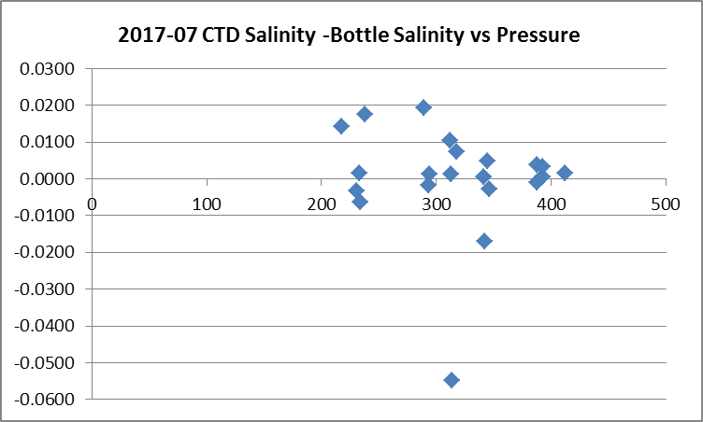

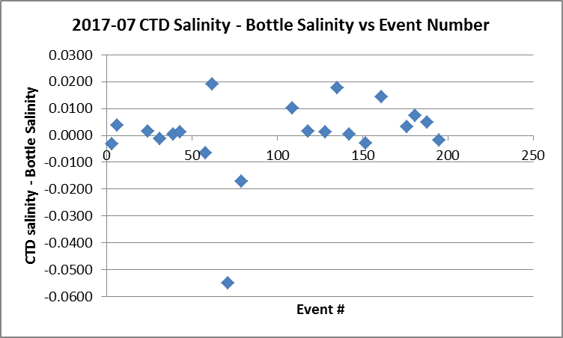

Looking at the plot versus event number shows that it is necessary to divide the data into groups:
 | median | Std. Dev.
Legs 1 and 2 (events 3-43) | 0.0009 | 0.0009
Leg 3 (events 61-79) including all bottles | -0.0117 | 0.0308
Leg 3 (events 61-79) excluding event #71 | -0.0064 | 0.0186
Leg 4, 5 and 6 (events 109-195) | 0.0033 | 0.0066

While the vertical offset between CTD and Niskin is not likely to be a significant source of error, incomplete flushing of Niskin bottles probably is. When bottles are fired at the bottom, the water in the Niskin is likely to be from somewhat higher in the water column so bottle salinity is likely to be lower than in situ values. This makes the CTD salinity appear to read too high. While there was some delay in analysis which might lead to slightly high bottle values, the delay was not severe and good liners were used, so such errors are likely very small. So finding that the CTD reads a little high for Legs 1 and 2 is encouraging and the results for Legs 4, 5 and6 look about as expected. A further source of error is spikes in CTD salinity near the bottom, with those found in cast #79 (towards low CTD salinity) and #135 (towards high CTD salinity) and both of those are outliers. Gradients likely varied seasonally as well, further complicating interpretation.

The comparison method is crude and there is a lot of scatter. Overall, it looks like the calibration of the temperature and conductivity are reasonable for all legs of the cruise.
- There were some doubts about the conductivity sensor used for Legs 1 and 2 since it was found to be damaged after cruise in mid-May. However, these results suggest it was operating well for Legs 1 and 2. Given that flushing may not be complete, it is possible that the CTD salinity is reading a little low, but the error is likely small.
- The results for Legs 4, 5 and 6 look reasonable overall although the scatter is large. If the sensor calibrations are good, we expect the salinity to read a little high due to inefficient flushing. Examination of individual CTD profiles shows a large spike near the bottom of cast #135; if that cast is excluded the CTD reads high by about 0.0024 and standard deviation of 0.005.
- The results for Leg 3 look poor, but with only 3 points of comparison, one of which includes a large spike in the CTD data, this is a weak conclusion. Since the same sensor was used as for Legs 4, 5 and 6, we can have some confidence in the CTD salinity.

For more details see file 2017-07-salinity-comp.xlsx.

Fluorescence
Most of the CHL samples were taken at 0m and 5m right after CTD casts, but for the Halibut Bank casts there was no CTD cast. The binned files were thinned to 1 and 5m; since there are no CTD data from 0m, the closest available CTD were selected. The thinned files were exported to a spreadsheet file and added to the bottle comparison spreadsheet.

The average ratio FL/CHL was 0.94 while the median value was ~0.78. The standard deviation was ~0.64. A fit of CTD fluorescence against extracted chlorophyll has a lot of scatter, as is expected due to high variability in both. A linear fit through the origin suggests that fluorescence is about 55% of extracted chlorophyll, but the fit looks poor. A comparison of the ratios at 0m and 5m shows a median ratio of ~0.9 at 5m and 0.6 at 0m. This may be due to better depth matches at 5m.
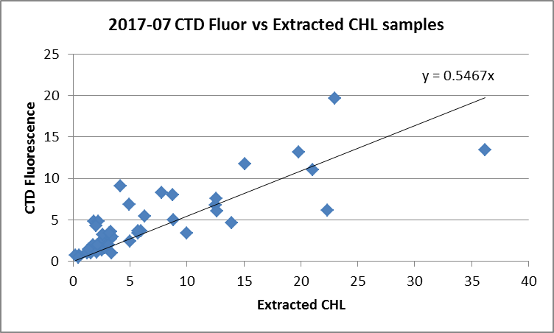

As expected based on past experience with these fluorometers, the CTD fluorescence reads higher than CHL when CHL<1ug/L and fairly close to CHL between 1 and 5ug/L. For CHL>5ug/L it reads lower approaching a ratio of ~0.5.

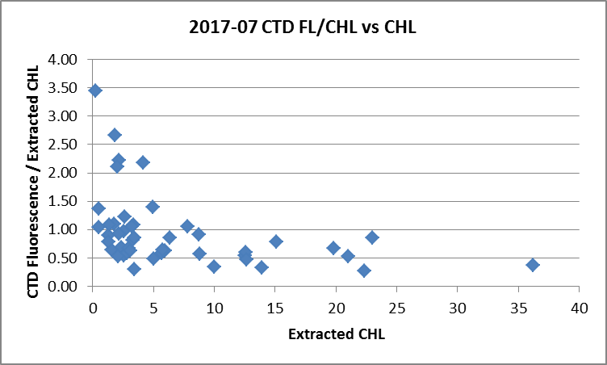

The results are very similar to others found using CTD fluorometers.

15. DETAILED EDITING
CTDEDIT was used to remove records near the top and bottom of many casts and records corrupted by shed wakes. It was also used to clean salinity where unstable features looked likely to be caused by misalignment of T and C. Most casts required some editing.
The following casts were not edited: 71, 92, 146, 174 and 181.
Cast #126 has many unstable features especially near the bottom, but the upcast looks the same. These instabilities may be real or there may have been a problem with the pump or plumbing.
Notes of editing details were made in the headers.

T-S plots were examined and no significant problems were found; there are small unstable features but in areas where they are expected.

16. Other calibration checks
Sensor History – The pressure sensor was used during 2016-29 and no problems were detected. The temperature sensor and conductivity sensor 4513 were used during 2016-29 but for only 4 casts with no calibration sampling. This was the first use of conductivity sensor 3396 since its latest factory calibration. The dissolved oxygen sensor was used for 2017-01 with good calibration sampling.
Comparison of repeat casts –There were many repeat casts but they were occupied weeks apart.
Historic Ranges – The local climatology is not representative of many of the sites occupied during this study and they are mostly close to shore where a 3-standard deviation climatology is not suitable. During Legs 1 and 2 all data fell within the climatology. During Leg 3 the salinity was occasionally low, mostly near the surface. During Legs 4 to 6 there are some temperature that look high near the surface and deep in Baynes Sound and a few salinity excursions. These do not appear to be systematic excursions but rather illustrate the limitations of the climatology both because this is an area of very high variability and the climatology is old.
Post-cruise calibrations – None were available.

17. CALIBRATE
CTD Salinity will not be recalibrated as it appears to be as close to bottles as we can expect given the scatter in the comparison.
There was no dissolved oxygen sampling so the results from 2017-01 will be applied.
The pressure does not appear to need recalibration.
CALIBRATE was run using file 2017-07-recal1.ccf to apply the following correction to the Dissolved Oxygen channel:
CTD Dissolved Oxygen Corrected = 1.0484* CTD Dissolved Oxygen + 0.0413

18. Fluorescence Filter
A median filter, size 5, was applied to the fluorescence data as they are spiky.

19. Bin Average and REMOVE
The files were bin averaged using 1db bins.

REMOVE was run to remove Scan_Number, Conductivity:Primary, Oxygen:Voltage, Descent Rate and Flag channels.

Dissolved Oxygen was derived in mass units and that was used to calculate DO saturation. Plots of near-surface saturation show values between 70% and 160%. This cruise covered a large area and had 6 surveys between February and September. These data are not useful in assessing the accuracy of the dissolved oxygen data, but do not look unreasonable.

REORDER was used to get the 2 dissolved oxygen channels together.

20. HEADER EDIT and final checks of CTD files.
Header Edit was used to add some header information, fix formats and channel names and to add the following note to the headers:
Data Processing Notes:
----------------------
Dissolved Oxygen and Fluorescence are nominal and unedited, except
that some records were removed in editing temperature and salinity.

While the CTD fluorescence data are expressed in concentration units, they
do not always compare well to extracted chlorophyll samples, particularly for
casts far from shore. It is suggested that extracted chlorophyll values be
checked where available.

Comparison with bottles suggests that the CTD salinity is reasonably close to bottle
salinity for both conductivity sensors, but there is a large scatter and flushing of
Niskin bottles is likely incomplete. No recalibration was applied.

There was no dissolved oxygen calibration sampling, so the recalibration used for
cruise 2017-01 was applied to these data since the same sensor was used and
calibration sampling was extensive.

For details on the processing see processing report: 2017-07-proc.doc.
A cross-reference listing was produced.
A header check was run on the CTD files and no further errors were found.
The sensor history was updated.
Plots of CTD casts were examined and no problems were found.

20. Final BOT file preparation
To enable searching of bottle data, BOT casts were created that contain sample data and, where available, CTD data from associated downcasts.

The SAL bottle data come from the bottom of CTD casts about 1m above the CTD.
The CHL bottle data usually come from BOT casts immediately after the CTD casts with the exception of Halibut Bank bottle data which are not associated with a CTD cast.

File 2017-07-bottle_plus_CTD.csv file was created earlier to do comparisons between bottles and CTD data. Some lines are missing because there were no CTD data available for a few casts, so lines were added to the spreadsheet so that BOT files can be created. Those include the Halibut Bank casts where no CTD casts occurred and 2 casts with no CTD data due to instrument malfunction.

Because the spreadsheet data were extracted from CTD files before final recalibration of dissolved oxygen, the DO values were exported again from a stage after that step.

Pressure and Depth:CTD will only be available where there are CTD data, so a separate depth channel called Depth:Nominal was prepared to indicate the depth at which the bottle is believed to have been fired. These entries are 1m above bottom for salinity and either 0m or 5m for CHL sampling.

The file was converted. It took many attempts as errors were gradually found and corrected.
The time and date are present as channels as these cannot be changed directly into header entries.

CLEAN was run to add START and END time. The END TIME is identical so the START time so it will be removed later. CLEAN was also used to enter 0 flags where the flag channels are empty and to remove channels with only pad values.

REMOVE was run to remove the DATE and TIME channels.
SORT was run to arrange files in order of increasing pressure.
HEADEDIT was used to add comments and to remove the END time and TIME ZERO and to add Data Type.
The final files have extensions BOT.
Those for Halibut Bank were adjusted so that the Data Description is “Bottle:Wire” instead of “Bottle:Wire + CTD Down”.
A cross-reference list and header check were run on the BOT files.

PARTICULARS – notes from log
The CTD was generally lowered to 10m, raised and held at 2m until about 2 minutes had passed. The full cast was then run. This approach enables easy removal of the data from the soak period by removing 960 records. However, for many casts the waiting period was longer or shorter than 2 minutes, so the number of records removed will have to be adjusted to avoid losing valuable data. Where variations are noted in the log book, they are listed below.

1 &3. CTD laptop time ahead by +6 minutes. CTD corrected after event 3.
3. Soaked for 3 minutes.
3. Niskin 2m above CTD for salinity sample.
6. Niskin 1m above CTD for salinity sample.
24. Niskin 1m above CTD for deep salinity sample.
31. Niskin 1-2m above CTD for salinity sample.
39. Niskin 1m above CTD for deep salinity sample.
43. Niskin 1m above CTD for deep salinity sample.
61. Sal sample @235m
71. Sal sample at bottom – 10m.
79. Sal sample. May have touched bottom.
109. Niskin 2m above CTD for salinity sample – 313m.
118. Niskin 2m above CTD for salinity sample - 413m
130. Soaked for 2.5 minutes.
150. Original upload failed. Later was uploaded and processed.
176. Winch start/stop on way down after 300m.
181. Niskin 1m above CTD for salinity sample -319m
188. Winch bogging down after 300m.
195. Niskin 1m above CTD for salinity sample – 294m

.

CRUISE SUMMARY
Cruise ID#: 2017-07
Dates: Start: 7 March 2017 End: 1 September 2017
Location: Strait of Georgia
Party Chief: Differed for each leg (Young/Belton/Fraser/Cooper/Romaine/Nemcek)
CTD# | Make | Model | Serial# | Used with Rosette? | CTD Calibration Sheet Competed?
1 | SEABIRD | 25 | 1123 | No | Yes

CTD CALIBRATION INFORMATION
Make/Model/Serial#: SEABIRD/SBE25/1123 Cruise ID#: 2017-07

Calibration Information – Legs #1 & 2
Sensor |  | Pre-Cruise |  | Post Cruise
Name | S/N | Date | Location | Date | Location
Temperature | 4888 | 7Nov2015 | Factory
Conductivity | 4513 | 28Oct2015 | Factory
ECO Fluorometer | 2214 | 02Jun2017 | ?
SBE43 Oxygen | 3234 | 11Nov2015 | Factory
Pressure | 1123 | 23May2014 | Factory

Calibration Information Leg #3 to #6
Sensor |  | Pre-Cruise |  | Post Cruise
Name | S/N | Date | Location | Date | Location
Temperature | 4888 | 7Nov2015 | Factory
Conductivity | 3396 | 22Dec2015 | Factory
ECO Fluorometer | 2214 | 02Jun2017 | ?
SBE43 Oxygen | 3234 | 11Nov2015 | Factory
Pressure | 1123 | 23May2014 | Factory

