REVISION NOTICE TABLE
DATE | DESCRIPTION OF REVISION

PROCESSING NOTES
Cruise: 2016-40
Agency: PBS, Ecosystem Science Division, Nanaimo, B.C.
Party Chief: Morris J. Location: WCVI
Project: Basin & Coastal Scale Interactions Platform: Frosti
Date: 27 October 2016 – 3 November 2016

Processed by: Germaine Gatien
Date of Processing: 3 February 2017 – 22 February 2017
Number of original HEX files: 38 (includes many repeat downloads of some files)
Number of CTD files: 27 Number of BOT files: 37

INSTRUMENT SUMMARY
SeaBird Model SBE-25 CTD (s/n 0404) was used with temperature sensor #2095, conductivity sensor #1764, Wetlabs ECO Fluorometer #4185, pH sensor #0852, oxygen sensor #1176 and pressure sensor 0482.

SUMMARY OF QUALITY AND CONCERNS
The log book was available, but there was no equipment list or list of personnel. The log times were in UTC. A spreadsheet was provided with positions, station names and water depths; this was very helpful since position information is not in the headers. The file names were non-standard, but as they were just missing a digit, that was easy to fix.

CTD data for casts 97 to 104 could not be found on the computer and the CTD had been returned to the factory for service, at which time the memory was wiped. There were problems noted at sea that resulted in no acquisition for casts 82 to 94, and it is possible no CTD data were acquired from casts 97-104.
The CTD was generally soaked at about 8db for about 1.5 to 2 minutes, but was not returned to the surface before the full cast. The CTD pumps did not come on until the instrument was at about 7.6db, so data above 8db are bad for all channels except pressure, even those that are not pumped including fluorescence and pH.

Stops for firing bottles were generally less than the recommended 30s and there is some evidence of shed wake corruption at the CTD level persisting when the bottle was fired.

The CTD had poorer pressure resolution than expected from a SeaBird 25. This was also noted during other recent cruises using this CTD. The CTD technician was informed that there may be a problem with the settings for the instrument.

The fluorometer produced many slightly negative values. It had not been recalibrated since late 2015. An offset of +0.275ug/L was applied based on the lowest values observed and achieving a fit of fluorescence against extracted chlorophyll samples that looks most like those typically found from this type of fluorometer.

The comparison of CTD salinity with bottle salinity suggests that the CTD salinity calibration is good to 0.005psu but the evidence is weak. Near-surface sampling involves temporal variability and large vertical salinity gradients and the distance between the Niskin and CTD is uncertain.

BOT files were produced containing all sample analysis results for each cast plus CTD upcast data from 7m, the estimated depth of bottle sampling.

WARNING: The pH:SBE:Nominal data should be used with caution; no field calibration data are available. Calibration is required for each cast to get absolute values, although general trends within a cast are likely real.

PROCESSING SUMMARY

Seasave - This step was completed at sea.

Preliminary Steps
CTD #0404 was used with the same sensors for parts of cruises 2016-31, 2016-58 and 2016-29 and for all of 2016-30.
The Daily Log was obtained.
Casts 97-109 are listed in the log but no raw files were found. There are notes about a battery failure that explain why casts 82-94 are missing. The battery was replaced after event #94. The CTD had been sent to the factory for service and the memory was wiped; the missing data not on the computer used at sea.
The cruise summary sheet was completed.
A single configuration was used. The calibration parameters were checked and no errors were found, though no confirmation was found for the pressure calibration.

Conversion of Raw Data
All casts were converted using the appropriate configuration files. There was an error in 2016-40-061.hex; once a carriage return was removed it could be converted.
The file names were in non-standard format with a 0 missing. The file names were fixed.

The pressure at the beginning and end of casts was about 0.2db so there is no evidence of a problem in pressure calibration. The pressure is full of steps of ~1.2db. This was noted on other 2016 cruises using this CTD.

Plots show that the channels all have reasonable profiles below 8db except for descent rate which is extremely noisy, presumably because of the odd pressure steps. The CTD was generally soaked at about 7.5 to 8db for 1.5 to 2 minutes. During this time the pumps obviously came on as temperature, conductivity, salinity and dissolved oxygen suddenly change values. Fluorescence also suddenly changes at a point corresponding to when the pumps appear to come on even though the fluorometer was not pumped. The pH channel also changes fairly rapidly at this time, again an unpumped channel.

A quick check was made of some data from cruise 2016-30 which had not yet been processed. There appears to be a similar feature but because there was an initial 10m soak it happens at about 10m, after which the CTD was returned to the surface to do a full cast. As is seen in the current data, the change is seen at about 50s into the cast, or just after the 45s mark when the pumps come on. It is not obvious why this affects fluorescence, though for pH the temperature is a factor. Whatever the reason the downcast data above 8db are not useful.

The times in the log are in UTC. As found for other recent cruises using CTD #0404, the times in the headers were in PDT but a day ahead. So 17 hours will need to be subtracted later.

Examination of pressure against scan count shows most bottle stops were at about 17db with variations from about 15 to 18db. The stops were generally very short at from 8 to 12 seconds, though occasionally as long as 25s. Since the bottles are usually mounted about 5m above the CTD, the estimated depth of sampling is ~12m. (Note: This was later determined to be incorrect with 7m being a better choice.)

WILDEDIT
This step was skipped as it does not usually work well on SBE25 data and no obvious spikes were noted.

FILTER
WFILTER with cosine file width 5 worked well on the temperature and conductivity and the resulting salinity looks improved. The pressure readings from this sensor are odd with the steps being ~1.2db, much grosser resolution than expected from an SBE25. This same problem was noted in 2015. WFILTER did improve the pressure but there were still many reversals until the setting was increased to width 9 for pressure.
WFILTER was run with a width of 9 for pressure, and a width of 5 for temperature and conductivity.

ALIGNCTD
As for other recent uses of this equipment a setting of +2.5s improves the alignment of dissolved oxygen with temperature. ALIGNCTD was run on all files using +2.5s.

CELLTM
SeaBird recommend the use of (α, 1/β) = (0.04, 8) for CELLTM for the SBE 25. CELLTM was run on all casts using that setting and it did improve correspondence of upcast and downcast data in T-S space.

DERIVE
Program DERIVE was run to calculate salinity and dissolved oxygen concentration.

Conversion to IOS Headers
The IOSSHELL routine was used to convert the CNV files to IOS Headers.
CLEAN was run to replace pad values in the pressure channel with interpolated values and to add event numbers to the headers.
Time was adjusted using program ADD TIME CHANNEL to subtract 17 hours because the start times in the files are wrong with entries in PDT and a day ahead.

Checking Headers
Some header information was missing: latitude, longitude, station name and water depth.
A spreadsheet was provided and that was used to prepare file 2016-40-header_mrg.csv. IOS SHELL program “MERGE:CSV file to headers” was used to add information from the csv file to the IOS files with output MRH.

A track plot was produced and no problems were found.
A cross-reference listing was produced and checked against the log entries, allowing for the fact that the log time entry for the first event is in UTC and all others in PDT.
A header check was also run and there are many problems noted that almost all pertain to the data above 8db in the downcast.

The surface check was run and the average surface value was 0.7db. These initial values all had extremely low salinity and were clearly gathered just as the CTDs entered the water. This is well within the pressure accuracy range, especially in light of the large steps observed in pressure.

BOTTLE FILE PREPARATION
There was no rosette available for this cruise.
Samples were taken from a Niskin Bottle mounted above the CTD.
To enable searching of bottle data, BOT files were prepared.

First, each of the analysis spreadsheets were examined to see what comments the analysts wanted included in the header file. These were used to create file 2016-40-bot-hdr.txt which will be updated as needed during processing.
EXTRACTED CHLOROPHYLL
Extracted chlorophyll and phaeo-pigment data were obtained in file QF2016-40chl*.xls which included comments, flags and a precision study.
NUTRIENTS
The nutrient data were obtained in spreadsheet QF2016-40nuts.xls. This includes a precision study.
SALINITY
Salinity analysis was obtained in 2016-40SAL.xls. Analysis was done approximately 22 to 29 days after collection.

Next, spreadsheet 2016-40_bottle_data.csv was prepared. Information from spreadsheet 2016-40 CTD-Bongo Data.xlsx was used to add station names and time and position information from CTD files. The chemistry data from analysts’ spreadsheets were added.
Some manipulation of entries was needed to get positions into correct IOS Header formats.
There were no CTD files for some of the casts, so those start times were entered by hand.
A 6-line header was added to enable formatting of time and date and the file was saved as 2016-40_bottle_6linehdr.csv.

Next, CTD data were obtained for the sampling depth. Establishing the appropriate depth was difficult. It was originally assumed that the Niskin bottle was mounted 4m to 5m above the CTD and CTD profiles showed that the CTD stopped at about 17.5db during the upcast. On one occasion it came up to 8db and was then dropped again to 17db showing that 17db was the intended firing depth. That suggests that the samples come from about 12m. However, a comparison of CTD salinity from 12m with bottle salinity was very poor. When the CTD data were selected from much higher in the water column, results improved.

Tests suggest that the bottle samples came from about 7m, so about 10.5m above the CTD. This fits with an observation that the CTD stopped at about 7.5db on the downcast and soaked for a minute or 2. (Soaking was intended to be at about 5db.) The CTD technician confirms that the Niskin bottle was attached during the soak, so the distance between the CTD and the Niskin would be the soak depth plus the distance from the deck to the water line which was estimated to be 3 to 4m, so about 10.5 – 11.5m. The CTD also stopped at ~7.5db on the upcasts, at which point the Niskin was removed.

So it appears that the samples come from 10 to 12m above the CTD depending on how far the deck is above the water line, so somewhere between 6db and 7db. In the comparison described in the next section upcast data from 7db gave the match which minimized outliers best.

To obtain data for comparison with the bottle samples the following steps were taken:
- DOWNCAST CTD data from 7db were extracted from CTD files by running DELETE, BIN AVERAGE (0.5db bins), THIN and Export Spreadsheet Output.
- To get upcast CTD data files were put through REVERSE, DELETE, BIN AVERAGE (0.5db bins), THIN and Export Spreadsheet Output.

After running the comparisons described below, the upcast data from 7db were added to the 6-line header file. That file was then converted to IOS Header files with extensions *.IOS.
CLEAN was run to add start times to the files based on Date and Time. This also adds STOP times which will be removed later. Empty channels were also removed and flag 2 was added to empty flag channels.
ADD TIME CHANNEL was used to add 7 hours to produce time in UTC. Note that the times in the 6-line header spreadsheet were taken from the log and are in PDT (after the first entry was corrected) and the date is correct, whereas for the CTD files the instruments date stamp was used and it had an error in date as well.
REMOVE was run to remove the DATE and TIME channels.
CALIBRATE was run to apply an offset of +0.275ug/L to the fluorescence channel based on the study described in the following section.

HEADER EDIT was run to fix formats and units, channels names, add some header items and remove the STOP TIME and TIME ZERO from the headers. Different comments were used for the casts with no available CTD data.
The header comment added to the files was as follows except for casts with no CTD data available from 7m:
Samples were gathered during CTD casts using a Niskin bottle attached above the
CTD. The depths are nominal and were estimated by examining CTD files to
determine the approximate depth at which the CTD stopped and subtracting the
distance between the CTD and Niskin bottle which is estimated to be 10 to 12m.
This is consistent with the results of a comparison of bottle salinity with
CTD salinity.

The final files have extensions BOT.
A cross-reference list and header check were run on the BOT files. No problems were found.

Compare
Salinity
A comparison was first run using downcast CTD data from 12m and then 11m. In both cases there is a huge scatter in the differences between CTD and bottle salinity with the CTD reading higher than bottles for most of the outliers. The largest differences are from casts in inlets and close to shore where vertical salinity gradients are larger than offshore.

As described in the previous section there is great uncertainty in the depth of the Niskin when it closed. Frequently the CTD rose to somewhere above the target depth, then dropped and waited, so that is assumed to be the depth of the CTD when the bottle fired. But the water in the Niskin bottle could come from the higher level, or from well below if there was poor flushing. The stops for bottles were frequently very short. If flushing were poor we would expect the CTD to read lower than bottles whereas it is mostly reading higher. The only explanation other than sensor calibration drift is that the Niskin bottles were further from the CTD than 5m.

Tests were run choosing upcast and downcast CTD data from a variety of depths to see if shallower sampling could explain the comparison. No matter whether downcast or upcast were selected the differences grew smaller as shallower data were selected and the standard deviations in the differences grew smaller. Plots of differences versus event numbers looked much flatter although outliers remain in the shallower casts. The best results came from the upcast at 7db, with the upcast data from 8db and the downcast 8db ranked 2nd and 3rd. Historically, downcast data have generally been found to give better matches than upcast, but the fact that the pumps did not come on until the CTD was at 8db during the downcast would be good reason to expect poorer matches from downcasts at 7db.

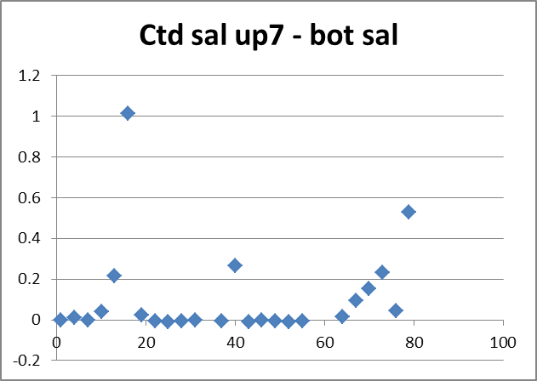

The CTD read higher than the bottles by a median value of 0.004psu but all the obvious outliers were to the positive side. . No estimate of sensor error is possible given the scatter in the differences and the many doubts about the sampling level, but the results do suggest that the CTD salinity is within 0.005psu.

For details see file 2016-40-salinity_comp.xlsx.

Fluorescence
Next the CTD fluorescence and extracted CHL samples were compared.
The fluorescence reads lower than the CHL even at low values of CHL which is not typical of results for this type of fluorometer. We usually see higher values for low CHL, and about equal values at 1ug/L.
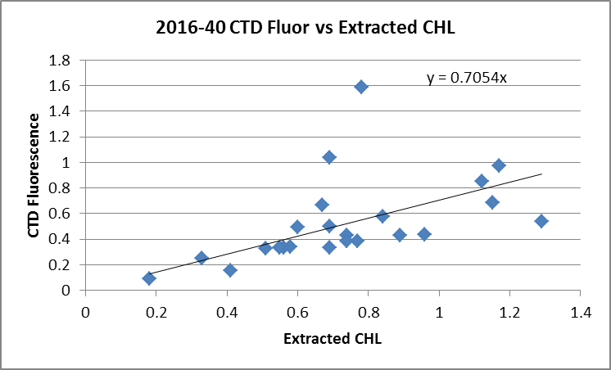

As noted earlier, there are many negative fluorescence values. It is not unusual to get some small negative values from isolated spikes or at great depth and this is generally handled by replacing the negative values with pad values. But for these data there are so many such values that it looks like a small offset should be applied. There are several possible offsets that might be chosen:
- The value -0.092 is often seen at the end of casts when salinity shows the CTD was likely out of water, and it is also seen at the bottom of some casts in water as shallow as 30db. Given that there are a few values even lower than that, applying an offset of +0.1ug/L looks like a reasonable choice. But we would not expect a 0 value for most of these casts at they are not very deep so this is likely an underestimate.
- For the deepest cast values are as low as -0.18ug/L at 200m. So that might be a reasonable “Dark value”.
- There are also values ~-0.275ug/L at the surface to 7m until the pumps come on. Assuming no water is getting to the sensor this might be the “zero” reading for this sensor.

Fits of CTD Fluorescence versus Extracted CHL were examined after making the different possible corrections to see if they look more like those we typically get from these fluorometers. The fit using the +0.275 correction produces a fit that is close to expectations. Fluorescence mostly reads higher than CHL below 0.8ug/L and close to or lower than CHL above 0.8ug/L.
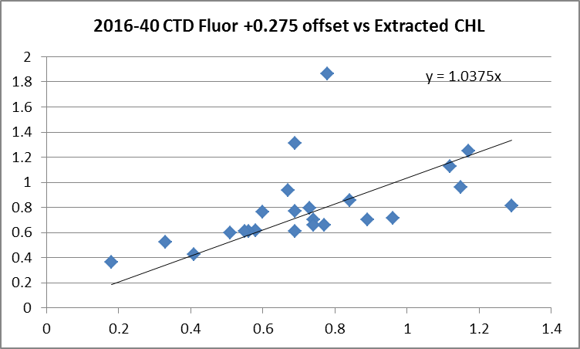

While this does not prove that the higher offset is the best choice, it lends some confidence to that choice.

For details see file 2016-40-Fluor-CHL_comp.xlsx.

The upcast data were bin-averaged and thinned to 7db and were then extracted to file 2016-40-Bottle_data.csv and the CTD data from that file were then added to the 6-line header file. There were no data as shallow as 7db from the upcasts of event #34 and 58, so pad values were entered. The addition of 0.275ug/L to the fluorescence values will be applied after conversion of the spreadsheet to IOS Header files.

For full details of the comparison see file 2016-40-fl-chl-comp1.xlsx.

SHIFT
pH
A shift of +10 records bring the upcast and downcast pH trace into better alignment with temperature traces, though it is hard to judge because the pH traces cannot capture sharp changes. For many casts there was little change in pH with depth.
SHIFT was run on all casts to advance pH:SBE by 10 records.
Conductivity
As was found the last few times CTD #0404 was used, all shifts applied to conductivity produced unstable features in the T-S plots. No adjustment was applied.
Fluorescence
The fluorometers on the SBE25s were not pumped, so a shift in alignment is expected to be small or unnecessary. Profile plots of temperature and fluorescence were examined but the steps in the fluorescence are hard to relate to variations in temperature which was filtered so the steps are gone. No alignment adjustment will be made.
Oxygen
The dissolved oxygen channel was aligned earlier in processing, but was checked again. As usual, the results vary from feature to feature as local vertical gradients and descent rates affect the alignment. No further shift will be applied.

DELETE, CLIP and CTDEDIT
DELETE was run on the SHFpH files and then REVERSE and DELETE were run on the same files. The outputs were examined in T-S space to see if the upcast files would be suitable for archiving. This would not normally be done, but the top 8db of the downcast data are not usable, so using upcast data is a way to get near-surface data. For some casts the upcast data look fine, but for many casts there are problems. There are cases of unstable features in T-S space that are not seen in the downcast. The differences are not huge, but the upcast data look harder to edit and less reliable.

DELETE was run on all casts using the following parameters:
Remove Surface Records in the top 10m.
Surface Record Removal: Last Press Min. Surface Swell Pressure Tolerance: 1.0
Swells deleted. Warning message if pressure difference of 2.00
Drop rates < 0.3m/s (calculated over 5 points) were deleted from 10db to 10db above the maximum pressure.
COMMENTS ON WARNINGS: There were no warnings.

CLIP was run on the DEL files to remove data to 7.7db since the pumps did not come on until the CTD was at about 7.6db.

The CLIP files were copied to *.EDT. All files were examined in CTDEDIT and some editing was applied to all casts. This mostly involved removal of records that appear to have been corrupted by shed wakes. The poor pressure resolution makes the descent rate data hard to interpret. It is hard to tell whether unstable features are real or due to sudden drops in descent rate were likely to lead to shed wakes. There was also some cleaning of salinity.

Inter-comparisons
Sensor History –CTD #0404 has been used on 4 other 2016 cruises but there was no calibration sampling.
Comparison of repeat casts –There were no repeat casts.
Historic Ranges – The local climatology is a 3-standard deviation climatology covering 3 months and a fairly large region, so it is considered a severe criterion for casts near shore. Nonetheless, profile plots were examined with the climatology superimposed. There was no local climatology for the northernmost casts.
- Temperatures were above the climatology maximum below between 40db and 70db for most of the casts off the west coast of Vancouver Island with the exception of the two casts from furthest offshore. The Juan de Fuca casts were all within the climatology. Similar observations have been made during other cruises in 2016 and late 2015 but those were mostly in the northern Strait of Georgia and near Cape Scott. In most cases the excursions look like they are due to deeper mixing than usual.
- Most salinity values fell inside the climatology. One shallow cast near shore had low salinity values. One appeared to have a cool, fresh intrusion near 80m depth and 2 casts had low salinity at depth corresponding to the high temperatures thought to be due to deeper mixing.
- There are not many observations from this region this late in the year. Excursions from climatology in this area are likely real and not due to sensor calibration problems.
Post-cruise calibrations – None available.

CALIBRATE and CLEAN
There was no DO calibration sampling and no useful history upon which to base a recalibration of the dissolved oxygen channel. Any error is likely to lead to values that are too low, though the surface saturation study suggests that such drift is not large.

There was salinity calibration sampling but due to the scatter and the uncertain depth from which samples came, no recalibration was applied. The salinity data appear to be reading within 0.005psu.
Pressure appears to be ok.

As discussed earlier there are many negative values in the fluorescence channel. These were corrected in the bottle data by adding 0.275ug/L to the fluorescence.
CALIBRATE was run to add 0.275ug/L to all fluorescence values in the EDT files.

Recalibration got rid of the negative values in fluorescence but there remain some negative values in near-surface SBE dissolved oxygen. (These were not seen in the near-surface upcast data used for the bottle files). These come from shortly after the pumps were turned on; there is always some delay after pumps come on before the DO sensor data become realistic.
CLEAN was run to replace negative values with pad values.

Fluorescence Filter
This step will be skipped as the fluorescence is not very spiky.

DO surface saturation, Bin Average and REMOVE
Dissolved oxygen was derived in mass units and dissolved oxygen% surface saturation was calculated and plotted. Near-surface values ranged from 63% to 103% with the only values <90% coming from Juan de Fuca Strait. The lowest is from JF01 where mixing is very deep. The casts from furthest offshore had saturation values of about 103% which is typical for the offshore. There is insufficient information to comment on DO sensor accuracy but there is no obvious evidence of a problem with it.

The files were bin averaged using 1db bins.
T-S plots were examined and no further editing was found necessary.

REMOVE was run to remove Scan_Number, Conductivity:Primary, Oxygen:Voltage, Descent Rate and Flag channels from all casts.

HEADER EDIT and final checks for CTD files
Header Edit was used to fix headers, fix formats and channel names and to add the following notes to the headers:
Data Processing Notes:
----------------------
Fluorescence, pH and Oxygen:Dissolved:SBE channels are nominal and unedited
except that some records were removed in editing temperature and salinity.

While the CTD fluorescence data are expressed in concentration units, they
do not always compare well to extracted chlorophyll samples, particularly for
casts far from shore.

There was no pH or dissolved oxygen calibration sampling.

Salinity sampling was too limited to justify recalibration as samples all came
from near the surface and at somewhat variable depth. However, the comparison
of CTD salinity with bottle salinity suggests that the CTD is reading within
0.005psu.

Comparison of fluorescence with extracted chlorophyll samples was used to help
determine a suitable correction to the offset for the fluorometer as there
were many negative fluorescence; that correction removed the many negative
values found using the offset from the configuration file.

WARNING: The pH:SBE:Nominal data should be used with caution; no field calibration
data are available. Calibration is required for each cast to get absolute
values, although general trends within a cast are likely real.

For details on the processing see the report: 2016-40-proc.doc.
----------------------------------------------------------------------------------

A cross-reference listing and header check were produced for the CTD files. No problems were found.

Data from BOT files were exported to a spreadsheet to confirm that no data were lost in the processing. It was noted that there were no CTD data for events #34 and 58. This was because the CTD had not recorded any data at the appropriate depth, so the header comment was amended to indicate what happened.

Track plots were produced using the BOT files since they are more complete than the CTD files. They were added to the end of this report.

The sensor history was updated.

Profile and T-S plots were examined and no problems were found. It was noted that the DO values are very low at mid-depth for cast #76, but the upcast shows the same feature as the downcast, so it is presumed to be real. Nearby casts have low DO, but not the very low values seen during #76.

Particulars
34. No CTD data from upcast at 7m
58. No CTD data from upcast at 7m.
61. Error in hex file – removed carriage return to repair.
67. No nutrient sample
82-94. Battery failed – no data recorded.
97-109. No files found.

CRUISE SUMMARY

Cruise ID#: 2016-40
Dates: Start: 27 October 2016 End: 3 November 2016
Location: WCVI
Party Chief: Morris J.
CTD# | Make | Model | Serial# | Used with Rosette?
1 | SEABIRD | 25 | 0404 | No

CTD CALIBRATION INFORMATION
ake/Model/Serial#: SEABIRD/SBE25/0404 Cruise ID#: 2016-40
Sensor |  | Pre-Cruise |  | Post Cruise
Name | S/N | Date | Location | Date | Location
Temperature | 2095 | 1Apr2011 | Factory
Conductivity | 1764 | 3Jan2014 | Factory
pH | 0852 | 18Jan2016
ECO Fluorometer | 4185 | 2Nov 2015 | ?
SBE43 Oxygen | 1176 | 19Dec2015 | Factory
Pressure | 482 | 4Jan2016 | Factory

