REVISION NOTICE TABLE
DATE | DESCRIPTION OF REVISION

PROCESSING NOTES
Cruise: 2016-20
Agency: PBS, Marine Ecosystems and Aquaculture Division, Nanaimo, B.C.
Location: Strait of Georgia
Project: Strait of Georgia Pelagic Ecosystem Survey
Party Chief: Forstrand L.
Platform: W.E. Ricker
Date: 31 July 2016 – 15 August 2016

Processed by: Germaine Gatien
Date of Processing: 26 January 2017 – 1 February 2017
Number of original HEX files: 5 Number of CTD files: 5
Number of bottle files: 5 Number of bottle casts processed: 5

INSTRUMENT SUMMARY
SeaBird Model SBE 25+ CTD (#1091) was mounted in a mini-rosette and attached were a Wetlabs CSTAR transmissometer (#983DR), a SBE 43 DO sensor (#1483) and an unpumped WetLabs ECO Fluorometer (#2216).

Seasave version V7 23.2 was used for acquisition.
The CTD deck unit was SBE model 33, #0083.
The salinometer used at IOS was a Guildline model 8400B Autosal, serial # 68572.
An IOS min-rosette with 6 5L bottles was used.

SUMMARY OF QUALITY AND CONCERNS
The Log Book contained no list of equipment or personnel and there was no information on the cover. While all the information could be obtained from other documents, it is safest to have the equipment list in the log completed by someone who is actually looking at the equipment. Event entries were complete. The rosette sampling log was in digital format and contained all information needed. There was also a digital cruise event log.

The raw files were saved with sequential names, but the processed files have been renamed so that the final 2 digits correspond to the event numbers in the log book.

Sample numbers were assigned by an analyst after the cruise and recorded in the document “2016_20 Flostrand Event, Rosette, Bongo, EK60 and MMO logs.xlsx”.

The water depths were entered incorrectly – this term refers to bottom depth, not maximum sampling level. The entries were corrected based on log book records.

There was salinity sampling but analysis was delayed for almost 4 months which generally leads to salinity values in bottles being higher than they should be due to evaporation and/or adsorption. Given the delay and limited sampling, the comparison was not considered reliable enough to justify recalibration of salinity. The history of the sensor suggests that the calibration is within 0.002psu.

The dissolved oxygen sensor malfunctioned during the last 3 casts, so the channel was removed. There was no dissolved oxygen calibration sampling, so the data were recalibrated based on the results of other cruises.

The ECO fluorescence values follow the usual pattern of being higher than extracted chlorophyll samples for CHL<1.5ug/L and fairly close to CHL above that.

PROCESSING SUMMARY

Seasave
This step was completed at sea; the raw data files have extension HEX.

Preliminary Steps
- The Log Book and digital rosette log sheets were obtained as well as well as a summary of rosette sampling and a plankton net tow log sheet. Sample numbers were assigned by an analyst after the cruise and recorded in the document “2016_20 Flostrand Event, Rosette, Bongo, EK60 and MMO logs.xlsx”.
- Nutrients, extracted chlorophyll and salinity data were obtained in QF spreadsheet format from the analysts.
- The cruise summary sheet was completed.
- The history of the pressure sensor, temperature and conductivity sensors was obtained; they had been used for 3 other cruises since they were last calibrated including 2016-56 which immediately preceded this cruise.

Conversion of Full Files from Raw Data
During 2016-56 it was found that the pressure calibrations were not the most recent, but they produced better results at the surface than the most recent calibration. Since the differences were small, the older calibration was used for 2016-56 and it was used at sea for this cruise. So it was chosen to convert the data for this cruise. The difference will be no more than 0.3db, which is well within the accuracy quoted for this instrument.

All hex files were converted file 2016-20-ctd.xmlcon.

A few casts were examined and all expected channels are present. Most profiles look reasonable except for dissolved oxygen which looked normal for event #4 but all casts after that have at least some questionable data. The initial soak data were recorded for casts 6 and 12; those data will need to be removed before running DELETE.
The descent rates for casts 8 and 12 were very noisy with some complete reversals of direction; the rate was kept quite high.

BOTTLE FILE PREPARATION
The ROS files were created using file 2016-20-ctd.xmlcon.

The ROS files were converted to IOS format. The names were changed so that the final 2 digits match the log event number.
They were put through CLEAN to create BOT files. Temperature and salinity were plotted for all BOT files to check for outliers and none were found.

A preliminary header check was run and no problems were found.

The BOT files were bin-averaged on bottle number and the output was used to create file ADDSAMP.csv. Sample numbers were added to the file based on the rosette log records.
The addsamp.csv file was converted to CST files, which will form the framework for the bottle files.
Those files were then bin-averaged and called SAMAVG.

Next, each of the analysis spreadsheets were examined to see what comments the analysts wanted included in the header file. These were used to create file 2016-20-bot-hdr.txt which will be updated as needed during processing.
EXTRACTED CHLOROPHYLL
Extracted chlorophyll and phaeo-pigment data were obtained in file QF2016-20chl*.xls which included comments, flags and a precision study. The spreadsheet was simplified by removing some columns and the file was saved as 2016-20chl.csv. The file was then converted to individual CHL files.
A correction was made to the sample number for the bottle that misfired – it should be sample #3, not #2.
NUTRIENTS
The nutrient data were obtained in spreadsheet QF2016-20nuts.xls. This includes a precision study. The file was simplified, reordered on sample numbers and saved as 2016-20-nuts.csv. The csv file was converted to individual NUT files.
SALINITY
Salinity analysis was obtained in 2016-20SAL.xls. Analysis was done within 105 to 111 days of collection. The file was simplified and saved as 2016-20sal.csv which was then converted to individual SAL files. All samples were flagged 4 due to the long delay.

The SAL, CHL and NUT files were merged with CST files in 3 steps.
After the 3rd step the files were put through CLEAN to reduce the headers to File and Comment sections only.

The merged files are ordered on sample number, but the SAMAVG files are ordered on bottle number, so one or the other set needs to be reordered in order to merge them. The MRGCLN1 files were reordered on Bottle_Number. The output files were named MRGCLN1s. Those files were then merged with SAMAVG files choosing the Bottle_Number from the SAMAVG files.

CLEAN was run to update header limits, add flag 0 to any empty flag channels and add event numbers.

Compare
Salinity
Compare was run with pressure as reference channel.

The average of the bottles when one severe outlier was excluded indicates that the CTD is lower than the bottles by an average of 0.007psu with a standard deviation of 0.011. The bottles from ~20m have the largest differences. There is a very high vertical salinity gradient around 20m for 4 of the 5 casts; that would exaggerate the effect of even slightly inefficient flushing of Niskin bottles which would raise bottle values, thus making the CTD look low. When those bottles were excluded only 5 remain. From those 5 the CTD appears to be low by an average of 0.003 and the standard deviation is 0.004. The individual differences were -0.006, -0.003, 0, +0.003, -0.006.

There was one major outlier, the bottom sample from event #4. The CTD data shows that Niskin #1 was definitely fired at 126db, but that does not prove that the bottle didn’t close early or late. The salinity value looks more like CTD data at 60m than 126m, but it is not so close to the CTD value at 60m to seem like it was accidentally taken from Niskin #3. The nutrient values for Niskin #1 look like near-bottom values and do not look at all like those found at 60m, so it does not look like the Niskin closed at the wrong depth. The sample was neither the first nor last to be analyzed so the outlier seems unlikely to be due to a salinometer problem. The value is not close to any other bottle sample. The CTD profiles look normal. No explanation was found but this is clearly a bad result. The analyst padded the value and changed the flag to 5.

Variability in salinity during bottom bottle stops was very high for casts #8 and 12 with a range of ~0.01psu during the stop. For one of those casts the CTD was low by ~0.003 and for the other it was high by ~0.003.

We would normally expect a larger effect of evaporation than these results suggest, but the result is primarily based on bottom bottles where the effect of poor flushing is to lower bottle values rather than raise them. That would offset the evaporation effect to some extent. It is possible that the CTD salinity is reading high, but there is insufficient evidence to conclude that and certainly not enough to justify recalibration of CTD salinity. Recent experience with these sensors during 2016-56 suggests that the calibration was good.

For full details for the COMPARE run see file 2016-20-sal-comp1.xls.

Fluorescence
COMPARE was run with extracted chlorophyll and CTD Fluorescence using pressure as the reference variable. The CTD fluorometer was a WetLabs ECO sensor. All samples came from the top 20m and extracted CHL ranged from 0.69ug/L to 24.87ug/L. Fluorescence from the ECO sensor read higher than the extracted CHL by up to a factor of 2.3 when CHL<1.5ug/L. For CHL>1.5ug/L the ratio of ECO fluorescence to CHL ranged from 0.7 to 1.3. These results look typical for this type of fluorometer.

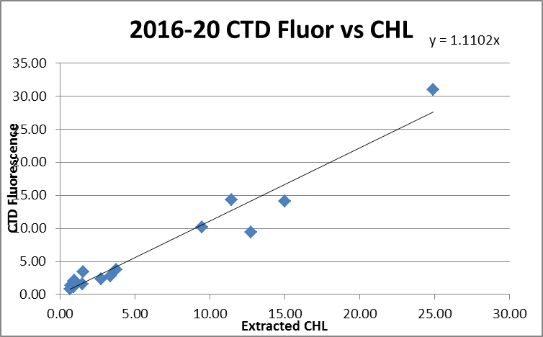

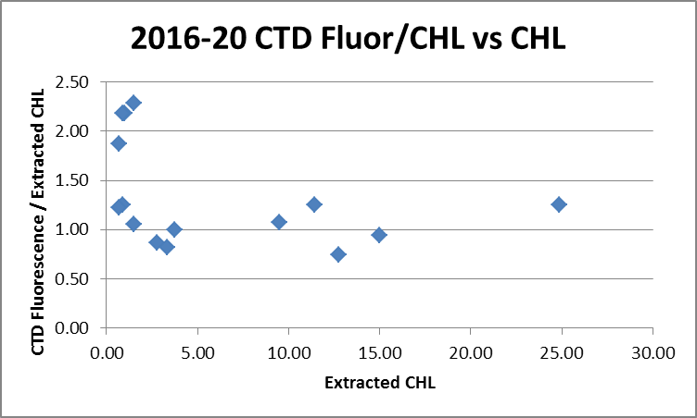

For full details of the comparison see file 2016-20-fl-chl-comp1.xlsx.

WILDEDIT
Program WILDEDIT was run to remove spikes from the pressure, conductivity & temperature only in the full cast files (*.CNV).
Parameters used were: Pass 1 Std Dev = 2 Pass 2 Std Dev = 5 Points per block = 25
The parameter “Keep data within this distance of the mean” was set to 0 so all spikes would be removed.
This did remove at least one near-surface spike in conductivity but the data are very smooth overall.

FILTER
There were many more casts available for testing during 2016-58, so the results of that cruise were applied to these data as well.
WFILTER was run using a cosine filter, size 5, on the pressure, temperature and conductivity channels. The traces are quite smooth to start with and there was no obvious change.

ALIGN DO
Because there are obvious problems in the DO data, the setting found for 2016-58 was used.
ALIGNCTD was run on all casts using +3.5s.
Cast #4 was examined after this step and the DO alignment is clearly improved.

CELLTM
The default setting of (α = 0.04, β=8) was applied. Tests showed that the correspondence of upcast and downcast were improved in T-S plots for every cast.

DERIVE
Program DERIVE was run on all casts to calculate primary salinity and dissolved oxygen concentration.

Conversion to IOS Header Format
The IOSSHELL routine was used to convert SEA-Bird 911+ CNV files to IOS Headers.
CLEAN was run to add event numbers and to replace pad values in the pressure channel with interpolated values based on record number.

Checking Headers
A cross-reference list was checked against the log book. No errors were found.
The header check indicates a problem with dissolved oxygen with impossibly high values in at least one file. The cruise number was wrong in the headers, so that was fixed in the CLN files. No other problems were seen. Fluorescence does not go off-scale.

The cruise track was plotted and added to the end of this report.

Surface check was run and shows an average surface pressure for the cruise was +1.3db. This seems low for the Ricker. However, the lowest value was for cast #12 when the surface soak data was logged and it is clear that the value of 0.23db was registered right at the beginning where salinity was ~0.05psu, so right at the surface as the instrument started recording. When that surface value is removed, the average is 1.8db. There is no evidence that pressure needs recalibration.

Altimetry and water depth information was exported to a spreadsheet. Only the first cast got within 15m of the bottom and the altimetry header value for that one looks fine. There was no altimetry header for the others, as those are only entered if the CTD gets within 15m of the bottom. The bottom depths were all entered incorrectly, using the maximum depth sampled instead. Those were corrected in the CLN and MRGCLN2 files based on entries in the log book.

Shift
Fluorescence
The fluorometer was not pumped, so a shift in alignment is expected to be small or unnecessary. Profile plots of temperature and fluorescence were examined but with the complexity of the near-surface fluorescence profiles and stops for bottles made the comparison uninformative. No alignment was applied to these data.
Dissolved Oxygen
The Dissolved Oxygen voltage channel was aligned earlier. A few casts were checked but little can be concluded due to the many problems in the DO data as well as the complexity of both traces and many stops for bottles. No further alignment was applied.
Conductivity
Tests were run on 3 casts using a variety of shifts. During the previous 3 cruises a setting of +0.4 records was selected, though improvements were slight for 2016-03. For this cruise a setting of +0.4 records worked well and was better than either +0.2 or +0.5 records.
SHIFT was not run on all casts using +0.4 records.

DELETE
The initial soak data were recorded for cast 12 and part of the soak for cast #8. The SHFC0 files were copied to *.CLIP. Then CLIP was used to remove 300 records from cast #8 and 700 records from cast #12. This will ensure that DELETE picks the best downcast data.

The following DELETE parameters were used:
Surface Record Removal: Last Press Min
Maximum Surface Pressure (relative): 10.00
Surface Pressure Tolerance: 1.0 Pressure was not filtered
Swells deleted. Warning message if pressure difference of 2.00
Drop rates < 0.30m/s (calculated over 5 points) will be deleted.
Drop rate applies in the range: 10db to 10db less than the maximum pressure
Sample interval = 0.25 seconds. (taken from header)
COMMENTS ON WARNINGS: There were no warnings.

Other Comparisons
Previous experience with these sensors –
This is the fourth known use of the pressure, temperature and conductivity sensors. The dissolved oxygen sensor has been used 5 times since it was last serviced at the factory. The only calibration sampling was from 2014-23 and 2016-02; the results from 2016-02 were applied to 2016-03 and 2016-56. There was a study of pressures during 2016-02 and it was found that the February 2015 calibration produced better results than that from July 2016. No further correction was made, and the same decision was made for 2016-03 and 2016-56. The salinity was found to be within 0.001 during 2016-02 and during 2016-56 it was found to be low by ~0.0015 and low by only 0.0005 for the 4 deepest casts. Calibration sampling for the dissolved oxygen sensor occurred during 2014-23 and 2016-02 and for both cruises the slope of the fit was ~1.04; the offsets were0.0037 and 0.1351, respectively. There were some problems with bubbles in samples during 2016-02 so the offset was not trusted. For 2016-03 and 2016-20 there was no DO sampling and corrections were made by multiplying all values by 1.04.
Historic ranges – All temperature and salinity data fell with the local climatology.
Repeat Casts – There were no repeat casts.
Post-Cruise Calibration – There were no post-cruise calibrations available.

DETAILED EDITING
CTDEDIT was used to remove noisy near-surface records and records corrupted by shed wakes. Salinity was cleaned lightly where it appeared that small alignment variations led to unstable salinity features. All files required some editing.

Initial Recalibration
There is no evidence that CTD pressure and salinity need recalibration.
It is likely that the dissolved oxygen does need recalibration but we have no calibration samples to guide us in that decision. When the sensor was used in 2014-23 the correction applied was
CTD DO Corrected = CTD DO * 1.04 + 0.0037
During 2016-02 the comparison with bottles led to the same slope but a much larger offset that may have been due to bubbles. For that cruise the CTD data were recalibrated using:
CTD DO Corrected = CTD DO * 1.04
During 2016-03 and 2016-56 there was no dissolved oxygen calibration sampling, so the 1.04 factor was used.
For this cruise file 2016-20-ctd-recal1.cal was prepared to apply:
CTD DO Corrected = CTD DO * 1.04

The MRGCLN2 and EDT files were recalibrated using file 2016-20-ctd-recal1.ccf.

Fluorescence Processing
This step was skipped because tests during other cruises using this equipment showed that the filter had little effect on spikes and over-smoothed other data.

BIN AVERAGE of CTD files
The following Bin Average values were applied to the FIL files (output AVG):
Bin channel = pressure Averaging interval = 1.000 Minimum bin value = .000
Average value will be used. Interpolated values are NOT used for empty bins.
On-screen plots were examined. The T-S plots look fine.

Final CTD File Steps (REMOVE and HEADEDIT)
The dissolved oxygen data were examined to see what data need to be removed. There are no useful DO data for events # 8 and #12, while event #10 downcast data are clearly bad above 200db and for the upcast #10 data are clearly bad above 300db. In the absence of calibration samples to confirm that the deep data are ok the dissolved oxygen data will be removed from cast #10 as well.

REMOVE was run on all casts to remove the following channels:
Scan_Number, Conductivity:Primary, Oxygen:Voltage:SBE, Altimeter, Descent_Rate and Flag.
Oxygen:Dissolved:SBE was removed from events #8, 10 and 12.

A second SBE DO channel (with umol/kg units) was added.
REORDER was run to get the two DO channels together.

HEADER EDIT was used to fix formats and channel names and to add the following comments:
----------------------------------------------------------------------------------
Fluorescence and transmissivity data are nominal and unedited except
that some records were removed in editing temperature and salinity.

For details on how the transmissivity calibration parameters were calculated
see the document in folder "\cruise_data\documents\transmissivity".

There was no salinity calibration sampling, but evidence from previous
cruises suggests errors are <0.002psu.

There was no dissolved oxygen calibration sampling. Recalibration was based
on an earlier cruise. No estimate can be made for the accuracy of the
Oxygen:Dissolved:SBE channel.

Channel Oxygen:Dissolved:SBE was removed from events #8, 10 and 12 due to
sensor malfunction.

For details on the processing see the report: 2016-20_Processing_Report.doc.
The Standards Check routine was run and no problems were found.
The Header Check was run and no problems were found.
A cross-reference list was produced.
The sensor history was updated.
The track plot looks fine.

Dissolved Oxygen Study
As a final check of dissolved oxygen data, % saturation was calculated and plotted. For the last 3 casts the value was near-zero. For event #4 it was 127%, a reasonable near-shore value when near-surface DO gradients are fairly high, as was the case for this cast. For event #6 which was offshore it was 103%, which is typical of well-mixed offshore casts.

Final Bottle Files
The MRGCOR2 files were put through SORT to order on increasing pressure.
REMOVE was run on all casts to remove the following channels:
Scan_Number, Conductivity:Primary, Descent Rate, Altimeter, Descent_Rate and Flag.
Channel Oxygen:Dissolved:SBE was removed from events #8, 10 and 12

HEADER EDIT was run to ensure formats and units are correct, change the channel name Bottle_Number to Bottle:Firing_Sequence and the name Bottle:Position to Bottle_Number and to add a comment about quality flags and analysis methods and a few notes about the CTD data processing.

Standards check and a header check were run on all files and no errors were found.
The track plot looks ok.
Plots of each file were examined to ensure no problems had crept in and none were found.
A cross-reference listing was produced for the CHE files.
Data were exported from the CHE files to file 2016-20-bottles-final.xlsx. The entries were compared with the rosette log sheets to ensure no samples had been missed and no problems were found.

Notes from Log Book
10. Choppy. 25-30 knots

CRUISE SUMMARY CTDs
 | CTD# | Make | Model |  | Serial# |  | Used with Rosette? |  | CTD Calibration Sheet Competed?
 | 1 | SEABIRD | 25 |  | 1091 |  | Yes |  | Yes
Calibration Information - 1091
Sensor |  |  |  |  |  | Pre-Cruise |  |  |  | Post Cruise
Name |  |  |  | S/N |  | Date |  | Location |  | Date | Location
Temperature |  |  |  | 4700 |  | 20Aug2014 |  | Factory
Conductivity |  |  |  | 3321 |  | 20Aug2014 |  | Factory
Transmissometer |  |  |  | 983DR |  | 5Feb2014 |  | IOS
SBE 43 DO sensor |  |  |  | 1483 |  | 17Jan2014 |  | Factory
WetLabs ECO Fluor |  |  |  | 2216 |  | n/a
Altimeter |  |  |  | ?
Pressure Sensor |  |  |  | 1091 |  | 12Feb2015 |  | Factory

