### Microplastics sampling

*Sarah-Ann Quesnel, Sarah Zimmermann (DFO-IOS)*

*P.I.: Peter Ross (Vancouver Aquarium)*

#### Background / Summary

Plastic litter has globally been recognized as a major threat to marine ecosystems, but increasing reports of microplastics (items < 5mm) have led to heightened concerns about plastic pollution in the world’s oceans. Microplastics are categorized as: (1) primary microplastics, which are deliberately manufactured, such as industrial plastic resin pellets (nurdles) or microbeads used in personal care products, and (2) secondary microplastics, which are the breakdown products from larger products, such as food and beverage containers or fibers from synthetic ropes and textiles/wastewater effluent. Approximately 80% of all plastic litter in the ocean is estimated to originate from land based sources (Andrady, 2011).

While concerns about debris and microplastic pollution have largely focused on areas close to human activities, remote regions are not immune from contamination. The two key attributes that make plastic products so desirable to consumers – durability and light weight – allow for their easy transport with ocean currents. Studies have revealed that plastic litter is found in the Arctic (Lusher et al. 2015; Obbard et al. 2014; Trevail, Kühn, and Gabrielsen 2015) with macro-plastic ingestion in seabirds, cetaceans and Greenland shark (Trevail, Kühn, and Gabrielsen 2015). The presence of microplastic in the Arctic was recently reported in ice cores, with 34 – 234 particles per m3 of ice was observed (Obbard et al. 2014). The authors noted the potential for huge quantities to be released as a consequence of melting sea ice melting due to climate change. A second report from Svalbard (Norway) found that a majority of microplastics in water consisted of fibers, with average concentrations of 0.34 (± 0.31 SD) particles per m3 in surface waters and 2.68 (± 2.95 SD) particles per m3 in subsurface water (-6 m) (Lusher et al. 2015). There have been no reports of ingestion of microplastics in arctic biota and our understanding of biological risks related to microplastics remains largely confined to laboratory studies. Previous research from our laboratory revealed ingestion of microplastic particles by two zooplankton species in the NE Pacific Ocean (*Neocalanus cristatus* and the euphausiid *Euphausia pacifica)* (Desforges, Galbraith, and Ross 2015). Ingestion of microplastics by zooplankton represents a potentially significant concern as this may impact the bottom of the marine food web and/or lead to trophic transfer in Arctic species that rely on zooplankton, such as Arctic Cod and Bowhead whales.

The scope of the sampling effort during this expedition was to define the spatial distribution of microplastics at the surface (5 m) along the ship’s cruise track in the North Pacific, Bering and Chukchi Seas.

In total, samples were collected from 15 locations from the seawater loop system with 2 sets of blanks.

#### Sampling method

Equipment:

WS Tyler USA Standard Test Sieve No. 230, 63um, .0025in, s/n 12115057. Filter with dent. At end of trip there were 5 pin-hole (or smaller) sized holes.

WS Tyler USA Standard Test Sieve No. 230, 63um, .0025in, s/n 143111147. At end of trip there were no clear holes, but they may have been masked by particles still stuck on the mesh.

End of cruise: sieves were soaked in hot soapy water, scrubbed with plastic bristle brush (similar to a mushroom brush), and rinsed with hot fresh water. Glass funnel rinsed with hot fresh water.

Filtrate of filtered seawater:

For the seawater loop (surface) samples, seawater from the fluorometer sensor line, running through a plastic hose (perhaps tygon?), was sieved through a brass #230 mesh sieve (pore size = 0.0625 mm, WS Taylor) for approximately 20 minutes, giving a total sieved volume of ~54 to 78 L per sample. During the 20 minute collection the sieve was covered by a sheet of aluminum foil to minimize airborne contamination. The sieve was then washed with both seawater loop flow from the back side of the filter and filtered seawater from a plastic squeeze bottle to decant the particulate material into a 20 mL scintillation vial with the help of a glass funnel. A piece of cling-wrap, rinsed with filtered seawater was put over the vial top followed by the aluminum lined cap to prevent the corrosion of the cap.

Acid was not added to the sample as a preservative.

1 L bulk sample:

Additionally, following the filtered volume into the scintillation vial, a 1L bulk sample (no filtering) was taken by filling a 1L pre-cleaned mason jar from the same seawater loop flow.

Blanks:

Approximately every seventh sample, blanks were collected. These consisted of

1. A filtrate blank was collected by using two sieves (same mesh size) nested together with sea-water loop flow running approximately 20minutes, the bottom sieve, presumably free of particles caught by the top sieve, was rinsed in the same way as described for the filtrate sample above, into a 20mL scintillation vial.
2. An air sample was collected by laying out a filter paper over the aluminium foil protected filtering operation during the 20 minute sampling to collect ambient plastic particulates that could contaminate the real sample. The filter was folded and wrapped back in its aluminum foil packet and labeled.
3. A 1L bulk blank was collected by filling a 1L pre-cleaned mason jar with seawater filtered using the brass #230 mesh sieve.

Flow rate:

Flow rate of the fluorometer sensor line outflow (the line used to collect microplastic samples) was measured periodically during the cruise using a volume of a calibrated 9L bucket or 60L carboy. The measurement into the 9L bucket averaged 1.91L/min and the 60L carboy averaged 2.785L/min. The difference may have been due to accuracy of volume (the ship was rolling during the 9L bucket sampling) or due to a change in the sea-water loop flow rate. The 2.785L/min rate was used to determine all volume measurements.

After sample collection the sieves and funnel were stored in aluminum foil on the stainless steel counter. Occasionally the sieves would be rinsed with fresh water after sampling. The sieves and funnel were rinsed with filtered seawater prior to starting any sampling.

Pictures were taken of the filtering setup.

Samples were collected by Di Wan (DFO-IOS), Saskia Kowallik (UVic) and Sarah Zimmermann (DFO-IOS) and stored in the totes provided at room temperature until the ship arrived back to IOS (October 2016). At IOS, samples were stored in the 4C coolers.

**Problems:**

The Water Properties’ microplastic sampling kit had 3 sieves of same mesh size. Inspecting the sieves before the cruise, 1 sieve clearly had holes in the mesh and was not brought out on this cruise. The other 2 sieves were free of holes. At the end of this cruise however it was noticed that the sieve sn12115057 (with the dent) had developed 5 very small pin-holes in the mesh. Aluminum foil used to keep the sieves clean between sampling, laid below and above the sieves was found to be corroding along with the sink counter under the foil. The foil and sieves were moved to sit on a plastic tote, but holes continued to appear in the foil. In the future it would be good to find something besides foil but that is non-plastic and non-lint (?) to cover the sieves during and between uses.

Possible sources of contamination:

Seawater passes through fluorometer (black plastic).

Seawater passes through sampling hose from fluorometer to sieves (clear flexible plastic hose, could be tygon or similar).

Filtered seawater in plastic squeeze bottle used to sweep mesh and fill 20mL scintalation vial with filtrate.

Plastic cling wrap (ie Saran Wrap) rinsed with filtered seawater used as barrier between 20mL scintillation vial and its foil lined cap.

Brush provided by Water Properties to clean out mesh on sieves had plastic bristles. This was only used at the end of the cruise after all sampling.

#### Sample Log

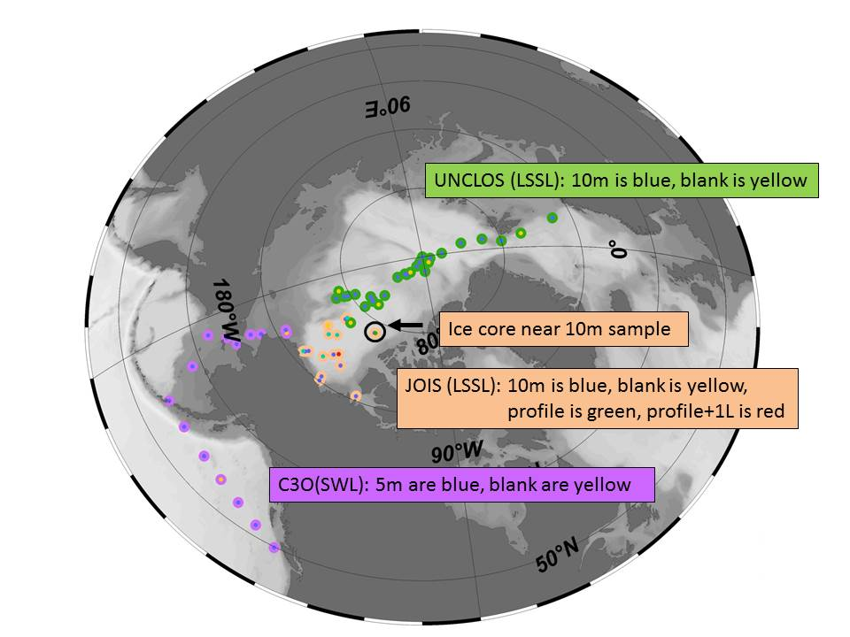

Figure . Sampling completed in 2016 for three IOS Arctic programs. C3O samples, collected from the Sir Wilfrid Laurier are shown with purple circles.

Please see  ***2016-17 Microplastic Log v2017-01-18.xls***



#### Photos

Photos of Sea-water sampling station:

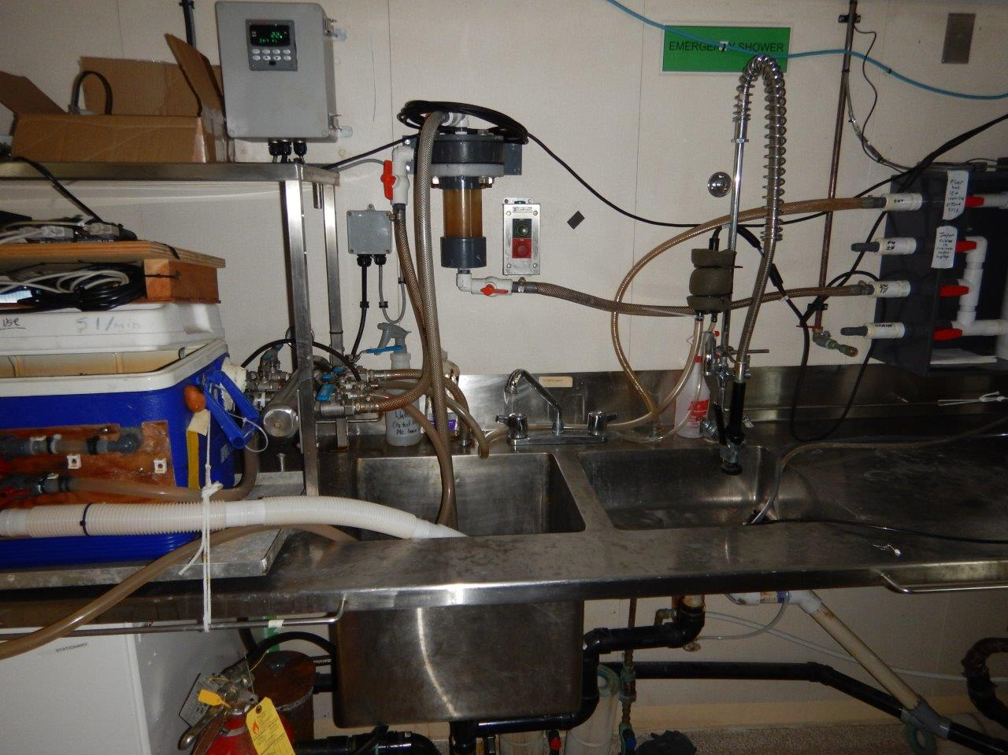

Figure 2. Surface Sea-Water "Loop" sampling area.

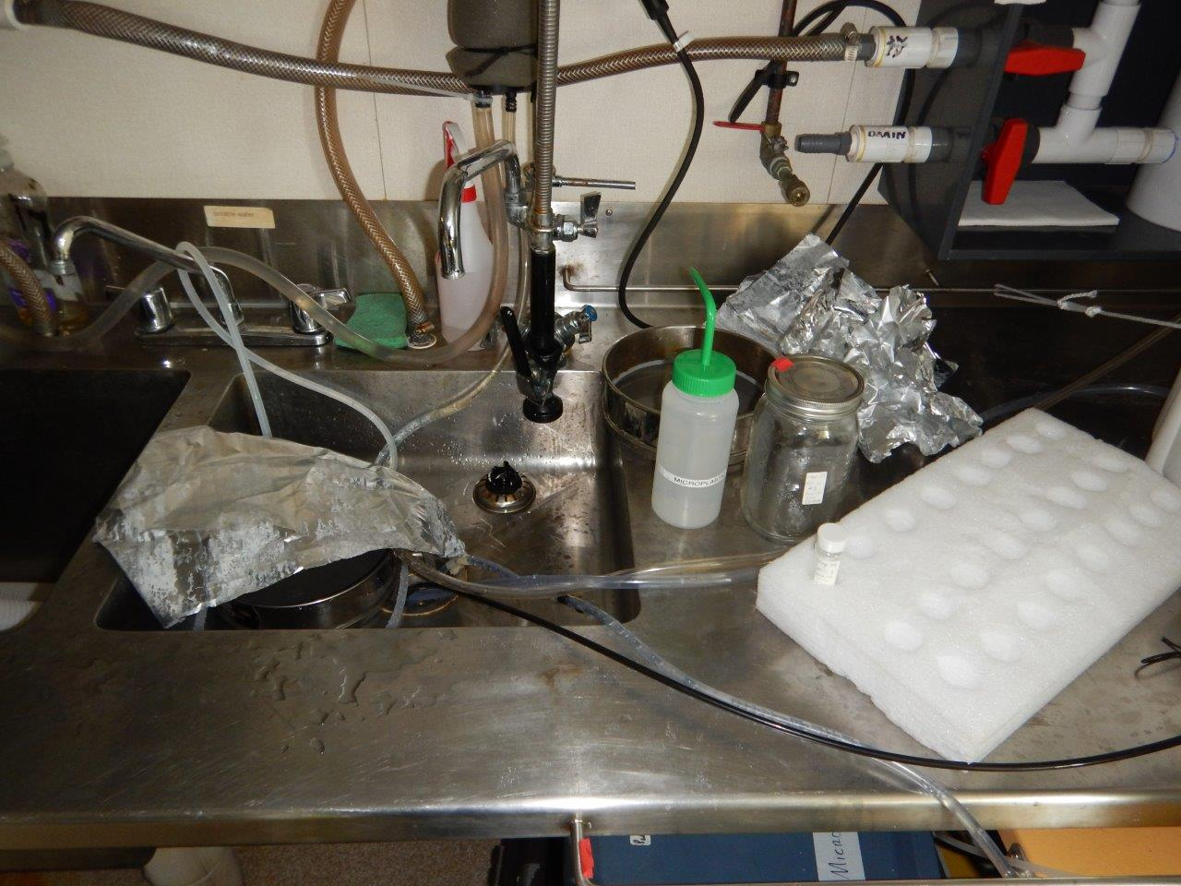

Figure 3. Set up for micro-plastic sampling. Note the plastic tubing, and plastic squirt bottle.

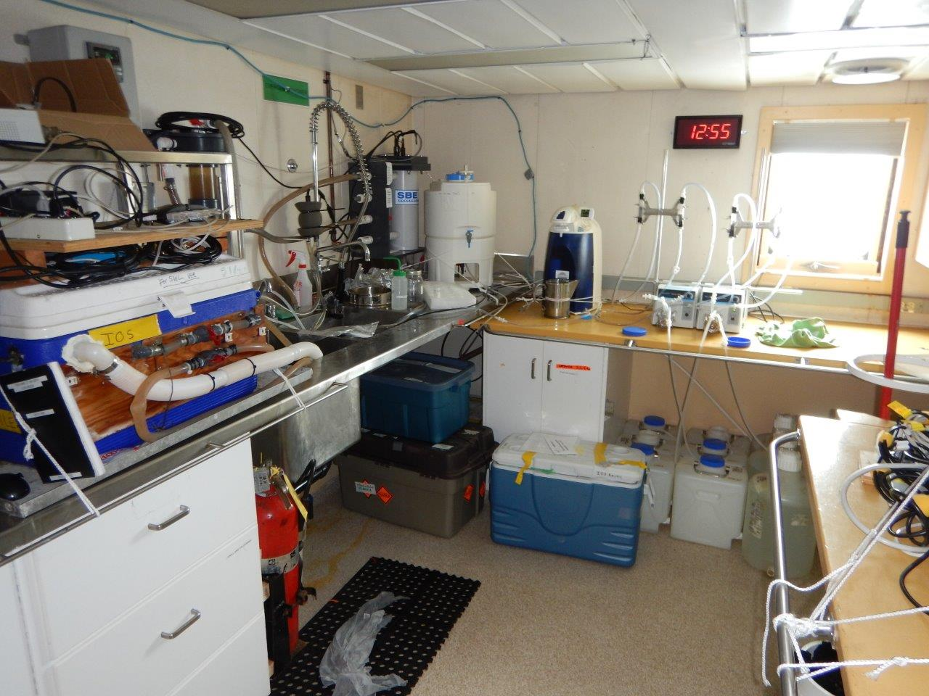

Figure 4. Bigger picture of the lab and sampling area.

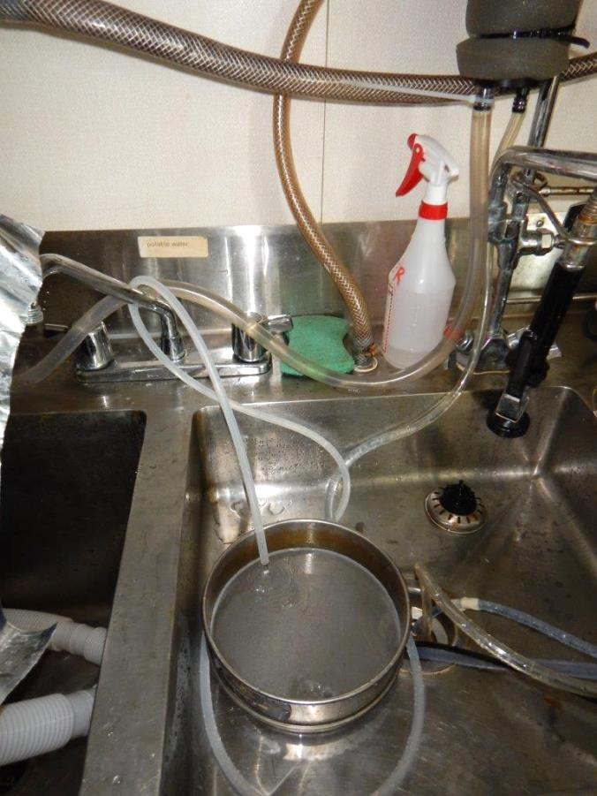

Figure 5. Sampling set up with aluminum foil removed for the picture.

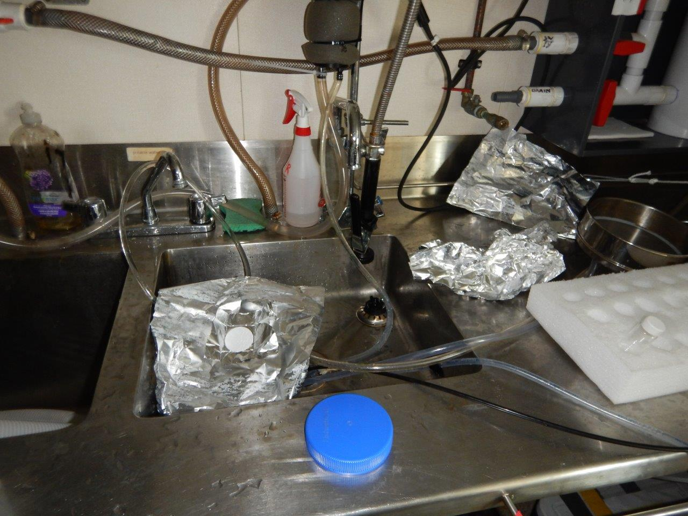

Figure 6. Sampling seawater and air particulate contamination. The sieve is under the aluminum foil.

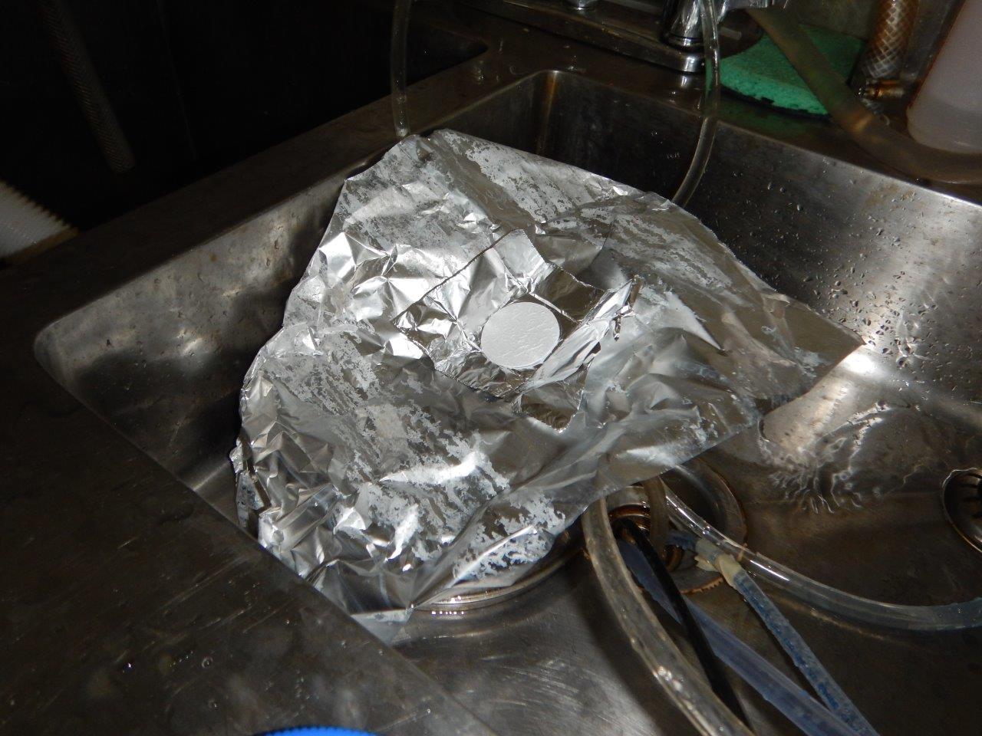

Figure 7. Zoom-in of above scene.

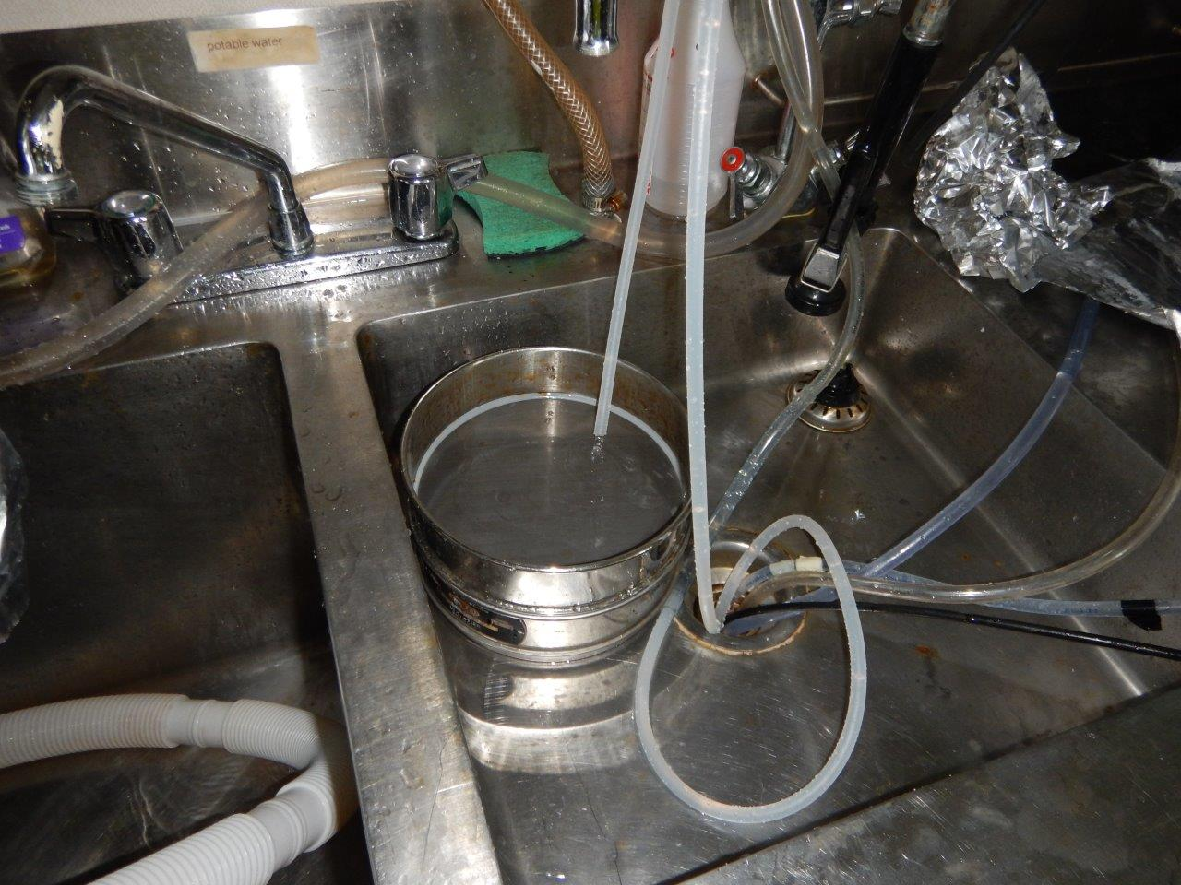

Figure 8. Showing method of taking blank sample by having water pass through a top sieve and blank filtrate collected from bottom sieve.



Figure 9. Another picture of sink area.

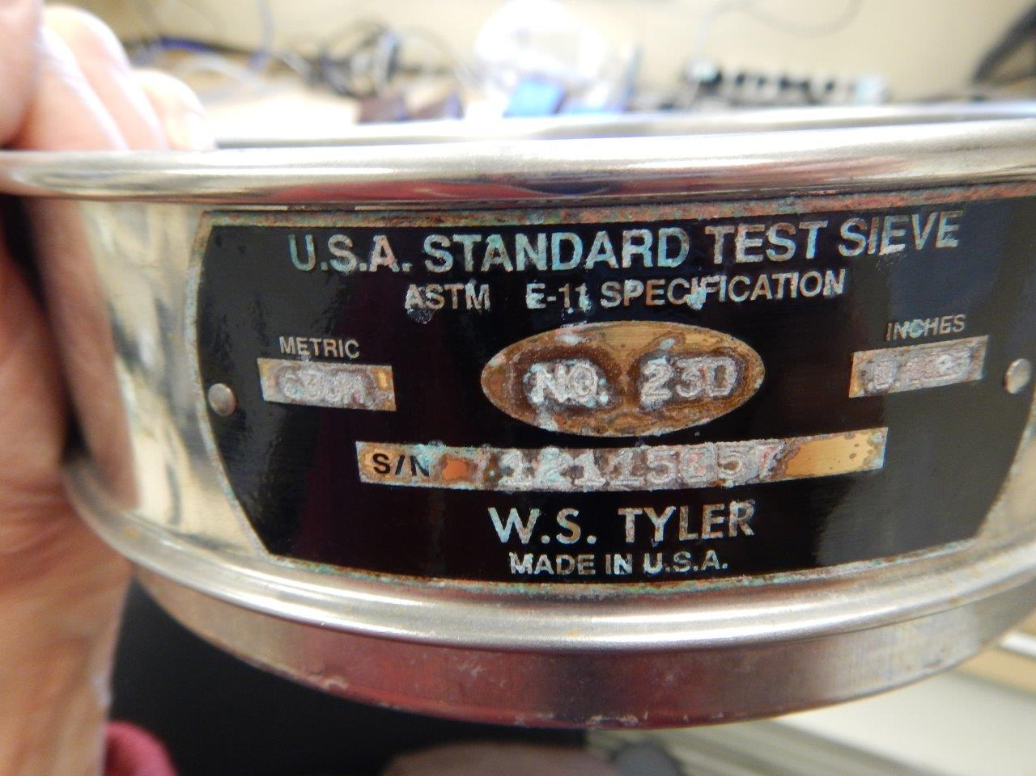

Figure 10. One of the sieves used for sampling.

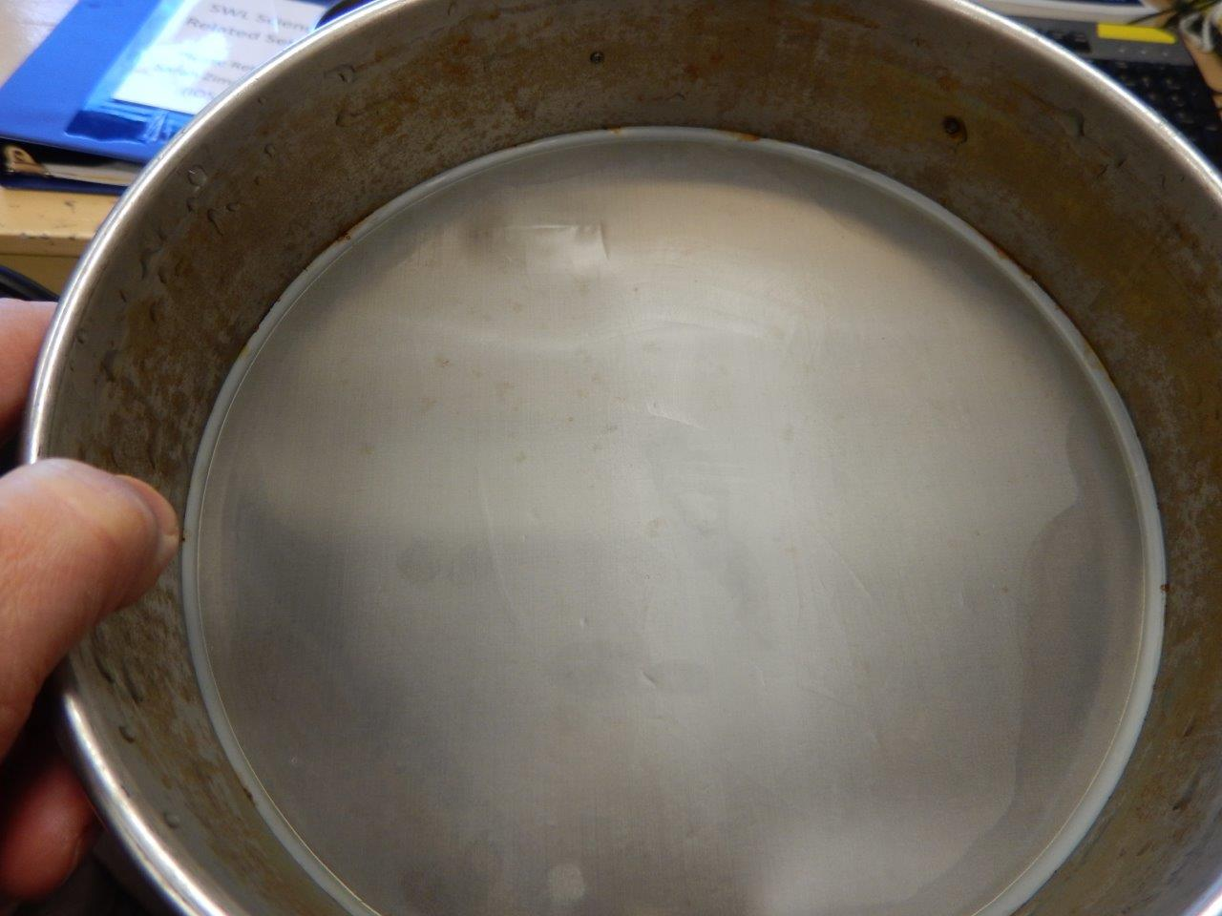

Figure 11. Sieve has a few very small pinprick holes. The holes are too small to be seen in photo.