## REVISION NOTICE TABLE

|  |  |
| --- | --- |
| DATE | DESCRIPTION OF REVISION |
|  |  |
| 20 March 2025 | Updated channel names & formats in TOB files. G.G. |
| 21-Jul-2021 | Changed channel name Temperature:Primary to Temperature:Intake G.G. |

## PROCESSING NOTES

Cruise: 2016-017

Agency: OSD

Location: North Pacific / Bering Sea / Chukchi Sea

Project: Canada’s Three Oceans / Distributed Biological Observatory

Party Chief: Vagle S.

Platform: Sir Wilfrid Laurier

Date: July 2, 2016 - July 21, 2016

Processed by: Germaine Gatien

Date of Processing: 2 September 2020 – 6 October 2020

Number of CTD HEX files: 61(1 surface data only

Number of CTD files: 60 Number of CHE files: 46

Number of TSG HEX files: 6 Number of TOB files: 5

# INSTRUMENT SUMMARY

A SeaBird Model SBE 911+ CTD (#0941) was used for this cruise. It was mounted in a custom-built compact 24-bottle rosette sampler and attached were a Wetlabs CSTAR transmissometer (#CST-1050-DR), an SBE 43 DO sensor (#1117), a SeaPoint Fluorometer (#2745), a Biospherical QSP-200L4S PAR sensor (#70123), a Biospherical Surface PAR (#20281) and an altimeter (#41098).

24 Ocean Test Equipment 10L bottles were mounted on the rosette.

A thermosalinograph (SeaBird 21 S/N 3274) was mounted with a fluorometer (SCF3275) and a remote temperature sensor #0271.

The data logging computer was the IOS ARCTIC computer.

The data acquisition program was Seasave 7.25.0.151 for the CTD and 7.23.2 for the TSG.

The deck unit was a Seabird model 11, serial # 11P53201-0800; it included a NMEA board to automatically add GPS positions into the header of the data files.

The salinometer used at IOS was a Guildline model 8400B Autosal, serial # 68572. Bottles were analyzed between 1 December 2016 and 7 December 2016.

# SUMMARY OF QUALITY AND CONCERNS

The Daily Science Log Book and rosette log sheets and TSG log as well as spreadsheets detailing sampling were provided. There are many deck pressure measurements recorded.

The secondary channels had bad data for 2 casts caused by jellyfish parts in the plumbing. The primary channels were selected for final files for all CTD casts.

The raw file names use the 2-digit cruise number that was standard in 2016. The names were changed to the 3-digit cruise number format in use at the time of processing.

For most casts the CTD was held at the surface for 1 to 4 minutes, then lowered to ~7 or 8m for a soak of ~3 minutes after which it was returned to ~2.5m. After a brief stop (usually ~20 to 30seconds) the full cast was run. A longer wait is recommended. In 2 cases there was no deep soak.

There were many unstable features in the top 50m to 100m that are associated with local minima in the descent rate, but those minima are often not so low that we expect to see corruption by shed wakes. Since they are seen in both temperature sensors the problem is likely not due to sensor malfunction. Since they are seen in a variety of regions from the Pacific and the Arctic, most such features are not believed to caused by active mixing. One possible explanation is problems in flow past the sensors – possibly something in the rosette set-up creating small eddies near the temperature sensors.

The bottle comparison indicated that the salinity was low by about 0.0055psu but the standard deviation was 0.008psu. Delay in analysis and poor flushing can account for most of the difference from bottles. The post-cruise calibration showed minimal drift in temperature and conductivity sensor calibrations, so CTD salinity calibration is considered within +/-0.002psu, though larger errors are expected due to minor misalignment in the presence of significant vertical temperature gradients, especially near the surface.

Near-surface plots indicate no problem with pressure and deck measurements show that the pressure sensor was performing well within specifications.

Channel Oxygen:Dissolved:SBE was recalibrated based on bottles samples taken in the Pacific

Ocean section of the cruise.

In the Chukchi Sea section of the cruise the salinity data was sometimes noisy in sections

where temperature was quite steady leading to some small unstable features.

There was no BL file for event #80 so one was fabricated based on plots of pressure versus scan number, thus enabling creation of a bottle file.

The dates in the TSG files were wrong, being a day later than indicated in the TSG log and in the Start Time for the files. This is likely due to 2016 being a leap year. This has been fixed in the final TOB files.

The TSG salinity and intake temperature data compared well with CTD data and loop samples and the post-cruise calibration shows only small drifts. The TSG fluorescence data are reasonably close to those from the CTD and 2 loop samples. Differences that were found may be due to slight mismatches in depth between CTD data and the level from which the water in the loop is drawn. No recalibration was applied except to correct the date.

# PROCESSING SUMMARY

##### Seasave

This step was completed at sea; the raw data files have extension HEX.

Files had cruise numbers that were standard in 2016 but that has changed, so the files were renamed with 2016-017 instead of 2016-17.

##### Preliminary Steps

The Daily Science Log Book and rosette log sheets were obtained. A post-cruise report is available.

Spreadsheet 2015-07_SWL_Chem and Logs.xlsx contains a sampling log with details on bottles fired and results of analyses.

The cruise summary sheet was completed.

There was no history available for the pressure sensor, conductivity and DO sensors; this was the first cruise on which most sensors were used after the last factory calibration.

The configuration files did not change through the cruise.

The calibration constants were checked for all instruments. The only error found was in the date of the transmissometer calibration. This was corrected and the file was saved as 2016-017-ctd.xmlcon.

For most casts the CTD was held at the surface for 1 to 4 minutes, then lowered to around 7 or 8m for a soak of about 3 minutes after which it was returned to about 2.5m. After a brief stop (usually ~20 to 30seconds) the full cast was run. In at least one case there was no deep soak.

There were a number of deck readings of pressure that were all between -0.1db and -0.1db which is well within the specifications for the sensor.

There was no sampling below 1000db, so no hysteresis tests were done.

##### BOTTLE FILE PREPARATION

The ROS files were converted including bottle number, bottle position, oxygen concentration and salinity.

The file for event #80 did not convert due to the absence of a BL file.

The full profiles were converted so that a BL file could be created for event #80. The scan #s were estimated by looking at the plot of pressure and temperature versus scan number, choosing a time when both pressure and temperature variations were low.

The files were then converted to IOS Header files and then put through CLEAN to add event numbers.

Temperature and salinity were plotted for all BOT files. There were some outliers but most were in shallow water where they are seen in both salinity channels and may reflect real variability or mismatches in T/C alignment in the presence of large vertical gradients. The only cases that look suspicious come from casts #41 and 46 where the 2 salinity channels differ significantly due to jelly fish contamination, particularly in the secondary system. No editing of the BOT files appears appropriate.

The BOT files were averaged on bottle number and those files were used to prepare an ADDSAMP file.

That file was edited to add sample numbers. Cast #203 had 1 bottle fired but no sampling occurred.

The ADDSAMP file was used to add sample numbers to the BOT files, creating SAM files. Those were bin-averaged on bottle number to create SAMAVG files.

Next, text file 2016-017-bot-hdr.txt was prepared to add an explanation of quality flags and some general comments from analysts.

Spreadsheet “2016-017_SWL_Chem and Logs _2019-02-06.xlsx” contained final analysis data. The file was simplified and saved as “2016-017_Chem.csv” in preparation for combining with the CTD data from the rosette files.

The comments from the nutrient channels were combined into one column for each set of nutrients.

There were many channels that had no flags or comments included.

The data were converted in 6 groups to ensure comments from all 6 comment columns were all transferred to the headers.

The MRG6 files were put through CLEAN to reduce the header to just the File and Comments sections.

SORT was run on channel bottle # and then merged with the SAM files with output MRG.

These files were put through CLEAN to remove SeaBird headers and comments from the secondary file.

##### Compare

Oxygen

An initial run of COMPARE led to the discovery of problems in the flag channels. There were many cases of a 5 flag that only pertained to one of the replicates. Those flags were changed to 2. There were also many flags with an apostrophe, ex. 6,3 and some with syntax OXY-2: 5 which means that the 2nd replicate was bad. In cases where there is a comment about OXY-1 it is confusing because there was not always an OXY-2, so it is not clear if the value reported is the “good” one or the “only” one. It was necessary to check with the analyst’s spreadsheet to resolve these problems. After fixing those errors the merge process was rerun.

The fit of differences between bottle DO and CTD DO versus CTD DO was fairly tight overall but there were 4 major outliers:

* Cast 15, sample 80 was flagged 36 because of problems in replicate2. If that value is deleted and rep 1 used instead the fit is much better. So Rep 1 was used with flag 2 and a comment.
* Cast 28, Sample 163 – No duplicate, analyst reported problem. Fairly high vertical DO gradient but an error due to poor flushing would have the opposite sign. Also out of line in profile. Change flag to 5 and pad.
* Cast 28, Sample 167 – Reps close, no comment. CTD DO a little noisy but not enough to account for the value being way out of line in the fit. The DO gradient is very high in this region so incomplete flushing of the Niskin bottle is likely explanation.
* Cast 28, Sample 169 was flagged 5 - value was padded.

The fit found when outliers were excluded based on large differences and then gradually removing points based on residuals:

Bottle DO = 1.0402 *Oxygen:Dissolved:SBE + 0.0271mL/L R2 =0.98

The fit found for event #21 which was deep enough to include bottles from below the oxygen minimum zone was very similar:

Bottle DO = 1.0401 *Oxygen:Dissolved:SBE + 0.0279mL/L R2 =0.92

The fits indicate that the SBE DO values are too low by ~4%; possible error sources are:

* Calibration drift generally leads to the sensors reading low but the drift estimate from late 2017 was <1%.(See section 10.)
* Slow sensor response may lead to the sensor not fully equilibrating during the 30s stop so that it reads lower than ambient waters especially in regions of high vertical gradient.
* Incomplete flushing leads to the bottle values being lower than ambient waters except at the bottom or below the OMZ where the opposite is true. This error is most significant in high vertical DO gradients and areas with steady descent rates. For the casts with DO sampling the descent rate was generally noisy, which should reduce this problem and few samples were taken in high gradients. This error offsets the calibration error somewhat making the CTD sensor look closer to ambient conditions than it really is.

For further discussion of DO calibration see §10.

There was no DO sampling for the shallow casts in the Bering and Chuckchi Seas. Those areas had low vertical DO gradients so the fits from the deeper Pacific casts should be a good estimate.

For more detail see file 2016-017-dox-comp1.xls.

Salinity

Compare was run with pressure as reference channel.

When outliers were excluded based on pressure being <50db and/or the standard deviation in CTD salinity being >0.001psu, the primary salinity was found to be low by 0.0055psu and the secondary low by 0.0042psu. The standard deviations in the fits were 0.008psu for the primary and 0.0089psu for the secondary. Most of the differences above 50m show the bottle salinity to be higher than the CTD, which is expected due to incomplete flushing in the presence of high salinity gradients. There were a few exceptions that come from bottom bottles in shallow water. We expect the “flushing” errors to have the opposite sign at the bottom. Usually those errors are small due to low vertical gradients in the 15m above the bottom, but for the last few casts there was a large gradient within 15db above the bottle firing level.

The only severe outliers are from events #41 from 50m up and all bottles from event #46 for which the secondary CTD salinity is obviously bad. This is easily explained by the note in the log that the rosette was covered by a jellyfish during #41 and that jelly parts clearly got into the secondary system during #46. After a thorough cleaning the comparison returned to normal. No further flags will be assigned as the problems are with the CTD, not the samples or analysis.

The difference between the two salinity channels based on the comparison is 0.0013psu with the primary reading lower than the secondary. The differences between channels in deep water during bottle stops shows a trend with the secondary reading higher throughout but differences gradually reducing with depth below 175db. There was only one cast that went deeper than 1000db. (Similar results were found for deep downcast files – see section 10.) The question arises as to which sensor is showing more pressure dependence. However, the differences are never large except near the surface where local variability is significant.

The only deep casts were from the early part of the cruise. While the differences from bottles vary greatly from one cast to another, the differences between the 2 CTD salinity channels are similar.   
Below 500db the average differences from bottles for both salinity channels is within 0.002psu if a few outliers are excluded. Those outliers all show CTD reading lower than the bottle samples. This might be due to some evaporation or desorption of glass particles into samples due to the 4-5 month delay in analysis – both those effects would increase the bottle salinity with evaporation being somewhat random.

For full details for the COMPARE run see file 2016-017-sal-comp1.xls.

Extracted Chlorophyll versus CTD Fluorescence

COMPARE was run using Chlorophyll:Extracted and SBE Fluorescence but CHL samples were analyzed in 3 different labs. The data from the North Pacific were analyzed at IOS. They have a small range of CHL – from 0.05 to 1.4ug/L. As is usually observed, the SBE fluorometer reads higher than the CHL samples at low CHL values. At CHL=1.4ug/L the fluorometer value was close to CHL.

The other 2 sets of CHL data were collected at the same stations but not always from the same bottles; they were analyzed at 2 different labs.

Set 2 had a range of CHl from 0.15 to 40ug/L and were analysed at the Chesapeake Biological Laboratory of the University of Maryland Center for Environmental Science.

The 3rd set of CHL data was analyzed at Clark University in conjunction with CDOM analysis and provided K. Frey. The range of CHL values was 0.075 to 50ug/L.

The correspondence between the CHL2 and CHL3 is reasonably good with the UMCES data reading about 88% of the Frey data. Below 20ug/L the two sets are closer. No flag channels were included for these 2 sets of CHL data.

For more information see file 2016-017-fl-chl.comp.xls.

##### Conversion of Full files from Raw Data

All files were converted using 2016-017-ctd.xmlcon. The hysteresis correction was not selected since all casts were shallow; the Tau correction will be used.

The file named 2016-007-0021tadpole.cnv contained only surface data so was not processed beyond conversion.

All channels were plotted for a few casts to check for problems in the conversion.

The SPAR signal looks wrong for cast #1 to 11. A log note indicates that during cast #15 a foam collar was found to have been left on the surface PAR sensor during previous casts.

No other problems were noted.

##### WILDEDIT

Program WILDEDIT was run to remove spikes from the pressure, conductivity & temperature only.

Parameters used were: Pass 1 Std Dev = 2 Pass 2 Std Dev = 5 Points per block = 50

The parameter “Keep data within this distance of the mean” was set to 0 so all spikes would be removed.

##### ALIGN DO

Fine-tuning of the DO sensor alignment is difficult when there are so many stops for bottles. For other cruises using this type of sensor settings between +2.5s to +3.5s worked quite well, so tests were run using 3 settings in that range. There was little difference among them but+3.5s is likely best for the shallow casts, so that was selected since many of the casts are shallow.

ALIGN was run on all casts using an advance of +3.5s.

##### CELLTM

As for ALIGNCTD tests are not helpful with so many stops and high variability, so settings were used that are always found reasonable, and often the best choice.

CELLTM was run using (α = 0.0245, β=9.5) for both the primary and secondary conductivity.

##### DERIVE

Program DERIVE was run on all casts to calculate primary and secondary salinity and dissolved oxygen concentration (using the Tau correction).

##### Tests

The differences between channels were plotted for 3 deep casts and are, roughly:

* Temperature differences are noisy and ~0 +/- 0.001Cº.
* Conductivity:Secondary – Conductivity:Primary ~0.0001S/m.
* Salinity:Secondary – Salinity:Primary ~0.0012psu.

Event #21 was a very deep cast so tests were run on that cast to see what can be learned about pressure dependence and calibration drift.

Cast #21 was put through steps #5 to 9 using the post-cruise calibration file, 2016-017-ctd-post.xmlcon.

Then a second run of DERIVE was run on both versions of that file to study differences between channel pairs for a selection of casts including the deepest cast.

At depth the primary salinity was reading lower by about 0.0014psu using the post-cruise calibration compared to the pre-cruise calibrations and the secondary was reading lower by about 0.004psu. There was little difference in temperature channels with the primary drifting slightly more than the secondary.

Using pre-cruise calibrations the two salinity channels differed by only 0.0006psu at the bottom while they differed by 0.0032psu using post-cruise calibrations.

From the COMPARE run we know that the 2 salinity channels differing by about 0.013psu overall, but almost all bottles included in the comparison came from early in the cruise. The salinity differences grew between the 2 calibrations and the secondary appears to have drifted most. The drift appears not to have been significant during the first leg of this trip and the equipment was used for another cruise between this one and the post-cruise service.

To study the pressure dependence of salinity differences plots were made of differences using pre-cruise and post-cruise calibrations. The was no significant difference in the pressure-dependence and the differences, while very noisy, are similar to those observed during bottle stops in the COMPARE step.

Dissolved oxygen values are lower using the post-cruise calibration which does indicate the sensor was drifting lower, but by between 0.5% and 1%, so not enough to explain the results of the comparison with bottles. This confirms that the bottle comparison reflects something other than calibration drift. Problems with Niskins flushing will not account for this as they would lead to the CTD DO looking too high (except for deep water in event #21 which was below the OMZ). Incomplete equilibration of the DO sensor will account for some error – changes of from 1% to 2.5% were found in DO values between the bottle firing time and the end of the bottle stop. Temperature did not change in the same way so slow DO sensor response is a possible cause. The pattern looks as though there is equilibration earlier but that may be the result of shed wakes keeping the values a little low but by the end of the stop most shed wake corruption has passed and values continue to rise. There may well have been further increases in DO if the stop had been longer. Another possible explanation is that there is external contamination of the DO membrane that is partially removed before the post-cruise calibration.

Conclusion: It does not appear that there was significant drift in the primary temperature and salinity channels. The drift in the secondary salinity could be as much as 0.003psu but likely less than that. Dissolved oxygen values appear to be low by about 4% due to a combination of calibration drift and slow sensor response.

##### Conversion to IOS Headers

The IOSSHELL routine was used to convert SEA-Bird 911+ CNV files to IOS Headers.

CLEAN was run to add event numbers and to replace pad values in the pressure channel with interpolated values based on record number.

##### Checking Headers

The header check was run. No problems were found.

Surface check was run and shows an average surface pressure for the cruise was -0.05db with associated low salinity values. The pressure values look to be accurate – frequent pressure checks on deck were between -0.01 and +0.01db.

The cross-reference check was compared with the log book and no errors were found.

The 8m-soak data need to be removed so that DELETE will select the most appropriate data.

Plots were made to determine how many records should be removed.

CLIP was used to remove the soak data. For cast #209 there was a second drop to fire bottles, but the 1st drop was selected for the downcast profile.

The altimeter readings and bottom depths from the headers of the CLN files were exported to spreadsheets. To see if the altimetry and/or bottom depth entries are reasonable a check value was calculated:

Check Value = Water Depth – Altimetry – Max Depth Sampled

The altimetry value is calculated with an algorithm taking data from the bottom 2db so we can’t expect the check value to be exact. There were only 2 casts with Check value >3m.

* Cast #41 – water depth was entered as 76m but in the log it was changed to 80. That value was entered.
* Cast #79 – water depth was entered as 42m but since the CTD reached 44m and was about 4m above the bottom, this is clearly not correct. A value of 48m was entered.
* Cast #132 – the water depth was corrected in the log but not in the header. The depth was changed to 50m.

The water depths were entered as 1000m for events #1 to #36; those were really cast depths, but the water depths were much larger. The values from the log were used to replace those depths except that the water depth entries were removed from casts 1, 4 and 6 because there were only rough estimates in the log.

The same changes were made to the bottle files, *.MRG; CLEAN was rerun on the MRG files.

The cruise tracks (with event #s and station names) were plotted and added to the end of this report. No problems were found.

##### Shift

Fluorescence

There is no indication in the log book as to whether the fluorometer was pumped or not. However, plots suggest that it was with a larger offset between fluorescence traces than is seen in temperature. SHIFT was run on all casts using the standard setting advancing the SeaPoint fluorescence channel by +24 records. The results look better.

Conductivity

Choosing alignment corrections is difficult because the salinity is very noisy in the top 50m or more and for many casts there is no deeper data. For many casts the instabilities are likely not due primarily to alignment problems. Shed wake corruption and real variability are possible cause. For the deeper casts it is possible to do some tests to see what setting works well below the surface waters. Those settings appear to make some improvement near the surface but leave many unstable features. It varies from one cast to another whether the primary or secondary has smoother features.

Tests were run on a few deeper casts and the best setting for the primary conductivity was found to be -0.7s and for the secondary and -0.2 for the secondary. Overall the secondary looks quite noisy but occasionally it looks better than the primary.

##### DELETE

The following DELETE parameters were used:

Surface Record Removal: Last Press Min

Maximum Surface Pressure (relative): 10.00

Surface Pressure Tolerance: 1.0 Pressure filtered over 15 points

Swells deleted. Warning message if pressure difference of 2.00

Drop rates < 0.30m/s (calculated over 11 points) will be deleted.

Drop rate applies in the range: 10db to 10db less than the maximum pressure

Sample interval = 0.042 seconds. (taken from header)

COMMENTS ON WARNINGS: The were no warnings.

##### Other Comparisons

Previous experience with these sensors – This was the first known use of the temperature, conductivity and dissolved oxygen sensors since the previous factory calibration.

Post-Cruise Calibration -

1 deep cast was converted using the post-cruise calibration. The primary salinity read lower by ~0.0014psu using the post-cruise calibration compared to the pre-cruise calibrations and the secondary read lower by ~0.004psu. There was little difference in temperature channels with the primary drifting slightly more than the secondary. Using pre-cruise calibrations the two salinity channels differed by only 0.0006psu at the bottom while they differed by 0.0032psu using post-cruise calibrations. Dissolved Oxygen values drifted low by <1%.

Historic ranges – There was no local climatology available.

Repeat Casts – There were no repeat casts; nearby casts are too shallow to test repeatability.

##### DETAILED EDITING

The primary channels were selected for editing and eventual archiving since they seem slightly more stable and at least 2 casts have bad secondary data.

CTDEDIT was used to remove some near-surface records that look like they are affected by shed wakes

or ship effects and other records corrupted by shed wakes. Salinity was cleaned, mostly in areas with high temperature gradients that lead to spiky features that are unstable. Editing was also applied to some unstable features that are look like they were corrupted by shed wakes but occurred under conditions where such corruption is not usually seen.

There were also many unstable features in the top 50m to 100m that are associated with local minima in the descent rate, but those minima are often not so low that we expect to see corruption by shed wakes. Below 100m the local vertical gradients are usually low so such effects would not be obvious. Some features and observations of these features:

* For the Pacific casts there were often extreme ranges of descent rate with rapid decelerations from 2m/s to <0.5m/s but for many of the casts with such unstable features the descent rates were much lower, so the extreme acceleration does not appear to be relevant.
* These features were noted in a variety of regions so cannot be explained by unusual mixing events near the surface.
* Both temperature and salinity are affected in both primary and secondary systems, though since conductivity and salinity data are temperature-dependent the problem may be in temperature only.
* It seems unlikely that both temperature sensors would be malfunctioning.
* A possible explanation was that there something in the rosette arrangement that caused wakes to get briefly trapped near the CTD T/C sensors so the temperature tended to be slightly too high. This would look like a shed wake and would likely be more significant when descent rates are fairly low.
* Variations in flow rate might could occur but would likely lead to greater effects on salinity than temperature, which is not generally the case with these features.

All casts required some editing.

Cast #168 had a section from 12m to 20m, just below a sharp interface, where salinity looks poor though the temperature data seemed ok. To ensure that this was not an artefact of one of the processing steps, data were examined just after conversion and the oddly high values were present. The salinity data in that section were removed but temperature data were left in place.

Plots were made to see if further editing was required. Many unstable features remain but most are fine-scale or would require removal of data where there is no obvious instrumental effect. A few casts were re-examined in CTDEDIT to see if further editing would be useful but in no case was extra editing applied.

##### Initial Recalibration

* Channel Oxygen:Dissolved:SBE will be recalibrated using the fit from section 4:

Oxygen:Dissolved:SBE (corrected)= 1.0402 *Oxygen:Dissolved:SBE + 0.0271

* The primary salinity was lower than bottles by 0.0055psu and the secondary lower by 0.0042psu but at depth the differences are mostly very small. It looks as though most of the difference is due to incomplete flushing and the outliers may be due to some evaporation or desorption of samples. No recalibration will be applied.
* Pressure does not need recalibration.

CALIBRATE was first run on the MRGCLN2 and SAM files using file 2016-017-recal1.ccf to apply the dissolved oxygen correction described above. COMPARE was rerun on the output files (MRGCOR1 and SAMCOR1) to see if this correction worked well and it did. File 2016-017-dox-comp2.xls shows a flat fit of differences versus SBE DO. The SBE DO was found to be low by an average of -0.003mL/L when 6 outliers were excluded. The scatter is largest between 4mL/L and 6mL/L where the DO gradient tended to be high. In a fit versus pressure it is again seen the cases with the SBE DO reading significantly low were mostly between 100 and 150m where there were large DO gradients.

CALIBRATE was then run on the edited CTD files using file 2016-017-recal1.ccf.

##### Special Fluorometer Processing

A median filter, fixed size=11, was applied to the fluorescence channel in the COR1 files to reduce spikiness. A few casts were examined before and after this step and showed that the filter was effective.

##### BIN AVERAGE of CTD files

The following Bin Average values were applied to the FIL files (output AVG):

Bin channel = pressure Averaging interval = 0.5 Minimum bin value = .000

Average value will be used. Interpolated values are NOT used for empty bins.

After averaging, page plots were examined on screen. Some unstable features remain as described in section 16. These are mostly close to the surface and very heavy editing would be needed to remove them; often the unstable feature is due to a very small reversal in salinity. No further editing was applied.

##### Final CTD File Steps (REMOVE and HEADEDIT)

REMOVE was run on the AVG files to remove the following channels (Output *.REM):

Scan_Number, Temperature:Secondary, Salinity:T1:C1, Conductivity:Secondary, Oxygen:Voltage:SBE, Altimeter, Status:Pump, Descent_Rate and Flag

Par:Reference was also removed from casts 1 to 11.

Change Units was run to derive dissolved oxygen in mass units.

Oxygen Saturation was derived and plots made of surface values which ranged from 90% to 160% with the majority between 102% and 110%. All but 1 of the casts from the Pacific Ocean fell within that range. The one outlier had a very high saturation of ~155%. That cast was checked to see if there were bad DO data but the data look fine and the transmissivity at the surface is extremely low indicating something interesting was happening in the top few metres.

REORDER was run to get the 2 DO channels together.

HEADER EDIT was used to fix formats and channel names and to add comments:

The Standards Check routine was run and no problems were found.

The Header Check was run and no problems were found.

The cross-reference list was produced and no problems were noted.

The final files were named CTD.

Profile plots were made. A few things were noted:

* The PAR values are significantly lower than the PAR:Reference which may be partly due to the CTD files generally not including data above 3m.
* Transmissivity fell to 0 at 200db and slowly recovered during event #4; those values were replaced with pad values.
* Fluorescence had some unbelievably high values around 200db during cast #32; those values were replaced with pad values.
* Jellyfish parts got into the secondary system on the upcast of event #41 and caused problems during event #46 as well. Checks were made to see if affected the fluorescence and SBE dissolved oxygen channels, but the profiles do not look out of line compared to nearby casts.

The track plot looks fine

The sensor history files were updated.

##### Final Bottle Files

The MRGCOR1 files were put through SORT to order on increasing pressure.

REMOVE was run on the MRGSORT files to remove the following channels (Output *.MRGREM):

Scan_Number, Temperature:Secondary, Salinity:T1:C1, Conductivity:Secondary, Oxygen:Voltage:SBE, Altimeter, Status:Pump, Descent_Rate and Flag and Bottle_Number:2nd.

Par:Reference was also removed from casts 1 to 11.

Change Units was run to add Oxygen:Dissolved:SBE in mass units. As draw temperature was not available this could not be done for the Oxygen:Dissolved channel.

REORDER was to rearrange the channel order.

HEADER EDIT was run to fix formats and units, fix a few headers, change the channel name Bottle_Number to Bottle:Firing_Sequence and the name Bottle:Position to Bottle_Number, to fix the platform name and chief scientist’s name and to add a comment about quality flags and analysis methods and a few notes about the CTD data.

Standards Check was run on the final files until all problems were found and addressed.

Plots were examined and a few potential problems were investigated:

* Given the problems with jellyfish on the secondary system during events #41 and #46, the fluorescence and dissolved oxygen profiles were compared with those of casts run immediately before and after. There is a lot of variability in the profiles but those 2 casts do not stand out as clearly wrong. No editing was applied.
* The nitrate for event #115 are all 0 with no flag; the values were checked and are correct. They are among those samples that partially thawed prematurely. The values are similar to those from the set analyzed at UMCES.

For a final check the CHE bottle data were exported to a spreadsheet and compared with the original input data. Differences were examined. There were small differences due to format changes and flags were different due to additions made in processing, mostly adding 6 to duplicates.

A Header Check was run and no problems were found.

A cross-reference list turned up no errors

The track plot was produced on screen and no errors were found.

##### Thermosalinograph Data

Date were provided in 6 hex files. The first is short and occurs before the time noted in the TSG log that the loop was turned on. It will be processed but not archived as the data cannot be considered reliable.

The TSG files have non-standard names with the format month/day but the contents are clear from the file names so they will not be changed unless the files prove unwieldy due to size.

There was an intake thermistor but no flow meter.

a.) Checking calibrations

The calibrations were checked and no errors were found in the parameters.

There were 2 CHL loop samples noted in the log book, but not in the information from the CHL analyst.

There were 8 salinity bottle samples and those were found in the salinity analysis spreadsheet.

b.) Conversion of raw files.

Configuration file 2016-017-tsg.xmlcon was used to convert all the files using 2016-017-tsg.xmlcon

The files were then converted to IOS HEADER format.

CLEAN was run to add End times and Longitude and Latitude minima and maxima to the headers.

ADD TIME CHANNEL was used to add Time and Date channels based on the Julian time.

Time-series plots were produced. There are some spikes in salinity that look likely to be produced by bubbles.

Fluorescence has a few spikes that may well be real.

The temperature differences are roughly 0.2deg C in areas where variability is low.

c.) De-spiking and Editing

All files were put through program Simple Despike to replace simple spikes in salinity of size >0.04psu with the average of adjacent values. This worked very well except for file TSG_20160710_1809 which has some bad data for the first 20 records as flow was established. A text editor was used to replace those records with pad values.

d.) Bin-averaging

The files were bin-averaged over 6 scans for the purpose of comparing to CTD data.

The track plot looks good. It was added to the end of this file.

e.) Checking Time Channel

The CTD data were thinned to reduce the files to a single point from the downcast at or within 0.5db of 5db. Those data were exported to file 2016-017-ctd-tsg-comp.xlsx.

The averaged TSG files were opened in EXCEL and reduced to the times of CTD files. There were 60 matches. The first attempt showed that the TSG dates were out by 1 day. The CTD dates agree with the log book. If CTD readings were compared with those 1 day later in the TSG files there was a good fit of positions. Temperature and salinity fit much better than when matching dates. The Start Time in the TSG files are correct; the problem is in the Julian Time channel and the Date channel derived from that.

To check for problems in the TSG clock or bad matches of TSG and CTD data, the differences between latitudes and longitudes were found. The median differences in latitude and longitude were both 0.00001°. The largest difference was ~0.0008° in latitude and 0.0022° for longitude for event #198. The TSG file shows there was considerable ship motion and temperature variation at that time. The CTD time might have been downloaded before the ship was fully stopped or there was a significant current moving the ship.

This comparison shows that both the times and positions are reliable for both systems.

This spreadsheet will also be used in step (f) to compare temperature, salinity and fluorescence from the CTD and TSG.

f.) Comparison of T, S and Fl from Loop and Rosette samples and TSG and CTD data

Differences were calculated. Cast #198 was an outlier so differences were also calculated excluding that cast and since the Pacific Ocean casts were well mixed at the surface they were also assessed as a group.

* T1 vs T2 The intake thermistor was connected throughout the cruise. The differences between the two TSG temperatures were between 0.05 and 0.86Cº with a median of 0.32Cº. The differences are slightly larger than those from the 2015 C3O cruises in this area but the temperature range was unusual in 2015 with no temperatures < 3ºC. When we match intake temperatures the differences are close to the 2015 results. And the fit of differences against intake temperature is similar to 2015.
* TSG vs CTD The spreadsheet comparing CTD and TSG files was examined to find the differences between the salinity, fluorescence and temperature channels for the CTD and the TSG.

The range of differences between TSG and CTD channels is larger than usual except for fluorescence.

|  |  |  |  |  |  |  |
| --- | --- | --- | --- | --- | --- | --- |
|  | Latitude difference | Longitude difference | Temp_Intake-Temp_CTD | Temp_Lab-Temp_CTD | SAL_TSG-SAL_CTD | FL_TSG/  FL_CTD |
| Including all casts | | | | | | |
| median | 0.00001 | 0.00001 | 0.0839 | 0.3195 | -0.0062 | 1.23 |
| stdev | 0.00014 | 0.00033 | 0.6734 | 0.7069 | 0.7663 | 0.37 |
| average | 0.00000 | 0.00005 | 0.2764 | 0.5043 | -0.1765 | 1.23 |
| max | -0.00076 | -0.00067 | -0.5615 | -0.5142 | -5.7212 | 0.37 |
| min | 0.00046 | 0.00223 | 4.4783 | 4.7167 | 0.1658 | 2.54 |
| All casts excluding event 198 | | | | | | |
| median | 0.00001 | 0.00000 | 0.0808 | 0.3110 | -0.0077 | 1.23 |
| stdev | 0.00010 | 0.00017 | 0.6762 | 0.7026 | 0.7715 | 0.37 |
| Pacific Ocean casts | | | | | | |
| median | 0.00000 | 0.00010 | 0.0390 | 0.2094 | -0.0008 | 1.26 |
| stdev | 0.00008 | 0.00024 | 0.0373 | 0.0406 | 0.0254 | 0.08 |

The TSG intake temperature is higher than the CTD temperature by a median of 0.084 Cº but for the Pacific Ocean casts it was higher by 0.039 Cº. The salinity differences are insignificant for the Pacific Ocean section and median values are small for the full cruise.

The TSG fluorometer readings are slightly higher than those from the CTD fluorometer. The 2 traces are similar in shape against event #s.

(See 2016-017-ctd-tsg-loop-comp.xls.)

* Loop Bottle - TSG Comparisons There were 8 salinity loop samples and 2 chlorophyll samples. A spreadsheet was prepared by combining the 8 loop salinity samples with TSG salinity. The TSG salinity was lower than the loop salinity by a median value of 0.0031psu and by 0.0037psu if 2 outliers were excluded.

The fluorescence readings (0.707ug/L and 0.290ug/L) were close to the 2 loop chlorophyll samples (0.641 ug/L and 0.292ugL). One was high by about 10% and the other was almost identical. Generally this type of fluorometer reads significantly higher than CHL when CHL values are low. However, there is a lot of variability in such comparisons so 2 values are insufficient to conclude that the result is odd.

(See 2016-017-CTD-TSG-Loop-comp.xls.)

* Calibration History

The TSG primary temperature and conductivity were recalibrated in December 2016. There is no indication of any repairs made before that calibration. One file was converted using the 2016 parameters and there was almost no change in temperature value. Salinity was lower by <0.002psu. There was another cruise between this one and the recalibration.

Conclusions

1. The TSG clock appears to have worked well, but the dates are wrong by 1 day, likely because 2016 was a leap year.

2. The temperature in the loop increases by about 0.15 Cº when intake temperature is ~14 ºC and by about 0.3 Cº when temperature is close to 0ºC. This is similar to the results for 2015 when intake temperatures are matched.

3. The TSG intake temperature reads higher than the CTD by a median of 0.32Cº but by only 0.21 Cº for the Pacific Ocean casts where near-surface vertical temperature gradients were generally lower than found in the Arctic casts. The post-cruise calibration shows little drift. So the median difference likely reflects mismatches in the levels from which the CTD and TSG data came.

4. The TSG Salinity was found to be reading lower than the CTD by a median of 0.006psu and by 0.008psu when 2 outliers are excluded. But if only the Pacific Ocean casts are used the difference is only 0.0008psu. Those casts mostly have low vertical gradients near the surface. The post-cruise calibration indicates there could be drift by up to 0.002psu but some of that is likely to have happened after this cruise. Recalibration will not be applied.

5. The fluorescence from the TSG looks reasonably close to that from the CTD and to loop extracted chlorophyll samples.

g.) Recalibration

Add Time Channel was run again to subtract 24 hours from each record.

i.) Preparing Final Files

REMOVE was used to remove the following channels from all files: Scan Number, Temperature:Difference and Flag.

HEADER EDIT was used to add a comment, change the DATA TYPE to THERMOSALINOGRAPH and add the depth of sampling to the header and to change the 2nd Time channel name to Time:Julian. Those files were saved as TOB1 files.

CALIBRATE was run using file 2016-017-recal1.ccf to subtract 1 from the Julian Time with output files TOB.

The TSG sensor history was updated.

As a final check plots were made of the cruise track and time-series and all look fine.

The cruise plot was added to the end of this report.

##### Producing final files

The sensor history was updated.

Particulars

Many on-deck pressure readings ranging from -0.01db and +0.01db.

1-11. During cast #15 a foam collar was found to have been left on the surface PAR sensor during previous casts. Channel PAR:Reference was removed

40. After this cast reached Dutch Harbour – TSG turned off.

41. Rosette covered with jellyfish. Got into plumbing ~50m on upcast.

46. After this cast plumbing examined and 4cm jelly part was removed from secondary T/C pair. Secondary salt looks poor on this cast due to jelly plug. Primary plumbing was flushed as well from pump end and temperature inlet end. Oxygen down/up profiles differ both in concentration and in depth of max/min features. Perhaps jelly was in the primary line as well.

51-58. Jelly on rosette.

80. 10-minute delay due to wraps on drum at start.

80. Filtered and unfiltered nutrients

85. CTD lowered and raised at 0.5m/s.

104. Vents open for many bottles.

193 &199. Nutrients filtered and unfiltered

203. Ice forcing us to be quick.

208. After this cast the angle of the oxy sensor and pump were changed slightly so water path is more upward. Down and up oxy overlay is poor – could be flow, could be the sensor, 10m offset and hysteresis even in 50m water.

# Institute of Ocean Sciences

# CRUISE SUMMARY

**CTDs**

|  |  |  |  |  |  |
| --- | --- | --- | --- | --- | --- |
| **CTD#** | **Make** | **Model** | **Serial#** | **Used with Rosette?** | **CTD Calibration Sheet Competed?** |
| 1 | SEABIRD | 911+ | 0941 | Yes | Yes |

|  |  |  |  |  |  |
| --- | --- | --- | --- | --- | --- |
| **Calibration Information CTD #941** | | | | | |
| **Sensor** | | **Pre-Cruise** | | **Post Cruise** | |
| **Name** | **S/N** | **Date** | **Location** | **Date** | **Location** |
| **Temperature** | **5048** | **24Nov2015** | **Factory** | **3Mar2017** | **Factory** |
| **Conductivity** | **3579** | **24Nov2015** | **Factory** | **29Dec2016** | **Factory** |
| **Secondary Temp.** | **5073** | **24Nov2015** | **Factory** | **31Dec2016** | **Factory** |
| **Secondary Cond.** | **3581** | **24Nov2015** | **Factory** | **29Dec2016** | **Factory** |
| **Transmissometer** | **1050DR** | **14June2014** |  | **12Apr2016** |  |
| **SBE 43 DO sensor** | **1117** | **24Nov2015** | **Factory** | **21Dec2016** | **Factory** |
| **SeaPoint Fluorometer** | **2745** | **16Apr2015** |  |  |  |
| **PAR** | **70123** | **4Apr2016** |  |  |  |
| **Surface PAR** | **20281** | **4Apr2016** |  |  |  |
| **Pressure Sensor** | **941** | **6April 2015** | **Factory** |  | **Factory** |
| **Altimeter** | **40853** | **12Feb2007** |  |  |  |

# TSG Make/Model/Serial#: SEABIRD/21/3274

|  |  |  |  |  |  |
| --- | --- | --- | --- | --- | --- |
| **Calibration Information** | | | | | |
| **Sensor** | | **Pre-Cruise** | | **Post Cruise** | |
| **Name** | **S/N** | **Date** | **Location** | **Date** | **Location** |
| **Temperature** | **3274** | **24Nov2015** | **Factory** |  | **Factory** |
| **Conductivity** | **3274** | **24Nov2015** | **Factory** |  | **Factory** |
| **Temperature SBE38** | **0271** | **2Nov2012** | **Factory** |  | **Factory** |
| **WETStar Fluorometer** | **3654** | **June 2014** | **Factory** |  |  |

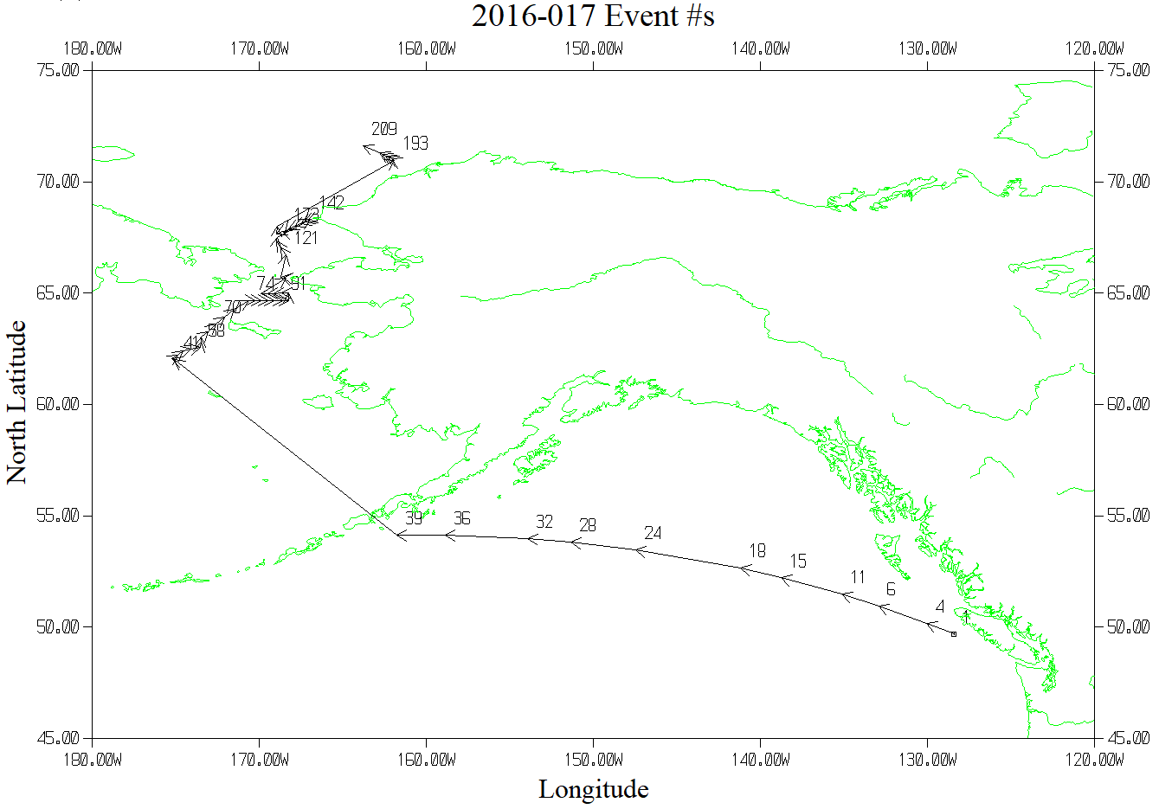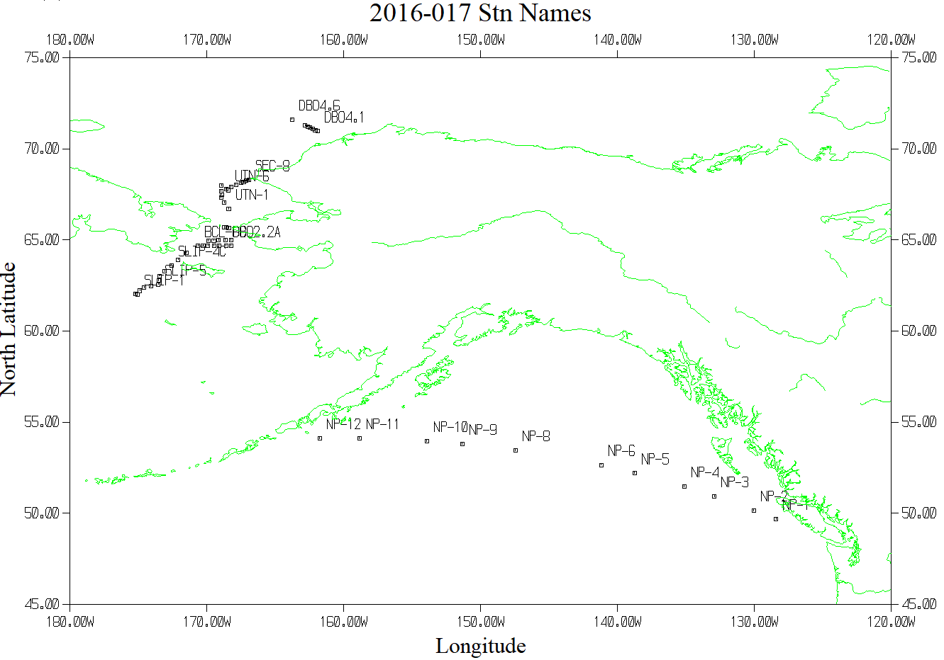

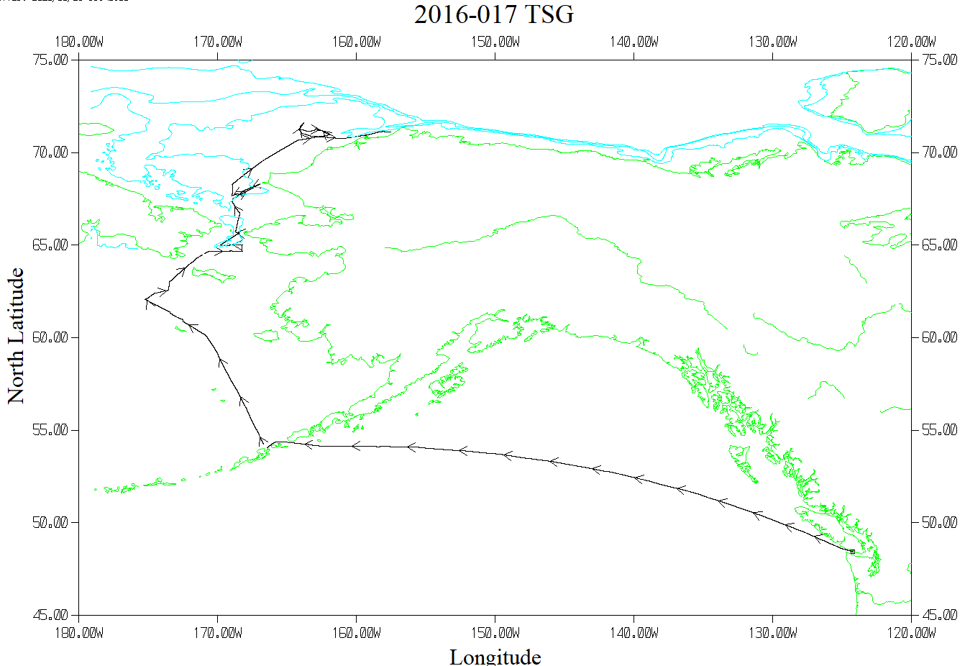

TSG Plot - 12 hours between arrows