REVISION NOTICE TABLE
DATE | DESCRIPTION OF REVISION

PROCESSING NOTES
Cruise: 2016-09
Agency: IOS, Ocean Sciences Division, Sidney BC
Party Chief: Young K. Location: Strait of Georgia
Project: Strait of Georgia Platform: Salacia
Date: 23 February 2016 – 6 August 2016

Processed by: Germaine Gatien
Date of Processing: 20 February 2017 – 28 February
Number of original HEX files: 102 (includes 2 repeats)
Number of CTD files: 100 Number of BOT files: 44

INSTRUMENT SUMMARY
A SeaBird Model SBE-25 CTD (s/n 0668) was used with temperature sensor #5130, conductivity sensor #3500, Wetlabs ECO Fluorometer #2214, dissolved oxygen sensor #1592 and pressure sensor 0668.

SUMMARY OF QUALITY AND CONCERNS
The log book was in good order and included notes about problems.

The file names were non-standard, but easily correctable since they included the event numbers.

Time zones are a problem for a cruise of this nature which spanned PST and PDT. The log book entries were sometimes in local time and sometimes UTC, but the calculation of UTC was error-prone. It is probably best to stick to local time in the log book for such cruises as long as it is clearly noted to be such. A log note about when the change occurs to from PST to PDT would also help. The instrument time stamp from the CTD was always wrong, but not in a consistent way. In July and August it was out by 6 days! Having the correct time in the instrument time stamp is important as that is the time that will go into the headers of the files. Correcting the times when the error is inconsistent is especially troublesome. The spreadsheet provided by the chief scientist was the most reliable source of information.

The CTD was generally lowered to 10m, raised and held at 2m until about 2 minutes had passed. The full cast was then run. This approach enables easy removal of the data from the soak period by removing 960 records. However, for many casts the waiting period was shorter than 2 minutes, so the number of records removed had to be adjusted to avoid losing valuable data.

There were salinity samples gathered near the bottom from 20 of the deepest casts. The comparison between the CTD and bottle salinity has a lot of scatter but suggests that the CTD is reading within 0.005psu. The comparison is too rough to justify recalibration given that depths aren’t matched exactly between the CTD and sampling level which leads to significant errors in the presence of fairly high salinity gradients. Furthermore, there was sufficient delay in some analyses to lead to significant evaporation of samples, especially since the bottle seals in use were found to be of inferior quality.

Extracted chlorophyll samples were taken at the surface and 5m, on separate casts run shortly after CTD casts. The comparison with CTD fluorescence is very noisy but shows the usual pattern of CTD fluorescence reading too high at low CHL and too low at high CHL.

There was no dissolved oxygen calibration sampling, so no correction was possible. Based on previous experience with such sensors the CTD DO values are likely a little low.

Bottle files were produced combining CTD data with analysis results using a different approach for the different types of samples:
- The salinity samples were taken when the CTD was at the bottom of casts, about 1m above the CTD. CTD data were taken from the bottom values of the final files. Some bottom data are removed in editing; this plus bin-averaging probably means the CTD data come from within 1m of the sampling depth.
- The extracted CHL samples were taken at the end of the CTD casts at 0m and 5m. There are no CTD data from 0m, either salinity + CTD data from the bottom of the cast, or extracted CHL + CTD data from the upcast CTD cast.
- There were casts at Halibut Bank that do not include a CTD cast, so there are no CTD data in those BOT files.

As is generally the case for small boat cruises, the headers do not contain position information or water depths and station names. This slows down processing of the data and the entry of the information is error-prone. To enter such details in the headers in a way that gets converted properly into IOS Header files, use a format like:
* Latitude: 48 39.53 N
* Longitude: 123 29.96 W
* Station:ABCD
* Depth: 171
There can be a space between the colon and entries but it is not necessary. Do not put units after the depth entry.

PROCESSING SUMMARY
1. Seasave - This step was completed at sea. The file names were non-standard.

2. Preliminary Steps
After making a copy of the raw files, one set were renamed in standard format.
This was very time-consuming but the event numbers were included in each file name, so it was clear how to rename them.
There were 2 copies of files 130 and 143; for the former, one version was very small and for the latter, the two were identical, at least in size.

The Daily Log was obtained.

The deployment method used was as follows: The CTD was switched on, a 2-minute timer was started and the CTD was put in the water. It was taken down to 10m, up to the surface, wait at the surface until the 2 minutes were up. The cast was then started. If a Niskin was needed it was attached 5m above the CTD. The CTD was taken to 10m off the bottom where a Niskin was fired if needed. The CTD was then brought up and switched off as it was taken out of the water. This method is helpful as by removing the first 960 records, the initial soak can be removed. Checks will be made later to see if, as sometimes happens, the downcast started too early so removing 960 records will remove valuable data.

The cruise summary sheet was completed.

A single configuration was file used at sea; the parameters were checked and were all correct. The file was saved as 2016-09-ctd.xmlcon.

3. Conversion of Raw Data
The first attempt to convert the raw files using configuration file 2016-09-ctd.xmlcon failed to convert events 41 to 75. The problem was in the header identification of temperature and conductivity sensors which were entered as -9. Entering the correct sensor numbers using a text editor made conversion work

Given problems with other cruises CTDs that do not have NMEA data, a few checks were made to see how consistent the instrument time stamp was with the log book and the spreadsheet provided by the chief scientist. The spreadsheet looks reliable. The log book sometimes has local time and sometimes UTC but it is noted when it is local. There was also a change in local time from PST to PDT during the cruise, which was actually a series of short cruises over 7 months. So it is not surprising that the UTC times in the log are frequently out by an hour. Note was made of that in the log and the times in the spreadsheet take account of that. The time stamps in the hex files are harder to comprehend and since those times will end up in the headers it will be important to fix the time later by grabbing it from the spreadsheet.

Plots show that the channels all produced reasonable values.

4. WILDEDIT
Since there are no obvious spikes in the data, this step was skipped. Once the data are converted to IOS SHELL, plotting should be done to ensure that spikes are not a problem.

5. WFILTER
Tests were run on a few casts using cosine filters of size 5, 7 and 9. As was found the last time this equipment was used, size 5 left small reversals in pressure while size 9 looks a little over-smoothed. Width 7 looked best. Temperature and conductivity filters of size 7 also look like the best choice. WFILTER was run using a cosine filter, size 7 on the pressure, temperature and conductivity channels. Plots were made before and after this step.

6. ALIGNCTD
Tests were run on a few casts to see what alignment made the offset between the upcast and downcast DO traces resemble that for the temperature traces. An advance of 2.5s produced the best results.
ALIGNCTD was run on all casts to advance the DO channel by 2.5s.

7. CELLTM
SeaBird recommend the use of (α, 1/β) = (0.04, 8) for CELLTM for the SBE 25 and it proved best when this equipment was last used. Tests proved hard to interpret, so the default choice was made.
CELLTM was run on all casts using (α, 1/β) = (0.04, 8).

8. DERIVE
Program DERIVE was run to calculate salinity and dissolved oxygen concentration (tau correction included). Plots were examined confirmed that steps 5, 6 and 7 had improved the data.

9. Conversion to IOS Headers
The IOSSHELL routine was used to convert the CNV files to IOS Headers.
CLEAN was run to add event numbers and replace pad values in the pressure channel with interpolated values.

10. Checking Headers
The times in the CLN files were compared with those in the event log. A few errors were found besides the obvious time zone problems:
- Event 5 should be on the 23rd of Feb.
- Event 130 was missing because there were 2 files identified as #130 at the raw stage – one was really 132 but was saved as 130 so the real 130 was overwritten. The names were fixed and reprocessed to this stage.
- The dates started to be wrong in the instrument date stamp in June when they were 6 days plus 6 hours early, so ~150 hours behind UTC, or 143 hours behind PDT. That continued through August. The difference in time was fine-tuned to 149.92 to get a better match with the log times. There is some drift through the June-August period but only a few minutes.
- For the first cast in June, #149, there is an inconsistency between the start time in the log (9:54 PDT) and the time found from the date stamp plus 149.2 hours (10:17 PDT). While the latter is the date stamp is clearly wrong, the size of the error is consistent for all other casts in June. The difference is only about 20 minutes. There was a log note about no data being collected during cast #149. Perhaps there was a second attempt after the NET cast so the time would make sense or it might be data from the NET cast. There are only a few data points in the file, so this will not be processed.
- Event #118 was saved as #119. This was changed in file names and event numbers.

Positions, station names and water depths are missing from the headers. A table was prepared with the missing information and saved as 2016-09-header-merge.csv.
IOS SHELL program “MERGE:CSV file to headers” was used to add the information from the csv file to the ATC files with output MRH.

An initial track plot turned up an error in the position of event 102 which should be 123 45.29W, not 124 45.29W. When that was corrected the plot looks ok.

Start times were exported to a spreadsheet and compared with the information in file 2016-09-event log.xlsx. A few errors were found and corrected. A few errors were also found in the spreadsheet and corrected there.

Track plots were produced and added to the end of this report with separate maps with event numbers for each of the 6 legs. The plot with station names from the August trip was added since that leg includes all stations occupied during the project.

HEADER CHECK was run. Negative values in dissolved oxygen and fluorescence were investigated. As was found for another recent cruise using this type of fluorometer and CTD, the fluorescence values out of water are -0.338. At depth there are values as low as -0.5ug/L; in the Strait of Georgia we usually see slightly positive values at depth. So adding 0.34ug/L to fluorescence may be appropriate. Before a decision is made on this the comparison of CHL and fluorescence will be examined to see if it suggests how to recalibrate fluorescence.

The surface check shows an average of 0.18db with many values of -0.01db which are associated with near-zero salinity values. The CTD was started just as it entered the water. Examination of the end of a few files shows the conductivity falling sharply when pressure is between -0.1db and +0.1db, which is as accurate as can be expected from this CTD.

The next step is to remove the data collected during soaks at 10m. For most casts, removing 960 scans will do this since the downcast was usually started at the 2 minute mark. As long as data from the initial downcast are removed, then the rest of the soak will be removed by DELETE.
CLIP was run to remove 960 records from each cast.
After this step plots were produced to check that there are no data left from the initial drop to the soak depth. For some casts too few or too many records were removed using that setting, so different values were selected until plots showed a full downcast was obtained.

11. SHIFT
Conductivity
Tests were run using values from +1 to -1 record to see which did best at removing noise from the salinity channel so that the T-S curves are just stable. The best results were with a setting of +0.5records.
SHIFT was run on all casts to apply that shift.
Fluorescence
The fluorometer was not pumped, so a shift in alignment is expected to be small or unnecessary. Profile plots of temperature and fluorescence were examined and confirm that the alignment is ok.
Dissolved Oxygen
This channel was aligned earlier, but checks were made by examining plots of temperature and dissolved oxygen; no further adjustment was found appropriate.

12. DELETE
DELETE was run on all casts using the following parameters:
Surface Record Removal: Last Press Min. Surface Swell Pressure Tolerance: 1.0
Swells deleted. Warning message if pressure difference of 2.00
Drop rates < 0.3m/s (calculated over 5 points) was deleted from 10db to 10db above the maximum pressure.
COMMENTS ON WARNINGS: There were no warnings.
Plots were made of pressure versus scan number to ensure there are sufficient surface data and for cast #124 it was found that too much data had been removed at the CLIP stage, so that was repeated removing only 500 records. SHIFT and DELETE were rerun for that file.

13. Initial Bottle Data Steps
There was no rosette available for this cruise. Samples were taken from a Niskin Bottle mounted about 1m above the CTD. To enable searching of bottle data, BOT files were prepared.

First, each of the analysis spreadsheets were examined to see what comments the analysts wanted included in the header file. These were used to create file 2016-09-bot-hdr*.txt which will be updated as needed during processing. The * indicates which leg of the cruise since the salinity data comments vary through the 6 legs.
EXTRACTED CHLOROPHYLL
Extracted chlorophyll and phaeo-pigment data were obtained in file QF2016-09chl*.xls which included comments, flags and a precision study.
SALINITY
Salinity analysis was obtained in 6 spreadsheets with names QF2016-09 TRIP * SAL*.xls.

Next, spreadsheet 2016-09-bottle_plus_CTD.csv was prepared. These will enable comparison of CTD data with salinity and chlorophyll samples. They contain data from the spreadsheet with time, positions, station names and event numbers plus the analysis results. The CHL event numbers were different from those of the CTD. The only CTD data available are from the cast that had just finished when the samples were taken, so the CTD event numbers will be used for the BOT files that will be created later. For the 6 casts at Halibut Bank there were no CTD casts.

14. Compare
Salinity Comparison
The DEL files were thinned to a bottom value and exported to a spreadsheet. They were combined with the salinity bottle data described in the previous section and saved as 2016-09-sal-comp.xlsx.

There were bottle samples taken from a Niskin bottle mounted about 1m above the CTD. A comparison was done between these values and CTD values recorded at the bottom. The CTD salinity was found to be lower than the bottle salinity by a median value of 0.0019. When 3 outliers were excluded the difference was 0.0022. We would expect the CTD to read a little higher than bottles due to the vertical gradient but it should be quite low at depth. The CTD salinity is higher than the bottles above 275m where gradients tend to be higher.
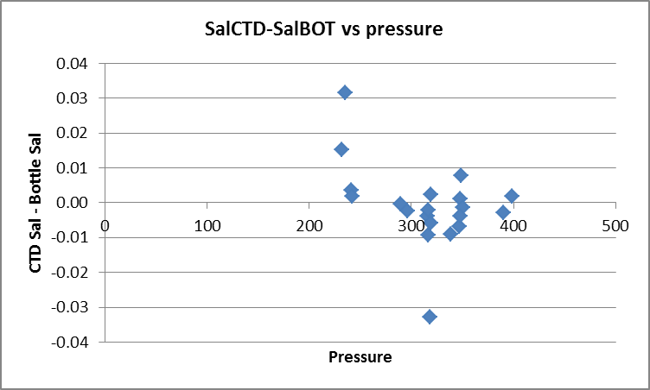

Delay in analysis of bottles is likely to lead to higher salinity in bottles thus making the CTD look like it is reading lower than it really is. The plot below shows the CTD salinity tending to be higher than bottles when analysis was quick and lower as the delay increases.
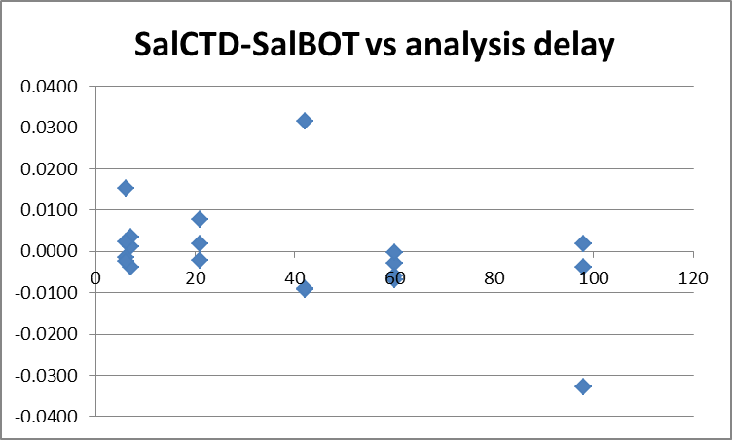

The comparison method is crude and there is a lot of scatter, so the results could not be used to justify recalibration. Nonetheless, a median difference of 0.002 when 3 outliers are excluded and the CTD salinity being within 0.005psu for 60% of the samples are very good signs.

For more details see file 2016-09-ctd-bottle-sal-comp.xlsx.

Fluorescence
Most of the CHL samples were taken at 0m and 5m right after CTD casts, but for the Halibut Bank casts there was no CTD cast.

The DEL files were thinned to 1, 2 and 5m; since there are no CTD data from 0m, the closest available CTD were selected. In some cases one bottle may have been fired during the CTD cast and the other in a separate cast immediately afterwards. The thinned files were exported to a spreadsheet file and added to 2016-09-bottle_plus_CTD.csv which was used to create the bottle comparison spreadsheet.

A comparison of the CTD fluorescence with the extracted chlorophyll had a lot of scatter, as is expected due to high variability in both. The average ratio FL/CHL was ~1.0 but the median value was ~0.5. The standard deviation was ~1. We expect the CTD fluorescence to read higher than CHL when CHL<1ug/L and fairly close to CHL between 1 and 5ug/L. For CHL>5ug/L we expect the fluorescence to read lower with a ratio of ~0.5. The near-surface comparison is expected to be poor because we don’t have CTD data from the same level. To see if that explains some of the scatter the 5m data were examined separately. The average value of FL/CHL was ~1.3 and the median ~1.0; the standard deviation was ~0.9. The ratio FL/CHL plotted against CHL shows the usual pattern for this type of fluorometer, although the scatter is much higher than we usually see. The difference in time between the downcast CTD data and the samples could easily account for that.

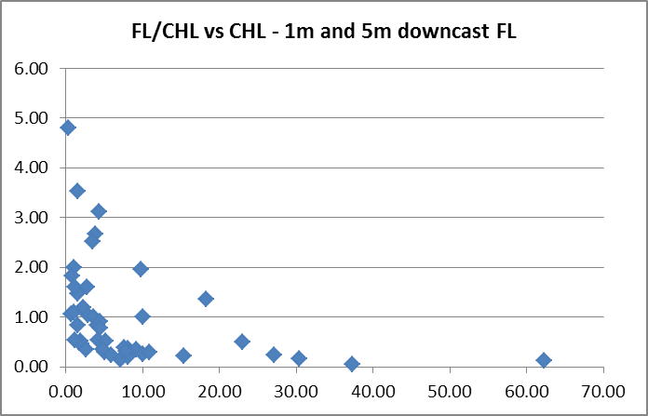
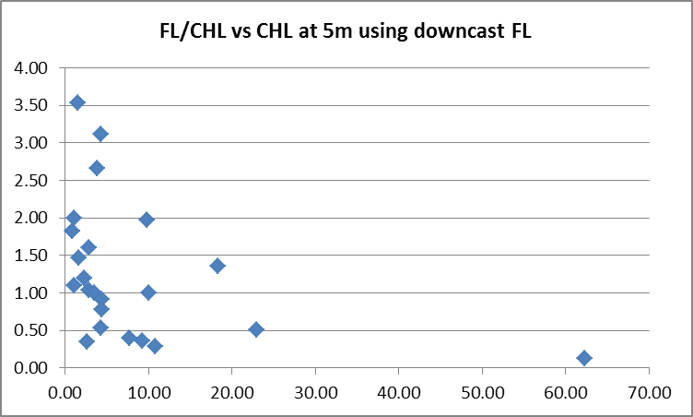

Upcast data could be used although they tend to be contaminated by shed wakes so that the fluorescence may reflect deeper conditions. However, given the deployment method this may not be a major problem, so the full files were put through REVERSE and then DELETE and THIN to do a comparison. The result was surprisingly similar.
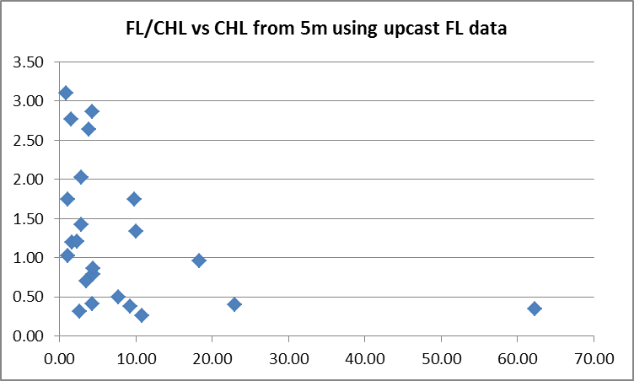

There is a lot of noise in the results but the averages and medians differ very little. Given that there is little difference, the downcast data will be selected to create bottle files since there are sometimes both salinity and CHL samples and the downcast CTD data are likely better for the salinity comparison.

One other thing checked was whether add an offset to the fluorescence improves the comparisons. First, some values in deep water were checked and they all seem low. There are a few slightly negative values, but they appear to be spikes, with no areas of consistently negative values. A test run made by adding 0.338ug/L to all fluorescence values based on the data at the beginning of casts; this showed very little effect on the fits. At the end of cast #207 there are some values as low as -0.275ug/L when the pressure is very close to zero and conductivity is near zero. So adding 0.34ug/L looks appropriate, but the change will not be significant as far as the comparison with chlorophyll goes.

15. DETAILED EDITING
CTDEDIT was used to remove records near the top and bottom of many casts and records corrupted by shed wakes. It was also used to clean salinity where unstable features looked likely to be caused by misalignment of T and C. Most casts required some editing.
The following casts were not edited: 1, 17, 20, 33, 64, 66, 75, 91, 95, 102, 145, 147, 159, 190, 201, 214
Notes of editing details were made in the headers.

T-S plots were examined and no significant problems were found; there are small unstable features but this is an area where they are expected.

16. Other calibration checks
Sensor History – These sensors were used for one other cruise in 2015. The salinity was found to be low by about 0.003psu, but the comparison was considered to be rough. No corrections were applied to any sensors.
Comparison of repeat casts –There were many repeat casts but they were occupied weeks apart.
Historic Ranges – The local climatology is not representative of many of the sites occupied during this study and they are mostly close to shore where a3-standard deviation climatology is not suitable. The salinity data mostly fell within the historic ranges, though there were often low values at the surface in February and March and a few slightly low values at about 160-170m in the central Strait of Georgia near Vancouver. In August salinity was high near the bottom in the central Strait of Georgia. Temperatures tended to be higher than the climatology maximum between May and August.
Similar observations to those made in late May and late June were made in the central Strait of Georgia in mid-June during 2016-07; different sensors were used for that cruise.
There is nothing in these observations to suggest any problems with sensor calibration.
Post-cruise calibrations – None were available.

17. CALIBRATE
CTD Salinity will not be recalibrated as it appears to be as close to bottles as we can expect given the scatter in the comparison.
There was no dissolved oxygen sampling and we have no history for this instrument.
The pressure does not need recalibration.
The fluorescence will be recalibrated by adding 0.338ug/L.
CALIBRATE was run using file 2016-09-recal1.ccf to add 0.338ug/L to the fluorescence channel.
Header check was run and confirms that there remain no negative values.

18. Fluorescence Filter
A median filter, size 5, was applied to the fluorescence data as they are spiky.

19. Bin Average and REMOVE
The files were bin averaged using 1db bins.

REMOVE was run to remove Scan_Number, Conductivity:Primary, Oxygen:Voltage, Descent Rate and Flag channels. Fluorescence was removed from cast #35; the cap was left on the sensor.

Dissolved Oxygen was derived in mass units and that was used to calculate DO saturation. Plots of near-surface saturation show values between 68% and 160%. This cruise covered a large area and had 6 surveys between February and August. In August, in the central Strait of Georgia, saturation ranged from 98% to 125%, and a median value of 110%. These data are not useful in assessing the accuracy of the dissolved oxygen data, but do not look unreasonable.

REORDER was used to get the 2 dissolved oxygen channels together.

20. HEADER EDIT and final checks of CTD files.
Header Edit was used to fix headers, fix formats and channel names, to remove the Altimetry header and to add the following note to the headers:
Data Processing Notes:
----------------------
Dissolved Oxygen and Fluorescence are nominal and unedited, except
that some records were removed in editing temperature and salinity.

While the CTD fluorescence data are expressed in concentration units, they
do not always compare well to extracted chlorophyll samples, particularly for
casts far from shore.

Comparison with bottles suggests that the CTD salinity is low by about 0.002psu
but there are too many uncertainties in the comparison to justify recalibration.

For details on the processing see processing report: 2016-09-proc.doc.
For cast #35 from which the fluorometer channel was removed, a note of explanation was added to the comment.

A cross-reference listing was produced.
A header check was run on the CTD files and no further errors were found.
The sensor history was updated.
Plots of CTD casts were examined and no problems were found.

20. Final BOT file preparation
To enable searching of bottle data, BOT casts will be created that contain sample data and, where available, CTD data from the preceding downcast.

The SAL bottle data come from the bottom of CTD casts.
The CHL bottle data usually come from BOT casts immediately after the CTD casts with the exception of Halibut Bank bottle data which are not associated with a CTD cast. The event numbers for the CTD and BOT differ by 1, though for event #116 the chlorophyll samples were given the same file name as the CTD file.

This process is complicated by the fact that some casts have only SAL or only CHL sampling, while others have both. While choosing data from the downcasts has been found in the past to provide the best comparisons, there are no CTD data available close to the surface for some casts with CHL sampling. However, there are only 4 cases with no CHL sampling at 1db and for one of those there are 2db data available, so downcast data will be selected. For cast #216 at Halibut Bank there was only a bucket sample.

File 2016-09-bottle_plus_CTD.csv was created using the bottle data from the COMPARE files. The final CTD files were thinned to bottom values for the casts that have salinity sampling and the data from those files were exported to a spreadsheet and added to the main spreadsheet.

CTD data to match CHL sample data were extracted in a similar fashion and added to the spreadsheet. Care was needed to line up the CTD data with samples as the Halibut Bank files had no CTD data to match. A six-line header was added and this file was saved as 2016-09-bottle_plus_CTD_6linehdr.csv. Latitude and Longitude needed adjusting to IOS Header format and the time and positions for Halibut Bank had to be entered by hand. Water depths could not be left blank so the Halibut Bank entry for the first occupation of that site was used to fill in those for the other casts.

Pressure and Depth:CTD will only be available where there are CTD data, so a separate depth channel called Depth:Nominal was prepared to indicate the depth at which the bottle is believed to have been fired. These entries are 1m above bottom for salinity and either 0m or 5m for CHL sampling.

The file was converted. It took many attempts as errors were gradually found and corrected.
The time and date are present as channels as these cannot be changed directly into header entries.

CLEAN was run to add START and END time. The END TIME is identical so the START time so it will be removed later. CLEAN was also used to enter 0 flags where the flag channels are empty and to remove channels with only pad values.

REMOVE was run to remove the DATE and TIME channels.

HEADEDIT was used to add comments and to remove the END time and TIME ZERO. The comments were adjusted for each leg since the salinity analysis comments vary.

The final files have extensions BOT. Those for Halibut Bank were adjusted so that the Data Description is Bottle:Wire instead of Bottle:Wire + CTD Down.
A cross-reference list and header check were run on the BOT files. One case of bad data was found and corrected.

Plots were made of all BOT casts and no problems were found.

Particulars
8. 2 bottles- 5m bottle had vent leak. Niskin has label 300. Do not use again.
16. Leaky spigot on surface bottle. Replaced spigot and o-rings.
20/21. Station should be GEO1.
35. Log notes that the cover was left on transmissometer; since there was no transmissometer it is assumed this should be fluorometer which has an unbelievable signal.
38. Re-do of 35
41-80. Time wrong in log by 1 hour – correct in spreadsheet
49. Problems with winch.
62. Problems with winch, came up a few metres and then back down.
78 – 82. Time wrong in log by an hour – fixed in spreadsheet .
107. Winch stop and start ~240m, slowed output
116-124. Had nothing to clean fluorometer. Winch slowed with partial stalls on deeper casts.
118. Forgot soak so restarted. Called #119 in file name in raw data. Changed to #118.
149. Log notes that no data were collected. A file exists with only a little deep data. Not processed.
153. Winch struggling
156. Winch totally stalled at bottom.
157. Leaky top cap on surface bottle.
190-227. Local time in log book. UTC in spreadsheet. Time in hex files off by about a week.
190.Test cast outside Pat Bay, testing winch and CTD
191. Fluor not cleaned
201. Windy! Very rolly.
205. Forgot to clean Fluor
212. Battery problem on Winch? Not holding charge
214. Lumpy seas
217. Very lumpy, big N West. Cancelled net.
218. Very bad conditions – massive seas.

CRUISE SUMMARY
Cruise ID#: 2016-09
Dates: Start: 23 February 2016 End: 19 August 2016
Location: Strait of Georgia
Party Chief: Young K.
CTD# | Make | Model | Serial# | Used with Rosette? | CTD Calibration Sheet Competed?
1 | SEABIRD | 25 | 0668 | No | Yes

CTD CALIBRATION INFORMATION
Make/Model/Serial#: SEABIRD/SBE25/0668 Cruise ID#: 2016-09

Calibration Information
Sensor |  | Pre-Cruise |  | Post Cruise
Name | S/N | Date | Location | Date | Location
Temperature | 5130 | 23May2014 | Factory
Conductivity | 3500 | 23May2014 | Factory
ECO Fluorometer | 2214 | ? | ?
SBE43 Oxygen | 1592 | 02Jun2014 | Factory
Pressure | 0668 | 23May2014 | Factory

