REVISION NOTICE TABLE
DATE | DESCRIPTION OF REVISION
30 Jan 2019 | Bottle spreadsheet converted to searchable BOT files.

PROCESSING NOTES
Cruise: 2015-56
Agency: MEAD
Location: SoG/JdF/WCVI/Hecate Strait
Project: Salmon Marine Interactions
Party Chief: Neville C. / Thiess M.
Platform: W.E. Ricker
Date: 15 September 2015 – 8 October 2015

Processed by: Germaine Gatien
Date of Processing: 17 May 2016 – 31 May 2016
Number of original HEX files: 115 Number of CTD files: 115
Number of original TSG files: 64 Number of TOB files: 64

INSTRUMENT SUMMARY
SeaBird Model SBE 911+ CTD (#0550) was used for this cruise. It was mounted in a rosette and attached an SBE 43 DO sensor (#1176), a Seapoint Fluorometer (#3641) and an SBE18 pH sensor (#0851).
TSG (#2488) was used with no flow meter, intake thermistor or added sensors.

SUMMARY OF QUALITY AND CONCERNS
The Daily Science Log Book was in good order.

Acquisition started late for 8 casts with the first data recorded when the CTD was between 10db and 34db. For those casts upcast files were produced with event numbers having a leading 9, so 2015-56-9038.ctd is the upcast for event #38. The quality of those files is somewhat lower since the CTD package mixes the water a little and carries deeper water with it.

There were no salinity or dissolved oxygen calibration samples available and none were collected on any other cruises using these sensors that have been run since the pre-cruise factory calibration was done. However, there were post-cruise factory calibrations available for temperature, conductivity and dissolved oxygen, so those were used to convert the raw data.

The ratio of CTD fluorescence to extracted chlorophyll looks typical of these types of fluorometers with values close to 1 (on average) for CHL<2ug/L, then falling to about 0.5 for CHL>5ug/L.

The raw TSG data included 64 files many of which were very short. There was no loop sampling. There were 60 CTD casts that overlapped with TSG files, but those casts contain few data above 4db, whereas the loop intake is at 3m. Starting CTD deployments a little shallower and/or gathering loop samples would enable better comparisons. The TSG salinity was lower than the 4m CTD salinity by about 0.56psu which may be due to the mismatch in depths in the comparison, conductivity sensor calibration drift and bubbles in the loop. The error likely varies from cast to cast. No recalibration was applied.

There was no TSG intake temperature sensor, so a proxy was created by subtracting 0.06 C degrees from the lab temperature based on the history of the sensor and the comparison with CTD temperatures.

PROCESSING SUMMARY

Seasave
This step was completed at sea; the raw data files have extension HEX.
The file names were in standard format.

Preliminary Steps
The Log Book was obtained.
It is noted that the water samples were taken 5m above the CTD with only 1 sample per cast. The plan was to stop the CTD at about 15m, so samples are from ~10m.
The same configuration file was used throughout the cruise and was saved as 2015-56-ctd.xmlcon.
The cruise summary sheet was completed.
The pressure sensor, conductivity and DO sensors have been used for 2 other cruises that have been processed since they were last calibrated at the factory.
A post-cruise calibration is available.
The extracted CHL and nutrient analysis spreadsheets were obtained and the data from each were combined in spreadsheet 2015-56-bottles.xlsx. This can be used to compare with fluorescence.
The calibration constants were checked for all instruments. No errors were found.

Conversion of Full Files from Raw Data
A new configuration file was prepared with post-cruise calibration parameters used for temperature, conductivity and dissolved oxygen. It was saved as 2015-56-ctd-post.xmlcon. A selection of casts was converted using the two configuration files and compared. The differences were very small with salinity differing by 0.0005 and 0.001 for the primary and secondary channels, respectively. Dissolved oxygen was reading low by about 0.3%, a very small drift.
Given that this cruise was closer to the post-cruise calibration date, those parameters were selected for converting the data.

All files were converted using con file 2015-56-ctd-post.xmlcon with hysteresis correction turned off and Tau correction turned on.

A few casts were examined and all expected channels are present and look reasonable.
As usual differences between channels were larger for upcasts than downcasts.

WILDEDIT
Program WILDEDIT was run to remove spikes from the pressure, conductivity & temperature only.
Parameters used were: Pass 1 Std Dev = 2 Pass 2 Std Dev = 5 Points per block = 50
The parameter “Keep data within this distance of the mean” was set to 0 so all spikes would be removed.

Checking one plot before and after this step shows a spike was removed.

ALIGN DO
Tests were run using a variety of settings to align DO with temperature. The best results were with +2.5s though this varies from feature to feature. A further refinement to this can be done later if necessary.
ALIGNCTD was used to advance the DO Voltage by 2.5s relative to the pressure.

CELLTM
The noise in the upcast makes the tests for the best parameters for this routine very difficult to interpret. Tests on previous cruises using these sensors showed the default setting of (α = 0.0245, β=9.5) did the best job and it does improve the data for both conductivity channels for these data.
CELLTM was run using (α = 0.0245, β=9.5) for both the primary and secondary conductivity.

DERIVE
Program DERIVE was run:
on all casts to calculate primary and secondary salinity and dissolved oxygen concentration.
on 3 casts to calculate the differences between primary and secondary channels for temperature, conductivity and salinity. These were placed in a test directory and will not be archived.

Test Plots and Channel Check
For this cruise the casts are all shallow making the comparison less reliable, but 3 casts were examined and the differences were:
Cast # | Press | T1-T0 | C1-C0 | S1-S0 | Descent Rate
2015-12-0006 | 360 | +0.0008 | -0.00003 | -0.0011 | Noisy, Mod
2015-12-0062 | 360 | +0.0007 | -0.0001 | -0.0016 | Steady, High
2015-56-0008 | 250 | +0.0003 | -0.0002 | -0.0025 | Steady, F.High
2015-56-0166 | 250 | +0.0002 | -0.0002 | -0.0023 | Steady, F.High
2015-56-0487 | 250 | +0.0001 | -0.00015 | -0.0015 | Steady, High
The differences are reasonably low. The salinity difference does show that the post-cruise calibration is not perfect for these data, though some of the difference may be due to causes other than calibration drift, such as different flow rates. To see if the pre-cruise calibration would be better, one cast was processed using those calibration parameters. All differences were a little larger. So the post-cruise calibration is the better choice.

Conversion to IOS Headers
The IOSSHELL routine was used to convert SEA-Bird 911+ CNV files to IOS Headers.
CLEAN was run to add event numbers and to replace pad values in the pressure channel with interpolated values based on record number.

Checking Headers
The header check was run. There is evidence of spikes in pressure and one fluorescence value that looks near the maximum. Plots show that the high fluorescence is in a single-spike, not a case of the fluorescence being off-scale. Such spikes are most likely to disappear in the DELETE step.

The surface check gave an average value of 4.5db which is not out of line for the Ricker. Checks of a few casts where data were available near the surface of the upcast show the conductivity falling very rapidly when the pressure is ~0.8db, but the pumps were off so this evidence is weak. There are no transmissivity data which might make the picture clearer, but the pH values look like the probe was in water and that sensor is not pumped. It is likely that acquisition stopped while the CTD was still in the water. Pressure is likely ok.

The cross-reference check was run and all station names were compared with the log book and times and positions were checked for a selection of casts. The only problems noted were with station names. The errors for casts #49 and 133 were noted in the log book. Others were events #16 and 340. All were corrected in the IOS and CLN files.

The cruise track was plotted and added to the end of this report. No problems were found.

Shift
Fluorescence
A shift of +24 is the usual setting used to align pumped SeaPoint fluorometers with temperature.
SHIFT was run on all casts to advance the fluorometer by +24 records. Before and after plots suggest this was effective in aligning the data.

Dissolved Oxygen
Checks were made of the alignment of DO and temperature and the shift applied earlier appears to have done a good job though, as usual, for some features it was too little or too much.

pH
Because of hysteresis in the pH signal, tests are best run on casts with distinctive features in the pH traces. This was done by finding the distance between such features in the upcast and downcast and comparing that with the temperature offset after applying a variety of shifts. The setting of +70 records produced good results.
SHIFT was run on all casts with the setting +70 records.

Conductivity
Tests were run on a few casts using a variety of settings to see which shift produces reasonably stable T-S plots. The bests result varied from feature to feature, but overall the best choice for the primary salinity was -1.35 records and for the secondary it was -1.1 records.
Two runs of SHIFT were used to apply advance the primary by -1.35 records and the secondary by -1.1 records.

DELETE
The following DELETE parameters were used:
Surface Record Removal: Last Press Min
Maximum Surface Pressure (relative): 10.00
Surface Pressure Tolerance: 1.0 Pressure filtered over 15 points
Swells deleted. Warning message if pressure difference of 2.00
Drop rates < 0.30m/s (calculated over 11 points) will be deleted.
Drop rate applies in the range: 10db to 10db less than the maximum pressure
Sample interval = 0.042 seconds (taken from header)

COMMENTS ON WARNINGS: There were many warnings for 5 casts, but they all pertained to upcast portions of casts so are of no concern for the downcast files.

DETAILED EDITING
The first issue is to decide which sensor pair to edit. There was little difference between the noise levels in the two T/S pairs, though the primary might be slightly better. The estimated drift from the post-cruise calibration is slightly lower for the primary temperature and salinity. So the primary channels were selected for editing.

CTDEDIT was used to remove spikes that appear to be due to instrumental problems and likely to affect the bin-averaged values and records corrupted by shed wakes including some surface records. As was noted when doing alignment tests, there are more small spikes in salinity than usual presumably due to variability in flow rates. All casts required some editing except for #2( pumps off), 310, 315 & 487.

A number of casts had acquisition starting late: 38 (10db), 71 (13db), 340 (34db), 372 (13db), 380 (12db), 391 (11db), 434 (16db) and 459 (12db).
All EDU files were copied to EDT.

T-S plots were examined and no further editing was found necessary. There are unstable features but they are in areas where they may well be real.

Comparisons
Comparisons with bottles – There was no salinity or dissolved oxygen sampling. There was extracted chlorophyll sampling, but this is never used for recalibration purposes. However, it will be examined later to see if the sensor was functioning normally.
Previous experience with these sensors –
These sensors have been used for 2 other cruises that have been processed since they were last calibrated at the factory, but there was no calibration sampling for DO or salinity during those cruises.
Historic ranges –Salinity values were below the historic minimum near the surface at many sites in Johnstone Strait and the east side of the Strait of Georgia. Such excursions are not unusual for these shallow near-shore sites. Salinity was also low near the bottom of some casts for west coast inlets, but the climatology is not suitable for inlets. The temperature data were higher than the climatology maximum in a section around 40db for some casts in the northern Strait of Georgia and offshore of the west coast of Vancouver Island; similar features have been noted from other 2015 cruises in this area when different sensors were used, so these values are real. However, close to the west coast of the island the near-surface temperature were within the normal range, while between 60 and 90db temperatures were often high. These variations are likely real since temperatures well above normal have been observed in different areas at different times. There is no evidence of systematic errors in temperature or salinity.
Repeat Casts –
There were no repeat casts and nearby casts were too shallow to make comparisons useful.
Post-Cruise Calibration
There are post-cruise calibrations available for conductivity, temperature and dissolved oxygen. The drift in oxygen looks very small. Temperature had drifted down by 0.0013Cº and salinity was high by ~0.0013.

Initial Recalibration
In the absence of any history or calibration sampling, no recalibration was applied to temperature, salinity or dissolved oxygen data. There is no evidence that pressure needs recalibration.

Fluorometer Processing
A median filter, fixed size=11, was applied to reduce spikiness in both fluorescence channels. A few casts were examined before and after this step and showed that the filter worked properly but there was little spikiness in the Wetlabs fluorescence signal, so the change is not large.

BIN AVERAGE of CTD files
The following Bin Average values were applied to the FIL files (output AVG):
Bin channel = pressure Averaging interval = 1.000 Minimum bin value = .000
Average value will be used. Interpolated values are NOT used for empty bins.

Comparisons of CTD and bottle samples
There were no salinity or dissolved oxygen calibration samples.

Fluorescence
There were extracted chlorophyll samples from 64 casts that were gathered while the CTD was stopped at between 14 and 16db. The Niskin was mounted 5m above the CTD, so the samples are from between 9 and 11db. In one case the CTD pumps were off so the fluorescence data will not be reliable.

In previous cruises it has been found that the comparison of samples with upcast CTD data is not very satisfactory, with a lot of scatter especially when the sampling level is near a fluorescence maximum. The CTD would be moving at 10db and during the upcast the equipment carries deeper water with it. The downcast CTD data are cleaner, so that despite the time difference we usually get a better comparison with samples. So the edited and bin-averaged downcast files were thinned to the data point closest to 10m. The CTD data from that level were combined with the extracted chlorophyll data in spreadsheet 2015-56-bottle-data.xlsx.

The ratio of CTD fluorescence to extracted chlorophyll looks typical of these types of fluorometers with values close to 1 (on average) for CHL<2ug/L, then falling to about 0.5 for CHL>5ug/L.
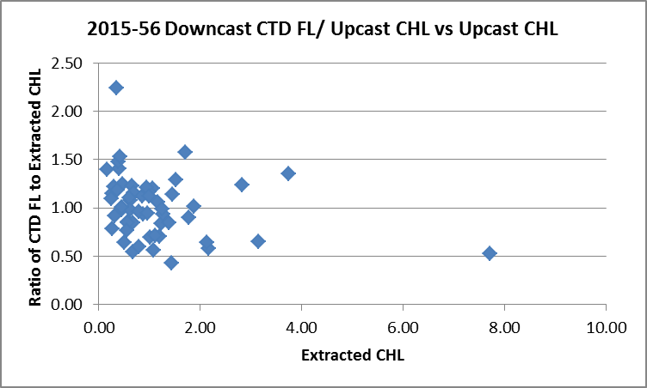

When a trend line is forced through the origin the CTD fluorescence is found to be about 80% of the extracted CHL.

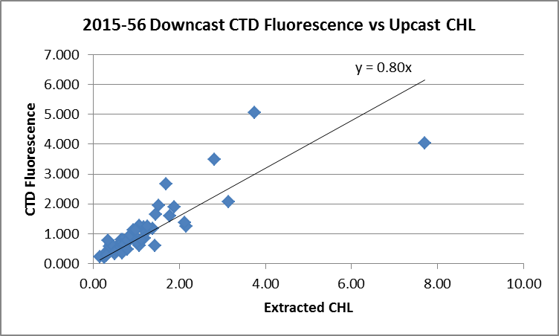

Final CTD File Steps (REMOVE and HEADEDIT)
REMOVE was run on all casts to remove the following channels:
Scan_Number, Temperature:Primary, Salinity:T0:C0, Conductivity:Primary, Conductivity:Secondary, Oxygen:Voltage:SBE, Status:Pump, Descent_Rate and Flag

REMOVE was run on cast #2 to remove the following channels:
Scan_Number, Temperature:Primary, Temperature:Secondary, Salinity:T0:C0, Salinity:T1:C1, Conductivity:Primary, Conductivity:Secondary, Oxygen:Voltage:SBE, Oxygen:Dissolved:SBE, Fluorescence:URU:Seapoint, Status:Pump, Descent_Rate and Flag

Profile plots were produced at this point to check for errors. No problems were found.
T-S plots were produced; there are some very small unstable features that likely reflect real conditions.

A second SBE DO channel (with umol/kg units) was added.
REORDER was run to get the two DO channels together.

HEADER EDIT was used to fix formats and channel names and two header entries and to add the following comments:

Data Processing Notes:
----------------------
Fluorescence, Dissolved Oxygen and pH data are nominal and unedited except that
some records were removed in editing temperature and salinity.

There was no calibration sampling for salinity or dissolved oxygen for this cruise
or from previous cruises using these sensors since the pre-cruise factory
calibration was done. Post-cruise calibrations were used in converting
temperature, conductivity and dissolved oxygen.

WARNING: The pH:SBE:Nominal data should be used with caution; no field
calibration data were available. Calibration is required for each cast
to get absolute values, although general trends within a cast are likely real.

For details on the processing see the report: 2015-56_Processing_Report.doc.

The same process was followed for the upcast files with the following message:
SPECIAL WARNING:
All data in this file are considered nominal. They come from the upcast portion
of the cast. Upcast data are of lower quality due to effects from the CTD,
Niskin bottle and cable carrying deeper water with them as they rise. The data
have not been through a graphical editor. The data are provided because the
acquisition of CTD data started late so there are no near-surface data in the
regular CTD files.

The pH:SBE:Nominal data should be used with caution; no field calibration data were
available. Calibration is required for each cast to get absolute values,
although general trends within a cast are likely real.

THE DATA IN THIS FILE COME FROM THE UPCAST PORTION OF THE CAST.
THE FILES WTIH EVENT NUMBERS 9038, 9071, 9340, 9372, 9380, 9391, 9434 and 9459
ARE FROM THE UPCAST WHILE FILES WITH EVENT #s 38, 71, 340, 372, 380, 391, 434
AND 459 ARE FROM THE DOWNCAST.

For details on the processing see the report: 2015-56_Processing_Report.doc.

The cross-reference list was produced and no problems were found.
The Standards Check routine was run and no problems were found.
The Header Check was run and no problems were found.
The final files were named CTD.
Profile plots were made and look ok.
The track plot looks ok.
The sensor history files were updated.

Dissolved Oxygen Surface Saturation
Dissolved Oxygen saturation was derived and plotted. The surface saturations varied from 50% to 150% which not surprising from a cruise that visited open ocean, narrow channels, tidally-mixed channels and areas near aquaculture farms. We expect values close to 100% in open ocean waters and the values found offshore of the west coast were between 96% and 102%. These values suggest that the dissolved oxygen sensor calibration is possibly slightly low, but reasonable.

Upcast files for casts with no data above 10db
For events #38, 71, 340, 372, 380, 391, 398, 434 and 459 the upcast DELREV files were filtered, bin-averaged and put through Remove and Edit Headers including adding a note about how they were prepared. They were renamed with a leading 9 in the event number. These files have not been through a graphical editor and the quality of upcast data is lower than downcast, but they are the only source of near-surface data. The event numbers within the files were changed to include a leading 9 as an extra warning.

As an example of how upcast and downcast compare see the profile and T-S plots below with upcast data in red and the corresponding downcast in blue.
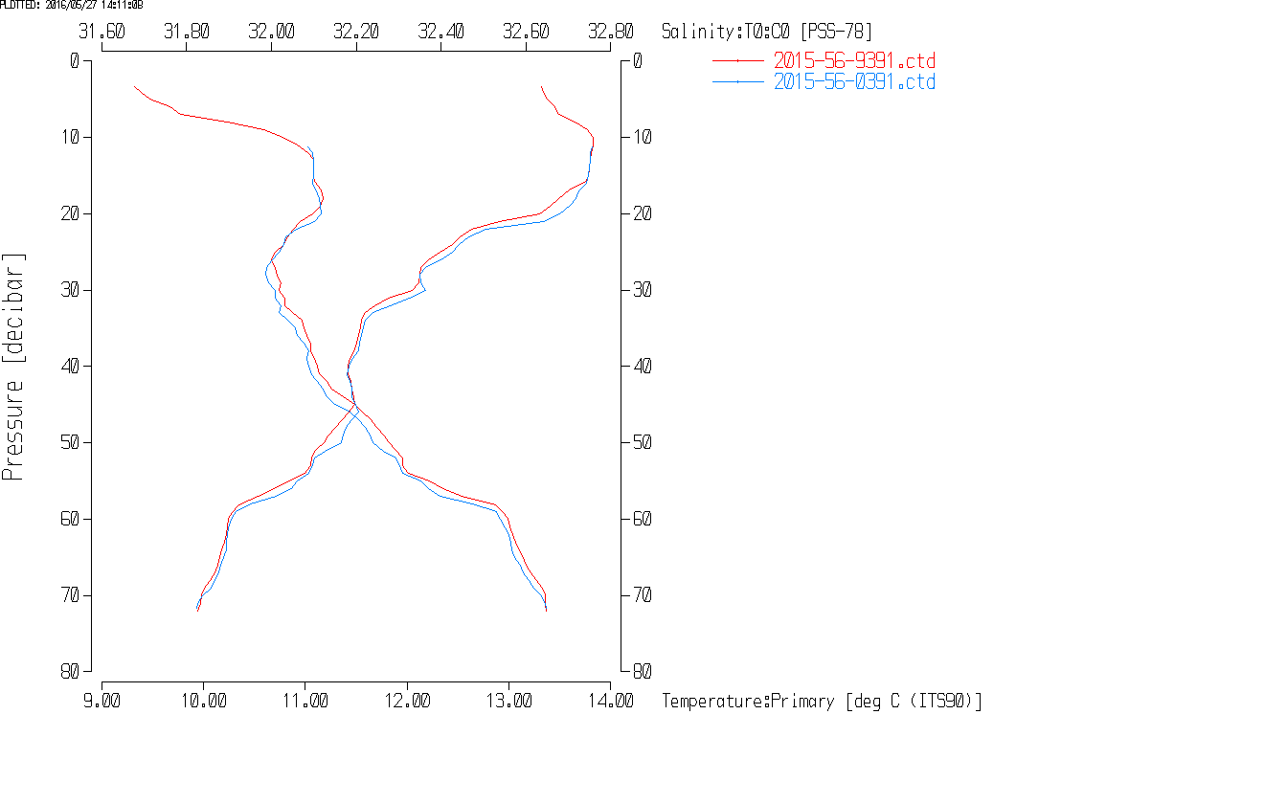
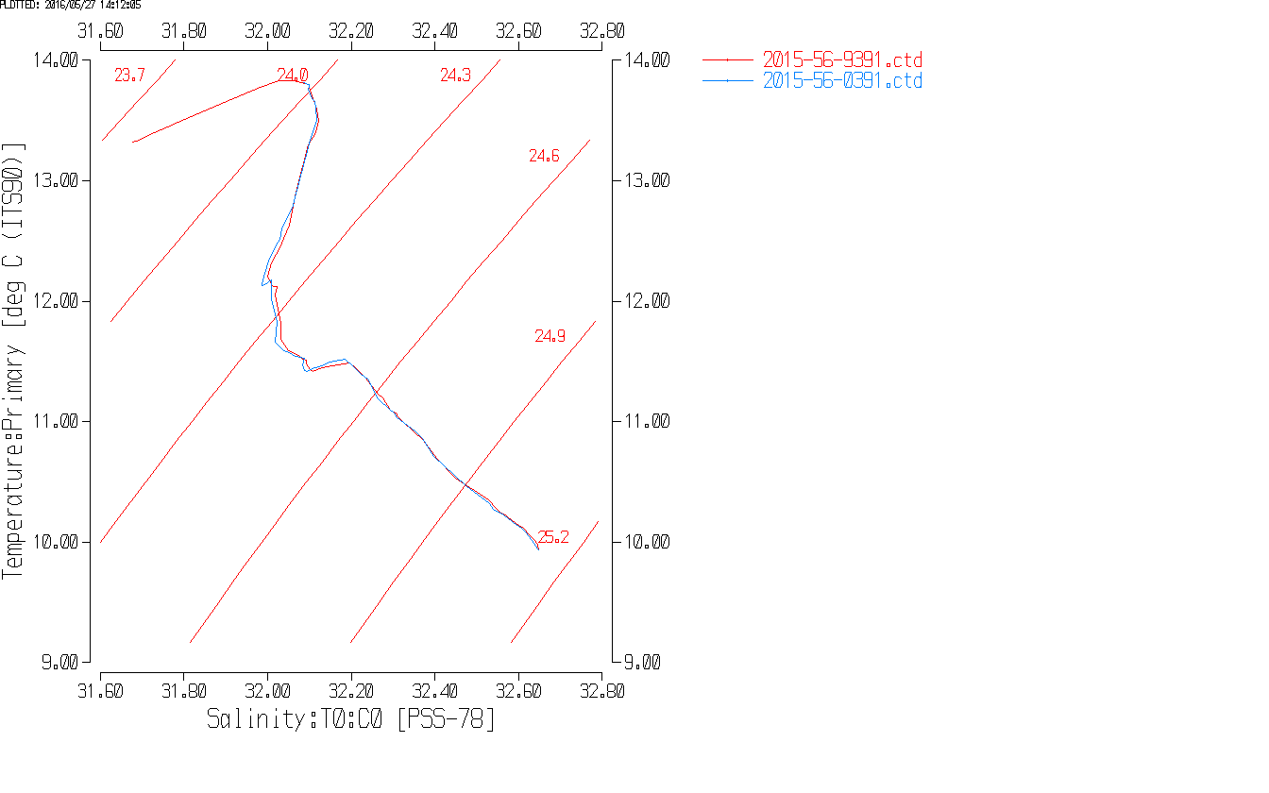

Thermosalinograph Data
There were no loop samples.

a.) Checking calibrations
The configuration files were all the same and all parameters were correct. One was saved as 2015-56-tsg.xmlcon

b.) Conversion of Files
There were 64 HEX files available.
The HEX files were converted to CNV files using the configuration file above.
They were then converted to IOS HEADER format.
CLEAN was run to add End times and Longitude and Latitude minima and maxima to the headers.
ADD TIME CHANNEL was used to add Time and Date channels. (*.ATC)

c.) Checking Time Channel
The CTD files were thinned to reduce the files to a single point from the downcast at or within 0.5db of 3 or 4db. The data were exported to spreadsheet 2015-46-TSG-CTD-comp.xlsx. The loop intake is at 3db. Where there are no data from 3db, the 4db values were used.

Program COMBINE was used to create a single file from the ATC files. That combined file was opened in EXCEL. The median and standard deviations were calculated over a 2-minute window (5 records) and saved. Then the file was reduced to the 64 times when there were CTD casts that overlapped with a TSG record. The resulting data were then added to file 2015-56-ctd-tsg-comp.xlsx.

The differences in latitude and longitude between the CTD casts and the TSG record when times were matched had average differences that were <0.0001°, and all but one difference was <0.0004°. The one case with larger differences was one during which there was obvious ship movement through the CTD cast. So the clock appears to have worked well and the matches made to construct the files were done correctly. There is always some drift through the stops so a perfect match is not expected.

d.) Comparison of T and S from TSG and CTD data
There were 60 casts that overlapped with TSG data. The biggest problem is that there were almost no data from 3db. Where there was a 3db bin, it was usually based on only 1 record. The TSG temperature was higher than the CTD by about 0.08Cº and the salinity was low by about 0.6psu. Given the time of year we expect fairly high near-surface gradients except in some of the areas where there was strong vertical mixing. Unfortunately, the best-mixed casts, judging from CTD plots, were mostly cases where there was no overlap with the TSG. But there are some that are well mixed between 4m and 6m and the differences for those are not notably different.
For details see 2015-56-ctd-tsg-comp.xls.

e.) Calibration History
The temperature and conductivity sensors were recalibrated in January 2014. They were used for 3 other Ricker cruises since then, but the only good comparison was from the first of those cruises, 2014-66. The TSG temperature was found to be high by 0.065 and the salinity low by 0.0045 in waters with low near-surface gradients. During 2015-15 the TSG temperature was found to be high by ~0.06 but the comparison with CTD salinity was not useful.
There were other cruises before the latest calibration that also made an estimate of heating in the loop to be on the order of 0.06Cº to 0.2Cº, with most September/October estimates being near the lower end of that range.

f.) Conclusions
1. The TSG clock appears to have worked well.
2. Water is estimated to have warmed in the loop by at least 0.06Cº based on the comparison and history of the TSG on the Ricker. This figure will be used to derive a proxy for intake temperature.
3. The salinity comparison is confusing. It is hard to believe that the calibration could have drifted by as much as 0.56psu. Some of the difference will be due to the mismatch in depth between TSG source water and CTD measurement in the presence of vertical gradients. The temperature differences don’t suggest large gradients, but there is often a sub-surface temperature maximum that could confound interpretation. For a few comparisons that were in fairly well-mixed waters the salinity differences don’t seem very different. Bubbles in the loop water could explain low salinity and there is some evidence for that in the traces with spikes to low values and generally noisy salinity, but those occur only occasionally. However, there may well be smaller bubbles which are not obvious. The differences did appear to be smaller for the first few casts. A note should be added to the headers that salinity appears to be low by about 0.5psu, but that this may vary from cast to cast and may be partly due to a mismatch between the depth from which the CTD and TSG data were gathered. There is insufficient evidence to justify a salinity recalibration.

g.) Editing
The ATC files were opened in CTDEDIT and editing was applied to a few files. There are some cases where there are sections of noisy conductivity and salinity where temperature is varying but in a much smoother way. This could indicate the presence of bubbles in the loop. There could also be minor alignment problems between temperature and conductivity, though it is odd that we don’t see spikes to higher salinity as well. So bubbles are more likely to be the source of the noisy data. Such noisy data is most often seen in Queen Charlotte Strait and off the west coast of Vancouver Island. Editing was applied to some files, while others looked like there were problems but the files were too short to distinguish which data were good and which bad.
Details on editing:
2015-56-0001 – Some records were removed from the beginning of the file where the flow appears to have not yet been turned on.
2015-56-0040 – A few salinity points were removed.
2015-56-0042 – Salinity points were cleaned lightly.
2015-56-0051 – Salinity points that appear bad were removed.
2015-56-0056 – Salinity points that appear bad were removed.
2015-56-0057 – Looks very noisy but too short to determine which (if any) data should be removed.
2015-56-0058 – Looks very noisy but too short to determine which (if any) data should be removed.
2015-56-0059 – A few salinity points were cleaned and a few removed.
2015-56-0064 – There are large spikes in salinity but they match temperature spikes so no editing was applied.

h.) Recalibration
No recalibration was applied to salinity due to lack of information but it is likely too low.
A recalibration will be made to the lab temperature in order to produce a proxy for intake temperature.
First, program ADD CHANNEL was used to create channel Temperature:Lab and set it equal to Temperature:Primary.
Then, file 2015-56-tsg-recal1.ccf was used to subtract 0.06 from Temperature:Primary.

i.) Preparing Final Files
REMOVE was used to remove the following channels from all casts: Scan_Number, Conductivity, Position:New and Flag.

HEADER EDIT was used to add a few header entries, add a comment, change the DATA DESCRIPTION to THERMOSALINOGRAPH and add the depth of sampling to the header and to change channel names to standard names and formats.
The files were saved with extension TOB.

There are station names which indicate the area where files begin. This is not usual for TSG files, but having them in the cross reference file may well be helpful to those searching for a particular area.
A cross-reference file was produced and a Header Check was run. No errors were found.
The TSG sensor history was updated.
As a final check plots were made of the cruise track and it looks fine.
The cruise plot was added to the end of this report.

Particulars from log (CTD)
2. Pumps off.
6. Niskin deployed after CTD cast completed – data archived until Niskin reached sampling depth then turned off.
16. Operator had problem turning pump off at end; started new file just to turn pumps off.
49. Station name needs to be changed from Set 29 to Set 28.
52. Station name needs to be changed from Set 29 to Set 29.
127. CTD stopped every 50m on way down to test wireless Notus sensors.
133. Station GEO1 named SET78 in file header.
136. Edge of Fraser River plume.
185. Associated to Trawl Set 111 (Event #187)
270. Winds gusting >60kts. CTD start delayed after data acquisition started due to winch issue.
296. Strong current. Stopped at 104m on upcast to correct inboard lead.
398. CTD hit bottom.

Institute of Ocean Sciences

CRUISE SUMMARY
CTDs
CTD# | Make | Model | Serial# | Used with Rosette? | CTD Calibration Sheet Competed?
1 | SEABIRD | 911+ | 0550 | No | Yes

Calibration Information CTD #443
Sensor |  | Pre-Cruise |  | Post Cruise
Name | S/N | Date | Location | Date | Location
Temperature | 2374 | 17Dec2014 | Factory | 16Dec2015 | Factory
Conductivity | 2128 | 10Mar2015 | Factory | 16Dec2015 | Factory
Secondary Temp. | 2710 | 23Dec2014 | Factory | 16Dec2015 | Factory
Secondary Cond. | 3184 | 19Dec2014 | Factory | 23Dec2015 | Factory
SBE 43 DO sensor | 1176 | 23Dec2014 | Factory | 19Dec2015 | Factory
Seapoint Fluorometer | 3641
SBE18 pH | 0851 | 4Sept2014 | Factory
Pressure Sensor | 75636 | 17Dec2014 | Factory

CRUISE SUMMARY TSG
Make/Model/Serial#: SEABIRD/21/2488 Cruise ID#: 2015-56

Calibration Information
Sensor |  | Pre-Cruise |  | Post Cruise
Name | S/N | Date | Location | Date | Location
Temperature | 3363 | 28Dec13 | Factory
Conductivity | 3363 | 28Dec13 | Factory

