REVISION NOTICE TABLE
DATE | DESCRIPTION OF REVISION
27 Mar 2025 | Updated channel names & formats in TOB files. G.G.
6 Jan 2016 | CTD and CHE files recalibrated based on post-cruise calibration. See notes in §26

PROCESSING NOTES
Cruise: 2015-46
Agency: Ocean Sciences Division
Location: Strait of Georgia, WCVI, Douglas Channel
Project: WCVI & WCDC Moorings
Party Chief: Johannessen S.
Platform: John P. Tully
Date: July 22, 2015 – August 5, 2015

Processed by: Germaine Gatien
Date of Processing: 14 October 2015 – 4 December 2015
Number of original HEX files: 66 (includes 2 files for 2 casts and 1 test)
Number of CTD files: 64 (2 for 1 cast) Number of bottle casts: 37
Number of TSG hex files: 2 Number of TOB files: 3

INSTRUMENT SUMMARY
SeaBird Model SBE 911+ CTD (#0506) was used for this cruise. It was mounted in a rosette and attached were a Wetlabs CSTAR transmissometer (#1396DR), a SBE 43 DO sensor (#1438), a SeaPoint Fluorometer (#3640), a Biospherical QSP-400 PAR sensor (#4565) and an altimeter (#62354).

A thermosalinograph (Seacat 21 S/N 3363) was mounted with a WetLabs fluorometer (#WS3S-953P), remote temperature sensor and a flow meter.

The data logging computer was #2 and then the Tully CTD laptop.
The data acquisition program was Seasave.
The CTD deck unit was an SBE model 11+, serial number 0508.
The salinometer used at IOS was a Guildline model 8400B Autosal, serial # 68572.
There were 24 10L bottles mounted on an IOS Rosette.

SUMMARY OF QUALITY AND CONCERNS
The Daily Science Log book was generally in good order with many useful comments, but a duplication of some sample numbers occurred because they hadn’t been entered in the Daily Science Log Book for one cast. There were a number of errors in entering the event numbers on the rosette log sheets. This was likely due to a last-minute change of order between activities, but it causes great confusion when some analysts are aware of the change and others are not. The samples that involve some action at sea tend to have the right event numbers, but nutrient and salinity analysts may not be aware of the change. It might be better to leave the event number blank until the cast actually starts; if you forget, analysts would be able to check the log book.

There were many erasures in the Daily Science Log Book and Sampling/Rosette Log sheets. It would be better to draw a line through the original entry and write the correction near it. This would make it easier to resolve discrepancies caused by some records reflecting the original entry and others the corrected entry. If it isn’t clear that there was a change, this can be baffling.

On several occasions the pumps were turned off a few seconds after the last bottle was fired. Since we usually capture data from a 10s window centred on firing time, a wait of at least 5 seconds is required to get the best possible data in the bottle files.

The chief scientist required PAR data from the top 2m even if the pumps were off. So CLEAN was run to replace the pumped channels with pad values where the Pump Status is 0. Before bin-averaging a spreadsheet was prepared with the data from the top 10m and some header information. For the regular metre-averaged CTD files, all records with pumps off were removed.

The Oxygen:Dissolved:SBE data are considered, very roughly, to be:
±1.0 mL/L from 0 to 25db
±0.5 mL/L from 25db to 75db
±0.1 mL/L from 75db to 100db
±0.05 mL/L below 100db

The salinity comparison was very confusing and no recalibration was applied. The sensors need a factory check which may enable an appropriate recalibration later. The comparison with bottles was noisy and there are good reasons to not trust the result, including poor flushing of bottles and occasional shifts in CTD values during upcasts. The comparison results are out of step with the history of these sensors and show an unusually large change in both sensors. The casts were mostly in quiet waters where the flushing of Niskin bottles is likely incomplete and the area is subject to a lot of variability making comparisons less reliable. It would have been helpful to have a full profile of salinity bottles at one of the deeper open water casts.

While there were no duplicate samples, there were usually samples from 2 bottles at the same depth. The average difference in such pairs was ~0.007 below 200db. For cast #26 at about 400m (well off the bottom) the 2 bottles looks like they contain water from about 60m lower and 80m lower. The same result was found using both downcast and upcast CTD data. The bottle stop occurred in an area with a low vertical salinity gradient. Problems in the collection and analysis of samples could account for some problems, but incomplete flushing is likely the main cause of the poor comparison.

The CTD fluorometer values were in good agreement with the extracted CHL overall. Any effect of poor flushing is averaged out as it affects bottles differently depending on whether they are above or below the chlorophyll maximum.

Cast 2015-46-9087.ctd contains data from a shallow cast that was aborted due to a ship problem. A full cast was run at the same station and is saved as 2015-46-0087.ctd. The shallow cast file was archived since the surface profile was clear and may be of some interest in studying variability near the surface.

A thermosalinograph was in use. The system performed well for the first file, but the positions were constant in the second one. Besides the usual TSG HEX files, there were 2 other sources of information. A RAW file contained time and all TSG data except fluorescence, but it also had bad positions and it had gaps when the ship stopped. The SCS file had time and positions but no data. Two separate attempts were made to produce usable TSG files. In the first the RAW file was combined with the SCS data by matching times and produced a file that compared reasonably well with CTD data, but it had no fluorescence data. The second attempt combined the TSG HEX and SCS files matching time; while that resulted in a file with fluorescence, the comparison with CTD values was poor for all variables. Further study showed that the time in the TSG HEX file was unreliable. So the file with no fluorescence had to be used.
TSG Salinity was recalibrated based on the history of the sensor since there was a lot of scatter in the comparison with CTD data. The fluorescence data in file #1 is raw, with volts as units. While a direct comparison was only possible for one CTD cast, it appears that fluorescence in ug/L would be roughly 10 times the raw values.

PROCESSING SUMMARY

Seasave
This step was completed at sea; the raw data files have extension HEX.
The raw files for event #1 in Saanich Inlet were originally missing, but were later found after other files were processed. Event #1was processed using the same method; bottles were fired for testing, but there was no sampling, so no CHE file was produced.
There was one split cast, event #10. The 2nd file contains upcast data only.

Preliminary Steps
The Log Book and rosette log sheets were obtained.
There was no rosette log sheet for event #2. (This was found later.)
Nutrients, extracted chlorophyll, dissolved oxygen and salinity data were obtained in QF spreadsheet format from the analysts.
The cruise summary sheet was completed.
The history of the pressure sensor, conductivity and DO sensors were checked.

The XMLCON files did not change through the cruise. The calibration constants were checked for all instruments and the only correction made was to the date format for the transmissometer.
The corrected file was saved as 2015-46-ctd.xmlcon.

Conversion of Full Files from Raw Data
All hex files were converted using 2015-46-ctd.xmlcon to create CNV files.
A few casts were examined.
Since there was a great interest in the surface data, these files contain a lot of data from the -0.5 to 0.5db range, though the pumps are generally off. It is hard to interpret the data since the pressure may be equilibrating, there may be water in the system that is gradually being replaced and the character of the water within 0.2db of the surface may be very different from that below it. Nonetheless, it is interesting to note that data from 0.2db does appear to be in the water, while 0.1db may not always be. These observations do support that the pressure is well within expected accuracy.

All expected channels are present.
There is a note in the log showing large differences between channels during the last cast. A quick check through the cruise shows differences possibly increasing with time.

The upcast and downcast temperature and conductivity channels track in the usual way, with the upcasts generally noisier and the channel pairs further apart than during downcasts. Dissolved oxygen, fluorescence, PAR, altimetry and transmissivity profiles all look normal. The descent rate was kept high and was mostly steady, but there are some places where it was fairly noisy.

At this point the two files with non-standard names 10/10b and 87/87b were examined to decide what to do with them:
- 10 and 10b – the downcast data are all in 10, so that will be used for the full profile. For the rosette file a join needs to be done. The rosette files will be named as 10 and 9010. After conversion to IOS HEADER format, they will be joined.
- 87 and 87b – 87 is shallow – Examination of the profiles of a few variables shows that they are very different from the 2nd cast and that the near surface and bottom are corrupted by shed wakes, so there is only useful data from about 3m to 13m. Since the ship moved and one profile has a fairly well-mixed surface layer and the other does not, there is little benefit in comparing them. But 87 will be renamed 9087 and 87b will be named 87 and both will be processed. This was not a rosette cast.

An error was found in the event number for the cast at DOUG45. The data file was called 2015-46-0032 at sea, but that event had already been assigned to a GRAB at the same site. The Daily Science log indicates that it is #33 although a number #32 is written above the 33. The event that follows is #34. The rosette log has event #32 entered. Some of the analysts used #33 and some #32. Changes were made so that all data have event #33 for this site.

BOTTLE FILE PREPARATION
The ROS files were created using file 2015-46-ctd.xmlcon.
The ROS files were converted to IOS format.
They were put through CLEAN to create BOT files.
Cast #1 had all bottles fired, but no sampling, so it was just examined to ensure all bottles fired and they did. No further processing will be applied to the bottle file for this event.
A preliminary header check was done and no problems were found. Fluorescence did not go off-scale.

File 2015-46-0010.bot was renamed as 2015-46-0010.bota and 2015-46-9010 was renamed as 2015-46-0010.botb. JOIN was then used to combine them into file 2015-46-0010.bot. that file was opened in Ultraedit to rename the Bottle Numbers for the bottles fired in the 2nd cast. The Niskin bottle numbers were all entered correctly.

Temperature and salinity were plotted for all BOT files to check for significant outliers and none were found. Pump status was plotted because the pumps were off for some data collected in these files. It was found that 8 of the files contained a little data taken while pumps were off. This happened at the end of casts and usually only involved a few records at the end of casts, but it does mean that the usual 10s window used for preparation of the CHE files will include some poor data. Choosing a window that starts earlier has some problems too as it gives less time for equilibration or includes fewer points in the average.

The BOT files were bin-averaged on bottle number and the output was used to create file ADDSAMP.csv. Sample numbers were added to the file based on the rosette log records.

A mistake was made in assigning sample numbers so there is repetition. This likely happened because no numbers had been entered in the Daily Science log book for event #107. The samples from cast 107 were renamed as 9312 to 9335 to avoid confusion. So far no samples have been received from that event, although the salinity analyst was confused by receiving a sample that appeared to be from that cast, but the rosette sheet did not agree. In fact the sample was from event #118.

The addsamp.csv file was converted to CST files, which will form the framework for the bottle files.
SAM files were created using the Add Sample Number routine. Those files were bin averaged on bottle number.

Next, each of the analysis spreadsheets were examined to see what comments the analysts wanted included in the header file. These were used to create file 2015-46-bot-hdr.txt which will be updated as needed during processing.

EXTRACTED CHLOROPHYLL
Extracted chlorophyll and phaeo-pigment data were obtained in file QF2015-46chl*.xls. The file included comments, flags and a precision study. A simplified version of the spreadsheet was prepared in which some columns were removed and the file was saved as 2015-46chl.csv which was then converted to individual CHL files.

DISSOLVED OXGYEN
Dissolved oxygen data were provided in spreadsheet QF2015-46oxy.xls which includes flags, comments and a precision study. Draw temperatures are available. The spreadsheet page with the final data was simplified and the file was then saved as 2015-46oxy.csv.
That file was converted into individual *.OXY files.

SALINITY
Salinity analysis was obtained in 2015-46SAL.xls. The analysis was done within 57-62 days of collection. The files were simplified and saved as 2015-46sal.csv. That file was then converted to individual SAL files.

NUTRIENTS
The nutrient data were obtained in spreadsheet QF2015-46nuts.xls.
Then the file was simplified, reordered on sample numbers and saved as 2015-46-nuts.csv. The file was converted to individual NUT files.

The SAL, CHL, OXY and NUT files were merged with CST files in 4 steps.
After the 4th step the files were put through CLEAN to reduce the headers to File and Comment sections only.
The merged files are ordered on sample number, but the SAMAVG files are ordered on bottle number, so one or the other set needs to be reordered in order to merge them. The MRGCLN1 files were reordered on Bottle_Number. The output files were named MRGCLN1s. Those files were then merged with SAMAVG files choosing the Bottle_Number from the SAMAVG files.
CLEAN was run on the MRG files to add 0 flags to empty flag channels and to update header limits. (MRGCLN2)

The output of the MRG files were exported to a spreadsheet and compared to the rosette log sheets to look for omissions. There were a few discrepancies:
- Event #10 -CHL was missing because it was identified as #9 in the spreadsheet.
In many cases there are erasures in the log books. It would be far better to draw a line through the error and enter the correction (in most cases there is room to do this); in this way when discrepancies occur it would be clearer which is correct.
- File #13 should be #12. There were no samples for this file.
- Event #25 should be 26 (DO spreadsheet only)
- Event #32 should be 33 (SAL and NUTS spreadsheets only)
- Event #40 should be 43 (SAL/DO/NUTS spreadsheets)
- Event 74 should be 73 (CHL only)
- Event 107 – these sample numbers were used in the following 4 casts. Since there was little or no sampling for IOS at #107, those sample numbers were renamed with a leading 9, so 9312 to 9335.
- Sample #312 salinity was entered for event #107, should be #118.
After the fixes the merge process was rerun and no further problems were found.

Compare
Salinity
Compare was run with pressure as reference channel.

There is a very large of scatter in the comparisons. Both salinity channels look very low compared to bottles. Outliers were removed based on standard deviation in the CTD salinity being >0.0015, differences >0.4 and pressures <140db. One other point was excluded because it looked clearly out of line and was a bottom bottle where this is not uncommon. To ensure the pressure distribution was the same for both sensor pairs, 2 points were removed from the primary comparison because they had been removed from the secondary. They did not affect the primary fit much since the average of the 2 points was very close to the average of what remains. After these exclusions the primary was found to be low by 0.0109 and the secondary low by 0.0166. The standard deviations were 0.008 and 0.007. The difference between them is about 0.006.

Another fit was done by excluding data above 140db and bottom bottles which often read low compared to the CTD since flushing tends to be a problem at the bottom, but the error that causes has the opposite sign to poor flushing elsewhere. The CTD does look lower using that fit, with the primary low by 0.0124 and the secondary by 0.0182. The standard deviations in the fits and the difference between sensors look very close to the first fits.

A fit was done with all data below 120db except for one outlier. The primary was found to be low by 0.0107 and the secondary by 0.0168 with standard deviations in the fit of 0.007 and 0.006.

While there were no duplicates there were 37 cases of pairs of bottles fired at the same depth. Comparison of the pairs indicates an average difference between them of 0.086, but when pairs from above 40m are excluded that falls to 0.0063 (18 pairs) and the deepest pair differed by only 0.0015.

One example studied was for event #26 at 401.8db. The bottle values are 33.2817 and 33.2877. The primary CTD salinity was 33.2740 at 401.8db; there was a problem with the CTD data above 400db but it did not appear to be an issue during this stop. To match the bottle values we have to look at 463db and 483db for the upcast data. Using downcast data we get 462db and 486db. The upcast and downcast are very similar. The local gradients are not very high. So we can’t account for the differences as being due to local variability. The only explanations are poor flushing, analysis problems or sampling problems.

During other recent cruises the differences between sensors and bottle and between pairs of sensors were much smaller. Possible explanations were examined.
- Poor flushing
Poor flushing is not unexpected as most casts were in quiet waters in inlets so that Niskin bottles might not flush well. However, when the casts with the noisiest descent rates were examined (10, 21 and 150) and 2 others that are fairly noisy (23 and 118), there still seem to be large negative differences in both sensors. A closer look shows that of the 5 casts where flushing is likely reasonably good, only cast #10 had low enough standard deviations in the salinity channel to expect reasonable results. And that cast was shallow enough that even the normal degree of flushing inefficiency might lead to large errors due to higher vertical gradients. At the bottom of cast #10 the salinity in the bottle is higher than the maximum salinity values measured by the CTD during the cast. If flushing were a problem at the bottom, we would expect the Niskin to contain lower salinity water, not higher. This suggests a problem in analysis or collection for that bottle.
- Sampling problems
These samples were analyzed within 10 to 33 days so we don’t expect a lot of evaporation or adsorption. The samples from the later casts were done promptly. Unfortunately, cast #10 waited a little over a month. That could lead to a small increase in salinity, but it is unlikely to be more than 0.002 unless the seals were poor. The analyst noted 3 bottles with salt crystals or loose caps and 2 overfilled bottles.
- Salinometer problems
The analyst noted 3 cases of unstable readings even after more rinsing and extra readings.
- Sensor drift
It is unusual to get both sensor pairs to change suddenly and by a large amount in a short time. These sensor pairs have been within 0.002 of each other in the previous 4 uses. For the most recent they were very close to each other but the comparison was noisy, analysis was delayed and flushing was an issue. For the most reliable comparison, 2015-09, the primary was high by about 0.0005 and the secondary low by about 0.0015. That comparison included many deep bottles and there is usually some pressure dependence in the differences between sensors either because of minor alignment problems being more significant in shallower waters or because of some pressure dependence in the drift itself. To compare with 2015-46 it would be better to pick only the bottles between 100db and 550db. There are only 8 of those during 2015-09 (all from 1 cast) and for 3 of those the standard deviation in the CTD salinity was high. Based on just the 5 that remain the primary was very close to bottles and the secondary low by about 0.002 for 2015-09.
- Other sensor problems
The standard deviations in the CTD salinity channels are no higher than seen during 2015-20 at the same depths. The differences between the two channels are larger than has been noted in other recent cruises, which included cruises in open waters and others in more protected areas. An initial check of differences between channels shows that these are variable with sudden changes associated with sudden shifts in a salinity channel, but examples were found of both shifting, so this is not a simple matter. During cast #23 the differences during the downcast were 0.007 and after a shift in the secondary salinity at the bottom it was ~0.014 for the upcast. It is not unusual to have the differences between channels change between downcast and upcast, perhaps because of the alignment of the CTD being slightly different or the effects of upcast wakes on flow rates, but sudden shifts above the bottom are not usually seen. For cast #26 there was a shift in the secondary followed by a larger one in the primary salinity. For cast #118 there was a bad section in both channels near the surface. These seem like flow problems.

So the problems noted here most likely come from a combination of poor flushing of Niskin bottles and erratic flow to the conductivity sensors. There may also be some sensor drift and problems with samples and analysis. Further study of this problem will be made when the full files have been processed further.

There are no major outliers that appear to be due to bottle sampling or analysis problems. The largest outliers are near the surface where variability is high. No further flags are suggested.

For full details for the COMPARE run see file 2015-46-sal-comp1.xls.

Dissolved Oxygen
COMPARE was run with pressure as the reference channel.
There is a lot of scatter in the fit. This is not unexpected given there is likely to be inefficient flushing of Niskin bottles in inlets and in the presence of high DO gradients leading to low bottle values. Calibration drift generally leads to CTD values being lower than bottle values, so the flushing effect is to bring the CTD close to bottles or even higher than bottles. Usually the effect is worst just below the surface, but for Effingham Inlet the DO gradients can be extremely high just above the hypoxic bottom waters seen at some sites.

- Most of the significant outliers are from around 10 and 20db, where there is likely poor flushing of Niskin bottles in the presence of high DO gradients. There were 2 outliers that come from just above the hypoxic layer. There are 2 that were investigated further:
    - Sample #321 Event 135 at the bottom, 31m. High DO gradient plus slightly poor flushing can account for the difference. No flag is justified.
    - Sample #325 Event #136 at 65m – The bottle sample (0.505mL/L) is flagged 3 due to a large particle in the sample and the analyst thought the value was probably too high. The CTD DO is very low (<0.1mL/L) for this bottle and for the one above it. This is an area where hypoxia is likely so the particle might be the problem, but poor flushing could also lead to the bottle looking high because this was a bottom bottle. Leaving the flag at 3 is reasonable.
- Sample #327 Event #136 at 30m – The CTD is higher than the bottle, but this is just above the hypoxic layer in a large vertical DO gradient, so even very slight inefficiency in flushing can explain this. No flag justified as there is no evidence of an analysis problem.
- Sample #334, Event 137 at 50m. The CTD is higher than the bottle but is just above the hypoxic layer, in an area of high variability. The standard deviation in the CTD data is high and only a slight mismatch in depths could lead to the difference. No flag needed.

When a few significant outliers are excluded and then others removed based on residuals, the fit is:
CTD DO Corrected = CTD DO * 1.02 +0.0295 (R² = 0.61) *
When last used (2015-18) the fit for this sensor was
CTD DO Corrected = CTD DO * 1.0234 +0.0260 (R² = 0.78)
so fit * is within the range expected.

There were casts in 4 quite different areas. The first was a single cast in the Strait of Georgia, but 10 out of 12 bottles fell in a narrow range of DO values and 3 bottles are outliers. The slope is not far different than that found for all casts, but it is very difficult to justify making a fit at all. Casts from the other 3 areas were examined separately.
- Douglas Channel excluding data from 10db, 20db and 1 other outlier. The fit looks pretty good but is overly dependent on a few surface values.
CTD DO Corrected = CTD DO * 1.0244 +0.0151 (R² = 0.41)
- Effingham Inlet is well known to be difficult when it comes to DO calibration due to hypoxia, high DO vertical gradients and poor flushing.
CTD DO Corrected = CTD DO * 1.0471 +0.0738 (R² = 0.13)
- Open ocean or casts in areas fairly exposed are likely to have better flushing (10, 21, 23, 150).
CTD DO Corrected = CTD DO * 1.0214 +0.0366 (R² = 0.93)
There is only 1 sample with DO < 2mg/L, so the offset is questionable. Setting the offset to 0 produces a bad result with a high slope and low R². When the offset is forced to match that found for 2015-18 the fit is:
CTD DO Corrected = CTD DO * 1.0239 +0.0260 (R² = 0.91)
That fit has a slope remarkably close to that of cruise 2015-18.
If the offset from Effingham Inlet is used with the data from the 4 offshore casts the fit is:
CTD DO Corrected = CTD DO * 1.0231 +0.0295 (R² = 0.92)

The open ocean casts are the most reliable and fall reasonably close to the full set, no doubt because much of the Effingham Inlet and Douglas Channel data were rejected in the fit. However, Effingham Inlet provides comparisons with low DO, so that offset is likely more reliable; the DO gradient is quite low where those bottles were fired so flushing is not a big issue. So using the open ocean data with the Effingham offset looks like the best choice.
For more detail see document 2015-46-dox-comp1.xlsx.

Plots of Titrated DO and CTD DO against CTD salinity were examined. No further outliers were found.

Fluorescence
COMPARE was run with extracted chlorophyll and CTD Fluorescence using pressure as the reference variable. The CTD fluorometer was a SeaPoint sensor. CHL values range from 0.3ug/L to 4.4ug/L. As usual we see fluorescence reading higher than CHL for low CHL. The ratio falls off as CHL rises, with the lowest ratio being 0.6. A fit of FL vs CHL has a slope of 1.01. Since the high CHL values coincide with high vertical gradients, the effect of poor flushing is that CHL may be lower than FL below the CHL maximum which was usually fairly shallow; above the CHL maximum the opposite is likely to be true.
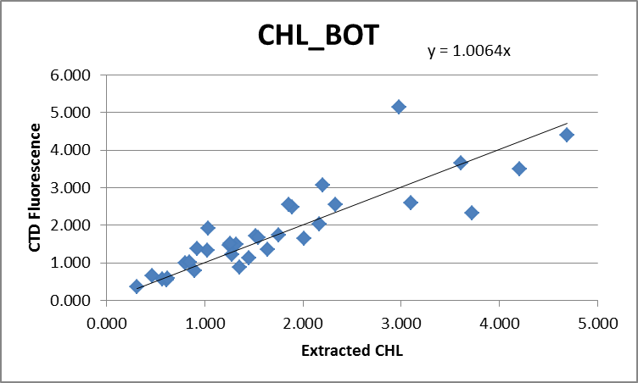

For full details of the comparison see file 2015-46-fl-chl-comp1.xlsx.

WILDEDIT
Program WILDEDIT was run to remove spikes from the pressure, conductivity & temperature only in the full cast files (*.CNV).
Parameters used were: Pass 1 Std Dev = 2 Pass 2 Std Dev = 5 Points per block = 50
The parameter “Keep data within this distance of the mean” was set to 0 so all spikes would be removed.

ALIGN DO
Tests were using a variety of settings for aligning the DO single with temperature. The best results were with +3s, the setting that has been used for the past few cruises using this sensor. ALIGNCTD was run on all casts using +3s.

CELLTM
The noise in the upcast makes the tests for the best parameters for this routine very difficult to interpret. Tests on previous cruises using these sensors showed the default setting of (α = 0.0245, β=9.5) did the best job and it does improve the data for both conductivity channels for these data.
CELLTM was run using (α = 0.0245, β=9.5) for both the primary and secondary conductivity.

DERIVE and Channel Comparisons
Program DERIVE was run on all casts to calculate primary and secondary salinity and dissolved oxygen concentration.
DERIVE was run a second time on all casts to examine differences between sensor pairs, to enable some tracing of salinity problems.

Differences from some of the deeper casts are entered in the table below. While none are very deep, it does allow us to check for sudden changes. Differences from earlier cruises using the same equipment are also shown with dark shading.

Cast # | Press | T1-T0 | C1-C0 | S1-S0 | Descent Rate
2015-03-0017 | 600 | +0.0001 | +0.0000 | +0.0004 | Moderate, steady
2015-17-0058 | 325 | +0.0008 | +0.0001 | -0.0001 | High, Steady
2015-20-0042 | 600 | -0.0018 | -0.0001 | +0.0006 XN | High, X Noisy
 | 1000 | -0.0010 | -0.0001 | +0.0004 N | “
2015-20-0078 | 600 | -0.0015 | -0.0001 | +0.0009 | High, Noisy
 | 1000 | -0.0011 | -0.0001 | -0.0003 | “
2015-20-0111 | 1000 | -0.0007 | 0 | +0.0010 | High, Noisy
2015-09-0018 | 1000 | -0.0009 | -0.0001 | -0.0006 | High, V.Noisy
2015-09-0104 | 1000 | -0.0007 | -0.0001 | +0.0006 | High, Moderate
2015-18-0008 | 230 | -0.0017 | -0.0010 | +0.0008 | High, Noisy
2015-18-0056 | 345 | -0.0024 | -0.0002 | +0.0002 | F.High, F.Steady
2015-18-0085 | 350 | -0.0025 | -0.0003 | -0.0005 | High, F.Steady
2015-46-0002 | 250 | -0.0008 | -0.0005 | -0.0046 | High, V. Steady
 | 300 | -0.0008 | -0.0005 | -0.0045
2015-46-0023 | 250 | -0.0014 | -0.0007 | -0.0062 | High, Steady
 | 350 | -0.0014 | -0.0007 | -0.0068
2015-46-0026 | 250 | -0.0015 | -0.0007 | -0.0065 | High, V.Steady
 | 300 | -0.0014N | -0.0007 | -0.0066
 | 350 | -0.0013 | -0.0007 | -0.0068
 | 500 | -0.0009 | -0.0007 | -0.0072
2014-46-0027 | 250 | -0.0012 | -0.0017 | -0.0174 | F.High, V.Steady
 | 350 | -0.0010 | -0.0016 | -0.0167
 | 500 | -0.0009 N | -0.0016 | -0.0170
2015-46-0030 | 250 | -0.0016 | -0.0008 | -0.0069 | High, V.Steady
 | 350 | -0.0014 | -0.0008 | -0.0072
 | 500 | -0.0011 | -0.0008 | -0.0076
2015-46-0093 | 250 | -0.0026 | -0.0007 | -0.0052 | High, Steady
 | 350 | -0.0022N | -0.0007 | -0.0055
2015-46-0116 | 250 | -0.0036VN | -0.0008N | -0.0055 | High, Noisy
 | 300 | -0.0028 | -0.0008 | -0.0059
 | 350 | -0.0025 | -0.0008 | -0.0060
2015-46-0150 | 250 | -0.0028 | -0.0010 | -0.0086 | High, Noisy
 | 350 | -0.0014 | -0.0009 | -0.0088
 | 500 | ~ -0.004XN | -0.0010VN | -0.0087
The current cruise includes many local reversals that may account for some very noisy differences despite descent rates that are either steady or just slightly noisy. These data have not had conductivity aligned, which may account for some of the differences in that channel and in salinity. The temperature differences are similar to those seen during the previous cruise, but with more variability. Conductivity differences are higher than from other recent cruises and the salinity differences are much higher.

To see if the temperature differences are affected by the local vertical temperature gradient, an estimate was made of the variation in a 20m window around 350m. The lowest variability was for the 2 casts with the largest temperature differences and lowest salinity differences, but cast #23 with smaller temperature differences looks quite different, so local gradients probably don’t explain the pattern. The highest gradient was from cast #150. Transmissivity values fell at the bottom of casts, enough to suggest the CTD was near bottom but not enough to suggest a touch-down.
Further investigation will be made after the conductivity channels are aligned.

Conversion to IOS Header Format
The IOSSHELL routine was used to convert SEA-Bird 911+ CNV files to IOS Headers.
CLEAN was run to add event numbers and to replace pad values in the pressure channel with interpolated values based on record number.

Checking Headers
A cross-reference list was checked against the log book. There were many discrepancies in station names between the log and header, or in some cases both entries had slightly different formats such as punctuation marks or an addition to show what activities were carried out. The station name is meant to be used to just indicate a site. The entries were changed in the CLN files and the MRG files.

An initial header check was run. There are clearly some spikes in temperature and conductivity, and hence salinity and dissolved oxygen.

The cruise track was plotted and added to the end of this report. A blow-up of the Douglas Channel stations was added since it is hard to see this area on the full map.

Surface check was run and shows an average surface pressure for the cruise was 0.6db. That value is unusually low because the CTD was started with pumps off right at the surface. Checking a few casts it looks as though the pressure was sometimes slightly negative with “in-water” values, but the pressure sensor may not have had time to equilibrate. For cast #8 the conductivity first appears to have “in-water” values at pressure about 0.1db. There were 2 deck pressure readings of 0.8db noted during events #1 and #13. This would suggest we should subtract 0.8db from all readings. This is out of step with the CTD observations, and another deck reading during cast #145 of 0.115db. During cast #91 the CTD was left running after the cast and the pressure readings varied from 0 to ~+ 0.1db. As has been noted in the past, the deck readings vary a lot and do not seem a reliable way to calibrate pressure unless you have many readings and they are reasonably consistent. There is no justification for changing the pressure offset.

Header entries of bottom depth and altimeter values at the bottom of the cast were exported to spreadsheets for the full files and for the bottle files. The bottom depths were checked against the log book. There were many discrepancies. The entries in the log book had obviously been changed in many cases likely because of rapid variations as the ship drifted slightly. A few checks suggest that the changes made in the log book were the best choice to reflect conditions when the CTD was at the bottom. So the headers were adjusted using the log entries.

Altimetry was checked for a selection of casts using plots of altimetry versus pressure. There were frequent spikes at the bottom but the algorithm worked well except for event #26 which had a reading of 15db, though the CTD clearly got closer. A reasonable estimate could be made since there was a clear signal 10m above the bottom. An estimate was entered along with a comment.

Shift
Fluorescence
SHIFT was run on the SeaPoint fluorescence channel in all casts using the usual advance of +24 records. Examination of plots after this step shows that the fluorescence offset is reasonably close to the temperature offset.

Dissolved Oxygen
The Dissolved Oxygen voltage channel was aligned earlier. A few casts were checked to see if the alignment looked ok, and as usual, there is a lot of variability with the up and downcast traces sometimes closer than temperature and sometimes further apart. This is likely due to varying vertical gradients. Where there are distinct features in T and DO profiles, they line up well. Overall the choice made earlier looks appropriate, so no further alignment will be applied.

Removal of pumped channels from surface records
The chief scientist wants transmissivity data from the top 2m when the pumps were off. So CLEAN was run to replace the pumped channels with pad values where the Pump Status is 0. This requires 6 separate runs for all pumped channels, 2 Temperature, 2 Conductivity, 1 Fluorescence and 1 Dissolved Oxygen. By doing this before running the conductivity alignment, there is no need to do runs for salinity as it will be recalculated in the next step. The pressure, PAR and transmissivity channels will not be affected. In theory this step could be done later, but it would be very awkward to edit the surface data. It would require display of pump status in an already crowded editing screen. Having pad values in T and S alerts the editor as to when the pumps came on, so none of the “pumps off” PAR and transmissivity data will be removed. Just before bin-averaging the surface data will be extracted to a spreadsheet and then all records with pumps off will be removed.

Conductivity
Tests were run on a few casts to see if the shifts used for the previous cruise suit these data and they did.
SHIFT was run on all casts using -0.9 records for the primary conductivity and +1.1 records for the secondary conductivity. Salinity was recalculated.

Salinity Channel Investigation
At this point a further study was made of the salinity channels to see whether one is a better choice than the other for archiving, or whether this had to be a cast by cast choice. Further, how should either channel be recalibrated?

The conclusion from §5 was that there were likely cases of poor flushing of Niskin bottles and erratic flow to the conductivity sensors. There may also be some sensor drift and problems with samples and analysis.

There are clearly some problems with the salinity. In§5 it was found that the primary salinity was higher than the secondary by between 0.005 and 0.009. No pattern was found to relate the variations to the following: descent rate of the CTD (a measure of sea state), whether casts were in open water or inlets, standard deviation in the CTD salinity ( a measure of local variability), transmissivity (to see if the CTD touched bottom), depth of sample (pressure dependence) and sample flags (only 2 were involved and COMPARE results don’t suggest a problem with either.)

Looking at data collected during bottle stops 2 patterns emerged:
- A table was produced including the differences between the 2 CTD salinity channels, the standard deviation in the primary salinity, pressure and the file pair number. Cases were removed if the standard deviation in the primary salinity being >0.0008. They were then sorted on the difference between the CTD channels. The 8 lowest came from a single cast, #26; that did not include the 2 deepest bottles from that cast. But in section 9 we saw that the downcast differences were not out of line, so this must be due to the odd shifts that happened during the upcast of #26.
- We only have 4 casts included in the comparison, but of those, the one with the CTD channels looking lowest compared to bottles is #26.
So cast #26 upcast is odd. Are other casts affected by smaller shifts? The fact that salinity pairs are closer together when both are farthest from bottles may be a coincidence; we don’t have enough data to say much about this except that it is suggestive of a problem other than calibration drift.

Some downcasts were examined in detail:
- Cast #2 has differences between sensors only slightly higher than seen in recent cruises.
- Cast #12 is shallow, has high vertical gradients and a noisy descent rate, so it is hard to judge, but the secondary salinity looks odd. In T-S space it looks more unstable. In profile it looks as though it is responding slowly. Primary is better.
- Cast #19 is shallow, but looks much like cast #2, but the differences look a little higher.
- Casts #20-22 have salinity difference like many casts that follow, but no significant shifts on upcasts.
- Cast #23 has the secondary salinity shift to lower values ~5m above the bottom, it bounces back briefly at the end of the bottom stop, but then resumes lower values and stays low throughout the upcast. Small spikes in transmissivity line up with spikes in salinity. The primary traces are more stable in T-S and upcast and downcast traces are closer in T-S than secondary.
- Cast #26 has a very odd upcast with a sudden shift in both salinity channels, but that in the primary is much larger. The primary gradually moves back towards its normal position with a fairly sudden shift at the end of the 300m bottle, but still appears to be shifting upwards after that. The upcast and downcast traces are significantly different in T-S space for both channels. For the primary it looks like some sort of blockage in the flow that gradually clears.
- Cast #27 has a large difference between salinity channels both down and up.
- Cast #30 has a difference of ~0.007 at the bottom of the downcast but then shifts to ~0.0016 for the upcast; the change is due to a shift in the secondary salinity.
- Cast #33 has a similar shift to that of #30 but it starts at 345db during the upcast; this one is also due to a shift in the secondary salinity. The upcast and downcast traces are closer in T-S space for the primary than the secondary.
- Cast #34 looks the almost the same up as down. Other casts checked from this point onwards have similar up and downcasts until cast #150.
- Cast #150. The primary channels have a slightly smoother T-S curve than the secondary even after alignment. However, in T-S space the secondary has downcast and upcast much closer than for primary. The differences are a little larger on the upcasts.
- It would be good to examine a cast from the offshore area with a full profile of bottles, but there is no such cast. Cast #26 was the most exposed cast that had a full profile of bottles, so that was examined. The differences continue to decrease from top to bottom, with the deepest bottles reading low by 0.006 and 0.0075, but if there is poor flushing near the bottom the bottle salinity may be a little low. At 400m the CTD is lower than the 2 bottles by 0.0077 and 0.0137. There were problems with both salinity channels during the upcast for #26, so another check was made by comparing with downcast data. This should be done by matching sigma-T rather than pressure. So sigma-T was derived and a rough check was made of how downcast and upcast CTD salinity matched on sigma-T surfaces. The differences were very similar to those found between bottles and upcast CTD salinity for 500db and 400db. Above that the bottle values are a little closer to the downcast than the upcast. The salinity gradient is fairly high above 400m. The comparison of the two 400m bottles is the same using upcast or downcast, so the 2nd bottle is likely unreliable. This is slight evidence that the primary salinity may be low by ~0.007.
 | Upcast CTD | Downcast CTD
Pressure | from bottle files | matching sigma-T
Bottle | Sal0-bot | sal0-bot
501.624 | -0.0075 | -0.0075
501.624 | -0.0060 | -0.0060
401.789 | -0.0077 | -0.0076
401.789 | -0.0137 | -0.0136
300.5 | -0.0259 | -0.0237
300.5 | -0.0189 | -0.0167
200.62 | -0.0216 | -0.0149
200.62 | -0.0233 | -0.0166
150.539 | -0.0192 | -0.0165
150.539 | -0.0166 | -0.0139

There are problems with both sensor pairs having sudden changes in values that do not look real; these are likely due to erratic flow rates to the conductivity cells. Overall, there are more odd features in the secondary salinity than the primary, and few problems in either in the downcasts. So the primary sensors are probably the better choice for archiving.

Recalibration is quite a puzzle as we have only the bottle comparison and the history of the sensor to consider, and those do not agree at all. There are good reasons to doubt the bottle comparison. The difference between conductivity sensor pairs is out of step with the sensor history. There is a history of problems with the secondary pump but those seem to have been fixed after cruise 2015-17. On the previous cruise the two salinity channels were very close but there was a lot of scatter. The comparison considered most reliable showed the primary very close to the bottles and the secondary low by an average of 0.0013. There is no post-cruise calibration available. The only other cruise that has used these sensors in 2015 and has not been processed had no salinity calibration sampling.

There are many sources of variability in all comparisons due to incomplete flushing of Niskin bottles and local variability causing high gradients and real changes between upcasts and downcasts. The difference between the two salinity channels varies, but a median value for the downcasts is about 0.0065. The history of the sensors shows the primary being quite close to bottles. While the difference could be related to flow, that seems unlikely to be such a steady difference.

The safest choice is to not recalibrate the primary salinity. If secondary salinity is chosen for any casts, then adding 0.0065 will bring them into rough alignment. When these sensors are next at the factory we may get a better explanation and have information suitable for recalibration.

DELETE
The following DELETE parameters were used:
Surface Record Removal: Last Press Min
Maximum Surface Pressure (relative): 10.00
Surface Pressure Tolerance: 1.0 Pressure filtered over 15 points
Swells deleted. Warning message if pressure difference of 2.00
Drop rates < 0.30m/s (calculated over 11 points) will be deleted.
Drop rate applies in the range: 10db to 10db less than the maximum pressure
Sample interval = 0.042 seconds. (taken from header)
COMMENTS ON WARNINGS: There were no warnings.

Other Comparisons
Previous experience with these sensors –
Conductivity, pressure and dissolved oxygen sensors were all recalibrated in late 2013 or early 2014. They were used for 1 cast during 2014-19 and all of 2014-50, 2015-01, 2015-03, 2015-17, 2015-20, 2015-09 and 2015-18.
- Both T/C sensor pairs produced salinity within 0.001 of bottles for 2015-20 and 2015-09 while from 2015-18 it appeared that both salinity channels were low by ~0.003, but the comparisons had more scatter than usual. The best comparison was from 2015-09 with many deep casts; it showed the primary to be high by an average of 0.0005 while the secondary was low by 0.0013. Repairs were made to the secondary pump after 2015-17.
- The pressure sensor was found to have drifted lower by about 1.25db during 2014-50 and that offset has been used since then.
- For 2014-50 the dissolved oxygen sensor was corrected using a linear fit of slope 1.0281 since there was too little sampling of waters with low DO values to estimate an offset. For 2015-01 the fit used had a slope of 1.0187 and offset of +0.056mL/L. For 2015-03 the slope was 1.0147 and the offset +0.0647mL/L. The lower slope may be due to incomplete flushing since the sensor drift leads to CTD DO values reading low, but if the samples are from lower in the water column they will generally be reading low too. The secondary pump problem may have affected the fit as well, but it does not appear to have been a large effect. For 2015-17 the comparison had a huge scatter, so the result of 2015-01 was used. For the offshore cruises 2015-20 and 2015-09 the slope/offset values applied were 1.0235/0.0248 and 1.0246/0.0452. For 2015-18 in Juan de Fuca and Strait of Georgia it was 1.0234/0.0260.

Historic ranges – Profile plots were made with 3-standard deviation climatology ranges of T and S superimposed. For many casts there was no local climatology available. For cast #32 the temperature at 50m was at the maximum, the temperature was above the maximum in the top 5db for casts #135-#141 and for cast #150 it was well above the maximum between 300 and 425db. Salinity was a little low above 5m for cast #118, low at the bottom of cast #140 and near the minimum for cast #150 at the depths where the temperature was high. There have been many reports of high temperatures and low salinity in 2014 and 2015, though the high temperatures for event #140 are deeper than reported from other cruises. That may be due to the climatology containing very few observations from station A1. There is no evidence of calibration problems, but the low salinity for cast #118 is likely due to poor flow in the CTD.

Repeat Casts – The only repeat casts were too shallow to assess repeatability.

Post-Cruise Calibration – There were no post-cruise calibrations available.

DETAILED EDITING
The primary T and S channels were selected for editing.
CTDEDIT was used to remove large spikes, remove or clean smaller salinity spikes that appear to be due to instrumental problems and likely to affect the bin-averaged values and records corrupted by shed wakes including some records from near the top and bottom of the casts. All files required some editing.

Initial Recalibration
Pressure will not be recalibrated.
Salinity may be reading low but the evidence is not clear. No recalibration will be applied at this time, but this decision can be revisited after a factory post-cruise report.
The dissolved oxygen data will be recalibrated using the results of §3
CALIBRATE was run using file 2015-46-recal1.ccf to correct the Oxygen:Dissolved:SBE channel in the SAM and MRGCLN2 files using:
CTD DO Corrected = CTD DO * 1.0231 +0.0295

COMPARE was rerun for dissolved oxygen using the recalibrated values. The results confirm that the recalibration was applied properly.
See file 2015-46-DO-comp2.xlsx for details.

CALIBRATE was then run on the EDT files.

Final Calibration of DO
The initial recalibration of dissolved oxygen corrects for sensor calibration drift. Alignctd corrects for transit time errors. Those 2 steps may partly correct for response time errors, but to see if a further correction is needed, a comparison is made of downcast CTD data to bottle data from the same pressure. Small differences are always expected due to ship drift, temporal changes, incomplete flushing of Niskin bottles and noise in CTD data. This cruise is especially prone to the flushing and variability problems.

Downcast files were bin-averaged to 0.5m bins for the casts with DO bottle samples. Those files were then thinned and compared to the bottle values in the MRG files. COMPARE was run to study the differences between the downcast CTD DO data and the titrated samples from upcast bottles. The scatter in the comparison is very high especially in the top 100m. The CTD DO is generally higher than bottles which is what we expect if flushing is incomplete as the bottles contain water from deeper in the water column where DO is lower. Below 50m the CTD DO is higher by an average of 0.018mL/L and below 100m it is 0.013mL/L. These differences are most likely due to incomplete flushing and no further calibration of CTD DO is justified.

Fluorescence Processing
A median filter, size 11, was applied to the fluorescence channel in the COR1 files. Plots of a few casts showed that the filter was effective. (Output:*.FIL)

At this stage files were clipped to 10db and data were extracted to spreadsheet 2015-46-surface-data.csv for the chief scientist. These include some header information and all channels to be archived.

BIN AVERAGE of CTD files
The following Bin Average values were applied to the FIL files (output AVG):
Bin channel = pressure Averaging interval = 1.000 Minimum bin value = .000
Average value will be used. Interpolated values are NOT used for empty bins.

On-screen plots were examined. No problems were found.

Final CTD File Steps (REMOVE and HEADEDIT)
REMOVE was run on all casts to remove the following channels:
Scan_Number, Temperature:Secondary, Salinity:T1:C1, Conductivity:Primary, Conductivity:Secondary, Oxygen:Voltage:SBE, Altimeter, Status:Pump, Descent_Rate and Flag.
A second SBE DO channel (with umol/kg units) was added.

REORDER was run to get the two DO channels together.

HEADER EDIT was used to fix formats and channel names and to add the following comments:

Data Processing Notes:
----------------------
Transmissivity, Fluorescence and PAR data are nominal and unedited
except that some records were removed in editing temperature and salinity.

For details on how the transmissivity calibration parameters were calculated
see the document in folder "\cruise_data\documents\transmissivity".

Dissolved oxygen was calibrated using the method described in SeaBird
Application Note #64-2, June 2012 revision.

The Oxygen:Dissolved:SBE data are considered, very roughly, to be:
±1.0 mL/L from 0 to 25db
±0.5 mL/L from 25db to 75db
±0.1 mL/L from 75db to 100db
±0.05 mL/L below 100db

The CTD was lowered without an initial soak at 10m.

For details on the processing see the report: 2015-46-proc.doc.

The following note was added to the header of cast 9087:
NOTE: There were 2 casts at station UC31, one to 16db and one to 36db.
For the full cast see file 2015-46-0087.CTD.

The Standards Check routine was run and no problems were found.
The Header Check was run and no problems were found.
The track plot looks fine.

Dissolved Oxygen Study
As a final check of dissolved oxygen data, % saturation was calculated and plotted. Values were highly variable ranging from 50% to 170%. The lowest values were found in the Hecate Strait area and in some narrow inlets in the Douglas Channel area where the near-surface DO gradients were either low or complex with some reversals. The highest values were in Saanich Inlet, Effingham Inlet and at station A1, areas with fairly high near-surface oxygen gradients. Given the wide range in DO gradients and surface saturation, these observations are not helpful in assessing the DO sensor calibration.

Final Bottle Files
CALIBRATE was run on the MRGCLN2 files and then the MRGCOR1 files were put through SORT to order on increasing pressure.

REMOVE was run on all casts to remove the following channels:
Scan_Number, Temperature:Primary, Salinity:T0:C0, Conductivity:Primary, Conductivity:Secondary, Oxygen:Voltage:SBE, Altimeter, Status:Pump, Descent_Rate and Flag.
A second SBE DO channel was added for both the CTD DO and bottle DO, with mass units and REORDER was run to get the 2 SBE DO channels together.

HEADER EDIT was run to ensure formats and units are correct, change the channel name Bottle_Number to Bottle:Firing_Sequence and the name Bottle:Position to Bottle_Number and to add a comment about quality flags and analysis methods and a few notes about the CTD data processing.

Standards check and a header check were run on all files and no errors were found.

Data from the CHE files were exported to a spreadsheet and compared with rosette sheets. There were two discrepancies:
- The rosette sheet for event #93 shows that salinity samples were to be taken from every bottle, but only every other bottle was sampled according to the salinity analysis spreadsheet. This was likely a last-minute decision, but there is no note about this on the rosette sheet or the Daily Science Log Book.
- Sample #409 of event #148 is marked as a duplicate on the rosette sheet, but the oxygen analysis file shows the duplicate was sample #408. Comparing values shows they really are duplicates, not a mislabelling.
The spreadsheet was saved as 2015-46-bottles_final.xlsx.

Plots of each file were examined. Cast #118 which was noted earlier to have primary salinity at the surface below the climatology minimum, looks suspicious. The secondary salinity values are much higher. This looks like a flow problem. We might pick the secondary channels for this cast, but they did not perform well, so the salinity values were replaced with pad values in the top 10m.

Producing final files
A cross-reference listing was produced for CTD and CHE files.
The sensor history was updated.

Thermosalinograph Data
There were no loop samples.

a.) Checking calibrations
There were 2 configuration files; there was a change in the fluorometer entry but the files are otherwise the same. The files were renamed as 2015-46-tsg1.xmlcon and 2015-46-tsg2.xmlcon. No errors were found in the calibration parameters. It was discovered that the fluorometer was not changed on the TSG; the 2nd con file was just a correction to show the right fluorometer, so the 2nd con file was renamed as 2015-46-tsg.xmlcon and used to convert all files. The fluorometer has scale 1 and no offset, so the output is a simple voltage.

b.) Conversion of Files
There were 2 HEX files available.
The HEX files were converted to CNV files using the appropriate configuration files.
They were then converted to IOS HEADER format.
CLEAN was run to add End times and Longitude and Latitude minima and maxima to the headers.
ADD TIME CHANNEL was used to add Time and Date channels. (*.ATC)

A track plot shows that the TSG records stop at 50°N in the Discovery Islands region.
Time-series plots were produced.
- File #1 –This file looks ok.
- File #2 –The data look fine except that the positions never change.

An SCS file was found which contains ship positions recorded every 10s, whereas the TSG data is recorded every 30s. This file was opened in EXCEL. The time format was fixed and the positions were separated into separate degrees and minutes columns to match the IOS Header format. Record numbers were added and MOD(record#,3) was used to enable sorting and selection of every 3rd record. The records with times that are closest to those in the TSG files were selected and those positions were copied to the CSV file created in the previous step. Due to some slight time drift one extra position was inserted that led to a better match for the latter part of the file. The differences in time are always within 15s. The resulting file was named 2015-46-0002atc-scs.csv.

The CSV file thus derived was too large to be converted to IOS SHELL format, so it was split into 2 sections, a column was added to each giving an event number. They were then converted to 2 IOS header files.
Those files were then put through CLEAN again and given extension CLN2. The ATC file for file #1 was renamed as CLN2 for consistency.
Some header information was lost in this process, so it was added using a text editor.

The track plot and time-series plot of data both looked fine after 1 bad position was fixed by interpolation. The fluorescence looks reasonable.

The flow rate was very steady except for zero flows in a short section in file #3 and at the end of file #4.

The heating in the loop averaged ~0.021Cº, but the standard deviation was 0.4Cº to 0.5Cº. This is presumably due to the high variability. The time taken to travel in the loop is more significant than usual which would lead to a poor match between the two readings.

c.) Checking Time Channel
The CTD files were thinned to reduce the files to a single point from the downcast at or within 0.5db of 4db. The data were exported to spreadsheet 2015-46-TSG-CTD-comp.xlsx.

The differences in latitude and longitude between the CTD casts and the TSG record when times were matched had median differences that were <0.0001°, and the maximum differences were 0.00013°, so the clock appears to have worked well and the matches made to construct the files were done correctly.

d.) Comparison of T, S and Fl from TSG and CTD data and rosette data
- T1 vs T2 The intake temperature sensor worked throughout the cruise. The median difference between intake temperature and lab temperature was ~0.021C° with a very high standard deviation, ~0.4C° to ~0.5C°. As usual the differences show some dependence on the intake temperature as heating is greatest when the latter is furthest from the ambient ship temperature. The intake temperature varied greatly through this cruise from about 10°C to 22°C.

- TSG vs CTD There were 61 casts that overlapped with TSG data. At first glance the comparison between the TSG and CTD data looks very poor, with large differences of variable sign. The sections with the largest salinity differences correspond to the head of Effingham Inlet, and some narrow channels such as Devastation Channel, Ursula Channel, Verney Passage and Gardiner Canal.
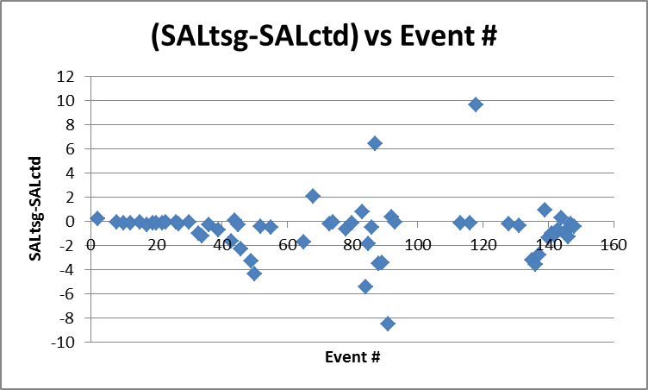
For temperature the largest differences are at SOGN, and west coast inlets including Effingham Inlet. Comparisons from Effingham Inlet and narrow channels generally don’t fit well those in other areas.

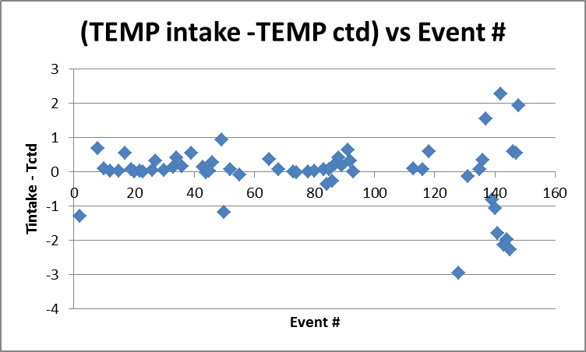

Plots of a few casts suggests that the highly variable differences might be due to large near-surface gradients with temperatures right at the surface being sometimes higher, sometimes lower than at 5m. There is some doubt about the depth from which the TSG draws water, but from previous cruises it appears that it comes from above the intake depth of 4m. We rarely have reliable CTD values near the surface. From this cruise there are more near-surface data than usual, but the pumps were not running so conductivity, and hence salinity, are not reliable there. Temperature data will not be ideal without pumping, but may be reasonable after a brief soak.

A few casts were examined in detail to see if there is any evidence of the TSG data being bad:
- Cast #2 – Station SOGN: The CTD appears to start right at the surface, probably slightly out of the water. It moves slightly higher during the 1.7 minutes at the surface and then starts downwards. The PAR readings suggest it entered the water when the pressure was about -0.1db and even before the pumps came on the temperature rose from about 13.5 to 16°C. There was a short stop at 1.3db and then the full cast began. At 2m and 4m the temperatures were ~16.1°C and ~15.8°C. The TSG reading at the beginning of the cast was ~14.7°C but there was a lot of variability in the TSG data, both just before and throughout the CTD cast with the TSG reading ranging from 14.5 to 16.2°C. So the TSG reading might agree with either 2m or 4m or the water may have been drawn from even deeper. The variability is too high to conclude anything about TSG data quality.
- Cast #50 – Doug 31: The CTD came on at 0.6db where the temperature was 12.9°C but the pumps were off. During a soak at 2.3db the pumps came on and temperature varied from 14.6°C to 15.1°C. The temperature dropped steadily below that reaching 13.1°C at about 8db. The TSG reading was 13.3°C at the beginning of the CTD cast but ranged from 13.1 to 15 during the 5minutes around that time. This range corresponds to CTD values seen between the surface and 8db. Again no clear evidence about TSG data quality.
- Cast #68 – Station Doug4: The CTD started at about 2.6m and the pumps came on shortly afterwards. The temperature during the soak was about 16.8°C. The temperature maximum of 17.5°C was at about 7m. During the soak period the CTD rose slightly and the temperature fell slightly, suggesting there were lower temperatures closer to the surface. The TSG read about 16.9°C as the CTD cast began. This suggests that the TSG sampled water from either above 2m or below 7m. 2m is closer to our expectations of where the loop water is drawn and getting a reasonable match there suggests that the TSG data is reasonably good.
- Cast #84 – DEV32: The CTD pumps came on at the beginning of a soak at 2.3db and the temperature read about 14.7°C. As it went down it increased to about 15.0°C at 4db and then decreased. The TSG reading of 14.6°C is close to the 2.3db values but would also match CTD readings at 5db. So the water might come from 2db or 5db. Again, matching the values around 2db suggests that the TSG data are reasonably good.
- Cast #148 – Station Eff 13: The CTD sat right at the surface for ~1 minute during which time the temperature varied between 16 and 17°C. The pumps were turned off. Very soon after the CTD started to move lower the temperature rose to about 17.75°C with pumps still off. The CTD stopped at 2m, the pumps were turned on and after 30s the full cast was started. When the pumps came on the temperature dropped slightly and then varied between 17.2 and 17.6°C. When it got to 4m the primary temperature was about 15.9°C. The TSG intake temperature at the time when the CTD started was 17.8°C and it didn’t vary much through the CTD cast. So the TSG is much higher than the CTD temperature at 4m, but just slightly higher than that at 2m.

These cast studies support the idea that the unusual comparisons between CTD and TSG are due to unusual near-surface temperature gradients. The vertical temperature gradients are high and often have a maximum near the sampling level. From other cruises we suspect that the TSG draws water from at least 2m above the 4m intake level. The case studies are compatible with that, but in several cases drawing from deeper waters would also fit the observations. There is no reliable evidence that the TSG calibration has drifted significantly.

The median differences show the TSG intake temperature to be higher than the CTD temperature by a median value of 0.07, or by as little as 0.02 if points are excluded with standard deviation in the TSG temperature being >0.01.
The TSG salinity was found to be low by a median value of 0.28 using all values or low by 0.15 when cases where standard deviations >0.05 are excluded.

The fluorescence values look reasonable for file #1, given they are voltages and need to be scaled.
(See 2015-46-ctd-tsg-comp-file1.xls.)

- TSG fluorescence versus Rosette CHL data
For the 1st file there was corresponding rosette sampling from CTD cast #2. The extracted chlorophyll values were 3.61ug/L at 1.4dband 2.17ug/L at 9.7db. The fluorometer on the CTD read ~3.5ug/L down to ~6m during the downcast. The TSG fluorometer value was 0.3V, so the scale factor should be about 10. There were no salinity samples for this CTD cast.

- Calibration History
The temperature and conductivity sensors were recalibrated in December 2013 and have been used for 6 previous cruises since then. The fluorometer was used in early 2014 with an old calibration and produced data that did not agree well with CTD data or loop samples.
    - During 2014-21 the TSG salinity was found to be lower than loop samples and CTD salinity by ~0.03 but the difference varied with flow rate which was highly variable. No recalibration was applied due to the variability in the comparisons and the fact that such a large drift in calibration on its first use seemed unlikely.
    - During 2014-19 the TSG salinity was found to be low by ~0.02, and the TSG temperature was found to be higher than the CTD temperature by ~0.005Cº.
    - 2014-22 results were not trusted.
    - 2015-01 salinity data were recalibrated by adding 0.02. Intake temperature was found to be higher than CTD temperature by from 0.005 Cº to 0.007 Cº.
    - During 2015-20 the salinity was found to be low by 0.025, the intake temperature high by ~0.008Cº.
    - During 2015-09 salinity was found to be low by about 0.03 and the intake temperature was higher than the CTD temperature by ~0.004Cº to ~0.006Cº

Conclusions
1. The TSG clock worked well.
2. The TSG flow rate looked good.
3. The TSG fluorescence is given in volts and was only found for the first file. For a rough estimate of fluorescence multiply by 10.
4. There was too much variability for reliable comparisons of temperature and salinity from the CTD and TSG sensors. TSG salinity is usually found to be lower than CTD salinity at 4m and TSG temperature higher than CTD temperature which is thought to be due to the loop drawing water from higher in the water column than the intake depth. The differences for this cruise have the usual sign, but are much greater than usual, which is likely because of large near-surface vertical gradients exaggerating the effect of poor depth matches for the two data sets.
5. The only reliable information for recalibration purposes comes from the history of the sensor which indicates that the TSG salinity is low by about 0.03 and that temperature does not require recalibration.

f.) Editing
REORDER was run on the ATC files so the Time (Julian) comes after the date and time channels.
The REO files were copied to *.EDT.
The file was opened in CTDEDIT and salinity was cleaned lightly. Some records were removed when the flow in the loop was turned off.

g.) Recalibration
File 2015-46-tsg-recal.ccf was prepared to add 0.03 to the salinity channel and was applied to the *.EDT files.

h.) Preparing Final Files
REMOVE was used to remove the following channels from all casts: Temperature:Difference, Conductivity. Fluorescence was removed from files 2-4.
The flow channel was not removed since it may be useful for further studies of optimal flow rate.

HEADER EDIT was used to add a few header entries, add a comment, change the DATA TYPE to THERMOSALINOGRAPH and add the depth of sampling to the header and to change channel names to standard names and formats.
The file was saved as a TOB file.
Header Check was run and an error was found and corrected.
The TSG sensor history was updated.
As a final check plots were made of the cruise track and it looks fine.
The cruise plot was added to the end of this report.

Further Notes
December 3, 2015: Further study of TSG files
A second attempt was made to produce TSG files with fluorescence.
The HEX file for file #2 contains fluorescence but the positions are stuck. The SCS file was used to add positions, matching time. Unfortunately, the resulting comparison with CTD casts was worse than from the files produced the first time. The TSG2_20150721-22455.RAW file shows very warm (~20°C) water around 17:00 on August 2. From the log we know that the ship was in Effingham Inlet at that time, so this is believable. And we have CTD data at EF01 with the same sort of surface temperature (19.4°C – 21°C in the top 4m). The data found by converting the 2015-46-0002.HEX file shows the same warm water, but earlier in the day when the ship was around station A1, which is harder to believe.

A few other comparisons show that the time in the two files are associated with quite different T and S values. Identifying some distinguishing patterns in T and S checks were made to see if there was a constant time offset, but it was varying, and that variation did not appear to be linear. The most damning evidence was a sudden change in temperature in the converted HEX file with a jump of 5C° between adjacent records with no skip in time. This appears to correspond to a time when the TXT file was not recording (during mooring work). When the RAW file starts again it has values that look like the converted HEX file after the jump. So I can only conclude that not only the positions got stuck in the TSG HEX file, but something was wrong with the time too. The time increases but it looks like it is being calculated by record number, taking no account of breaks in the record. So we can produce fluorescence but can’t say where or when it was collected. This approach was abandoned.

December 18, 2015
A study was made of one cast where CTD salinity did not agree well with values from a moored CTD. No significant problem was found in the CTD data except that near the bottom there may well have been some corruption by shed wakes that might lower the CTD values. For details see report 2015-46-cast19.docx. Other casts agreed well with moored CTD data.

January 6, 2016: Recalibration of CTD and CHE files
The factory drift reports are rough and show the conductivity cell error leading to salinity being low by ~0.0041 which was partly offset by the temperature reading low by ~0.0008 deg C, for a net salinity error of something like -0.0033.

The drift was also examined by reconverting a few files using the post-cruise calibration parameters. Those suggest the salinity is low by 0.0036 and temperature is low by 0.0013Cº. That is reasonably close to the drifts found above given that the drift statement of 0.0002/month could be anywhere between 0.00015 or 0.0024 per month.

Recalibration was applied to the CTD and CHE files using file 2015-46-recal2.ccf to add 0.0036 to channel Salinity:T0:C0 and to add 0.0013 to channel Temperature:Primary.

Particulars – notes from log book
1. Deck pressure 0.8db
2. No Rosette log sheet available.
10. Split into 2 files because water sampler was set to 6 bottles so another cast was need to fire 10 more.
19. Whitecaps; surface bubbly.
27. Sample #122 is a bucket sample.
34. Sample #145 is a bucket sample.
36. Cast to calibrate moored instruments – through pine needles.
55. Sample #213 is a bucket sample.
65. Sample #222 is a bucket sample.
73. Bottle #4 was missed, so went back down from 75m to get it.
87. Two attempts – first abandoned at 14m on way down. Did not overwrite. Ship repositioned slightly. So 2 files. No bottles. First file renamed 2015-46-9087; second named 2015-46-0087.
107. Non-standard file name – corrected after conversion. Altimeter cut out 10m above bottom.
113. Cast for mooring calibration.
116. Cast for mooring calibration. Extreme spikes in DO and SAL at bottom and in %Tran on way up. Maybe hit bottom?
131. Cast for mooring calibration. 1-2m heave.
139. H2S smell in bottom 2 bottles, >50m
140. Jellyfish tentacles.
143. T, O2 and %Trans spikes during upcast while stopped.
144. No sample 380. Jellyfish tentacles.
145. P on deck 0.115db.
146. Oil and rust coming off wire.
150. Deep salinity sample. 0.004deg C and 0.007psu differences.

CRUISE SUMMARY
CTDs
CTD# | Make | Model | Serial# | Used with Rosette? | CTD Calibration Sheet Competed?
1 | SEABIRD | 911+ | 0506 | Yes | Yes

Calibration Information
Sensor |  | Pre-Cruise |  | Post Cruise
Name | S/N | Date | Location | Date | Location
Temperature | 2023 | 31Jan2013 | Factory
Conductivity | 1763 | 1Jan2014 | Factory
Secondary Temp. | 5013 | 27Feb2013 | Factory
Secondary Cond. | 3394 | 3Jan2014 | Factory
Transmissometer | 1396DR | 5Feb2014 | IOS
SBE 43 DO sensor | 1438 | 3Jan2014 | Factory
PAR | 4565 | 16Mar2011 | IOS
SeaPoint Fluor. | 3640 | n/a
Pressure Sensor | 506 | 30Dec2013 | Factory
Altimeter | 1252 | n/a

CRUISE SUMMARY TSG
Make/Model/Serial#: SEABIRD/21/3363 Cruise ID#: 2015-46

Calibration Information
Sensor |  | Pre-Cruise |  | Post Cruise
Name | S/N | Date | Location | Date | Location
Temperature | 3363 | 28Dec13 | Factory
Conductivity | 3363 | 28Dec13 | Factory
WetLabs Fluorometer | WS3S-953P | ?
Temperature:Secondary | ? | ?
Flow meter | ? | n/a

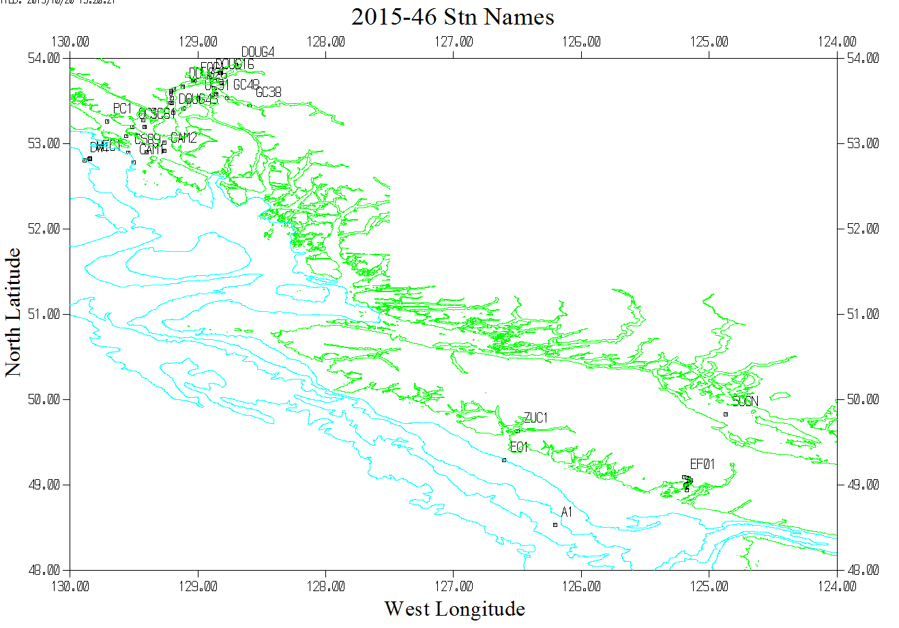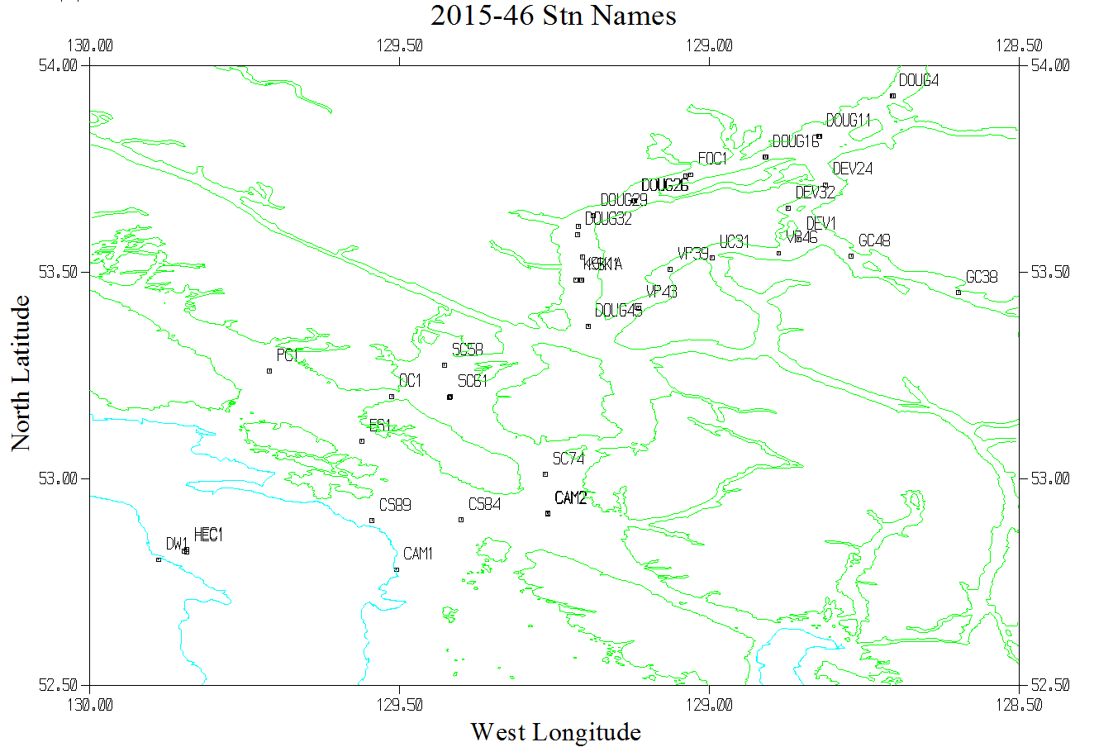
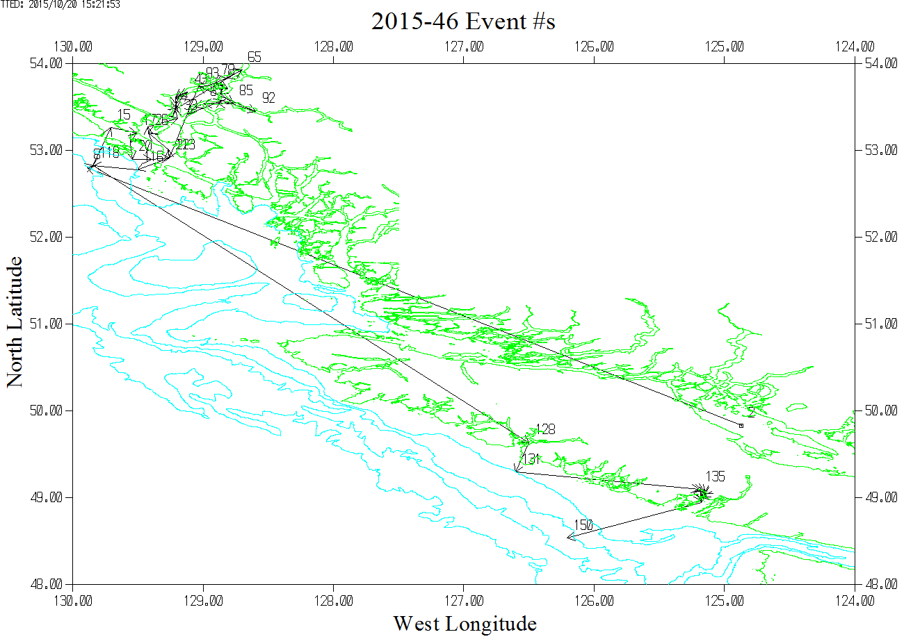

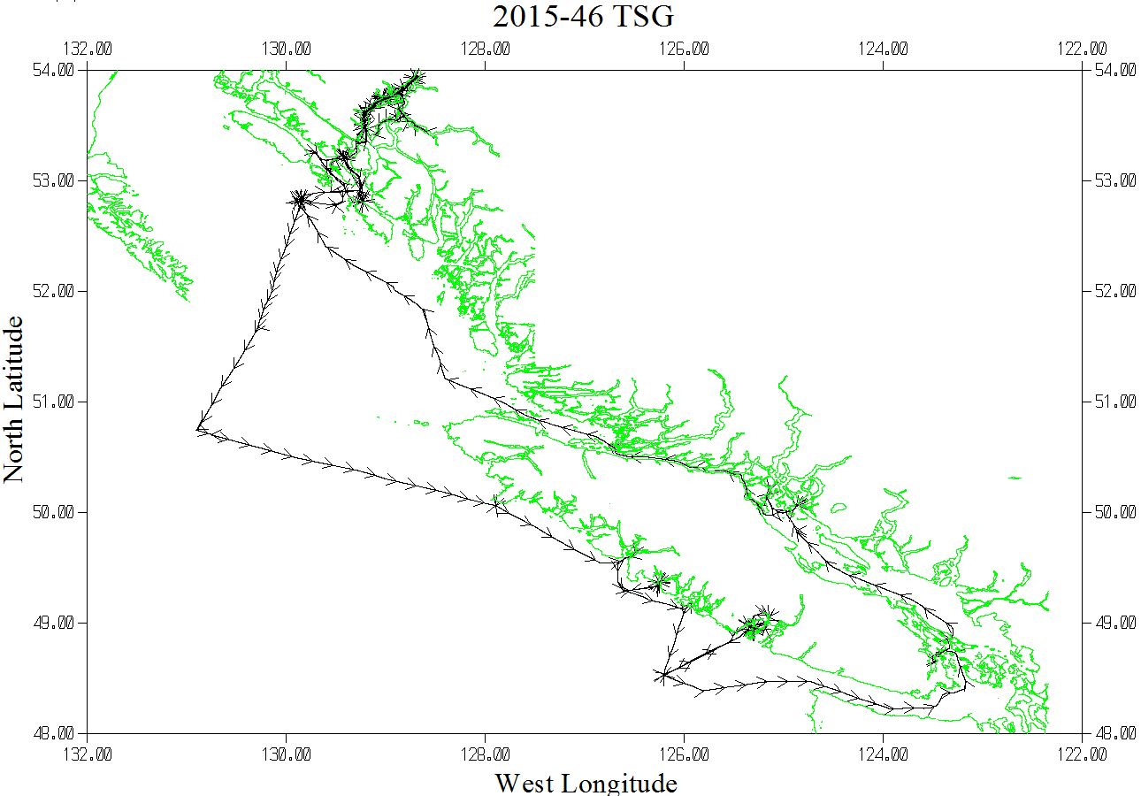
This TSG plot shows 1 position per hour.

