REVISION NOTICE TABLE
DATE | DESCRIPTION OF REVISION

PROCESSING NOTES
Cruise: 2015-40
Agency: PBS, Salmon And Freshwater Ecosystems, Nanaimo, B.C.
Party Chief: Zubkowski T. Location: Strait of Georgia
Project: High Seas Salmon Platform: Neocaligus
Date: 22 June 2015 – 25 June 2015

Processed by: Germaine Gatien
Date of Processing: 10 May 2016 – 11 May 2016
Number of original HEX files: 5 Number of CTD files: 0

INSTRUMENT SUMMARY
SeaBird Model SBE-19+ CTD (s/n 5299) was mounted with oxygen sensor #47.

SUMMARY OF QUALITY AND CONCERNS
There was no logbook available but there was a scan of the Bridge log.

There were errors in the calibration file used at sea for the SBE19. The most recent values had not been used. The computer clock had a date that was wrong by more than 4 months.

There was no calibration sampling.

The data from this cruise are considered bad based on differences between upcasts and downcasts, comparisons with data from other cruises close in either space and/or time, profile shapes and comparisons with local climatology. It is likely that the pump was not working or that the duct was blocked. The only unpumped channel is pressure and it looks normal.

The sensors behaved normally when next used.

PROCESSING SUMMARY
1. Seasave - This step was completed at sea. The file names were non-standard.

2. Preliminary Steps
There was no log book available but there was a scan of a bridge document with the necessary information. There were only 5 shallow casts.
The cruise summary sheet was completed.
A single configuration was file used for the 5 casts.

There were errors in the SBE19+ calibrations. There was a more recent calibration for the temperature and conductivity and the pressure values had the right date, but the parameters were incorrect. The correct values were entered and the configuration file was saved as file 2015-40-ctd.xmlcon.

These sensors were recalibrated in December 2014 or February 2015 and were used for 4 short cruises in May, June, July and August 2015, with no calibration sampling. As of May 2016 no other data have been processed that used these sensors.

3. Conversion of Raw Data
All casts were converted using file 2015-40.
Plots of the data show serious problems with all channels except pressure.
- Plots of temperature versus record number show that temperature fell through the soak period achieving something believable just at the end. Temperature then fell gradually throughout both downcast and upcast except for a slight rise in the final 10m.
- Salinity profiles vary from one cast to another with sometimes the downcast looking almost normal and at other times the upcast looks better.
- Dissolved Oxygen profiles are more complex but do not look normal. Typically the DO values drop throughout but do rise near the surface on the upcast.
While it is likely that none of these data are salvageable, some processing was applied so that quality tests could be run.

The names were in standard format.
The times in the headers for the SBE19 are in PDT but the dates are off by more than 4 months.

4. FILTER
Usually a low-pass filter is applied to pressure and conductivity for the SBE19+ CTDs, but for these data the pressure is very smooth so a filter looks unnecessary. Adjusting the conductivity made a slight difference, though it did not produce significantly smoother T-S plots. However, it didn’t hurt and just in case it helps, the filter usually applied to these sensors was used.
A low-pass filter with a 0.2s time constant to increase the pressure resolution and a 0.5s time constant was applied to the conductivity to force it to have the same response as the temperature.

5. ALIGNCTD
For these data there is no evidence as to whether the temperature and dissolved oxygen are aligned well or not. This can be addressed later in SHIFT if there is any evidence it is worth doing.
This step was skipped.

6. CELLTM
CELLTM was run using the SeaBird recommended parameters, (α, 1/β) = (0.04, 8) since useful tests are impossible with these data.

7. DERIVE
Program DERIVE was run to calculate salinity and dissolved oxygen concentration.

8. Conversion to IOS Headers
The IOSSHELL routine was used to convert the CNV files to IOS Headers. This was done separately for each CTD to get the correct information in the headers.

CLEAN was run to replace pad values in the pressure channel with interpolated values.

Note that all times in the file headers are in PDT. The dates are also wrong in the files so 3055 hours were added (127 days + 7 hours).

9. Checking Headers
Some header information was missing: latitude, longitude, station name and water depth.
Spreadsheet 2015-40-merge.csv was prepared with entries taken from the bridge log.
IOS SHELL program “MERGE:CSV file to headers” was used to add information from the csv file to the IOS files with output MRH.

A cross-reference listing was produced and checked against the log entries and no errors were found.

A header check was also run and shows that there are some negative values likely to be from surface records that will disappear when DELETE and CLIP have been run.

A track plot looks fine.

The surface check shows a value of -0.09db, but this is not very useful for this type of CTD sampling as there may be records that are in-water but with pumps off. This is especially true for this cruise when the pumps appear to have never come on.

10. SHIFT
Conductivity
Based on the results of 2015-26 a shift of -0.4 records was applied to the conductivity.

12. DELETE, CLIP and CTDEDIT
DELETE was run on all casts using the following parameters:
Remove Surface Records in the top 10m.
Surface Record Removal: Last Press Min. Surface Swell Pressure Tolerance: 1.0
Swells deleted. Warning message if pressure difference of 2.00
Drop rates < 0.3m/s (calculated over 5 points) was deleted from 10db to 10db above the maximum pressure.
COMMENTS ON WARNINGS: There were no warnings.

CLIP was run to remove data with pressure <1.2db.

13. CALIBRATE
There was no calibration sampling and no useful history to enable estimates.

14. Bin Average and REMOVE
The files were bin averaged using 1db bins.

15. Inter-comparisons
Sensor History – These sensors were recalibrated in December 2014 or February 2015 and were used for 4 short cruises in May, June, July and August 2015, with no calibration sampling. No other data have been processed that used these sensors.
Comparison of repeat casts –There were no repeat casts.
Historic Ranges – Plots of temperature and salinity with the local climatology superimposed show salinity much lower and temperature much higher than the historic range. While temperatures a little above the normal range have been seen in this area during other 2014/2015 cruises, these are very large differences and the shape of the profiles are very different.
Post-cruise calibrations – None available.

Comparisons with 2015-18, 2015-39 and 2015-41 There is 1 cast from 2015-18 that is close in space and time to cast 2015-40-0015, though 2015-18 is in deeper water. There are also casts 2015-39-0014 and 2015-41-0019 that visited the same site a month before and a month after 2015-40-0015. Data from these 4 cruises were plotted together.

For salinity, we can see that the values were not too bad at the surface, but increase very little with depth. This is likely because the pump was not working or there was a blockage in the duct. The May (2015-39) and July (2015-41) profiles are quite close to each other, and not very different from the deeper cast from 2015-18.

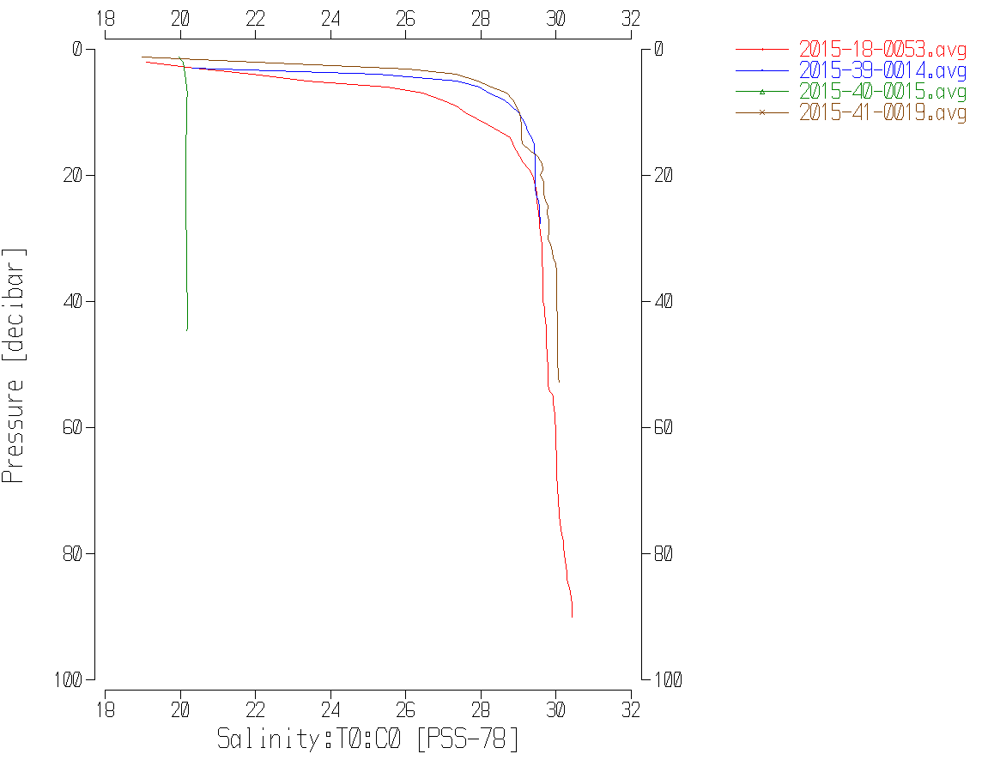

Temperature data are also out of line for this cruise, and have a completely different profile shape.

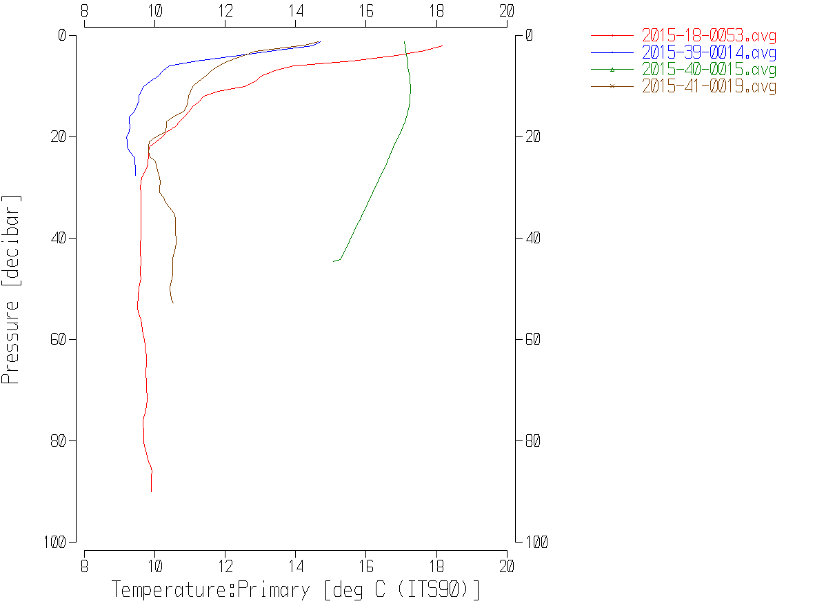

Dissolved oxygen is extremely low for 2015-40, and out of line with all the other cruises.

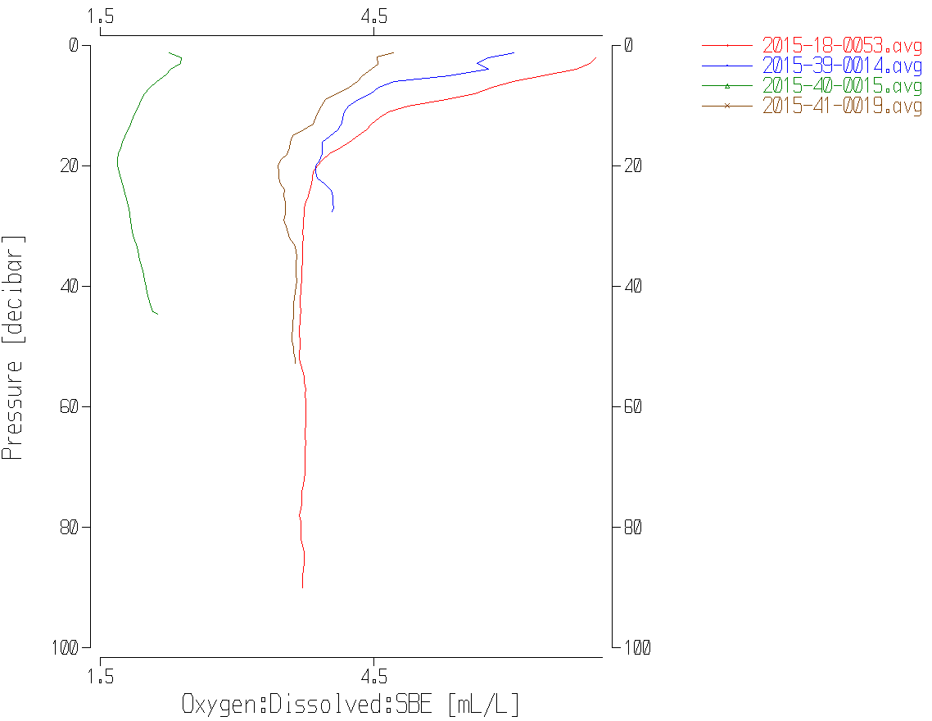

The dissolved oxygen saturation was derived and was <40% compared to 120%, 95% and 75% from the other casts. There can be a wide range of saturation rates in these near-shore casts, but I have never seen a maximum value as low as 40%. During the May cruise in the same area the range was 87% to 124%.

It is clear from these comparisons that these data are not useful.
The data will be backed up but should not go to the OSD DATA ARCHIVE.
18. HEADER EDIT and final checks.
Header Edit was used to fix headers, fix formats and channel names and to add the following note to the headers:
Data Processing Notes:
----------------------
The data from this cruise are considered bad based on differences between upcasts
and downcasts, comparisons with data from other cruises close in either space
and/or time, profile shapes and comparisons with local climatology.
It is likely that the pump was not working or that the duct was blocked.
The only unpumped channel is pressure and it looks normal.

The sensors behaved normally when next used.

For details on the processing see processing report: 2015-40-proc.doc.

The sensor history was updated.

CRUISE SUMMARY

Cruise ID#: 2015-40
Dates: Start: 22 June 2015 End: 25 June 2015
Location: Strait of Georgia
Party Chief: Zubkowski T.
CTD# | Make | Model | Serial# | Used with Rosette?
1 | SEABIRD | 19+ | 5299 | No

CTD CALIBRATION INFORMATION
Make/Model/Serial#: SEABIRD/SBE25/5299 Cruise ID#: 2015-40
Sensor |  | Pre-Cruise |  | Post Cruise
Name | S/N | Date | Location | Date | Location
Temperature | 5299 | 13Dec2015 | Factory
Conductivity | 5299 | 13Dec2015 | Factory
SBE43 Oxygen | 47 | 20Dec2014 | Factory
Pressure | 5299 | 19Dec2014 | Factory
