REVISION NOTICE TABLE
DATE | DESCRIPTION OF REVISION

PROCESSING NOTES
Cruise: 2015-26
Agency: PBS, Marine Ecosystems and Aquaculture Division, Nanaimo, B.C.
Party Chief: Neville C. Location: Strait of Georgia
Project: Salish Sea Marine Survival Platform: Summerhawk/OceanVenture
Date: 6 May 2015 – 13 August 2015

Processed by: Germaine Gatien
Date of Processing: 4 May2016 – 6 May 2016
Number of original HEX files: 33 Number of CTD files: 33

INSTRUMENT SUMMARY
Three CTDs were used for this cruise:
- SeaBird Model SBE-25 CTD (s/n 0404) was used with temperature sensor #2095, conductivity sensor #1764, Wetlabs ECO Fluorometer #2216, pH sensor #0851, oxygen sensor #1483 and pressure sensor 0482.
- SeaBird Model SBE-25 CTD (s/n 0334) was used with temperature sensor #2968, conductivity sensor #2173, Wetlabs ECO Fluorometer #2215, pH sensor #0852, oxygen sensor #766 and pressure sensor 0464.
- SeaBird Model SBE-19+ CTD (s/n 5299) was mounted with oxygen sensor #47.

SUMMARY OF QUALITY AND CONCERNS
This was a complex cruise using 3 different CTDs and requiring two different processing schemes. Two vessels were used. There are also interweaving event numbers associated with two separate, but related, surveys in Cowichan Bay and Big Qualicum. While there are repeated event numbers from the two areas, there are no repeats for CTD casts. If we use event numbers in the usual way, then ordering files by event numbers will not match the order casts were run, and it will produce a mix of files from the two different areas. So it was decided to rename the files from the Cowichan Bay casts with a leading 9 in the event number, so that ordering casts on event number enables easy sorting to go with the 2 surveys. File names 2015-26-9*** are from Cowichan Bay and 2015-26-0*** are from Big Qualicum.

The log book had equipment lists for the SBE25 configurations, but not for the SBE19. There was a good record of which CTD was in use for each cast. The times were sometimes in UTC and sometimes in PDT, but again there was a good record of which was used. A spreadsheet was provided with positions, station names, water depths and CTD serial numbers; this was very helpful.

There were errors in the calibration file used at sea for the SBE19. The most recent values had not been used. Fortunately, the resulting errors were very small. The computer clock for one of the CTDs had a date that was wrong by more than 4 months.

The CTD was soaked above 1db, generally for 1–1.5 minutes, though in at least one case it was only 15s. A soak of 3 to 5 minutes is recommended by the manufacturer but that is to allow the instrument’s temperature to equilibrate. If the temperature difference between air and water is not large, a 1 minute soak may be sufficient.

CTD #0404, which was used for the first 5 CTD casts in Big Qualicum, had poorer pressure resolution than expected from a SeaBird 25 and the pH sensor malfunctioned for cast 2015-26-0022.ctd.
CTD #0334 performed as expected except that a dissolved oxygen sensor was entered in the log and configuration file, but no data were acquired; so the sensor either malfunctioned or was not actually mounted, or there was a problem with the connection.
CTD #5299 performed as expected. It did not have a pH sensor or fluorometer.

WARNING: The pH:SBE:Nominal data should be used with caution; no field calibration data were available. Calibration is required for each cast to get absolute values although general trends within a cast are likely real.

There was no calibration sampling.

PROCESSING SUMMARY
1. Seasave - This step was completed at sea. The file names were non-standard.

2. Preliminary Steps
The Daily Log was obtained.
The cruise summary sheet was completed.
A single configuration was file used for each CTD.

The calibration parameters were checked and no problems were found with the 2 SBE25 CTDs.
There were errors in the SBE19+ calibrations. There was a more recent calibration for the temperature and conductivity and the pressure values had the right date, but the parameters were incorrect. No calibration was found with those values, so it is not known how they were obtained. A test run using both sets of parameters showed that there was only a slight change in temperature, conductivity and pressure when the correct variables were used.

The configurations were saved as file 2015-26-sbe25-0334.xmlcon, 2015-26-sbe25-0404.xmlcon and 2015-26-sbe19.xmlcon.
These sensors have had little known use since they were last calibrated and where there were other cruises using them there was no calibration sampling except for the dissolved oxygen sensor used for the oxygen sensor on CTD0404.

3. Conversion of Raw Data
All casts were converted using the appropriate configuration files.
Plots show that the channels all have reasonable profiles except that there is only noise from the DO channel for CTD #0404.
The non-standard names for the files will not be changed until after the DERIVE step since the names help with choosing the correct configuration file needed for that step.
The times in the headers for the SBE25s are PDT.
The times in the headers for the SBE19 are in PDT but the dates are off by more than 4 months.

4. WILDEDIT
This step was skipped as it does not usually work well on SBE25 or SBE19 data. There were no obvious spikes to remove from pressure, temperature or conductivity.

5. FILTER
Tests were run on a few casts to choose a filter for these data.
SBE25 0404 -The pressure looks spiky for all widths tested using WFILTER but the filter worked well on the temperature and conductivity and the resulting salinity looks good. The pressure readings from this sensor are odd with the steps being ~1.3db, much grosser resolution than expected from an SBE25.
While the WFilter is the usual choice for the SBE25s, a test was run using a low-pass filter with a 0.5s time constant for pressure and a 1s time constant for conductivity. The results were much better for pressure than with the Window Filter and the salinity looks fine.

SBE25 0334– There is a lot of fine-scale noise in the pressure, temperature and conductivity channels. But the pressure resolution looks normal with steps of ~0.15db. WFILTER was run with a filter width of 5 and this worked well without over-smoothing. When salinity is derived it looks much better with this filter. A test was made using a low-pass filter, but it was no better than the window filter which is the usual choice for this CTD type.

SBE19 5299 - A low-pass filter with a 0.2s time constant to increase the pressure resolution and a 0.5s time constant was applied to the conductivity to force it to have the same response as the temperature. This worked well producing smoother salinity but leaving some small features and pressure looks good. This is the usual choice for this type of CTD.

So WFILTER was run on all casts from the SBE 25 – 0334 using a width of 5 for pressure, temperature and conductivity.
FILTER was run on all casts from the SBE 25 – 0443 using a 1s time constant for pressure and a 0.5s time constant for conductivity.
FILTER was run on all casts from the SBE 19 – 5299 using a 0.2s time constant for pressure and a 0.5s time constant for conductivity.

6. ALIGNCTD
There were different DO sensors on each CTD.
For the SBE19 a setting of +2 seconds looks best overall, and was applied to all files.
For SBE25-0334 a setting of +3seconds looks best overall, and was applied to all files.
For SBE25-0404 there is no DO signal to align.

7. CELLTM
SeaBird recommend the use of (α, 1/β) = (0.04, 8) for CELLTM for the SBE 25. Tests on one cast show that was an appropriate choice, so CELLTM was run on all casts using that setting.
This step was not run on the SBE19 casts.

8. DERIVE
Program DERIVE was run to calculate salinity and dissolved oxygen concentration.
At this point the files were renamed in standard format. See document 2015-26-cast-summary.xlsx for a list of original event numbers and the standard file names, along with times, positions, station names, and bottom depths. Table 1at the end of this report contains some of that information.

9. Conversion to IOS Headers
The IOSSHELL routine was used to convert the CNV files to IOS Headers. This was done separately for each CTD to get the correct information in the headers.
CLEAN was run to replace pad values in the pressure channel with interpolated values.
Note that all times in the file headers are in PDT. So ADD TIME CHANNEL was used to add 7 hours to header times of the SBE25 files. The dates are wrong in the SBE19+ files so 3055 hours were added (127 days + 7 hours).

10. Checking Headers
Some header information was missing: latitude, longitude, station name and water depth.
A spreadsheet was provided and that was used to prepare file 2015-26-merge.csv. IOS SHELL program “MERGE:CSV file to headers” was used to add information from the csv file to the IOS files with output MRH.

A cross-reference listing was produced and checked against the log entries and no errors were found.

A header check was also run and shows that there are many values that must come from spikes; these will likely disappear when the surface is clipped and DELETE is run. One error was found and corrected and no further errors were found on a rerun.

A track plot is very messy if all casts are shown together, so files from the two project areas were plotted separately and added to the end of the report.

The surface check is not very useful for this type of sampling as there may be records that are in-water but with the pump not on. To supplement that information we can look at records from the end of the cast although the CTD can be out of the water but carrying water with it so that it appears to be in the water for a few seconds. At best we can make a rough guess about how the pressure sensors performed.
- For the SBE25 #0404 the pressure starts at +0.5db but then drops to values closer to 0db within 1 or 2 records. The pressure resolution is poorer than usual for this type of CTD. Salinity generally shows in-water values below -0.4db. On the way up the CTD appears to leave the water at about -0.2 to -0.7db.m but there is some delay as the CTD carries some water with it. The pressure is likely good to ±0.5db, which is within the specifications. The pressure from this sensor was unusually noisy though filtering makes it look smooth.
- For the SBE25 # 0334, the surface values are about -0.1db but the salinity is very low. The salinity starts to rise at about 0db but the pumps would not have been on yet. On the way up there are in-water values until about -0.4db to -0.9db. The pressure is likely good to ±0.5db, which is within the specifications.
- For the SBE19 the pressure looks close to zero based on both downcasts and upcasts.

11. SHIFT
pH
Profile plots were made of pH and temperature to see what alignment steps are necessary.
- For CTD 0404, the first 4 casts look like an adjustment might help. Tests showed that a shift of +5 records is appropriate. But for event #22 the pH signal is bad with a profile unlike any other during this cruise and upcast completely different from downcast. The pH channel should be removed from that file.
- For CTD #0334 the pH varies little from top to bottom so judging the effect of an alignment shift is difficult. But the setting used for CTD 0404 does seem to improve it very slightly.
- CTD #5299 did not have a pH sensor mounted.
So SHIFT was run to advance the pH channel by +5 records for both SBE25s.

Conductivity
For all conductivity shifts salinity was recalculated.
For the SBE19+ a shift of -0.4 records to the conductivity improved the salinity as demonstrated on a T-S plot. The change was not large.
For the SBE25 #0404 every shift tested makes the data look worse. No adjustment is needed.
For the SBE25 #0334 a shift of +0.5 records improved the data slightly.

Fluorescence
The fluorometers on the SBE25s were not pumped, so a shift in alignment is expected to be small or unnecessary. Profile plots of temperature and fluorescence were examined and show that alignment is quite good. No further alignment adjustment will be made.

Oxygen
The dissolved oxygen channel was aligned earlier in processing, but was checked again. As usual, the results vary from feature to feature as local vertical gradients and descent rates affect the alignment. No further shift will be applied.

12. DELETE, CLIP and CTDEDIT
DELETE was run on all casts using the following parameters:
Remove Surface Records in the top 10m.
Surface Record Removal: Last Press Min. Surface Swell Pressure Tolerance: 1.0
Swells deleted. Warning message if pressure difference of 2.00
Drop rates < 0.3m/s (calculated over 5 points) was deleted from 10db to 10db above the maximum pressure.
COMMENTS ON WARNINGS: The only warnings were from the upcast of one file.

Plots were made to see what editing was needed. It was clear that most data above 1.2db were poor, being from the soak period or the time when the descent was just starting. There were large spikes and obviously unstable features.
CLIP was run to remove data with pressure <1.2db.

All files were examined in CTDEDIT and some editing was applied to 22 casts. This involved removing records corrupted by shed wakes and light cleaning of salinity. Some fluorescence spikes near the top of the water column were removed from the SBE404 files.
All CLIP files were copied to EDT and then the CTDEDIT output files were copied to EDT to produce a complete set of files.

14. Inter-comparisons
Sensor History – There is no useful history for these sensors since they were last calibrated at the factory. They were not used on any other cruises with calibration sampling.
Comparison of repeat casts –There were no repeat casts. Some were close in space, but not in time, and they were shallow, so they are not useful for quality control. They do fall into groups on a T-S space, showing marked differences between the two areas and some spread with time.
Historic Ranges – Plots of temperature and salinity with the local climatology superimposed show salinity within the normal range, but a lot of the temperature data are above the maximum. While this might just mean the climatology is too severe for near-shore data, it should be noted that temperatures above the climatology maximum have been noted over much of the top 100m of the Strait of Georgia waters in 2015.
Post-cruise calibrations – None available.

15. CALIBRATE
There was no calibration sampling and no useful history to enable estimates.

16. Fluorescence Filter
This step will be skipped as the fluorescence is not very spiky.

17. Bin Average and REMOVE
The files were bin averaged using 1db bins.
T-S plots were examined and just a few small unstable features were noted; those could be real, so no further editing was applied.

REMOVE was run to remove Scan_Number, Conductivity:Primary, Oxygen:Voltage, Descent Rate and Flag channels from all casts.
As well channel pH:SBE was removed from event #22 and channel Oxygen:Dissolved:SBE from events 4-22.
The platform name was wrong for casts 9094-9112. It should be Ocean Venture. This was fixed using a text editor on the REM files.
18. HEADER EDIT and final checks.
Header Edit was used to fix headers, fix formats and channel names and to add the following note to the headers:
Data Processing Notes:
----------------------
Fluorescence data are nominal and unedited, except that some records
were removed in editing temperature and salinity.

There was no salinity calibration sampling and no other information
available on which to base a recalibration.

WARNING: The pH:SBE:Nominal data should be used with caution; no field
calibration data were available at the time of processing. Some data
were removed in editing temperature and salinity and where the pH
sensor had clearly malfunctioned, but the data are otherwise unedited.

Calibration is required for each cast to get absolute pH values,
although general trends within a cast are likely real.

For details on the processing see processing report: 2015-26-proc.doc.
A cross-reference listing was produced.
A header check was run on the CTD files and no further errors were found.
The sensor history was updated.

CRUISE SUMMARY

Cruise ID#: 2015-26
Dates: Start: 12 May 2015 End: 15 July 2015
Location: Discovery Islands
Party Chief: Neville C.
CTD# | Make | Model | Serial# | Used with Rosette?
1 | SEABIRD | 25 | 0404 | No
2 | SEABIRD | 25 | 0334 | No
3 | SEABIRD | 19+ | 5299 | No

CTD CALIBRATION INFORMATION
Make/Model/Serial#: SEABIRD/SBE25/0404 Cruise ID#: 2015-26
Sensor |  | Pre-Cruise |  | Post Cruise
Name | S/N | Date | Location | Date | Location
Temperature | 2095 | 1Apr2011 | Factory
Conductivity | 1764 | 3Jan2014 | Factory
pH | 0851 | 4Sep2014 | IOS
ECO Fluorometer | 2216 | ? | ?
SBE43 Oxygen | 1483 | 17Jan2014 | Factory

Make/Model/Serial#: SEABIRD/SBE25/0334 Cruise ID#: 2015-26
Sensor |  | Pre-Cruise |  | Post Cruise
Name | S/N | Date | Location | Date | Location
Temperature | 2968 | 23Dec2014 | Factory
Conductivity | 2173 | 19Dec2014 | Factory
pH | 0852 | 31Dec14 | IOS
ECO Fluorometer | 2215 | May 2015 | ?
SBE43 Oxygen | 0766 | 23Dec2014 | Factory
Pressure | 464 | 23Dec2014 | Factory

Make/Model/Serial#: SEABIRD/SBE25/5299 Cruise ID#: 2015-26
Sensor |  | Pre-Cruise |  | Post Cruise
Name | S/N | Date | Location | Date | Location
Temperature | 5299 | 19Dec2014 | Factory
Conductivity | 5299 | 19Dec2014 | Factory
SBE43 Oxygen | 47 | 20Dec2014 | Factory
Pressure | 5299 | 19Dec2014 | Factory
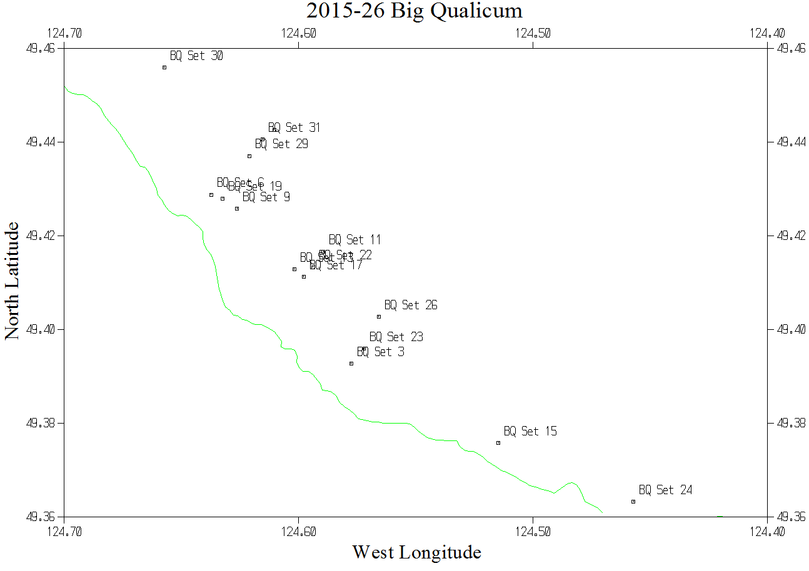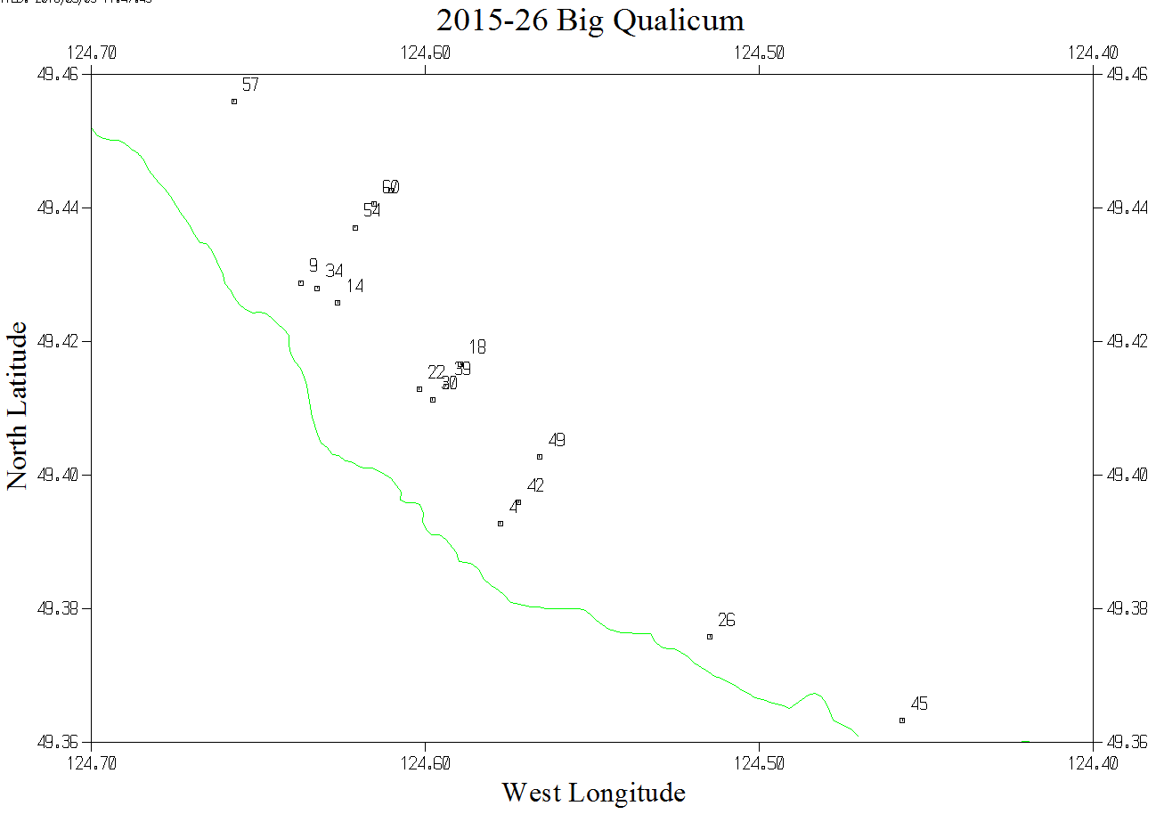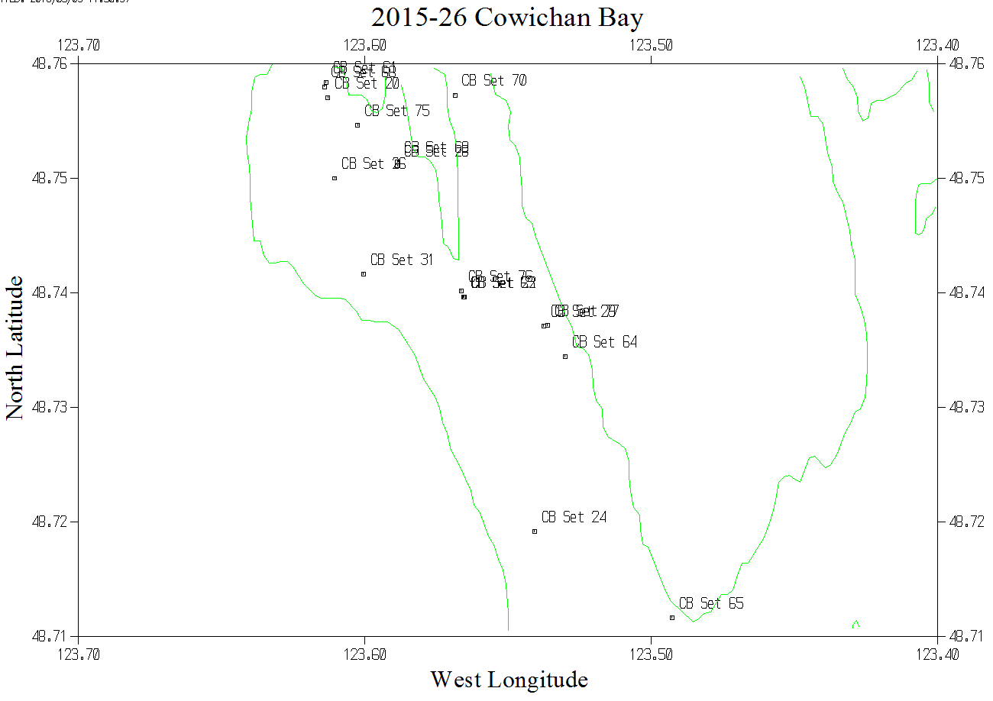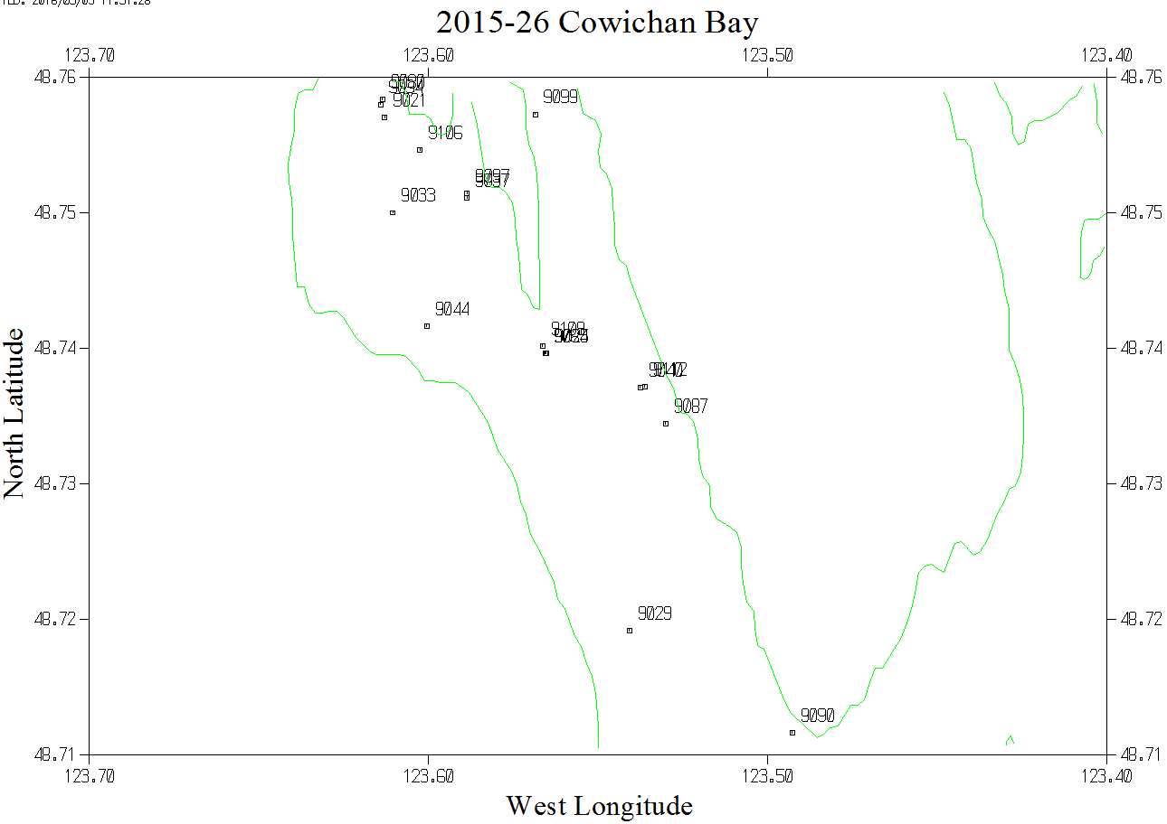
Table 1: List of events from log and the associated file names to be used in the archive.
Event # in Log | Date | Site | CTD | Vesssel | New File name
4 | 27-May | BQ | 404 | Summerhawk | 2015-26-0004
9 | 27 | BQ | 404 | Summerhawk | 2015-26-0009
14 | 28 | BQ | 404 | Summerhawk | 2015-26-0014
18 | 28 | BQ | 404 | Summerhawk | 2015-26-0018
22 | 28 | BQ | 404 | Summerhawk | 2015-26-0022
21 | 01-Jun | CB | 334 | Summerhawk | 2015-26-9021
25 | 1 | CB | 334 | Summerhawk | 2015-26-9025
29 | 1 | CB | 334 | Summerhawk | 2015-26-9029
33 | 2 | CB | 334 | Summerhawk | 2015-26-9033
37 | 2 | CB | 334 | Summerhawk | 2015-26-9037
40 | 2 | CB | 334 | Summerhawk | 2015-26-9040
44 | 2 | CB | 334 | Summerhawk | 2015-26-9044
80 | 30-Jun | CB | 5299 | Summerhawk | 2015-26-9080
84 | 30 | CB | 5299 | Summerhawk | 2015-26-9084
87 | 30 | CB | 5299 | Summerhawk | 2015-26-9087
90 | 30 | CB | 5299 | Summerhawk | 2015-26-9090
26 | 03-Jul | BQ | 5299 | Summerhawk | 2015-26-0026
30 | 3 | BQ | 5299 | Summerhawk | 2015-26-0030
34 | 3 | BQ | 5299 | Summerhawk | 2015-26-0034
39 | 3 | BQ | 5299 | Summerhawk | 2015-26-0039
42 | 3 | BQ | 5299 | Summerhawk | 2015-26-0042
45 | 4 | BQ | 5299 | Summerhawk | 2015-26-0045
49 | 4 | BQ | 5299 | Summerhawk | 2015-26-0049
54 | 4 | BQ | 5299 | Summerhawk | 2015-26-0054
57 | 4 | BQ | 5299 | Summerhawk | 2015-26-0057
60 | 4 | BQ | 5299 | Summerhawk | 2015-26-0060
63 | 4 | BQ | 5299 | Summerhawk | 2015-26-0063
94 | 12-Aug | CB | 5299 | Ocean Venture | 2015-26-9094
97 | 12 | CB | 5299 | Ocean Venture | 2015-26-9097
99 | 12 | CB | 5299 | Ocean Venture | 2015-26-9099
106 | 13 | CB | 5299 | Ocean Venture | 2015-26-9106
109 | 13 | CB | 5299 | Ocean Venture | 2015-26-9109
112 | 13 | CB | 5299 | Ocean Venture | 2015-26-9112

