REVISION NOTICE TABLE
DATE | DESCRIPTION OF REVISION
May 29, 2025 | Cleaned flag values. SH
21 July 2020 | Added HPLC data. G.G.

PROCESSING NOTES
Cruise: 2015-21
Agency: OSD
Location: WCVI
Project: La Perouse
Party Chief: Yelland D.
Platform: John P. Tully
Date: 3 September 2015 – 14 September 2015

Processed by: Germaine Gatien
Date of Processing: 16 December 2015 – 25 January 2016
Number of original HEX files: 95 Number of CTD files: 95
Number of bottle files: 48 Number of bottle casts processed: 48
Number of original TSG files: 2 Number of processed TSG files: 2

INSTRUMENT SUMMARY
A SeaBird Model SBE 911+ CTD (#0443) was used for this cruise. It was mounted in a rosette and attached were a Wetlabs CSTAR transmissometer (#1396DR), a SBE 43 DO sensor (#997) on the secondary pump, a SeaPoint Fluorometer (#3640) on the primary pump, a Biospherical QSP-400 PAR sensor (#4565), and an altimeter (#62354).

A thermosalinograph (Seacat 21 S/N 3363) was mounted with a Wet Labs WETstar fluorometer (S/N ws-3s 953p), remote temperature sensor and a flow meter.

Seasave version V7 22.4 was used for acquisition.
The deck unit was a Seabird model 11, serial number 0619.
All casts were run with the LARS mid-ship station.
The salinometer used at IOS was a Guildline model 8400B Autosal, serial # 68572.
The oxygen kit was Scripps kit #2.
An IOS rosette with 24 10L bottles was used.

SUMMARY OF QUALITY AND CONCERNS
The Daily Science Log, rosette log sheets and analysis logs were in good order.

There was a problem with the data from the secondary channels during part of the downcast of event #20, so primary temperature and salinity were archived for that cast and most of the dissolved oxygen data were replaced with pad values. For all other casts the secondary channels were selected for the archive.

The comparison of salinity samples with the CTD salinity was not considered reliable. There was an unusually large scatter. After many outliers were removed to produce a flat fit of differences versus pressure, the secondary salinity was lower than the bottles by 0.0032 but the standard deviation was 0.0037. Similar results were found for the primary salinity. Sample analysis was done about 2.5 months after collection so there was probably some evaporation which would raise the salinity in the bottles in an uneven fashion which may explain the analyst’s finding of poor precision. Further, adsorption of samples is estimated to raise sample salinity by ~0.003. During 2015-10 when the same sensors were used and analysis was prompt, it was determined that while the secondary salinity was lower than bottles by about 0.0018, some of that difference was likely due to factors other than calibration drift. No recalibration was applied to the 2015-10 salinity data and the same decision was made for this cruise.

As usual, the SeaPoint fluorescence is higher than the extracted CHL for CHL<2ug/L. As CHL values rise, the ratio of FL/CHL falls until it reaches about 0.5.

The Oxygen:Dissolved:SBE data are considered, very roughly, to be:
±0.5 mL/L from 0 to 100db
±0.2 mL/L from 100db to 500db
±0.02 mL/L below 500db

The thermosalinograph worked throughout the cruise. Fluorescence is reported in volts since the sensor has not been calibrated. A comparison with the fluorometer mounted on the CTD provides an estimate of TSG fluorescence in ug/L: FL(ug/L) ≈ 15.61 * FL(volts) -0.81
This should be considered a rough guide only.
As was noted during the previous cruise, there were 1-sided spikes in the salinity traces of size up to ~0.5psu. The larger salinity spikes were cleaned using a graphical editor, but they may well be indicative of a more general problem of bubbles reducing salinity. Salinity was recalibrated by adding 0.18psu based on sensor history and comparisons with CTD casts and 1 loop sample.

PROCESSING SUMMARY

Seasave
This step was completed at sea; the raw data files have extension HEX.

Preliminary Steps
The Log Book and rosette log sheets were obtained.
Nutrients, extracted chlorophyll, dissolved oxygen, NH4 and salinity data were obtained in QF spreadsheet format from the analysts.
The cruise summary sheet was completed.
The history of the pressure sensor, conductivity and DO sensors were checked. All were used during 2015-10 which immediately preceded this cruise.
The XMLCON files did not change through the cruise.
The calibration constants were checked for all instruments and the only correction needed was to fix a spelling error and to adjust the value of E in the DO parameters based on hysteresis tests done during 2015-10. The corrected file was saved as 2015-21-ctd.xmlcon.

Conversion of Full Files from Raw Data
All hex files were converted using 2015-21-ctd.xmlcon to create CNV files.
Voltage6 and Voltage7 were converted. These are from the Rinko dissolved oxygen sensor and will be used for research, but will not be archived at this time.

A few casts were examined and all expected channels are present.
There is a problem with the secondary temperature in cast #20 downcast. The upcast is likely ok. The pumps were on. The casts before and after #20 look normal.
The temperature and conductivity channels are close at depth. Near the surface there is a lot of variability especially during upcasts. There appear to be more spikes in the primary sensors than secondary but both have such features.
The altimeter appears to have worked well. Fluorescence, transmissivity and PAR look ok.

BOTTLE FILE PREPARATION
The ROS files were created using file 2015-21-ctd.xmlcon.
The ROS files were converted to IOS format.
They were put through CLEAN to create BOT files.
Temperature and salinity were plotted for all BOT files to check for outliers. As usual there were many near the surface, but they mostly look like real variations. For casts 4, 6, 39, 52, 57, 58 and 90 both salinity channels have some spikes that were cleaned using CTDEDIT.
The output files were copied to *.bot.

A preliminary header check and a cross-reference check were run and no problems were found. CTD fluorescence did not go off-scale.

The BOT files were bin-averaged on bottle number and the output was used to create file ADDSAMP.csv. First, the file was sorted on event number and Bottle Position order. Then sample numbers were added based on the rosette logs.
There was some confusion in sample numbers:
- Cast #32 – One bottle was fired for water only. No sample number was assigned. That line was removed from the ADDSAMP file as no entry is needed for that bottle in the bottle file.
- Cast #141/145 – Sample #327 was used for both casts. Since there was no OSD sampling for cast #141 the sample number for that cast was changed to #9327. So no adjustments are needed to analysis spreadsheets.
- Cast #160 – Niskin #19 was fired twice but since it was already closed by the first firing, the second is irrelevant to the bottle file and that line was removed from the ADDSAMP file.
Sort was used to ensure that the ADDSAMP file was in sample number order.
The addsamp.csv file was converted to CST files, which will form the framework for the bottle files.
The SAM files were bin-averaged on bottle # and called SAMAVG.

Next, each of the analysis spreadsheets were examined to see what comments the analysts wanted included in the header file. These were used to create file 2015-21-bot-hdr.txt which will be updated as needed during processing.

EXTRACTED CHLOROPHYLL
Extracted chlorophyll and phaeo-pigment data were obtained in file QF2015-21chl*.xls. The file included comments and flags and a precision study. A simplified version of the spreadsheet was prepared and saved as 2015-21chl.csv. The csv file was then converted to individual CHL files.

DISSOLVED OXGYEN
Dissolved oxygen data were provided in spreadsheet QF2015-21oxy.xls which includes flags, comments and a precision study. Draw temperatures are available. The spreadsheet page with the final data was simplified and was then saved as 2015-21oxy.csv. That file was converted into individual *.OXY files.

SALINITY
Salinity analysis was obtained in 2015-21SAL.xls. The analysis was done between 76 and 82 days of collection. The files were simplified and saved as 2015-21sal.csv. File 2015-21sal.csv was then converted to individual SAL files.

NUTRIENTS
The nutrient data were obtained in spreadsheet QF2015-21_nutrients*.xlsx. This includes a precision study. The file was simplified, reordered on sample numbers and saved as 2015-21-nuts.csv. The file was converted to individual NUT files.

NH4
NH4 data were obtained in file 2015-21_NH4.xls which included a report on precision. The file was simplified and saved as 2015-21NH4.csv and converted to individual NH4 files. The event numbers were missing, so those were added to both files.

The SAL, CHL, OXY, NUT and NH4 files were merged with CST files in 5 steps.
After the 5th step the files were put through CLEAN to reduce the headers to File and Comment sections only.

The merged files are ordered on sample number, but the SAMAVG files are ordered on bottle number, so one or the other set needs to be reordered in order to merge them. The MRGCLN1 files were reordered on Bottle_Number. The output files were named MRGCLN1s. Those files were then merged with SAMAVG files choosing the Bottle_Number from the SAMAVG files.

The output of the MRG files were exported to a spreadsheet and compared to the rosette log sheets to look for omissions. Errors found or things to be adjusted were:
- Cast #32 – The line for the deep bottle should be removed from the SAMAVG file.
- Cast #39 - The rosette log indicates that NH4 samples were gathered at station LC09/A3, samples 128, 129, 131, but there are none in the NH4 analysis spreadsheet. The analyst checked and finds no record of the samples so they were assigned pad values and flag 9 with the comment “Sample planned but not collected”.
- Cast #43 – The rosette log indicates that NH4 samples were gathered at station LC08, samples 140-142, but there are none in the NH4 analysis spreadsheet. The analyst checked and finds no record of the samples so they were assigned pad values and flag 9 with the comment “Sample planned but not collected”.
- Cast #160 – the line for the 2nd firing of Niskin 19 needs to be removed from the SAMAVG file.
After these corrections the merge process was repeated and CLEAN rerun.

Compare
Dissolved Oxygen
COMPARE was run with pressure as the reference channel.

There were no extreme outliers, but the 5 most significant outliers were examined. Three of them came from high gradient areas and another was near a subsurface maximum in DO, places where we don’t expect a great match. One of the high-gradient samples had been flagged 3 due to concerns about accuracy. The only sample that looks suspicious is sample #96 from the bottom of cast #37 at 1474db. The bottle value is 0.069 and the CTD DO is 0.645mL/L. The DO sample looks out of line in the profile of bottle values. The full CTD profile shows the sampling level is well below the DO minimum so the bottle value is unlikely. Examination of the raw data shows that there was a typo and the bottle value should be 0.690mL/L, not 0.069.

When outliers were excluded based on residuals the fit found was:
CTD DO Corrected = CTD DO * 1.0225 + 0.0309
This is reasonably close to the fit from the previous cruise:
CTD DO Corrected = CTD DO * 1.0151 + 0.0426 (2015-10)

There are few bottles from below the DO minimum which is at about 1000m. A plot was made that showed the points below 1100m in green with others in red and this showed no signs of hysteresis.
For more details see document 2015-21-dox-comp1.xlsx.

Plots of Titrated DO and CTD DO against CTD salinity were examined. No further outliers were found.

Salinity
Compare was run with pressure as reference channel. The scatter is large with CTD values mostly lower than the bottles. Between 10 and 50m at casts #95 and 103 there are some outliers with CTD values higher than bottles. Examination of the profiles shows some very complex variations at those depths in both the downcasts and upcasts. Whether this is due to CTD malfunction or some complex interleaving, will be examined later. For now, it is clear that the local reversals could account for the CTD salinity reading lower than samples. There was no sampling at those depths for other casts. The scatter makes identification of outliers problematic, but when cases are excluded from the comparison if the difference is outside the range -0.0011 to 0.009 for the primary salinity and outside the range -0.01 and +0.01 for the secondary salinity, fairly flat fits are achieved. The average of the points left in the fit shows the primary salinity to be low by 0.0045 and the secondary by 0.0032. The standard deviations are 0.004 and 0.0037.

The analysis precision was poor with Sp=0.005 after 1 out of 7 pairs was excluded from the calculation. There was a delay in analysis of 72 to 84 days which that may lead to bottle values being high due to evaporation and desorption of samples.

Plots of differences against time and against salinity show no trends except for the odd data from 20-50m, levels only sampled during casts #95 and #103. So what appears to be a time-related variation is more likely due to different depths sampled in different parts of the cruise.

For full details for the COMPARE run see file 2015-21-sal-comp1.xls.

Fluorescence
COMPARE was run with extracted chlorophyll and CTD Fluorescence using pressure as the reference variable. The CTD fluorometer was a SeaPoint sensor.

CHL values ranged from ~0.27 to 8.6ug/L. The plot of FL/CHL vs CHL below shows the usual pattern that CTD fluorescence is higher than the extracted CHL for CHL<2ug/L, but it is not as much higher as often seen. As CHL values rise the ratio of FL/CHL falls until it reaches about 0.5.
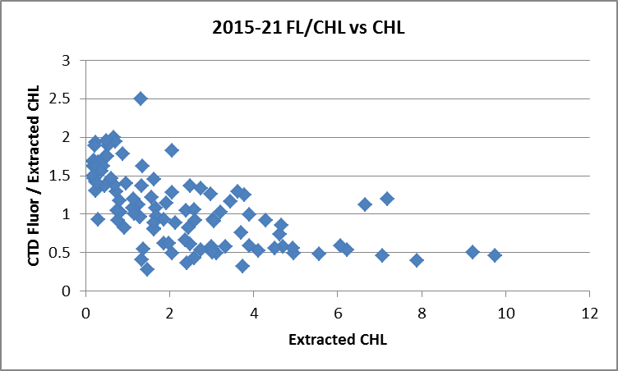

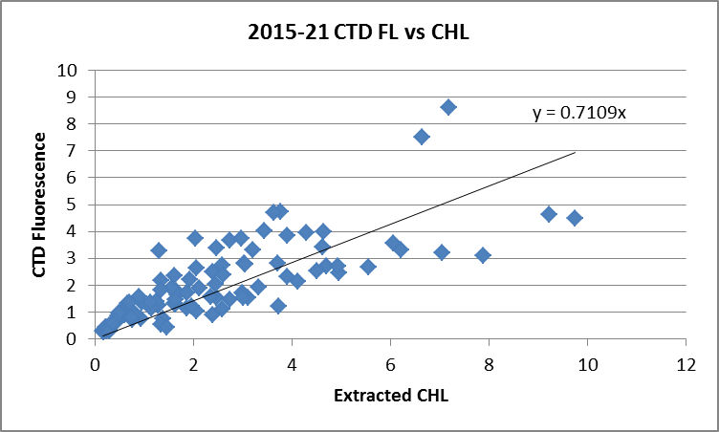
For full details of the comparison see file 2015-21-fl-chl-comp1.xlsx.

WILDEDIT
Program WILDEDIT was run to remove spikes from the pressure, conductivity & temperature only in the full cast files (*.CNV).
Parameters used were: Pass 1 Std Dev = 2 Pass 2 Std Dev = 5 Points per block = 50
The parameter “Keep data within this distance of the mean” was set to 0 so all spikes would be removed.

ALIGN DO
Tests were run on a few casts and results with a setting of +2.5 to +3.5 all looked reasonable, but +3.5 was best overall.
ALIGNCTD was run on all casts using +3.5s.

CELLTM
The noise in the upcast makes the tests for the best parameters for this routine very difficult to interpret. During other recent cruises, the default setting of (α = 0.0245, β=9.5) looked better for both conductivity channels than others tested. One cast was checked for this cruise and the default setting does improve the data.
CELLTM was run using (α = 0.0245, β=9.5) for both the primary and secondary conductivity.

DERIVE and Channel Comparisons
Program DERIVE was run on all casts to calculate primary and secondary salinity and dissolved oxygen concentration.

Before conversion the first 20,189 records were removed from cast #93. The CTD had been lowered to about 125m, sat there for 25 minutes due to swell. It was then returned to the surface and restarted, but to ensure that DELETE does not choose the data from the initial drop a text editor was used to remove the data.

DERIVE was run a second time on a few of the deeper casts to examine differences between sensor pairs. The shaded values are from the previous cruise that used these sensors.

Cast # | Press | T1-T0 | C1-C0 | S1-S0 | Descent Rate
2015-10-0039 | 500 | -0.0012 | -0.00034 | -0.0024 | High, Moderate
 | 1000 | -0.0010 | -0.00015 | -0.0005 | “
 | 1900 | -0.0011 | -0.00007 | +0.0003 | “
2015-10-0070 | 500 | -0.0010 | -0.00016 | -0.0008 | High, Very Noisy
 | 1000 | -0.0010 | -0.00006 | +0.0003 | “
 | 1900 | -0.0013 | -0.00002 | +0.0009 | “
2015-10-0099 | 500 | -0.0011 | -0.00016 | -0.0009 | High, Very Noisy
 | 1000 | -0.0010 | -0.00006 | +0.0004 | “
 | 1900 | -0.0013 | -0.00003 | +0.0010 | “
2015-21-0034 | 1000 | -0.0013 | -0.00014 | -0.0002 | High, Mod
 | 1900 | -0.0014 | -0.00006 | +0.0008 | Med, Noisy
2015-21-0068 | 1000 | -0.0013 | -0.00008 | +0.0002 | High, VNoisy
 | 1900 | -0.0012 | -0.00004 | +0.0009 | “
2015-21-0099 | 1000 | -0.0014 | -0.00008 | +0.0004 | High, XNoisy
 | 1900 | -0.0013 | -0.00002 | +0.0012 | “
The differences are similar to those seen in the previous cruise and show no significant change through this cruise. Temperature differences are a little higher than usual and the other differences are very small.

Conversion to IOS Header Format
The IOSSHELL routine was used to convert SEA-Bird 911+ CNV files to IOS Headers.
CLEAN was run to add event numbers and to replace pad values in the pressure channel with interpolated values based on record number.

Checking Headers
A cross-reference list was checked against the log book. A few station names had format that was different from the usual for this project, for example LBP01 was changed to LBP1. The times in the log book are close to those in the file headers.

The cruise track was plotted and added to the end of this report.

Surface check was run and shows an average surface pressure for the cruise was 2.9db which is reasonable for the Tully. The lowest pressure recorded was +1.8db; the associated conductivity, transmissivity and salinity have “in-water” values and the pumps were on.

A header check was run. The range of fluorescence indicates there may be off-scale data. A check of fluorescence values for cast #50 shows a spike at depth in an area where the CTD reversed direction; this will probably disappear when DELETE is run. However, checks should be made after DELETE to ensure there are no remaining problems with fluorescence going off-scale. (Note: after DELETE no off-scale fluorescence values remained.)

The lowest pressure measured was 0.5db at cast #70. This occurred after the pumps were turned off but the transmissivity indicates that the sensor was in water.

The altimeter and water depth readings from the headers of the CLN and SAMAVG files were exported to a spreadsheet. After checking maximum pressures against water depth, plots were made to check the altimetry for casts where the entries look unlikely. Only one problem was found where a bottle file with only a surface bottle had an entry that would have implied there was sampling near the bottom. The altimeter header was removed from the MRG, SAM and SAMAVG files for cast #9.

Water depths differed from those in the log book in many cases. When the difference was >3m, the entry was changed in the CLN and SAMAVG files to match the log.

Shift
Fluorescence
SHIFT was run on the SeaPoint fluorescence channel in all casts using the usual advance of +24 records. Plots show that the fluorescence offset is reasonably close to the temperature offset after this step.

Dissolved Oxygen
The Dissolved Oxygen voltage channel was aligned earlier. A few casts were checked to see if the alignment looked ok, and it did. No further alignment is needed for the DO concentration channel,

Conductivity
Tests were run on 3 casts to see if the alignment settings used for 2015-10 were suitable for these data. The best primary shift was the same, but a slightly larger shift was found better for the secondary.
SHIFT was run on all casts using +0.2 records for the primary conductivity.
SHIFT was run on all casts using -0.9 records for the secondary conductivity.

DELETE
The following DELETE parameters were used:
Surface Record Removal: Last Press Min
Maximum Surface Pressure (relative): 10.00
Surface Pressure Tolerance: 1.0 Pressure filtered over 15 points
Swells deleted. Warning message if pressure difference of 2.00
Drop rates < 0.30m/s (calculated over 11 points) will be deleted.
Drop rate applies in the range: 10db to 10db less than the maximum pressure
Sample interval = 0.042 seconds. (taken from header)
COMMENTS ON WARNINGS: There were no warnings.

Other Comparisons
Previous experience with these sensors –
The sensors were used during 2015-10 which immediately preceded this cruise.
Historic ranges – Profile plots were made with 3-standard deviation climatology ranges of T and S superimposed. Salinity values were mostly within the climatology except for some values below the minima near the surface close to shore and for a few casts in deeper waters (750-1000m) at about 400 or 600m. Temperatures were frequently above the maxima. This was mostly seen in the top 100m for casts near shore to the south and in the northern Strait of Georgia, a little deeper in the southern Strait of Georgia and near the bottom at many Queen Charlotte Sound stations. There have been many observations of unusually high temperatures in the region in the past 2 years, so the observations do not suggest a calibration problem.
Repeat Casts – There were no repeat casts.
Post-Cruise Calibration – There were no post-cruise calibrations available.

DETAILED EDITING
An initial examination to decide which channels to archive showed more noise in the primary salinity than in the secondary. However, it also showed a lot of spikes towards low salinity in both channels at a few casts, mostly between 20 and 30m but occasionally above or below that. It is important to understand the source of such spikes before editing.

Most spikes would appear to be related to shed wake corruption and can be seen in other variables as well as salinity. But for some cases the temperature does not show the same character and there is no evidence of shed wakes. Such spikes are most common near-shore and towards the south and were not seen in the Strait of Georgia. They are unstable so do not look like the result of interleaving and they do not correspond to noise in other channels. These do appear to be instrumental in source. Perhaps small spikes occur at other depths but those near the surface are exaggerated by higher temperature gradients. So for editing such spikes should be removed either through interpolation or removing the points.

The secondary channels were selected for editing except for cast #20 which had bad secondary salinity for much of the profile.

CTDEDIT was used to remove large spikes, remove or clean smaller spikes that appear to be due to instrumental problems and likely to affect the bin-averaged values and records corrupted by shed wakes including some records from near the top and bottom of the casts. Some bad salinity points were removed. All files required some editing.

After editing T-S plots were examined for all casts. There were a few small unstable features in the T-S plots but they are near the surface and near-shore, so possibly real. No further editing was applied.

Recalibration
There is no evidence to suggest that the pressure channel needs adjustment.

During the previous cruise, 2015-10, the secondary salinity was found to be low by about 0.0018 with a standard deviation of 0.0024, based on the bottle comparison and by 0.0014 based on the 22 bottles fired at 2000m during a single cast when 1 outlier was removed. The Autosal accuracy is considered ±0.002 and there may have been a small effect from incomplete flushing of Niskin bottles which would make the CTD look a little low. Although sample analysis was prompt, there could also have been very small effects from evaporation or desorption of samples which would also lead to the CTD looking slightly low. No recalibration was considered justified for 2015-20. Given unreliable salinity comparisons for 2015-21 and no history to suggest it is needed, no recalibration of salinity is justified.

For cast #20 the primary sensors were selected, but since the salinity values near the surface are close to the secondary values no recalibration was applied to that channel.

File 2015-21-recal1.ccf was created to correct the Oxygen:Dissolved:SBE channel using:
CTD DO Corrected = CTD DO * 1.0225 + 0.0309
This correction was first applied to the SAM and MRGCLN2 files. COMPARE was rerun and the results confirm that the recalibrations were applied properly. When outliers were removed based on residuals (~4% of samples were excluded) the average of differences in the DO fit was -0.0004mL/L and the standard deviation was 0.027mL/L.
(See file 2015-21-DO-comp2.xlsx for details.)

CALIBRATE was then run on the EDT files.

Final Calibration of DO
The initial recalibration of dissolved oxygen corrects for sensor calibration drift. Alignctd corrects for transit time errors. Those 2 steps may partly correct for response time errors, but to see if a further correction is needed, a comparison is made of downcast CTD data to bottle data from the same pressure. Small differences are expected due to ship drift, temporal changes, incomplete flushing of Niskin bottles and delayed response and noise in CTD data.

Downcast files were bin-averaged to 0.5m bins for the casts with DO bottle samples. Those files were then thinned and compared to the bottle values in the MRG files. COMPARE was run to study the differences between the downcast CTD DO data and the titrated samples from upcast bottles.

When all data were included the CTD DO was higher than the titrated samples by an average of ~0.013mL/L with a standard deviation of 0.159mL/L. There are two known sources of error that do not involve calibration drift: slow response of the DO sensor in high gradients and poor flushing of Niskin bottles. Both will lead to the downcast DO from the sensor reading higher than the bottles above the DO minimum. Examination of cases with DO<1mL/L shows that for those above the DO minimum the sensor reads slightly high, while below the minimum it reads low. So those data are consistent with the 2 error sources discussed above. Near the surface the DO sensor tends to read a little lower than bottles, but there is a lot of scatter. Since there are frequent sub-surface DO maxima and highly variable local gradients the scatter is expected. For intermediate DO values there is a lot of scatter, but the sensor tends to read high. These are all from above the DO minimum and many are from high-gradient depths.

No further recalibration is justified. See 2015-21-dox-comp3.xlsx for details.

Fluorescence Processing and special files for Dr. Peña
The COR1 files were clipped to 150db and processed in 2 ways, with a filter and without a filter, followed by 0.5m-bin averaging in both cases.
Those files were set aside for Dr. Peña.

A median filter, size 11, was applied to the fluorescence channel in the COR1 files. Plots of a few casts showed that the filter was effective. (Output:*.FIL)

BIN AVERAGE of CTD files
The following Bin Average values were applied to the FIL files (output AVG):
Bin channel = pressure Averaging interval = 1.000 Minimum bin value = .000
Average value will be used. Interpolated values are NOT used for empty bins.

On-screen plots were examined. The only problem found was with the dissolved oxygen data for cast #20. For this cast the secondary salinity was bad and the DO sensor was mounted on the secondary pump. Between 13 and 56db the DO values look bad, so they were replaced with pad values in the CTD file.

Final CTD File Steps (REMOVE and HEADEDIT)
REMOVE was run on all casts except #20 to remove the following channels:
Scan_Number, Temperature:Primary, Salinity:T0:C0, Conductivity:Primary, Conductivity:Secondary, Oxygen:Voltage:SBE, Altimeter, Status:Pump, Descent_Rate and Flag.

REMOVE was run on cast #20 to remove the following channels:
Scan_Number, Temperature:Secondary, Salinity:T1:C1, Conductivity:Primary, Conductivity:Secondary, Oxygen:Voltage:SBE, Altimeter, Status:Pump, Descent_Rate and Flag.

The PAR channel was removed from casts: #34-38, 66-93 and 95-108.

A second SBE DO channel (with umol/kg units) was added.
REORDER was run to get the two DO channels together.

HEADER EDIT was used to fix formats and channel names and to add the following comments:

Data Processing Notes:
----------------------

Transmissivity, Fluorescence and PAR data are nominal and unedited except that
some records were removed in editing temperature and salinity.

A graphical editor was used to remove records from obviously bad sections of
temperature and salinity data, and some salinity data were smoothed to
remove small spikes. Where there was corruption of salinity data that
was not seen in temperature data, only salinity points were removed.

For details on how the transmissivity calibration parameters were calculated
see the document in folder "\cruise_data\documents\transmissivity".

Dissolved oxygen was calibrated using the method described in SeaBird
Application Note #64-2, June 2012 revision, except that a small
offset in the fit was allowed.

Downcast Oxygen:Dissolved:SBE data are considered, very roughly, to be:
±0.5 mL/L from 0 to 100db
±0.2 mL/L from 100db to 500db
±0.02 mL/L below 500db

For details on the processing see document: 2015-21_Processing_Report.doc.

The Standards Check routine was run and no problems were found.
The Header Check was run and no problems were found.
A cross-reference list was produced.
The sensor history was updated.
The track plot looks fine.

Dissolved Oxygen Study
As a final check of dissolved oxygen data, % saturation was calculated and plotted. Values ranged from 70% to 120% with about 87% of the values lying between 95% and 105%. Lower values were seen in areas where active mixing is likely such as Haro Strait and Rivers Inlet and a few were found near Vancouver. The higher values came mostly from the west coast of Vancouver Island in fairly shallow water, but not really close to the coast. The values suggest that the DO calibration is reasonably good.

Final Bottle Files
The MRGCOR2 files were put through SORT to order on increasing pressure.

Before running REMOVE, data from the bottle files were exported to a spreadsheet file for the use of Glenn Cooper in his study of a Rinko DO sensor that was also in use. The Voltage 6 and Voltage 7 data are required for this study.

REMOVE was run on all casts to remove the following channels:
Scan_Number, Temperature:Primary, Salinity:T0:C0, Conductivity:Primary, Conductivity:Secondary, Oxygen:Voltage:SBE, Altimeter, Status:Pump, Descent_Rate, Voltage:6 and Voltage:7 and Flag.
The PAR channel was removed from casts: #37 and 70-103.

A second SBE DO channel was added for both the CTD DO and titrated DO, with mass units and REORDER was run to get the 2 SBE DO channels together.

HEADER EDIT was run to ensure formats and units are correct, change the channel name Bottle_Number to Bottle:Firing_Sequence and the name Bottle:Position to Bottle_Number and to add a comment about quality flags and analysis methods and a few notes about the CTD data processing.

Data were exported from the CHE files to file 2015-21-bottles-final.xlsx. The entries were compared with the rosette log sheets to ensure no samples had been missed and no further discrepancies were found.

Standards check and a header check were run on all files. No problems were found.
The track plot looks ok.
Plots of each file were examined to ensure no further problems were found.
A cross-reference listing was produced for the CHE files.

Thermosalinograph Data
There were extracted chlorophyll and salinity samples taken at only 1 time during the cruise, at 1950 on Sept. 10th while the ship was underway.

a.) Checking calibrations
The 2 configuration files identical. One file was renamed as 2015-21-tsg.xmlcon. No errors were found in the calibration parameters.

b.) Conversion of Files
The 2 files were converted to CNV files using configuration file 2015-21-tsg.con.
Those CNV files were then converted to IOS HEADER format.
CLEAN was run to add End times and Longitude and Latitude minima and maxima to the headers.
ADD TIME CHANNEL was used to add Time and Date channels.

A time-series plot showed that the data look reasonable though there are frequent one-sided spikes in the salinity of size ~0.5 and a single large spike in fluorescence. The flow rate was very steady at ~1 for most of the cruise, but there was a 7-hour period on September 8th when it was steady but at ~1.5. There is no note in the TSG log about why this happened.

The track plot looks fine. The plot was added to the end of this report.

c.) Checking Time Channel
The CTD files were thinned to reduce the files to a single point from the downcast at or within 0.5db of 4db and exported to a spreadsheet which was saved as 2015-21-ctd-tsg-comp.xls. There were 88 casts which overlapped with TSG files.

The TSG files were opened in EXCEL, median and standard deviations (over 5 records) were calculated for intake temperature, lab temperature, salinity and fluorescence and the files were reduced to the times of CTD files and loop samples.

To check for problems in the TSG clock or bad matches of TSG and CTD data, the differences between latitudes and longitudes were found. The differences in latitude and longitude were all ≤0.0004° and the median differences in both were 0.0000°. This shows both the times and positions are reliable for both systems.

d.) Comparison of T, S and Fl from Loop & Rosette Samples and TSG and CTD data
- T1 vs T2 The intake temperature sensor worked throughout the cruise. The median difference was 0.177C° and 178C° for the two TSG files. There was the usual dependence on intake temperature with warming ranging from about 0.15C° when the intake temperature was ~17°C and 0.24C° when the intake temperature was ~11°C. There were some outliers near the end of the cruise that are presumed to be due to high temperature variability so that the error due to ignoring the time difference between intake and lab is significant. (Generally we assume that the effect is small and non-systematic.)
- Flow Rate The flow rate was high for 7 hours but that period does not overlap with any of the CTD casts.
- TSG vs CTD The spreadsheet comparing CTD and TSG files was then examined to find the differences between the salinity, fluorescence and temperature channels for the CTD and the TSG.
 | Lat Diff | Long diff | Tintake-Tctd | Tlab-Tctd | SALtsg-SALctd | FLtsg/FLctd
average | 0.00000 | 0.00001 | 0.05725 | 0.26275 | -0.32152 | 0.11919
median | 0.00000 | 0.00000 | 0.01155 | 0.19360 | -0.20975 | 0.10138
stdev | 0.00008 | 0.00010 | 0.33078 | 0.23870 | 0.59127 | 0.04923
max | 0.00022 | 0.00034 | 2.42370 | 2.05230 | 0.11800 | 0.26749
min | -0.00018 | -0.00018 | -1.16590 | -0.14070 | -4.43050 | 0.04896

1. Intake Temperature The intake temperature is higher than the CTD temperature by a median of 0.0116C° (standard deviation 0.331C°). Removing 18 outliers as identified from a plot of differences versus cast #, the median is slightly lower at 0.0109C° and the standard deviation is much lower at 0.016C°. When the data were sorted on standard deviation in the intake temperature over 2 minutes and those with standard deviation < 0.005 are selected, the median has the intake temperature within 0.001 of the CTD. That comparison included 28 casts.
2. LAB TEMP The lab temperature was higher than the CTD temperature by a median value of 0.194 C° (standard deviation 0.239 C°).
3. SALINITY TSG salinity data are lower than the CTD salinity by a median value of 0.210 (standard deviation 0.591). This is a very large standard deviation. A plot of differences shows there were two areas where the differences were very large. So if we exclude the first 5 casts and 9 casts from late in the cruise, the median difference is similar at 0.209 but the standard deviation is much lower at 0.047. And if we sort the data on standard deviations in the TSG salinity the median value of first 10 differences is -0.178. Using the first 28 cases it is -0.192.
4. FLUORESCENCE
The TSG fluorescence data are uncalibrated and expressed in volts. The ratio of the TSG fluorescence to that from the CTD has a median value of 0.10 (standard deviation 0.05).
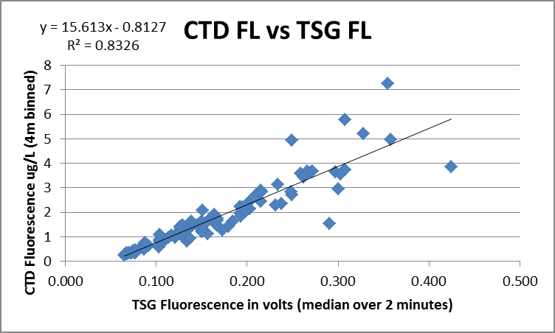

(See 2015-21-ctd-tsg-comp.xls.)

- Loop Bottle - TSG Comparisons
For the 1 loop sample the ratio of the TSG fluorescence (median over 2 minutes) to the extracted CHL from the loop is 0.098. The TSG salinity is lower than the salinity sample from the loop by 0.184. The flow rate was close to 1 when the sampling occurred.
(See 2015-21-loop-TSG-comp.xlsx.)

- TSG Fluor vs Surface Rosette (chlorophyll)
There were many extracted chlorophyll samples from rosette bottles – the times do not match with the data that were extracted from the TSG files but assuming the ship did not move a lot we hope to find some consistency in the comparison of those samples with the TSG fluorescence. When the ratio of TSG FL / CHL is plotted against pressure it suggests that the voltages are ~10% of the CHL values, though there is a lot of variability at 5m. This is consistent with the comparison between the CTD and TSG fluorometers. That is a little surprising as we don’t expect a really good match between the CTD fluorometer and extracted CHL. This can probably be explained by there not being many high values, CHL>5ug/L, where the fluorometers usually read low. As well, the CTD fluorometer compared better with CHL than usual during this cruise.
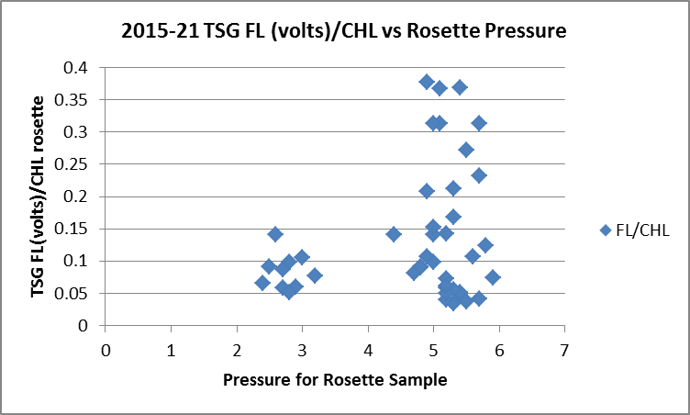

- Calibration History
The temperature and conductivity sensors were recalibrated in December 2013 and have been used for 9 other cruises since then. It was mounted on the Vector for 1 of those. The fluorometer has only been used once before with this equipment and no calibration information is available.

During 2015-10 the TSG fluorometer values were about 15% of the CTD fluorometer, but there was high variability. The fluorescence data were archived in volts.

During 2014-21 the TSG salinity was found to be lower than loop samples and CTD salinity by ~0.03 but the difference varied with flow rate which was highly variable. No recalibration was applied due to the variability in the comparisons and the fact that such a large drift in calibration on its first use seemed unlikely. During 2014-19 the TSG salinity was found to be low by ~0.02. 2014-22 results were not trusted. For 2015-01, -20 and -09 the salinity was lower than loop samples and the CTD salinity by about 0.02, 0.025 and 0.03, respectively. During 2015-18 the salinity was found to be low by 0.014 but the TSG was so noisy that this was not trusted. 2015-01 salinity data were recalibrated by adding 0.02. For 2015-10 the salinity was recalibrated by adding 0.17 since it was lower than loop by that amount and lower than the CTD by 0.1 to 0.18,

During 2014-19 the TSG temperature was found to be higher than the CTD temperature by ~0.005Cº. For 2015-09 the intake temperature was higher than CTD temperatures by 0.004 to 0.006, and salinity was lower than loop samples and CTD salinity by about 0.03. During 2015-10 the intake temperature was found to be higher than CTD temperature by from 0.004Cº to 0.007Cº. There was no useful comparison from 2015-46.

Conclusions
1. The TSG clock worked well.
2. The TSG flow rate was steady at ~1, except for a 7-hour section during which it was ~1.5.
3. The temperature in the loop increases by roughly 0.15 to 0.24Cº depending on intake temperature.
4. The TSG intake temperature was higher than the CTD temperature by a median of ~0.011C which is a little higher than other cruises since the last factory calibration. But when data are restricted to 28 casts with the lowest standard deviation in the TSG intake temperature, the median difference is <0.001.
5. The TSG Salinity is lower than the CTD salinity by between 0.1 and 0.4 (excluding 1 extreme outlier). When all data are included the TSG is lower than the CTD salinity by a median value of 0.21 with a very high standard deviation (0.59). Removing obvious outliers reduces the standard deviation significantly, but has little effect on the median. When the casts with the 10 lowest standard deviations in the TSG salinity are selected, the TSG is low by a median of 0.178. For the one loop sample, the TSG is lower than the sample by 0.18. Taken together with the results of the previous cruise, recalibration by adding 0.18 looks reasonable.
6. The fit of CTD fluorescence in ug/L against TSG fluorescence in volts indicates that the TSG fluorescence should be calibrated using:
TSG FL(ug/L) = 15.61 * TSG FL (volts) -0.81
However, that is based on a comparison with 4m-binned CTD data. The comparison with rosette CHL samples suggests that there is a tighter fit at 3db than at 5db, so the water being sampled by the TSG may come from shallower than 4m. The fit against CHL samples lead to an estimate that the TSG Fluorescence should be multiplied by about 10, and for low CHL that fits the equation above reasonably well. The 1 loop CHL sample had the value 2.29ug/L which was ~10X the TSG fluorescence. Using the equation above we would expect a ratio of about 11.5.
No recalibration will be applied as there are too many variables to consider, but a note will be made in the header comments that a rough estimate of fluorescence in ug/L may be obtained by applying the equation above.
7. There were many spikes towards low salinity, up to about 0.5psu. These may be caused by bubbles and might account for low overall TSG salinity. Editing will remove some of the spikes but it is likely that there are other small ones that are not as obvious.
9. The salinity will be recalibrated by adding 0.18 to the salinity. This may overcorrect for areas with few spikes, but for most of the record it will under-correct. Part of the error may be due to calibration drift, but it is unlikely to account for most of the error.

f.) Editing
The ATC files were copied to *.EDT.
Each file was opened in CTDEDIT and the salinity channels were cleaned.
.
g.) Recalibration
File 2015-21-tsg-recal.ccf was prepared to add 0.18 to the salinity channel and was applied to both *.EDT files.

h.) Preparing Final Files
REMOVE was used to remove the following channels from all casts: Scan Number, Temperature:Difference, Conductivity:Primary, Flag and Position:New channels.

HEADER EDIT was used to add a comment, change the DATA TYPE to THERMOSALINOGRAPH and add the depth of sampling to the header and to change channel names to standard names and formats.
Those files were saved as TOB files.

The Standards Check and Header Check were run and no problems were found.
The TSG sensor history was updated.
As a final check plots were made of the cruise track and it looks fine.
The cruise plot was added to the end of this report.

Particulars
PAR ON: 1-32, 39-65, 94, 109-164
Out of Order firing: 160

32. Niskin #3 fired at 250m for water – no sample number assigned – not needed in CHE file.
33. Should be named 34.
93. Rosette went down to 125m but swell on beam so sat @125m for 15 minutes. Brought to surface and then restarted downcast. Start archiving under same data file. Scan count @20700 for new downcast at 16:19
160. Niskin #19 was fired at 5m but had already been closed at the correct depth of 200m.

CRUISE SUMMARY
CTDs
CTD# | Make | Model | Serial# | Used with Rosette? | CTD Calibration Sheet Competed?
1 | SEABIRD | 911+ | 0443 | Yes | Yes

Calibration Information
Sensor |  | Pre-Cruise |  | Post Cruise
Name | S/N | Date | Location | Date | Location
Temperature | 2106 | 17Dec2014 | Factory
Conductivity | 2280 | 19Dec2014 | Factory
Secondary Temp. | 2663 | 15Jan2015 | Factory
Secondary Cond. | 2754 | 19Dec2014 | Factory
Transmissometer | 1396DR | 5Feb2014 | IOS
SBE 43 DO sensor | 0997 | 17Jan2015 | Factory
PAR | 4565 | 16Mar2011 | IOS
SeaPoint Fluor. | 3640 | n/a
Pressure Sensor | 0443 | 17Dec2014 | Factory
Altimeter | 62354 | n/a | Factory

CRUISE SUMMARY TSG
Make/Model/Serial#: SEABIRD/21/3363 Cruise ID#: 2015-21

Calibration Information
Sensor |  | Pre-Cruise |  | Post Cruise
Name | S/N | Date | Location | Date | Location
Temperature | 3363 | 28Dec13 | Factory
Conductivity | 3363 | 28Dec13 | Factory
WetLabs Fluorometer | Ws3s-953p
Temperature:Secondary | ? | ?
Flow meter | ? | n/a

