REVISION NOTICE TABLE
DATE | DESCRIPTION OF REVISION
27 March 2025 | Updated channel names & formats in TOB files. G.G.
31 Jan 2019 | Bottle spreadsheet converted to searchable BOT files.

PROCESSING NOTES
Cruise: 2015-15
Agency: SAFE
Location: B.C. Coast
Project: Strait of Georgia Juvenile Salmon / High Seas Salmon
Party Chief: Neville C. / Thiess M
Platform: W.E. Ricker
Date: 23 June 2015 – 20 July 2015

Processed by: Germaine Gatien
Date of Processing: 16 November 2015 – 22 April 2016
Number of original CTD HEX files: 97 Number of CTD files: 97
Number of original TSG HEX files: 77 Number of TOB files: 77

INSTRUMENT SUMMARY
SeaBird Model SBE 911+ CTD (#0585) was used for this cruise. Attached were a Seapoint Fluorometer (#3685) and an SBE18 pH sensor (#0851). The log indicates that an SBE 43 DO sensor (#1119) was also attached but there was no signal from that channel.

The deck unit was a Seabird model 11, serial number 0424.
The salinometer used at IOS was a Guildline model 8400B Autosal, serial # 68572.
An SBE21 Thermosalinograph (serial #2488) sampled every 30s.

SUMMARY OF QUALITY AND CONCERNS
The Daily Science Log was in good order.

This cruise has 2 legs with different project names and chief scientists:
- Strait of Georgia / Chrys Neville for events 2-214
- High Seas Salmon / Mary Thiess for events 215-373

The secondary conductivity sensor began to malfunction during the upcast of event #1. It continued through this cruise and through 2015-61 when the same sensor was used. Damage to the cell was reported during a factory check after 2015-61. The primary sensors were selected for archiving.

The log and configuration files indicate that a dissolved oxygen sensor was attached to the CTD but there was no signal found. It either malfunctioned or was not attached properly. It did work during 2015-61.

The stops for bottles were mostly shorter than the recommended 30s and occasionally extremely short, and the depth of sampling varied more than usual. The low near-surface salinity gradients for most casts reduced the consequences of the short stops, but the comparison was still noisy with many outliers. The comparison of bottle salinity with downcast CTD salinity suggests that the salinity was low by ~0.001. A post-cruise calibration showed it to be high by 0.003. There was one cruise after 2015-15 and before the factory check. So it is likely that the CTD was reading high during this cruise, but possibly by <0.003. The analysis of samples was fairly prompt, but evaporation and adsorption of samples might still raise bottle salinity a little and there is likely some effect due to incomplete flushing of Niskin bottles. If we assume that the bottles are higher than ambient waters by 0.003 and the CTD is lower than bottles by 0.001, this would imply that the CTD is actually reading high by about 0.002. So it is likely that the CTD is reading high, but by no more than 0.003. Recalibration was applied by subtracting 0.002.

The CTD fluorometer had the usual sort of correspondence with extracted CHL. For 1ug/L<CHL<5ug/L the values were reasonably close while the fluorometer read lower than CHL for higher CHL. Below 1ug/L there was a lot of noise in the comparison.

There was a major problem with the TSG data acquisition which has also been reported from an early 2016 Ricker cruise. The TSG stops frequently and this is often not noticed for many hours. The thermosalinograph data consist of 77 fragments with frequent large gaps in time. See the map at the end of the report to understand how this affected coverage.

There were no loop samples. A comparison was made between the temperature and salinity from the TSG and the CTD where the two overlapped in time. While the TSG salinity appeared to be lower than that from the CTD by about 0.11, this may be largely due to a mismatch in the depth from which the two data sets derive. CTD data came from an average pressure of 3.4db, while the TSG intake is at about 3m. Gradients can be very large at these depths and we do not expect errors of this size from calibration drift. No recalibration was applied to salinity due to this uncertainty.

The temperature comparison is also affected by the depth mismatch, but we expect little drift in the sensor and we have some history to help make an estimate of heating in the loop of the Ricker. This enabled an estimate that the water warmed by about 0.06Cº in the loop. This value was used to calculate Temperature:Primary which is a proxy for intake temperature. Temperature:Lab is the uncorrected temperature measured by the TSG in the lab.

PROCESSING SUMMARY

Seasave
This step was completed at sea; the raw data files have extension HEX.

Preliminary Steps
The Log Book was obtained. There were notes about problems during a few casts: pumps not working, pH buffer bottle left on and data acquisition started before the soak at 10m.
The cruise involved two separate projects.

The same configuration file was used throughout the cruise.
The cruise summary sheet was completed.
The history of the pressure sensor, conductivity, fluorometer and DO sensors were obtained.
The extracted CHL, nutrient and salinity analysis spreadsheets were obtained and the data from each were combined in spreadsheet 2015-15_bottle_data.csv.

The calibration constants were checked for all instruments and no errors were found.

Conversion of Full Files from Raw Data
All files were converted using con file 2015-15-ctd.xmlcon with hysteresis correction turned off.
A few casts were examined and all expected channels are present. The two temperature channels were close during downcasts, with the usual larger differences on the upcast.
The conductivity channels are far apart, by ~0.03 to 0.04, and for some casts the secondary conductivity differs much more between downcast and upcast than the primary conductivity. The configuration file was rechecked but no error was found.

DERIVE was run to get salinity and a few casts were checked against the bottle salinity. This was a rough comparison but it indicates that the primary salinity was reasonably close to the bottles, while the secondary was too high by about 0.2psu.
The fluorescence and pH traces look normal.
There is no dissolved oxygen signal. Tests were run to see if it was entered on the wrong channel, but there is no signal in any of the voltages said to be empty.

The pumps did not come on for the first 2 casts; the only data in these files that are not pumped are the pH and pressure channels.

WILDEDIT
Program WILDEDIT was run to remove spikes from the pressure, conductivity & temperature only.
Parameters used were: Pass 1 Std Dev = 2 Pass 2 Std Dev = 5 Points per block = 50
The parameter “Keep data within this distance of the mean” was set to 0 so all spikes would be removed.

ALIGN DO
There is no signal in the dissolved oxygen channel, so this step was skipped.

CELLTM
CELLTM was run using (α = 0.0245, β=9.5) for both the primary and secondary conductivity.

DERIVE
Program DERIVE was run twice:
- on all casts to calculate primary and secondary salinity; dissolved oxygen concentration was not derived since there is no signal in the DO voltage channel.
- on a few casts to calculate the differences between primary and secondary channels for temperature, conductivity and salinity. These were placed in a test directory.

Test Plots and Channel Check
These sensors had not been used since the previous factory calibration. The casts don’t go deeper than 250m. Three casts from the cruise that followed are included. The differences found at a sample of casts were:
Cast # | Press | T1-T0 | C1-C0 | S1-S0 | Descent Rate
2015-15-0002 | 240 | +0.0013 | -0.0006 | -0.0076 | Steady, Mod.
2015-15-0007 | 240 | -0.0001 | +0.0498 | +0.0509 | Steady, High
2015-15-0123 | 240 | +0.0014 | +0.0443 | +0.4530 | Steady, Mod
2015-15-0245 | 240 | +0.0004 | +0.0184 | +0.2023 | Noisy, High
2015-15-0362 | 240 | +0.0013 | +0.0422 | +0.4308 | Steady, Mod
2015-61-0014 | 240 | +0.0010 | +0.0067 | +0.0728 | FNoisy, High
“ | 950 | +0.0007 | +0.0074 | +0.0870 | FNoisy, High
2015-61-0076 | 950 | +0.0008 | +0.0090 | +0.1057 | XNoisy, Mod
“ | 1500 | +0.0011 | +0.0092 | +0.1109 | XNoisy, High
2015-61-0077 | 950 | +0.0011 | +0.0163 | +0.1937 | XNoisy, High
“ | 1500 | +0.0010 | +0.0167 | +0.2028 | XNoisy, High
The differences for the first downcast look normal, but during the upcast the secondary salinity suddenly rose. The conductivity and salinity differences remain high thereafter, possibly increasing with time. During the cruise that followed the differences were a little reduced, but then started climbing again. In the middle of 2015-61 the sensors were changed. Initial salinity comparisons confirm that the secondary salinity is much farther from bottles than the primary.

Because the bad data showed up during the upcast, the idea that the CTD might have hit bottom was investigated. Without transmissivity and/or altimetry channels there is no strong evidence. The sensor failed about 40m from the bottom of the cast.

Conversion to IOS Headers
The IOSSHELL routine was used to convert SEA-Bird 911+ CNV files to IOS Headers.
The project name and chief scientist should be:
- Strait of Georgia / Chrys Neville for events 2-214
- High Seas Salmon / Mary Thiess for events 215-373
CLEAN was run to add event numbers and to replace pad values in the pressure channel with interpolated values based on record number.

Checking Headers
The header check was run and some negative values were found in pressure. There were no negative fluorescence values.
The surface check gave an average value of 3.7db which reasonable for the Ricker.
Cast #251 was stated to have been aborted, but there are data down to 131db so it seems worth processing.
Cast #254 did not come on until the CTD was at 12.9db.

There were a few slightly negative pressures with pressures off and salinity values very low. Many casts stop when the pressure is ~0.3db. There are many values around 0.3db that look to be close to the surface. The pressure may be slightly low, but likely within 0.2db. When it was used in 2015-61 no recalibration was applied.

The cross-reference check was compared with the log book and no errors were found.
The cruise track was plotted and added to the end of this report. No problems were found.

Shift
Fluorescence
A shift of +24 is the usual setting used to align the Seapoint fluorescence when pumped, and it works well for these data.
SHIFT was run on all casts to advance the fluorescence by +24 records.

pH
Because of hysteresis in the pH signal, tests are best run on casts with distinctive features in the pH traces. Tests were run on a number of casts to see what setting worked best. The results were far from clear especially during the first leg when the profiles were very smooth and the shift had little apparent effect. Later in the cruise there are more distinctive features and it appears that a shift of +50 improves the correspondence. That is the shift that was used when the sensor was used during 2015-19 in September, though it was mounted on a different CTD.
SHIFT was run on all casts with the setting +50 records.

Conductivity
Tests were run on 5 casts using a variety of settings to see which shift produces reasonably stable T-S plots. The best results were found by using -0.7 records for the primary conductivity. No tests were run on the secondary conductivity since that sensor malfunctioned.
SHIFT was run to advance the primary conductivity by -0.7 records; salinity was recalculated.

DELETE
Before running DELETE a text editor was used to remove the first 3500 records from cast #166 because they came from the soak period.

The following DELETE parameters were used:
Surface Record Removal: Last Press Min
Maximum Surface Pressure (relative): 10.00
Surface Pressure Tolerance: 1.0 Pressure filtered over 15 points
Swells deleted. Warning message if pressure difference of 2.00
Drop rates < 0.30m/s (calculated over 11 points) will be deleted.
Drop rate applies in the range: 10db to 10db less than the maximum pressure
Sample interval = 0.042 seconds (taken from header)
COMMENTS ON WARNINGS: There were no warnings.

All files were put through REVERSE and then DELETE to obtain data for comparison with bottles.
The files were bin-averaged and then thinned to 9.5db.

Comparisons of CTD and bottle samples
Bottle samples were taken for casts #215 to #373. The salinity, chlorophyll and nutrients data were combined in a single spreadsheet. A salinity sample was found for event #237 that has no CHL or NUTS samples, and for event #257, salinity is missing. The station name corresponds to #257 and there was no CTD cast #237, so it is assumed that the salinity bottle labelled #237 should be #257.

The CTD was stopped at about 14.5m during the upcasts and after a short wait the Niskin bottle mounted 5m above that was fired. For this type of sampling, there are always variations in the depth of the stop, but during this cruise there was more variation than usual, with at least 6 casts stopping at about 10m rather than 15m.

There was also a lot of variation in the length of stops with very few lasting the usual 30s. For event #281 the stop lasted about 4s and the CTD salinity was still falling when the CTD started to move again. While the bottle salinity agrees fairly well with the downcast salinity at 10m, it is much lower than the CTD as measured during the upcast because the CTD has not equilibrated. Fortunately, the Niskin closed at a depth where the vertical salinity gradient was low, so the bottle value is reasonably representative of the ambient waters. This means that the comparison with downcast data is likely to be more reliable than that with the upcast data.

These variations reduce the reliability of the bottle comparison, and for some casts the Niskin contents may not have enough time to equilibrate. Where near-surface gradients are low, this is not a huge problem, but for most casts they are high enough to lead to poor matches.

SALINITY
When all bottles are included in the comparison the downcast salinity is high by an average of ~0.02, but the median shows it high by ~0.002. By removing cases where the CTD salinity and bottle salinity differ by more than 0.01, the median shows the downcast salinity to be low by 0.0009. The upcast differences are much higher at an average of ~0.06 and a median of ~0.02 when all data are included, with the CTD being higher. When the cases with large differences are excluded the CTD upcast values are higher than bottles by a median value of ~0.002.

 |  |  |  |  | CTD down-Bottle | CTD up-Bottle
using all data |  |  |  | average | 0.0214 | 0.0646
 |  |  |  | median | 0.0017 | 0.0183
 |  |  |  | stdev | 0.1115 | 0.1473
excluding salinity differences >.01 |  |  |  | median | -0.0009 | 0.0019
 |  |  |  | stdev | 0.0051 | 0.0050
 |  |  |  | count | 21 | 17

The analysis of samples was fairly prompt (within 23-62days), but evaporation and adsorption of samples would likely raise bottle salinity a little and there is likely some effect due to incomplete flushing of Niskin bottles which would raise the values further. If we assume that the bottles are higher than ambient waters by 0.003 and the CTD is lower than bottles by 0.001, this would imply that the CTD is actually reading high by about 0.002. A calibration from December 2015 shows that there was drift upwards by ~0.003, but 2015-15 was the first time these sensors were used, and there was a cruise after this one. A correction of -0.002 looks appropriate and should produce salinity within ±0.002.

FLUORESCENCE
For fluorescence there were often subsurface maxima at about 15 to 20m, so if the fluorometer has not had time to equilibrate it may read high on the upcast. The bottles may also contain water with higher CHL than ambient conditions, but the gradient is often lower at the bottle level than at the level at which the CTD stops, so bottle values may be more reliable than upcast CTD data. This sort of comparison is always very noisy, but the overall impression is that the sensor behaved as normal with fairly good correspondence with extracted CHL for 1ug/L<CHL<5ug/L and lower values from the fluorometer for higher CHL. Below 1ug/L there is a lot of noise in the comparison.
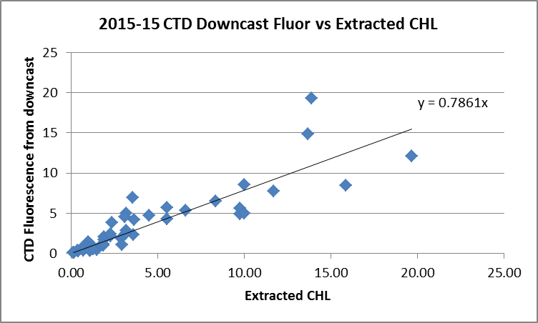.
For details see file 2015-15-bottle-ctd-comparison.xlsx.

While the matches are not as reliable as usual, CTD data from the downcast at 9.5db were added to the bottle data in file 2015-15-Bottle-Data.csv. These include temperature, salinity, pH and fluorescence.

- Other Comparisons
Previous experience with these sensors –
Salinity:
This was the first use of the conductivity and temperature sensors since they were last recalibrated. They were used during the cruise that followed, 2015-61, for casts #1-77, after which they were replaced because the salinity channels were so far apart. The secondary salinity was found to be bad.

Pressure:
The pressure sensor was recalibrated in May 2013 and the factory offset was found appropriate for the 7 cruises since then that have been processed. No recalibration was applied for data from 2015-61.

Historic ranges – Where local climatology was available most data fell within the limits. All temperature and salinity data from Juan de Fuca Strait and the west coast of Vancouver Island fell within the 3-standard deviation limits. However, in Queen Charlotte Strait and parts of the Strait of Georgia there were cases of temperature being high in parts of the top 50m. For just a few of those casts salinity was low. High temperatures have been observed during many cruises of 2015. These observations do not suggest any problem with sensor calibrations.

Repeat Casts –
There were no repeat casts.

Post-Cruise Calibration
The secondary conductivity was found to have malfunctioned when it was examined at the factory in December 2015. The drift in the primary temperature and conductivity implied a drift upwards of about 0.003 in salinity.

- DETAILED EDITING
The primary sensors were selected for editing and archiving.

CTDEDIT was used to remove spikes that appear to be due to instrumental problems and likely to affect the bin-averaged values and records corrupted by shed wakes including some surface records.

Cast #287 – The primary temperature and salinity were bad from about 100db to the bottom for the downcast and for all of the upcast. The pump status had not changed and the secondary channels look ok. Since the secondary salinity is not reliable they could not be selected for this cast, so the primary channels were used, but data below 100db were removed. The change coincided with a sudden slowing of the CTD near the bottom, though it does not appear that the CTD touched bottom.

All casts required some editing except for the first 2 casts which will have temperature and salinity removed later.

- Initial Recalibration
The pressure does not need recalibration.

Various limitations in the comparison of CTD salinity with bottles make it unreliable for determining what recalibration should be applied, though it suggests that there had been little drift in conductivity. The post-cruise calibration indicates that the primary salinity was high by about 0.003 in December 2015, but there was a cruise after this one, so it is unlikely all that drift occurred by the end of this cruise.
So there is insufficient evidence to recalibrate salinity.

No recalibration was applied.

- Fluorometer Processing
A median filter, fixed size=11 was applied to reduce spikiness in fluorescence channel.

- BIN AVERAGE of CTD files
The following Bin Average values were applied to the FIL files (output AVG):
Bin channel = pressure Averaging interval = 1.000 Minimum bin value = .000
Average value will be used. Interpolated values are NOT used for empty bins.

- Final CTD File Steps (REMOVE and HEADEDIT)
REMOVE was run on all casts to remove the following channels:
Scan_Number, Temperature:Secondary, Salinity:T1:C1, Conductivity:Primary, Conductivity:Secondary, Oxygen:Voltage:SBE, Status:Pump, Descent_Rate and Flag
For events #2 and 7 the pumped channels Temperature:Primary, Salinity:T0:C0 and Fluorescence:URU:Seapoint were also removed.
For event #85 channel SBE:pH was also removed.

Cast #251 was aborted due to a major hydraulic leak, but the data that was collected looks fine, so it will be archived.

Profile plots were produced at this point to check for errors. No problems were found.
T-S plots were produced; there are some small unstable features that likely reflect real conditions; these are found close to shore, mostly in the Johnstone Strait area.

HEADER EDIT was used to fix formats and channel names and to add the following comments:
---------------------------------------------------------------------------------------------
Fluorescence and pH data are nominal and unedited except that
some records were removed in editing temperature and salinity.

Recalibration of channel Salinity:T0:C0 was based on a post-cruise
calibration and a comparison with bottle samples. Stops for
bottles were often very short and there was a cruise between this
one and the post-cruise calibration, but the salinity is likely
good to +/- 0.002.

A dissolved oxygen sensor was mounted but no data were acquired.

WARNING: The pH:SBE:Nominal data should be used with caution; no field
calibration data were collected. Calibration is required for each cast to get
absolute values, although general trends within a cast are likely real.

For details on the processing see the report: 2015-15_Processing_Report.doc.
---------------------------------------------------------------------------------------------
Different comments were placed in the files for events #2 and #7 because the pumps were off, #85 because pH was removed and #251 because the cast was aborted before reaching the bottom.

The cross-reference list was produced and no problems were found.
The Standards Check routine was run and no problems were found.
The Header Check was run and no problems were found.
The final files were named CTD.
The track plot looks fine.
The sensor history files were updated.

- Thermosalinograph
Data were provided in 77 hex files with non-standard names.
There was no external thermistor or flow meter.
There were no loop salinity samples taken.

a.) Checking calibrations
The configuration file was checked and the parameters are correct.
The file was saved as 2015-15-tsg.con.

b.) Conversion of Files
The hex files were converted to CNV files using configuration file 2015-15-tsg.con.
The file names were non-standard so were renamed.
They were then converted to IOS HEADER format. The two legs were given different information.

CLEAN was run to add End times and Longitude and Latitude minima and maxima to the headers.
ADD TIME CHANNEL was used to add Time and Date channels based on the Julian time.
A track plot shows that there are many large gaps.
At least 9 files contain less than 30 minutes of data and there are only 2 to 5 minutes of data in files 2015-15-0006, 2015-15-0029 and 2015-15-0033.

Time-series plots were produced. No obvious problems were found other than the short lengths.

c.) Checking Time Channel
The CTD data were exported to a spreadsheet which was saved as 2015-15-ctd-tsg-comp.xls.

22 CTD casts both overlapped with TSG data and had CTD data between 3 and 3.5m. Many of the comparisons come immediately after the TSG file was started.

The TSG file was opened in EXCEL, median and standard deviations (over 5 records) were calculated for temperature and salinity and the file was reduced to the times of CTD files. Those data were added to the CTD data. The standard deviation will help check which comparisons are most reliable.

To check for problems in the TSG clock or bad matches of TSG and CTD data, the differences between latitudes and longitudes were found. The differences in latitude and longitude were all <0.001° and the median differences in both are 0.0001°. This shows both the times and positions are reliable for both systems.
This spreadsheet will also be used in step (d) to compare temperature and salinity.

d.) Comparison of T and S from TSG and CTD data
Salinity
When the differences between the TSG salinity (median over 2 minutes) and the CTD salinity from 3db are plotted against the standard deviation in the TSG salinity, the scatter is large. When cases with standard deviations > 0.005 are excluded, the picture is only slightly clearer as seen in the plot below.
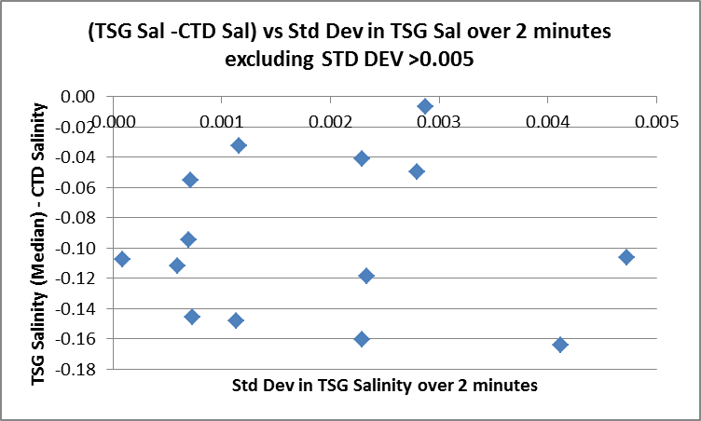

The TSG is lower than the CTD salinity by a median value of 0.1078 (standard deviation 1.27) using all available points of comparison. Excluding those with high standard deviation in the TSG data, the median is almost identical, at -0.1071 but the standard deviation is reduced to 0.05. The TSG intake is at about 3m. The CTD files contain bin-averaged data with average pressures between 3.2db and 3.5db. There are no data any higher for comparison. So the vertical salinity gradient may explain why the TSG is reading lower than the CTD. There evidence of the TSG reading low is much to weak to justify recalibration of the TSG.

Lab Temperature
The lab temperature shows similar scatter to that of the salinity. We expect some heating in the loop that will lead to the TSG temperature reading higher than the CTD. Further, we expect that the TSG may read a little higher due to the CTD sampling a little below the intake.

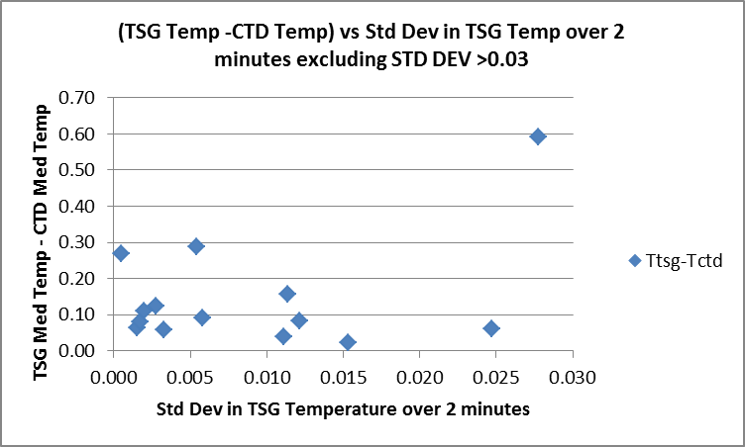

When all data are included the TSG temperature is high by a median of 0.0984Cº and a standard deviation of 0.48Cº. When cases with standard deviation >0.03 are excluded the median difference is 0.086Cº with a standard deviation of 0.15Cº. When cases with Ttsg-Tctd >0.02 are excluded the median difference is 0.081Cº with a standard deviation of 0.053Cº.

We expect more heating in the loop when the intake temperature is much lower than the ambient temperature on the ship. The temperature range during this cruise was large with high temperatures in part of the Strait of Georgia and lower ones elsewhere. Yet, in the areas where we might expect little temperature change in the loop, the differences range from -0.59 to +1.68 Cº. This is likely because the near-surface temperature gradients are very high in the same places where temperatures are high. So a small mismatch in the pressures for the TSG and CTD data will lead to a large error. For the 3 cases with the lowest ambient temperature the differences between TSG and CTD were about 0.08Cº, 0.09Cº and 0.12Cº. Those were in areas where vertical gradients were probably lower than in the Strait of Georgia. For another cast with an apparent low surface gradient and high ambient temperature, the difference was about 0.03Cº. So we get a rough idea that the range of heating in the loop would be from ~0 to 0.9.

The only other information available for this TSG while in use on the Ricker since it was last calibrated is from 2014-66 in October 2014. The ambient temperatures at that time were similar to the middle of the range measured during this cruise and the lab temperature was thought to be high by 0.06Cº due to heating in the loop. The salinity was thought to be low by 0.0045. There is also some history from 2012 in March and October when the temperature was thought to be high by 0.065Cº. Temperature drift is usually very small, so we can expect results to vary little due to the factory calibration. So that estimate is within the range of what we think the loop heating might be for this cruise. Since most of the TSG data were collected in the cooler waters, it looks reasonable to use 0.06Cº as an estimate of heating in the loop.

Conclusions
1. The TSG clock appears to have worked well.
2. The TSG temperature is likely higher than the ambient waters by about 0.6Cº. This may include error due to calibration drift and heating in the loop but the former is likely to be much smaller than the latter.
3. The TSG salinity appears to be lower than the CTD salinity but the evidence is weak due to scatter in the comparison and the likelihood that at least some of the difference is due to a mismatch in depth of the TSG intake and the CTD sampling.

e.) Editing
No editing was found necessary.

g.) Recalibration
Because there is no intake temperature available we want to create a proxy for that. So channel Temperature:Lab was created, set equal to Temperature:Primary and placed after Temperature:Primary.

File 2015-15-tsg-recal1.ccf was used to subtract 0.060 from Temperature:Primary which will serve as a proxy for Temperature:Intake.

h.) Preparing Final Files
REMOVE was used to remove the following channels from all casts: Scan Number, Conductivity:Primary, Flag and Position:New channels.

HEADER EDIT was used to add a comment, change the DATA TYPE to THERMOSALINOGRAPH and add the depth of sampling to the header and to ensure channel names have standard names and formats. Those files were saved as TOB files.

The TSG sensor history was updated.
As a final check plots were made of the cruise track and it looks realistic.
The cruise plot was added to the end of this report.

Particulars

2. Pumps did not turn on.
7. Pumps did not turn on.
10. Pumps ok.
13. CTD after event 14 (Net)
29. CTD after event 30 (Net)
85. pH buffer bottle not removed for this cast.
93. Strong current – issues with wire angle for both CTD and bongo. CTD not located near associated fish set.
96. Very strong current – Johnstone Strait
100. Very strong current – Johnstone Strait
120. CTD after event 121 (Net)
166. Soak period archived – will need to remove
251. Cast aborted – downcast data look useful until acquisition stopped.

Institute of Ocean Sciences

CRUISE SUMMARY
CTDs
CTD# | Make | Model | Serial# | Used with Rosette? | CTD Calibration Sheet Competed?
1 | SEABIRD | 911+ | 0585 | No | Yes

Calibration Information CTD #443
Sensor |  | Pre-Cruise |  | Post Cruise
Name | S/N | Date | Location | Date | Location
Temperature | 4752 | 23Jan2014 | Factory
Conductivity | 3396 | 19Dec2014 | Factory
Secondary Temp. | 2449 | 06Apr2014 | Factory
Secondary Cond. | 2399 | 17Jan2014 | Factory
SBE 43 DO sensor | 1119 | 21Jan2014 | Factory
Seapoint | 3685
SBE18 pH | 0851 | 04Sep2014 | Factory
Pressure Sensor | 0585 | 30Dec2013 | Factory

TSG
Make/Model/Serial#: SEABIRD/21/2488 Cruise ID#: 2015-15

Calibration Information
Sensor |  | Pre-Cruise |  | Post Cruise
Name | S/N | Date | Location | Date | Location
Temperature | 2488 | 7Jan14 | Factory
Conductivity | 2488 | 7Jan14 | “

