REVISION NOTICE TABLE
DATE | DESCRIPTION OF REVISION
27Mar 2025 | Updated channel names & formats in TOB files. G.G.
13 Dec.2016 | BOT files added. For details see note at end of this report. G.G.

PROCESSING NOTES
Cruise: 2015-12
Agency: MEAD
Location: WCVI
Project: La Perouse Acoustic Trawl Survey
Party Chief: Boldt
Platform: W.E. Ricker
Date: 621 July 2015 – 4 August 2015

Processed by: Germaine Gatien
Date of Processing: 5 August 2015 – 6 January 2016
Number of original HEX files: 26 Number of CTD files: 26
Number of original TSG files: 8 Number of TOB files: 8

INSTRUMENT SUMMARY
SeaBird Model SBE 911+ CTD (#0550) was used for this cruise. It was mounted in a rosette and attached an SBE 43 DO sensor (#1176), a Seapoint Fluorometer (#3641) and an SBE18 pH sensor (#0851). TSG (#2488) was used with no flow meter, intake thermistor or added sensors.

SUMMARY OF QUALITY AND CONCERNS
The Daily Science Log Book was in good order.

There were no salinity calibration samples available. Two were taken but they remained on the ship long enough that the quality was likely degraded and they were from fairly shallow water so were considered of very limited use and not worth getting analyzed.

The comparison between the SBE Fluorometer data and the extracted chlorophyll samples showed a pattern typical of these sensors. The fluorometer read close to the CHL samples for CHL < 5ug/L and about 50% of the CHL for CHL>5ug/L. The chlorophyll maximum was usually about 5 to 10m below the bottle stop level, so inefficient Niskin flushing might partly account for the fluorometer reading lower than CHL.

There was no dissolved oxygen sampling and the oxygen sensor has not been used on any other cruise from which data has been processed since it was last recalibrated at the factory. The surface oxygen saturation values are reasonable, but there is too much variability in this region to put much weight on that judgment.

The TSG data includes 8 files, many of them short, with gaps between them. There was no loop sampling. There were only 4 CTD casts that overlapped with TSG data and those casts start too deep to provide a good comparison. Given so few data and high variability in both data sets, no great weight can be put on the comparison of temperature and salinity, but it did establish that the TSG clock performed well, and suggests that the water in the loop originates somewhat above the intake depth.

PROCESSING SUMMARY

Seasave
This step was completed at sea; the raw data files have extension HEX.
The file names were not in standard format. The raw files were renamed.

Preliminary Steps
The Log Book was obtained in digital format.
It is noted that the water samples were taken 4m above the CTD with only 1 sample per cast.
The same configuration file was used throughout the cruise.
The cruise summary sheet was completed.
The pressure sensor, conductivity and DO sensors have not been used for any other cruises that have been processed since they were last calibrated at the factory.
The extracted CHL and nutrient analysis spreadsheets were obtained and the data from each were combined in spreadsheet 2015-12-bottles.csv.

The calibration constants were checked for all instruments. No errors were found.

Conversion of Full Files from Raw Data
All files were converted using con file 2015-12-ctd.xmlcon with hysteresis correction turned off.
A few casts were examined and all expected channels are present.
As usual differences between channels were larger for upcasts than downcasts. The differences between temperature traces were noisier than for the conductivity.
As mentioned in the log the primary salinity and temperature were bad for cast #59, especially in the upcast.
The fluorometer, pH and dissolved oxygen traces look normal.

WILDEDIT
Program WILDEDIT was run to remove spikes from the pressure, conductivity & temperature only.
Parameters used were: Pass 1 Std Dev = 2 Pass 2 Std Dev = 5 Points per block = 50
The parameter “Keep data within this distance of the mean” was set to 0 so all spikes would be removed.

ALIGN DO
A setting of +4s was used during other recent cruises using this DO sensor, but it has been recalibrated since then. Checks of the offset between distinctive features in T and DO suggest that +5s is better for this cruise.
ALIGNCTD was used to advance the DO Voltage by 5s relative to the pressure.

CELLTM
The noise in the upcast makes the tests for the best parameters for this routine very difficult to interpret. Tests on previous cruises using these sensors showed the default setting of (α = 0.0245, β=9.5) did the best job and it does improve the data for both conductivity channels for these data.
CELLTM was run using (α = 0.0245, β=9.5) for both the primary and secondary conductivity.

DERIVE
Program DERIVE was run:
on all casts to calculate primary and secondary salinity and dissolved oxygen concentration.
on 2 casts to calculate the differences between primary and secondary channels for temperature, conductivity and salinity. These were placed in a test directory and will not be archived.

Test Plots and Channel Check
For this cruise the casts are all shallow making the comparison less reliable, but two casts were examined and the differences were:

Cast # | Press | T1-T0 | C1-C0 | S1-S0 | Descent Rate
2015-12-0006 | 360 | +0.0008 | -0.00003 | -0.0011 | Noisy, Mod
2015-12-0062 | 360 | +0.0007 | -0.0001 | -0.0016 | Steady, High

Conversion to IOS Headers
The IOSSHELL routine was used to convert SEA-Bird 911+ CNV files to IOS Headers.
CLEAN was run to add event numbers and to replace pad values in the pressure channel with interpolated values based on record number.

Checking Headers
The header check was run. No problems were noted other that there is evidence of spikes in pressure.

The surface check gave an average value of 4.2db which is not out of line for the Ricker. Checks of a few casts where data were available near the surface of the upcast show the conductivity falling very rapidly when the pressure is ~0.8db, but the pumps were off so this evidence is weak. There are no transmissivity data which might make the picture clearer, but the pH values look like the probe was in water and that sensor is not pumped. It is likely that acquisition stopped while the CTD was still in the water and there is no record of any other uses of this pressure sensor since it was last calibrated. Pressure is likely ok.

The cross-reference check was compared with the log book and the only problem noted is with the station names. The log book contains station names for only 12 casts and only the last 4 casts had those station names entered in the headers. For the first 12 casts and for event #55 the event number was entered as the station name. It was left blank for others. The station names were edited in the CLN files to make them match the log book; where there is no entry in the log the station name line was removed.

The cruise track was plotted and added to the end of this report. No problems were found.

Shift
Fluorescence
A shift of +24 is the usual setting used to align pumped SeaPoint fluorometers with temperature.
SHIFT was run on all casts to advance the fluorometer by +24 records. Before and after plots suggest this was effective in aligning the data.

Conductivity
Tests were run on a few casts using a variety of settings to see which shift produces reasonably stable T-S plots. The bests result varied from feature to feature, but overall the best choice for the primary salinity was -1.0 records and for the secondary it was -0.7 records.
Two runs of SHIFT were used to apply advance the primary by -1.0 records and the secondary by -0.7 records.

Dissolve Oxygen
Checks were made of the alignment of DO and temperature and the shift applied earlier appears to have done a good job though, as usual, for some features it was too little or too much.

pH
Because of hysteresis in the pH signal, tests are best run on casts with distinctive features in the pH traces. This was done by finding the distance between such features in the upcast and downcast and comparing that with the temperature offset after applying a variety of shifts. The setting of +50 records produced good results.
SHIFT was run on all casts with the setting +50 records.

DELETE
The following DELETE parameters were used:
Surface Record Removal: Last Press Min
Maximum Surface Pressure (relative): 10.00
Surface Pressure Tolerance: 1.0 Pressure filtered over 15 points
Swells deleted. Warning message if pressure difference of 2.00
Drop rates < 0.30m/s (calculated over 11 points) will be deleted.
Drop rate applies in the range: 10db to 10db less than the maximum pressure
Sample interval = 0.042 seconds (taken from header)

COMMENTS ON WARNINGS: There were many warnings for 3 casts, but they all pertained to upcast portions of casts so are of no concern for the downcast files. However, it was found that the Remove Surface Records feature had removed too much data from event #55, likely because of a long stop at the surface followed by a quick drop to 10m followed by another long stop. DELETE was rerun on that file with the Remove Surface Records feature not selected.

Comparisons of CTD and bottle samples
There were no salinity samples available. A few were taken but they remained on the ship long enough that the quality was likely degraded and they were from fairly shallow water so were considered of very limited use, so no attempt was made to get them analyzed.

Fluorescence
There were 7 extracted chlorophyll samples. Plots of upcast data were examined to make an estimate of the depth at which the CTD stopped, and then fluorescence values from 4m above that were recorded. Plots of downcast data were also made and approximate fluorescence values recorded.

The ratio of the fluorescence from the upcast to the extracted chlorophyll in the bottle is highly variable, probably because the stopping level was often near the CHL maximum or in an area of great variability and we get the CTD fluorescence at a time when the CTD is moving, so the sensor may not have fully responded to the change. The fluorescence maximum was sometimes above and sometimes below the sampling level, and local gradients were often large. The downcast fluorescence compares reasonably well, with the fluorometer reading close to the CHL when CHL < 5ug/L and about 45% of the CHL for CHL>5ug/L. That is a typical response for this type of fluorometer.
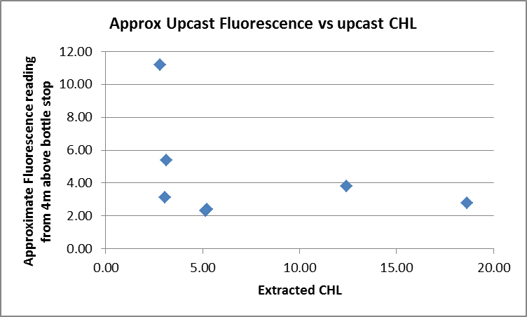
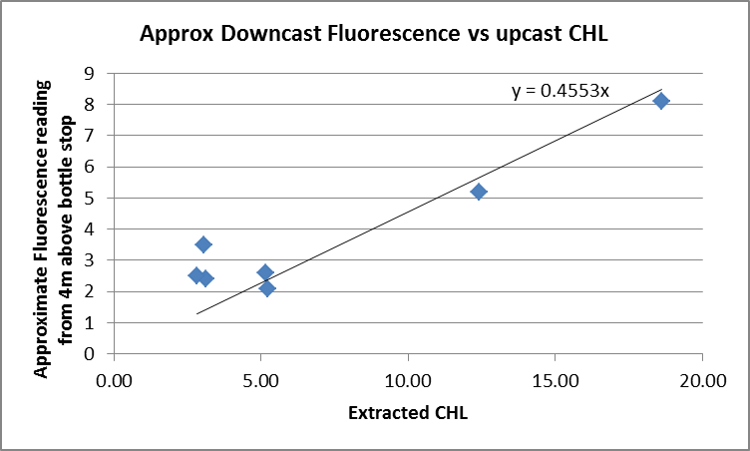

Other Comparisons
Previous experience with these sensors –
There is no history for these sensors; no cruise that has been processed used these sensors since they were last calibrated at the factory.
Historic ranges –All salinity data fell within the local climatology. The temperature data were mostly within the climatology except for some values above the maximum in a section between 40 and 60db at a cast near the mouth of Juan de Fuca Strait and at ~120db at station GEO1 in the Strait of Georgia. The 3-standard deviation climatology is too severe for near-shore areas, and there were many cases of high temperatures observed in 2014 and 2015 in the North Pacific. These excursions from the climatology are considered real variations and not evidence of calibration drift.
Repeat Casts –
There were no repeat casts and nearby casts were too shallow to make comparisons useful.
Post-Cruise Calibration
There were no post-cruise calibrations available.

DETAILED EDITING
The first issue is to decide which sensor pair to edit. There was little difference between the noise levels in the two T/S pairs, though the secondary might be slightly better near the surface. There was one cast with poor primary T/S data, so the secondary channels were chosen for editing.

CTDEDIT was used to remove spikes that appear to be due to instrumental problems and likely to affect the bin-averaged values and records corrupted by shed wakes including some surface records.
All casts required some editing.
All EDU files were copied to EDT.

Initial Recalibration
In the absence of any history or calibration sampling, no recalibration was applied to temperature, salinity or dissolved oxygen data. There is no evidence that pressure needs recalibration.

Fluorometer Processing
A median filter, fixed size=11, was applied to reduce spikiness in both fluorescence channels. A few casts were examined before and after this step and showed that the filter worked properly but there was little spikiness in the Wetlabs fluorescence signal, so the change is not large.

BIN AVERAGE of CTD files
The following Bin Average values were applied to the FIL files (output AVG):
Bin channel = pressure Averaging interval = 1.000 Minimum bin value = .000
Average value will be used. Interpolated values are NOT used for empty bins.

Final CTD File Steps (REMOVE and HEADEDIT)
REMOVE was run on all casts to remove the following channels:
Scan_Number, Temperature:Primary, Salinity:T0:C0, Conductivity:Primary, Conductivity:Secondary, Oxygen:Voltage:SBE, Status:Pump, Descent_Rate and Flag

Profile plots were produced at this point to check for errors. No problems were found.
T-S plots were produced; there are some very small unstable features that likely reflect real conditions.

A second SBE DO channel (with umol/kg units) was added.
REORDER was run to get the two DO channels together.

HEADER EDIT was used to fix formats and channel names and to add the following comments:

Data Processing Notes:
----------------------
Fluorescence and pH data are nominal and unedited except that some
records were removed in editing temperature and salinity.

There was no calibration sampling and no record of the sensors being used
during previous cruises. No recalibration was applied.

WARNING: The pH:SBE:Nominal data should be used with caution; no field
calibration data were available. Calibration is required for each cast to get
absolute values, although general trends within a cast are likely real.

For details on the processing see the report: 2015-12_Processing_Report.doc.

The cross-reference list was produced and no problems were found.
The Standards Check routine was run and no problems were found.
The Header Check was run and no problems were found.
The final files were named CTD.
Profile plots were made and look ok.
The track plot looks ok.
The sensor history files were updated.

Dissolved Oxygen Surface Saturation
Dissolved Oxygen saturation was derived and plotted. The surface saturations were about 70% in the Strait of Juan de Fuca and Haro Strait; this is typical of these well-mixed areas. Most other values were between 110% and 130% with a few readings between 130% and 180%. The higher readings were seen during casts with high sub-surface fluorescence values. These values suggest that the dissolved oxygen sensor calibration is reasonable, but the evidence is weak.

Thermosalinograph Data
There were no loop samples.
The files had non-standard names that include dates. The names were not changed.

a.) Checking calibrations
The configuration files were all the same and all parameters were correct.

b.) Conversion of Files
There were 8 HEX files available.
The HEX files were converted to CNV files using the corresponding configuration files.
They were then converted to IOS HEADER format.
CLEAN was run to add End times and Longitude and Latitude minima and maxima to the headers.
ADD TIME CHANNEL was used to add Time and Date channels. (*.ATC)

c.) Checking Time Channel
The CTD files were thinned to reduce the files to a single point from the downcast at or within 0.5db of 3 or 4db. The data were exported to spreadsheet 2015-46-TSG-CTD-comp.xlsx. The loop intake is at 3db though data from other ships suggest that water is drawn from above the intake level. Where there are data from 3db, the 4db value was removed, but for most there are no data from 3db.

Before removing the 4db data from the 5 casts where there was 3db data, the differences were examined. We expect the temperature to be lower at 4db than at 3db and usually it was, but in 2 cases it was higher. The data tend to be noisy at this level due to ship effects, shed wakes and natural variability. For temperature the differences between 3db and 4db ranged from being low by 0.006 to high by 0.01Cº. In all cases salinity at 4db was equal to or higher than at 3db with a range from 0 to 0.003. This gives us at least a vague idea of how the TSG temperature and salinity might be expected to differ from the CTD values at 4db.

There were only 4 CTD casts that overlapped with the TSG files.

The differences in latitude and longitude between the CTD casts and the TSG record when times were matched had average differences that were <0.0002°, and the maximum difference was 0.00035°, so the clock appears to have worked well and the matches made to construct the files were done correctly. There was some drift through the stops as seen from both the CTD log and TSG records, so a perfect match is not expected.

d.) Comparison of T and S from TSG and CTD data
There were 4 casts that overlapped with TSG data. Given so little data and the high variability from both data sets, no great weight can be put on the comparisons of temperature and salinity, but one was done to at least ensure that differences were not so large as to suggest malfunction of the TSG.

The TSG salinity was lower than the CTD salinity by an average of 0.446psu and a range of 0.39 to 0.60psu. These differences may indicate that the water in the loop is coming from higher in the water column than the shallowest CTD data and probably higher than the intake depth.

The TSG temperature was higher than the CTD temperature by an average of 0.480Cº and a range of 0.084 Cº to 0.771 Cº. The difference would be partly due to heating in the loop, which varies with the difference between the intake temperature and the ambient temperature of the ship and depends on the length of time in the loop. From summer cruises on other ships we find heating in the loop on the order of 0.1 to 0.2Cº. So, it is likely that much of the difference is due to the water in the loop coming from higher in the water column than the water sampled by the CTD, which we expect based on the salinity comparison.
For details see 2015-46-ctd-tsg-comp.xls.

e.) Calibration History
The temperature and conductivity sensors were recalibrated in January 2014. They were used during 2014-66 when the temperature was found to be high by 0.065Cº and salinity high by 0.0045. That was based on comparisons with CTDs and there was a lot of variability between inlets and offshore. We would expect less heating in the loop in August than October. The TSG was used on at least one cruise in July that hasn’t been processed yet and possibly on other cruises.

f.) Conclusions
1. The TSG clock appears to have worked well.
2. The only data available for comparison indicates that the TSG salinity looks reasonable and that the water likely comes from above the intake depth of 3m. The history is not consistent with the few points of comparison available for this cruise.

g.) Editing
The ATC files were opened in CTDEDIT and no editing was found necessary.

h.) Recalibration
No recalibration was applied.

i.) Preparing Final Files
REMOVE was used to remove the following channels from all casts: Scan_Number, Conductivity, Position:New and Flag.

HEADER EDIT was used to add a few header entries, add a comment, change the DATA DESCRIPTION to THERMOSALINOGRAPH and add the depth of sampling to the header and to change channel names to standard names and formats.
The files were saved with extension TOB.

The file names were changed to standard format, as follows:
WCVI_2015July28a – 2015-12-0001
WCVI_2015July28b – 2015-12-0002
WCVI_2015July28c – 2015-12-0003
WCVI_2015July28d – 2015-12-0004
WCVI_2015July28e – 2015-12-0005
WCVI_2015July28f – 2015-12-0006
WCVI_2015July28g – 2015-12-0007
WCVI_2015July31a – 2015-12-0008

The station names were removed from the first 3 files as they don’t make sense in an underway data file.
A cross-reference file was produced and a Header Check was run. No errors were found.
The TSG sensor history was updated.
As a final check plots were made of the cruise track and it looks fine.
The cruise plot was added to the end of this report.

Particulars (CTD)

1. At anchor.
7 & 8. Local time PDT in log book
59. Odd salinity on upcast, back to normal at ~14m.

Institute of Ocean Sciences

CRUISE SUMMARY
CTDs
CTD# | Make | Model | Serial# | Used with Rosette? | CTD Calibration Sheet Competed?
1 | SEABIRD | 911+ | 0550 | No | Yes

Calibration Information CTD #443
Sensor |  | Pre-Cruise |  | Post Cruise
Name | S/N | Date | Location | Date | Location
Temperature | 2374 | 17Dec2014 | Factory
Conductivity | 2128 | 10Mar2015 | Factory
Secondary Temp. | 2710 | 23Dec2014 | Factory
Secondary Cond. | 3184 | 19Dec2014 | Factory
SBE 43 DO sensor | 1176 | 23Dec2014 | Factory
Seapoint Fluorometer | 3641
SBE18 pH | 0851 | 4Sept2014 | Factory
Pressure Sensor | 75636 | 17Dec2014 | Factory

CRUISE SUMMARY TSG
Make/Model/Serial#: SEABIRD/21/2488 Cruise ID#: 2015-12

Calibration Information
Sensor |  | Pre-Cruise |  | Post Cruise
Name | S/N | Date | Location | Date | Location
Temperature | 3363 | 28Dec13 | Factory
Conductivity | 3363 | 28Dec13 | Factory
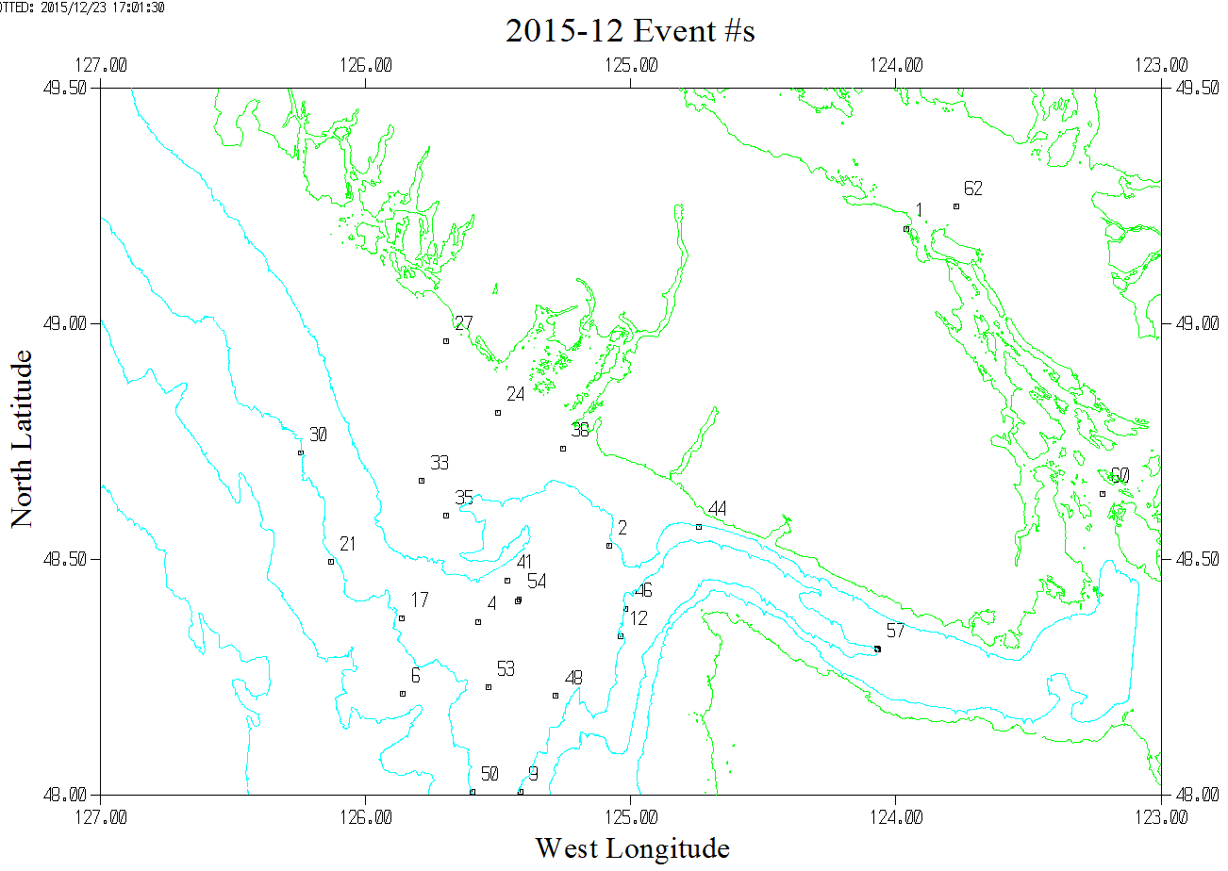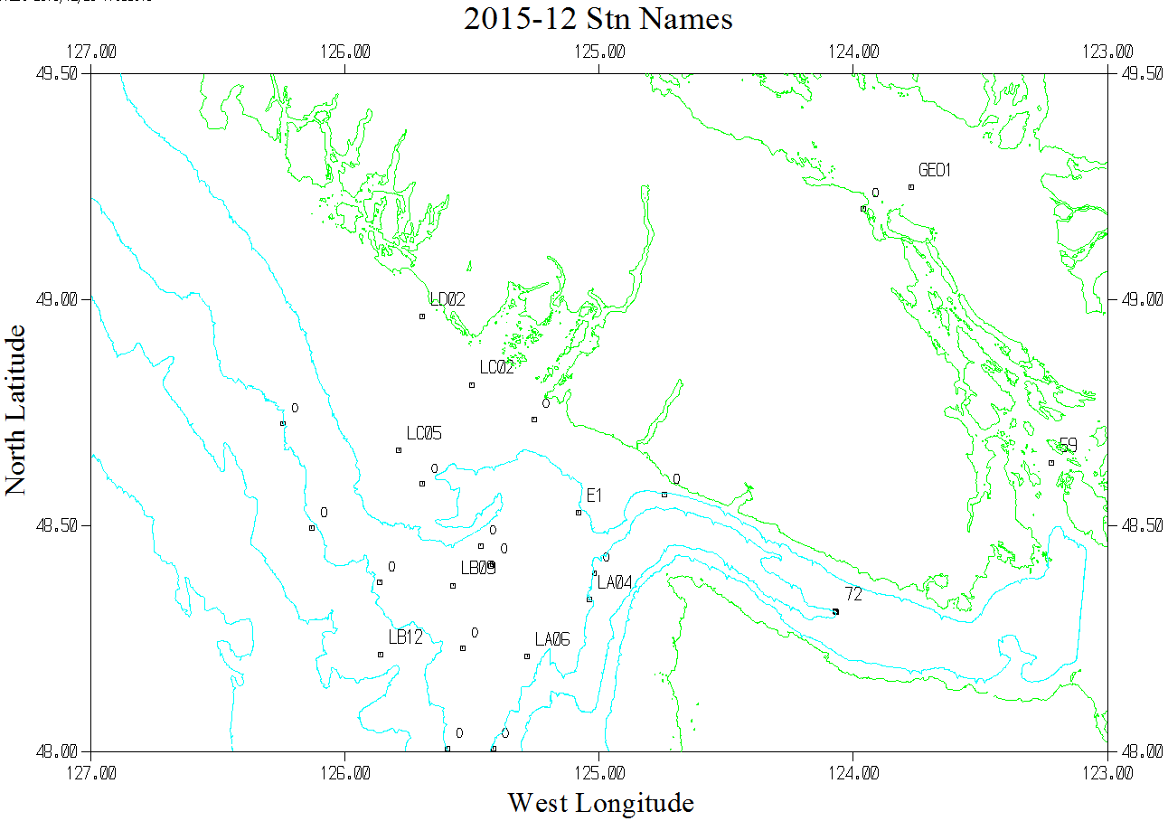
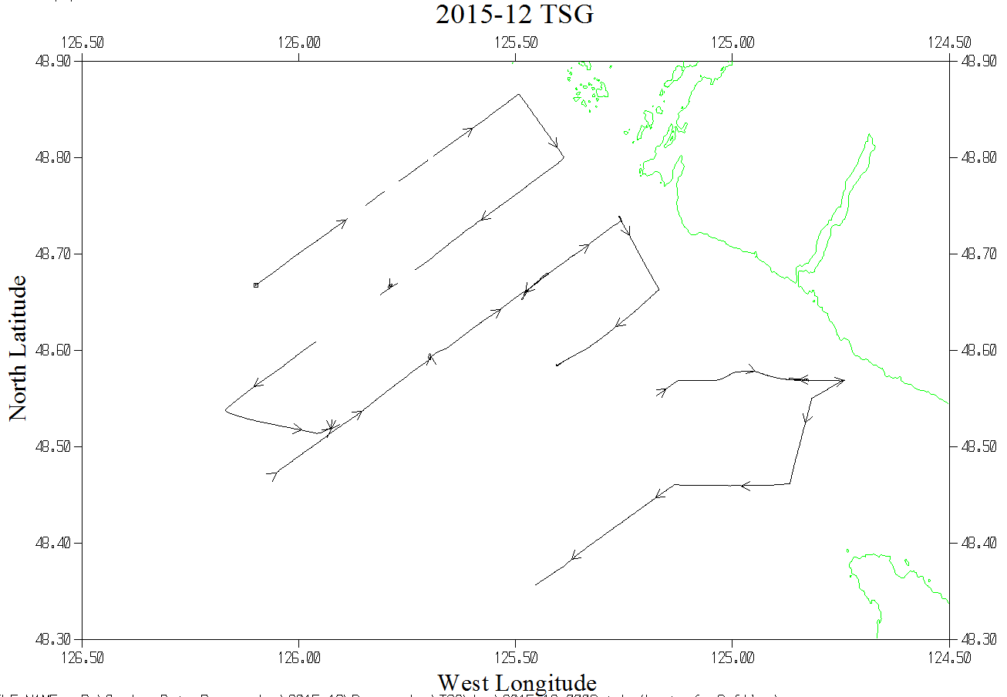

13 Dec. 2016 – To enable searching of bottle data that were previously available only in spreadsheet format, BOT files were created by taking time and position information from CTD files and using chemistry data from analysts’ spreadsheets. The samples came from a Niskin

Bottle mounted above the CTD.

