REVISION NOTICE TABLE
DATE | DESCRIPTION OF REVISION

PROCESSING NOTES
Cruise: 2014-08
Agency: MEAD
Location: West Coast Vancouver Island
Project: La Perouse Pelagic Ecosystem Survey
Party Chief: Boldt J.
Platform: W.E. Ricker
Date: 22 July 2014 – 3 August 2014

Processed by: Germaine Gatien
Date of Processing: 17 April 2015 – 21 April 2015
Number of original CTD HEX files: 16 Number of CTD files: 17 (#9003 is upcast for event #3)

INSTRUMENT SUMMARY
SeaBird Model SBE 911+ CTD (#0550) was used for this cruise. Attached were an SBE 43 DO sensor (#1176) and a WET Labs ECO_AFL Fluorometer (#2215) on the primary pump and an unpumped SBE18 pH sensor (#0851).
The deck unit was a Seabird model 11.
The salinometer used at IOS was a Guildline model 8400B Autosal, serial # 68572.

SUMMARY OF QUALITY AND CONCERNS
The Daily Science Log was missing a list of participants and the equipment list was incomplete.

For event #3 archiving was not started until the CTD was at 47db, so the upcast was processed and saved as 2014-9003.ctd. Both the incomplete downcast and the upcast were processed.

The primary salinity was recalibrated by adding 0.001 based on an assumption that half the drift implied by the post-cruise calibration had occurred at the time of this cruise.

There were only 2 salinity samples and they waited more than 3 months for analysis because they were left in the Water Properties workshop at IOS hidden under other gear. Since the sample bottle used a seal that is prone to evaporation, the analyst flagged the samples 4 because of the delay.

The fluorometry traces show little spiking so the sampling rate was presumed to have been set low. This rate is adjusted within the sensor itself and is set before the cruise. Normally we have a lot more detail in this channel and use a filter to reduce it. No filter was applied to these data.

There was dissolved oxygen sampling for only the 1st of the 8 cruises that have used this sensor between factory visits. The results of cruise 2014-01 were used to recalibrate DO. The post-cruise factory calibration suggests a drift that is reasonably close to the correction applied.

PROCESSING SUMMARY

Seasave
This step was completed at sea; the raw data files have extension HEX.

Preliminary Steps
The Log Book was obtained. It had no list of participants and the equipment list was incomplete.

The configuration stayed the same throughout the cruise; one file was saved as 2014-08-ctd.xmlcon.
The cruise summary sheet was completed.
The history of the pressure sensor, conductivity, fluorometer and DO sensors were obtained.
The salinity analysis spreadsheet was obtained; there were 2 samples taken at ~190m and 107m.

The calibration constants were checked for all instruments. The only change made was to the dissolved oxygen factor E (from 3.6 to 3.75) to reflect tests run using 2014-01 data to fine-tune the hysteresis setting. This will not affect this cruise since the hysteresis correction will not be needed, but it was changed to avoid confusion in the future.

Conversion of Full Files from Raw Data
All files were converted using con file 2014-08-ctd.xmlcon with hysteresis correction turned off.
A few casts were examined and all expected channels are present.
The two temperature and conductivity channels are fairly close to each other during the downcasts but are noisier in the upcasts.
The fluorometer, pH and dissolved oxygen traces look normal.
The descent rate is fairly noisy but kept high (and not TOO high).

WILDEDIT
Program WILDEDIT was run to remove spikes from the pressure, conductivity & temperature only.
Parameters used were: Pass 1 Std Dev = 2 Pass 2 Std Dev = 5 Points per block = 50
The parameter “Keep data within this distance of the mean” was set to 0 so all spikes would be removed.

ALIGN DO
A setting of +4s was found appropriate to advance the DO voltage for 6 other Ricker cruises of 2014, both before and after this one. Checks of the offset between distinctive features in T and DO suggest that +4s is right for this cruise too.
ALIGNCTD was used to advance the DO Voltage by 4s relative to the pressure.
Plots were examined before and after that step and the results with +4s look reasonable.

CELLTM
A setting of (α = 0.03, β=9) was found appropriate for the thermal mass correction for 6 other Ricker cruises using these sensors in 2014, both before and after this one.
CELLTM was run using (α = 0.03, β=9) for both the primary and secondary conductivity.
Tests were run on a few casts but were hard to interpret because the upcast and downcast traces were often very different, but in areas where the profiles were similar CELLTM did improve the correspondence on a T-S curve.

DERIVE
Program DERIVE was run twice:
- on all casts to calculate primary and secondary salinity and dissolved oxygen concentration.
- on a few casts to calculate the differences between primary and secondary channels for temperature, conductivity and salinity. These were placed in a test directory and will not be archived.

Test Plots and Channel Check
When these sensors were used during 2014-01 there was so much noise in the data that no reasonable comparison could be made between channels. For cruises 2014-16, 2014-17, 2016-36, 2014-51, 2014-66 and this cruise, the casts are all fairly shallow, making comparison less reliable than if we were looking at very low gradient zones as found in deeper water. The deepest sampling was about 250m for most of the other cruises, so some casts from each of the other cruises were compared with 1 from this cruise at 240db. The differences were:
Cast # | Press | T1-T0 | C1-C0 | S1-S0 | Descent Rate
2014-16-0224 | 240 | +0.0003 | +0.00013 | +0.0011 | Fairly steady
2014-16-0087 | 240 | +0.0004 | +0.0002 | +0.0017 | Fairly steady
2014-17-0155 | 240 | -0.0001 | +0.0004 | +0.0006
2014-17-0170 | 240 | -0.0002 | -0.00005 | -0.0004
2014-36-0016 | 240 | -0.0003 | -0.00003 | ~0 noisy | Fairly steady
2014-36-0141 | 240 | -0.0002 | -0.0001 | -0.0013 | Fairly steady
2014-36-0174 | 240 | -0.0002 | -0.0002 | -0.0017 N | Fairly steady
2014-08-0005 | 240 | -0.0006 VN | -0.00025 N | -0.0024 N | Noisy,moderate
2014-51-0003 | 240 | -0.0003 | -0.00058 | -0.0061 | Noisy,moderate
2014-51-0013 | 240 | -0.0006 | -0.00057 | -0.0060 | Noisy,moderate
2014-66-0045 | 240 | ~0 N | -0.00043 | -0.0044 | Fairly steady
2014-66-0159 | 240 | -0.0001 | -0.00058 | -0.0062 | Fairly steady
2014-66-0181 | 240 | ~0 | -0.00064 | -0.0072 | Fairly noisy
The differences from this cruise and the earlier ones look different from the 2 later ones. There is some suggestion that the differences between the conductivity and salinity are growing. It will be seen later that post-cruise calibrations show that drift was smaller than this study shows. There may be differences in the conductivity channels while moving that are due to alignment variations rather than calibration drift.

Conversion to IOS Headers
The IOSSHELL routine was used to convert SEA-Bird 911+ CNV files to IOS Headers.
CLEAN was run to add event numbers and to replace pad values in the pressure channel with interpolated values based on record number. As is typical of this type of fluorometer, there were some negative values, so Fluorescence values <0ug/L were replaced with pad values.

Checking Headers
The header check was run and the only problems noted were some pressure spikes but they are found at the end of the files after the pumps had been turned off, probably right at the surface.

The surface check gave an average value of 3.0db which is a little low for the Ricker but for the shallowest ones the associated salinity is very low. There were a few slightly negative pressures, but they were seen at the end of casts and are associated with very low conductivity and occur after the pumps were turned off. It looks like a 0db pressure is very close to the surface.

The cross-reference check was compared with the log book and one cast (#22) had the station name for the previous site; that was fixed with a text editor.

The cruise track was plotted and added to the end of this report. No problems were found.

For 3 casts acquisition began before the initial soak. Routine DELETE will pick data from the initial drop to 10m and patch that to the 10m – bottom part of the full cast. So it is important to remove records from the soak time to select the best available data.

CLIP was used to remove some initial records from casts #1, 8 and 11.

Shift - Alignment
Fluorescence
A shift of +12 is the usual setting used to align the Wetlabs ECO fluorescence with temperature and it was used for 2014-36. 2014-51 and 2014-66 when the same sensor was used. Tests were run on a few casts and the results look good.
SHIFT was run on all casts to advance the ECO fluorometer by +12 records.

Conductivity
For the 6 other 2014 Ricker cruises using these sensors that have been processed, the best results were found using -0.7records for the primary conductivity. For the secondary -0.9 was best for the first 3 cruises but -1.3records worked better for 2014-51 and 2014-66. Tests were run and the 2014-66 setting worked better for the current cruise.
Two runs of SHIFT were used to apply advance the primary by -0.7 records and the secondary by -1.3 records.

Dissolve Oxygen
Checks were made of the alignment of DO and temperature to see if the shift applied earlier (§5) had done a good job; it worked very well for some features but was too little or too much for others. The worst results were with the shallowest casts, likely because there were many reversals in the DO gradients; the problem is likely to be a response problem rather than alignment. The earlier adjustment appears to be the best we can achieve overall.

pH
Because of hysteresis in the pH signal, tests are best run on casts with distinctive features in the pH traces. This was done by finding the distance between such features in the upcast and downcast and comparing that with the temperature offset after applying a variety of shifts. Settings between +50 and +60 records produced the best results overall during 2014-36. A setting of +55records looked good for 2014-51 and 2014-66 with the same equipment, and the setting +55 looks good for these data as well.
SHIFT was run on all casts with the setting +55 records.

DELETE
The following DELETE parameters were used:
Surface Record Removal: Last Press Min
Maximum Surface Pressure (relative): 10.00
Surface Pressure Tolerance: 1.0 Pressure filtered over 15 points
Swells deleted. Warning message if pressure difference of 2.00
Drop rates < 0.30m/s (calculated over 11 points) will be deleted.
Drop rate applies in the range: 10db to 10db less than the maximum pressure
Sample interval = 0.042 seconds (taken from header)
COMMENTS ON WARNINGS: There were many warnings but all were from the upcast near the surface so will have no impact on the DEL files.

For file #3 REVERSE was run and then DELETE to get a REVDEL file that may be useful to get the top 50m. There was no warning in that DELETE run. The upcast file was renamed as 2014-08-9003.del

Comparisons of CTD and bottle salinity samples
There were only 2 salinity samples and they waited more than 3 months for analysis because they were left in the Water Properties workshop hidden under other gear. Since the sample bottle used a seal that is prone to evaporation, the analyst flagged the samples 4. The salinity gradient was too high for cast #41 to allow a good comparison, but for cast #44 the gradient is lower. The primary salinity was lower than the sample by about 0.007. This is the sort of difference that might be due to evaporation of the sample.

Other Comparisons
Previous experience with these sensors –
Salinity:
The conductivity and temperature sensors were both recalibrated in late January 2013 and they were used for 8 cruises before the next factory visit. The comparisons with bottles, where there was sampling, were not fully trusted. The best sampling was from 2014-01 when the primary salinity was found to be low by about 0.004, but even for that cruise there was some concern that there might be some evaporation of samples and some small effect from poor flushing especially in light of that being the first use of the sensors since the previous factory visit. The primary sensors were only used for one cast so were recalibrated to match the secondary which was not corrected.
Dissolved Oxygen:
The DO sensor was used for 8 cruises between factory calibrations, but only 2014-01 included DO sampling, so the fit from that cruise was used for all the others (slope/offset = 1.0502/+0.0142). During 2014-01 data hysteresis tests were done and factor E was fine-tuned.
Pressure:
The pressure sensor was recalibrated in May 2013 and the factory offset was found appropriate for the 5 cruises since then that have been processed.

Historic ranges – All temperature and salinity data fell within the local climatology except for records close to the bottom of the deepest cast, #5; temperature was near the maximum there and the salinity was slightly below the minimum. This reflects conditions noted widely in the North-East Pacific in 2014.

Repeat Casts –
There were no repeat casts.

Post-Cruise Calibration
Post-cruise calibrations were obtained from March 2015 for the primary conductivity and December 2014 for the other temperature and conductivity sensors. They show that the primary and secondary temperature sensors were reading slightly low, by 0.0008C° and 0.0007°, respectively. The conductivity sensors had drifted so that the primary salinity was low by 0.0026 and the secondary low by 0.0046 salinity units. The combined effect produces primary and secondary salinity low by about 0.002 and 0.004psu. Since this was the 5th of 8 cruises between calibrations, it is assumed that half the drift occurred by the time of this cruise. So salinity is likely low by 0.001.

There are post-cruise calibrations for both pH sensors but the data provided are from after modifications to the sensors, so not appropriate for data collected earlier.

The pressure post-calibration shows the pressure may be slightly low by no more than 0.8db, but this calibration was done as part of some equipment modifications that might possibly affect the offset.

- DETAILED EDITING
The first issue is to decide which sensor pair to edit. The primary T-S plots look better and the primary temperature and salinity have been selected for cruises 2014-36, 2014-51 and 2014-66. So the primary channels were selected for archiving for this cruise too.

CTDEDIT was used to remove spikes that appear to be due to instrumental problems and likely to affect the bin-averaged values and records corrupted by shed wakes including some surface records.
All casts required some editing. Notes were entered in the headers about editing applied.

Because downcast acquisition did not begin until the CTD was at 47db for cast #3, both the downcast and upcast files were edited. The upcast was saved as 2014-9003.edt. A comparison of the 2 files shows there are significant differences, but there is a lot of variability, particularly between 100 and 120db for both up and downcast. So differences may be in part real, though it is expected that the upcast data are of lower quality due to the CTD carrying deeper water with it. See below a comparison of the two edited files below 50m before bin-averaging.

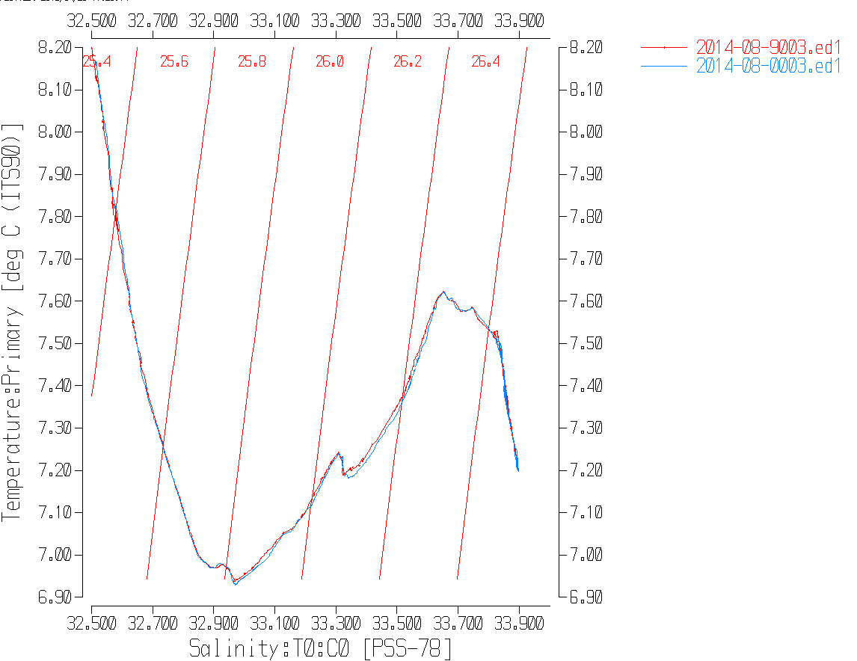
- Initial Recalibration
Using the post-cruise pressure calibration from December 2014 would produce pressure higher by about 0.8db, but it is possible it was affected by modifications to equipment that were carried out at that time and there may have been drift between this cruise and December 2014. There were some very low salinity values associated with low pressures in these data, so it looks like the sensors were very close to the surface. No recalibration will be applied.

The post-cruise calibration indicates that the primary salinity was low by about 0.002 in March 2015. This was the 5th of 8 cruises between factory visits, so it is reasonable to estimate that half the drift had occurred by the time of this cruise. The primary salinity will be recalibrated by adding 0.001.

The only information available about the SBE dissolved oxygen sensor since it was last recalibrated comes from 2014-01, so the correction applied to that data set will also be used for this cruise:
DOX_CTD Corrected = DOX_BOT = 1.0502* DOX_CTD +0.0142

File 2014-08-recal1.ccf was prepared to apply the above correction to Oxygen:Dissolved:SBE and to add 0.001 to the primary salinity. CALIBRATE was run on the EDT files.

Fluorometer Processing
At this stage a median filter, fixed size=11, is usually applied to reduce spikiness in fluorescence channels, but examination of all casts shows little spikiness, so this step was skipped. It looks like the sampling rate was set low on the sensor just as it was for 2014-66.

BIN AVERAGE of CTD files
The following Bin Average values were applied to the FIL files (output AVG):
Bin channel = pressure Averaging interval = 1.000 Minimum bin value = .000
Average value will be used. Interpolated values are NOT used for empty bins.

Final CTD File Steps (REMOVE and HEADEDIT)
REMOVE was run on all casts to remove the following channels:
Scan_Number, Temperature:Secondary, Salinity:T1:C1, Conductivity:Primary, Conductivity:Secondary, Oxygen:Voltage:SBE, Status:Pump, Descent_Rate and Flag

Profile plots were produced at this point to check for errors. No problems were found.
T-S plots were produced; there are some small unstable features that likely reflect real conditions.
A second SBE DO channel (with umol/kg units) was added.
REORDER was run to get the two DO channels together.

HEADER EDIT was used to fix formats and channel names and to add the following comments:

----------------------------------------------------------------------------------
Data Processing Notes:
----------------------
Fluorescence and pH data are nominal and unedited except that some
records were removed in editing temperature and salinity.

Dissolved oxygen was calibrated using the results of cruise 2014-01 when the
same sensor was used. There was no calibration sampling from this cruise.

Recalibration of the salinity channel was based on a report from the factory on
drift in the temperature and conductivity sensors as of 23 December 2014 and
3 March 2015, respectively. That report shows the primary salinity had drifted
low by about 0.002. This was the 5th of 8 cruises between the factory
checks so it was estimated that about the CTD salinity was reading low by
about 0.001.

WARNING: The pH:SBE:Nominal data should be used with caution; no field
calibration data were collected. Calibration is required for each cast to get
absolute values, although general trends within a cast are likely real.

For details on the processing see the report: 2014-08_Processing_Report.doc.

The cross-reference list was produced and no problems were found.
The Standards Check routine was run and no problems were found.
The Header Check was run and no problems were found.
The final files were named CTD.
The track plot looks fine.
The sensor history files were updated.

Dissolved Oxygen Surface Saturation
Dissolved Oxygen saturation was derived and plotted. The surface saturations varied from about 80% to 125% with a median value of ~110%. The values from furthest offshore are mostly ~110%. The lowest values were at two deeper casts from the south end of the region and the highest were close to shore and to the north. The values look reasonable, but we have no DO sampling to confirm them. During 2014-51 which followed this cruise, the saturation was somewhat lower, so while it may look a little high this is likely due to real conditions, not calibration problems.

Particulars
1. Archiving started during initial soak period.
3. Archiving did not start until CTD was at 50m.
8. Archiving started during initial soak period.
11. Archiving started during initial soak period; wait before downcast less than 1 minute.
17. Wait before downcast only 20s.
Institute of Ocean Sciences

CRUISE SUMMARY CTDs
CTD# | Make | Model | Serial# | Used with Rosette? | CTD Calibration Sheet Competed?
1 | SEABIRD | 911+ | 0550 | No | Yes

Calibration Information CTD #443
Sensor |  | Pre-Cruise |  | Post Cruise
Name | S/N | Date | Location | Date | Location
Temperature | 2710 | 31Jan2013 | Factory | Mar2015 | Factory
Conductivity | 2128 | 29Jan2013 | Factory | Dec2014 | Factory
Secondary Temp. | 2374 | 31Jan2013 | Factory | Dec2014 | Factory
Secondary Cond. | 3396 | 30Jan2013 | Factory | Dec2014 | Factory
SBE 43 DO sensor | 1176 | 5Mar2013 | Factory | 23dec14 | Factory
WetLabs ECO-AFL/FL | 2215
SBE18 pH | 0851 | 29May2012 | Factory | 4Sept14 | Factory
Pressure Sensor | 75636 | 25Mar2013 | Factory | 17Dec14 | factory

