EVISION NOTICE TABLE
DATE | DESCRIPTION OF REVISION
Jan 2019 | Bottle spreadsheet converted to searchable BOT files.
27June 2108 | Corrected CTD file name and event number from 232 to 233. G.G.

PROCESSING NOTES
Cruise: 2013-65
Agency: PBS, Salmon and Freshwater Ecosystems, Nanaimo, BC
Location: Coast of Vancouver Island
Project: High Seas Salmon
Chief Scientist: Morris J.
Platform: W.E. Ricker
Date: 15 October 2013 – 9 November 2013

Processed by: Germaine Gatien
Date of Processing: 7 May 2014 – 20 May 2014

Number of original hex files: 66 Number of CTD casts processed: 66

INSTRUMENT SUMMARY
A SeaBird Model SBE 911+ CTD (#0506) was mounted with an SBE43 Dissolved Oxygen sensor (#1438), a WetLabs ECO-FL Fluorometer #2215 and an SBE pH sensor #0852. The deck unit was #0424.

SUMMARY OF QUALITY AND CONCERNS
The log book had a personnel list but mostly just first names were entered; a full list was available in the post-cruise report. The equipment list was completed; it indicates that the fluorometer was pumped. This is not the usual method used for this sensor and the technician who prepared the CTD believes it was not pumped. There were some changes made to station names in the log, but in two cases there were contradictory notes about which name was correct.

There were post-cruise calibrations available for all temperature, conductivity, pressure and dissolved oxygen sensors in late December 2013 or early January 2014. Those show that there was no significant drift in the secondary salinity. The post-cruise calibrations were used for the conversion of pressure, temperature, conductivity and dissolved oxygen data. This may lead to an underestimate of DO since the corrections found in bottle comparisons are usually larger than post-cruise calibrations would suggest. It is not known if this is due to problems with the bottle comparisons, or if those comparisons address other sources of error beyond calibration drift. There had been no cruise using the same DO sensor and including DO calibration sampling since spring 2013, so conversion using the post-cruise calibration looked like the best choice.

The secondary temperature and salinity were chosen for the archive except for 2 casts in which those channels had much higher noise level than in the primary. The post-cruise calibration indicated that there was no significant drift in the secondary salinity channel, so it was not recalibrated. The primary salinity was recalibrated to bring it into line with the secondary salinity.

The SBE pH data should be used with caution; no field calibration data are available. Calibration is required for each cast to get absolute values, although general trends within a cast are likely real.

File 2013-65-0004 contains upcast data from 0 -47db because the pumps were not turned on until the CTD reached 47db of the upcast. The quality of upcast data are considered lower than downcast.

PROCESSING SUMMARY

Seasave
This step was completed at sea; the raw data files have extension HEX.

Preliminary Steps
The Log Book was obtained. Problems noted included some errors in station names. There were corrections entered in the log that had also been made to the file headers, but for casts #175 and 177, there are contradictory notes. And for event #4 the pumps were off until the CTD got to 60db of the upcast.

The cruise summary sheet was completed.
The histories of the dissolved oxygen, conductivity and pressure sensors were obtained.

There were post-cruise calibrations for temperature, conductivity, dissolved oxygen and pressure. There were no cruises between this one and the factory visit, and the calibration sampling from this cruise is only from near the surface, so it looks wise to use the post-cruise calibrations. Tests on a previous cruise showed that the pressure was improved by using the post-cruise calibration. The secondary salinity will not be affected much since there was negligible drift. There was a small drift in the primary. For the dissolved oxygen tests were done to see how large a change had taken place. As is often seen, the post-cruise drift estimate suggests a smaller correction than has been found on earlier bottle comparisons. It is not known if this is due to problems with the comparison or if the comparison also catches errors due to factors than calibration drift. There was no recent cruise that used this DO sensor and included calibration sampling, so the post-cruise calibration was used. However, it may result in DO values that are too low by ~2%. An examination of the surface saturation may give a better idea of whether this is true, though with few casts well offshore this is not a very reliable test.

The configuration file did not change through the cruise. The file used at sea was updated with pressure, temperature, conductivity and dissolved oxygen post-cruise calibrations and saved as 2013-65-ctd.xmlcon.

Conversion of Raw Data
All data were converted using file 2013-65-ctd.xmlcon.

Plots were made for a few casts.
- The temperature channels are similar for downcasts, but noisy on upcasts.
- Similarly, conductivity differences are low on downcasts, noisier on upcasts.
- Fluorescence data are sometimes offset a little more than temperature, sometimes are too spiky to see a difference between down and upcast. The usual 12 records shift used for ECO fluorometers will likely be appropriate.
- Dissolved Oxygen and pH profiles look normal with a larger offset between upcast and downcast than seen in the temperature traces.

WILDEDIT
Program WILDEDIT was used to remove spikes from the pressure, temperature and conductivity channels only.
Parameters used were: Pass 1 Std Dev = 2 Pass 2 Std Dev = 5 Points per block = 50

ALIGNCTD
Various advancements were tested to make DO and temperature traces have the same offset between downcast and upcast data. Overall the best results were with a setting of +4.5s. This advance is much larger than that used for the 2 previous cruises using this equipment, but closer to those used for this sensor in the past.
ALIGNCTD was used to advance the DO signal relative to temperature by 4.5s.

CELLTM
Tests were run on 4 casts using a variety of settings. The results are hard to interpret because the upcast data are very noisy. But overall (α=0.03, 1/β=9) look best for both channels.
CELLTM was run using (α=0.03, 1/β=9) for both the primary and secondary conductivity for all casts.

DERIVE
Program DERIVE was run on all casts to calculate primary and secondary salinity, dissolved oxygen concentration and descent rate; the tau correction was applied.

The casts are too shallow to make a study of differences between channel pairs very useful. The two conductivity channels are quite close together, but the temperatures are far enough apart to cause salinity values to differ by about 0.002. So temperature must have changed between this cruise and the factory calibration. Mis-alignment of sensors can cause some of this. But to be safe it is probably best to use the secondary sensors since they showed virtually no drift between calibrations.

Conversion to IOS Headers
The IOSSHELL routine was used to convert SEA-Bird 911+ CNV files to IOS Headers.
CLEAN was run to add event numbers and to replace pad values in the Pressure channel using linear interpolation based on scan number.

Checking Headers
A cross-reference list was produced and checked against log records. The problems found were that there was no file for Event #1 and file 2013-65-0002 corresponds to Event #4.

A header check was run. There are many odd values from Event #4. They are seen at the end of the cast when the pumps were left running with pressures near-zero. The salinity values are very low. The pressures are very noisy compared to what is seen when the CTD is stopped in the water. Within 5 scans pressure varies by 1.2db. The source of the noise is unknown, but it does show care is needed in judging pressure based on surface readings. A plot of pressure does show that, on average, it is very close to zero during this period. The negative fluorescence values are from the end of cast #4 as well and are likely from out of the water.

The surface report indicates that the average surface pressure was 3.4db, varying from 2.6 to 4.2db. The surface values are associated with salinity values ~30 to ~31.5. This looks reasonable.

SHIFT
Fluorescence
Usually it is found necessary to advance the ECO fluorescence by +12 records (0.5s) relative to pressure. For these data this step made the alignment worse and applying no shift looked best. The same thing was found for the previous cruise, 2013-15.

Conductivity
Tests were run on 5 casts shifting both conductivity channels using a variety of settings close to the ones used the last time these sensors were used. For the primary conductivity the best setting was -0.5 records and for the secondary it was -1.2 records.
All casts were put through SHIFT using -0.5 records for the primary and -1.2 records for the secondary conductivity.

Dissolved Oxygen
The SBE DO data have already been aligned, but all casts were examined to see if further adjustments are required. The results are confusing with cases where the DO traces are closer than temperature traces and other cases where the opposite is true; this was also noted for the previous cruise. The shift already applied is likely the best we can do.
SHIFT will not be run on this channel.

pH
Tests were run to see if advancing the pH data was necessary to align it with temperature. Checking a few plots the upcast and downcast pH traces was somewhat confusing, but an advance of about 75 records generally improved the data.
SHIFT was run on all casts using a setting of +75 records.

DELETE
The shifted files were put through REVERSE.
DELETE was run twice, first on the SHFpH files and next on the REV files. For event #4 the upcast is the only usable part of the file. For the others the upcast will be used for comparison with the bottle samples.

The following DELETE parameters were used:
Surface Record Removal: Last Press Min Maximum Surface Pressure (relative): 10.00
Surface Pressure Tolerance: 1.0 Pressure filtered over 15 points
Swells deleted. Warning message if pressure difference of 2.00
Drop rates < 0.30m/s (calculated over 11 points) will be deleted.
Drop rate applies in the range: 10db to 10db less than the maximum pressure
Sample interval = 0.042 seconds. (taken from header)
COMMENTS ON WARNINGS: There were many warnings for each set of files. All but one of the warnings came from the upcast except for Event #164 where the pressure is very noisy around 145db. The DELETE program worked well in selecting data from that section.

STUDY OF SENSOR PERFORMANCE
Judging by plots of pressure versus scan numbers the CTD was stopped between 13.5 and 15.5db, so the Niskin bottle would have been at about 8.5 to 10.5db when it was closed.
The DEL and DELREV files were bin-averaged (0.25m bins) and then thinned to values of 9db and 10db. Those data were exported to 4 spreadsheets with names like 2013-65-downcast-9m-ctd.xlsx.

Before looking at how the CTD data compared with bottles, the differences between the temperature and salinity channels were calculated.

CTD data from | Temp 1 –Temp 0 | Sal 1 – Sal 0
9m downcast | +0.0009 | -0.0025
10m downcast | +0.0010 | -0.0024
9m upcast | +0.0007 | -0.0016
10m upcast | +0.0005 | -0.0018

- Temperature channel pairs – The secondary temperature was higher than the primary and there is little difference among the 4.
- Salinity channel pairs – The differences in salinity are slightly larger during the downcasts. The post-cruise calibrations indicated that the secondary salinity had not drifted since the previous calibration. The primary salinity was found to have drifted low by about 0.002. A few test conversions using the pre-cruise calibration do show that the primary salinity was lower than the secondary by between 0.001 and 0.002 most of the time. Since the primary salinity is higher than the secondary by about 0.002 in the comparison using post-cruise calibrations, it would have been lower by that amount during the cruise.

COMPARISON WITH BOTTLES
The nutrient, chlorophyll and salinity bottle data were combined in spreadsheet 2013-65-bottle_ctd_data.xlsx.

The salinity bottle and fluorescence values were then added to the 4 spreadsheets with CTD data to see which depth provides a better match. The differences from the early part of the cruise were very noisy, but a section from cast #118 to #208 was much quieter, so the median of that section was chosen for all comparisons.
CTD data from | Sal 0 – Sal:Bot | Sal 1 – Sal:Bot | Fluor/CHL
9m downcast | +0.0021 | -0.0004 | 1.14
10m downcast | +0.0022 | -0.0001 | 1.14
9m upcast | +0.0030 | +0.0017 | 1.14
10m upcast | +0.0054 | +0.0030 | 1.14

For the 10m downcast data a second method was used to reduce the noise in the comparison. Casts for which the Primary CTD salinity was higher than the Secondary by between 0.001 and 0.003 were selected for comparison with the bottle salinity. The results were almost identical to those shown above.

The Niskin bottle stops a few metres above the target level and sinks to the final depth where it is assumed the bottle closed. This might lead to salinity in the Niskin bottle below ambient values. On the other hand, when there is sampling in areas of high gradients and fairly steady CTD ascent rates, we often see evidence of incomplete flushing of bottles so that they contain deeper water with higher salinity than ambient waters. The ascent rate was moderately noisy, so this should not be a major problem, but there may be some error due to incomplete flushing. So the contents of the Niskin can come from a range of depths. We cannot expect consistent differences between bottles and CTD salinity. The median values were chosen as most likely to be reliable.

The fluorescence comparison in the table is not very meaningful since chlorophyll values were low through the period used to prepare the table. If we include all the data, the median value is lower.

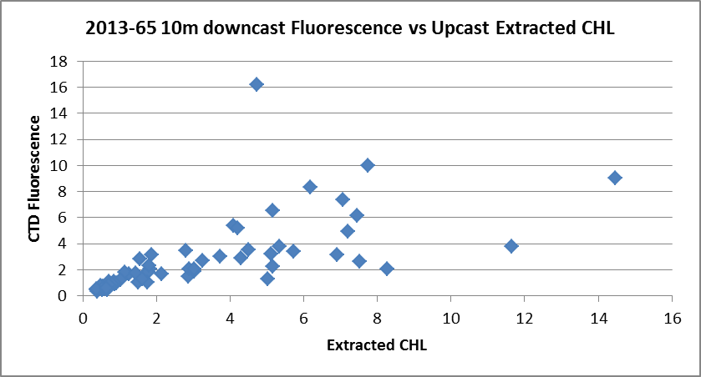

The ratio of CTD fluorescence to Extracted CHL has a lot of scatter, but is mostly >1 for low CHL values and drops to ~0.5 at the high end of the CHL range.

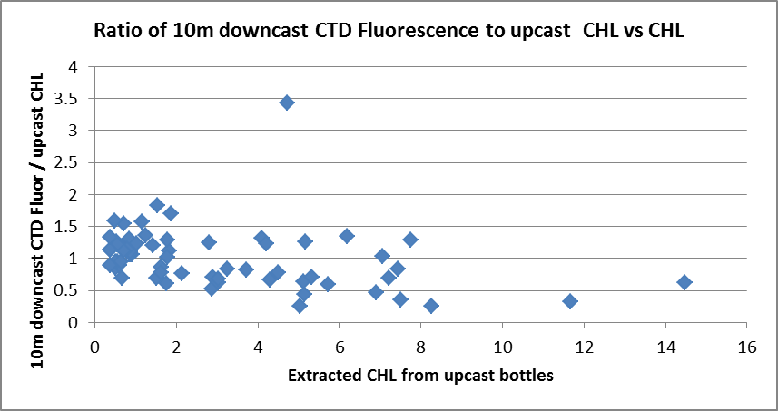

Based on the assumption that the secondary salinity is reliable, the downcast data look like the best choice for addition to file 2013-65-bottle_ctd_data.xlsx. This is the usual conclusion for such comparisons. The 10m CTD downcast data was added to the spreadsheet.

Other Comparisons
Previous experience with these sensors –
- This is the 3rd known use of the T and C sensors since they were last recalibrated, and there was no salinity sampling from the previous 2 cruises.
- The pressure sensor has been used many times since it was recalibrated in April 2011. For some recent cruises there were pressure values that appeared to be too low, so a correction was applied. For 2013-48 and 1013-15 which preceded this cruise, the post-cruise calibration was used.
- The dissolved oxygen sensor has been used for 9 previous cruises since its last factory service. There was calibration sampling for 4 of these cruises. The slope of corrections has increased gradually. The results of 2013-36 were used for recalibration of the previous 2 cruises.

Historic ranges – Data were plotted with the 3-standard deviation plots of temperature and salinity ranges where local climatology was available. Temperature values were all within historic ranges. Near-surface salinity values were consistently low to a depth of between 5 and 15db in the central area of the west coast of Vancouver Island. A similar result was found for 2 earlier cruises, though the low salinity was seen as deep as 50m for those cruises. Salinity was slightly low at the bottom of the 2 casts from the eastern side Queen Charlotte Strait. These excursions are not likely to be due to calibration drift given the consistent observation in those particular areas. Moreover, the 3-standard deviation climatology is too severe for stations this close to shore.

Post-cruise calibration – The primary conductivity was reported to have -0.0001 salinity units drift per month in January 2014 while the secondary had 0 drift. The primary temperature had drifted down by 0.00028C°/year while the secondary had drifted up by 0.00002C°/year. These drifts would lead to primary salinity being low by ~0.002 in January 2014 while the secondary salinity would have negligible error.
The pressure was recalibrated in January 2014 and the slope and offset had changed.
The SBE DO sensor was recalibrated in January 2014 and the drift was approximately 5%.

DETAILED EDITING
The secondary temperature and salinity were selected for archiving for the 2 previous cruises based on post-cruise calibration information and the secondary salinity looks a little smoother than the primary, though the difference is slight.
For cast #4 the upcast file, 2013-65-0004.DELREV, was edited, removing data below 47db because the pumps were off for the downcast and the upcast up to 47db.
For casts #7 and 16 the secondary salinity looked bad near the surface, so the primary channels will be selected for those casts.

All DEL files were copied to *.EDT.

CTDEDIT was used to clean the secondary temperature and salinity data for all casts except #7 and 16.
CTDEDIT was used to clean the primary temperature and salinity data for casts #7 and 16.
All casts required some editing.
All edited files were copied to *.EDT.

Initial Recalibration
The post-cruise pressure calibration was used based on information from the previous cruise.
Pressure and dissolved oxygen will not be recalibrated.
Secondary Salinity will not be recalibrated. The post-cruise calibration of the T and C sensors suggests drift near zero for the secondary sensors as of January 2014.
Primary Salinity was used for two casts, so that channel will be recalibrated by subtracting 0.002 based on differences from the secondary.
File 2013-65-recal1.ccf was prepared and run to subtract 0.002 from channel Salinity:T0:C0.

Fluorescence Processing
The COR1 files were put through a median filter, size 11, applied to the fluorescence channel only.

BIN AVERAGE of CTD files
The following Bin Average values were applied to the filtered files (output AVG):
Bin channel = pressure Averaging interval = 1.000 Minimum bin value = .000
Average value will be used. Interpolated values are NOT used for empty bins.
After averaging, T-S plots were examined on screen and look fine.

Profile plots were made to check all channels and no problems were noted. There are a few unstable features in T-S plots but they are small and likely real.

FINAL CTD files steps (REMOVE and HEADEDIT)
The following channels were removed from all casts except #7 and 16: Scan_Number, Temperature:Primary, Salinity:T0:C0, Conductivity:Primary, Conductivity:Secondary, Oxygen:Voltage:SBE, Status:Pump, Descent_Rate and Flag.
The following channels were removed from cast #7 and 16: Scan_Number, Temperature:Secondary, Salinity:T1:C1, Conductivity:Primary, Conductivity:Secondary, Oxygen:Voltage:SBE, Status:Pump, Descent_Rate and Flag.

A second CTD dissolved oxygen channel was derived with units umol/kg.

Dissolved Oxygen saturation was calculated and surface values were plotted. The values in the top 5m varied from ~70% to ~125%, with the lowest values in Juan de Fuca Strait, Johnstone Strait and a few casts in Queen Charlotte Sound. Those values look reasonable since those areas are subject to strong vertical mixing. Values were slightly higher in other parts of Queen Charlotte Sound and Discovery Passage. The highest values were near shore on the west coast of Vancouver Island while a little further offshore saturation values were between 90% and 110%. The lowest values are reasonable since they are from areas with strong mixing. Values near 100% are expected as we move offshore.

HEADER EDIT was used to fix formats and channel names and to add the following comments:

Data Processing Notes:
----------------------
The Fluorescence:URU:Wetlabs data are nominal and unedited except that
some records were removed in editing temperature and salinity.

The only calibration sampling was from about 10m, so recalibration could not
be based on that information. Since there were post-cruise calibrations
available, those parameters were used in processing the pressure,
temperature, conductivity and dissolved oxygen sensor data.

The factory calibrations of the temperature and conductivity sensors in
January 2014 imply that there was no significant drift in secondary
salinity since the previous factory service. No recalibration was
applied to the secondary salinity. For events #7 and 16 the primary
salinity was used: that channel was recalibrated based on how
it compared with the secondary salinity.

WARNING: The pH:SBE:Nominal data should be used with caution; no field
calibration data were available at the time of processing.
Calibration is required for each cast to get absolute values, although
general trends within a cast are likely real. The data are unedited
except that some records were removed in editing temperature and salinity.

For details on the processing see processing report: 2013-65-proc.doc.

Producing final files
The Standards Check routine was run; no errors were found.
The final files were named CTD.
A cross-reference listing was produced for CTD files.
HEADER CHECK was run and no problems were found.
A cruise track was plotted and no errors found.
The sensor history was updated for the CTD sensors.

Particulars:
1. Event #1 – file missing.
2. Event #2 was a NET cast but there is a Hex file with that name. Station JF2, so should be event #4.
4. Event #4 – pumps off until 60db during upcast.
148-177. Station Names corrected in log book. In 2 cases there are 2 separate, contradictory corrections.
175. There are contradictory notes in log indicating that the station name was wrong in the file, but it is not clear if it should be QCST 30 or QCST 28. It was originally QCST 31. But the file had already been changed to QCST 28, so that was assumed to be correct.
177. Another case of contradictory information in the log. QCST 29 assumed to be correct.

Institute of Ocean Sciences

CRUISE SUMMARY
CTD
CTD# | Make | Model | Serial# | Used with Rosette? | CTD Calibration Sheet Competed?
1 | SEABIRD | 911+ | 0506 | No | Yes

Calibration Information CTD #506
Sensor |  | Pre-Cruise |  | Post Cruise
Name | S/N | Date | Location | Date | Location
Temperature | 2038 | 25May12 | Factory | 31De2013 | Factory
Conductivity | 1763 | 25May12 | Factory | 31De2014 | Factory
Secondary Temp. | 4883 | 25May12 | Factory | 2Jan2014 | Factory
Secondary Cond. | 3394 | 25May12 | Factory | 3Jan 2014 | Factory
SBE 43 DO sensor | 1438 | 2Apr2011 | Factory | 3Jan2014 | Factory
WetLabs Eco Fluorometer | 2215 | 19June2013 | IOS
SBE pH | 0851 | 29May 2012 | Factory
Pressure Sensor | 506 | 15Apr2011 | Factory | 30Dec2014 | Factory

